**Meenakshi Nagarajan**

**U00618268**

**EGR 7050 Design and Analysis of Engineering experiments**

**Homework 2**

1. *The breaking strength of a fiber is required to be at least 150 psi. Past experience has indicated that the standard deviation of breaking strength is $σ=3$ psi. A random sample of four specimens is tested, and the results are y1 =145, y2 =153, y3 = 150, and y4 =147.*

*(****a****) State the hypotheses that you think should be tested in this experiment.*

*(****b****) Test these hypotheses using $α$ = 0.05. What are your conclusions?*

*(****c****) Find the P-value for the test in part (b).*

*(****d****) Construct a 95 percent confidence interval on the mean breaking strength.*

***Solution:***



$H_{0}:μ=150$ $H_{1}:μ>150$

It is given in the question that, the breaking strength is required to be **at least** 150. Therefore, a test for $H_{1}:μ>150$ has been chosen.

1. $α$*= 0.05*

Output from JMP:

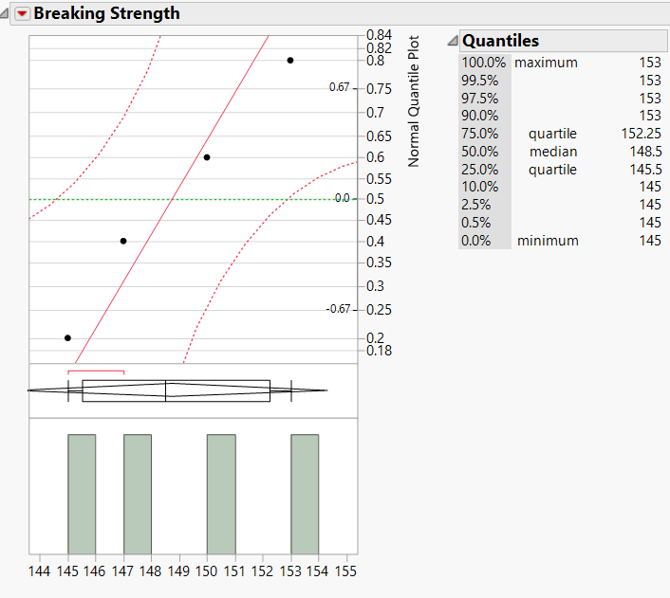

This Normal probability plot shows that all the points lie close to the line and within the error bounds.

***Fig. 1*** *Normal quantile plot*

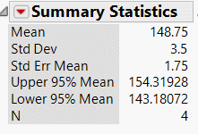

***Fig. 2*** *Summary statistics*

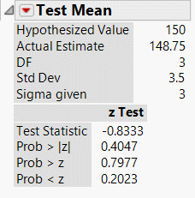

2.16 c) Represents P value for $H_{1}:μ>150$. Larger P value shows that there is no strong evidence to reject $H_{0}$

Standard deviation

Sample mean

***Fig. 3*** *Test Mean*

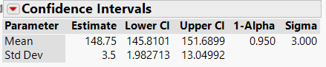

2.16 d) 95% confidence interval of mean breaking strength

***Fig. 4*** *Confidence Intervals*

**One sample z test**

n = 4, $σ$ =3, $\overline{y}=\frac{145+153+150+147}{4}$ = 148.75,

- 2.5/3 = **- 0.8333**

From z table, $Z_{0.05}$ =1.645. $Z_{0} is not greater than Z_{0.05}$. Hence, $H_{0} cannot be rejected$

1. P-value is P = 1 – $φ$ (-0.8333) = 1 – 0.2033 = **0.7967**
2. 95% C.I can be found by,

2. *The shelf life of a carbonated beverage is of interest. Ten bottles are randomly selected and tested, and the following results are obtained:*

|  |  |
| --- | --- |
| Days | |
| 108 | 138 |
| 124 | 163 |
| 124 | 159 |
| 106 | 134 |
| 115 | 139 |

1. *We would like to demonstrate that the mean shelf life exceeds 120 days. Set up appropriate hypotheses for investigating this claim.*
2. *Test these hypotheses using 0.01. What are your conclusions?*
3. *Find the P-value for the test in part (b).*
4. *Construct a 99 percent confidence interval on the mean shelf life.*

***Solution:***

1. *To find out if mean shelf life exceeds 120 days, the hypotheses would be*

$H_{0}:μ=120$ $H_{1}:μ>120$

$α=0.01$

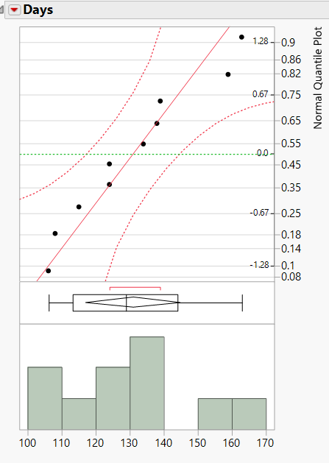

Normal quantile plot shows that all points lie close to line of fit and within error bounds.

Fig. 5 Normal quantile plot

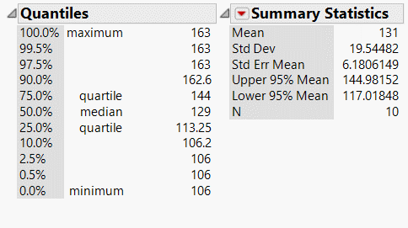

*Fig. 6 Summary statistics*

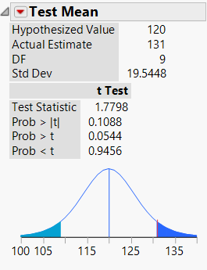

2.20 c) Represents P value for $H_{1}:μ>120$.

Standard deviation

Sample mean

*Fig. 7 Test mean*

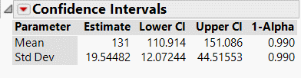

2.20 d) Upper and lower limits of 99% confidence interval

*Fig. 8 Confidence intervals*

$\overline{y}=131$, $S^{2}= \sum_{i=1}^{10}{\frac{{\left(y_{i}-\overline{y}\right)}^{2}}{n-1}}$ = 529+49+49+625+256+49+1024+784+9+64/9 = 382

S = $\sqrt{382}$ = 19.54

$t_{0}=\overline{(y}-μ_{0})/(s/\sqrt{n})$ = 131-120 / (19.54/ $\sqrt{10}$)

=11/6.18

= 1.78

$t_{0.01,9}=2.821$

${t_{0} not greater than t}_{0.01,9}. Therefore, H_{0} cannot be rejected.$

1. P-value: **P =0.0544** for $H_{1}:μ>120$ (from JMP)
2. The 99% CI is , $\overline{y}-t_{α/2,n-1}\frac{s}{\sqrt{n }}≤ μ≤$ $\overline{y}+t_{α/2,n-1}\frac{s}{\sqrt{n }}$

$131-\left(3.250\right)\left(6.18\right)≤μ≤131+\left(3.250\right)\left(6.18\right)$ = $110.915≤μ≤151.0$

*3. Consider the shelf life data in Problem 2.20. Can shelf life be described or modeled adequately by a normal distribution? What effect would the violation of this assumption have on the test procedure you used in solving Problem 2.15?*

***Solution:***

From the normal quantile plot of the previous problem, it could be seen that all points lie close to the normal line and within the error bounds. Therefore, it can be modeled by a normal distribution.

*4. Twenty observations on etch uniformity on silicon wafers are taken during a qualification experiment for a plasma etcher. The data are as follows:*

|  |  |  |  |  |
| --- | --- | --- | --- | --- |
| *5.34* | *6.65* | *4.76* | *5.98* | *7.25* |
| *6.00* | *7.55* | *5.54* | *5.62* | *6.21* |
| *5.97* | *7.35* | *5.44* | *4.39* | *4.98* |
| *5.25* | *6.35* | *4.61* | *6.00* | *5.32* |

1. *Construct a 95 percent confidence interval estimate of $σ^{2}.$*
2. *Test the hypothesis that $σ^{2}=1.0.$ Use $α=0.05.$ what are your conclusions?*
3. *Discuss the normality assumption and its role in this problem.*
4. *Check normality by constructing a normal probability plot. What are your conclusions?*

*Solution:*

$\frac{\left(n-1\right)S^{2}}{ℵ_{α/2,n-1}^{2}}≤ σ^{2}≤\frac{\left(n-1\right)S^{2}}{ℵ_{1-(α/2),n-1}^{2}}$

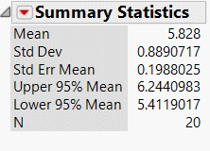

Standard deviation

Sample mean

*Fig. 9 Summary statistics*

*From JMP, S = 0.8891, $S^{2}=0.7905$*

*C.I is $\frac{\left(n-1\right)S^{2}}{ℵ_{α/2,n-1}^{2}}≤ σ^{2}≤\frac{\left(n-1\right)S^{2}}{ℵ_{1-(α/2),n-1}^{2}}$*

$\frac{\left(19\right)0.7905}{32.852}≤ σ^{2}≤\frac{\left(19\right)0.7905}{8.907}$

$0.457≤ σ^{2}≤1.686$

1. *Test the hypothesis that $σ^{2}=1.0.$ Use $α=0.05.$ what are your conclusions?*

$H_{0}:σ^{2}=1$ $H_{1}:σ^{2}≠1$

Test statistic:

$ℵ_{0}^{2}=\frac{(n-1)S^{2}}{σ_{0}^{2}}$

= $\frac{19(0.7905)}{1}$

= **15.0195**

Thus**, $ℵ_{0}^{2}$**  is neither greater than $ℵ_{α/2,n-1}^{2}$ nor less than $ℵ_{1-(α/2),n-1}^{2}.$ Hence, ${ H}_{0} cannot be rejected.$

It is concluded that $σ^{2}=1$

1. *Discuss the normality assumption and its role in this problem.*

Normality assumption is important in variance test. Normality can be assumed only if the data is very close to the line else this might lead to incorrect conclusions.

1. *Check normality by constructing a normal probability plot. What are your conclusions?*

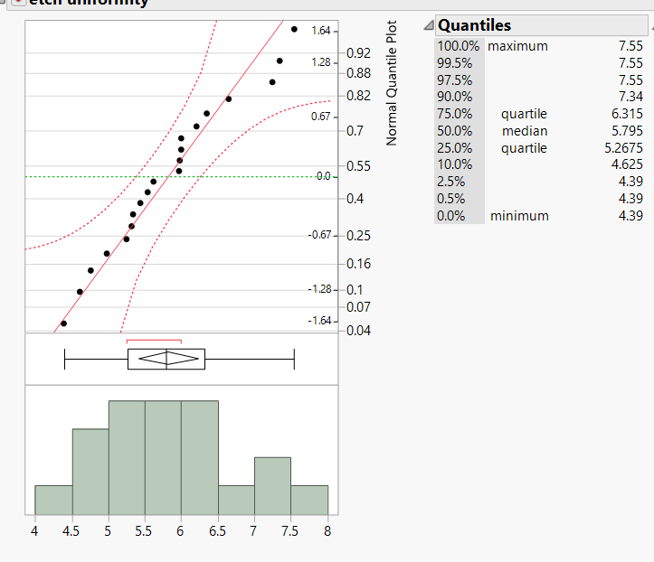

Normal quantile plot all points lie close to line though within the error bounds.

*Fig. 10 Normal quantile plot*

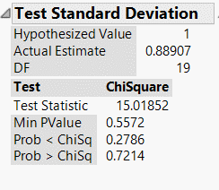

P value is 0.5572. (greater than 0.05) Hence null hypothesis $H_{0}:σ^{2}=1$ cannot be rejected

*Fig. 11 Test statistic*

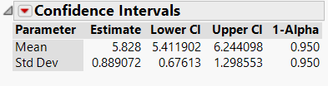

95% CI of standard deviation

*Fig. 12 Confidence intervals*