**Meenakshi Nagarajan**

**U00618268**

**EGR 7050 Design and Analysis of Engineering experiments**

**Homework 3**

1. *Two machines are used for filling plastic bottles with a net volume of 16.0 ounces. The production engineers are interested in both the mean and the variance of the fill volumes.*

|  |  |  |  |
| --- | --- | --- | --- |
| *Machine 1* | | *Machine 2* | |
| *16.03* | *16.01* | *16.02* | *16.03* |
| *16.04* | *15.96* | *15.97* | *16.04* |
| *16.05* | *15.98* | *15.96* | *16.02* |
| *16.05* | *16.02* | *16.01* | *16.01* |
| *16.02* | *15.99* | *15.99* | *16.00* |

1. *Test the hypothesis that the variances of fill volume are equal for the two machines. Use α = 0.05.*
2. *Using the results of (a) choose an appropriate test, and test whether the two machines have equal mean fill volumes. Use α = 0.05. What is the P-value for this test?*
3. *Check the assumption of normality for each machine.*

***Solution:***



$H_{0}: {σ_{1}}^{2}={σ_{2}}^{2}$ $H_{1}:{σ_{1}}^{2}≠{σ_{2} }^{2}$

Given, $α=0.05$

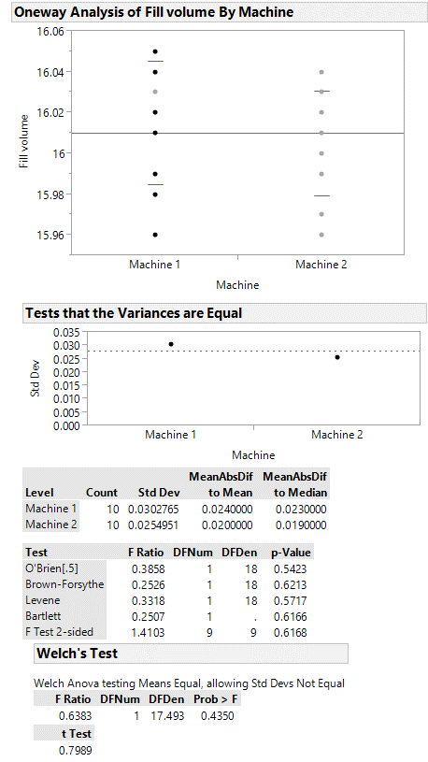

P value is greater than the significance level 0.05. Thus, there is no strong evidence to reject null hypothesis. So it can be concluded that this set of data can be analyzed with an equal variance Means/ ANOVA/ pooled-t test.

***Fig. 1*** *One way analysis*

1. $H_{0}: μ_{1}$ = $μ_{2}$ $H_{1}: μ_{1}≠μ_{2}$

Assuming equal variance,

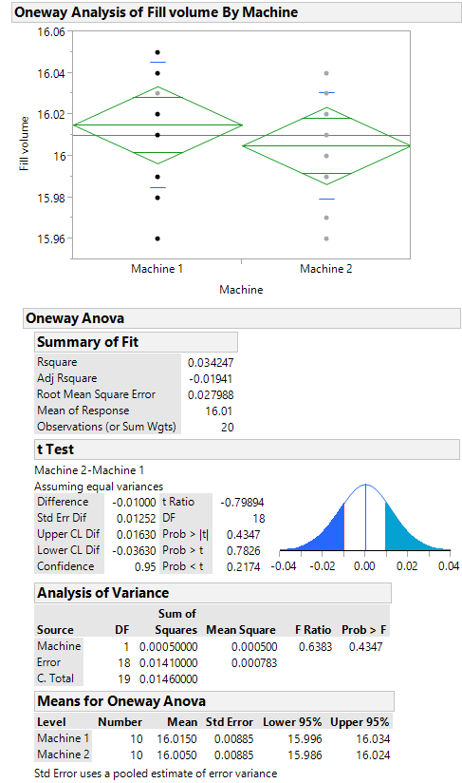

P value greater than 0.05 shows that there is no enough evidence to reject null hypothesis. Therefore, it can be concluded that there is no difference in group means.

***Fig. 2*** *Means/ ANOVA/ pooled-t*

1. From JMP,

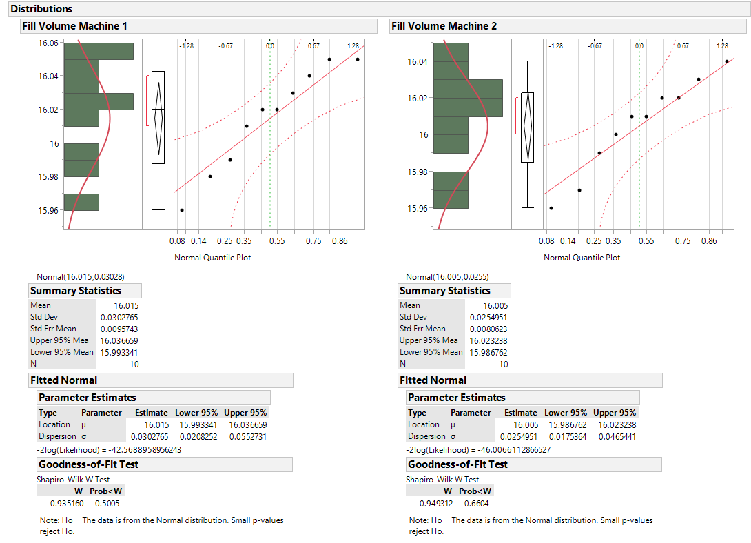 ***Fig. 3*** *Distribution of Machine 1 and 2*

Normal plot for Machine 1 and 2.

As P value greater than 0.05, it can be assumed that data is from the normal distribution.

This assumption can be checked using the normal quantile plot of two machines. It shows that all points lie close to the line and within the error bounds. Hence, it could be concluded that the data is from a normal distribution.

1. *An article in the Journal of Strain Analysis (vol. 18, no. 2, 1983) compares several procedures for predicting the shear strength for steel plate girders. Data for nine girders in the form of the ratio of predicted to observed load for two of these procedures, the Karlsruhe and Lehigh methods, are as follows:*

|  |  |  |
| --- | --- | --- |
| **Girder** | **Karlsruhe Method** | **Lehigh Method** |
| *S1/1* | *1.186* | *1.061* |
| *S2/1* | *1.151* | *0.992* |
| *S3/1* | *1.322* | *1.063* |
| *S4/1* | *1.339* | *1.062* |
| *S5/1* | *1.200* | *1.065* |
| *S2/1* | *1.402* | *1.178* |
| *S2/2* | *1.365* | *1.037* |
| *S2/3* | *1.537* | *1.086* |
| *S2/4* | *1.559* | *1.052* |

***Solution:***

1. I*s there any evidence to support a claim that there is a difference in mean performance between the two methods? Use $α=0.05$.*

$H_{0}: μ_{d}$ = $0$ $H_{1}: μ_{d}≠0$

The test statistic is,

$$t_{0}=\frac{\overline{d}}{S_{d}/\sqrt{n}}$$

Where $\overline{d}=\frac{1}{n}\sum_{j=1}^{n}{d_{j}}$ is the sample mean of differences and

$$S_{d}={\left[\frac{\sum_{j=1}^{n}{{\left(d_{j}-\overline{d}\right)}^{2}}}{n-1}\right]}^{1/2}$$

Degrees of freedom, $n-1=8$

${From JMP, t}_{0}=\frac{0.2739}{0.1351/\sqrt{9}}$ = $\frac{0.2739}{0.045}$ = 6.086

If ${ t}_{0}>t_{0.025,8}$, we would reject $H_{0}.$

From t distribution, $t_{0.025,8}=2.306$. Therefore, from the above condition, $H_{0}$ can be rejected.

It can be concluded that, there is a difference in mean performance between the two methods.

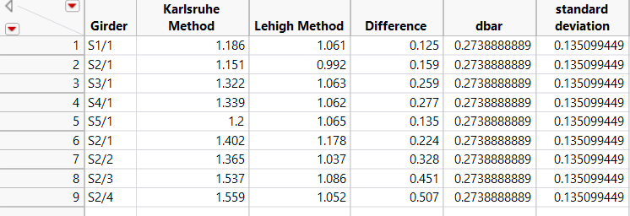

***Fig. 4*** *Data table in JMP*

1. *What is the P-value for the test in part (a)?*

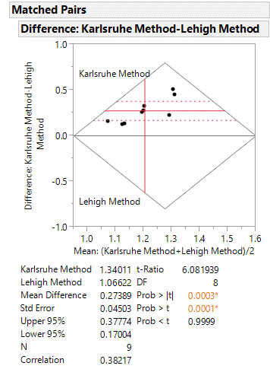

2.34b) the small P value indicates that this difference is statistically significant

***Fig.5 Paired t test***

1. *Construct a 95 percent confidence interval for the difference in mean predicted to observed load.*

95 percent C.I on $μ_{1}-μ_{2}$ is $\overline{d}±t_{0.025,8}{(S}_{d}/\sqrt{n})$

$0.2739±\left(2.306\right)\left(0.045\right)$

0.1703 $≤μ_{d}≤$ 0.3777

95 percent C.I is (0.1703, 0.3777)

1. *Investigate the normality assumption for both samples.*

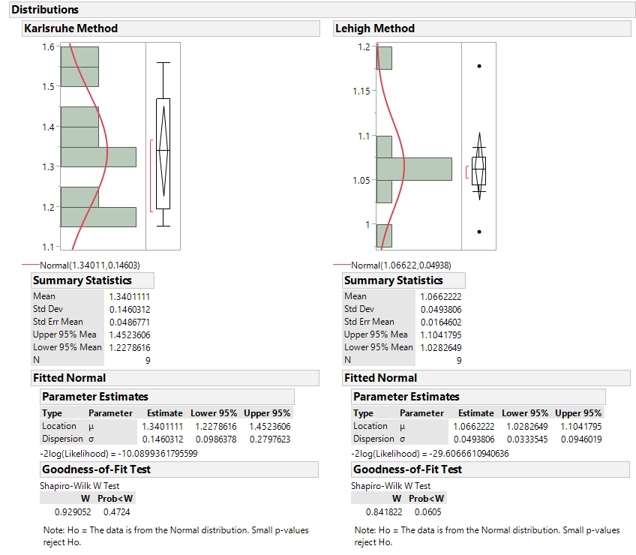

In both methods, P value is greater than 0.05. Therefore, it can be assumed that data is from normal distribution.

***Fig. 6*** *Distribution of Lehigh method and Karlsruhe method*

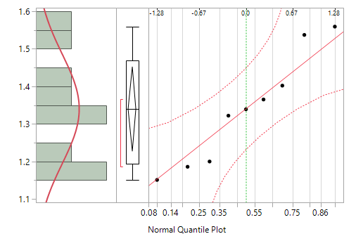

***Fig. 7*** *Normal quantile plot of Karlsruhe method*

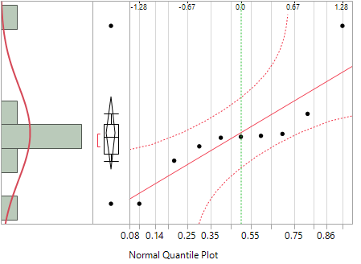

***Fig. 8*** *Normal quantile plot of Lehigh method*

In Karlsruhe method, all points lie close to the line and within the error bounds. Hence, the data is from a normal distribution whereas in Lehigh method, not all points lie close to the line and within the error bounds. Hence, the data is not from a normal distribution

1. *Investigate the normality assumption for the difference in ratios for the two methods.*

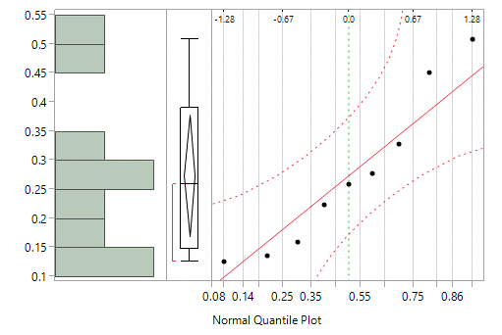

***Fig. 9*** *Normal quantile plot for difference*

From the above plot, it could be seen that all points lie within the error bounds and close to the line and could be assumed that it is distributed normally.

1. *Discuss the role of the normality assumption in the paired t-test.*

In paired t test, by pairing we could eliminate the additional source of variability. Hence the difference in ratio for two methods will be normally distributed but not the individual samples.

1. *An experimenter has conducted a single-factor experiment with six levels of the factor, and each factor level has been replicated three times. The computed value of the F- statistic is $F_{0}$ = 5.81. Find bounds on the P-value.*

***Solution:***

As the experimenter has conducted experiment with 6 levels of factor, a=6. Thus, D.F = 6-1 = 5

As each factor level has been replicated thrice, N = 18

Degrees of freedom of error within treatments is N-a = 18 – 6 = 12.

Given $F_{0}$ = 5.81 = $\frac{{MS}_{Treatments}}{{MS}_{E}}$

From the P value calculator, it is calculated as **0.00594169**

1. A computer ANOVA output is shown below. Fill in the blanks. You may give bounds on the P-value.

One-way ANOVA:

|  |  |  |  |  |  |
| --- | --- | --- | --- | --- | --- |
| **Source** | **DF** | **SS** | **MS** | **F** | **P** |
| Factor | 3 | 36.15 | ? | ? | ? |
| Error | ? | ? | ? |  |  |
| Total | 19 | 196.04 |  |  |  |

***Solution:***

${MS}_{Factor}$*= $\frac{{SS}_{Factor}}{a-1}$*

***=*** *36.15/3 =* ***12.05***

${MS}_{Error}$*= $\frac{{SS}_{Error}}{N-a}$*

${SS}_{Error}= {SS}_{T}-{SS}_{Factor}$

$=196.04-36.15$*=* **159.89**

N – 1 = 19 $→$ N = 20

a – 1 = 3 $→$ a = 4

N – a = **16**

${MS}_{Error}$*= $\frac{{SS}_{Error}}{N-a}$*

*= 159.89/16 =* **9.993**

$F_{0}=\frac{{MS}_{Factor}}{{MS}_{Error}}=\frac{12.05}{9.993}=1.206$

From P value calculator, **P = 0.339**

|  |  |  |  |  |  |
| --- | --- | --- | --- | --- | --- |
| **Source** | **DF** | **SS** | **MS** | **F** | **P** |
| Factor | 3 | 36.15 | 12.05 | 1.206 | 0.339 |
| Error | 16 | 159.89 | 9.993 |  |  |
| Total | 19 | 196.04 |  |  |  |

1. *An article in the ACI Materials Journal (Vol. 84, 1987, pp. 213–216) describes several experiments investigating the rodding of concrete to remove entrapped air. A 3-inch * 6-inch cylinder was used, and the number of times this rod was used is the design variable. The resulting compressive strength of the concrete specimen is the response. The data are shown in the following table:*

|  |  |  |  |
| --- | --- | --- | --- |
| ***Rodding Level*** | ***Compressive Strength*** | | |
| *10* | *1530* | *1530* | *1440* |
| *15* | *1610* | *1650* | *1500* |
| *20* | *1560* | *1730* | *1530* |
| *25* | *1500* | *1490* | *1510* |

1. *Is there any difference in compressive strength due to the rodding level? Use $α=$ 0.05.*

$H_{0}:There is no difference in compressive strength$

$H_{1}:There is difference in compressive strength$

As P-value 0.2138 (from JMP) is greater than $α=$ 0.05. Therefore, we do not reject null hypothesis.

Thus, it can be concluded that there is no difference in compressive strength.

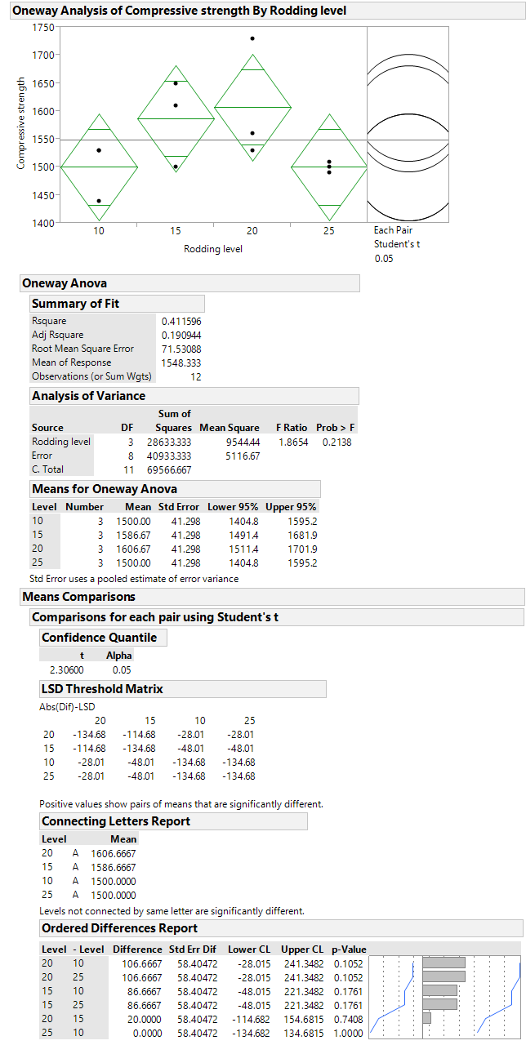

P value for rodding level.

Levels connected by same letter are not significantly different

***Fig. 10*** *One way ANOVA*

1. *Find the P-value for the F statistic in part (a).*

From the JMP output, P value for the F statistic is 0.2138

1. *Analyze the residuals from this experiment. What conclusions can you draw about the underlying model assumptions?*

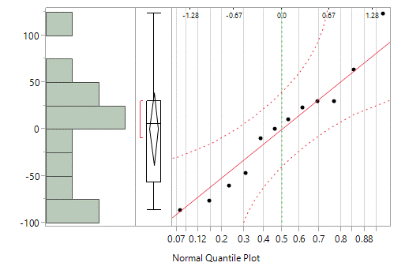

***Fig. 11*** *Normal quantile plot of residuals*

It shows that there are no outliers and data is close to the line. Therefore, normality assumption is true.

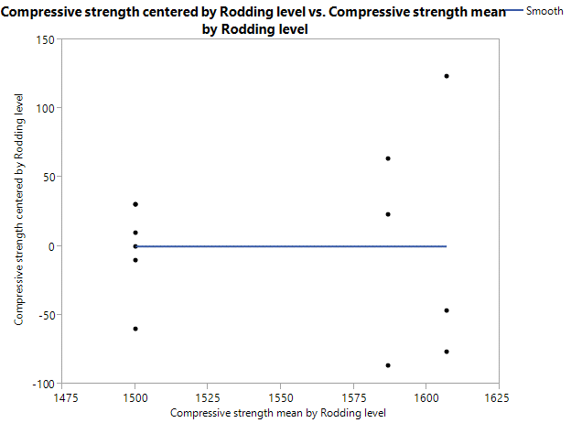

***Fig. 12*** *Residuals vs. Fitted*

From this graph, it could be concluded that there is no relationship between residuals and the fitted values.

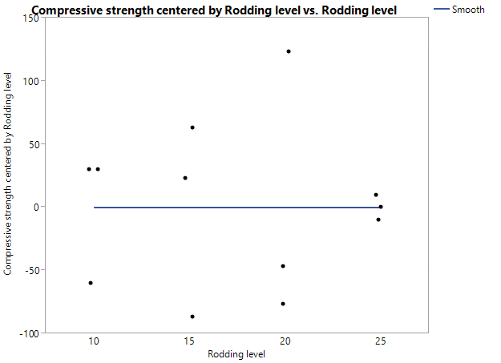

***Fig. 13*** *Residuals vs. Rodding level*

From this graph, it could be concluded that there is no relationship between residuals and the rodding level.

Therefore, it could be concluded that the underlying model assumptions are not violated.