**Meenakshi Nagarajan**

**U00618268**

**EGR 7050 Design and Analysis of Engineering experiments**

**Homework 4**

1. *A product developer is investigating the tensile strength of a new synthetic fiber that will be used to make cloth for men’s shirts. Strength is usually affected by the percentage of cotton used in the blend of materials for the fiber. The engineer conducts a completely randomized experiment with five levels of cotton content and replicates the experiment five times. The data are shown in the following table.*

|  |  |  |  |  |  |
| --- | --- | --- | --- | --- | --- |
| ***Cotton weight percent*** | ***Observations*** | | | | |
| *15* | *7* | *7* | *15* | *11* | *9* |
| *20* | *12* | *17* | *12* | *18* | *18* |
| *25* | *14* | *19* | *19* | *18* | *18* |
| *30* | *19* | *25* | *22* | *19* | *23* |
| *35* | *7* | *10* | *11* | *15* | *11* |

1. *Is there evidence to support the claim that cotton content affects the mean tensile strength? Use $α$ =0.05.*

***Solution:***

1. $H_{0}:$*Percentage of cotton used in the fiber does not affect mean the tensile strength*

$H_{1}:$*Percentage of cotton used in the fiber affects the mean tensile strength*

Given, $α=0.05$

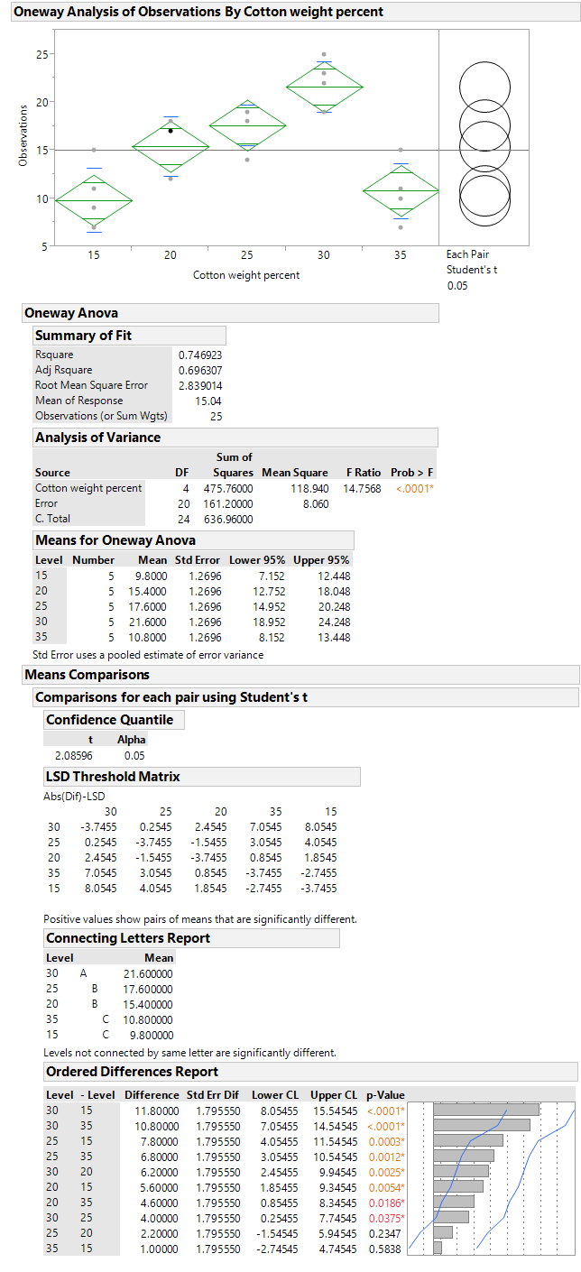

P value is less than significance level $α=0.05$ and $F_{0}>F_{0.05,4,20}.$ Therefore, reject null hypotheses.

From connecting letters report, we could see that level 30 is different from the rest of the levels. Similarly, levels 25, 20 are different from levels 35, 15. We cannot detect a significant difference between levels 25, 20 and levels 35,15.

***Fig. 1*** *OneWay ANOVA*

Thus, it could be concluded that the percentage of cotton used in the fiber affects the mean tensile strength.

1. *Analyze the residuals from this experiment and comment on model adequacy.*

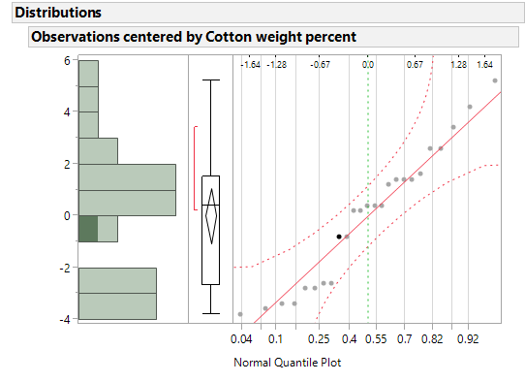

***Fig.2*** *Normal quantile plot*

Points are close to the line and are within the error bounds. There is no significant evidence of deviation from normality for the residuals.

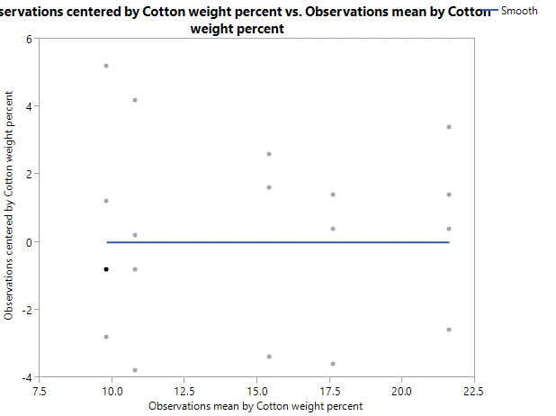

***Fig. 3*** *Residual vs. Fitted*

There are no outliers in the residual vs. fitted plots. There is a similar range of variation across different fitted values. There is no significant deviation from equal variance assumption.

1. *An experiment was performed to investigate the effectiveness of five insulating materials. Four samples of each material were tested at an elevated voltage level to accelerate the time to failure. The failure times (in minutes) are shown below:*

|  |  |  |  |  |
| --- | --- | --- | --- | --- |
| ***Material*** | ***Failure Time (minutes)*** | | | |
| *1* | *110* | *157* | *194* | *178* |
| *2* | *1* | *2* | *4* | *18* |
| *3* | *880* | *1256* | *5276* | *4355* |
| *4* | *495* | *7040* | *5307* | *10050* |
| *5* | *7* | *5* | *29* | *2* |

***Solution:***

1. *Do all five materials have the same effect on mean failure time?*

$H_{0}:$*Mean failure time is same for all materials*

$H_{1}:$*Mean failure time is different for all materials*

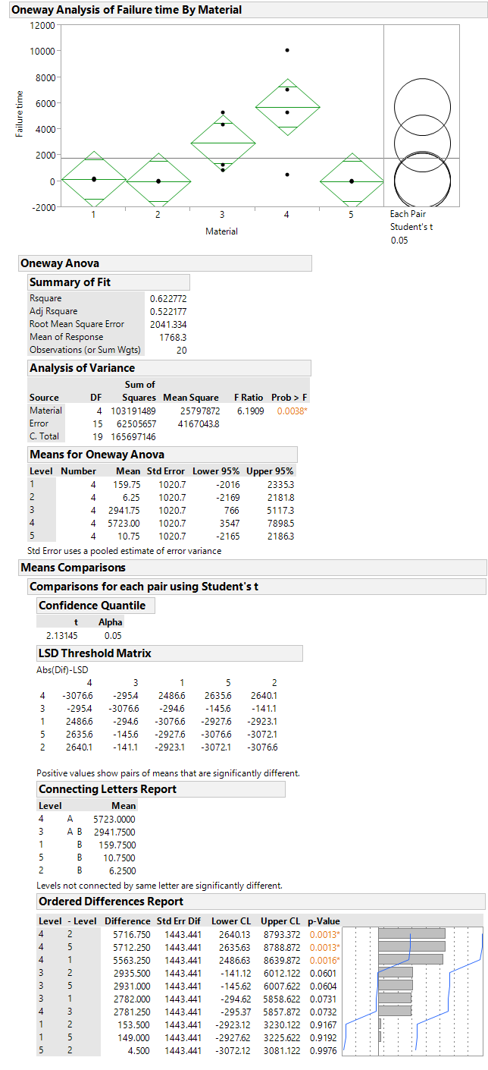

P value is less than significance level $α=0.05$ and $F_{0}>F_{0.05,4,15}$. Therefore, reject null hypothesis.

***Fig. 4*** *OneWay ANOVA*

Therefore, we could conclude that mean failure time is not the same for all materials.

1. *Plot the residuals versus the predicted response. Construct a normal probability plot of the residuals. What information is conveyed by these plots?*

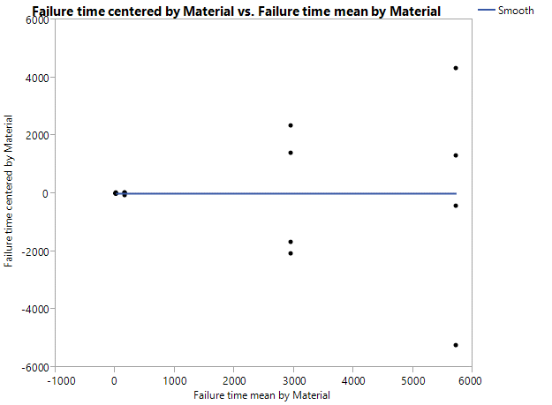

***Fig. 5*** *Residuals vs. Predicted*

The figure shows that variance is not constant for all the predicted values.

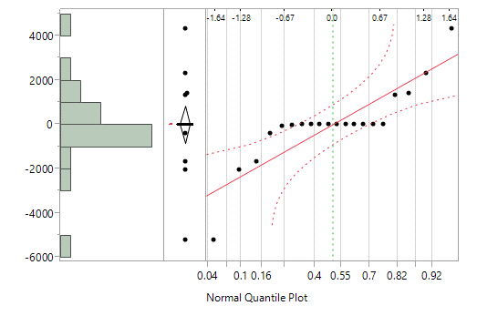

***Fig. 6*** *Normal quantile plot*

The figure clearly shows that points are not close to the line and outside the error bounds. This shows that normality assumption is not valid.

1. *Based on your answer to part (b) conduct another analysis of the failure time data and draw appropriate conclusions.*

Let us plot a bivariate fit of Log(Mean) and Log(Standard deviation).

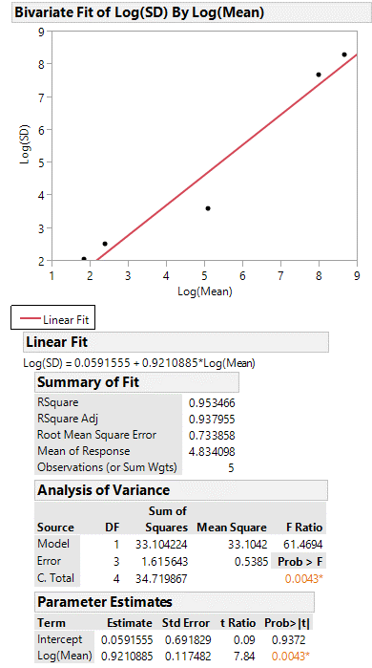

***Fig. 7*** *Log(Mean) vs. Log(S.D)*

From the plot, we could see that slope of the fit line is 0.9210 which is close to 1. So, from the table 3.9, a log transformation would be appropriate.

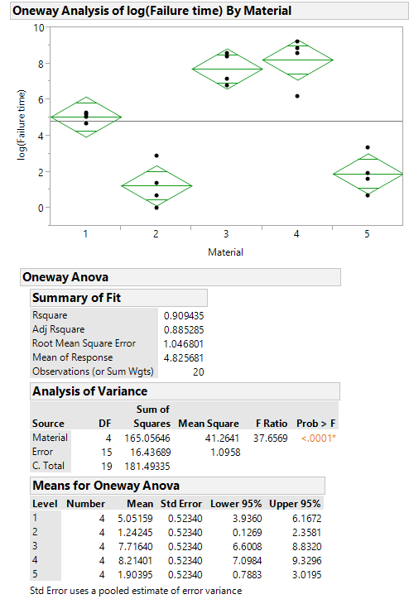

35.1463

After changing the error degree of freedom, other values are adjusted. P value is still small.

1.17406

14

P value is less than significance level $α=0.05$. Therefore, reject null hypotheses.

***Fig. 8*** *OneWay ANOVA*

Therefore, we could conclude that mean failure time is not the same for all the materials.

Lower t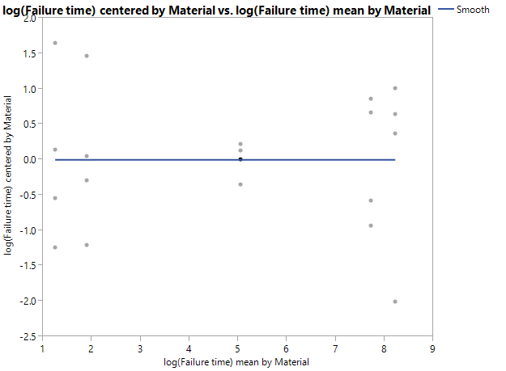

***Fig. 9*** *Residuals vs. Predicted*

This plot has been improved with transformed data although range of variation of one of the materials is lower than others.

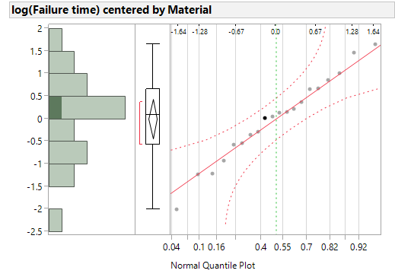

***Fig. 10*** *Normal quantile plot*

This shows that all points lie close to the line and within the error bounds. Hence the assumptions are not violated.