**Meenakshi Nagarajan**

**U00618268**

**EGR 7050 Design and Analysis of Engineering experiments**

**Homework 5**

1. *Four different designs for a digital computer circuit are being studied to compare the amount of noise present. The following data have been obtained:*

|  |  |  |  |  |  |
| --- | --- | --- | --- | --- | --- |
| ***Circuit Design*** | ***Noise Observed*** | | | | |
| *1* | *19* | *20* | *19* | *30* | *8* |
| *2* | *80* | *61* | *73* | *56* | *80* |
| *3* | *47* | *26* | *25* | *35* | *50* |
| *4* | *95* | *46* | *83* | *78* | *97* |

1. *Is the same amount of noise present for all four designs? Use $α$ =0.05.*

***Solution:***

$H_{0}:$*amount* *of* *noise present in all four designs are same*

$H_{1}:$*amount of noise present in at least one design is not same*

Given, $α=0.05$

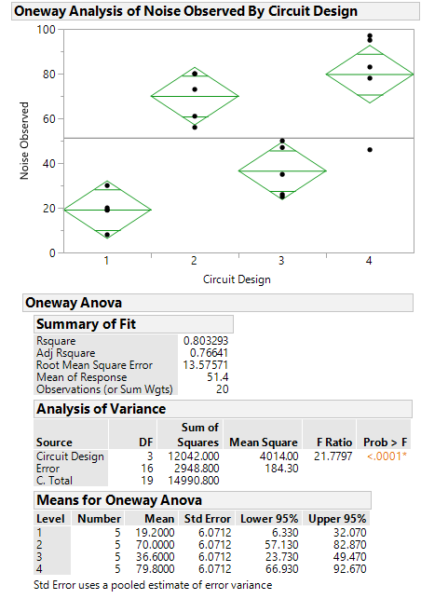

P value is less than the significance level, $α=0.05$. Thus, null hypothesis could be rejected.

***Fig. 1*** *Oneway ANOVA*

Thus, it could be concluded that amount of noise present in at least one design is not same.

1. *Analyze the residuals from this experiment. Are the analysis of variance assumptions satisfied?*

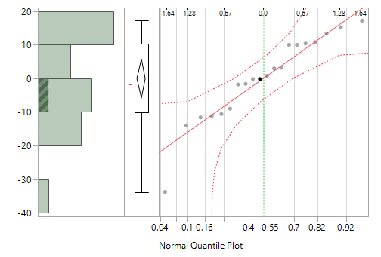

***Fig. 2*** *Normal quantile plot*

Many points are close to the line and are within the error bounds. There is no significant evidence of deviation from normality for the residuals.

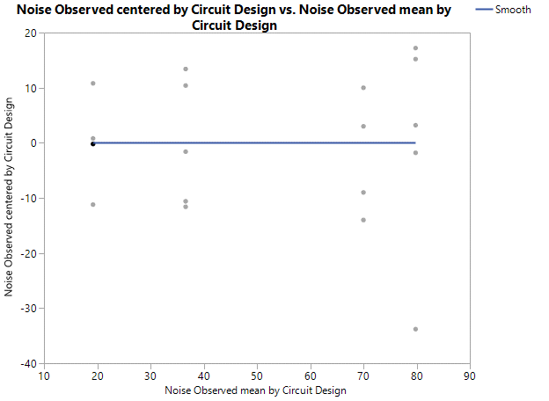

***Fig. 3*** *Residual vs. Fitted*

There are no outliers in the residual vs. fitted plots. There is a similar range of variation across different fitted values. There is no significant deviation from equal variance assumption.

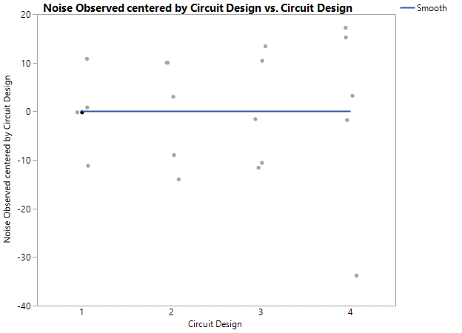

***Fig. 4*** *Residual vs. circuit design*

The above plot indicates a constant variance.

From the above figures, it could be concluded that analysis of variance assumptions are satisfied.

1. *Which circuit design would you select for use? Low noise is best.*

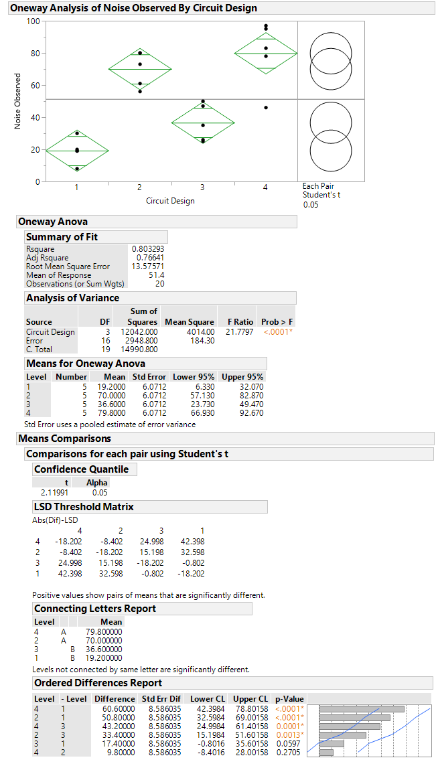

The p value for difference between level 1 & 3 is greater than $α=0.05$.

From Fisher’s LSD analysis, we see that levels 4,2 are different from levels 1,3. We cannot find a significant difference between levels 4&2 and levels 3&1.

***Fig. 5*** *Oneway ANOVA*

Therefore, it could be concluded that circuit design 1 is having the lower noise.

1. Reconsider the experiment described in Problem 3.24. Suppose that Circuit Design 1 is a control. Use Dunnett’s test with α = 0.05 to compare all of the other means with the control.

***Solution:***

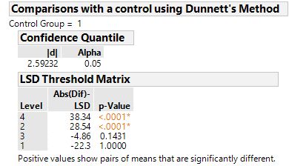

***Fig. 6*** *Dunnett’s test*

This shows that, level 4 and 2 treatment means are significantly different from the control group but not level 3.

1. The ANOVA from a randomized complete block experiment output is shown below.

|  |  |  |  |  |  |
| --- | --- | --- | --- | --- | --- |
| **Source** | **DF** | **SS** | **MS** | **F** | **P** |
| **Treatment** | 4 | 1010.56 | ? | 29.84 | ? |
| **Block** | ? | ? | 64.765 | ? | ? |
| **Error** | 20 | 169.33 | ? |  |  |
| **Total** | 29 | 1503.71 |  |  |  |

***Solution:***

1. *Fill in the blanks. You may give bounds on the P-value.*

${DF}_{Error}=(a-1)(b-1)=20$

$4(b-1)=20$

$(b-1)=5$

${SS}_{E}={SS}_{T}-{SS}_{Treatments}-{SS}_{Blocks}$

$169.33=1503.71-1010.56-{SS}_{Blocks}$

${SS}_{Blocks}=323.82$

${MS}_{Treatment}={SS}_{Treatments}/(a-1)$

${1010.56}/4=252.64$

${MS}_{Error}={SS}_{Error}/(a-1)(b-1)$

$169.33/20$*=****8.4665***

*F- value of block* ***= ${MS}_{Block}/{MS}_{Error}$***  *= 64.765/8.4665 =* ***7.65***

*From the P value calculator, P-value for treatment is* ***less than******0.0001***

*P-value for block is* ***0.0004***

1. *How many blocks were used in this experiment?*

*The degrees of freedom for block is 5.*

$\left(b-1\right)=5$

***No. of blocks $b=6$***

1. *What conclusions can you draw?*

$H_{0}:$*All treatment means are same*

$H_{1}:$*At least one mean is different*

*At significance level $α=0.05,$ 0.0001< 0.05. Therefore, null hypothesis could be rejected. It could therefore be concluded that there exists a difference between treatment means.*

$H_{0}:$*No significant difference in blocks*

$H_{1}:$*There exists a significant difference in blocks*

*At significance level $α=0.05,$ 0.0004 < 0.05. Therefore, null hypothesis could be rejected. It could therefore be concluded that there exists a significant difference in block.*

1. *A consumer products company relies on direct mail marketing pieces as a major component of its advertising campaigns. The company has three different designs for a new brochure and wants to evaluate their effectiveness, as there are substantial differences in costs between the three designs. The company decides to test the three designs by mailing 5000 samples of each to potential customers in four different regions of the country. Since there are known regional differences in the customer base, regions are considered as blocks. The number of responses to each mailing is as follows.*

|  |  |  |  |  |
| --- | --- | --- | --- | --- |
| ***Design*** | ***Region*** | | | |
| ***NE*** | ***NW*** | ***SE*** | ***SW*** |
| *1* | *250* | *350* | *219* | *375* |
| *2* | *400* | *525* | *390* | *580* |
| *3* | *275* | *340* | *200* | *310* |

***Solution:***

1. *Analyze the data from this experiment.*

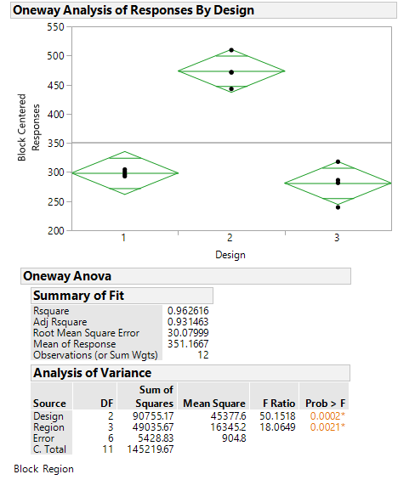

P value for both the treatment and block is less than $α=0.05.$

***Fig. 7*** *ANOVA*

$H_{0}:$*No significant difference in design*

$H_{1}:$*There exists a significant difference in design*

For both design and region, P-value is less than $α=0.05,$ therefore null hypothesis could be rejected. Thus, it could be concluded that there exists a significant difference in design.

1. *Use the Fisher LSD method to make comparisons among the three designs to determine specifically which designs differ in the mean response rate*

From Fisher’s LSD analysis, we see that Design 2 has a significantly different mean than the others. Design 1 and 3 cannot be differentiated for $α=0.05$

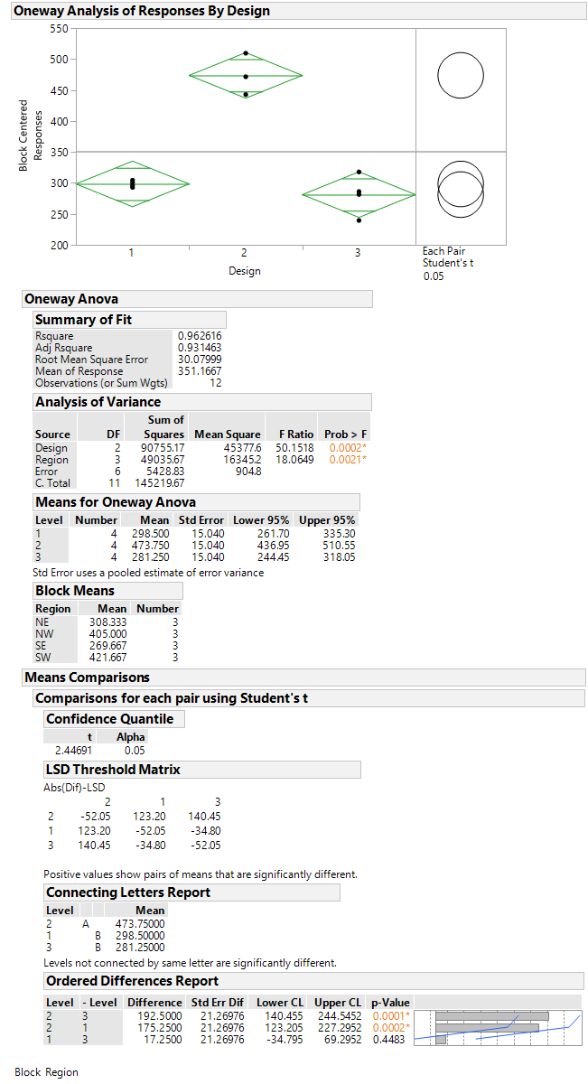

***Fig. 8*** *Oneway ANOVA*

1. *Analyze the residuals from this experiment.*
2. *The effect of five different ingredients (A, B, C, D, E) on the reaction time of a chemical process is being studied. Each batch of new material is only large enough to permit five runs to be made. Furthermore, each run requires approximately $11/{2 }$ hours, so only five runs can be made in one day. The experimenter decides to run the experiment as a Latin square so that day and batch effects may be systematically controlled. She obtains the data that follow. Analyze the data from this experiment (use, $α=0.05$) and draw conclusions.*

|  |  |  |  |  |  |
| --- | --- | --- | --- | --- | --- |
| ***Batch*** | ***Day*** | | | | |
| ***1*** | ***2*** | ***3*** | ***4*** | ***5*** |
| ***1*** | *A=8* | *B=7* | *D=1* | *C=7* | *E=3* |
| ***2*** | *C=11* | *E=2* | *A=7* | *D=3* | *B=8* |
| ***3*** | *B=4* | *A=9* | *C=10* | *E=1* | *D=5* |
| ***4*** | *D=6* | *C=8* | *E=6* | *B=6* | *A=10* |
| ***5*** | *E=4* | *D=2* | *B=3* | *A=8* | *C=8* |

***Solution:***

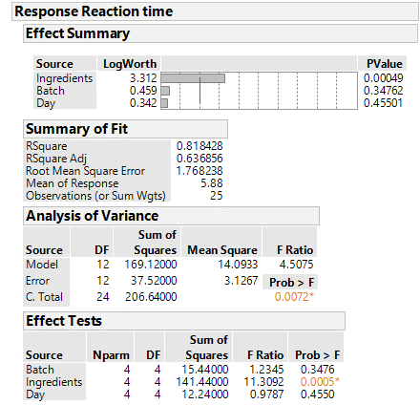

The other two P values (Batch = 0.3476 and Day=0.4550) are greater than $α=0.05$. This concludes that there is no significant difference in the batch and no significant difference between the days.

JMP says that, the P value of ingredients is 0.0005 which is less than $α=0.05$. This shows that the Ingredients has a significant effect on Response Reaction time.

***Fig.*** *Fit Least Squares*

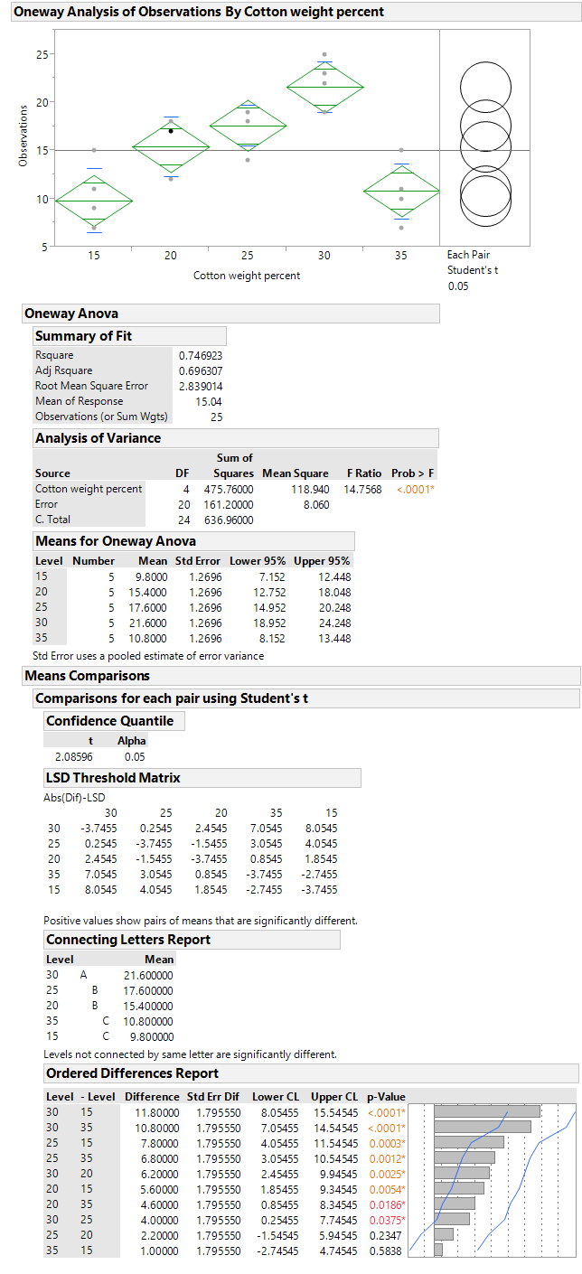

P value is less than significance level $α=0.05$ and $F_{0}>F_{0.05,4,20}.$ Therefore, reject null hypotheses.

From connecting letters report, we could see that level 30 is different from the rest of the levels. Similarly, levels 25, 20 are different from levels 35, 15. We cannot detect a significant difference between levels 25, 20 and levels 35,15.

***Fig. 1*** *OneWay ANOVA*

Thus, it could be concluded that the percentage of cotton used in the fiber affects the mean tensile strength.

1. *Analyze the residuals from this experiment and comment on model adequacy.*

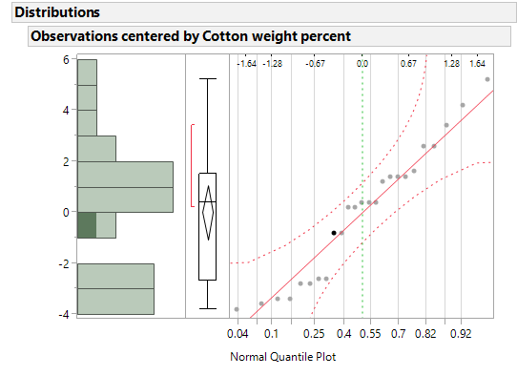

***Fig.2*** *Normal quantile plot*

Points are close to the line and are within the error bounds. There is no significant evidence of deviation from normality for the residuals.

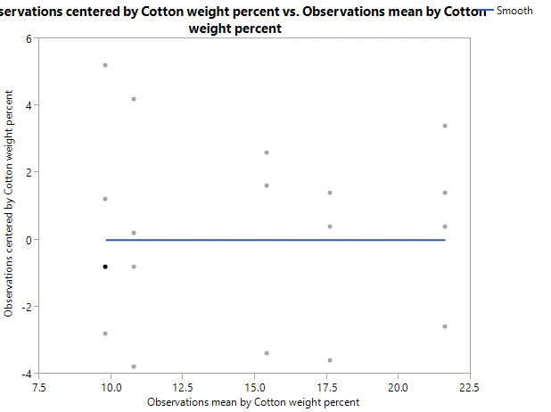

***Fig. 3*** *Residual vs. Fitted*

There are no outliers in the residual vs. fitted plots. There is a similar range of variation across different fitted values. There is no significant deviation from equal variance assumption.

1. *An experiment was performed to investigate the effectiveness of five insulating materials. Four samples of each material were tested at an elevated voltage level to accelerate the time to failure. The failure times (in minutes) are shown below:*

|  |  |  |  |  |
| --- | --- | --- | --- | --- |
| ***Material*** | ***Failure Time (minutes)*** | | | |
| *1* | *110* | *157* | *194* | *178* |
| *2* | *1* | *2* | *4* | *18* |
| *3* | *880* | *1256* | *5276* | *4355* |
| *4* | *495* | *7040* | *5307* | *10050* |
| *5* | *7* | *5* | *29* | *2* |

***Solution:***

1. *Do all five materials have the same effect on mean failure time?*

$H_{0}:$*Mean failure time is same for all materials*

$H_{1}:$*Mean failure time is different for all materials*

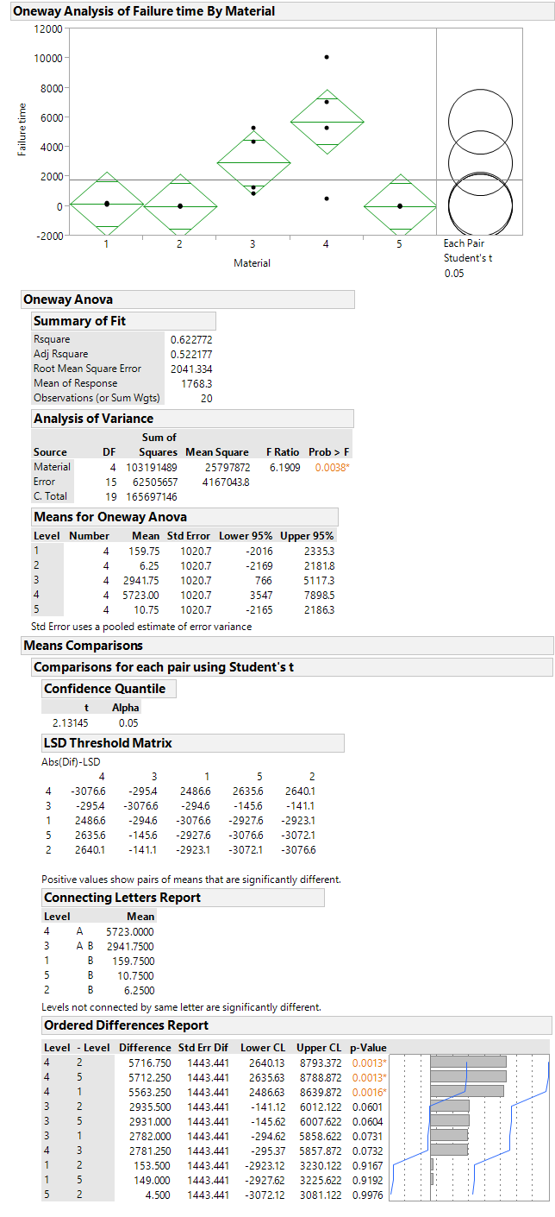

P value is less than significance level $α=0.05$ and $F_{0}>F_{0.05,4,15}$. Therefore, reject null hypothesis.

***Fig. 4*** *OneWay ANOVA*

Therefore, we could conclude that mean failure time is not the same for all materials.

1. *Plot the residuals versus the predicted response. Construct a normal probability plot of the residuals. What information is conveyed by these plots?*

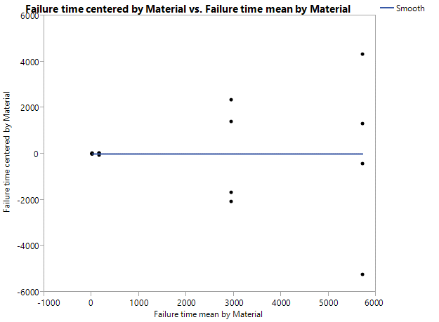

***Fig. 5*** *Residuals vs. Predicted*

The figure shows that variance is not constant for all the predicted values.

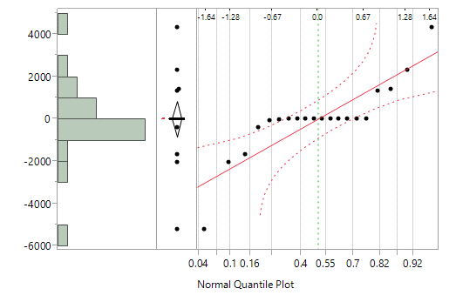

***Fig. 6*** *Normal quantile plot*

The figure clearly shows that points are not close to the line and outside the error bounds. This shows that normality assumption is not valid.

1. *Based on your answer to part (b) conduct another analysis of the failure time data and draw appropriate conclusions.*

Let us plot a bivariate fit of Log(Mean) and Log(Standard deviation).

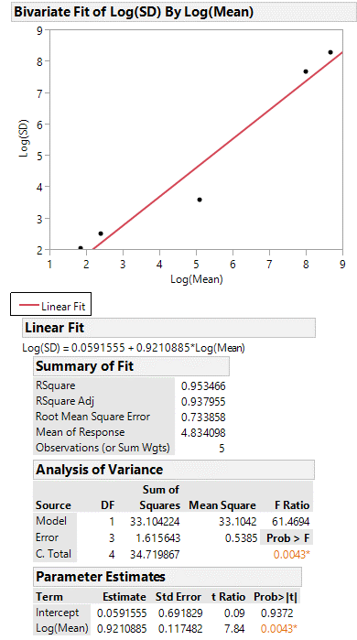

***Fig. 7*** *Log(Mean) vs. Log(S.D)*

From the plot, we could see that slope of the fit line is 0.9210 which is close to 1. So, from the table 3.9, a log transformation would be appropriate.

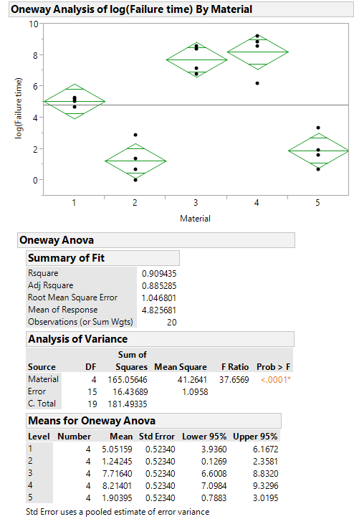

35.1463

After changing the error degree of freedom, other values are adjusted. P value is still small.

1.17406

14

P value is less than significance level $α=0.05$. Therefore, reject null hypotheses.

***Fig. 8*** *OneWay ANOVA*

Therefore, we could conclude that mean failure time is not the same for all the materials.

Lower t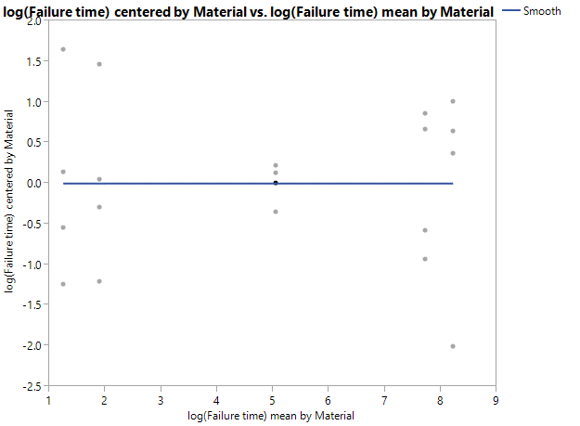

***Fig. 9*** *Residuals vs. Predicted*

This plot has been improved with transformed data although range of variation of one of the materials is lower than others.

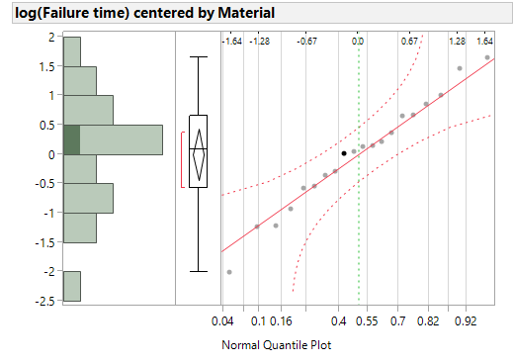

***Fig. 10*** *Normal quantile plot*

This shows that all points lie close to the line and within the error bounds. Hence the assumptions are not violated.