**EGR 7050 Design and Analysis of Engineering experiments**

**Homework 7**

1. *An engineer is studying the mileage performance characteristics of five types of gasoline additives. In the road test he wishes to use cars as blocks; however, because of a time constraint, he must use an incomplete block design. He runs the balanced design with the five blocks that follow. Analyze the data from this experiment (use, $α=0.05$) and draw conclusions.*

|  |  |  |  |  |  |
| --- | --- | --- | --- | --- | --- |
| ***Additive*** | ***Car*** | | | | |
| *1* | *2* | *3* | *4* | *5* |
| *1* |  | *17* | *14* | *13* | *12* |
| *2* | *14* | *14* |  | *13* | *10* |
| *3* | *12* |  | *13* | *12* | *9* |
| *4* | *13* | *11* | *11* | *12* |  |
| *5* | *11* | *12* | *10* |  | *8* |

***Solution:***

$H_{0}:$*No significant difference in gasoline additives*

$H_{1}$: *There is a significant difference in gasoline additives*

Given, $α=0.05$

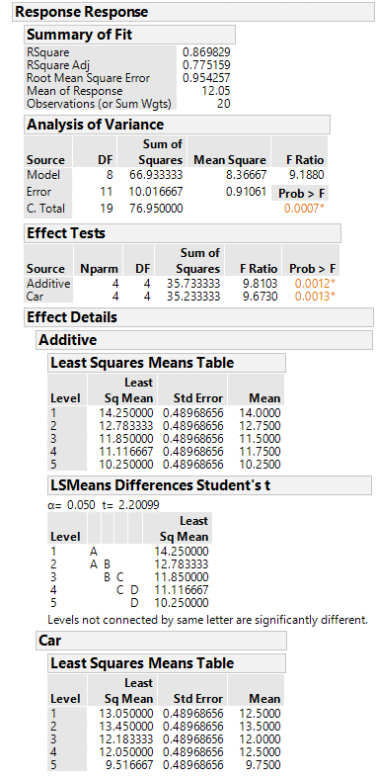

P value is less than $α=0.05$. Thus, reject null hypothesis and conclude that there is a significant evidence that at least one additive results in a significant different mean.

From the Fishers LSD analysis, we see that adjacent pairs of additive could not differentiated for $α=0.05$.

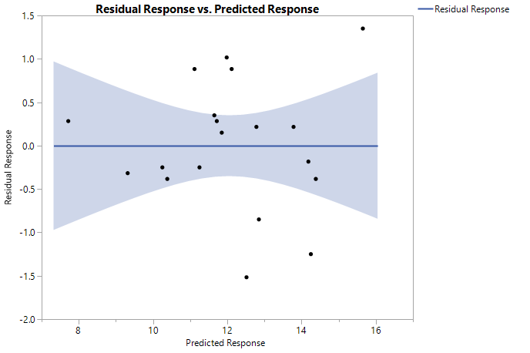

Residual vs. predicted plot does not show any strong evidence for unequal variance. There is similar range of variation across different fitted values.

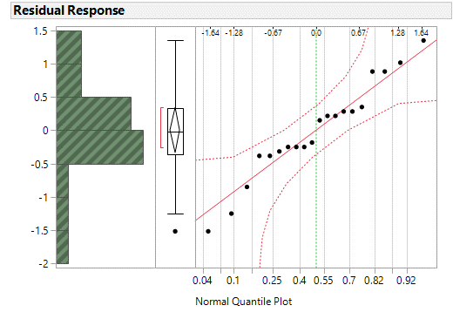

All points are close to the line and lie within the error bounds. Hence, normality assumption is not violated.

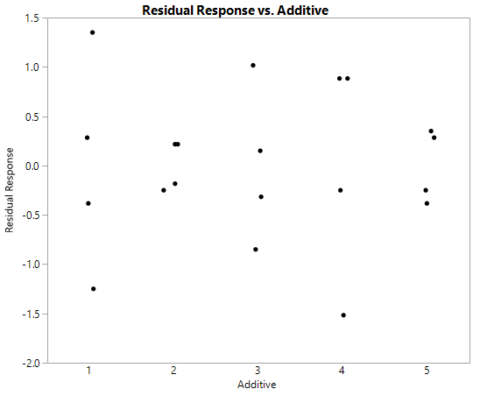

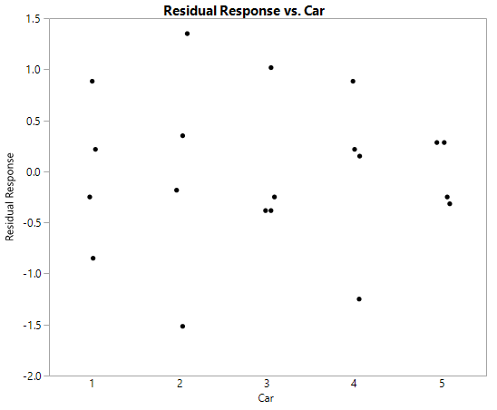

The above plots does not show any pattern in the variance. There is similar range of variation across different fitted values although the range is somewhat smaller for car 3 and 5 and additives 2 and 5.

1. The following output was obtained from a computer program that performed a two-factor ANOVA on a factorial experiment.

|  |  |  |  |  |  |
| --- | --- | --- | --- | --- | --- |
| **Source** | **DF** | **SS** | **MS** | **F** | **P** |
| A | 1 | 0.322 | ? | ? | ? |
| B | ? | 80.554 | 40.2771 | 4.59 | ? |
| Interaction | ? | ? | ? | ? | ? |
| Error | 12 | 105.327 | 8.7773 |  |  |
| Total | 17 | 231.551 |  |  |  |

***Solution:***

1. Fill in the blanks in the ANOVA table. You can use bounds on the P-values.

$a-1=1$

$a=2$

${MS}_{A}=\frac{{SS}_{A}}{a-1}$

$=\frac{0.322}{1}=0.322$

$F_{0}=\frac{{MS}_{A}}{{MS}_{E}}$ = $\frac{0.322}{8.7773}$ **= 0.0367**

${MS}_{B}=\frac{{SS}_{B}}{b-1}$

$40.2771=\frac{80.554}{b-1}$

$b-1=\frac{80.554}{40.2771}=1.99 ≈2$

$(a-1)(b-1)=2$

${SS}_{E}={SS}_{T}-{SS}_{AB}-{SS}_{A}-{SS}_{B}$

105.327 $=231.551-{SS}_{AB}-0.322-80.554$

${SS}_{AB}=231.551-105.327-0.322-80.554$

$=45.348$

${MS}_{AB}=\frac{{SS}_{AB}}{(a-1)(b-1)}$ = $45.348/2$ = 22.674

$F_{0}=\frac{{MS}_{AB}}{{MS}_{E}}$ = 22.674/8.7773 = **2.583**

From P value calculator**,** P value for A = 0.8513

P value for B = 0.0331

P value for AB = 0.1167

|  |  |  |  |  |  |
| --- | --- | --- | --- | --- | --- |
| **Source** | **DF** | **SS** | **MS** | **F** | **P** |
| A | 1 | 0.322 | 0.322 | 0.0367 | 0.8513 |
| B | 2 | 80.554 | 40.2771 | 4.59 | 0.0331 |
| Interaction | 2 | 45.348 | 22.674 | 2.583 | 0.1167 |
| Error | 12 | 105.327 | 8.7773 |  |  |
| Total | 17 | 231.551 |  |  |  |

1. How many levels were used for factor B?

b-1 = 2

**b = 3 levels**

1. How many replicates of the experiment were performed?

Total number of observations = 18

a =2, b =3 levels

|  |  |  |  |
| --- | --- | --- | --- |
|  | 1 | 2 | 3 |
| 1 | $$y_{111},y_{112},y_{113}$$ | $$y_{121},y_{122},y_{123}$$ | $$y_{131},y_{132},y_{133}$$ |
| 2 | $$y_{211},y_{212},y_{213}$$ | $$y_{221},y_{222},y_{223}$$ | $$y_{331},y_{332},y_{333}$$ |

Number of replicates formed is 3

1. What conclusions would you draw about this experiment?

$H_{0}:$*No significant difference in A*

$H_{1}:$*There is a significant difference in A*

P value for A is 0.8513 which is greater than $α=0.05$. Therefore, do not reject null. It could therefore be concluded that **there is no significant difference in A.**

$H_{0}:$*No significant difference in B*

$H_{1}:$*There is a significant difference in B*

P value for B is 0.0331 which is less than $α=0.05$. Therefore, reject null. It could therefore be concluded that **there is a significant difference in B**.

$H_{0}:$*No significant difference in AB*

$H_{1}:$*There is a significant difference in AB*

P value for AB is 0. 0.1167which is less than $α=0.05$. Therefore, do not reject null. It could therefore be concluded that **there is no significant difference in AB.**

1. An article in Industrial Quality Control (1956, pp.5–8) describes an experiment to investigate the effect of the type of glass and the type of phosphor on the brightness of a television tube. The response variable is the current necessary (in microamps) to obtain a specified brightness level. The data are as follows:

|  |  |  |  |
| --- | --- | --- | --- |
| **Glass type** | **Phosphor Type** | | |
| 1 | 2 | 3 |
| 1 | 280  290 285 | 300 310 295 | 290 285 290 |
| 2 | 230 235 240 | 260 240 235 | 220 225 230 |

1. Is there any indication that either factor influences brightness? Use $α=0.05$

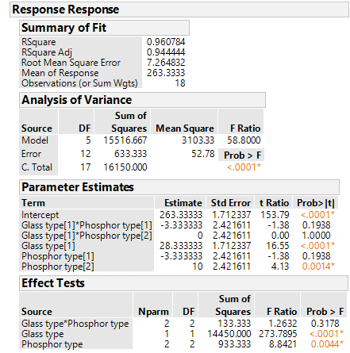

b. Interaction effect is not significant at $α=0.05$.

a. Both glass type and phosphor type are significant at $α=0.05$.

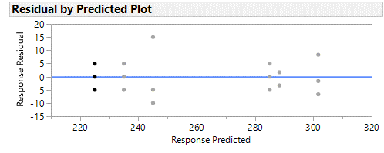

1. Do the two factors interact? Use $α=0.05$

$H_{0}:$*No significant difference in interaction*

$H_{1}:$*There is a significant difference in interaction*

Interaction effect is not significant at $α=0.05$ as p value is greater than $α=0.05$. Hence, do not reject null hypothesis.

1. The yield of a chemical process is being studied. The two factors of interest are temperature and pressure. Three levels of each factor are selected; however, only nine runs can be made in one day. The experimenter runs a complete replicate of the design on each day. The data are shown in the following table. Analyze the data, assuming that the days are blocks.

|  |  |  |  |  |  |  |
| --- | --- | --- | --- | --- | --- | --- |
| ***Temperature*** | ***Day 1 pressure*** | | | ***Day 2 pressure*** | | |
| ***250*** | ***260*** | ***270*** | ***250*** | ***260*** | ***270*** |
| ***Low*** | *86.3* | *84.0* | *85.8* | *86.1* | *85.2* | *87.3* |
| ***Medium*** | *88.5* | *87.3* | *89.0* | *89.4* | *89.9* | *90.3* |
| ***High*** | *89.1* | *90.2* | *91.3* | *91.7* | *93.2* | *93.7* |

***Solution:***

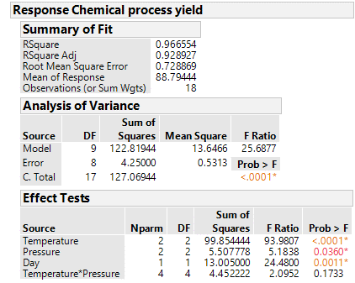

The interaction effect is not significant at $α=0.05$.

The temperature and pressure effect are significant at $α=0.05.$

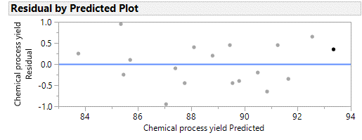

Residual vs. predicted plot does not show any strong evidence for unequal variance. There is similar range of variation across different fitted values.

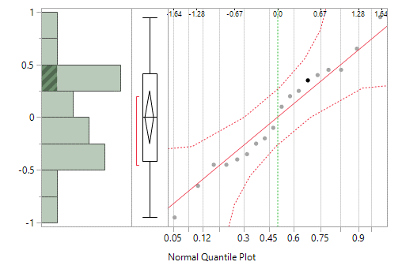

All the points lie close to the line and within error bounds. Therefore, the normality assumption is true.

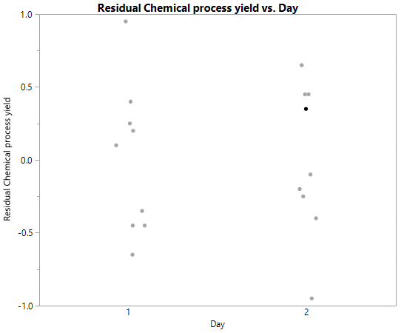

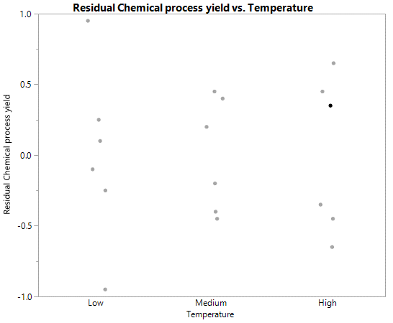

Residual vs. Day and Residual Vs. Temperature does not show any strong evidence for unequal variance. There is similar range of variation across different fitted values.

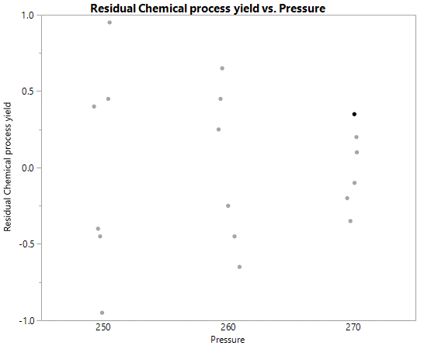

There is some decrease in the residual variance as pressure increases. But this doesn’t seem to affect the normality of residuals.