**EGR 7050 Design and Analysis of Engineering experiments**

**Homework 8**

1. *An experiment was performed to improve the yield of a chemical process. Four factors were selected, and two replicates of a completely randomized experiment were run. The results are shown in the following table:*

|  |  |  |  |  |  |
| --- | --- | --- | --- | --- | --- |
| Treatment Combination | Replicate | | Treatment Combination | Replicate | |
| I | II | I | II |
| (1) | 90 | 93 | d | 98 | 95 |
| a | 74 | 78 | ad | 72 | 76 |
| b | 81 | 85 | bd | 87 | 83 |
| ab | 83 | 80 | abd | 85 | 86 |
| c | 77 | 78 | cd | 99 | 90 |
| ac | 81 | 80 | acd | 79 | 75 |
| bc | 88 | 82 | bcd | 87 | 84 |
| abc | 73 | 70 | abcd | 80 | 80 |

***Solution:***

1. *Estimate the factor effects*

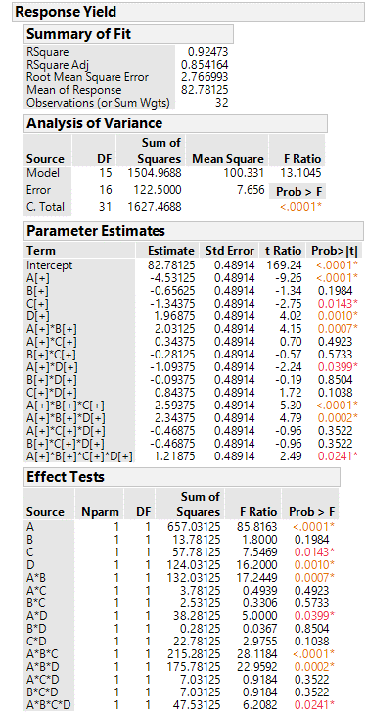

a) This gives the estimates of factors and interactions. Factors A, C, D, AB, AD, ABC, ABD, ABCD are significant at 5% level.

*Fig. 1 Effect estimates*

1. *Prepare an analysis of variance table and determine which factors are important in explaining yield.*

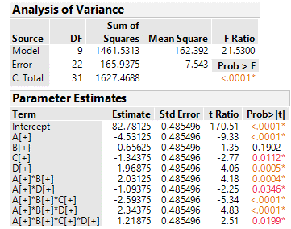

The same factors are found to be significant at 5% level except factor B. But this is included in the model to preserve hierarchy.

*d. Plot the residuals versus the predicted yield and on a normal probability scale. Does the residual analysis appear satisfactory?*

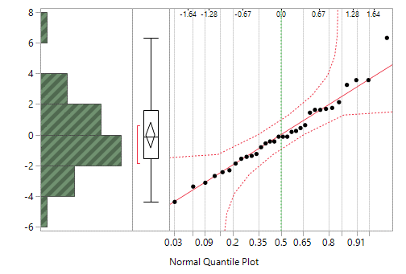

*Fig. 2 Normal quantile plot*

Not all points lie close to the line. One point is away from the straight line. Therefore, this does not support normality assumption.

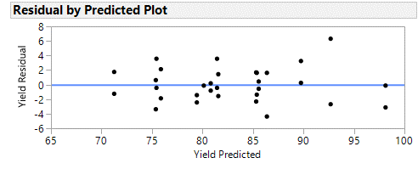

*Fig. 3 Residual vs. Predicted*

It shows that there is a relationship between size of residuals and predicted values. Thus, assumptions are violated.

1. *In a process development study on yield, four factors were studied, each at two levels: time (A), concentration (B), pressure (C), and temperature (D). A single replicate of a 24 design was run, and the resulting data are shown in Table P6.7.*

|  |  |  |  |  |  |  |  |  |  |
| --- | --- | --- | --- | --- | --- | --- | --- | --- | --- |
| Run Number | Actual run order | A | B | C | D | Yield (lbs) |  | Factor levels | |
| Low(-) | High (+) |
| 1 | **5** | - | - | - | - | 12 | A(h) | 2.5 | 3.0 |
| 2 | **9** | + | - | - | - | 18 | B(%) | 14 | 18 |
| 3 | **8** | - | + | - | - | 13 | C(psi) | 60 | 80 |
| 4 | **13** | + | + | - | - | 16 | D($\dot{-}C$) | 225 | 250 |
| 5 | **3** | - | - | + | - | 17 |  |  |  |
| 6 | **7** | + | - | + | - | 15 |  |  |  |
| 7 | **14** | - | + | + | - | 20 |  |  |  |
| 8 | **1** | + | + | + | - | 15 |  |  |  |
| 9 | **6** | - | - | - | + | 10 |  |  |  |
| 10 | **11** | + | - | - | + | 25 |  |  |  |
| 11 | **2** | - | + | - | + | 13 |  |  |  |
| 12 | **15** | + | + | - | + | 24 |  |  |  |
| 13 | **4** | - | - | + | + | 19 |  |  |  |
| 14 | **16** | + | - | + | + | 21 |  |  |  |
| 15 | **10** | - | + | + | + | 17 |  |  |  |
| 16 | **12** | + | + | + | + | 23 |  |  |  |

***Solution:***

1. *Construct a normal probability plot of the effect estimates. Which factors appear to have large effects?*

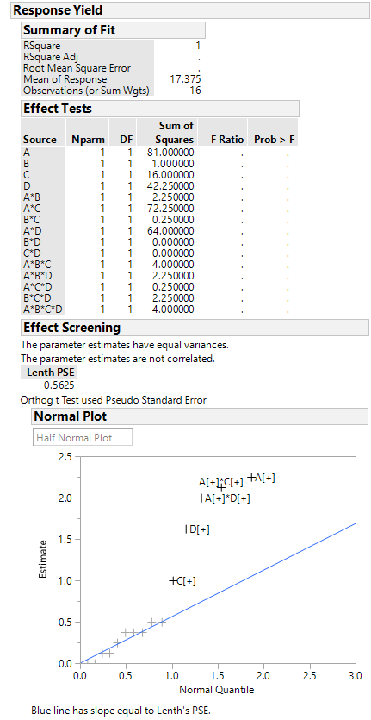

From half-normal plot of effect estimate, we could see that effects A, C, D and interactions AC and AD appear to have large effects.

*Fig. 4 Response plot*

1. *Conduct an analysis of variance using the normal probability plot in part (a) for guidance in forming an error term. What are your conclusions?*

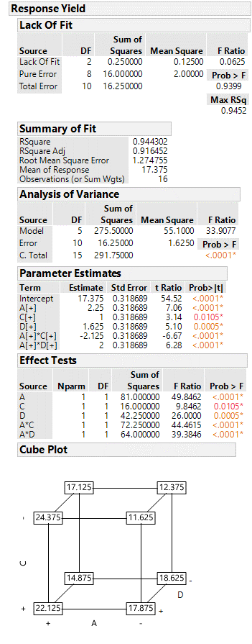

For $α=0.05,$ these effects A,C,D,AC and AD are significant.

1. *Write down a regression model relating yield to the important process variables.*

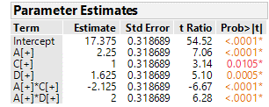

These give the coefficients of the regression model.

Regression model:

$Yield=17.375+2.25*A+1.00*C+1.625*D-2.125*A*C+2.00*A*D$

$Yield=17.375+2.25*Time+1.00*Pressure+1.625*Temperature-2.125*Time*Pressure+2.00*Time*Temperature$

1. *Analyze the residuals from this experiment. Does your analysis indicate any potential problems?*

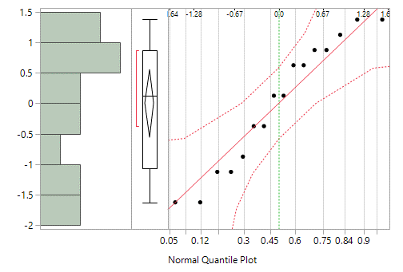

All points lie close to the line and within error bounds. Hence, normal probability plot supports the normality assumption.

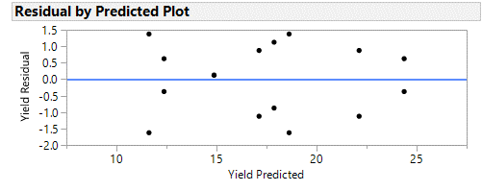

It shows similar range of residuals across all the fitted values. Therefore, we could not see any problems with the variance of the residuals.

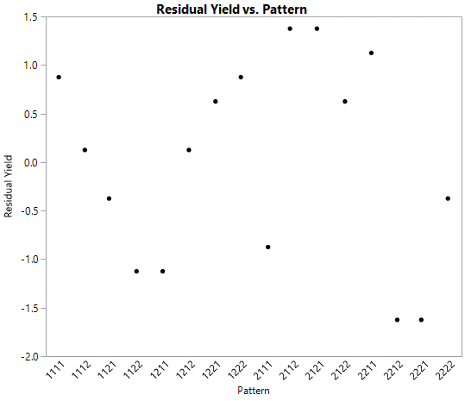

This shows no unusual pattern and there no problems with the variance of residuals.

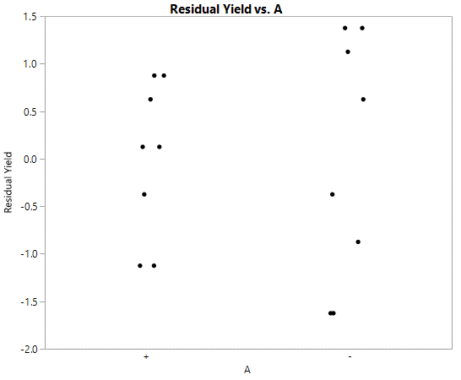

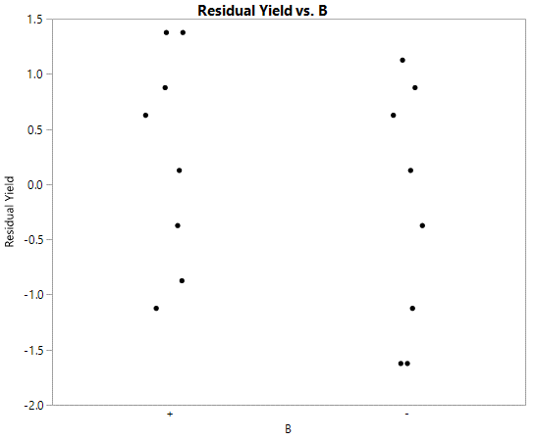

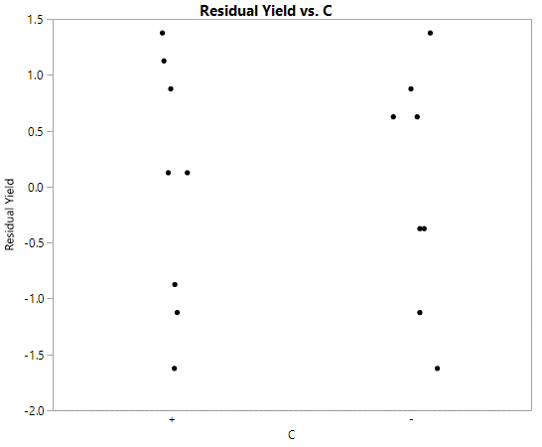

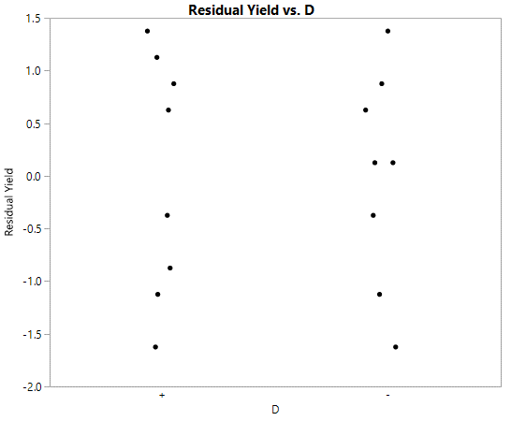

The range of residuals across two levels of each of the four factors are same.

1. *Consider the data from the first replicate of Problem 6.7. Construct a design with two blocks of eight observations each with ABCD confounded. Analyze the data.*

|  |  |  |  |  |  |
| --- | --- | --- | --- | --- | --- |
| Treatment Combination | Replicate | | Treatment Combination | Replicate | |
| I | II | I | II |
| (1) | 90 | 93 | d | 98 | 95 |
| a | 74 | 78 | ad | 72 | 76 |
| b | 81 | 85 | bd | 87 | 83 |
| ab | 83 | 80 | abd | 85 | 86 |
| c | 77 | 78 | cd | 99 | 90 |
| ac | 81 | 80 | acd | 79 | 75 |
| bc | 88 | 82 | bcd | 87 | 84 |
| abc | 73 | 70 | abcd | 80 | 80 |

***Solution:***

Two blocks of eight observations each with ABCD confounded can be written as:

|  |  |
| --- | --- |
| **Block 1** | **Block 2** |
| (1) = 90 | a=74 |
| ab=83 | b=81 |
| ac=81 | c=77 |
| bc=88 | d=98 |
| ad=72 | abc=73 |
| bd=87 | abd=85 |
| cd=99 | acd=79 |
| abcd=80 | bcd=87 |

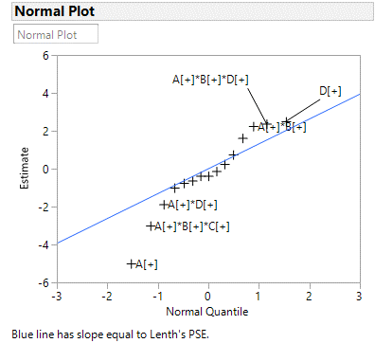

From the normal plot, significant factors can be identified as A, ABC, AD, AB, ABD, D.

Factors B, AC, BC and BD are included to preserve hierarchy.

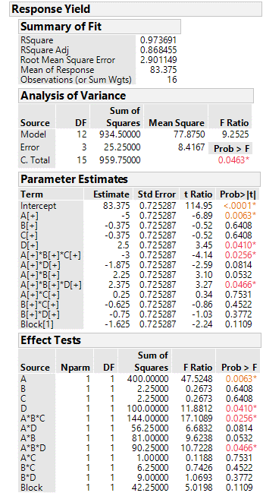

P values of A, D, ABC and ABD are less than $α=0.05$. These are significant at 5% level. This confirms our initial assessment.

