**EGR 7050 Design and Analysis of Engineering experiments**

**Homework 9**

1. Consider the single replicate of the $2^{4}$ design in Example 6.2. Suppose that we ran five points at the center (0, 0, 0, 0) and observed the responses 93, 95, 91, 89, and 96. Test for curvature in this experiment. Interpret the results.

|  |  |  |  |  |  |  |
| --- | --- | --- | --- | --- | --- | --- |
| Run Number | Factor | | | | Run Label | Filtration Rate (gal/h) |
| A | B | C | D |
| 1 | - | - | - | - | (1) | 45 |
| 2 | + | - | - | - | a | 71 |
| 3 | - | + | - | - | b | 48 |
| 4 | + | + | - | - | ab | 65 |
| 5 | - | - | + | - | c | 68 |
| 6 | + | - | + | - | ac | 60 |
| 7 | - | + | + | - | bc | 80 |
| 8 | + | + | + | - | abc | 65 |
| 9 | - | - | - | + | d | 43 |
| 10 | + | - | - | + | ad | 100 |
| 11 | - | + | - | + | bd | 45 |
| 12 | + | + | - | + | abd | 104 |
| 13 | - | - | + | + | cd | 75 |
| 14 | + | - | + | + | acd | 86 |
| 15 | - | + | + | + | bcd | 70 |
| 16 | + | + | + | + | abcd | 96 |

***Solution:***

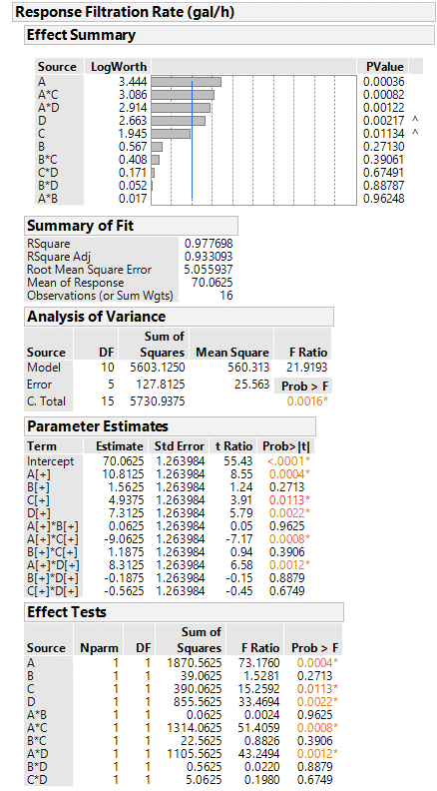

P value for A, C, D, AC and AD are less than 0.05. Therefore, main effects A, C and D and the interaction effects AC and AD are significant at 5% level

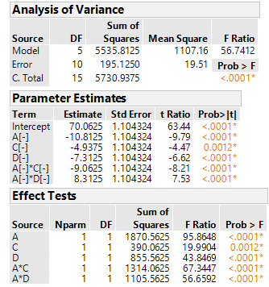

P value for curvature is less than 0.05. Hence it could be concluded that curvature is significant at 5% level.

ANOVA for reduced model.

**Hand calculation:**

The sum of squares for the Pure Quadratic (curvature) component

${SS}_{PureQuadratic}$ = $\frac{n_{F}n_{C}{\left({\overline{y}}_{F}-{\overline{y}}_{C}\right)}^{2}}{n_{F}{+n}_{C}}$

= $\frac{\left(16\right)\left(5\right){\left(70.0625-92.8\right)}^{2}}{16+5}$

${SS}_{PureQuadratic }$ = 1969.5

The sum of squares 1 degree of freedom.

${MS}_{PureQuadratic }$ = 1969.5

The mean square for pure error is

$${MS}_{PureError}=\sum_{i∈CenterPoints}{{\left(y_{i}-{\overline{y}}_{c}\right)}^{2}}/(n_{c}-1)$$

= $\frac{{\left(93-92.8\right)}^{2}+{\left(95-92.8\right)}^{2}+{\left(91-92.8\right)}^{2}+{\left(89-92.8\right)}^{2}+{\left(96-92.8\right)}^{2}}{4}$

= 8.2

F-statistic:

F = ${MS}_{PureQuadratic }/{MS}_{PureError}$ = 1969.5/8.2 = 240.18

From F table, $F_{0.01,1,4}=21.2$. F statistic is much larger than $21.2.$ Thus, P-Value is much smaller than 0.01. There is strong evidence that PureQuadratic component of the model is not zero. Thus, there is an indication of curvature.

1. Partner name: **Ashwin Anbazhagan Angammal**
2. Factor Definition table

|  |  |  |  |
| --- | --- | --- | --- |
| Factor | Catapult Variable | High Level (+) | Low Level (-1) |
| A | Cup Position | 2 | 5 |
| B | Tower Pin | 2 | 4 |
| C | Stop Pin | 2 | 5 |