A

REPORT

ON

**BRAIN TUMOR CLASSIFICATION**

BY

SARGARI MEENA REDDY

21STUCHH010081

Project Report submitted to **ICFAI TECH** as a partial fulfillment of the requirements for the award of the Degree of B. Tech in Computer Science & Engineering under the supervision of **Mr. SHADAB AHMAD**



**Department of Computer Science**

**Faculty of Science & Technology,**

**The ICFAI Foundation for Higher Education, Hyderabad**

2024

**CERTIFICATE**

This is to certify that the project entitled “BRAIN TUMOR CLASSIFICATION” by Sargari Meena (21STUCHH010081) has been submitted in the partial fulfillment of the requirements for the award of the degree of Bachelor of Technology in Computer Science and Engineering from the Faculty of Science & Technology (FST), IFHE Hyderabad. The results embodied in this project have not been submitted to any other University or Institution for the award of any degree or diploma.

**DECLARATION**

I declare that the work contained in the Project Report is original and it has been done by me under the supervision of Ms. Shadab Ahmad. The work has not been submitted to any other University for the award of any degree or diploma.

DATE: April 2024

**ACKNOWLEDGEMENT**

Many people helped me directly and indirectly to complete my project successfully. I would like to take this opportunity to thank one and all. First, I would like to express my deep gratitude towards my internal guide Dr. SHADAB AHMAD, Department of CSE for his support in the completion of my dissertation. I wish to express my sincere thanks to, Dr. P. ROHINI, HOD, Dept. Of CSE and to our director Dr. K. L. NARAYANA for providing the facilities to complete the dissertation.

I would like to thank all our faculty and friends for their help and constructive criticism during the project period. Finally, I am very much indebted to our parents for their moral support and encouragement to achieve goals

.

**ABSTRACT**

Brain tumors are regarded as one of the most aggressive disorders in both children and adults. Brain tumors make for 85-90 percent of all primary Central Nervous System (CNS) malignancies. Every year, around 11,700 people are diagnosed with brain tumors. The 5-year survival rate for patients with a malignant brain or CNS tumor is around 34% for males and 36% for women. Brain tumors are divided into benign, malignant tumors, and pituitary tumors. Etc. Proper therapy, planning, and precise diagnostics should be implemented to increase patients' life expectancy. Magnetic Resonance Imaging (MRI) is the most effective tool for detecting brain malignancies. The scans generate a vast amount of picture data. The radiologist examines these photographs. A manual examination can be prone to errors because of the intricacies and features of brain tumors.

Automated classification techniques based on Machine Learning (ML) and Artificial Intelligence (AI) have consistently outperformed manual categorization. As a result, presenting a system for detection and classification that uses Deep Learning Algorithms such as convolution neural Network (CNN), Artificial Neural Network (ANN), and transfer learning (TL) will be beneficial to doctors all over the world.

**TABLE OF CONTENTS**

**ABSTRACT**

**CHAPTER NO**.**1**

1.1 INTRODUCTION

**CHAPTER 2**

**2.1** LITERATURE SURVEY

**CHAPTER 3**

**AIM AND SCOPE**

3.1 AIM

3.2 SYNOPSIS

**CHAPTER4**

4.1 EXISTING SYSTEM

4.2 PROPOSED SYSTEM

4.3 REQUIREMENT SPECIFICATION

4.4 HARDWARE AND SOFTWARE SPECIFICATION

4.5 SOFTWARE DESCRIPTION

4.6 METHODOLOGY

**CHAPTER 5**

5.1 NONFUNCTIONAL REQUIREMENTS

5.2 SEQUIENCE DIAGRAM

5.3 USE CASE DIAGRAM

5.4 ACTIVITY DIAGRAM

5.5 COLLABORATION DIAGRAM

5.6MODULES

5.7TEST PROCEDURE

**CHAPTER 6**

RESULT AND CONCLUSION

REFERENCES

**LIST OF FIGURES**

4.6 MRI OF HUMAN BRAIN

5.1 ARCHITECTURE DIAGRAM

5.2 SEQUENCE DIAGRAM

5.3 USE CASE DIAGRAM

5.4 ACTIVITY DIAGRAM

5.5 COLLABORATION DIAGRAM

5.6.3 IMAGE SEGMENTATION

**CHAPTER 1**

**INTRODUCTION**

**1.1 INTRODUCTION:**

Tumors will have a huge effect on the brain. Brain cells are destroyed in the area affected by tumors and can cause brain collapse. The result of the tumor depends on the size and makes perfect sense. If anything happens to the brain our whole system collapses. Some neurons in the ages brain cannot regenerate and some neurons stop regeneration as a person ages. If the tumor is situated in any of those non-regenerative areas, a person might even lose one of his/her senses. Discovering the tumor at an early stage can save a person’s life. Artificial Intelligence is revolutionizing Healthcare in many areas such as Disease Diagnosis with medical imaging, Surgical Robot, and maximizing hospital efficiency. Deep learning has been proven to be superior in detecting diseases from X-rays, MRI scans, and CT scans which could significantly improve the speed and accuracy of diagnosis. Tumors are located and diagnosed through a very keen medical procedure. Magnetic Resonance Image (MRI) is one such process. We are going to train and validate our model on MRI. These images are sent into to model to train it to detect and locate brain tumors.

Segmenting brain tumors in multi-modal imaging data is a challenging problem due to the unpredictable shapes and sizes of tumors. Deep Neural Networks (DNNs) have already been applied to segmentation problems and have shown significant performance improvement compared to the previous methods [4]. We use Convolutional Neural Networks (CNNs) to perform the brain tumor segmentation task on the large dataset of brain tumor MR scans provided by BRATS2015. CNNs are DNNs in which trainable filters and local neighborhood pooling operations are applied alternatingly on the raw input images, resulting in a hierarchy of increasingly complex features. Specifically, we used multi-modality information from T1, T1c, T2, and Flair images as inputs to different CNNs. The multiple intermediate layers apply convolution, pooling, normalization, and other operations to capture the highly nonlinear mappings between inputs and outputs. We take the output of the last hidden layer of each CNN as the representation of a pixel in that modality and concatenate the representations of all the modalities as features to train a random forest classifier.

Magnetic resonance imaging (MRI) is a widely used medical technology for the diagnosis of various tissue abnormalities, and the detection of tumors. The active development of computerized medical image segmentation has played a vital role in scientific research. This helps the doctors to take necessary treatment easily with fast decision-making. Brain tumor segmentation is a hot point in the research field of Information technology with biomedical engineering. Brain tumor segmentation is motivated by assessing tumor growth, treatment responses, computer-based surgery, treatment of radiation therapy, and developing tumor growth models. Therefore, computer-aided diagnostic systems are meaningful in medical treatments to reduce the workload of doctors and give accurate results. This chapter explains the causes, awareness of brain tumor segmentation and its classification, the MRI scanning process and its operation, brain tumor classifications, and different segmentation methodologies

**CHAPTER 2**

**LITERATURE SURVEY**

**2.1 LITERATURE SURVEY:**

* Habib [1], used an artificial convolutional neural network (ANN) to detect tumors with a similar brain tumor dataset employed in this paper. He achieved 88.7% accuracy while testing. He used different neural networks which provided him better accuracy. The neural network consists of two max pooling layers and one convolutional 2d (Convo2d) layer in a sequential pattern.
* Lin and Chang [2], used K-means clustering algorithms with color-based segmentation to track objects of the brain tumor. K-means clustering clusters similar places together with color. The interesting part of this paper is, that they clustered color-spaced images from greyscale with the K-means algorithm.
* The researchers in [4] used MRI or second resonance images to detect brain tumors. They classified MRI images which is complex because of the variation in brain tumor size and shapes. Decision Tree classifier and multi-layer perceptron are the two supervised learning techniques to detect brain tumors.
* In this paper [7], the authors explained how misdiagnoses made by image processing or machine learning affect us and showed that they never always give accurate solutions or results. Other variables need to be taken care of while detecting brain tumors. In this paper, they used the MRI augmentation technique. Which is sending images in a model from various angles and different perspectives. This technique allows the model to train on various new images and that got a good result and scores. They used a CNN along with Link Net architecture.
* Sharma and Komal [7] proposed a method that involves feature detection of brain tumors and classification based on MRI data. They used various filters and image segmentation over images.
* **S**inthia and Malathi [8] proposed a CNN that automated the detection and segmentation of brain tumors. A neural network was constructed using the TensorFlow library. BRATS2015 dataset is used by them
* Guotai Wang [9], these researchers proposed an application of deep learning that can interact with users. The application consists of different convolutional neural network 4 architectures that can create a model that can make segmentation of MRI images and can even highlight certain brain organs. The interesting part is that users can tune and make these organs pop up. They provided multiple architectures and compared them to get perfect results.
* In this paper, the authors [10], proposed the essential task carried out by MRI images in disease diagnosis. They even shared a few methods of MRI image processing to implement them in other papers. Google Net architecture codenamed Inception-v1 is the improved utilization of computing resources inside the network [14]. The network with the inception architecture is faster than the network with non- non-inception architecture. The Google Net architecture including the inception module uses a rectified linear activation function, average pooling layer and not fully connected layer, and dropout after removing the fully connected layer.
* Alex Net's [15] architecture is deeper and much greater than Lent's architecture. It consists of eight layers, five convolutional layers most of which are followed by max pooling, and three fully connected layers. The output is the 1000-way SoftMax that represents the classes. It is trained on two parallel GTX 580 GPU 3 GB which communicate only in certain layers. This scheme reduces the top-5 error rates. Alex Net is improved with Zeit architecture which visualizes the Alex Net activities within the layers to debug problems and obtain better results. It allows observing the evolution of features during training and maps the activities back to the pixel space in intermediate layers

**CHAPTER 3**

**AIM AND SCOPE**

**3.1AIM**   
To detect the Brain Tumor using Two-Pathway-Group Conventional Neural Networks. Use the traditional two-way cluster neural network for brain tumor detection.

**3.2 SYNOPSIS**

Brain tumor identification is a challenging task in the early stages of life. But now it has become advanced with deep learning. Now a day’s issue of brain tumor automatic identification is of great interest. To detect the brain tumor of a patient we consider the data of patients like MRI images of a patient’s brain. Here our problem is to identify whether the tumor is present in the patient’s brain or not. It is very important to detect the tumors at the starting level for a healthy life of a patient. There is much literature on detecting these kinds of brain tumors and improving the detection accuracies. In this paper, we estimate the brain tumor severity using the Convolutional Neural Network algorithm which gives us accurate results

**CHAPTER 4**

**SYSTEM DESIGN & METHODOLOGY**

**4.1 EXISTING SYSTEM**

Existing systems describe the automation of cell segmentation. The technique is used for interactive multi-label segmentation for N-dimensional images. It segments the areas that are more difficult to segment. This method is iterative and provides feedback to the user as the segment is calculated.

**4.2 PROPOSED SYSTEM**

We take a second dimension to propose a new strategy for MRI of the patient's brain. Here pre-processing is done with Gaussian, which can be a line filter. Then, by identifying the area of the tumor, the GLCM functions are used to extract functions from the image. CNN architecture of bidirectional clusters for brain tumor segmentation, At the same time, it uses its own functions and international information dissemination functions. This model provides equivalence in the two-channel CNN model to reduce backward jitter and overcome parameter sharing. Finally, we integrated the cascaded architecture into the dual-channel CNN pool, during which the basic CNN pins were processed as additional sources, and finally, combined the CNN into a two-way architecture, thereby improving the overall performance. Compared with the currently disclosed progressive method, this method is improved, and the complexity of the process is still quite pleasant.

**4.3 REQUIREMENT SPECIFICATIONS**

CANCEROUS brain tumors present themselves as unnatural, uncontrolled growth and division of cells in the brain. Although brain tumors are not very common, they are one of the deadliest cancers. For example, in the United States alone, approximately 23,000 new cases of brain cancer were diagnosed in 2015. It is an abnormality in the brain tissues that damages the nervous system severely, which results in patient death. are the most common brain tumors that are infiltrative and occur near white matter Fibers. They may spread to any part of the brain making it difficult to detect. They are considered high-grade gliomas

one of the most aggressive tumors with a median survival of 15 months. Glioma can be measured by MRI using a variety of sequences, such as B. T2-weighted reversal recovery (transition) with fluid attenuation, T1-weighted(T1), contrast-enhanced T1 (T1c) and T2-weighted (T2), use existing automated techniques to segment brain tumors. Healthy brains consist of three types of tissues: grey matter, white matter, and cerebrospinal fluid. Detection and segmentation of cancerous cells using MRI not only helps to detect the presence of tumors and their location, but it also enables the identification of tumor size, necrotic tissue, tumorous tissue (vascularized or not), and Edema (swelling near the tumor). Brain tumors vary in shape and appearance (gliomas look the same as gliomas, strokes, etc.), which makes them difficult to separate radiologists. Furthermore, they may appear at any location in the brain: depending on the origin of the brain tumor, they can be classified as either primary tumors or metastatic brain tumors. The edges of brain tumors are often ambiguous and fuzzy and are hard to distinguish from healthy tissues. Therefore, a more sensitive alternative to MRI is needed to improve the detection of tumors and to increase the survival rate of people with brain tumors Machine-assisted image segmentation and subsequent quantification of cancer tissue provide valuable information for early diagnosis and characterization of neuropathology, which can then be used for appropriate treatment. Anatomical structure. In addition, this is very important for early diagnosis, and it helps early prevention by formulating treatment strategies. Cancerous cells are normally quantified using the number of lesions, their volume, and biomarkers that are related to cognitive deficits. As a result, the quantitative analysis of affected regions requires accurate lesion segmentation, this is challenging due to differences in the size, shape, location, and frequency of cancer lesions. Perhaps the most accurate brain tumor segmentation results are achieved manually by an expert; however, this is an expensive, time-consuming, tedious, impractical task, error-prone, and dependent on differences between observers. As a result, doctors usually only use qualitative or visual inspections, or at best only rough measurements, such as the approximate volume and number of tumors. Manual segmentation of brain tumors from large MRI images is a difficult and time-consuming task. The existing methods of segmenting brain tumors can usually be divided into generative models or discriminatory models [1]. Generative models require prior information and segmentation of brain tumors, whereas discriminative models depend on a set of features and classifiers. The most adopted classifiers are support vector machines (SVMs), random forests, neural-genetic algorithms, and networks. In contrast, automatic brain tumor segmentation methods use hand-designed features and a variety of image features (e.g., shape, area, perimeter, circularity, etc.), intensity (e.g., mean, variance, standard deviations), and texture (e.g., contrast, entropy, correlation, etc.). Recently, deep learning, and in particular the Convolutional Neural Network

(CNN) has become the methodology of choice for medical image analysis, following its tremendous success in routine computer vision applications [2], [3]. Regarding the detection of tumors, the generation of candidates, and the reduction of false positives, using deep learning-based methods, unambiguously outperformed traditional machine learning approaches [4]– [7]. This achievement was acknowledged in 2015 when the Deep Medic software for brain lesion segmentation, which was based on a 3D-CNN coupled with a 3D fully connected CRF, won the ISLES 2015 challenge [8]. Additional deep learning-based brain tumor segmentation methods were presented in the 2013, 2015, and 2017 challenges. Different deep learning models were adopted, including FCNN [9]– [4], [11], 3DCNN [12], [13], FCNN with CRF [14], 3D U-Net [15], [16] and Auto encoders [17], [18]

**4.4 HARDWARE AND SOFTWARE SPECIFICATION**

**4.4.1 HARDWARE REQUIREMENTS**

● Hard Disk: 500GB and Above

● RAM: 4GB and Above

● Processor: I3 and Above

**4.4.2 SOFTWARE REQUIREMENTS**

✔ Operating System: Windows 7, 8, 10 (64 bit)

✔ Software: Python

✔ Tools: Anaconda (Jupiter Notebook IDE)

**4.5 SOFTWARE DESCRIPTION:**

**PYTHON**

Python is a free, open-source programming language. Therefore, all you have to do is install Python once, and you can start working with it. Not to mention that you can contribute your code to the community. Python is also a cross-platform-compatible language. So, what does this mean? Well, you can install and run Python on several operating systems. • Python is also a great visualization tool. It provides libraries such as Matplotlib, seaborn, and Bokeh to create stunning visualizations

**B. PANDAS**

* Pandas is a popular Python package for data science, and with good reason: it offers powerful, expressive, and flexible data structures that make data manipulation and analysis easy, among many other things. The Data Frame is one of these structures. Pandas is a high-level data manipulation tool developed by Wes McKinney. It is built on the NumPy package, and its key data structure is called the Data Frame. Data Frames allow you to store and manipulate tabular data in rows of observations and columns of variables.
* Pandas is built on top of the NumPy package, meaning a lot of the structure of NumPy is used or replicated in Pandas. Data in pandas is often used to feed statistical analysis in SciPy, plotting functions from Matplotlib, and machine learning algorithms in Scikit-learn. There are two types of data structures in pandas: Series and Data Frames.
* a) Series: A pandas Series is a one-dimensional data structure
* b) Data Frame: A pandas Data Frame is a two (or more) dimensional data structure a table with rows and columns.

**4.6 METHODOLOGY**

**4.6.1 CONVOLUTIONAL NEURAL NETWORK**

A Convolutional Neural Network (ConvNet/CNN) is a Deep Learning algorithm that can take in an input image, assign importance (learnable weights and biases) to various aspects/objects in the image, and be able to differentiate one from the other. The pre-processing required in a ConvNet is much lower as compared to other classification algorithms. While in primitive methods filters are hand-engineered, with enough training, Convents could learn these filters/characteristics. The architecture of a ConvNet is analogous to that of the connectivity pattern of Neurons in the Human Brain and was inspired by the organization of the Visual Cortex. Individual neurons respond to stimuli only in a restricted region of the visual field known as the Receptive Field. A collection of such fields overlaps to CD over the entire visual area. The objective of the Convolution Operation is to extract the high-level features such as edges, from the input image. Convents need not be limited to only one Convolutional Layer. Conventionally, the first Cavalier is responsible for capturing the Low-Level features such as edges, color, gradient orientation, etc. With added layers, the architecture adapts to the High-Level features as well, giving us a network, which has a wholesome understanding of images in the dataset, like how we would.

**4.6.2 MAGNETIC RESONANCE IMAGING (MRI)**

The MRI is a diagnostic tool used for analysing and studying the human anatomy. The medical images are acquired in various bands of the electromagnetic spectrum. The wide variety of sensors used for the acquisition of images and the physics behind them, make each modality suitable for a specific purpose. In MRI, the pictures are produced using a magnetic field, which is approximately 10,000 times stronger than the Earth’s magnetic field. The MRI produces more detailed images than other techniques, such as CT or ultrasound. The MRI also provides maps of anatomical structures with a high soft-tissue contrast. Basically, the magnetic resonance of hydrogen (1H) nuclei in water and lipids is measured by an MRI scanner. As the signal values are 12-bit coded, 4096 shades can be represented by a pixel [11]. The MRI scanners require a magnetic field, and it is available at 1.5 or 3 T. In comparison with the earth’s magnetic field (~50 ft.), the magnetic field of a 3 T MRI scanner is approximately 60,000 times the earth's field. The patient is placed in a strong magnetic field, which causes the protons in the water molecules of the body to align either in a parallel or anti-parallel orientation with the magnetic field. A radiofrequency pulse is introduced, causing the spinning protons to move out of the alignment. When the pulse is stopped, the protons realign and emit a radio frequency energy signal that is localized by the magnetic fields and is spatially varied and rapidly turned on and off. A radio antenna within the scanner detects the signal and creates the image. Functional MRI is a technique for examining brain activation, which, unlike PET, is non-invasive with relatively high spatial resolution

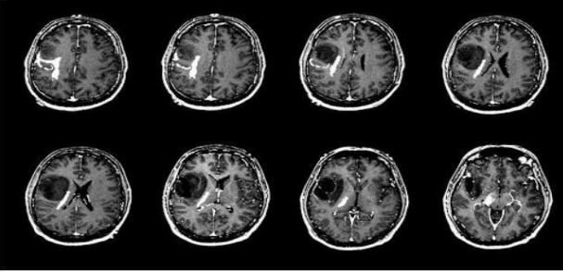

The most common method utilizes a technique called blood oxygen level-dependent contrast. This is an example of endogenous contrast, making use of the inherent signal differences in blood oxygenation content. In the normal resting state, a high concentration of deoxyhaemoglobin attenuates the MRI signal due to its paramagnetic nature. However, the neuronal activity, in response to some task or stimulus, creates a local demand for the oxygen supply, which increases the fraction of oxyhaemoglobin causing a signal increase on T2 or T2*-weighted images. In a typical experiment, the patient is subjected to a series of rest and task intervals, during which MRI images are repeatedly acquired. A radio antenna within the scanner detects the signal and creates the image. Functional MRI is a technique for examining brain activation, which, unlike PET, is non-invasive with relatively high spatial resolution. The signal changes during time are then examined on a pixel-by-pixel basis to test how well they correlate with the known stimulus pattern. The pixels that demonstrate a statistically significant correlation are highlighted in color and overlaid onto a grayscale MRI image to create an activation map of the brain. The location and extent of activation are linked to the type of stimulus. Thus, a simple thumb-finger movement task will produce activation in the primary motor cortex

**CHAPTER 5**

**DESIGN AND IMPLEMENTATION**

**CONSTRAINTS IN ANALYSIS**

♦ Constraints as Informal Text

♦ Constraints as Operational Restrictions

♦ Constraints Integrated in Existing Model Concepts

♦ Constraints as a Separate Concept

♦ Constraints Implied by the Model Structure

**CONSTRAINTS IN DESIGN**

♦ Determination of the Involved Classes

♦ Determination of the Involved Objects

♦ Determination of the Involved Actions

♦ Determination of the Require Clauses

♦ Global actions and Constraint Realization

**CONSTRAINTS IN IMPLEMENTATION**

The hierarchy of relationships can lead to more classes and more complex implementation structures. Therefore, it is recommended to convert the hierarchical structure of the relationship to a simpler structure, such as a classic plane structure. The developed hierarchical model can be easily converted into a flat two-part model. On the one hand, it is composed of classes, on the other it is composed of flat relationships. Since flat relationships are easy to implement, they are preferred at the design level. There are no logos or functions related to the plane relationship. The plane relationship follows the concept of entity relationship modelling and many object-oriented technologies

**NONFUNCTIONAL REQUIREMENT**

**PERFORMANCE REQUIREMENT:** The application at this side controls and communicates with the following three main general components. embedded browser in charge of the navigation and access to the web service.

**SERVER TIER:** The server side contains the main parts of the functionality of the proposed architecture. The components at this tier are the following. Web Server, Security Module, Server-Side Capturing Engine, Preprocessing Engine, Database System, Verification Engine, Output Module

.

**SAFETY REQUIREMENTS**

1. Software is essential for safety. In this case, there are issues related to the integrity level.

2. Even if the software is part of a security-critical system, it may not necessarily be critical to security. For example, a program can only write transactions.

3. If the system is to have a higher integrity level, and it is shown that the software has this integrity level, the hardware must have at least the same integrity level.

4. If the hardware and software of the system are (in a broad sense) unreliable, it makes no sense to write "perfect" code in any language.

5. If a computer system is to run software with a higher integrity level, the system should not support software with a lower integrity level at the same time.

6. Systems with different security level requirements should be separated.

7. Otherwise, the highest level of integrity should be applied to all systems in the same environment

**5.1 ARCHITECTURE DIAGRAM:**

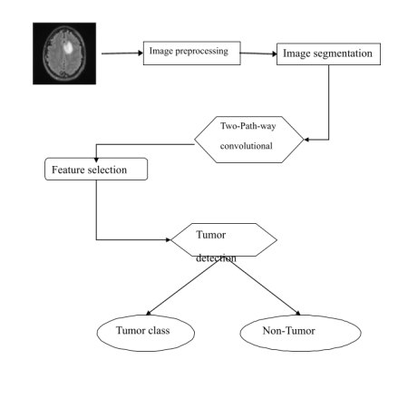

**5.2 SEQUENCE DIAGRAM**

A sequence diagram is an interaction diagram that shows how and in what order the processes interact. This is the construction of message sequence diagrams, sometimes called event diagrams, event scenarios, and sequence diagrams.

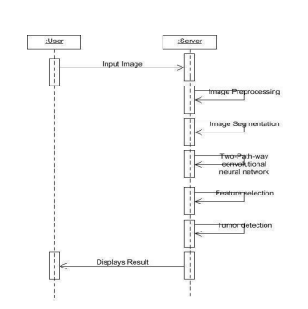

**5.3 USE CASE DIAGRAM**

Unified Modeling Language (UML) is a universal, standardized modeling language used for software development. This standard is managed and created by the asset management team. UML contains many graphical markup techniques for creating visual models of software-intensive systems. It is used to define, visualize, modify, construct, and record the artifacts of object-oriented, software-intensive systems under development. Unified Modeling Language (UML) is a universal modeling language that has been standardized in the field of software development. This standard is managed and created by the asset management team. It is used to define, visualize, modify, construct, and document the artifacts of intensively developed object-oriented software systems. Use case Diagram Use case diagrams are used to graphically describe the functions provided by the system based on participants, their goals, and any dependencies between these use cases. The use case diagram consists of two parts: Use case: A use case describes a series of actions through which the subject can be measured and drawn as a horizontal ellipse. Participants: Participants are individuals, organizations, or external systems that play a role in one or more interactions with the system.

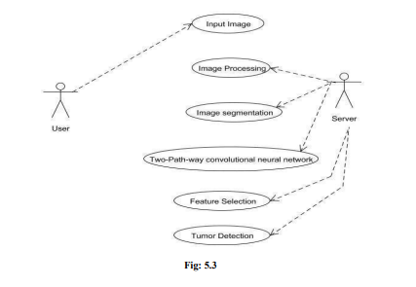

**5.4 ACTIVITY DIAGRAM**

An activity diagram is a graphical representation of workflows of stepwise activities and actions with support for choice, iteration, and concurrency. An activity diagram shows the overall flow of control. The most important shape types:

● Rounded rectangles represent activities.

● Diamonds represent decisions.

● Bars represent the start or end of concurrent activities.

● A black circle represents the start of the workflow.

● An encircled circle represents the end of the workflow.

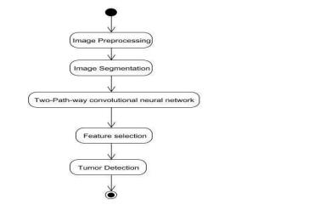

**5.5 COLLABORATION DIAGRAM**

UML collaboration diagram illustrates the relationship and interaction between software objects. They assume that use cases, system usage contracts, and domain models already exist. The collaboration diagram shows the messages sent between the class and the object

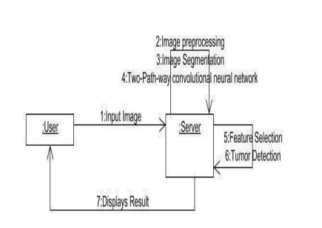

**5.6 MODULES**

❖ Image acquisition

❖ Image pre-processing

❖ Image segmentation

❖ Convolutional neural network

❖ Tumor detection

**MODULE EXPLANATION**:

**5.6.1** **IMAGE ACQUISTION** The primary Phase is acquiring images. After the Image collection, the obtained images must be prepared with a wide range of vision. First, capture the input images from the available source

**5.6.2 PRE-PROCESSING**

The images which are collected are subjected to pre-processing. In Pre- processing stage basic steps are image resizing and applying Gaussian filters for a perfect input clear image for easy identification of an image. Pre-processed images will be segmented digitally into various pixels. We do this segmentation for an image to modify its representation to have more clarity in analysing the images.

**5.6.3 IMAGE SEGMENTATION**

In the first stage, the pre-processed brain Magnetic Resonance image will be transformed into a binary image with a threshold of 128 for the cutoff. Pixel values higher than the specified thresholds are mapped as white, with other regions marked as black; these two allow various regions to be generated around the disease. In the second stage, an erosion process of morphology is used to extract white pixels. Eventually, the eroded area and the original image are separated into two equal areas, and the region with black pixels from the eroding is counted as a mask of the brain Magnetic Resonance image. In this paper, wavelet transformation is used for the efficient segmentation of the brain Magnetic Resonance image. Figure 3 shows the fully automatic heterogeneous segmentation. Figure 3(a) shows the axial image and its segmentation figure 3(b) the Coronal image and its segmentation figure 3 (c) Sagittal images and their segmentation.

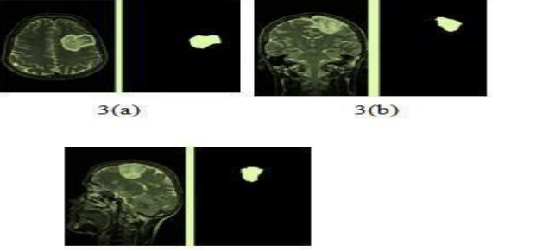

**FEATURE EXTRACTION**

In the feature extraction process, we can implement the effective texture operator which labels the pixels of an image. Here we extract the features and characteristics of Images for easy detection of brain tumors.

**CLASSIFICATION**

Convolutional neural networks algorithm is used for classification of brain images. It is producing the best results for the image

**TUMOR DETECTION**

Finally, analyze the image using filters and Convolutional neural networks algorithm to detect the tumor or non-tumor.

**5.7 TEST PROCEDURE**

**SYSTEM TESTING:**

Testing is performed to identify errors. It is used for quality assurance. Testing is an integral part of the entire development and maintenance process. The goal of the testing during this phase is to verify that the specification has been accurately and completely incorporated into the design, as well as to ensure the correctness of the design itself. For example, the design must not have any logic faults in the design is detected before coding commences, otherwise, the cost of fixing the faults will be considerably higher as reflected. Detection of design faults can be achieved using inspection as well as walkthrough. Testing is one of the important steps in the software development phase.

Testing checks for the errors, of the project testing involves the following test cases: Static analysis is used to investigate the structural properties of the Source code. Dynamic testing is used to investigate the behaviors of the source code by executing the program on the test data.

**5.7.1. TEST DATA AND OUTPUT UNIT TESTING**

Unit testing is conducted to verify the functional performance of each modular component of the software. Unit testing focuses on the smallest unit of the software design (i.e.) the module. The white box testing techniques were heavily employed for unit testing.

**5.7.2 FUNCTIONAL TESTS**

Functional test cases involved exercising the code with nominal input values for which the expected results are known, as well as boundary values and special values, such as logically related inputs, files of identical elements, and empty files. Three types of tests in Functional test

* Performance Test
* Stress Test
* Structure Test

**PERFORMANCE TEST**

It determines the amount of execution time spent in various parts of the unit, program throughput, and response time and device utilization by the program unit

**STRESS TEST**

Stress Tests are those tests designed to intentionally break the unit. A Great deal can be learned about the strengths and limitations of a program by examining the way a programmer in which a program unit breaks.

**STRUCTURED TEST**

Structure Tests are concerned with exercising the internal logic of a program and traversing execution paths. How the White-Box test strategy was employed to ensure that the test cases could Guarantee that all independent paths within a module have been exercised at least once.

* Exercise all logical decisions on their true or false sides.
* Execute all loops at their boundaries and within their operational bounds.
* Exercise internal data structures to ensure their validity.
* Checking attributes for their correctness.
* Handling end-of-file conditions, I/O errors, buffer problems, and textual errors in output information

Integration testing is a systematic technique for constructing the program structure while at the same time conducting tests to uncover errors associated with interfacing. i.e., integration testing is the complete testing of the set of modules that make up the product. The objective is to take untested modules and build a program structure tester should identify critical modules. Critical modules should be tested as early as possible. One approach is to wait until all the units have passed testing, and then combine them and then test. This approach has evolved from unstructured testing of small programs. Another strategy is to construct the product in increments of tested units. A small set of modules are integrated and tested, to which another module is added and tested in combination. And so on. The advantages of this approach are that interface dispenses can be easily found and corrected.

The major error that was faced during the project was linking. When all the modules are combined the link is not set properly with all support files. Then we checked out for interconnection and the links. Errors are localized to the new module and its intercommunications. The product development can be staged, and modules integrated in as they complete unit testing.

Testing is completed when the last module is integrated and tested.

**CHAPTER 6**

**RESULT AND CONCLUSION**

**RESULT**

Our data set contains tumor and non-tumor MRI images obtained from various online sources. Use a convolutional neural network for detection. Modelling is done using Python language. Calculate the accuracy and compare it with all other modern methods.

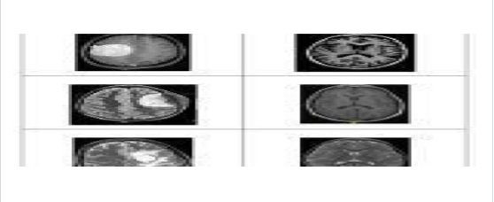

To determine the effectiveness of the proposed brain, training accuracy, verification accuracy, and verification loss need to be calculated. Tumor classification scheme. The current technology for detecting brain tumors uses SVM (Support Vector Machine) classification. Feature extraction requires output. Based on the feature value, the classification output is generated, and the accuracy is calculated. Tumor and non-tumor detection based on support vector machines take a long time and have poor calculation accuracy. The proposed CNN-based classification does not require a separate feature extraction step. The value of this function is taken from CNN itself. In the picture. The classification results of tumor and non-tumor brain imaging are shown. Therefore, the complexity and calculation time are low and accurate. The figure shows the results of brain tumor classification accuracy. Finally, according to the value of the probability score, it is classified as a brain tumor or a non-tumor brain. Normal brain imaging is the least likely. The score value is compared with normal and neoplastic brains.

**CONCLUSION**

Our data set includes tumor MRI images and non-tumor images obtained from various online sources. Radiation podia contains real patient cases. Tumor images are obtained from the test data set of "Radio podia and Brain Tumor Image Segmentation Benchmark (BRATS) 2015". The detection is carried out through a convolutional network. Modeling is done using Python language. Calculate the accuracy and compare it with all other modern methods. To determine the effectiveness of the proposed brain, training accuracy, verification accuracy, and verification loss need to be calculated. Tumor classification scheme. The current technology for detecting brain tumors uses SVM (Support Vector Machine) classification. Feature extraction requires output. Based on the feature value, the classification output is generated, and the accuracy is calculated. Tumor and non-tumor detection based on support vector machines take a long time and have poor calculation accuracy. The proposed CNN-based classification does not require a separate feature extraction step. The value of this function is taken from CNN itself. In the picture. The classification results of tumor and non-tumor brain imaging are shown. Therefore, the complexity and calculation time are low and accurate. The figure shows the results of brain tumor classification accuracy. Finally, according to the value of the probability score, it is classified as a brain tumor or a non-tumor brain. Normal brain imaging is the least likely. The score value compared with normal and neoplastic brains

**REFERENCES**

* Aboussaleh, et al. “Brain Tumor Segmentation Based on Deep Learning’s Feature Representation”, Journal of Imaging, 2021.
* Aryan Methyl. “Brain Tumor Detection using Deep Learning and Image Processing”, IEE, 2021.
* Badza MM, Barjaktarovic MC. “Classification of brain tumors from MRI images using a convolutional neural network”, Appl. Sci., Vol 10(6), 2020.
* Buckner. J.C, et al, "Central nervous system tumors." In Mayo Clinic Proceedings, Vol. 82, 2007, 1271- 1286.
* Choi J, et al, “A Framework Facilitates Development of a Mobile App”, Vol 250, 2018, 97-100.
* Choudhury, et al, “Brain Tumor Detection and Classification Using Convolutional Neural Network and Deep Neural Network” IEEE, 2020.
* Chu AL, et al. “Mobile app helps trainees manage emergencies at the bedside”, AEM Educ Train, 2021.
* Deepa, et al. “Review of Brain Tumor Detection from Tomography”, International Conference on Computing for Sustainable Global Development (INDIACom), 2016.
* Deepak S, et al. “Brain tumor classification using deep CNN features via transfer learning”, Com Biol Med, 2019.
* Dicianno, et al, “Perspectives on the Evolution of Mobile (mHealth) Technologies and Application to Rehabilitation”, Vol. 95(3), 2015, 397–405. 43
* Dr. Someswararao, et al. “Brain Tumor Detection Model from MR Images using Convolutional Neural Network”, 2020.
* Esmail M. Y, et al, “Brain Tumor Detection by using Artificial Neural Network” International Conference on Computer, Control, Electrical, and Electronics Engineering (ECE), 2018.
* Gajendra Raut, et al. “Deep Learning Approach for Brain Tumor Detection and Segmentation” IEE, 2021.
* Grampurohit. S, et al, “Brain tumor detection using deep learning models”, in Proc. IEEE India Council Int. Subsections Conf. (INDISCON), 2020, 129-134.
* Gupta and Dwivedi, “A Simplified Overview of World Health Organization Classification Update of Central Nervous System Tumors 2016” J Neurosis Rural Pract, 2017, 629–641. 16. Heba Mohsen, et al, “Classification using deep learning neural networks for brain tumors”, Future Computing and Informatics Journal, 2018, 68-71.
* Heimans, J, “Impact of brain tumor treatment on quality of life.” J Neurol, Vol 249(8), 2002, 955-60.
* Hemanth. G, et al. “Design and Implementing Brain Tumor Detection using Machine Learning Approach”, IEE, 2019.
* Hossain, et al, “Brain tumor detection using convolutional neural network”, 1st International Conference on Advances in Science, Engineering and Robotics Technology, ICASERT Neuroscience Informatics, Vol 2, Issue 4, 2022.
* Khan, et al, “Brain tumor segmentation using K-means clustering and deep learning with synthetic data augmentation for classification”, JMET, 2020. 21. Louis, et al., “The 2016 World Health Organization Classification of Tumors of the Central Nervous System: A Summary”, 2016