**Steps for creating a new subscription for Academies Handbook in SFDC**

1. Login into Salesforce
2. Search for the Account [B2C] that you want to create a new subscription for e.g. by entering the account name or number in the search text box
3. Click on the ‘New Quote’ button
4. Select the option for ‘new subscription for this account’.

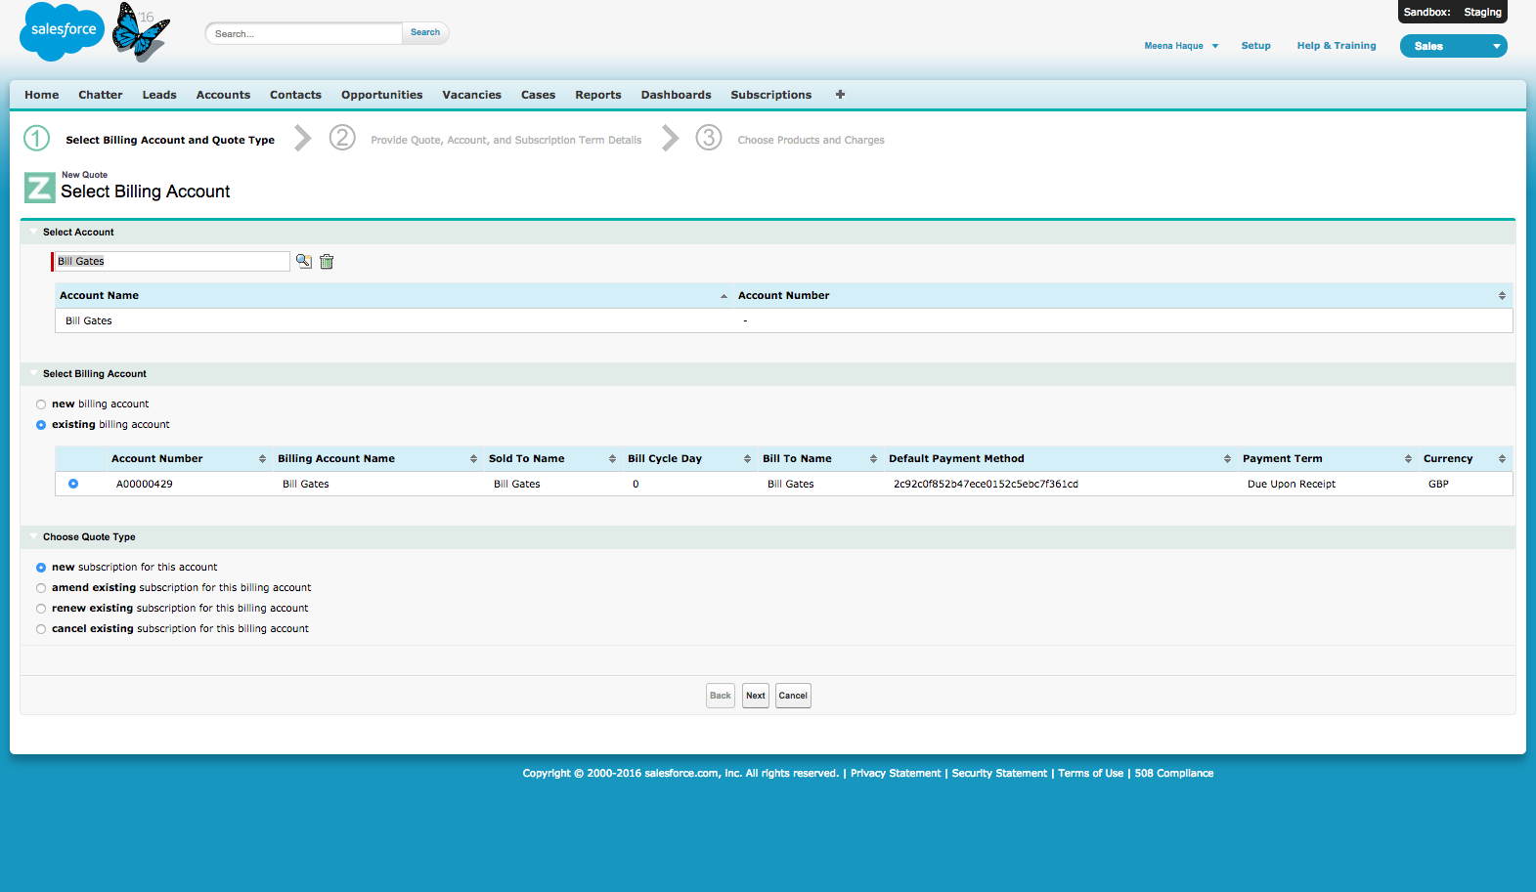

1. Click on Next
2. Complete the following fields on the Quote page

**Quote Name :** e.g Academies Handbook

**Valid Until:** select the current date e.g. 09/02/2016

**Ship to Contact (Mailing address) :** .e.g Bill Gates

**Bill to Contact:**  .e.g. Bill Gates

**Start Date:** select the current date e.g. 09/02/2016

**Initial Term in months (often 12) :** 1

* this needs to set to 1 as the product is a one off product not a subscription over a period of 12 months

**Renewal Term in months (often 12) :** 0

* this needs to set to 0 as the product is a one off product and no renewal period applies

**Auto Renew :** unchecked

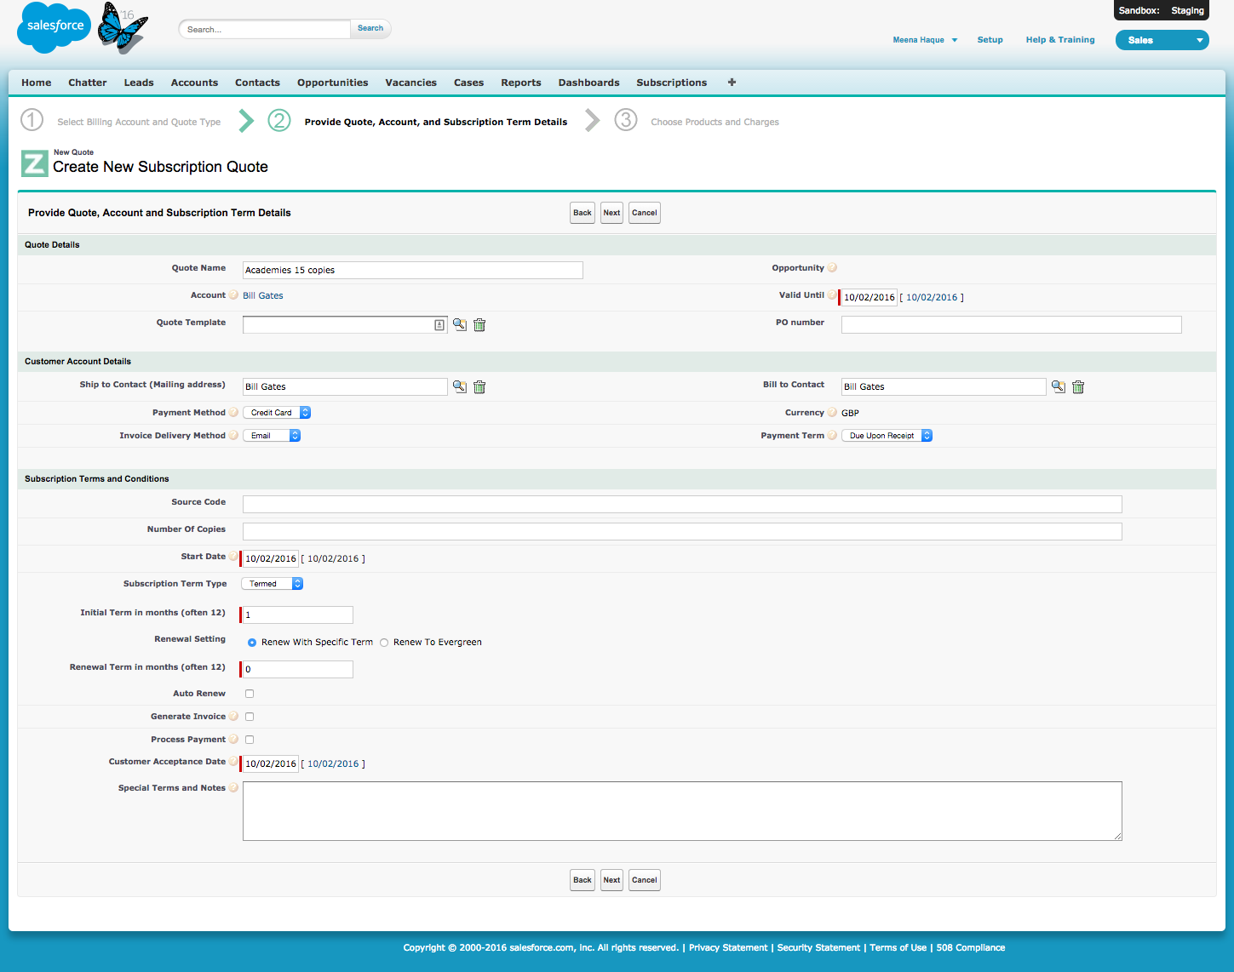

7. Click on Next

8. Click on the magnify glass icon next to the **‘Product’** field. This will bring up a pop up window displaying all subscription products

9. Type in ‘Academies Handbook’ in the search text box on the pop up window and click on the Search button.

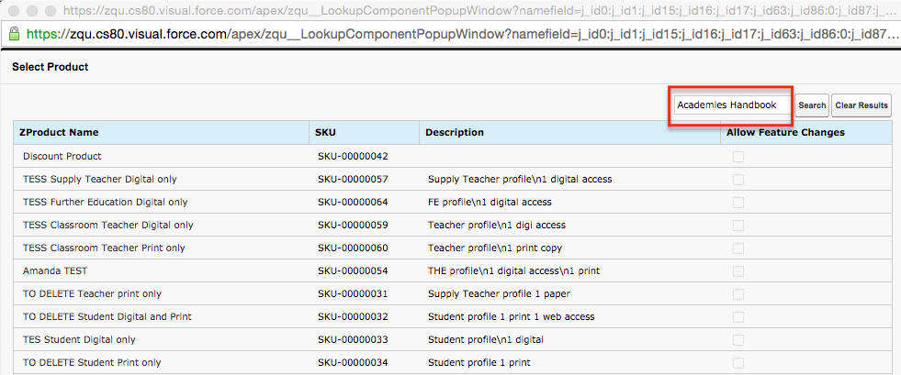

9. Click on the ‘Academies Handbook’ link displayed within the product table.

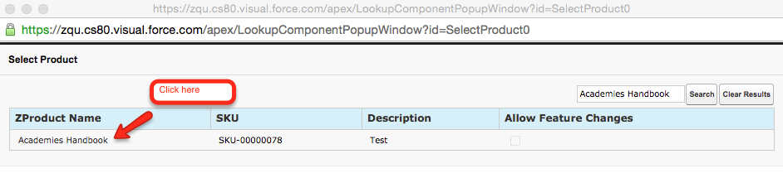

10 .Click on the magnify glass icon next to the **‘Rate Plan’** field. This will bring up a pop up window displaying the appropriate rate plans for the product selected. Select the product rate plan you require. e.g. 2016 - Academies Handbook 15 Copies

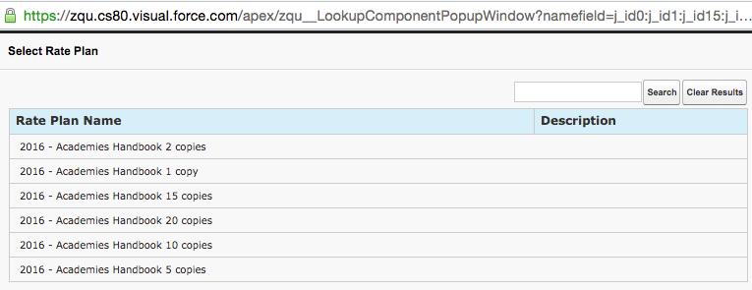

11.Select the product rate plan you require. e.g. 2016 - Academies Handbook 15 Copies

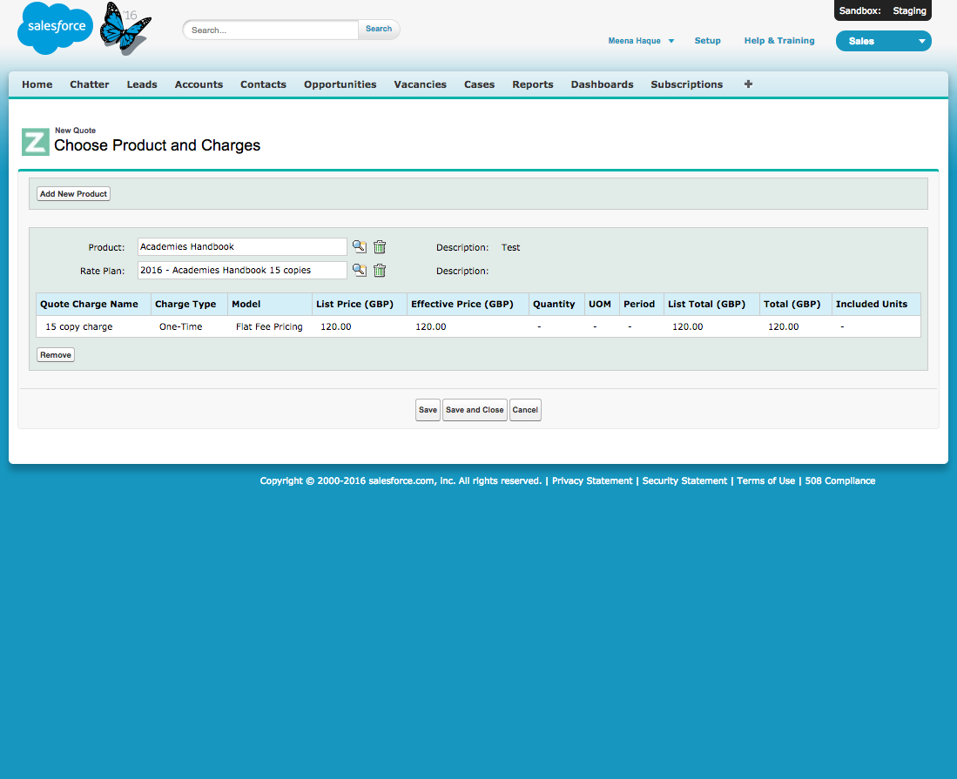

12. Click on ‘Save and Close’

13. Review the Quote details and when ready click on the **‘Send to Z-Billing’** button

14. Review the details on the Order Preview page. Click on the ‘Submit’ button when ready. This will bring up a warning message. This is a known bug.

15. Click on ‘Continue’ on the pop up window

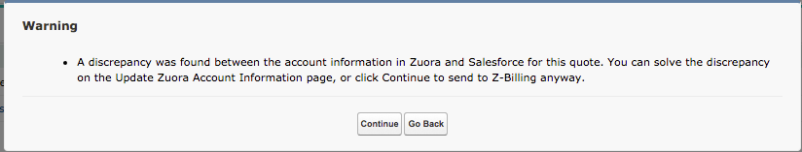

16. Click on ‘Ok’ on the confirmation pop up window

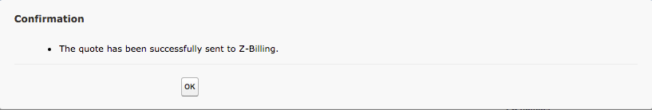

17. Navigate back to the Account page for the account that you have just created the new Academies subscription either by clicking on the Account name displayed within the ‘Recent Items’ list or by typing in the name in the search text box.

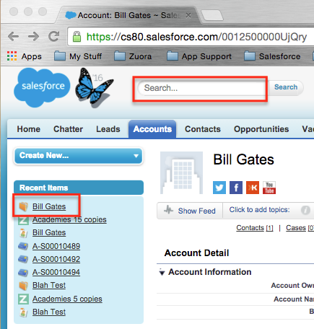

18. Scroll down to the Subscription panel and click on the newly created sub. In this example it would be the subscription for Academies Handbook 15 Copies [A-S00010497](https://cs80.salesforce.com/a3t250000008Sm2) . Click on the Sub link.

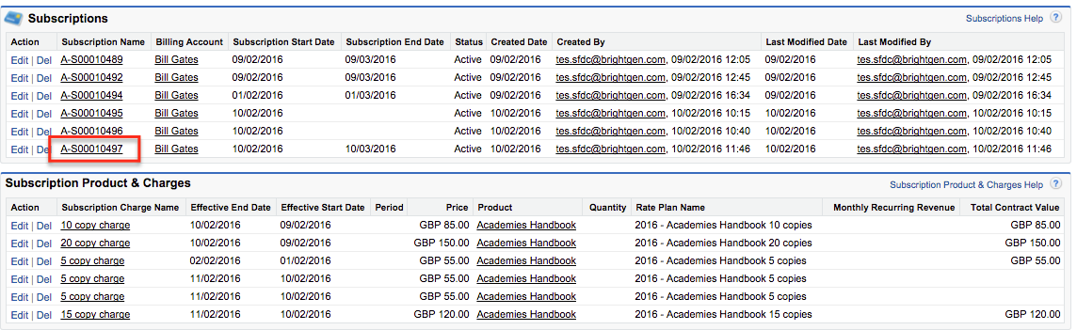

19. Review the subscription details on the Subscription page. The **Initial Term** should be 1 Month, **Renewal Term** set to 0 Month and **AutoRenew** unchecked.

