Jenkins

How to change credentials in Jenkins?

First all of when you login in Jenkins, you will find the screen

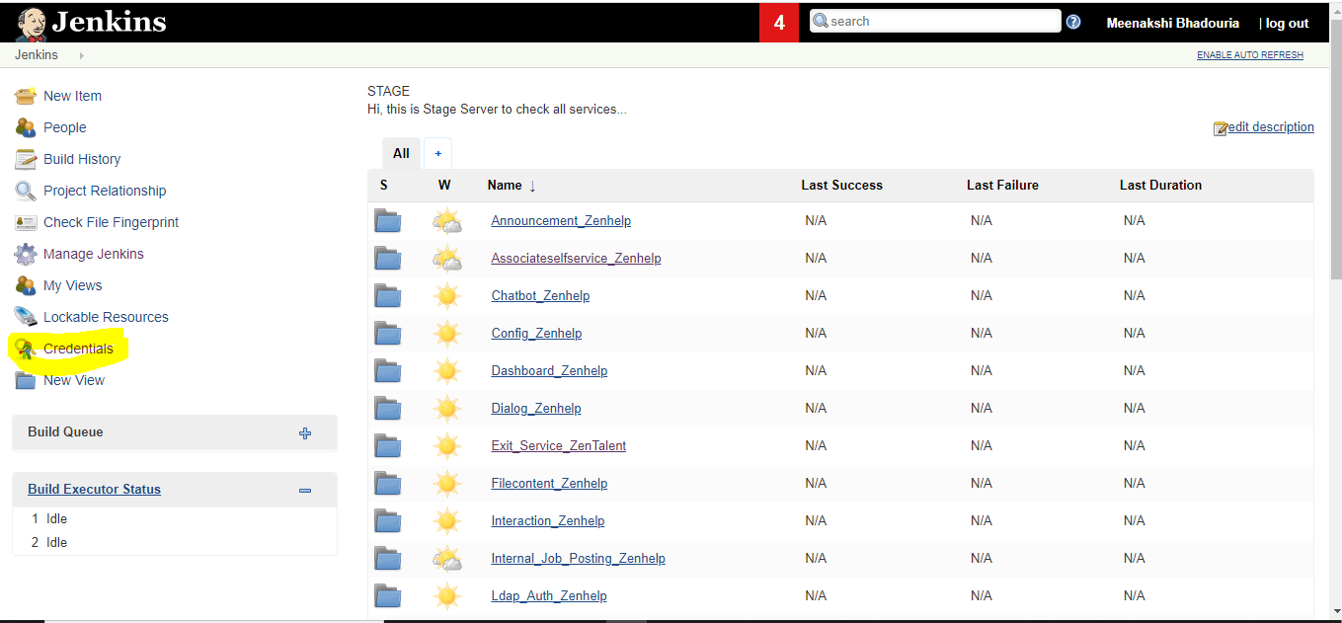
Click on Credentials

The next screen which appears is

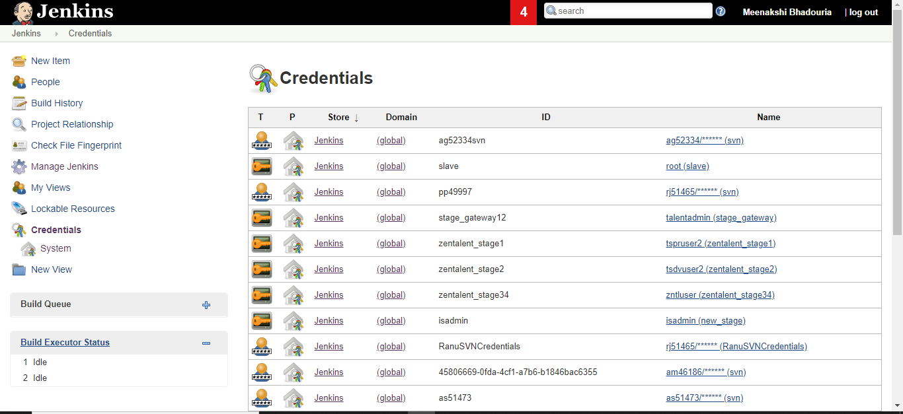

here all the credentials will be listed

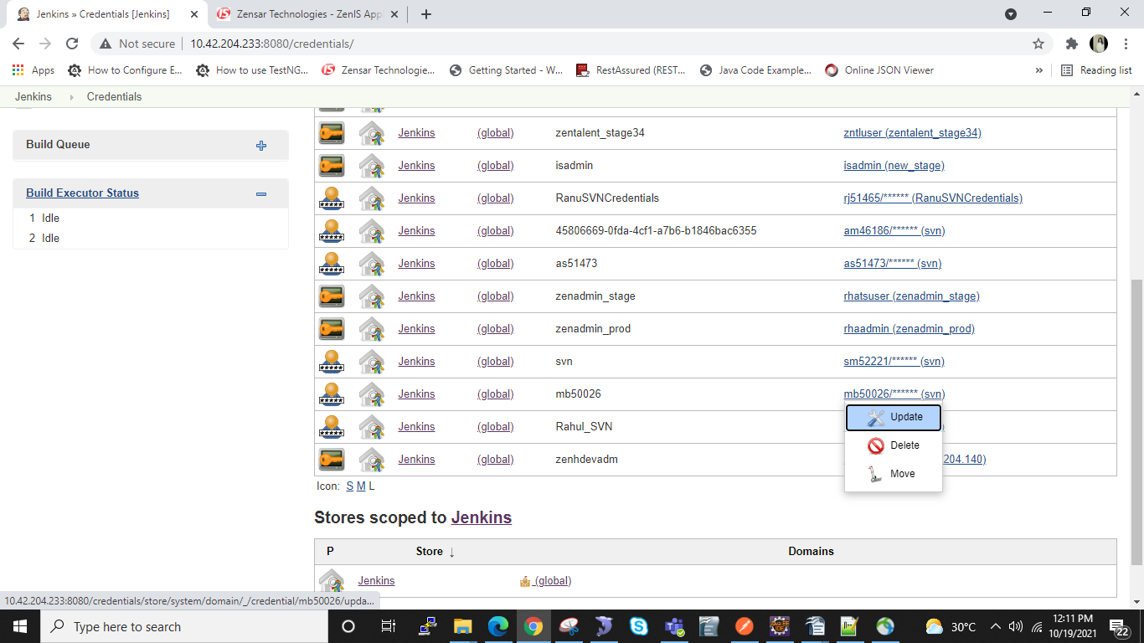

by clicking on update you can update your credentials

When you click on update below screen will appear and you can update your password and username if you want.

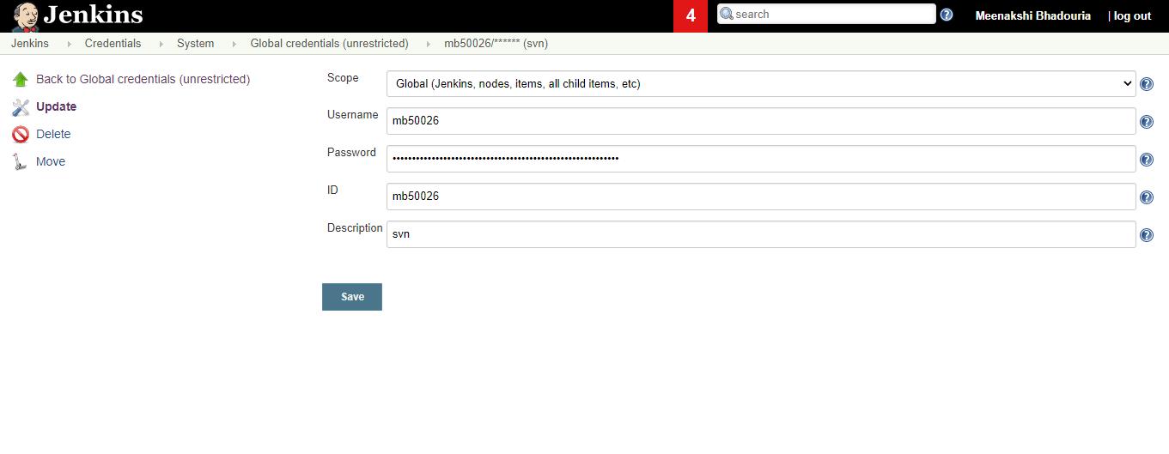
If you want to add your credentials, click on credentials then on system

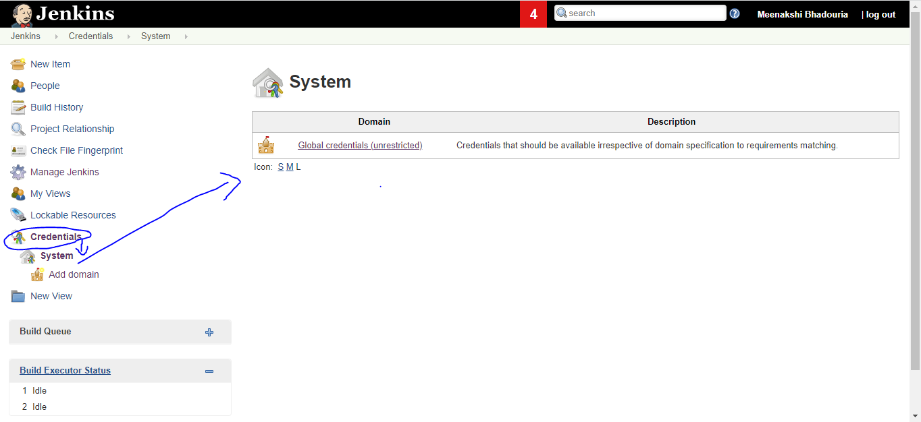

Click on global crendentials

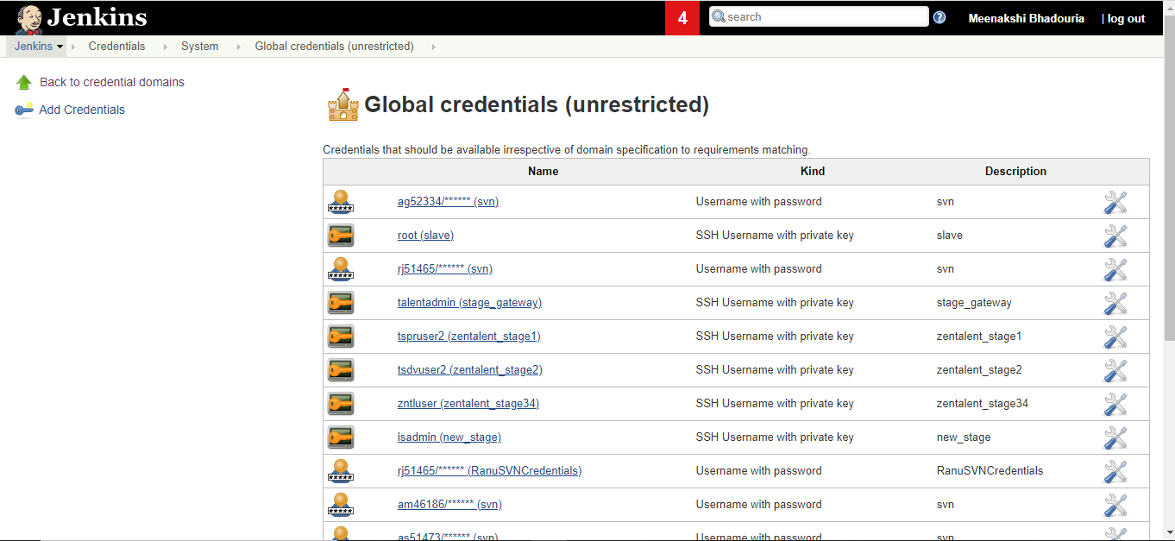

This Screen will appear and from here you can click on Add Credentials and by providing the details you can add your credentials.

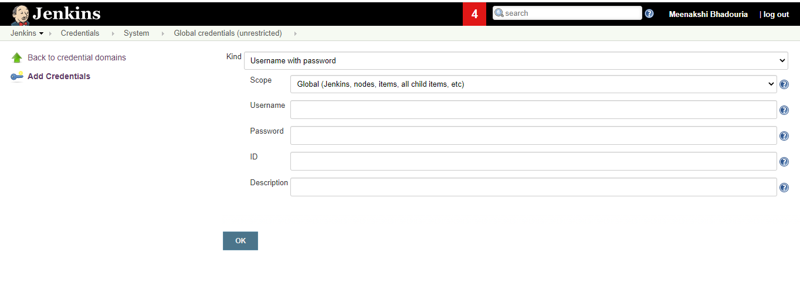
How to add new user to Jenkins and give them access.

Click on Manage Jenkins

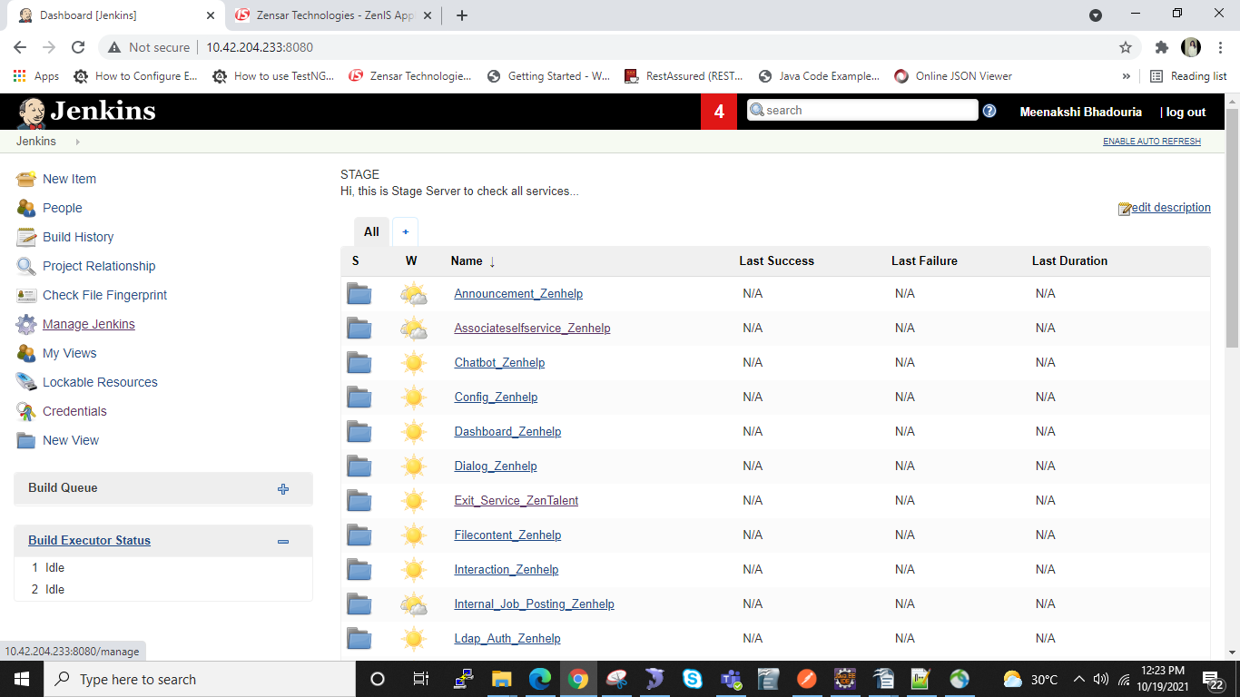

After clicking on the manage jenkins and if you scroll down the screen below screen will appear

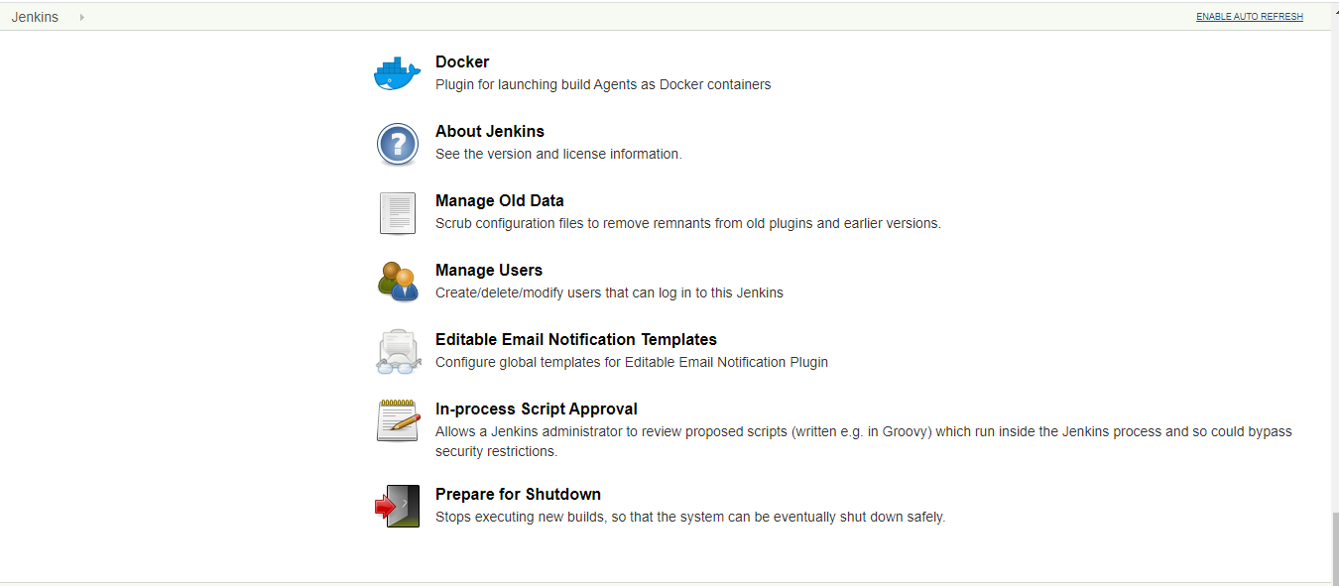

Here you have to click on Manage Users

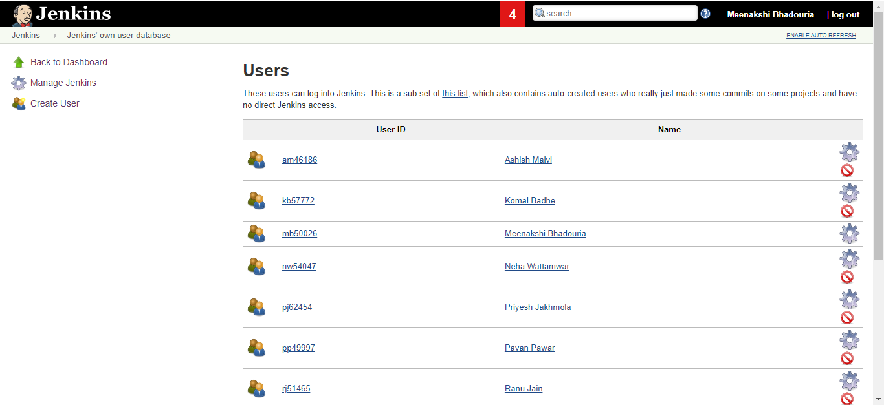

If you click on Manage users above screen will appear you can add user by clicking on Create user

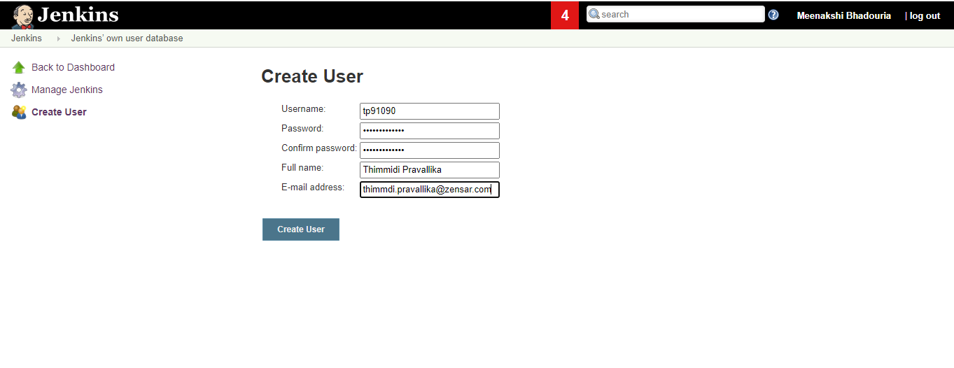

you can fill all the mandatory details, once you click on create user , new user will be created.

How to assign role to a role?

Click on Manage Jenkins

After clicking on the manage jenkins and if you scroll down the screen below screen will appear

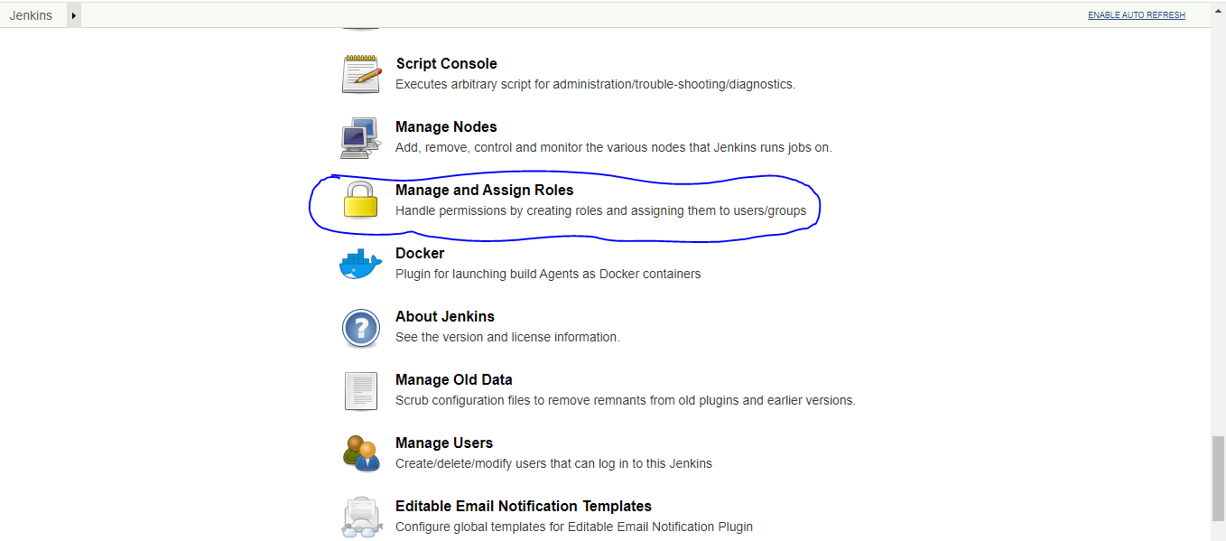

you have to click on Manage and Assign Roles , below screen will appear after clicking .

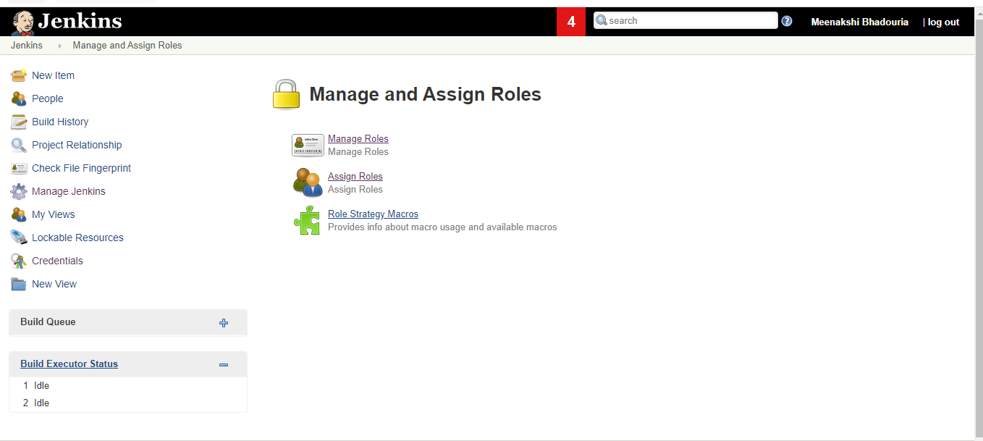

You have to click on Assign Roles,

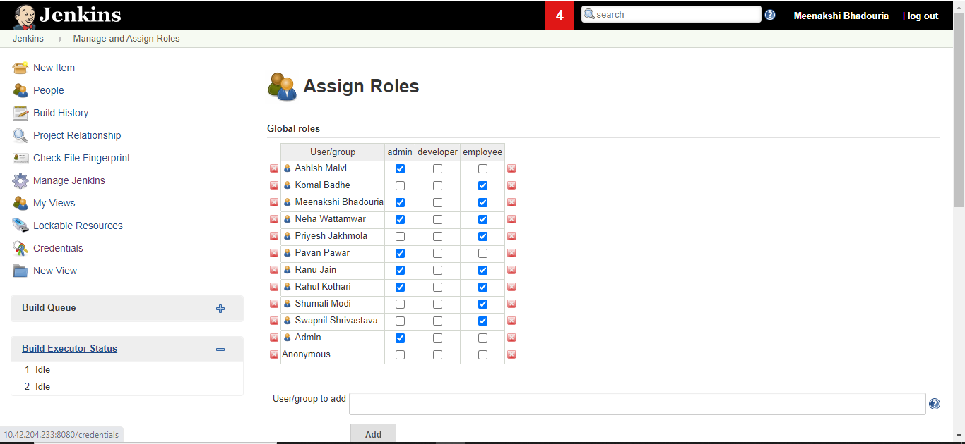

then

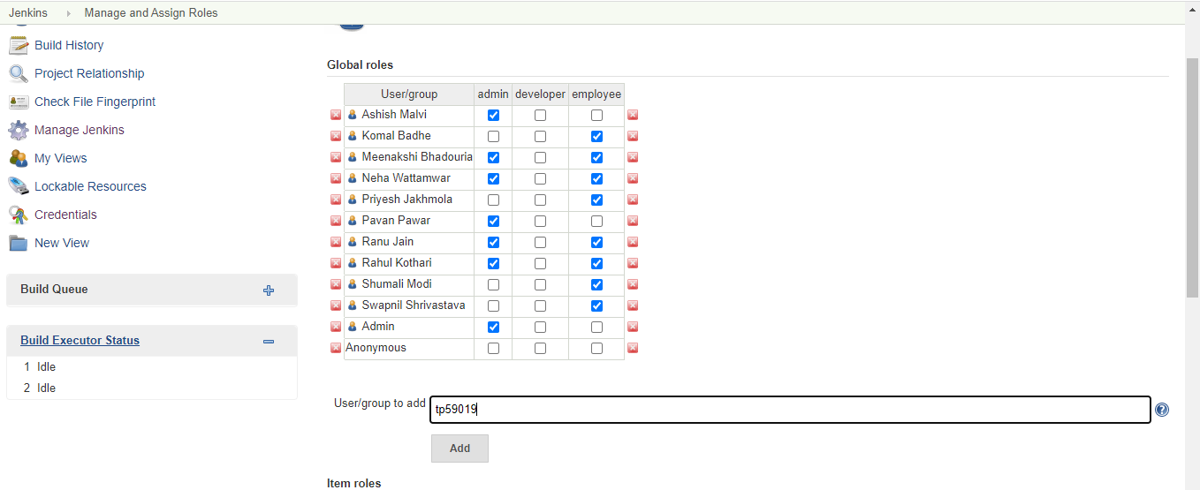

Add the UserId and click on Add button

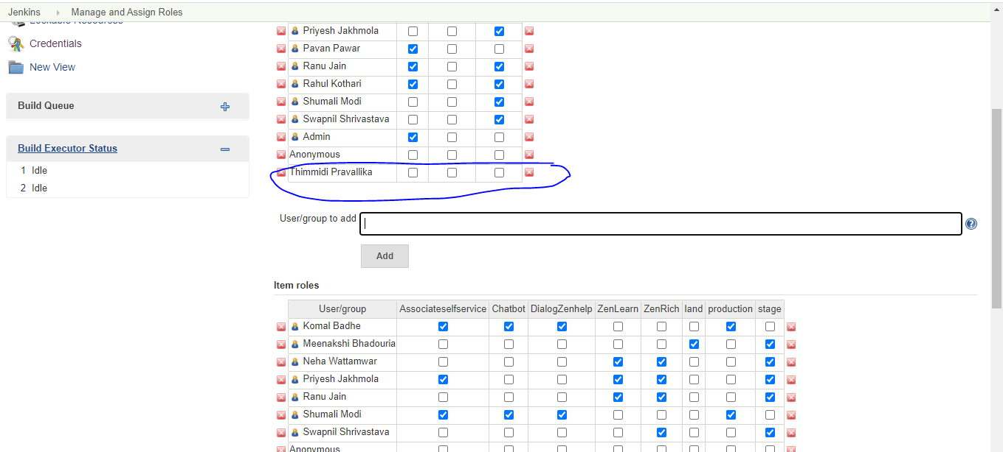

you can see the user will be added
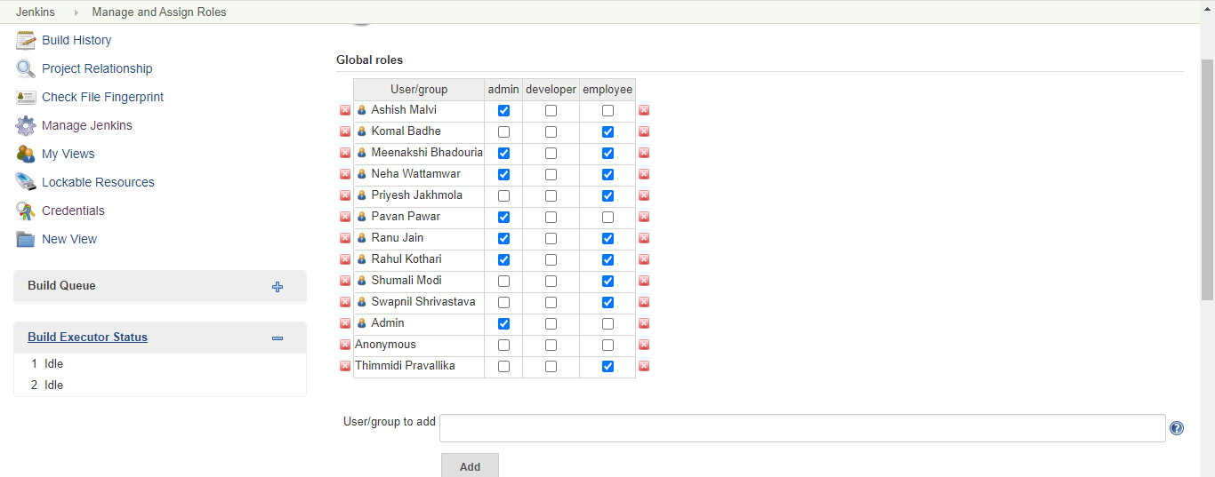
After Adding you can assign role as I have selected employee.

If you scroll down a little , below screen will appear and you can add the modules and environment will user will be eligible to access.

You can add the user and assign the environment and modules which will be accessible by the user
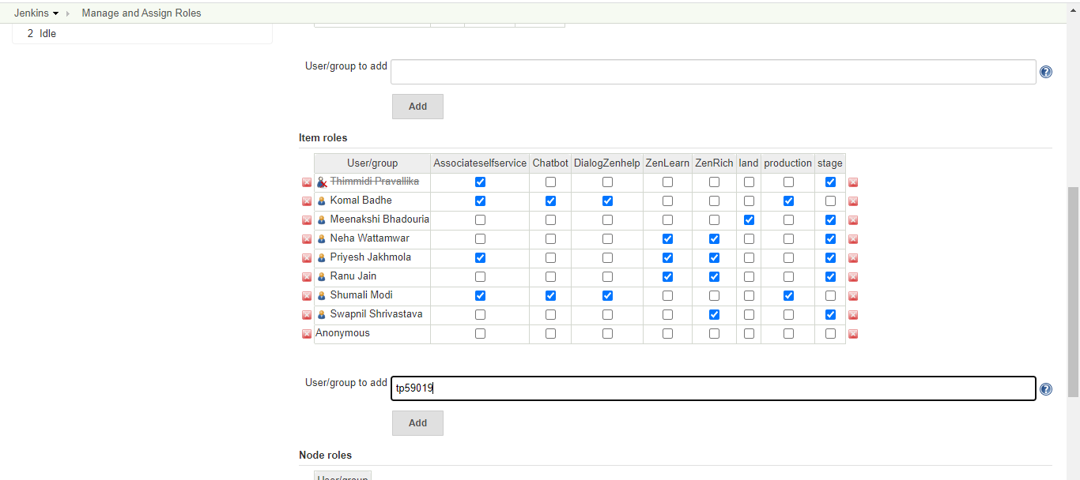

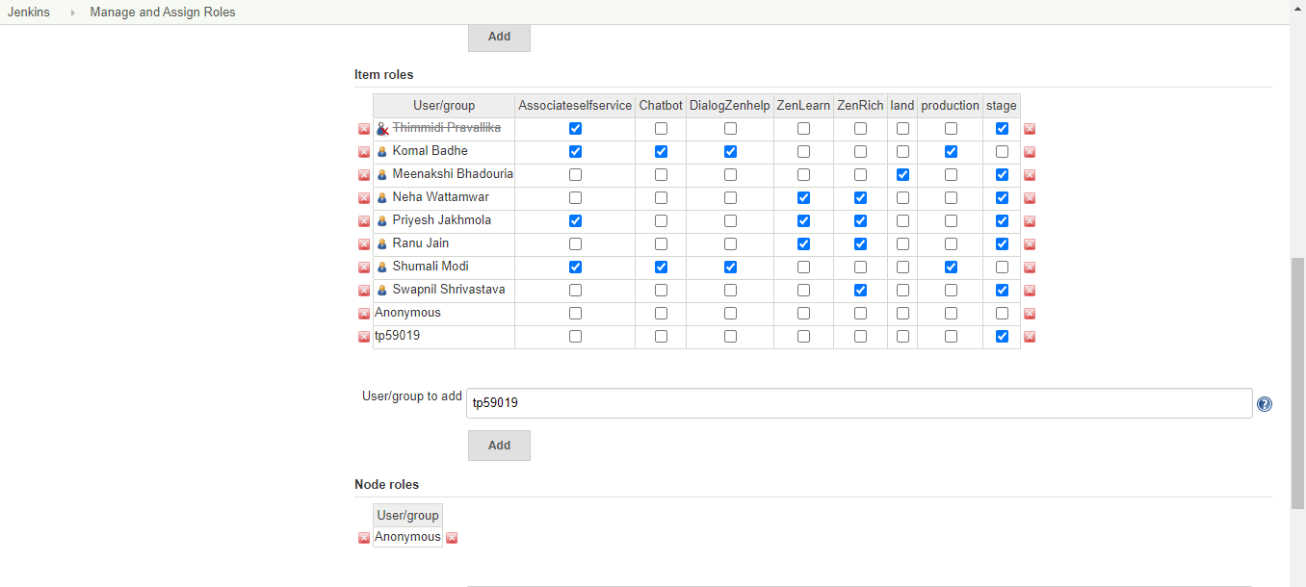

After Assigning roles you have to click on save or apply button to save your changes.

What happens when you click on Manage Roles

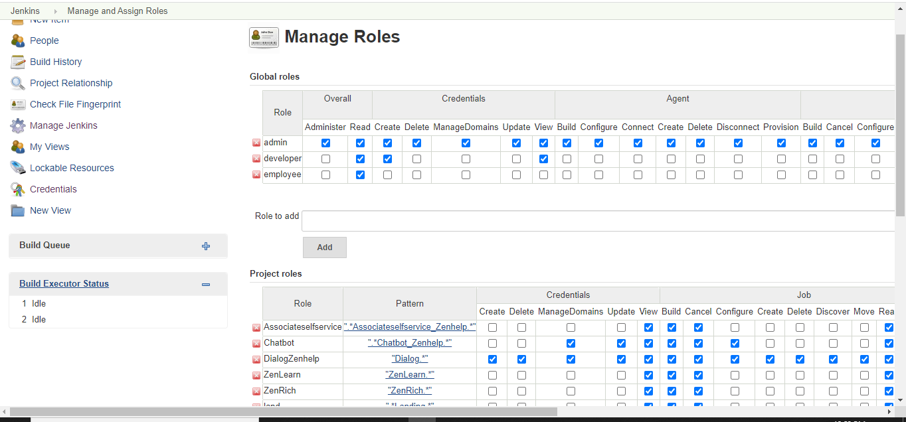
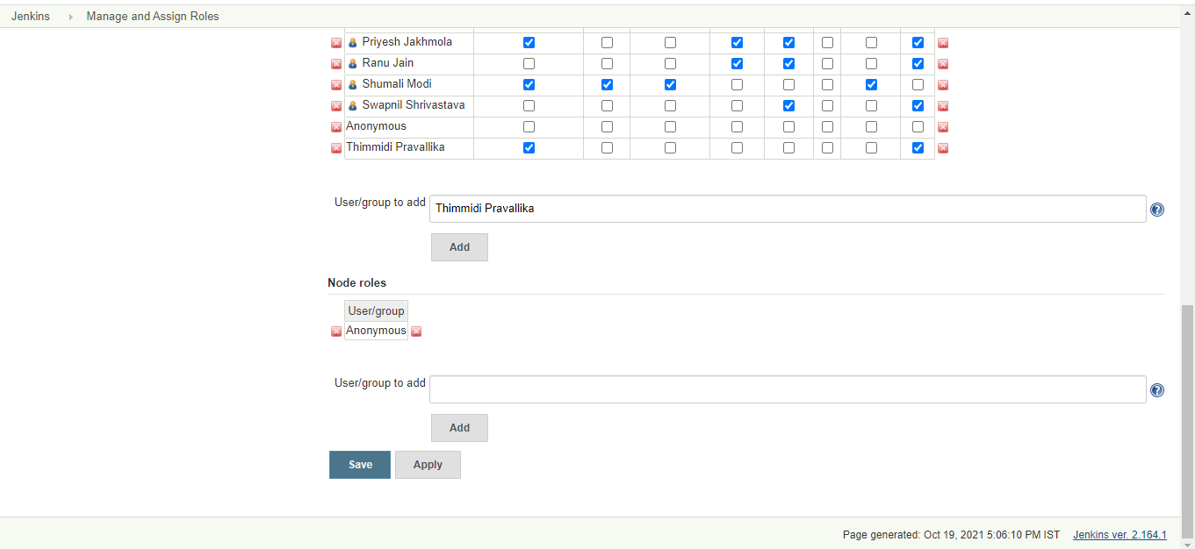

Above screen will appear and you can add the roles which has to given to which user.

One can assign the role project wise also

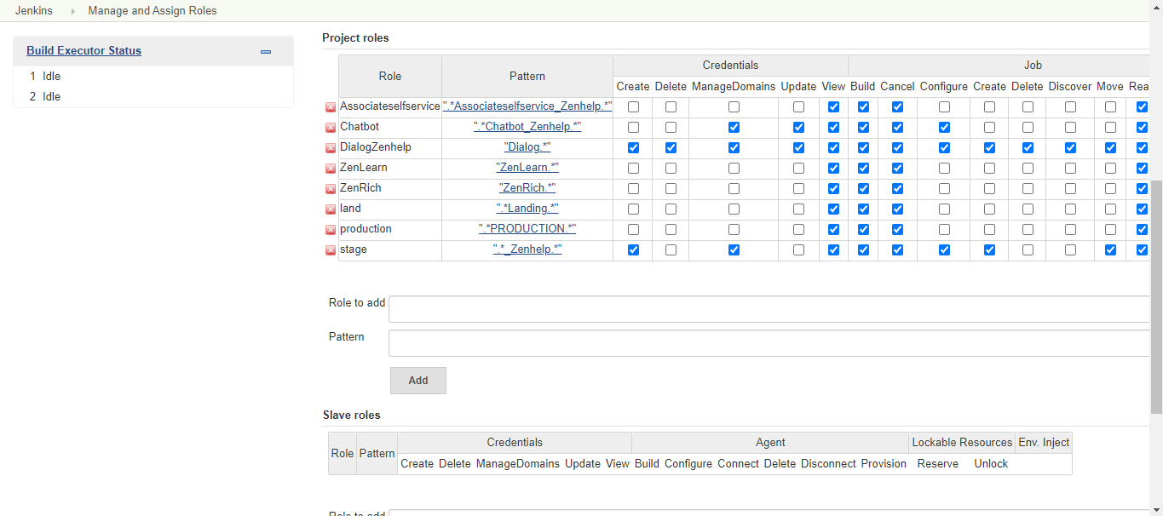

After all the changes user must click on Save or Apply button

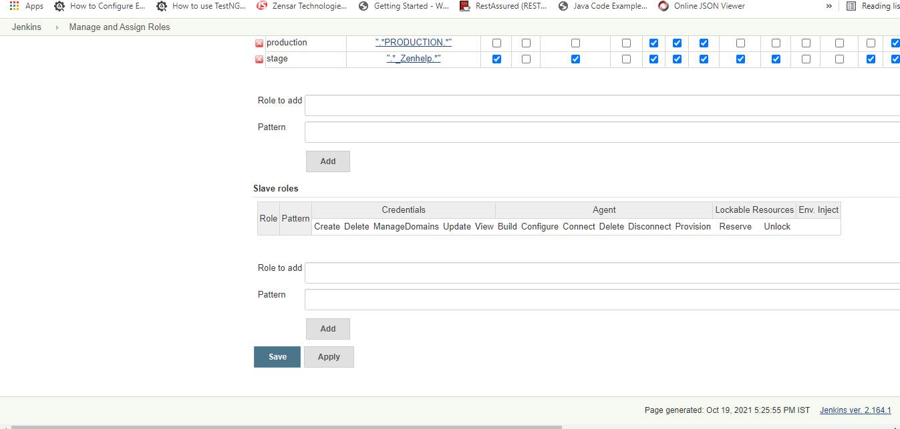

How to add or update environment variable in Jenkins ?

First login to the Jenkins and then click on the Manage Jenkins then

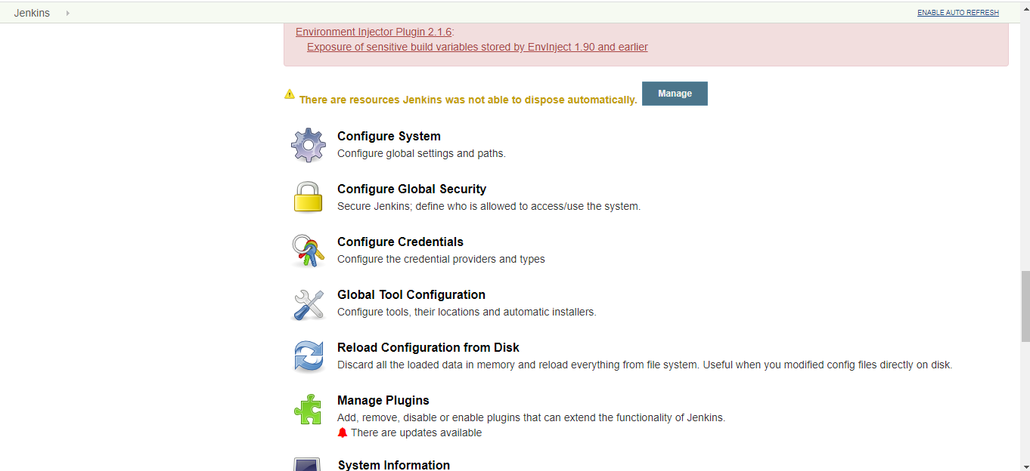
click on Configure System

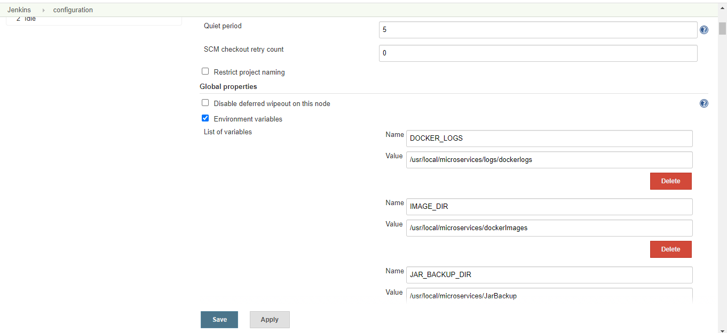

you can add or update your global environment variables.
Click on Save or apply to save your changes.

