/*Alter Table:

1.Add a new column linkedin_profile to employees table to store LinkedIn URLs as varchar.*/

ALTER TABLE employees ADD COLUMN linkedin_profile VARCHAR(100);

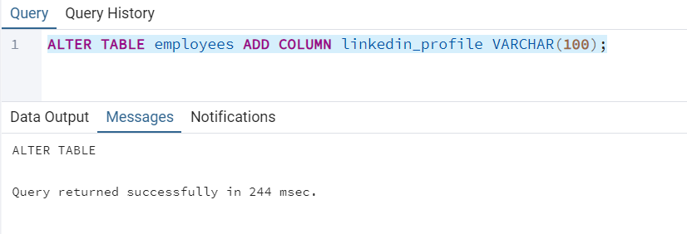

2.Change the linkedin_profile column data type from VARCHAR to TEXT.

ALTER TABLE employees

ALTER COLUMN linkedin_profile TYPE TEXT;

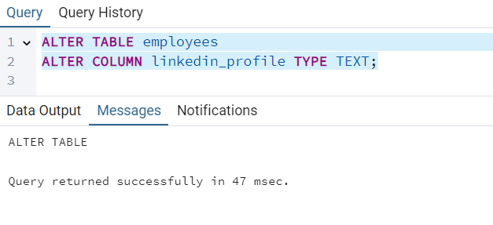

3.Add unique, not null constraint to linkedin_profile

ALTER TABLE employees

ADD CONSTRAINT U_constraint UNIQUE(linkedin_profile);

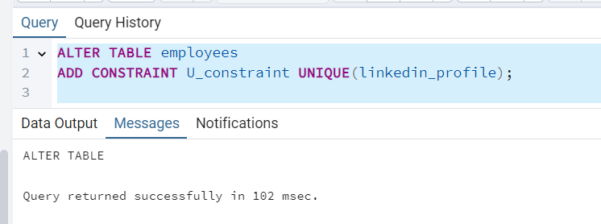

ALTER TABLE employees

ALTER COLUMN linkedin_profile SET NOT NULL;

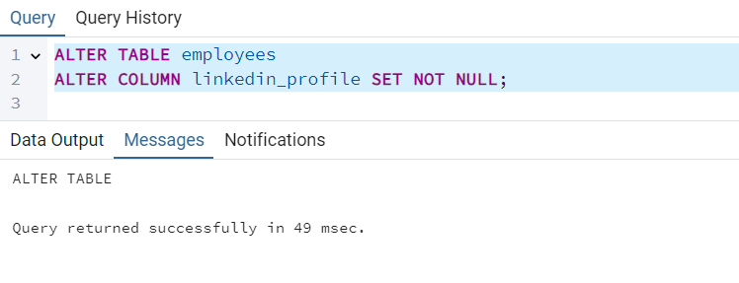

4.Drop column linkedin_profile

ALTER TABLE employees

DROP COLUMN linkedin_profile;

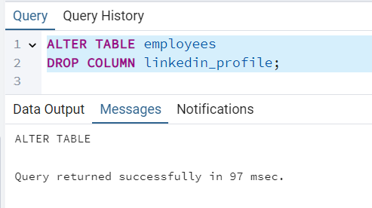

/*Querying (Select)

1.Retrieve the first name, last name, and title of all employees*/

SELECT SPLIT_PART(employeename, ' ', 1) AS first_name,

SPLIT_PART(employeename, ' ', 2) AS last_name,title

FROM employees;

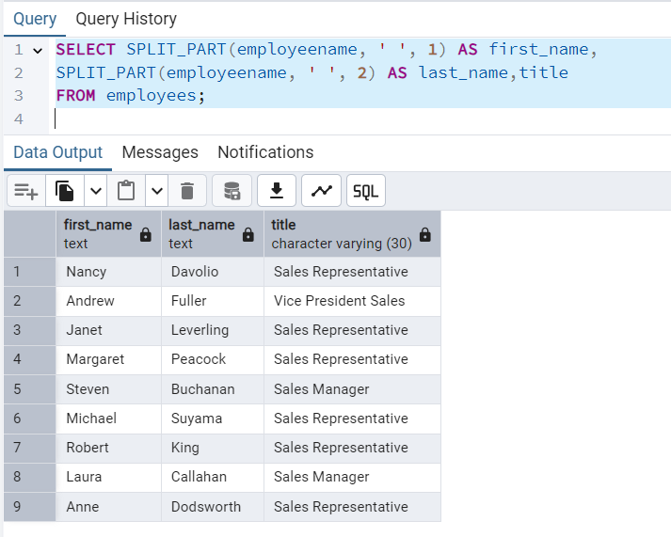

2.Find all unique unit prices of products

SELECT DISTINCT unitprice FROM products;

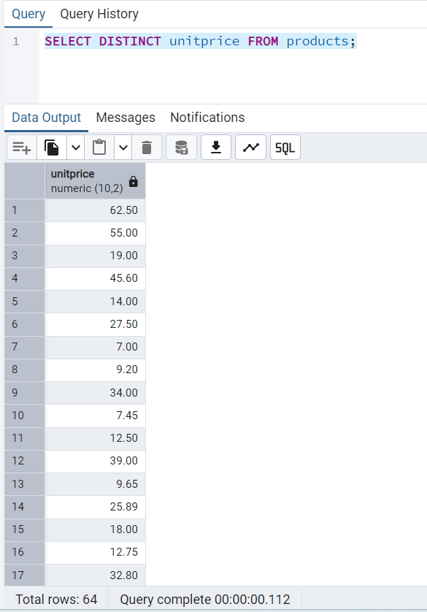

3.List all customers sorted by company name in ascending order

SELECT * FROM customers

ORDER BY companyname ASC;

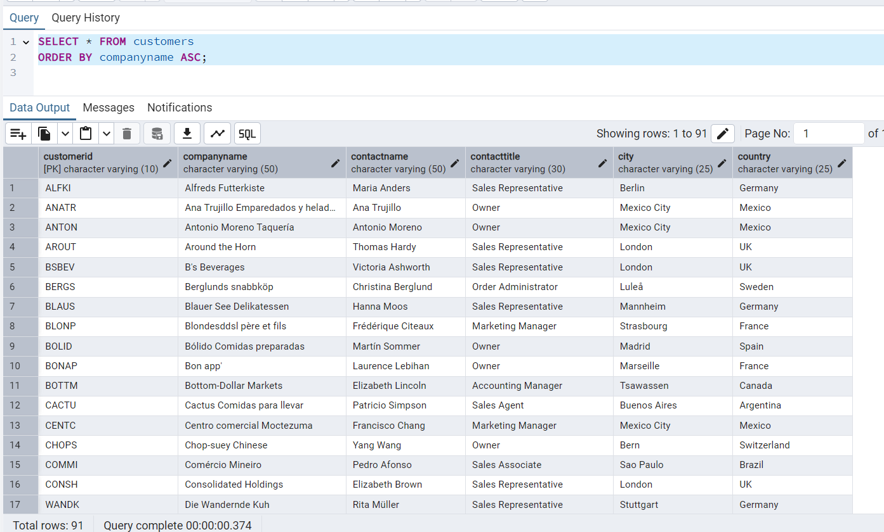

4.Display product name and unit price, but rename the unit_price column as price_in_usd

SELECT productname, unitprice as price_in_usd from products

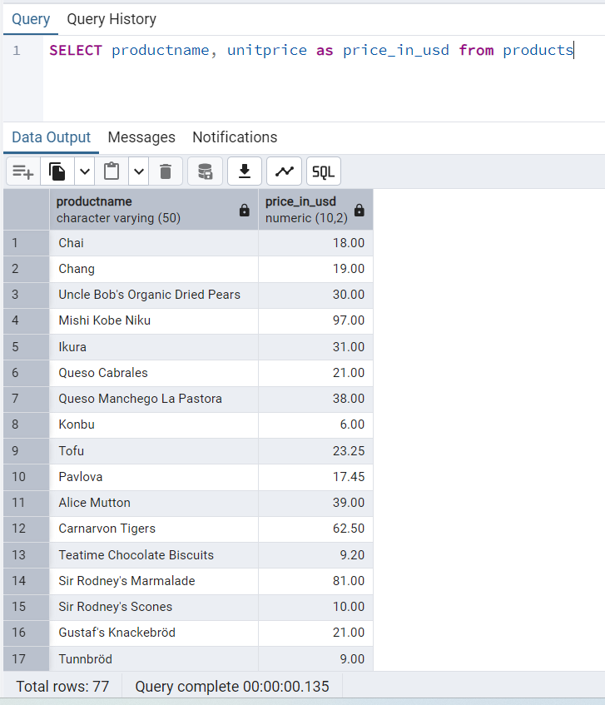

/*Filtering

4.Get all customers from Germany.*/

SELECT * FROM customers WHERE country ='Germany';

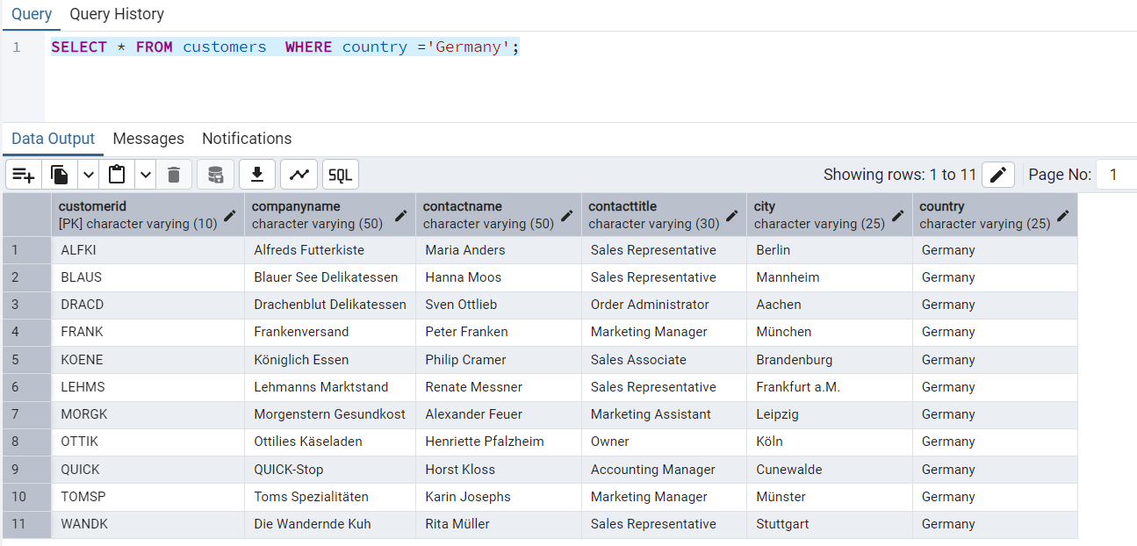

2.Find all customers from France or Spain

SELECT * FROM customers WHERE country ='France' OR country ='Spain';

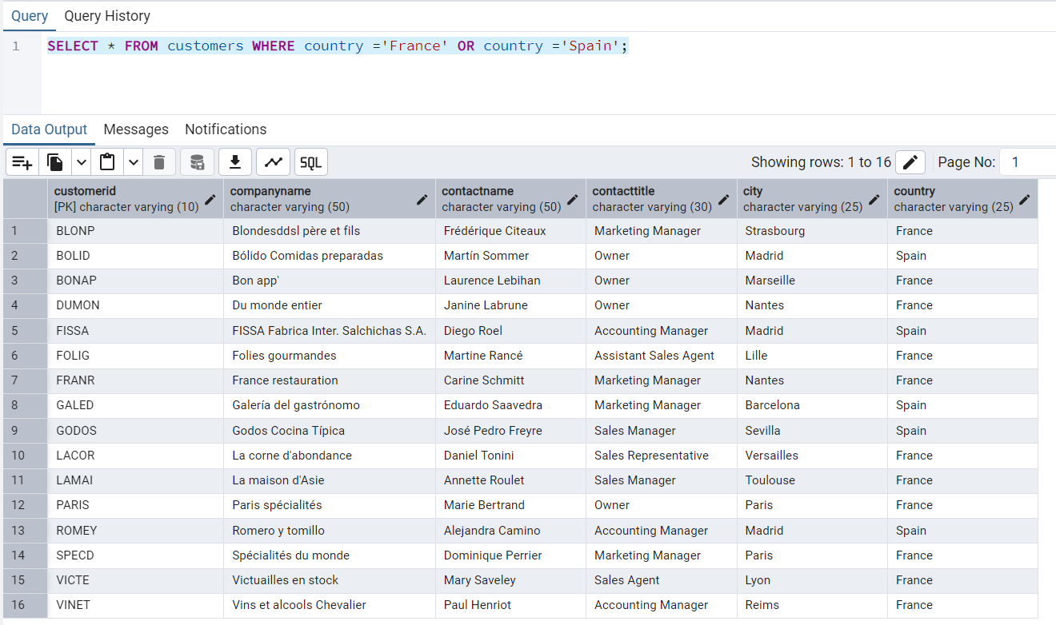

3.Retrieve all orders placed in 1997 (based on order_date), and either have freight greater than 50 or the shipped date available (i.e., non-NULL) (Hint: EXTRACT(YEAR FROM order_date))*/

SELECT * FROM orders WHERE EXTRACT('year' FROM orderdate)=1997 AND (freight>50 OR shippeddate IS NOT NULL) ;

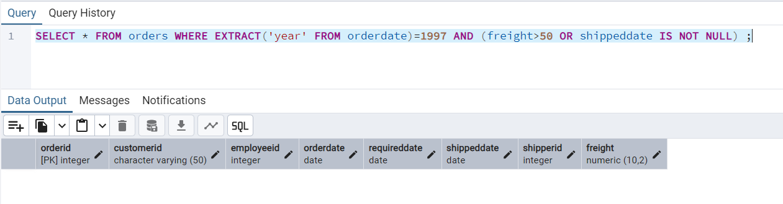

/*Filtering

1.Retrieve the product_id, product_name, and unit_price of products where the unit_price is greater than 15.*/

SELECT productid,productname,unitprice FROM products WHERE unitprice>15;

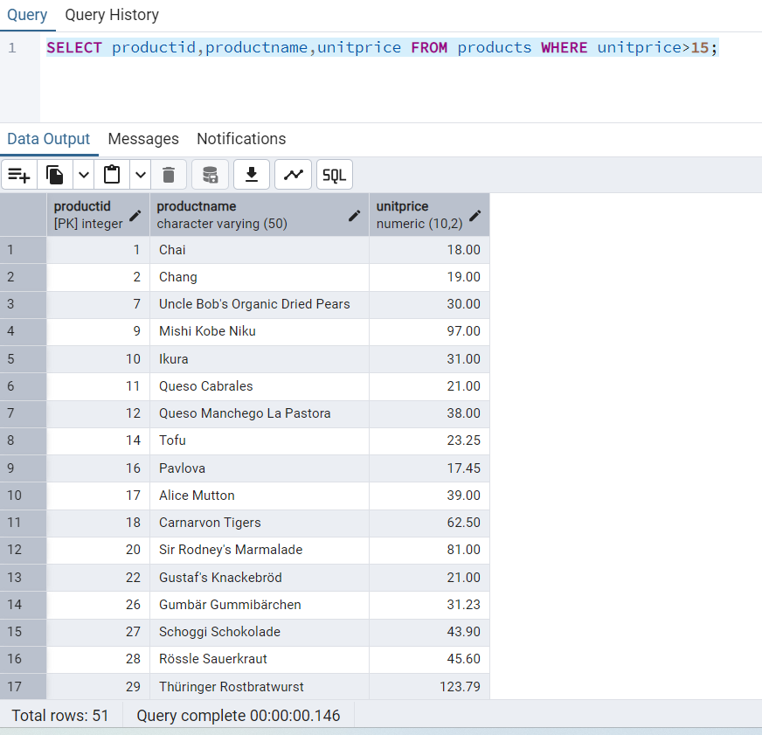

2.List all employees who are located in the USA and have the title "Sales Representative".

SELECT * FROM employees WHERE country='USA' AND title='Sales Representative';

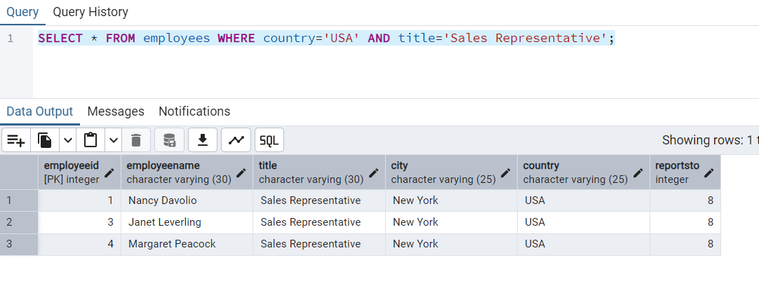

3.Retrieve all products that are not discontinued and priced greater than 30.

SELECT * FROM products WHERE discontinued = 'false' AND unitprice>30;

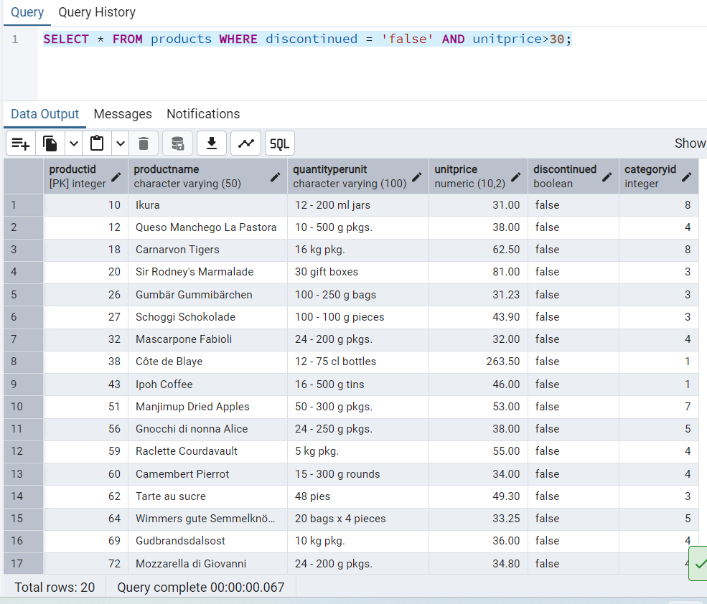

/*LIMIT/FETCH

1.Retrieve the first 10 orders from the orders table.*/

SELECT * FROM orders ORDER BY ordered FETCH FIRST 10 ROWS ONLY;

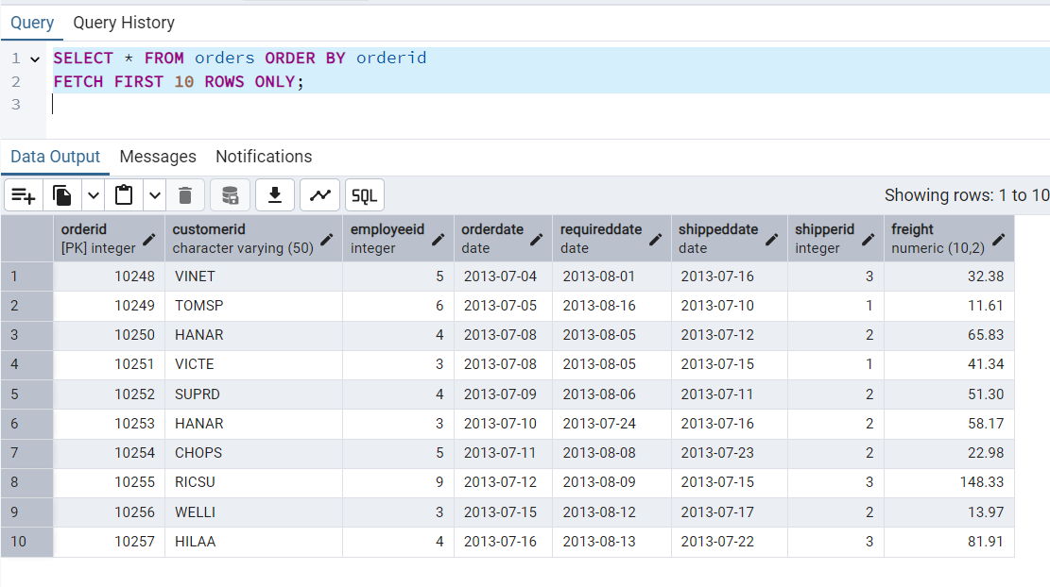

2.Retrieve orders starting from the 11th order, fetching 10 rows (i.e., fetch rows 11-20).

SELECT * FROM orders ORDER BY orderid

OFFSET 10 ROWS

FETCH FIRST 10 ROWS ONLY;

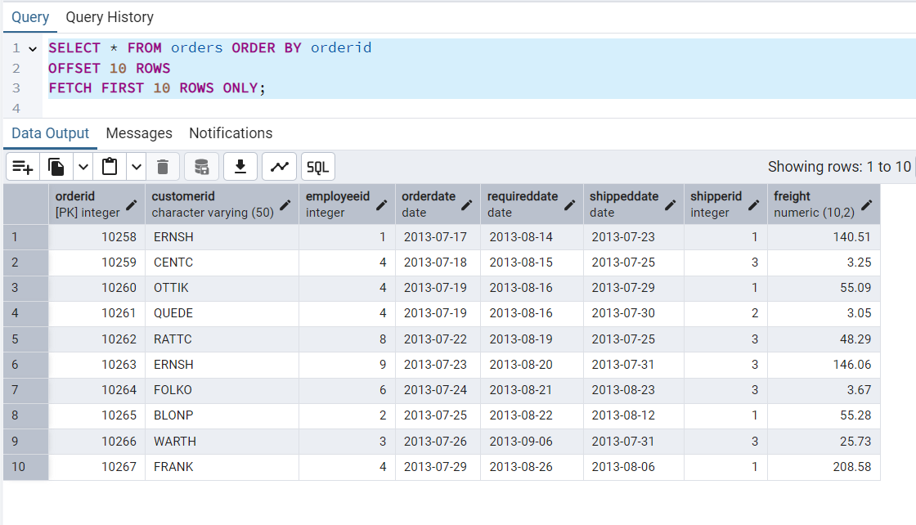

/*Filtering (IN, BETWEEN)

1.List all customers who are either Sales Representative, Owner*/

SELECT * FROM customers WHERE contacttitle IN('Sales Representative','Owner');

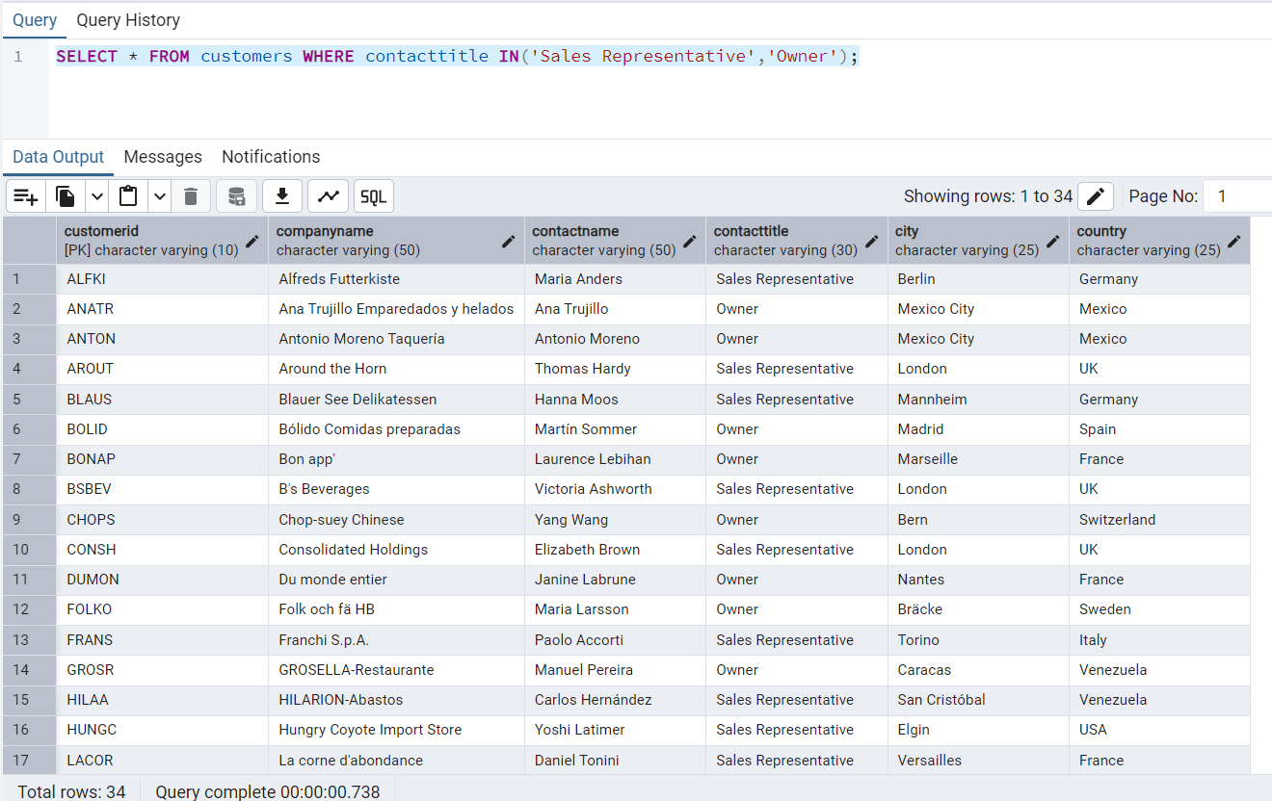

2.Retrieve orders placed between January 1, 2013, and December 31, 2013.

SELECT * FROM orders where orderdate BETWEEN '2013-01-01' AND '2013-12-31';

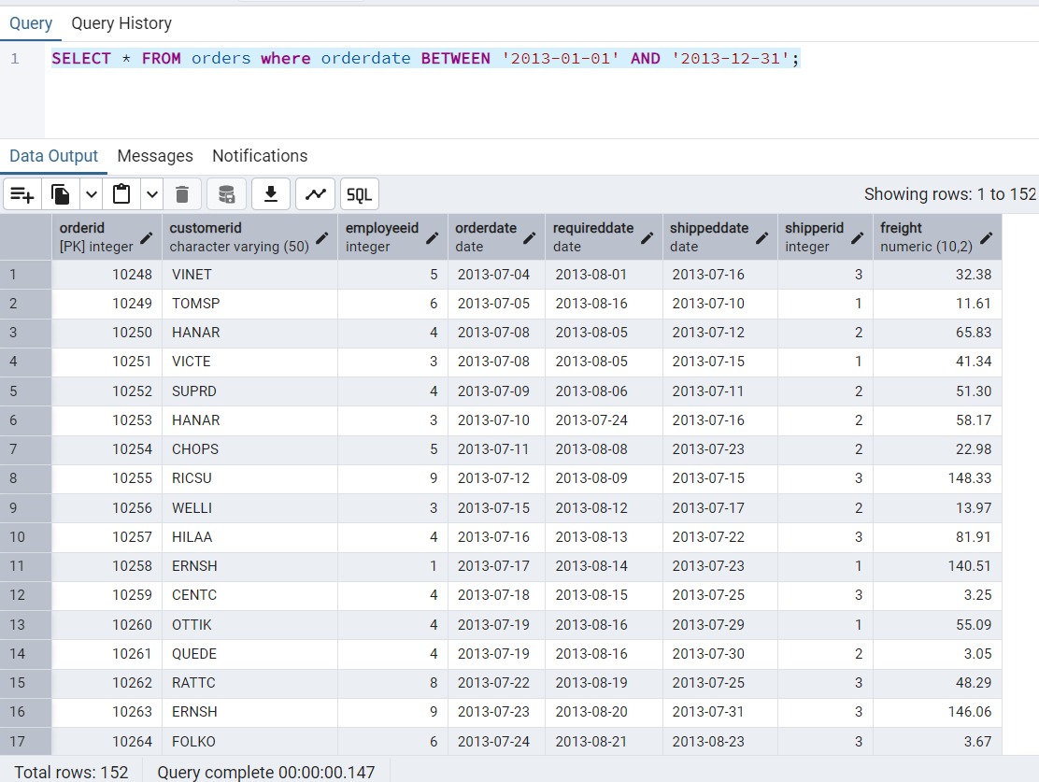

/*Filtering

1.List all products whose category_id is not 1, 2, or 3.*/

SELECT * FROM products WHERE categoryid NOT IN(1,2,3);

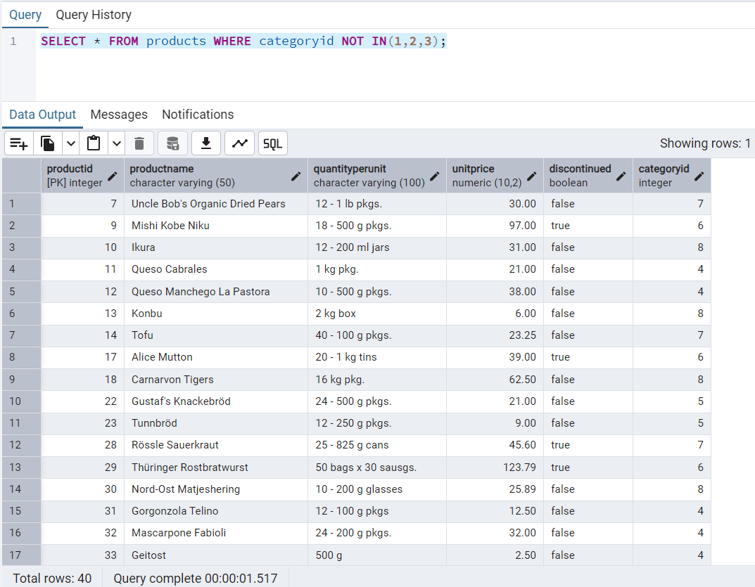

2.Find customers whose company name starts with "A".

SELECT * FROM customers where companyname like 'A%';

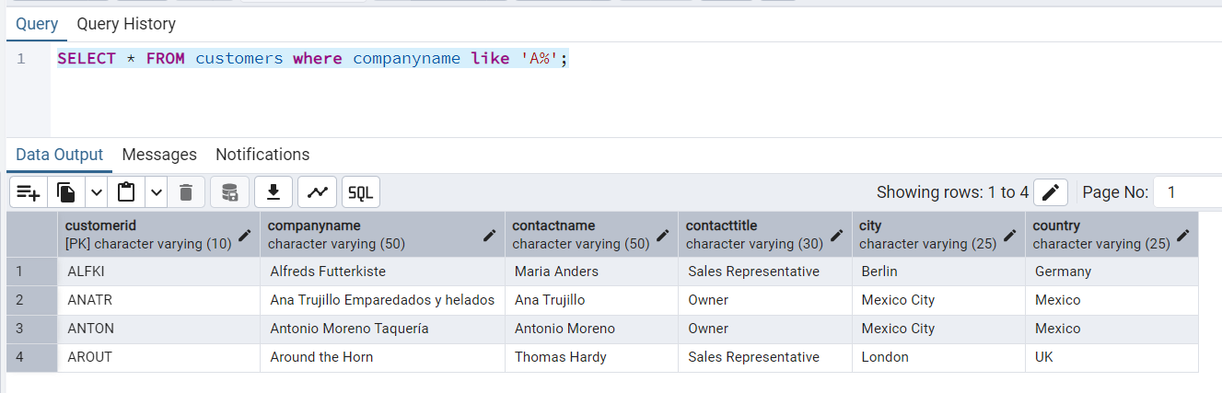

/*INSERT into orders table:

1.Task: Add a new order to the orders table with the following details:

Order ID: 11078

Customer ID: ALFKI

Employee ID: 5

Order Date: 2025-04-23

Required Date: 2025-04-30

Shipped Date: 2025-04-25

shipperID:2

Freight: 45.50*/

INSERT INTO orders(orderid,customerid,employeeid,orderdate,requireddate,shippeddate,shipperid,freight)

VALUES(11078,'ALFKI',5,'2025-04-23','2025-04-30','2025-04-25',2,45.50);

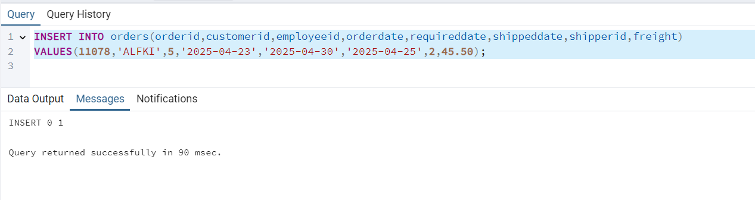

/*Increase(Update) the unit price of all products in category_id =2 by 10%. (HINT: unit_price =unit_price * 1.10)*/

UPDATE products SET unitprice=unitprice*1.10 WHERE categoryid=2;

