**SAS Admin duties** - SAS Admin duties include maintaining servers - checking status, starting, stopping servers whenever necessary. There is also Adsync - syncing users into Metadata,

1. **Server - Status, Start, Stop**
2. Go to Scripts location - cd /n01/data/gma/scripts
3. Status, start, stop

Status - ./sas-status.sh

Start - ./sas-start.sh

Stop - ./sas-stop.sh

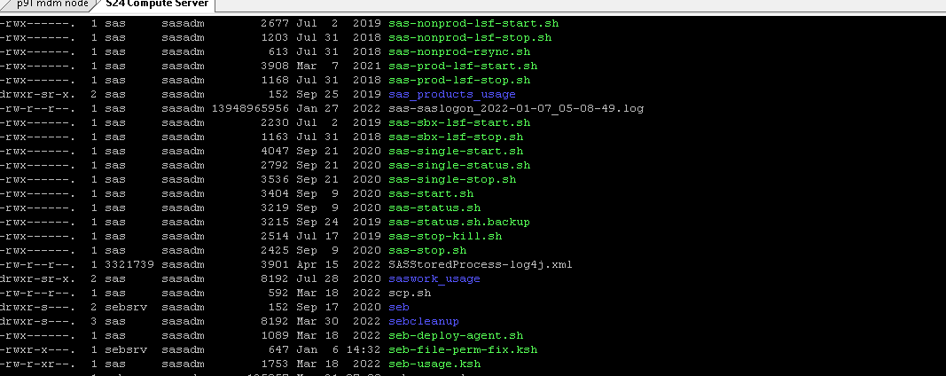

1. **ADSYNC**   
     
   dzdo su - sasads

Cd /c01/data/tenant200/security

/c01/sasdata/tenant200/public/batchsas.sh -s SAS9_importad.sas

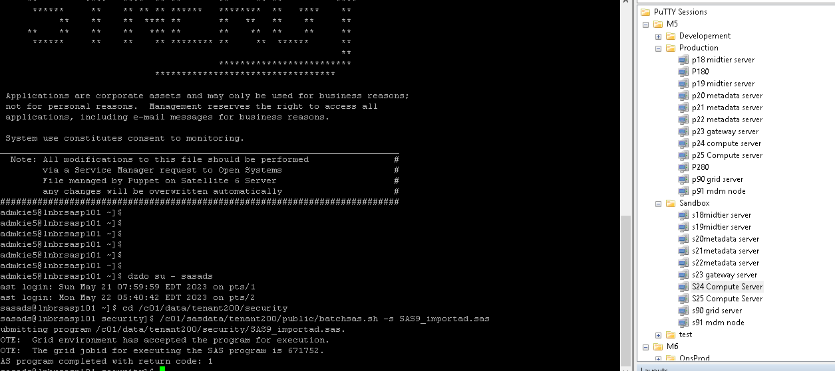

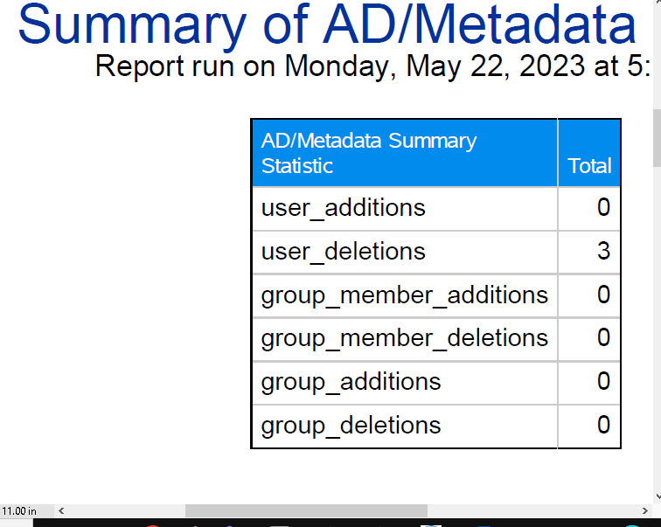

**3. Clearing Up Space - Memory Utilization**

DRILLING DOWN LOGS   
  
Dzdo su - sas

Df -h

Cd /c01/data/sas

du -sh * (to check what is the largest memory)

From here, keep checking what is occupying more GB/MB from memory and choose the one with the most memory.

Rm -rf *the largest file*

(rm -> remove, rd - since it is a file)