Arrays:
- Question: Print elements of an array
Question description: Write a C program to read n elements into an array and display them.
Sample data:
Enter the number of elements: 5
Enter the elements: 10 20 30 40 50

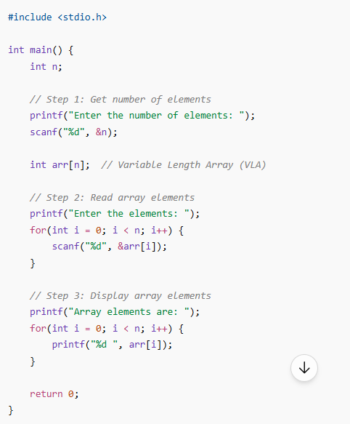

2. Question: Sum of all elements in array
Question description: Write a C program to find the sum of all array elements entered by the user.
Sample data:
Input: 1 2 3 4 5
Expected output:
Sum = 15
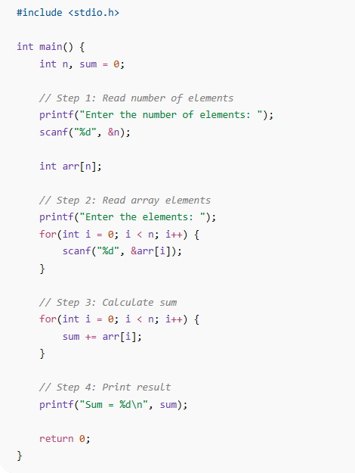

3. Question: Find maximum and minimum element
Question description: Write a C program to find the largest and smallest element in the array.
Sample data:
Input: 8 3 15 6 2
Expected output:
Maximum = 15
Minimum = 2
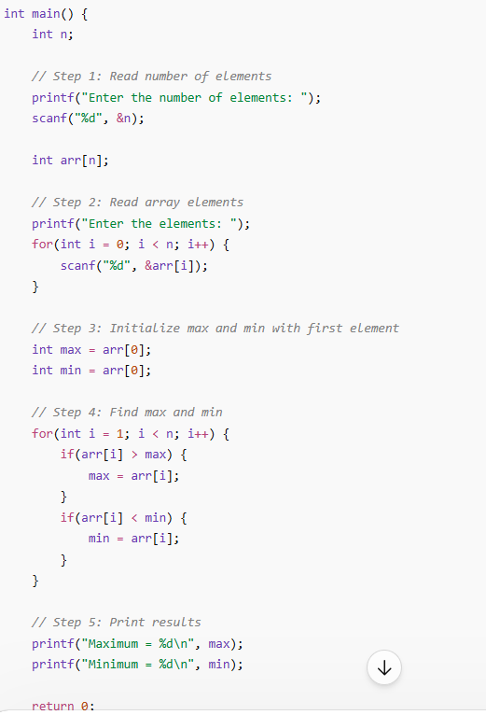

4. Question: Count even and odd elements
Question description: Write a C program to count how many even and odd numbers are in the array.
Sample data:
Input: 4 7 9 10 22
Expected output:
Even: 3
Odd: 2
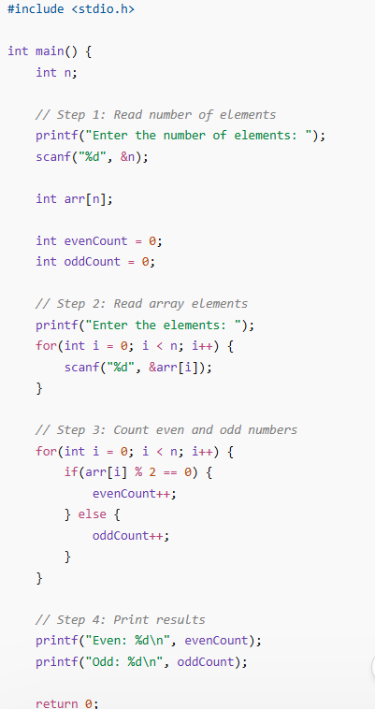

5. Question: Copy array elements
Question description: Write a C program to copy all elements from one array to another.
Sample data:
Input: 1 2 3 4 5
Expected output:
Copied array: 1 2 3 4 5
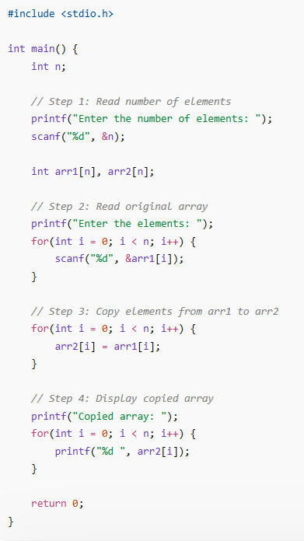

6. Question: Count negative elements
Question description: Write a C program to count total number of negative elements in an array.
Sample data:
Input: -1 3 -4 5 0 -7
Expected output:
Total negative elements: 3
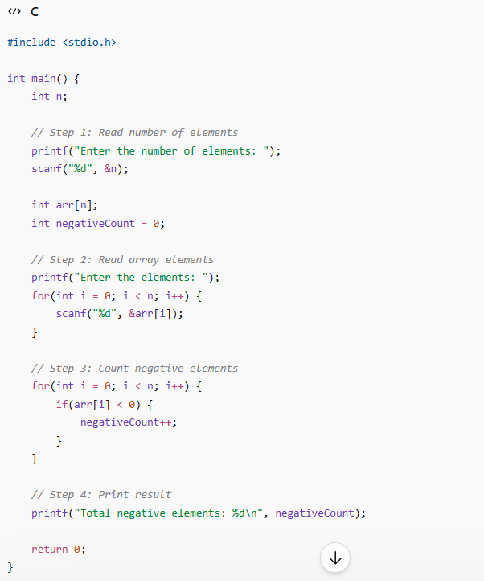

7. Question: Find for an element
Question description: Write a C program to search for a number in an array and print its index.
Sample data:
Array: 10 20 30 40 50
Find: 30
Expected output:
Element found at index: 2
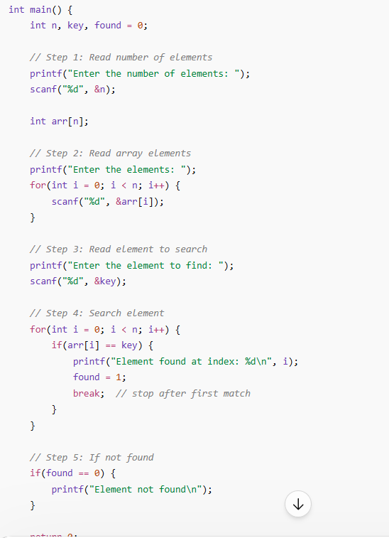

8. Question: Reverse an array
Question description: Write a C program to reverse an array in-place.
Sample data:
Input: 10 20 30 40 50
Expected output:
Reversed array: 50 40 30 20 10
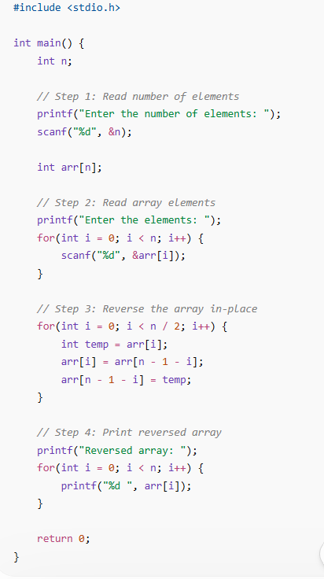

9. Question: Insert element at position
Question description: Write a C program to insert a number at a given position in an array.
Sample data:
Array: 10 20 30 40
Insert: 25 at position 2
Expected output:
Array after insertion: 10 20 25 30 40
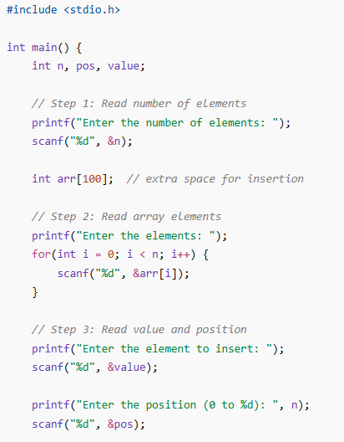
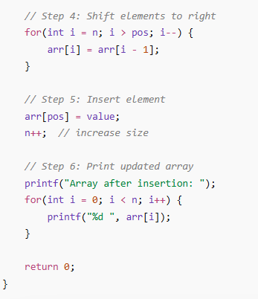
10. Question: Delete element at position
Question description: Write a C program to delete a number at a given position in an array.
Sample data:
Array: 10 20 30 40
Delete at position: 2
Expected output:
Array after deletion: 10 20 40
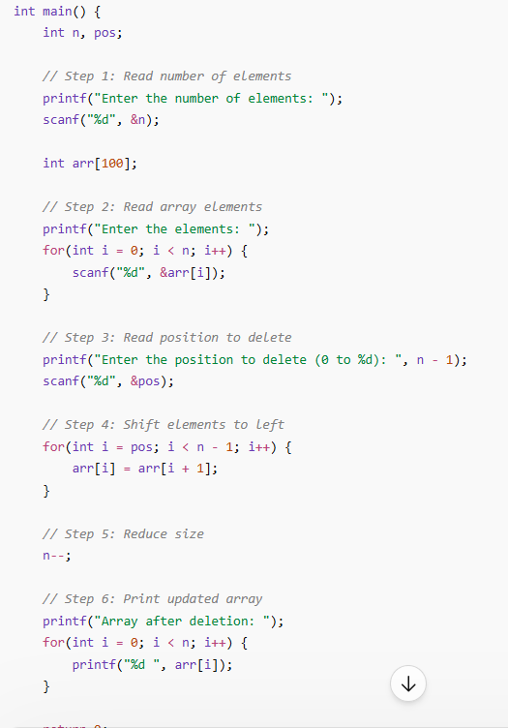

11. Question: Sort array in ascending order
Question description: Write a C program to sort elements in ascending order.
Sample data:
Input: 20 5 10 8
Expected output:
Sorted array: 5 8 10 20
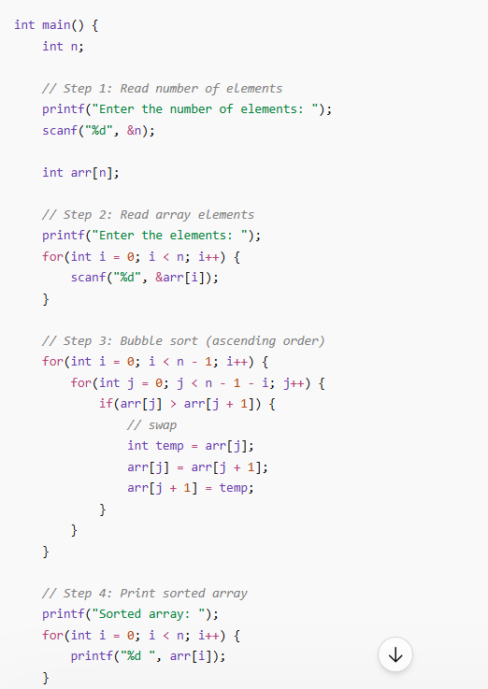

12. Question: Sort array in descending order
Question description: Write a C program to sort array elements in descending order.
Sample data:
Input: 7 2 9 4
Expected output:
Sorted array: 9 7 4 2
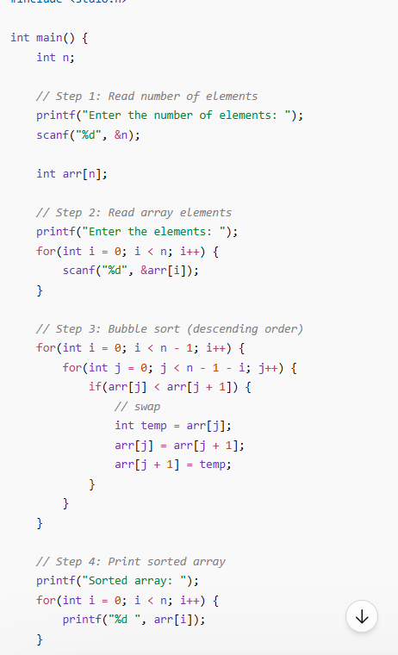

13. Question: Merge two arrays
Question description: Write a C program to merge two arrays into a third array.
Sample data:
Array 1: 1 2 3
Array 2: 4 5 6
Expected output:
Merged array: 1 2 3 4 5 6
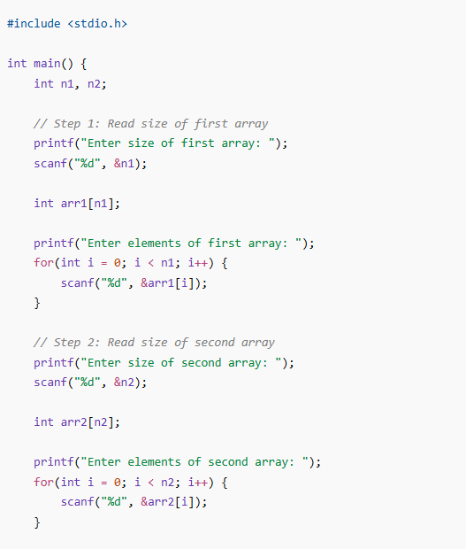
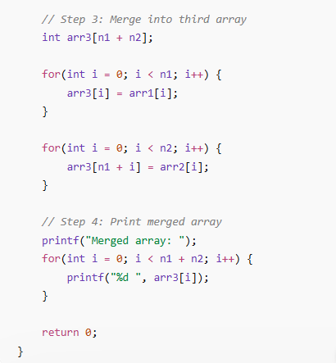
14. Question: Frequency of each element
Question description: Write a C program to count the frequency of each element in an array.
Sample data:
Input: 1 2 2 3 3 3
Expected output:
1 occurs 1 time
2 occurs 2 times
3 occurs 3 times
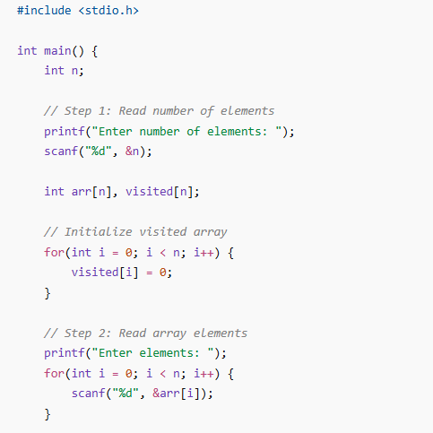
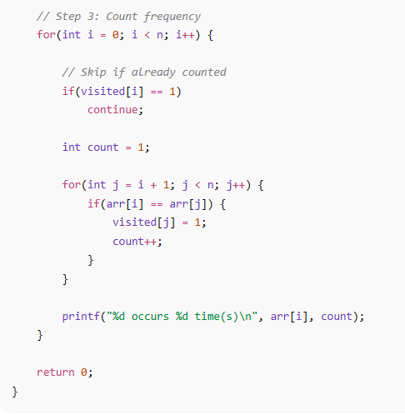
15. Question: Remove duplicate elements
Question description: Write a C program to remove duplicate elements from an array.
Sample data:
Input: 2 3 2 4 3 5
Expected output:
Array after removing duplicates: 2 3 4 5
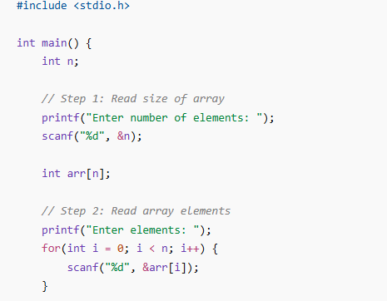
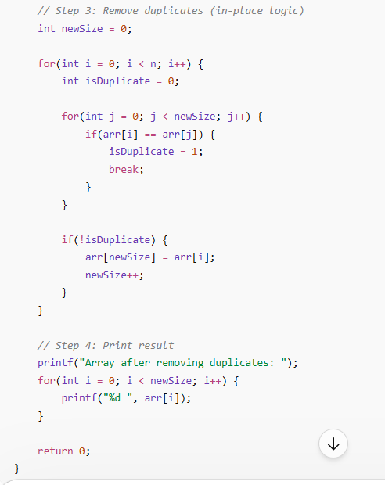
16. Question: Find duplicate elements
Question description: Write a C program to find all duplicate elements in an array.
Sample data:
Input: 1 2 3 2 4 1
Expected output:
Duplicate elements: 1 2
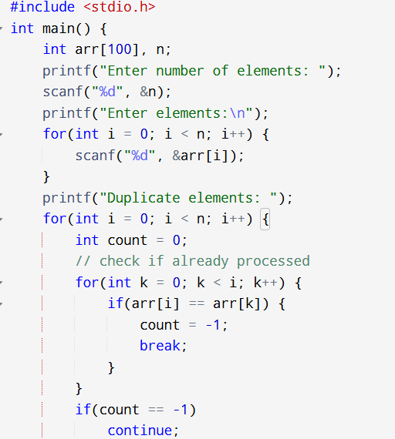

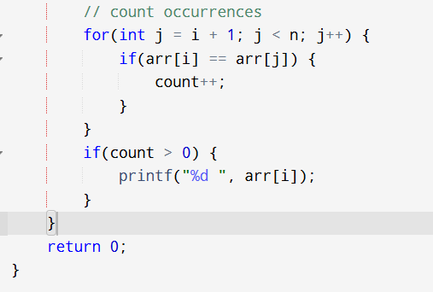
- Question: Find second largest element
Question description: Write a C program to find the second largest number in the array.
Sample data:
Input: 10 20 50 40
Expected output:
Second largest: 40
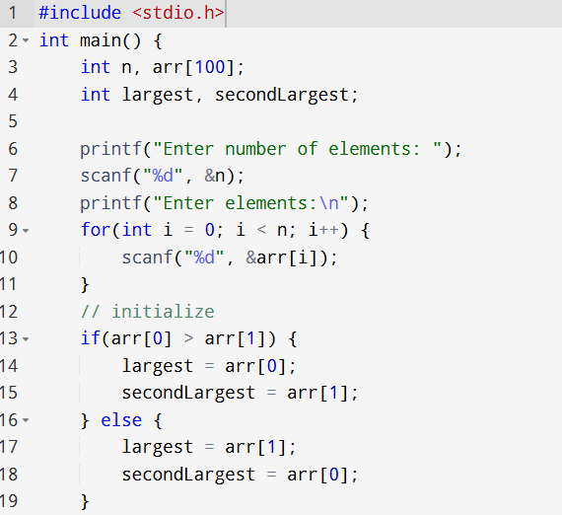
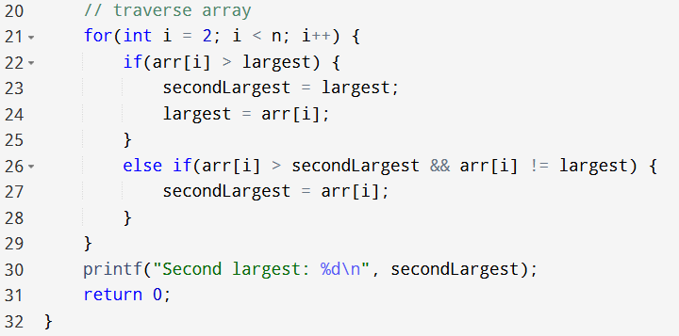

- Question: Difference between max and min
Question description: Write a C program to find the difference between largest and smallest elements in an array.
Sample data:
Input: 5 1 9 3 6
Expected output:
Difference: 8
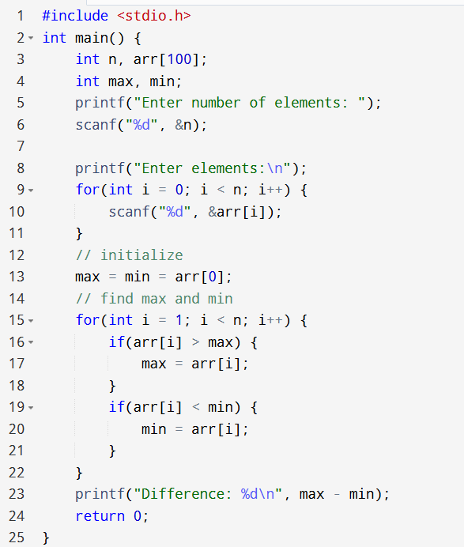

- Question: Left rotate array by n
Question description: Write a C program to rotate an array to the left by n positions.
Sample data:
Array: 1 2 3 4 5
Rotate by: 2
Expected output:
Rotated array: 3 4 5 1 2
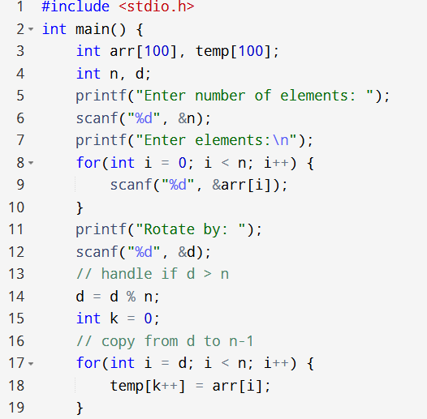
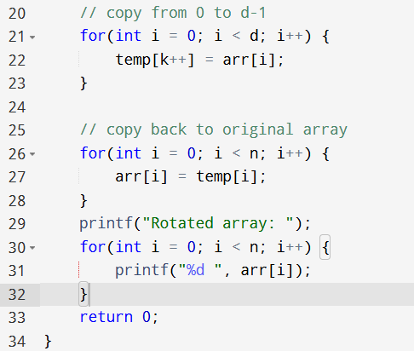
- Question: Right rotate array by n
Question description: Write a C program to rotate an array to the right by n positions.
Sample data:
Array: 1 2 3 4 5
Rotate by: 2
Expected output:
Rotated array: 4 5 1 2 3
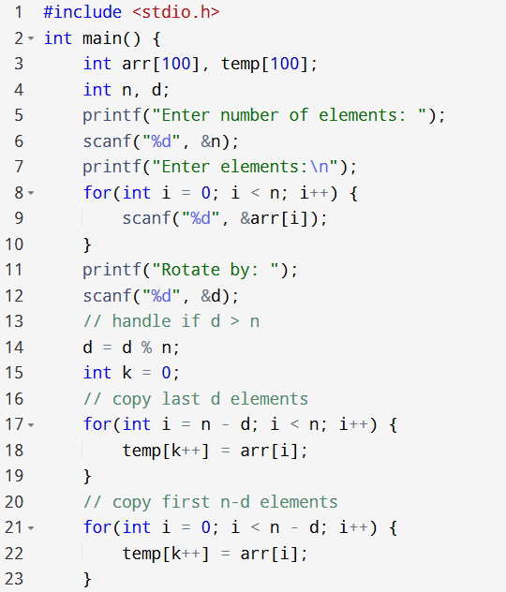
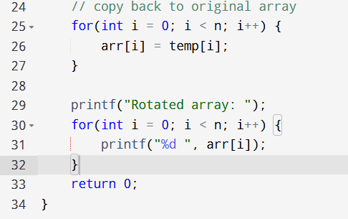
- Question: Sum of even numbers
Question description: Write a C program to find the sum of all even numbers in an array.
Sample data:
Input: 2 3 4 5 6
Expected output:
Sum of even numbers: 12
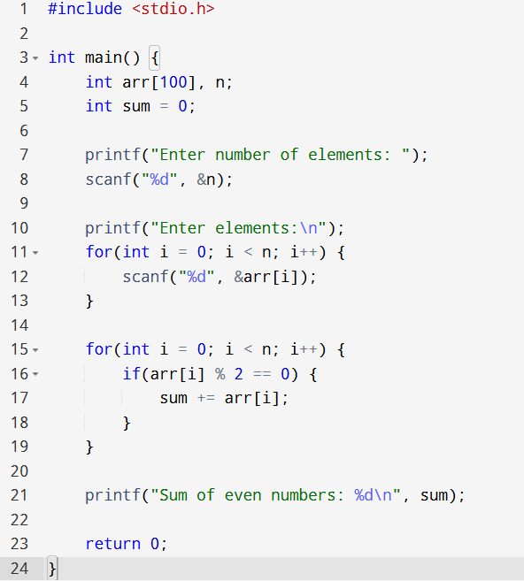

- Question: Count prime numbers
Question description: Write a C program to count and display all prime numbers in an array.
Sample data:
Input: 2 4 5 6 7 8
Expected output:
Primes: 2 5 7
Count: 3
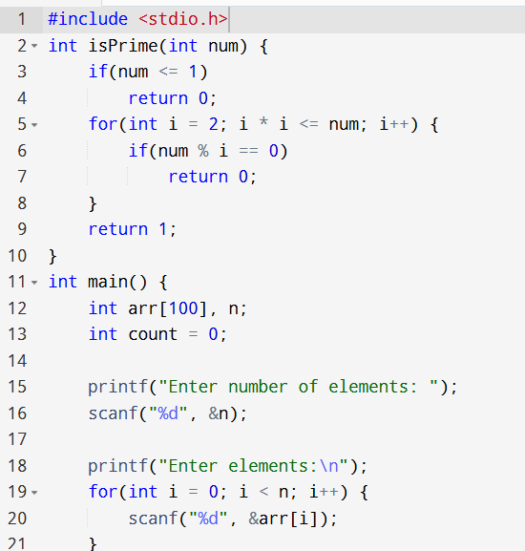
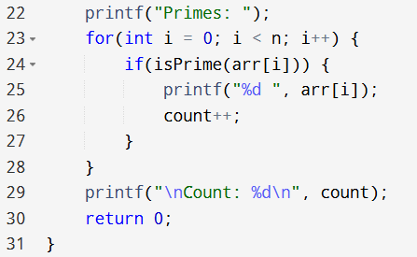

- Question: Count duplicate elements
Question description: Write a C program to count how many duplicate values are in the array.
Sample data:
Input: 1 2 3 1 4 2
Expected output:
Total duplicate elements: 2
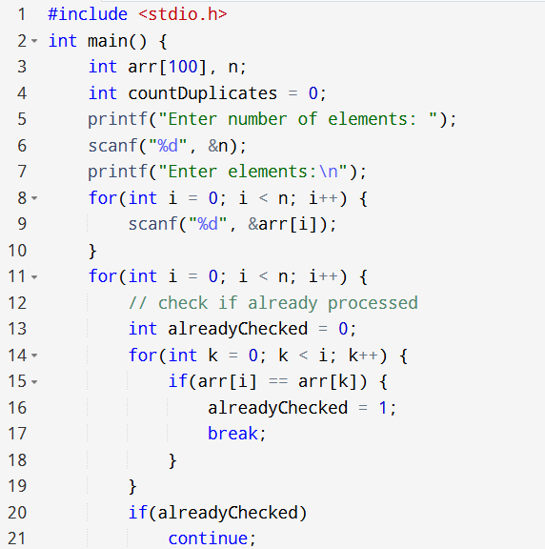
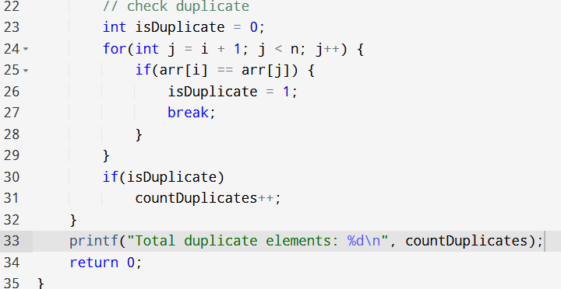
- Question: Split array into halves
Question description: Write a C program to split the array into two halves and print them separately.
Sample data:
Input: 1 2 3 4 5 6
Expected output:
First half: 1 2 3
Second half: 4 5 6
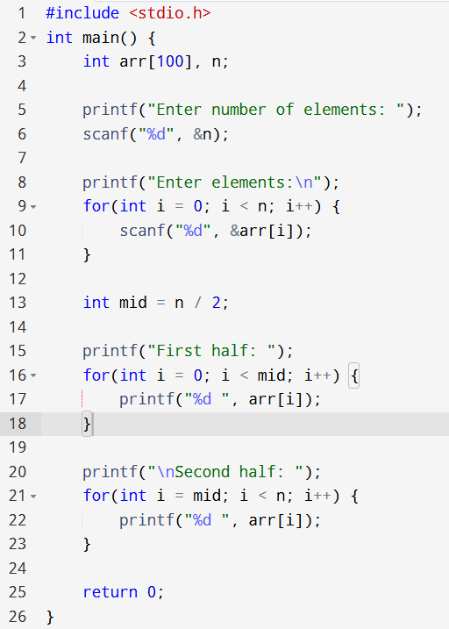

- Question: Segregate even and odd
Question description: Write a C program to arrange all even numbers first and then all odd numbers.
Sample data:
Input: 1 2 3 4 5 6
Expected output:
Even numbers: 2 4 6
Odd numbers: 1 3 5
