Strings:
1. Program: Reverse order of words in a given string
Input: "hello world from C"
Output: "C from world hello"
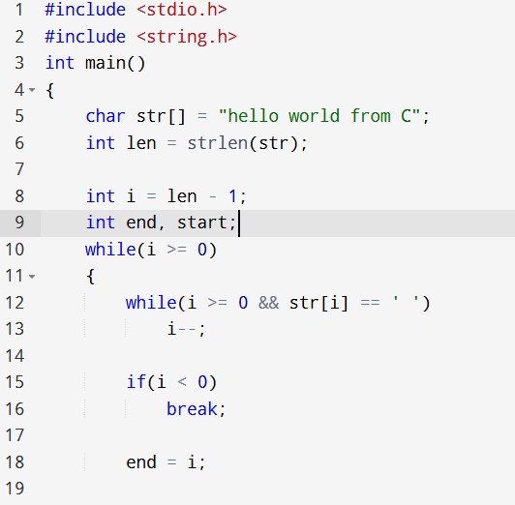
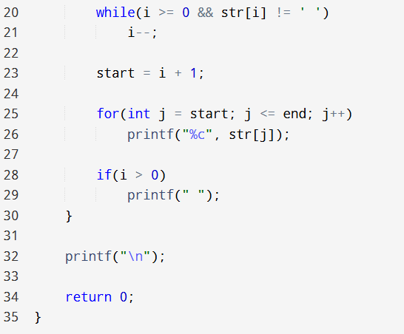

2. Program: Remove all repeated characters from a given string
Input: "programming"
Output: "progamin"
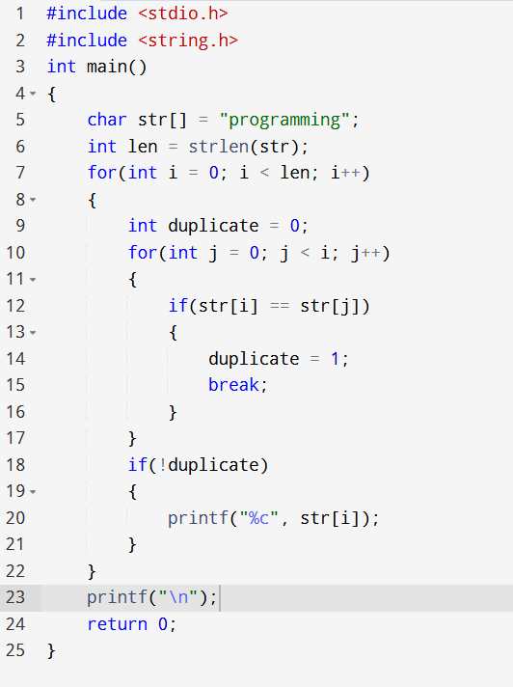

3. Program: Find highest frequency character in a string
Input: "engineering"
Output: 'e' appears 3 times
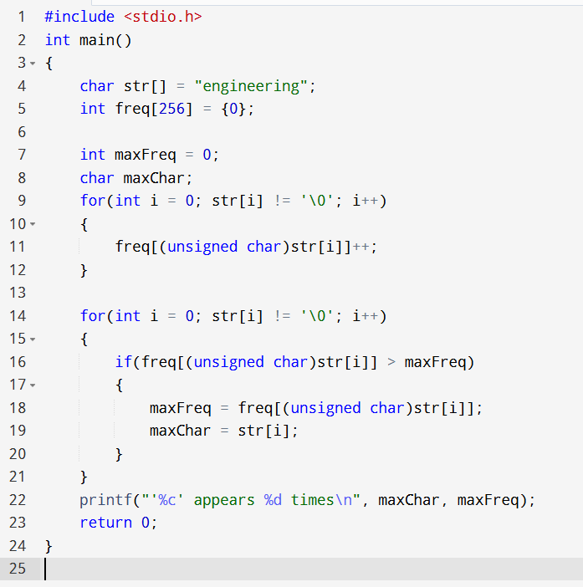

4. Program: Find lowest frequency character in a string
Input: "engineering"
Output: 'g', 'r', 'n' each appear once
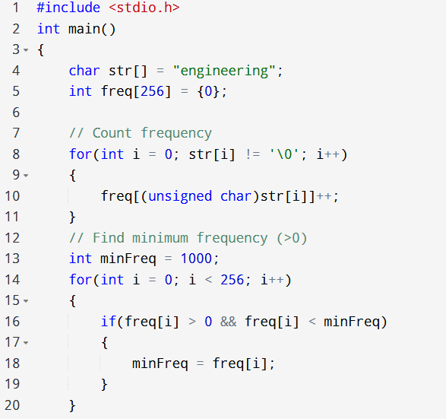
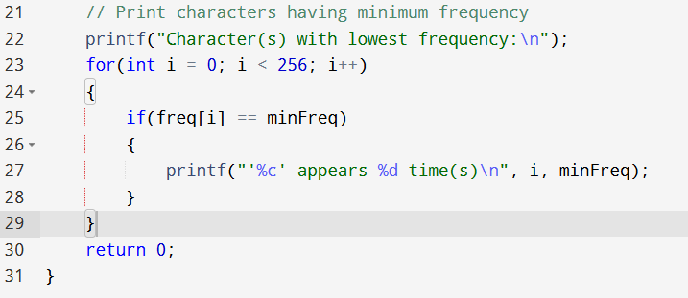

5. Program: Reverse a string without using library functions
Input: "OpenAI"
Output: "IAnepO"
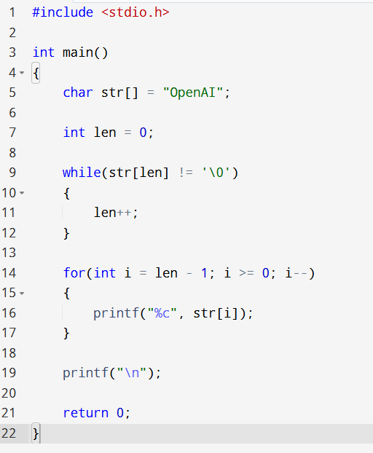

6. Program: Remove all extra blank spaces from a given string
Input: " This is ChatGPT "
Output: "This is ChatGPT"
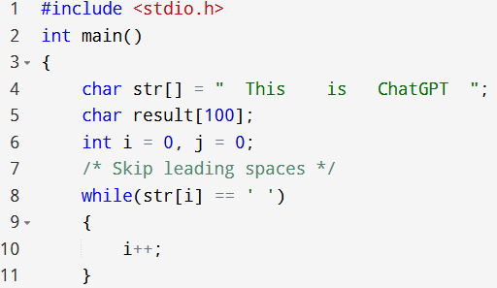
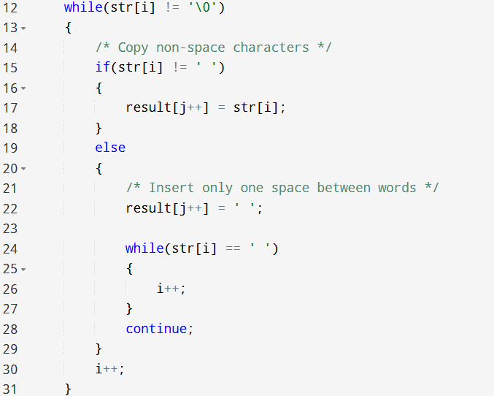
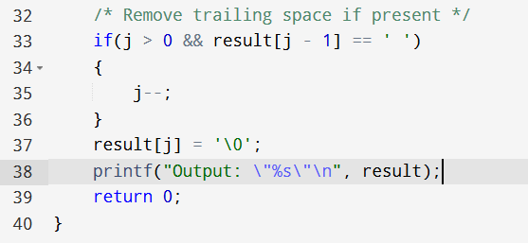
7. Program: Replace all occurrences of a character with another in a string
Input: "banana", replace 'a' with 'o'
Output: "bonono"
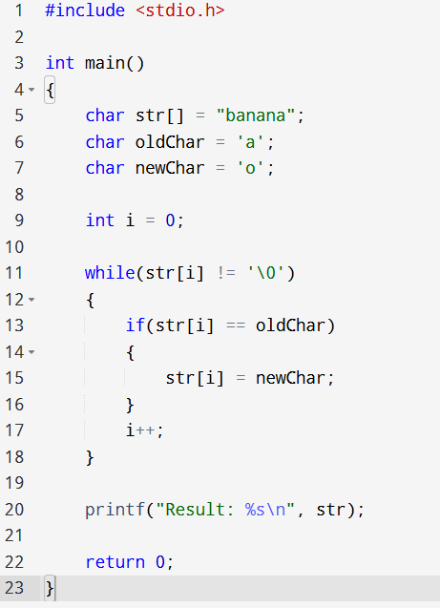

8. Program: Count frequency of each character in a string
Input: "success"
Output:
s = 3
u = 1
c = 2
e = 1
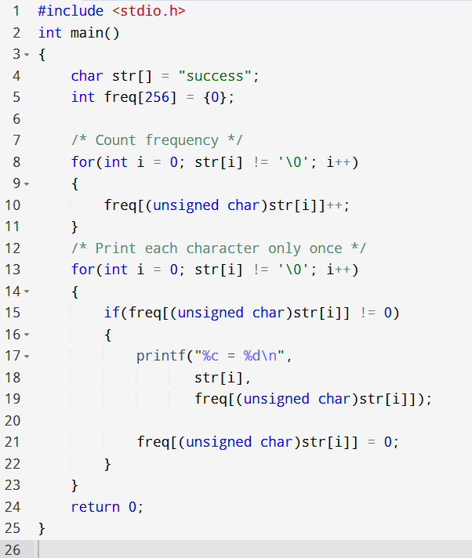

9. Program: Find first occurrence of a word in a given string
Input: "this is a test string", word: "test"
Output: Found at position 11
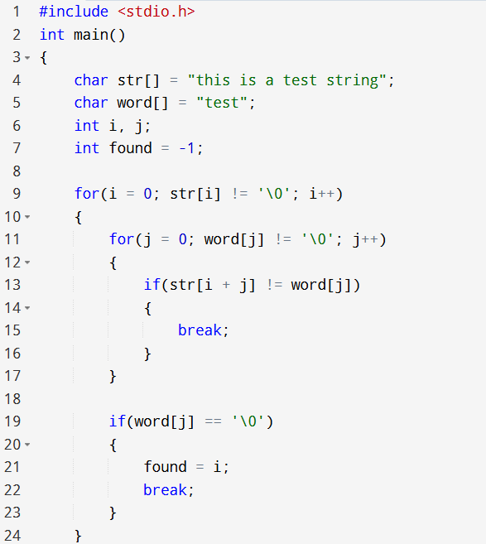
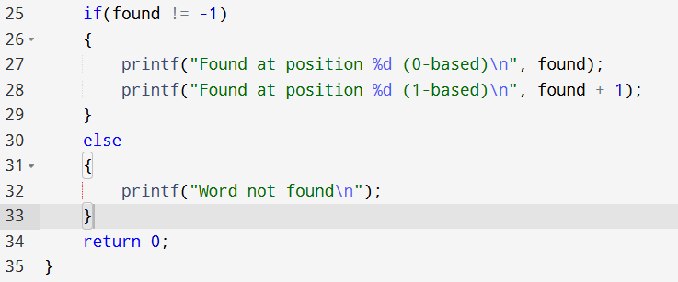

10. Program: Remove all occurrence of a word in given string
Input: "hello world hello universe", remove: "hello"
Output: "world universe"
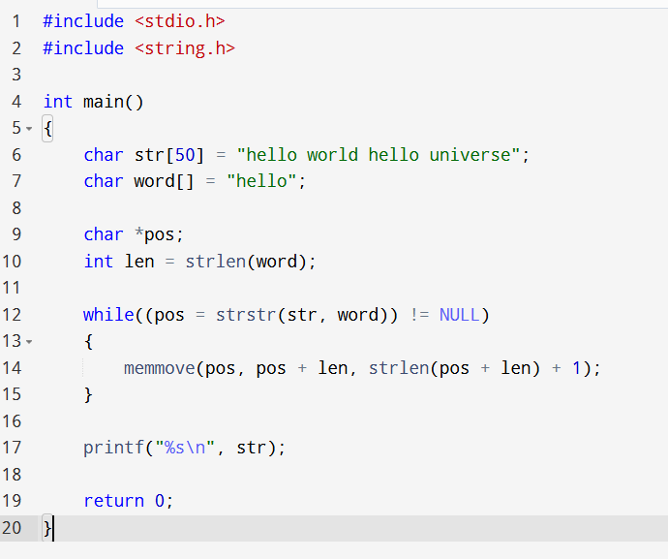

11. Program: Count total number of words in a string
Input: "C programming is fun"
Output: 4
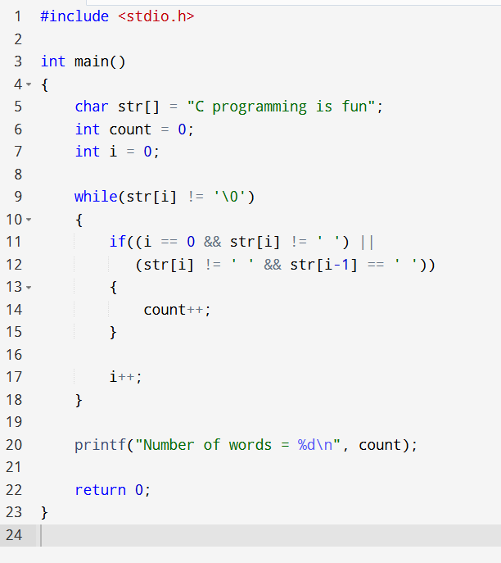

12. Program: Toggle case of each character of a string
Input: "HeLLo"
Output: "hEllO"
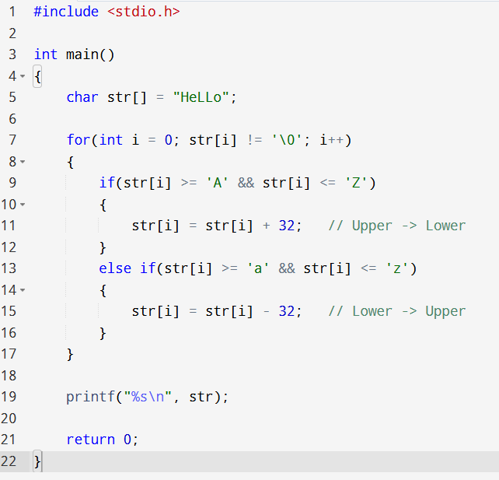

13. Program: Remove last occurrence of a character from string
Input: "mississippi", remove 's'
Output: "missipippi"
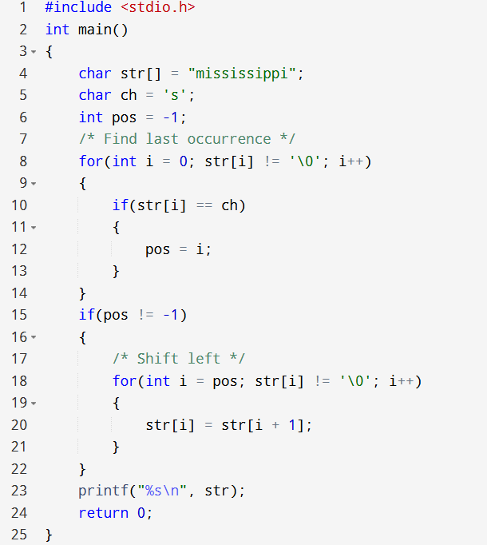

14. Program: Replace first occurrence of a character with another in a string
Input: "google", replace 'o' with 'a'
Output: "gagole"
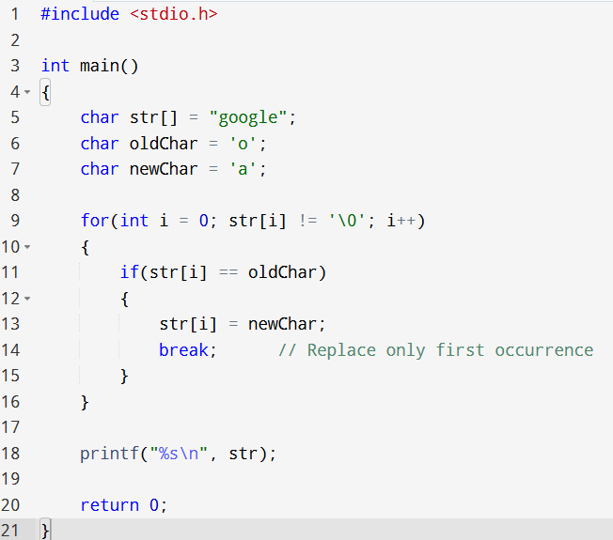

15. Program: Count occurrences of a word in a given string
Input: "hi hello hi hey hi", word: "hi"
Output: 3

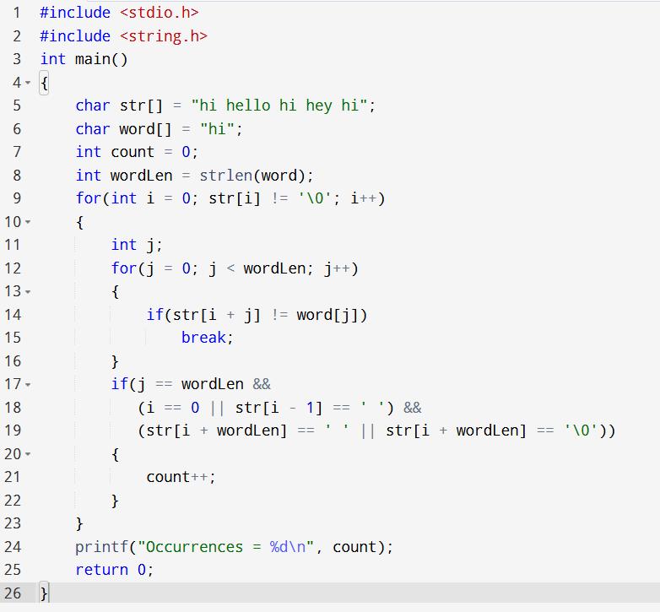

16. Program: Check whether a string is palindrome or not
Input: "madam"
Output: "Palindrome"
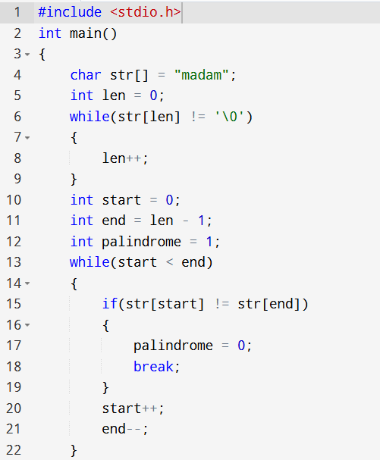
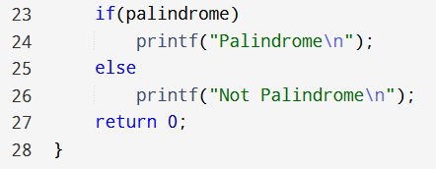

17. Program: Find last occurrence of a character in a string
Input: "ababcabc", find 'b'
Output: Position: 6
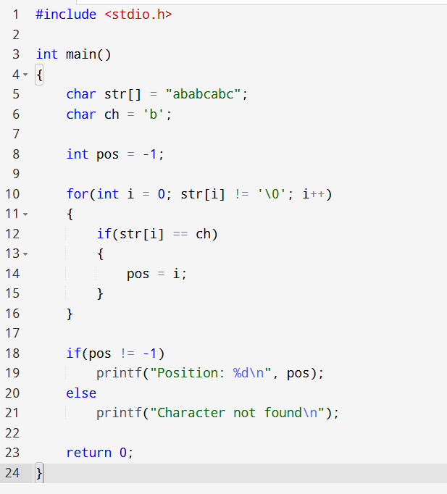

18. Program: Trim both leading and trailing white space characters from given string
Input: " Hello World "
Output: "Hello World"

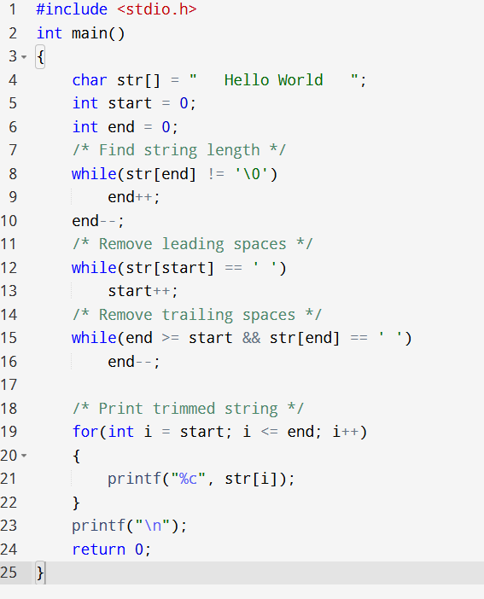

19. Program: Find first occurrence of a character in a given string
Input: "elephant", find 'e'
Output: Position: 0

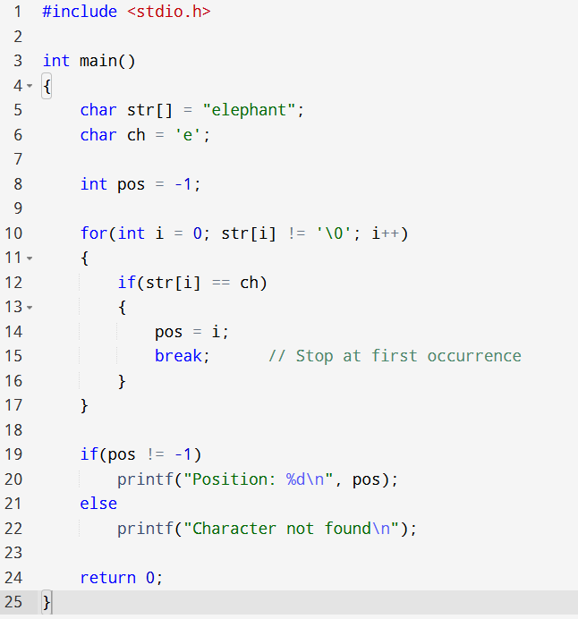

20. Program: Find all occurrences of a word in given string
Input: "the sky is the limit in the sky", search "the"
Output: Found at positions: 0, 15, 30

