10 - Dynamic memory allocations
Exercise 1: Allocate Memory for an Integer
Goal: Understand how to allocate memory for a single variable using malloc.
Activity:
- Log Session a pointer to an integer.
- Use malloc to allocate memory for one integer.
- Assign a value to that memory.
- Print the value through the pointer.
- Free the allocated memory.
- Include NULL check after malloc.
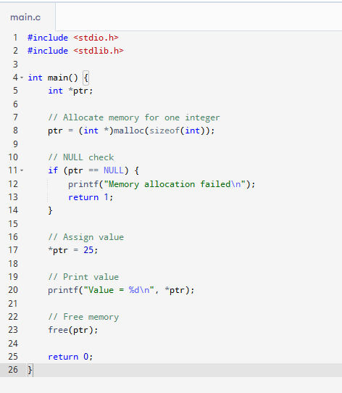

Exercise 2: Allocate and Store a List of Integers
Goal: Practice allocating memory for an array of integers.
Activity:
- Ask the user to enter the number of integers.
- Allocate memory dynamically using malloc based on input.
- Use a loop to take integer inputs into the allocated array.
- Display the entered values.
- Free the allocated memory.
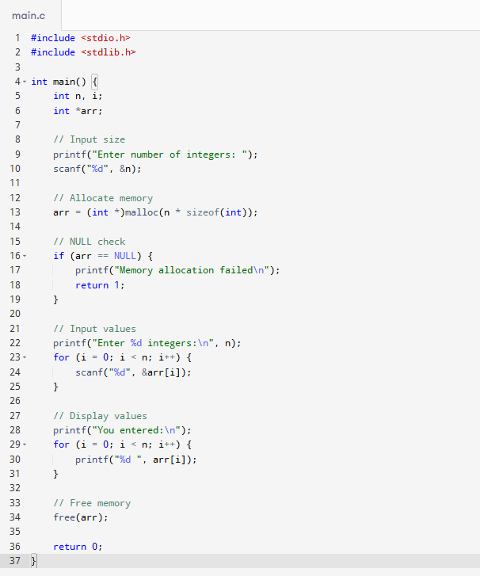

Exercise 3: Zero-Initialize an Integer Array
Goal: Understand how calloc initializes memory.
Activity:
- Ask the user for the number of elements.
- Allocate memory using calloc.
- Print the initial values (before user input).
- Assign values, then display them.
- Free the memory after use.

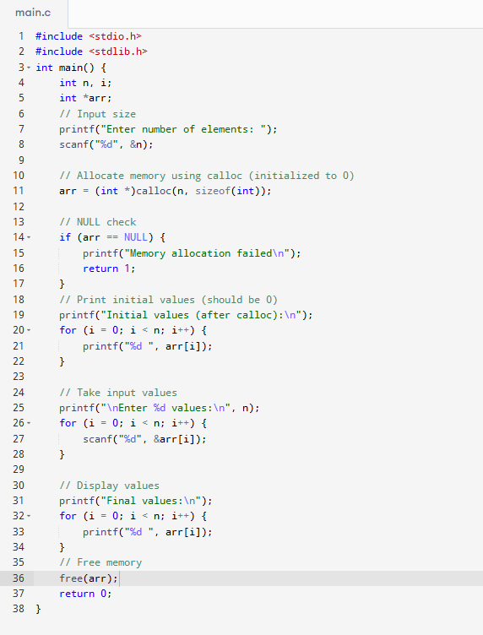

Exercise 4: Compare malloc and calloc
Goal: Learn the key difference between malloc and calloc.
Activity:
- Allocate two arrays using malloc and calloc with the same size.
- Print the default values in both arrays.
- Use a loop for printing to understand initialization differences.
- Free both arrays.
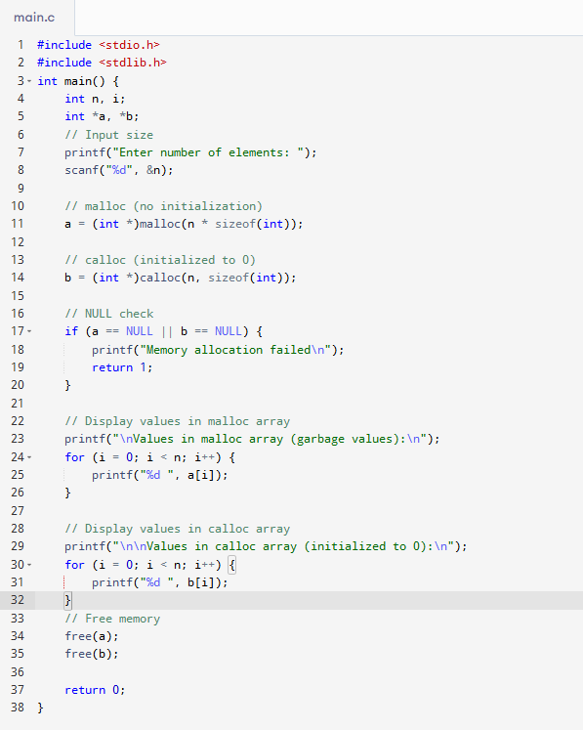

Exercise 5: Reallocate an Array Dynamically
Goal: Use realloc to extend an array as needed.
Activity:
- Allocate memory for 2 integers.
- Ask the user for values.
- Then resize the array to 5 integers using realloc.
- Accept more values into the resized array.
- Print all values.
- Free the memory at the end.
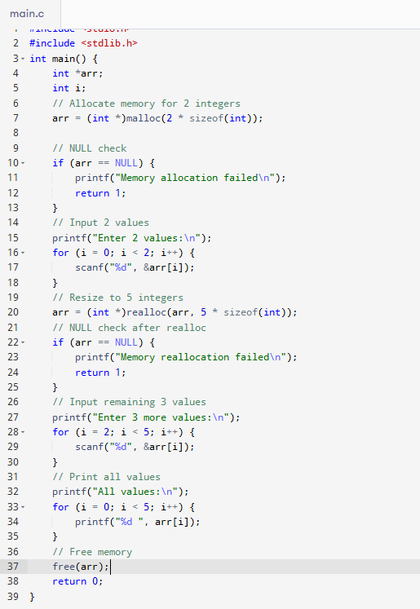

Exercise 6: Log Session a Dynamic 2D Array
Goal: Learn how to allocate and access a 2D array dynamically.
Activity:
- Ask the user for number of rows and columns.
- Allocate memory for an array of row pointers.
- Allocate each row separately using malloc.
- Accept values for each row-column index.
- Display the matrix.
- Free each row and then the row pointer array.
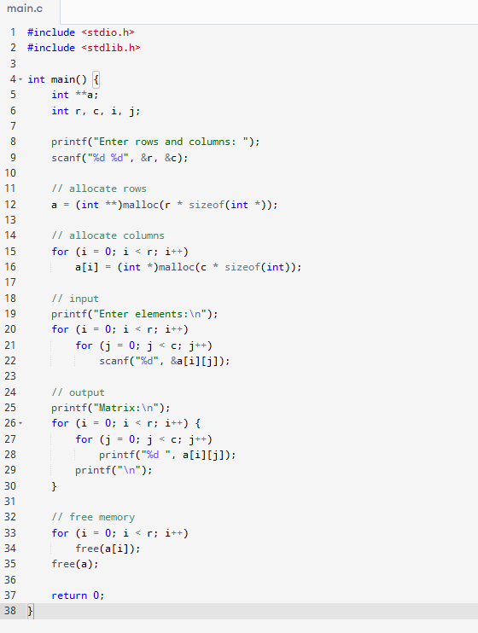

Exercise 7: Dynamic String Input
Goal: Handle strings with dynamic memory allocation.
Activity:
- Ask the user to enter a string.
- Find its length using strlen.
- Allocate memory to store the string using malloc.
- Copy the string to the new memory.
- Print the copied string.
- Free the memory.

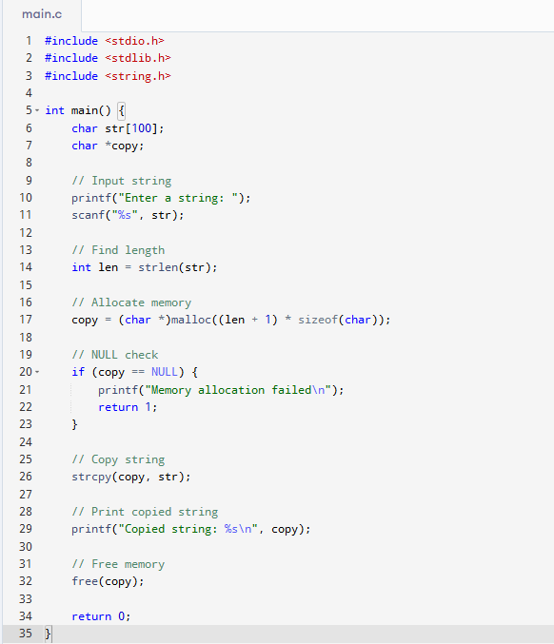

Exercise 8: Implement Custom strdup()
Goal: Practice duplicating a string using dynamic memory.
Activity:
- Log Session a function that takes a string as input.
- Allocate memory for a copy of the string.
- Copy character by character.
- Return the copied string.
- Call this function and display the result.
- Free the copied string.
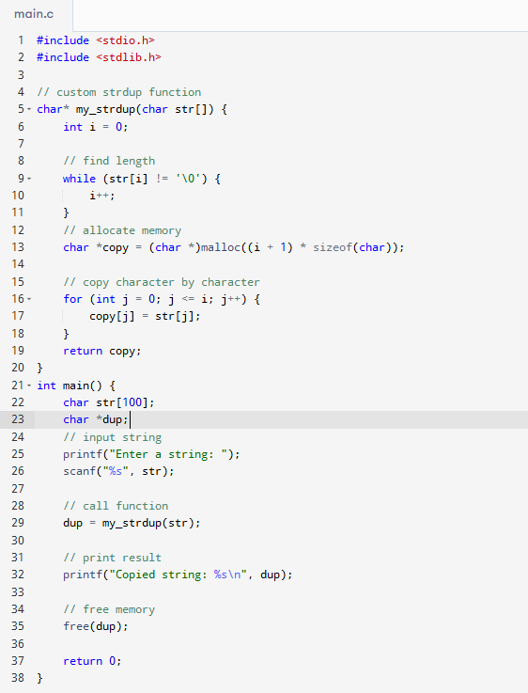

Exercise 9: Log Session a Linked List with 3 Nodes
Goal: Apply dynamic memory to build a simple linked list.
Activity:
- Define a struct for a node with data and next.
- Use malloc to create 3 nodes dynamically.
- Link the nodes manually.
- Traverse and print the list.
- Free all nodes after traversal.

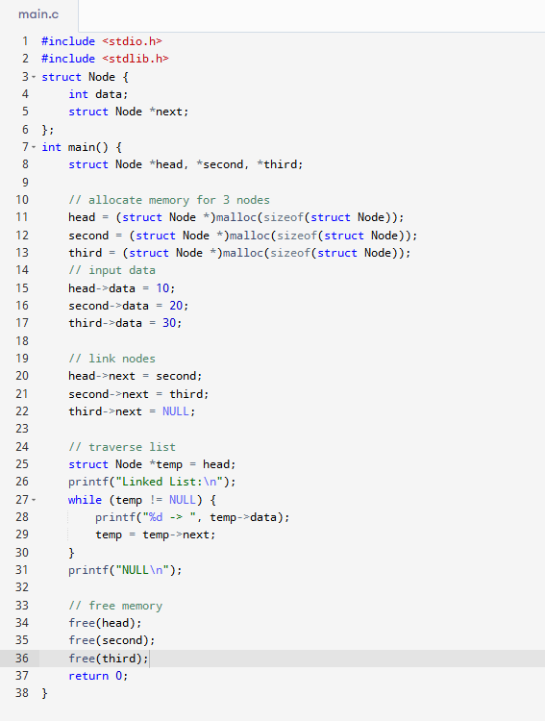

Exercise 10: Log Session and Reverse an Array
Goal: Use pointers to reverse dynamically allocated memory.
Activity:
- Allocate an array of integers using malloc.
- Accept n values.
- Reverse the array using pointer arithmetic (not indexing).
- Print reversed values.
- Free the memory.
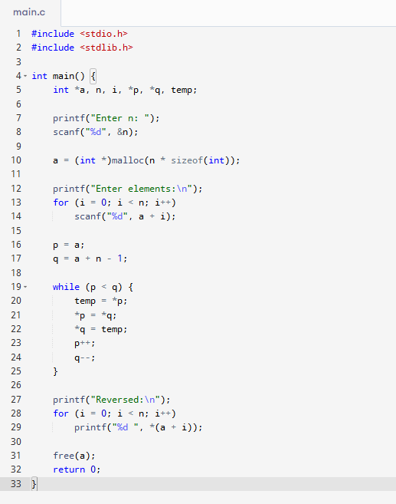

Exercise 11: Accept Characters Until Enter Pressed
Goal: Dynamically grow a string buffer with realloc.
Activity:
- Start with a small buffer.
- Accept characters one by one.
- Reallocate buffer each time a new character is added.
- Stop on newline character.
- Null-terminate and print the string.
- Free the memory.

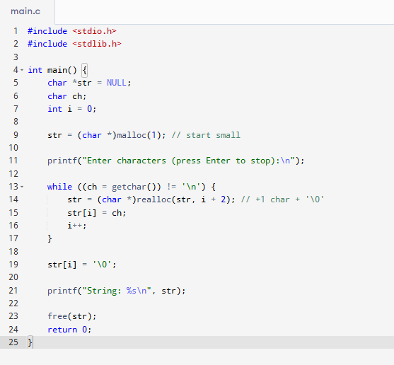

Exercise 12: Track Frequency of Elements
Goal: Use calloc for zero-initialized counting.
Activity:
- Allocate an integer array of size 100 using calloc.
- Accept n numbers between 0 and 99.
- Increment the value at each index to count frequency.
- Display the frequencies.
- Free the memory.

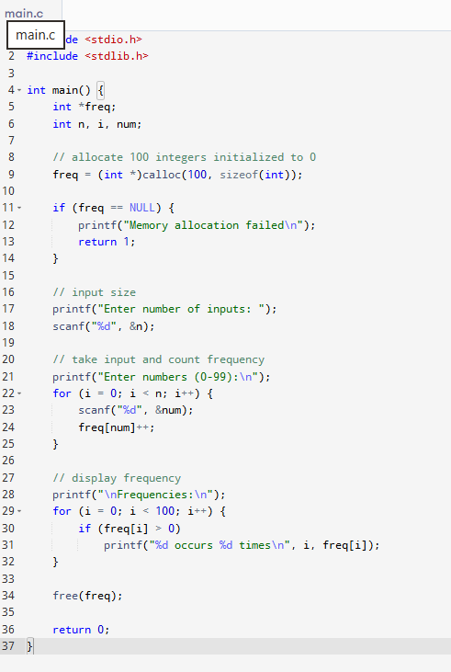

Exercise 13: Memory Leak Simulation
Goal: Understand what a memory leak is.
Activity:
- Allocate memory using malloc and assign values.
- Intentionally skip free().
- Run the program with tools like valgrind to observe the leak.
- Fix the leak by adding proper free().
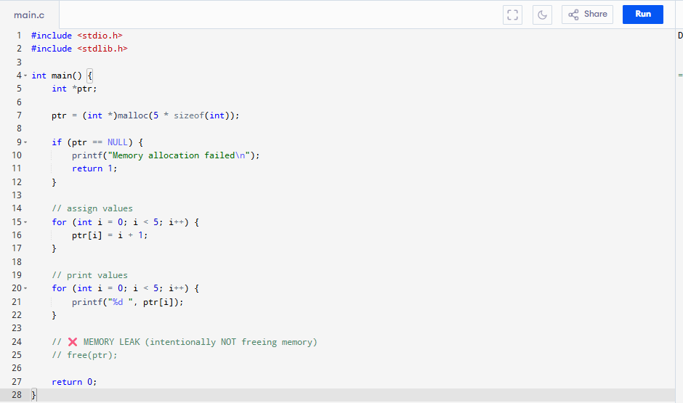

Exercise 14: Tokenize String Dynamically
Goal: Store each word of a sentence in dynamically allocated memory.
Activity:
- Accept a sentence as input.
- Use strtok() to split it into words.
- Use malloc to copy each token into a new memory block.
- Store them in a pointer array.
- Print all words and free each block.
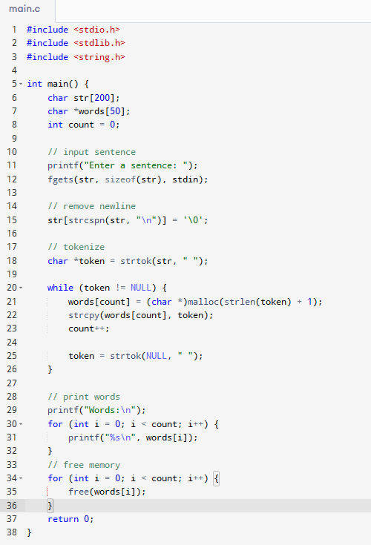

Exercise 15: Dynamic Menu-Driven Array
Goal: Handle operations on a dynamic array with growing size.
Activity:
- Start with an empty array.
- Provide a menu with options: Add element, Display, Exit.
- Use realloc each time user adds an element.
- Print array contents.
- Free memory on exit.
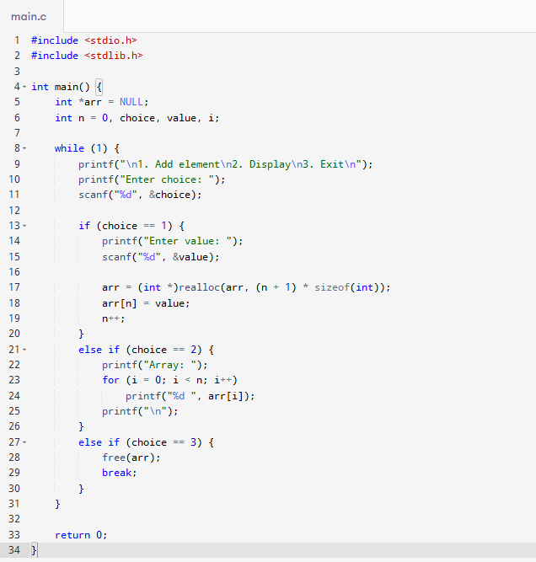

Exercise 16: Safe Memory Allocation Check
Goal: Practice error-checking after allocation.
Activity:
- Try allocating a large chunk of memory (e.g., 1GB).
- Check if the pointer is NULL.
- If successful, print a success message.
- If failed, handle the error gracefully.
- Free if allocation succeeded.
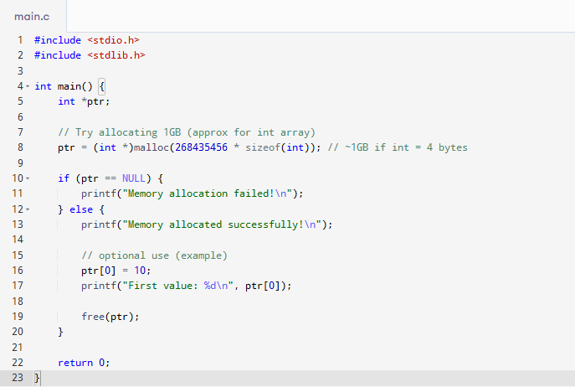

Exercise 17: Struct Array with Dynamic Allocation
Goal: Allocate memory for array of structs.
Activity:
- Define a struct (e.g., name and age).
- Ask user how many entries to store.
- Allocate memory using malloc.
- Accept values and display them.
- Free the memory.
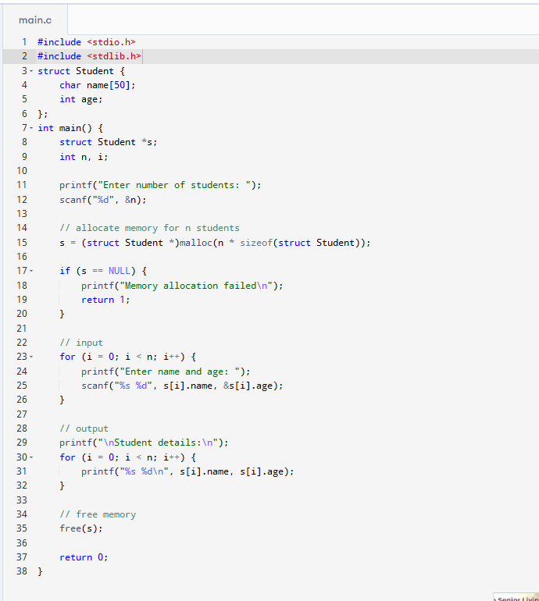

Exercise 18: Insert Element at Any Position
Goal: Modify dynamic array and shift elements.
Activity:
- Allocate memory for an array.
- Accept n values.
- Ask user to insert a value at a specific position.
- Use realloc to increase size.
- Shift elements and insert new value.
- Print final array and free memory.
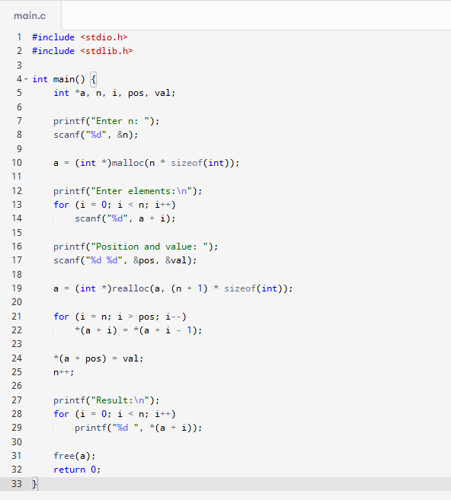

Exercise 19: Dynamic Array of Pointers to Integers
Goal: Work with array of pointers using malloc.
Activity:
- Ask user for count.
- Allocate array of int* pointers.
- Use malloc to assign an integer for each pointer.
- Assign and print values.
- Free all integers and the array.
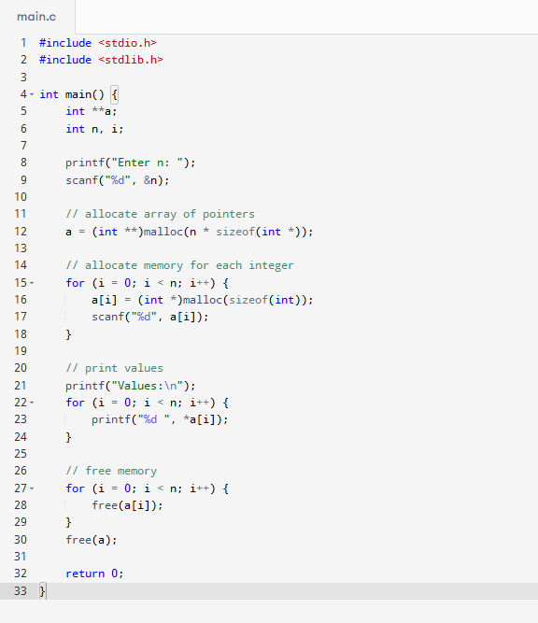

Exercise 20: Simulate Memory Fragmentation
Goal: Understand fragmentation with sequential malloc and free.
Activity:
- Allocate multiple memory blocks of varying sizes.
- Free some in between.
- Allocate a new block that fits only in fragmented space.
- Observe behavior.
- Free all at the end.
