Single linked list:
1. Merge Sorted Lists Challenges
Question:
Write a C program to merge two sorted singly linked lists into a single sorted linked list.
Sample data:
List 1: 1 3 5 7
List 2: 2 4 6
Expected output:
Merged list: 1 2 3 4 5 6 7
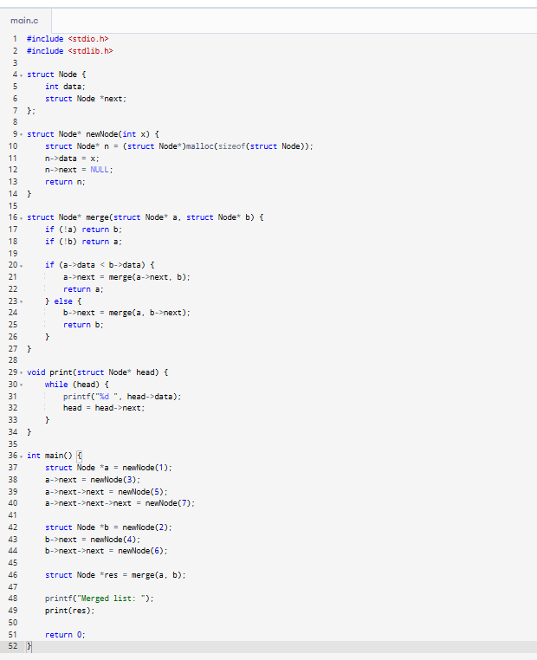

2. Loop Detection Challenges
Question:
Write a C program to detect and remove a loop in a singly linked list.
Sample data:
List: 1 → 2 → 3 → 4 → 5 → (loop to 2)
Expected output:
Loop detected and removed.
List after removal: 1 2 3 4 5
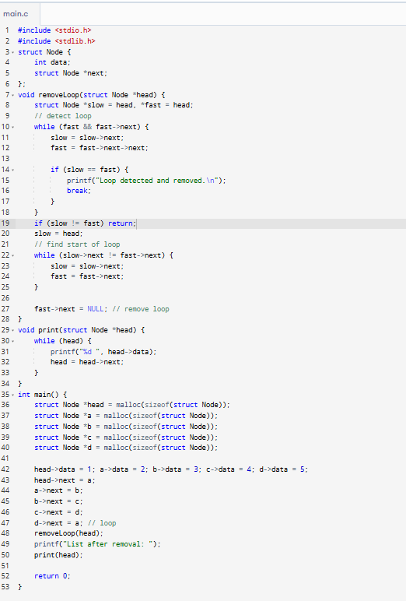

3. Palindrome Check Variants
Question:
Write a C program to check if a singly linked list is a palindrome.
Sample data:
List: 1 2 2 1
Expected output:
Linked list is a palindrome.
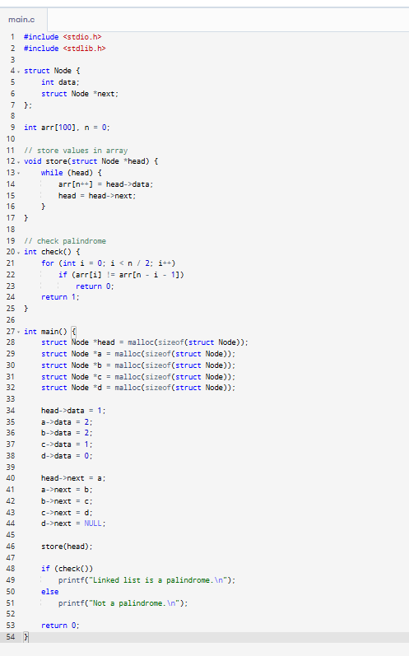

4. Copy with Random Pointers Challenges
Question:
Write a C program to create a deep copy of a singly linked list where each node has a random pointer.
Sample data:
List: 1 2 3 5 7
Random pointers: 1→3, 2→5, 3→7, 5→1, 7→3
Expected output:
New list with same data and random pointers correctly mapped.
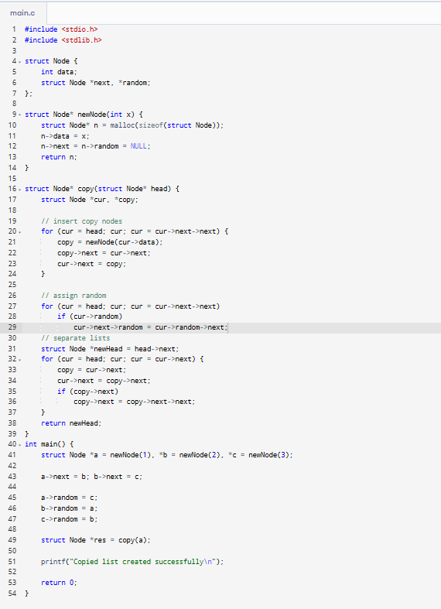

5. Intersection Finder Variants
Question:
Write a C program to find the intersection point of two singly linked lists.
Sample data:
List A: 1 2 → 3 4
List B: 5 → 3 4
Expected output:
Intersection found at node with data: 3
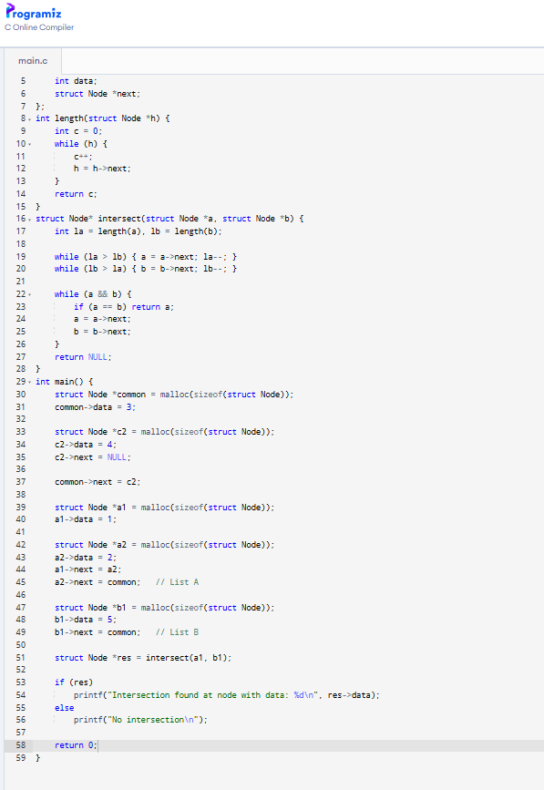
6. Partitioning with Dual Pivots
Question:
Write a C program to partition a linked list around a value x.
Sample data:
List: 3 5 7 5 9 2 1
x = 5
Expected output:
Reordered list: 3 2 1 5 7 5 9
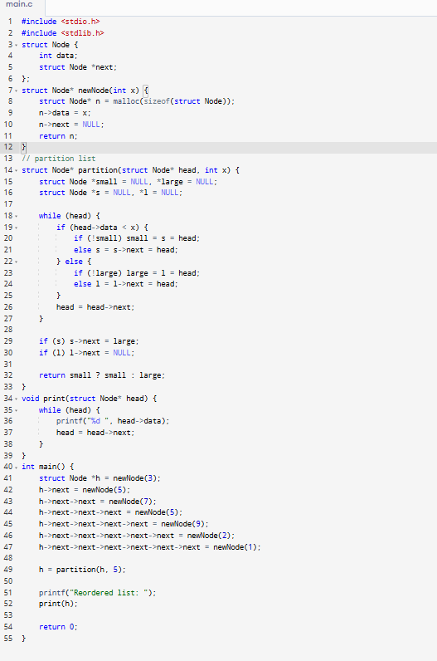

7. Linked List Addition Variants
Question:
Write a C program to add two numbers represented by linked lists.
Sample data:
List 1: 8 7 9 2
List 2: 2 1 2 3
Expected output:
Result: 0 9 1 6 (carry handled)
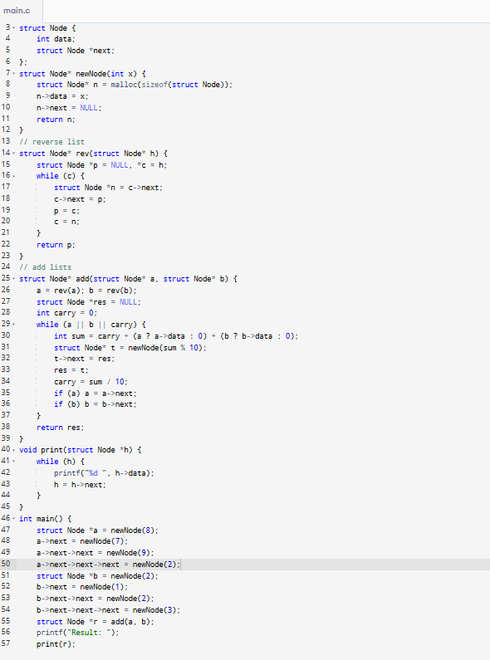

8. List Rotation Challenges
Question:
Write a C program to rotate a linked list to the right by k places.
Sample data:
List: 1 3 4 7 9
k = 2
Expected output:
Rotated list: 4 7 9 1 3
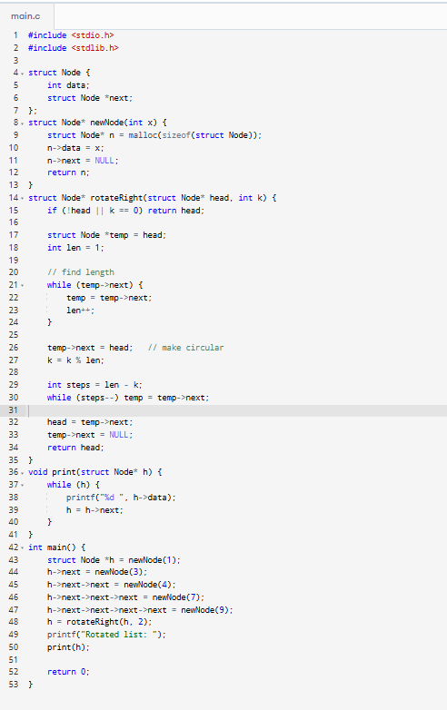

9. Kth Node Swapping Variants
Question:
Write a C program to swap Kth node from beginning and end.
Sample data:
List: 1 2 3 4 5
k = 2
Expected output:
Swapped list: 1 4 3 2 5
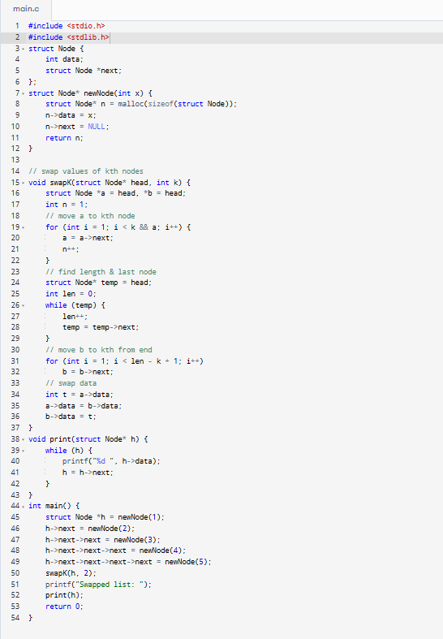

10. Linked List Sorting Challenges
Question:
Write a C program to sort a singly linked list using merge sort.
Sample data:
List: 2 3 1 7 5
Expected output:
Sorted list: 1 2 3 5 7
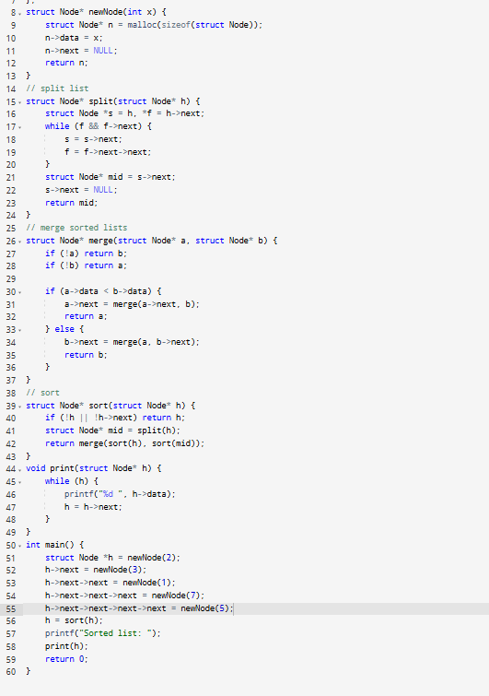

11. Nth Node from End Variants
Question:
Write a C program to retrieve the nth node from the end.
Sample data:
List: 1 3 5 11
n = 3
Expected output:
Result: 3
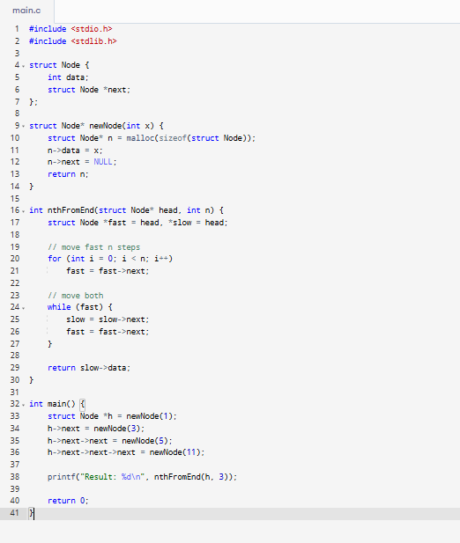

12. Merging K Sorted Lists Challenges
Question:
Write a C program to merge K sorted linked lists.
Sample data:
List-1: 10 20 50
List-2: 30 40 60
List-3: 10 70 100
Expected output:
Merged list: 10 10 20 30 40 50 60 70 100
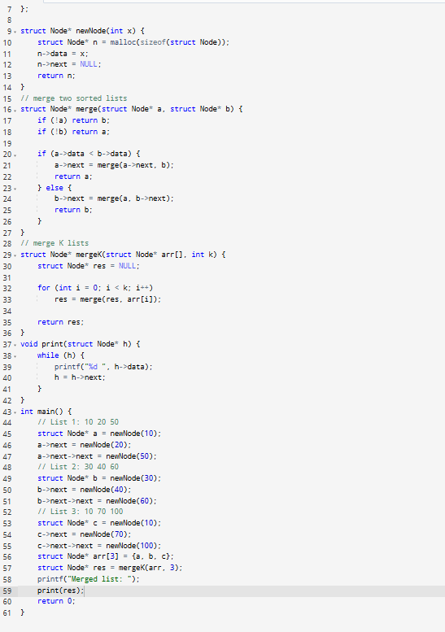

13. Reordering by Parity Challenges
Question:
Write a C program to place all even-numbered nodes after odd-numbered nodes.
Sample data:
List: 1 2 3 4 5 6
Expected output:
Reordered list: 1 3 5 2 4 6
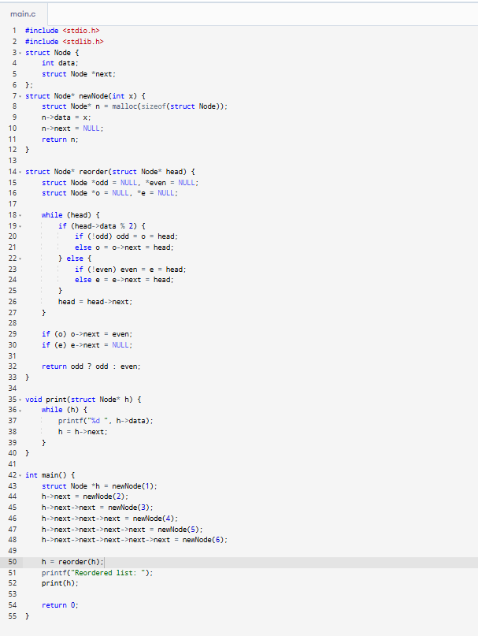

14. Pairwise Reversal Challenges
Question:
Write a C program to reverse nodes in pairs.
Sample data:
List: 1 2 3 4 5
Expected output:
Reversed in pairs: 2 1 4 3 5
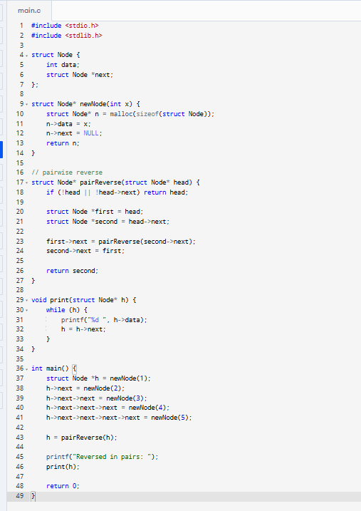

15. Block Reversal Variants
Question:
Write a C program to reverse nodes in blocks of size k.
Sample data:
List: 1 2 3 4 5 6
k = 3
Expected output:
Reversed: 3 2 1 6 5 4
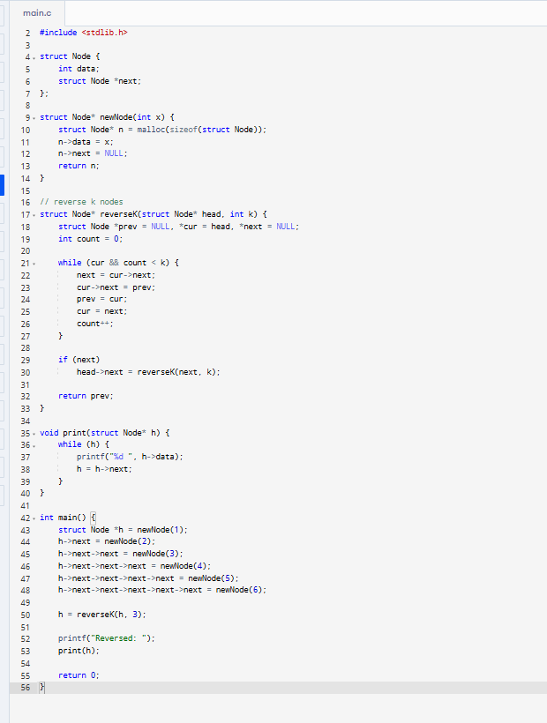
16. Alternate K-Node Reversal Challenges
Question:
Write a C program to reverse alternate k nodes.
Sample data:
List: 1 2 3 4 5 6 7 8
k = 2
Expected output:
Reversed: 2 1 3 4 6 5 7 8
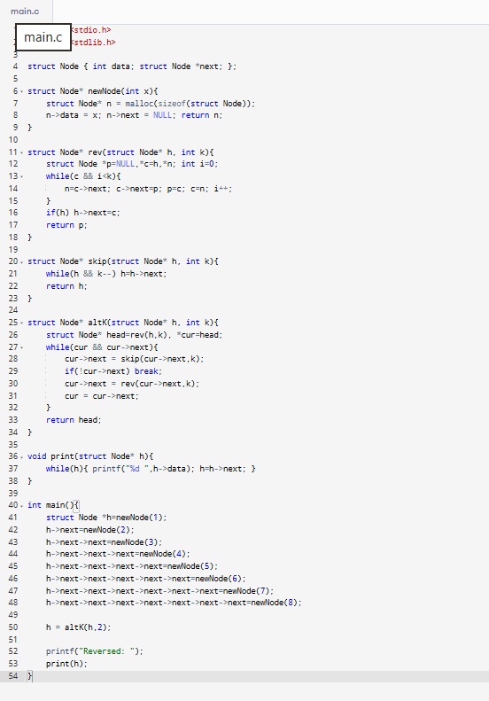

17. Halving the List Challenges
Question:
Write a C program to split a list into two halves.
Sample data:
List: 1 2 3 4 5 6
Expected output:
First half: 1 2 3
Second half: 4 5 6
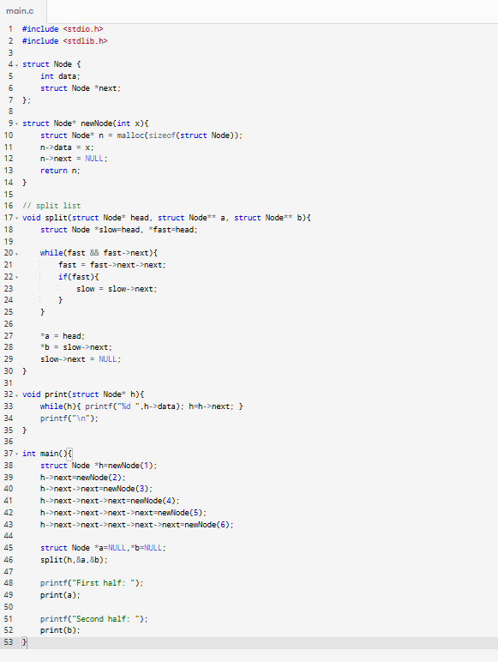

18. Alternate Node Merging Challenges
Question:
Write a C program to merge alternate nodes of two linked lists.
Sample data:
List1: 9 7 5
List2: 10 8 6
Expected output:
Merged list: 9 10 7 8 5 6
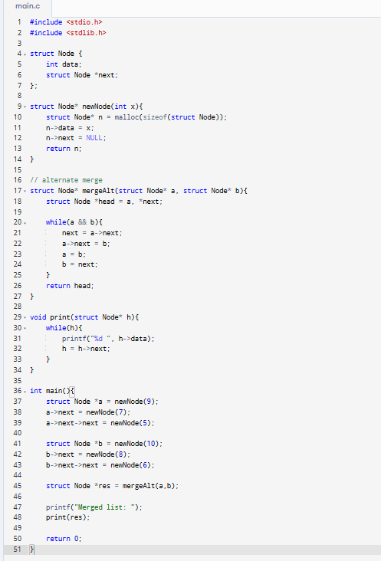

19. Alternate Interleaving Challenges
Question:
Write a C program to interleave two lists alternatively.
Sample data:
List1: 1 3 5
List2: 2 4 6
Expected output:
Result: 1 2 3 4 5 6
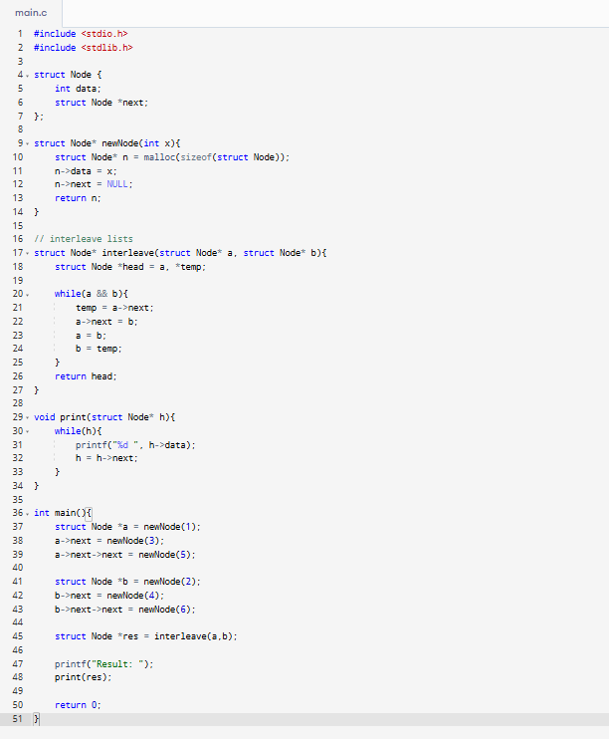

20. Adjacent Node Swapping Variants
Question:
Write a C program to swap every two adjacent nodes.
Sample data:
List: 1 2 3 4 5
Expected output:
Swapped list: 2 1 4 3 5
