File Handling:
- Make a new file and save some text entered by the user.
Input: File name: test.txt
Text: Hello, this is my first file!
Output: File 'test.txt' created and saved.
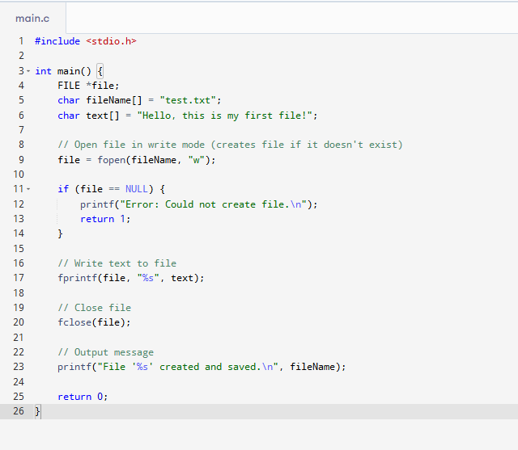
- Open an existing file and display its contents on the screen.
Input: File name: test.txt
Output: Hello, this is my first file!
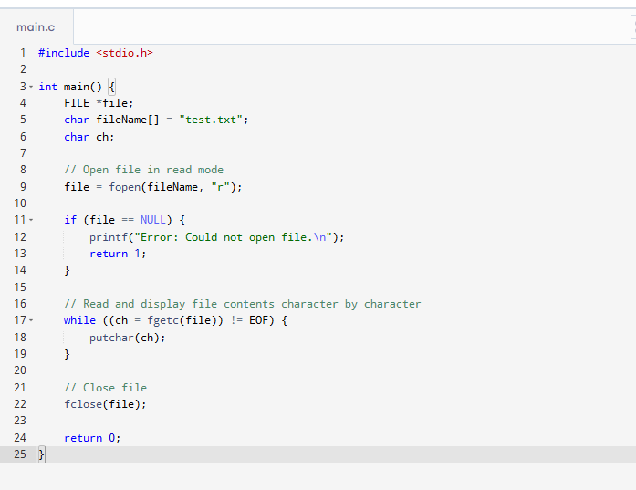
- Take several lines from the user and write all of them into a file.
Input: File name: lines.txt
Number of lines: 3
Lines: Line one, Line two, Line three
Output: All lines saved in 'lines.txt'.
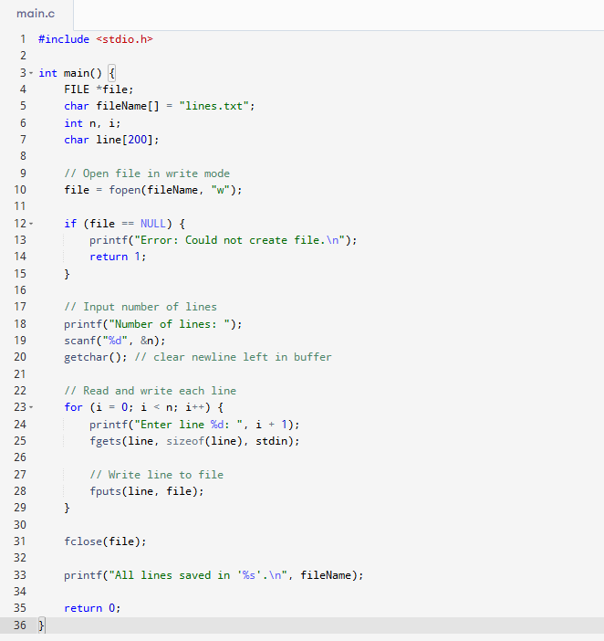
- Read every line from a file and store those lines in an array.
Input: File name: lines.txt
Output: Line one, Line two, Line three (as array elements)
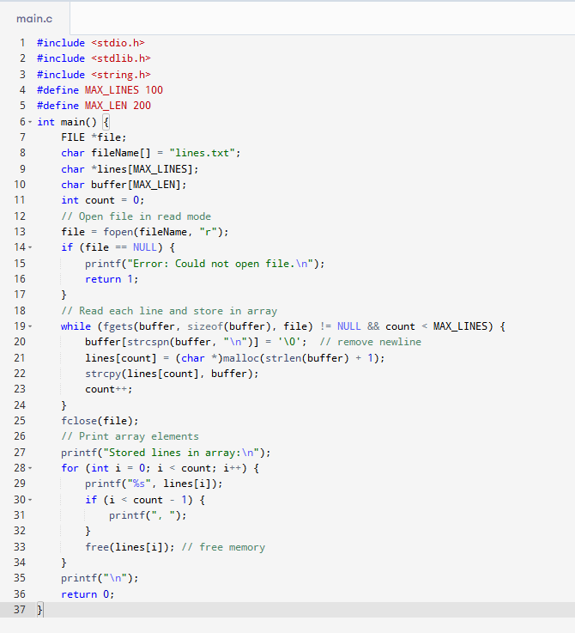

- Add more lines to the end of a file without erasing its current content.
Input: File name: lines.txt
Number of new lines: 2
New lines: Line four, Line five
Output: File now contains: Line one, Line two, Line three, Line four, Line five
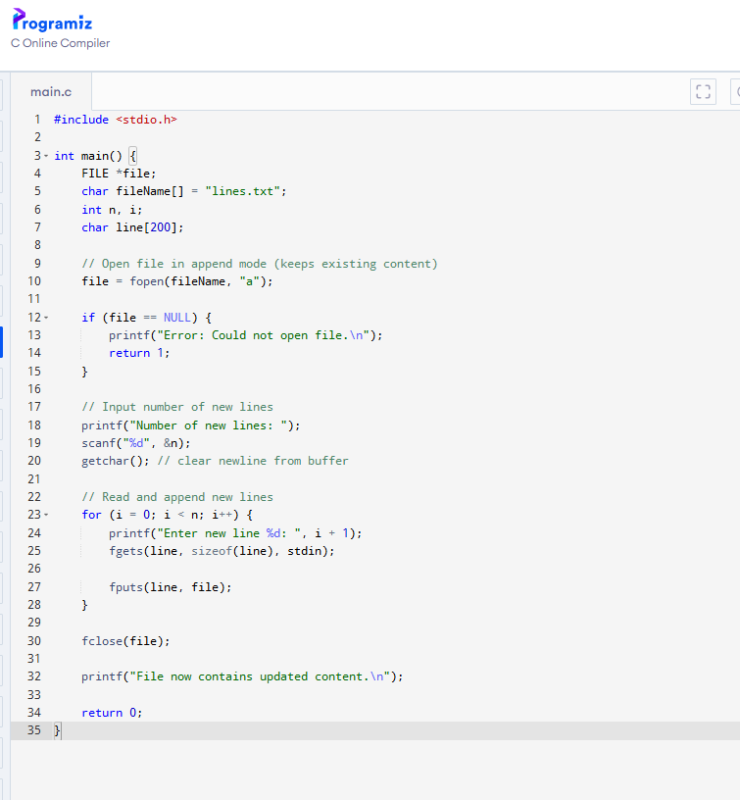

- Copy everything from one file and save it into another file.
Input: Source file: lines.txt
Destination file: copy.txt
Output: File 'lines.txt' copied to 'copy.txt'.
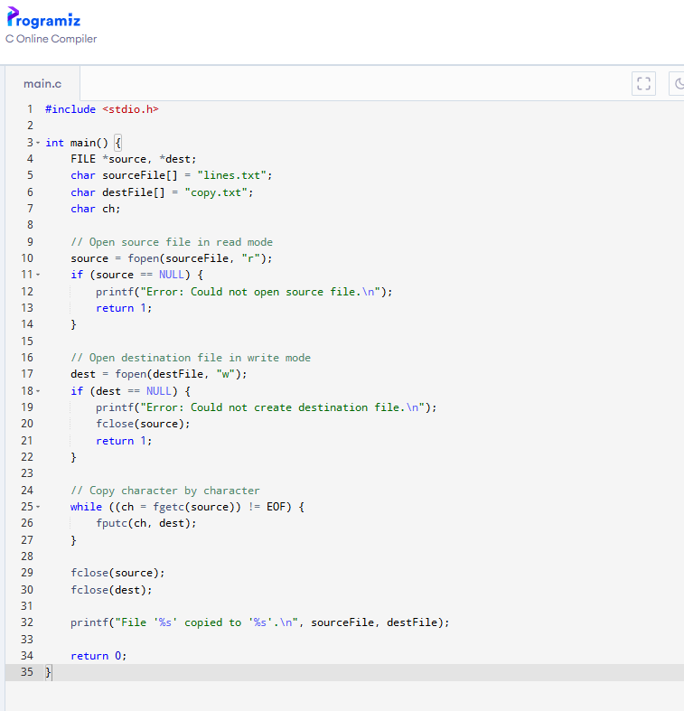

- Delete a file from the computer.
Input: File name: temp.txt
Output: File 'temp.txt' deleted.
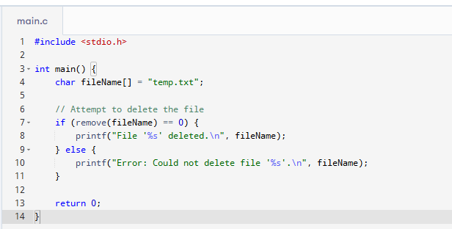
- Read a value from a file into a variable, and also write a variable’s value back into a file.
Input: File name: number.txt (contains: 42)
Output: Read variable: 42; After writing value 100, file now contains: 100
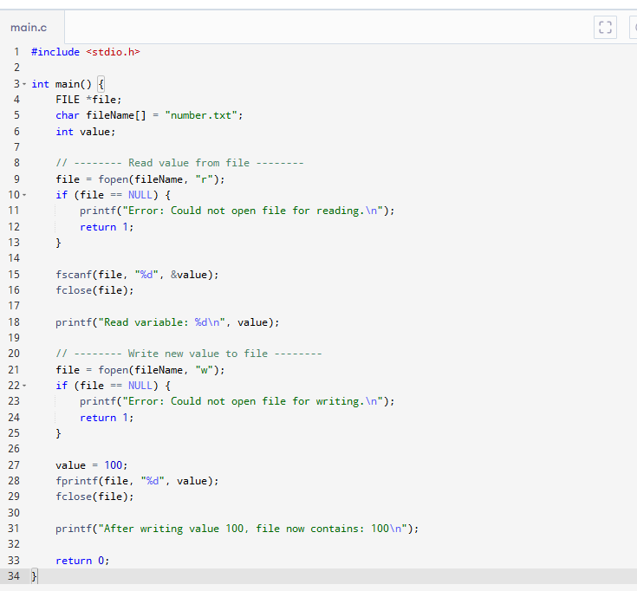

- Count how many lines are present in a text file.
Input: File name: lines.txt
Output: Total lines: 5
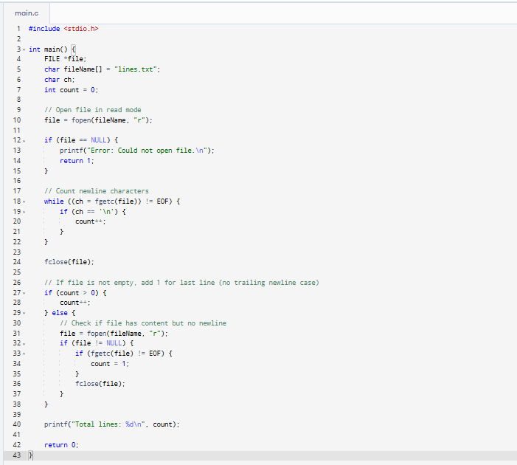

- Count both the number of words and the number of characters in a file.
Input: File name: info.txt (content: This is a test file.)
Output: Words: 5
Characters: 21
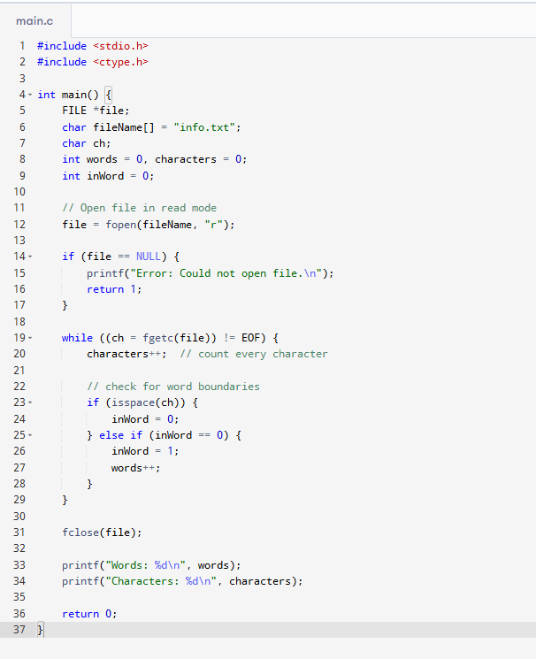

- Show all the contents in a file and also print the total number of lines.
Input: File name: lines.txt
Output: (shows all lines)
Total lines: 5
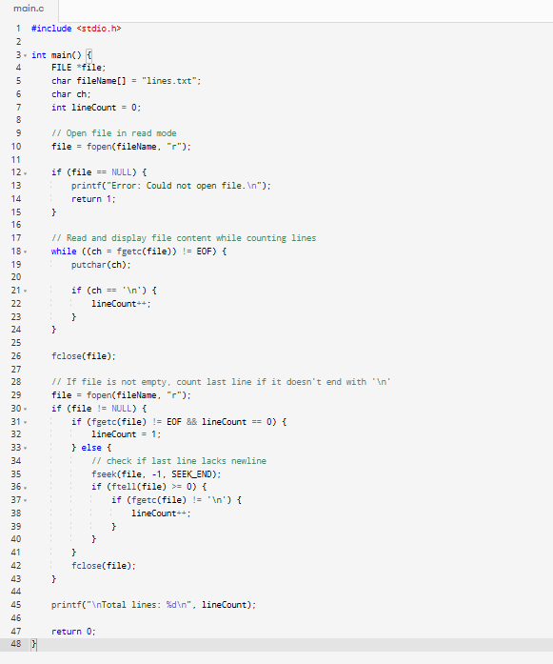
- Remove a specific line (by line number) from a file.
Input: File name: lines.txt
Line to remove: 2
Output: File now contains all lines except line 2.
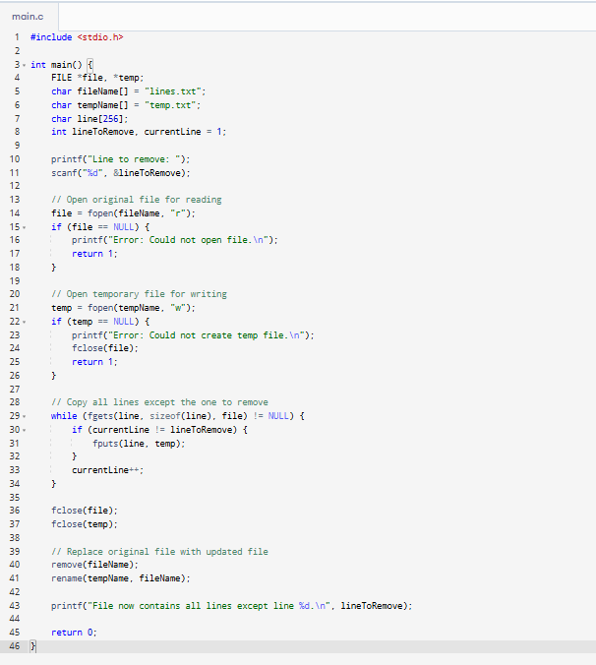
- Change a particular line in a file to some new text.
Input: File name: lines.txt
Line number: 3
New text: This line has been changed!
Output: File now contains new text at line 3.
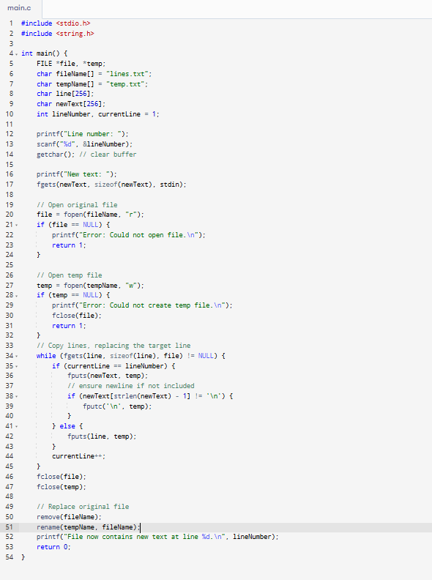
- Replace every use of a chosen word in a file with a different word.
Input: File name: info.txt
Word to replace: file
Replacement: document
Output: Content after: This is a test document.
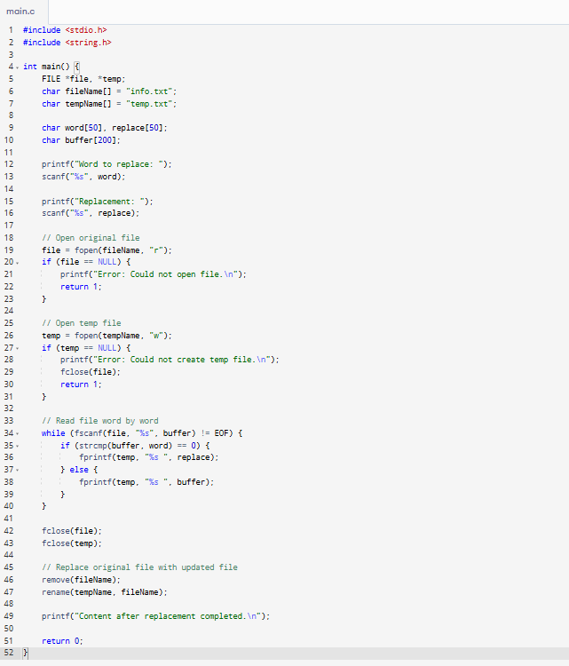
- Change all the letters in a file to uppercase.
Input: File name: info.txt (content: Hello World!)
Output: HELLO WORLD!
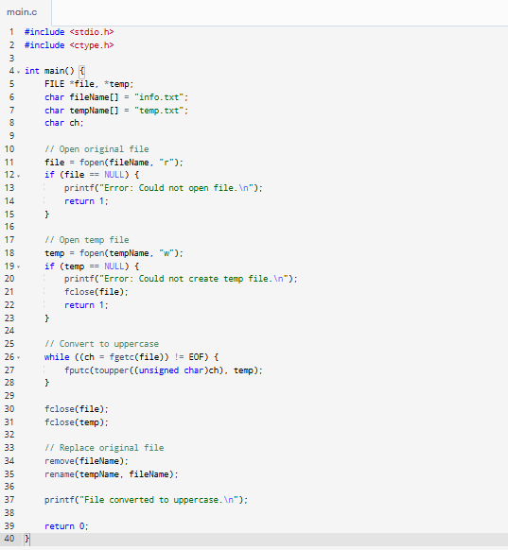
- Change all the letters in a file to lowercase.
Input: File name: info.txt (content: Hello World!)
Output: hello world!
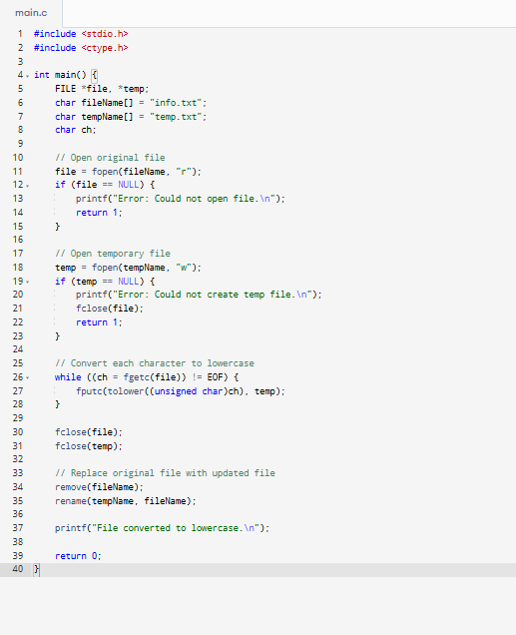
- Capitalize the first letter of each word in a file.
Input: File name: info.txt (content: hello world!)
Output: Hello World!
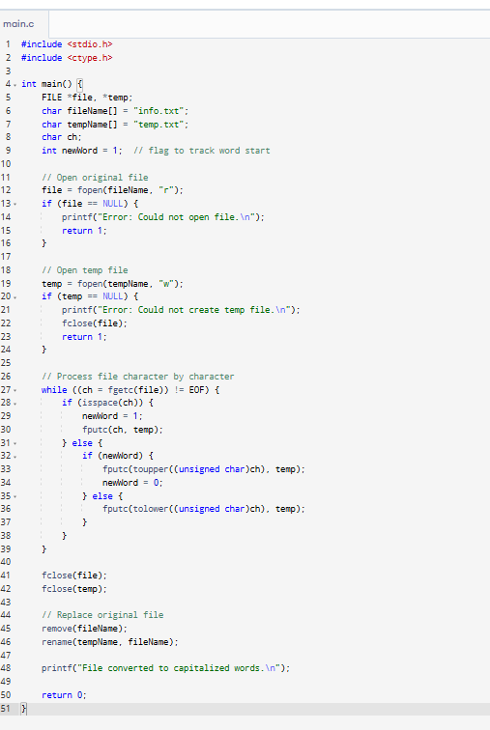
- Display the lines of a file in reverse order (from last to first).
Input: File name: lines.txt
Output: Shows lines from bottom to top
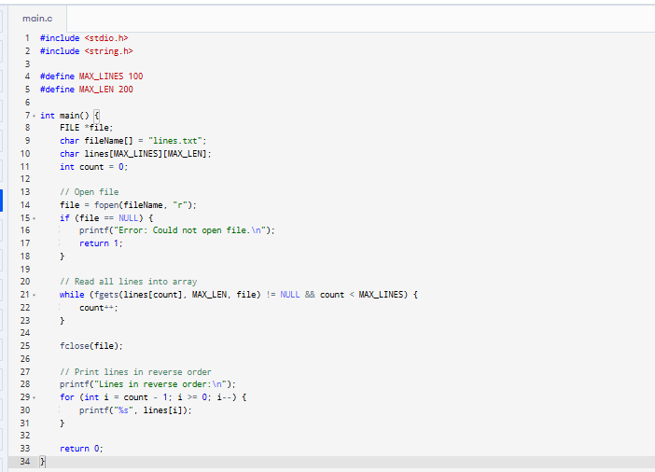
- Encrypt (scramble) a file’s content so it can’t be read easily.
Input: File name: secret.txt (content: my password)
Output: File now contains: (garbled/encrypted text)
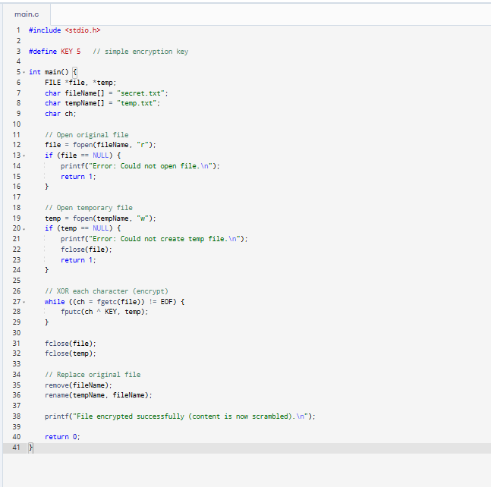
- Decrypt a scrambled (encrypted) file and make it readable again.
Input: File name: secret.txt (content: encrypted)
Output: File now contains: my password
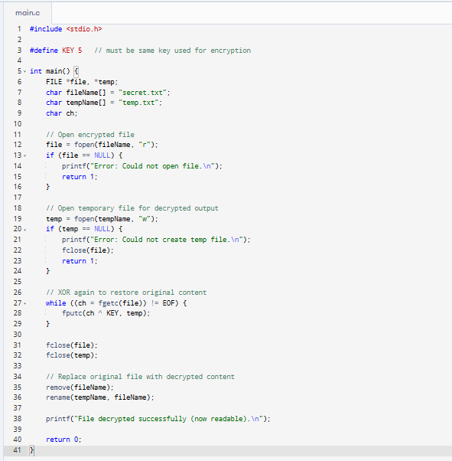

- Join two files together and save the result in a new file.
Input: File 1: a.txt (AAA)
File 2: b.txt (BBB)
New file: ab.txt
Output: ab.txt content: AAA
BBB
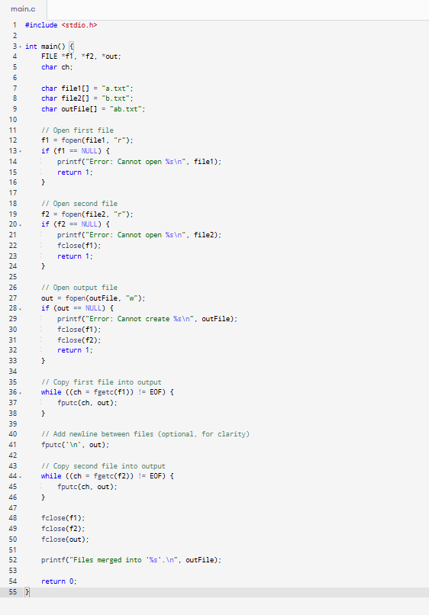
- Merge alternate lines from two files into a third file.
Input: File 1: a.txt (A1, A2)
File 2: b.txt (B1, B2)
New file: merge.txt
Output: merge.txt: A1, B1, A2, B2
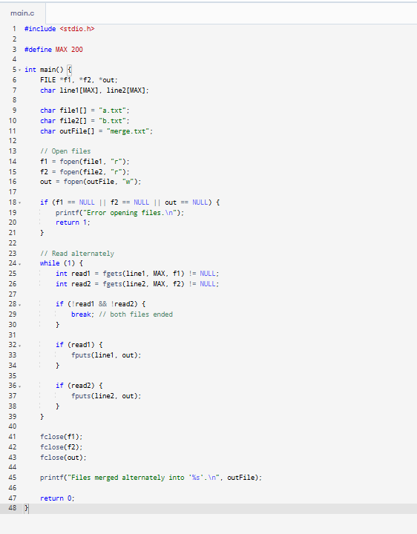
- Take everything from one file and append it to the end of another file.
Input: File1: main.txt (Main)
File2: extra.txt (Extra)
Output: main.txt now contains: Main, Extra
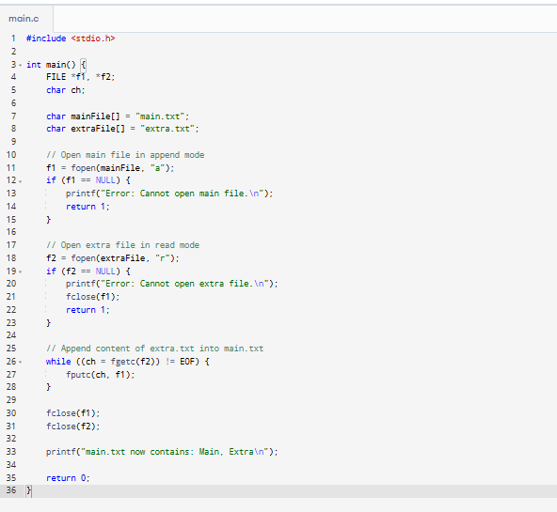
- Check if two files are exactly the same or not.
Input: File1: a.txt, File2: b.txt
Output: Files are identical or Files are different
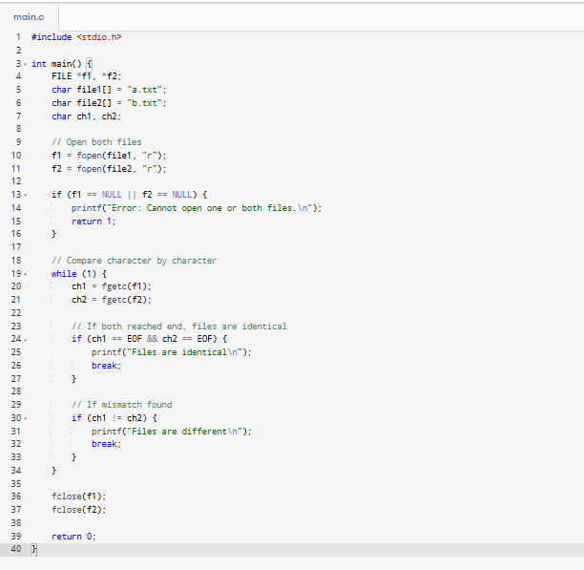
- List all the files found inside a directory (folder).
Input: Directory: myfolder/
Output: file1.txt, file2.txt, notes.doc
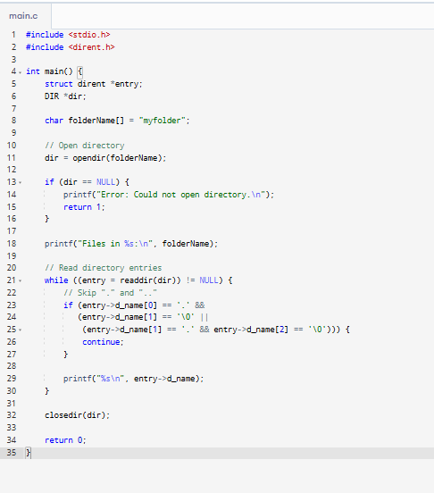
- Find out how big a file is (in bytes).
Input: File name: a.txt
Output: Size: 36 bytes
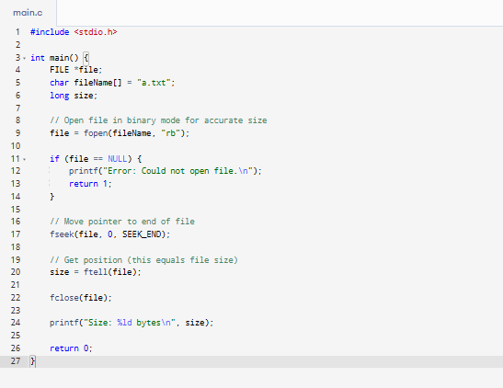
- Show the last modification date and time of a file.
Input: File name: a.txt
Output: Last modified: Sat Nov 26 17:32:15 2022
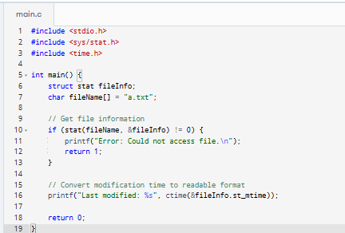
- Find the common folder path among a group of file paths.
Input: /home/user/docs/a.txt, /home/user/docs/b.txt, /home/user/docs/old/c.txt
Output: /home/user/docs
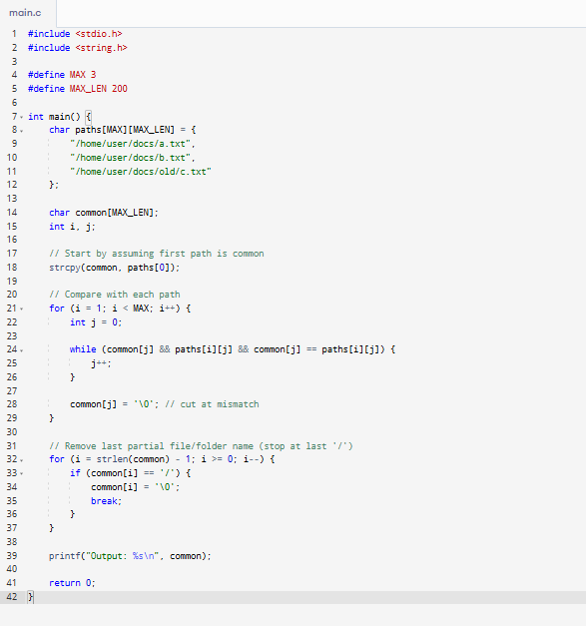
- Store employee details in a file and update them as needed.
Input: Add new employee: Name: John, Age: 25
Output: Employee added (info saved in file)
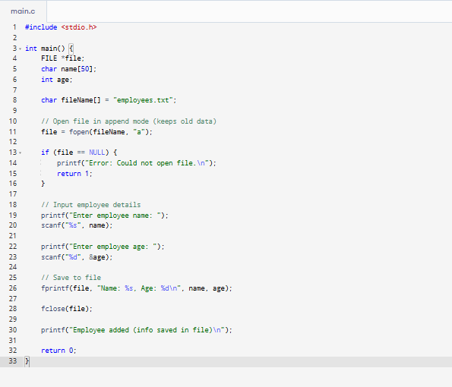
- Log Session a grocery store inventory where you can add, update, or remove items using a file.
Input: Add item: Milk, 2 litres, Rs.40
Output: Inventory file now includes the new item
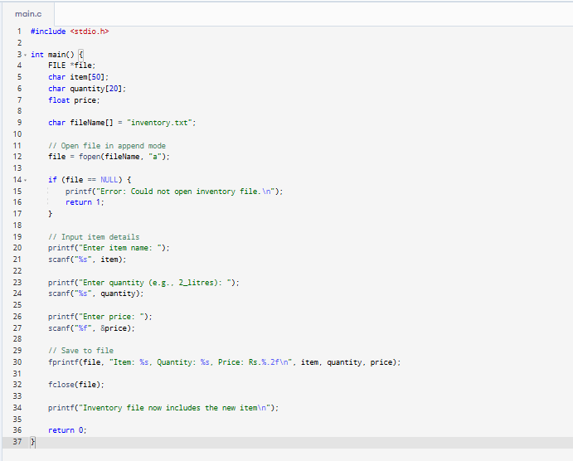
- Add up numbers given as command line arguments and write the answer into a file.
Input: Arguments: 3 4 5, Output file: sum.txt
Output: sum.txt contains: 12
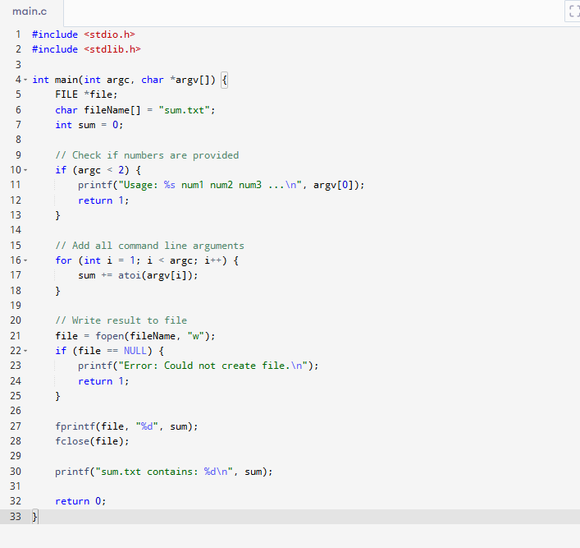
- Count how many lines in a file end with a semicolon.
Input: File: data.txt (lines, some end with ;)
Output: Lines ending with semicolon: 2
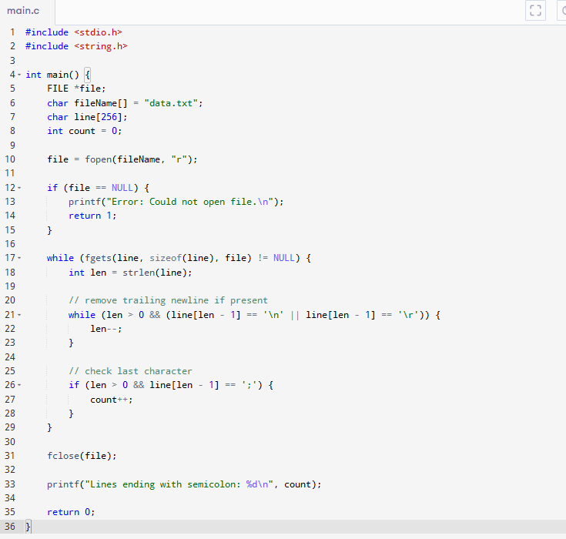
- Count how many empty (blank) lines are in a file.
Input: File: data.txt
Output: Blank lines: 1
