Bitwise Operators:
- What are the functions of bitwise operators AND, OR, XOR, and shift operations?

Operator | Name | Main Function
& | AND | Keeps common bits
` | ` | OR
^ | XOR | Toggles bits
<< | Left shift | Multiply by 2ⁿ
>> | Right shift | Divide by 2ⁿ

- Write a program to perform the following operations on the Least and Most Significant Bits (LSB/MSB) of a given integer:
- Set the LSB to 1
- Clear the LSB (set to 0)
- Toggle the LSB
- Set the MSB to 1
- Clear the MSB (set to 0)
- Toggle the MSB
- Set a specific bit to 1
- Clear a specific bit
- Toggle a specific bit
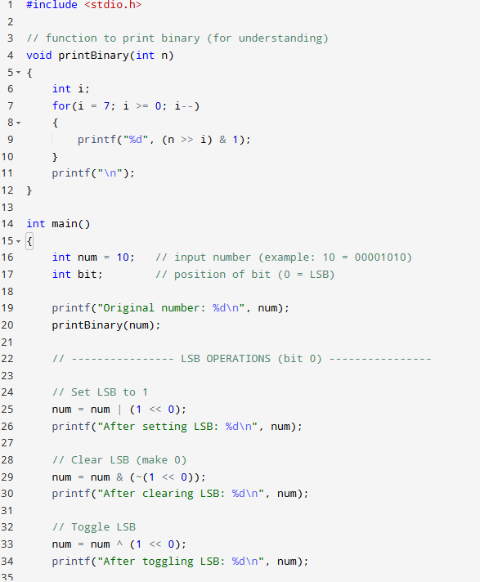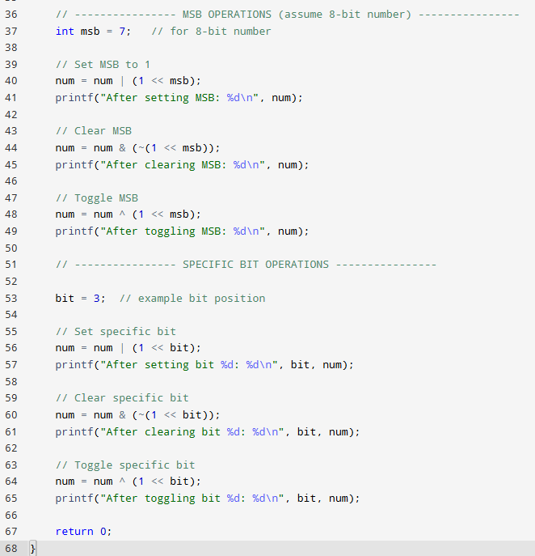
- Write a program to modify specific portions of a given integer:
- Set all bits in the Least Significant Byte (LSB) to 1
- Set all bits in the Most Significant Byte (MSB) to 1
- Set all bits in the Least Significant Nibble to 1
- Set all bits in the Most Significant Nibble to 1
- Set n bits to 1 (user input)
- Clear n bits (set to 0), with n as input
- Toggle n bits (user input)
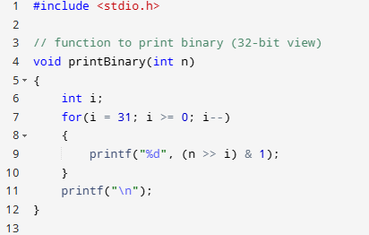
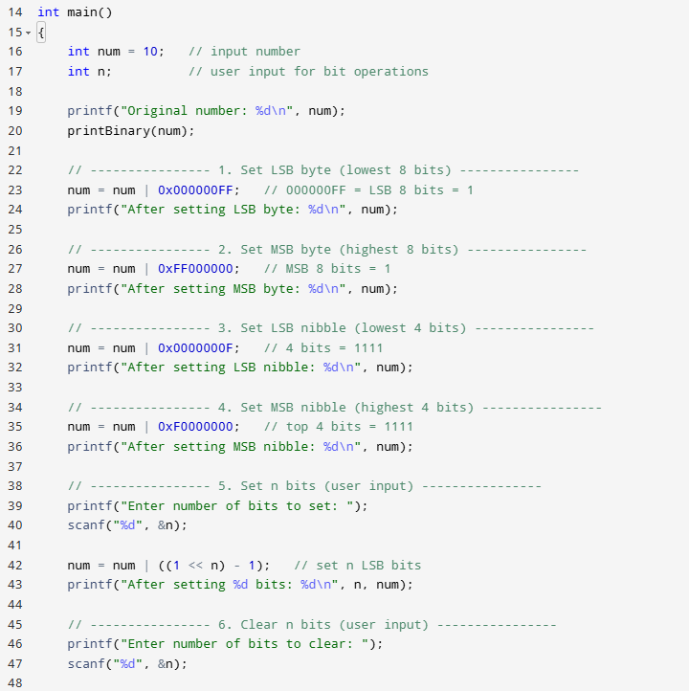
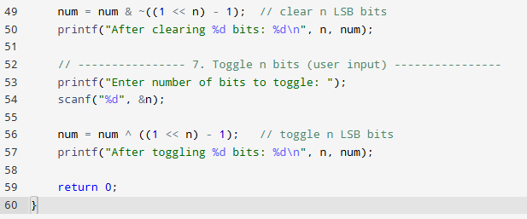
- Write a program to check bit status in an integer:
  - Check if LSB is set (1) or not (0)
  - Check if MSB is set (1) or not (0)
  - Check if the nth bit is set (1) or not (0) (user input)
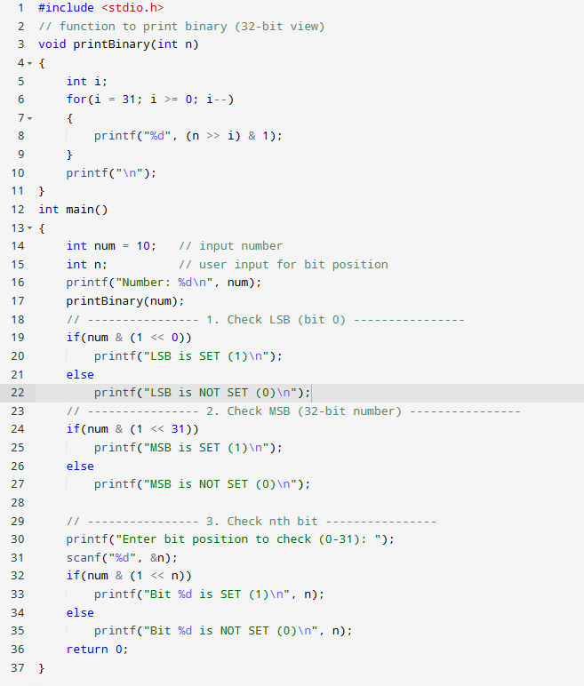
- Write macros to set, clear, and toggle the nth bit using bitwise operators.
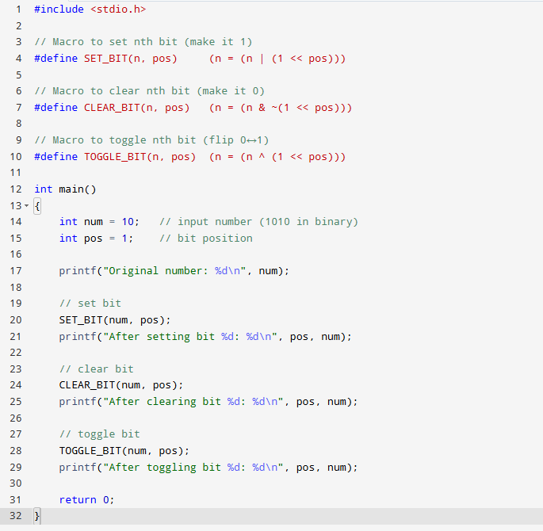

- Write a C program to count the number of set bits in an unsigned integer.
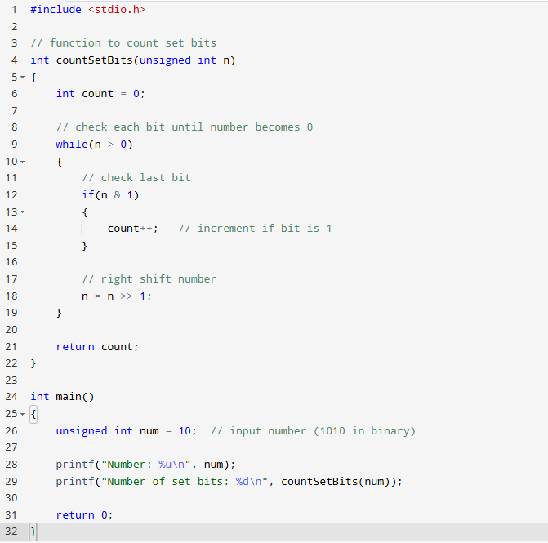

- How can you count the number of set bits in a floating-point number?

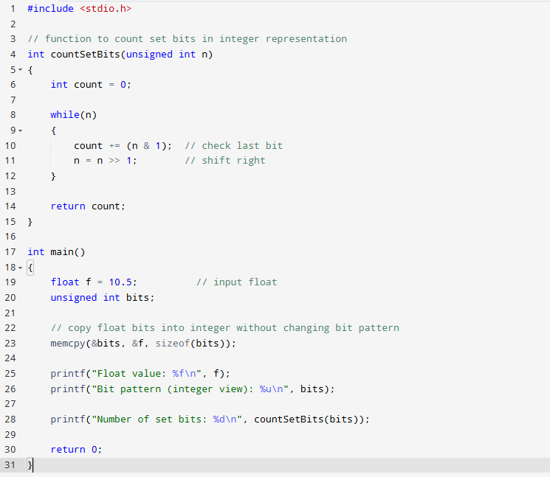

- Write a C program to count the number of bits set to 1 in an integer. Also compare different methods. Additionally, check if the 20th bit of a 32-bit integer is set.
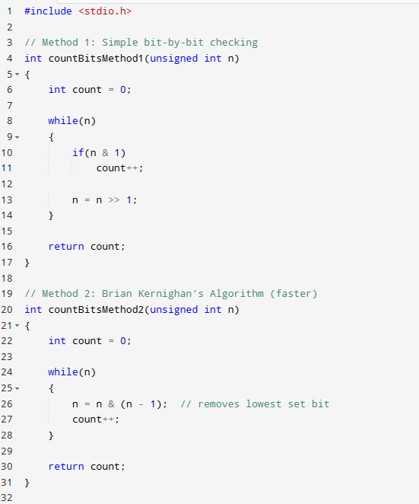
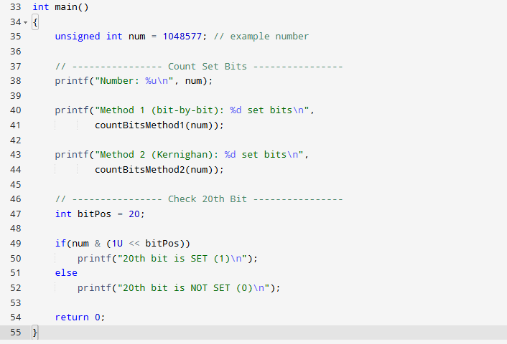
- Write a C program to check whether a number is a power of 2 using bitwise operations.
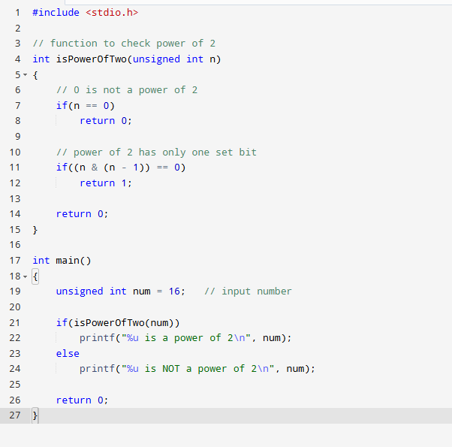

- Write a C program to determine whether a number is odd or even using bitwise operators.

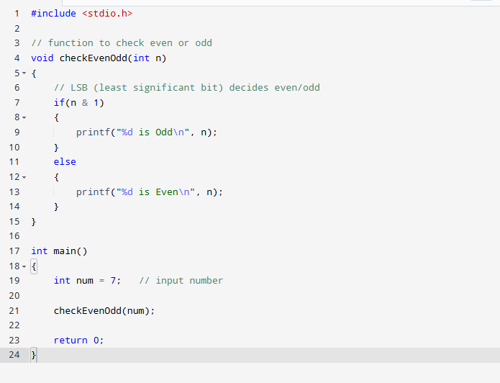

- Implement the function setbits(x, p, n, y) that sets n bits in x starting at position p with the rightmost n bits of y.

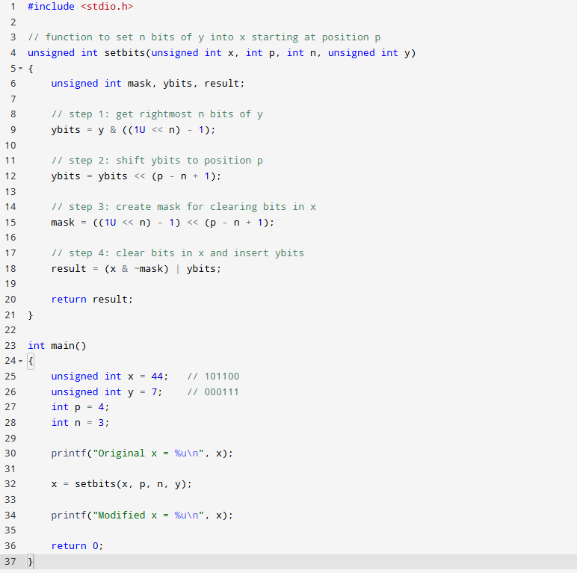

- Given two integers A and B, write a program to count the number of bits that need to be flipped to convert A into B.

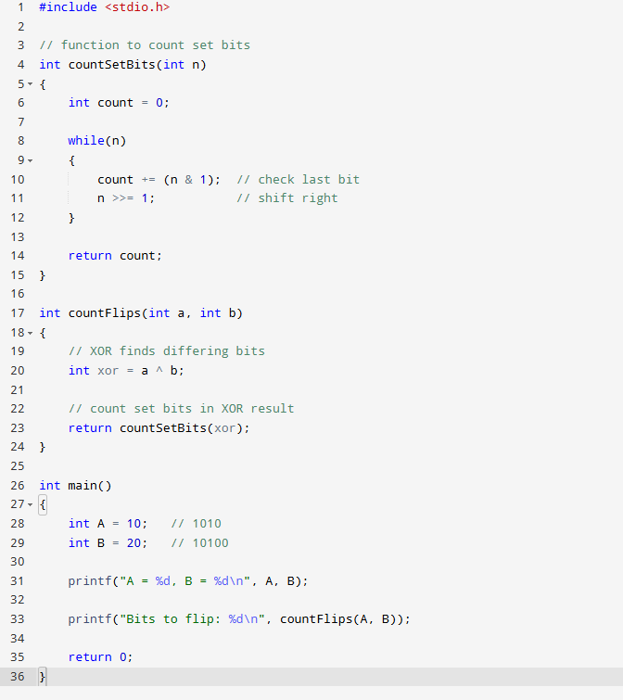

- Write a program to reverse all bits in an integer.
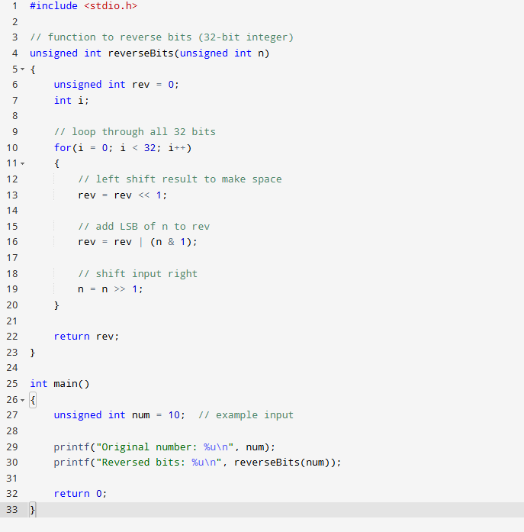

- Write a program to reverse:
  - Bits at odd positions
  - Bits at even positions
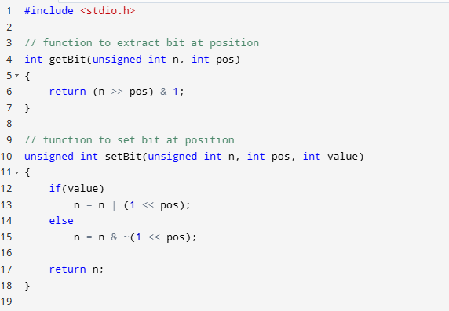
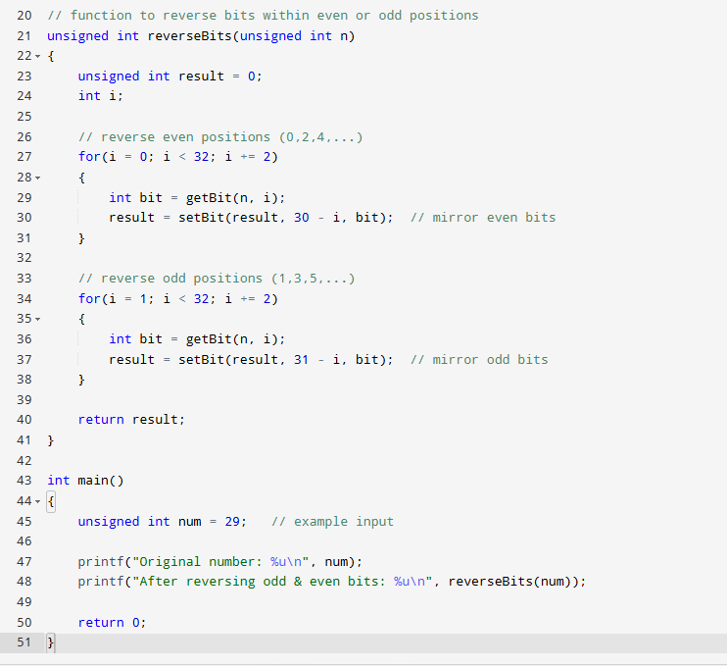
- Write a program to multiply a number by 9 using bitwise shift operations.
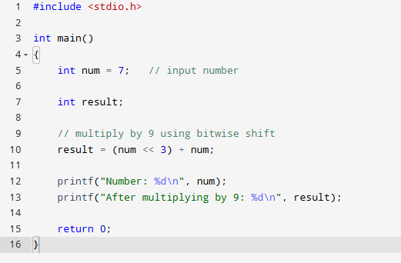

- Write a program to determine the size (in bits) of an integer using bit shifts.
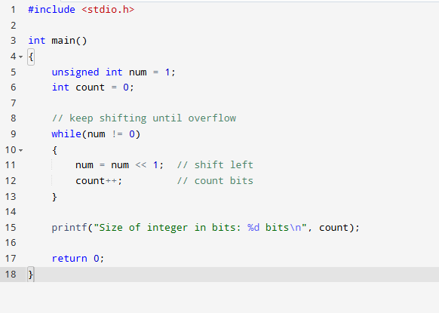

- Write a program to convert a Little Endian integer to its Big Endian equivalent.
