Pointer_Arithmetic
Question 1: Pointer Increment and Access
Task: Log Session an integer array with 5 elements. Use a pointer to access and print the third element by incrementing the pointer appropriately.
Sample data:
1
int arr[] = {5, 10, 15, 20, 25};
Expected output:
Third element is 15
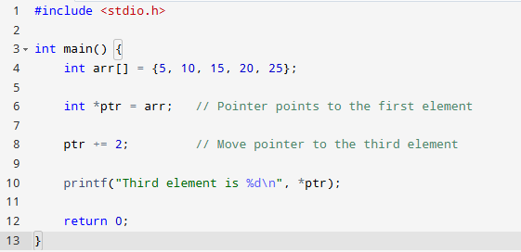
Question 2: Pointer Addition
Task: Using the same array, print the last element by adding an integer to the pointer.
Sample data:
1
int arr[] = {5, 10, 15, 20, 25};
Expected output:
Last element is 25

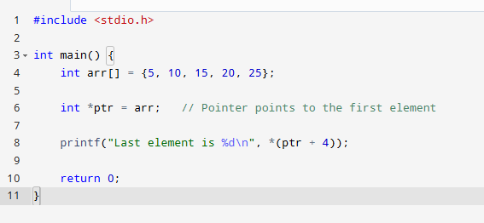
Question 3: Pointer Subtraction
Task: Given two pointers pointing to elements of an integer array, find the distance (number of elements) between them.
Sample data:
1
2
3
int arr[] = {2, 4, 6, 8, 10};
int *p1 = &arr[4]; // points to 10
int *p2 = &arr[1]; // points to 4
Expected output:
Distance between pointers is 3
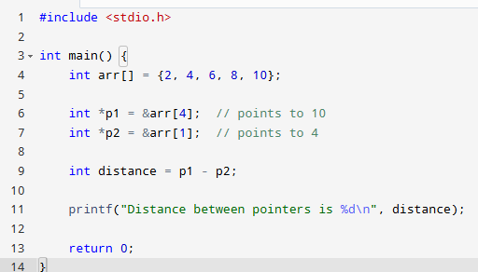
Question 4: Pointer Comparison
Task: Write code to compare two pointers to elements in an array and print which one points to the element with a smaller index.
Sample data:
1
2
3
int arr[] = {11, 22, 33, 44, 55};
int *ptr1 = &arr[2]; // points to 33
int *ptr2 = &arr[4]; // points to 55
Expected output:
Pointer ptr1 points to an earlier element than ptr2
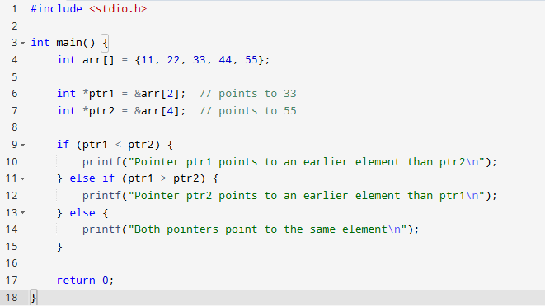
Question 5: Traverse Array with Pointer Arithmetic
Task: Using only a pointer (no array indexing), print all elements of the array.
Sample data:
1
int arr[] = {100, 200, 300, 400};
Expected output:
100 200 300 400
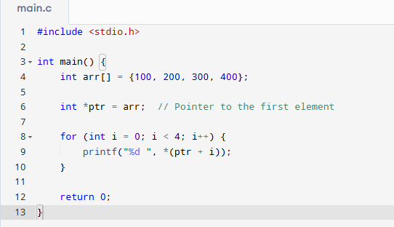
Question 6: Invalid Pointer Arithmetic
Task: Explain why the following code snippet is invalid and what would happen if you try to compile/run it:
1
2
3
4
int arr[5];
int *p1 = &arr[1];
int *p2 = &arr[3];
int *p3 = p1 + p2; // Invalid operation
Expected output:
Error: Cannot add two pointers in C. Pointer addition is not defined.
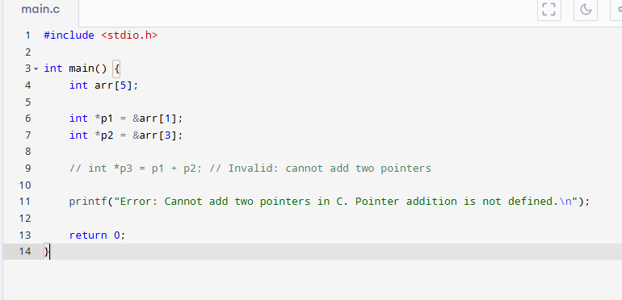

Question 7: Pointer Arithmetic with Different Data Types
Task: Log Session a double array and use pointer arithmetic to print the second element. Explain how pointer arithmetic differs for double compared to int.
Sample data:
1
double darr[] = {1.1, 2.2, 3.3};
Expected output:
Second element is 2.2
Explanation:
Pointer increments by the size of double (usually 8 bytes), so moving pointer by 1 points to the next double element.
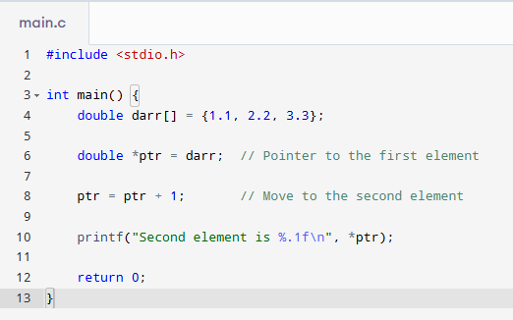
Question 8: Pointer Arithmetic and Array Bounds
Task: Write code that attempts to access memory outside an array using pointer arithmetic and explain why this is unsafe.
Sample data:
1
2
int arr[] = {10, 20, 30};
int *ptr = arr + 5; // Out of bounds
Expected output:
Undefined behavior - accessing memory outside the array may cause crash or unexpected results
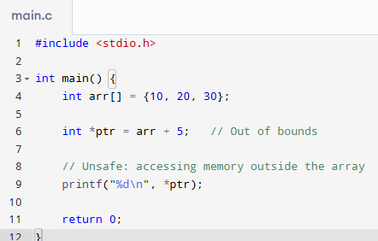
Question 9: Reverse Array using Pointer Arithmetic
Task: Write a function that reverses an integer array in place using pointer arithmetic only (no array indexing).
Sample data:
1
int arr[] = {1, 2, 3, 4, 5};
Expected output:
Reversed array: 5 4 3 2 1
