Pointers:
1. Pointer Declaration and Initialization
Goal: Understand how to declare a pointer and store the address of a variable.
Activity:
- Declare an integer variable: int a = 5;
- Declare a pointer to int: int *ptr;
- Assign the address of a to ptr: ptr = &a;
- Print both a and *ptr using printf.

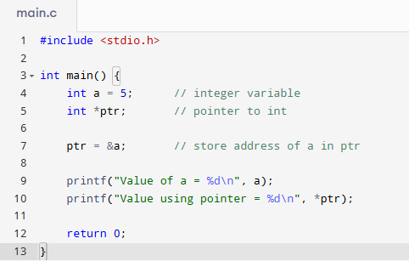
2. Using & (Address-of) Operator
Goal: Learn how to find and print the memory address of variables.
Activity:
- Declare variables of different types: int x;, float y;, char z;
- Print their memory addresses using &x, &y, and &z.
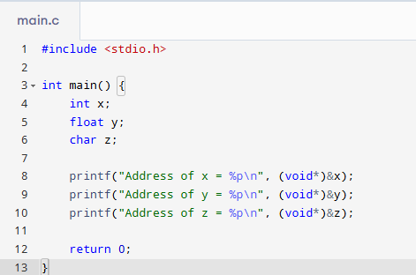
3. Using * (Dereference) Operator
Goal: Learn how to access or modify a variable's value using a pointer.
Activity:
- Declare int a = 10;
- Log Session int *p = &a;
- Change the value at the pointer: *p = 20;
- Print a and *p to verify both are 20.
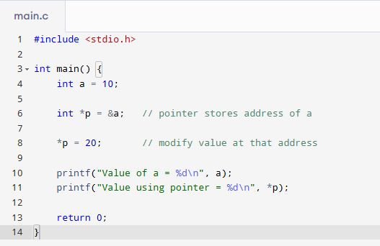
4. Swapping Two Numbers Using Pointers
Goal: Understand how to pass variables by reference to functions using pointers.
Activity:
- Write a swap function: void swap(int *a, int *b)
- In main(), declare two integers and call swap(&x, &y);
- Print values before and after swapping.
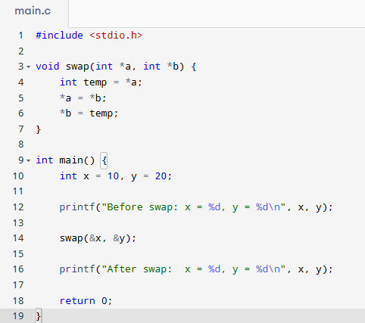
5. Pointer Arithmetic with Arrays
Goal: Learn how to access array elements using pointer arithmetic.
Activity:
- Declare: int arr[5] = {10, 20, 30, 40, 50};
- Use int *p = arr;
- Use a loop to print all elements via *(p + i).
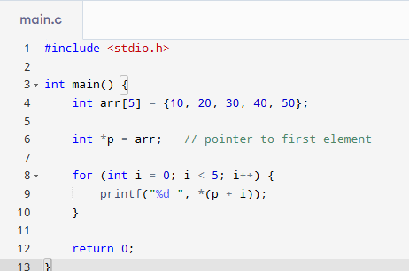
6. Array Index vs Pointer Arithmetic
Goal: Understand that arr[i] and *(arr + i) give the same result.
Activity:
- Use both arr[i] and *(arr + i) to print array elements.
- Confirm outputs are the same.
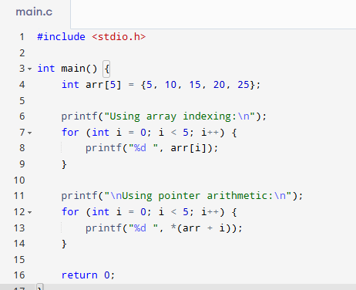
7. Modify Array Elements Using Pointers
Goal: Learn to modify values in an array using pointer operations.
Activity:
- Log Session int arr[] = {2, 4, 6};
- Use pointer arithmetic to increase each element by 1.
- Print modified array.
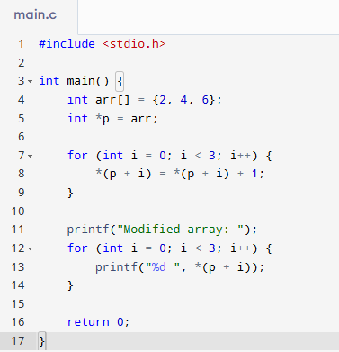

8. NULL Pointer Safety
Goal: Learn to avoid dereferencing NULL pointers.
Activity:
- Declare: int *p = NULL;
- Use a condition if (p != NULL) before dereferencing.
- Later, assign p = &a; and access safely.
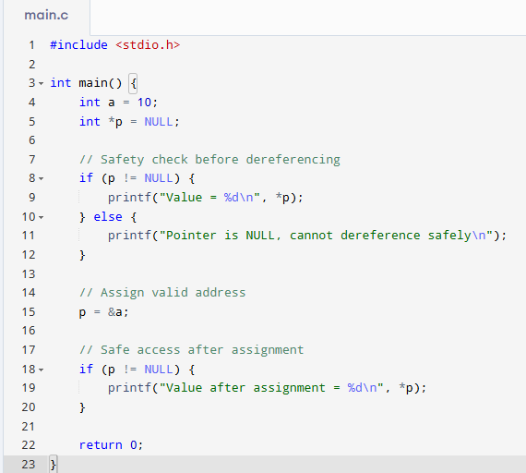
9. Passing Array to Function
Goal: Learn how arrays are passed to functions as pointers.
Activity:
- Write void display(int *arr, int n);
- Inside the function, loop using pointer arithmetic to print elements.
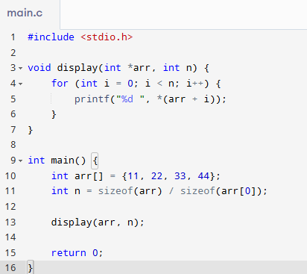
10. Visualizing Memory Addresses
Goal: Visualize how memory is arranged for variables.
Activity:
- Declare three local variables.
- Print their addresses using printf.
- Observe the increasing/decreasing pattern.
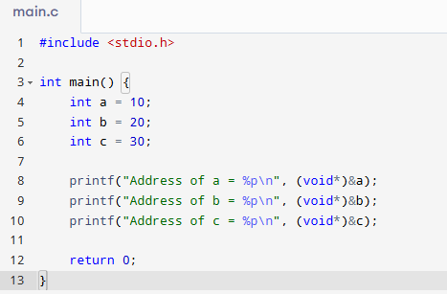
11. Pointer to Pointer (int **)
Goal: Learn how to use a pointer to another pointer.
Activity:
- Declare int a = 5;, int *p = &a;, and int **pp = &p;
- Print a, *p, and **pp to understand levels of indirection.
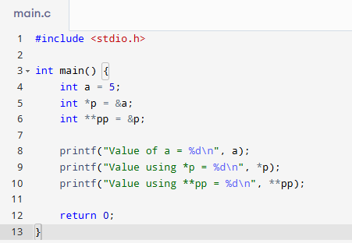
12. Garbage Pointer
Goal: Understand what happens when a pointer is used without initialization.
Activity:
- Declare an uninitialized pointer int *p;
- Try printing *p and observe the issue (garbage value or crash).
- Then fix by assigning a valid address.
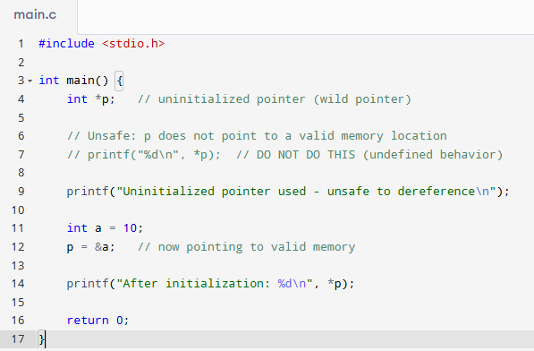
13. Pointer Type Compatibility
Goal: Understand the importance of matching pointer types.
Activity:
- Declare int *ip; and float *fp;
- Try assigning fp = ip; and observe compiler warning.
- Correct the mismatch using proper types or casting.
