Function Pointers:
- Mathematical Operations with Function Pointers
Log Session four simple mathematical functions (add, subtract, multiply, divide) that accept two integer arguments and return an integer.
Use a single function pointer to dynamically select and execute one of these operations based on user input.
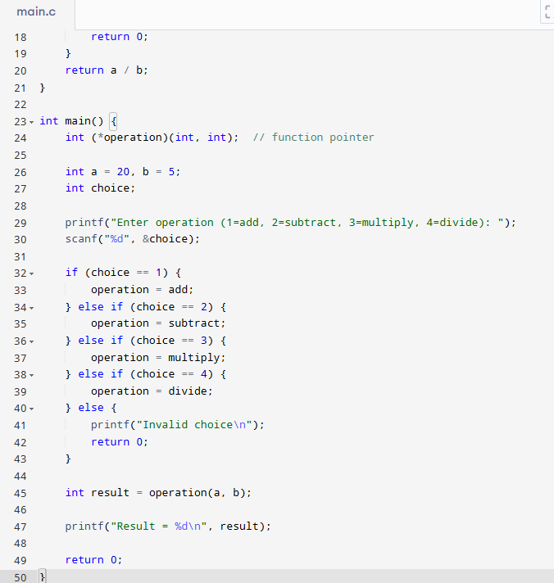

- Sorting Algorithms Selector
  - Implement three sorting functions (bubbleSort, selectionSort, insertionSort) that sort an integer array.
  - Store pointers to these sorting functions in an array of function pointers.
  - Prompt the user to choose a sorting method, and use the selected function pointer to sort a user-provided integer array.
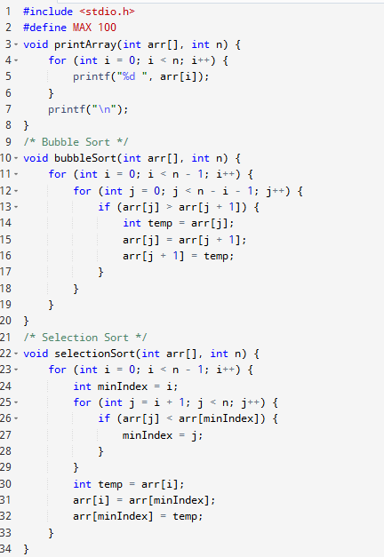
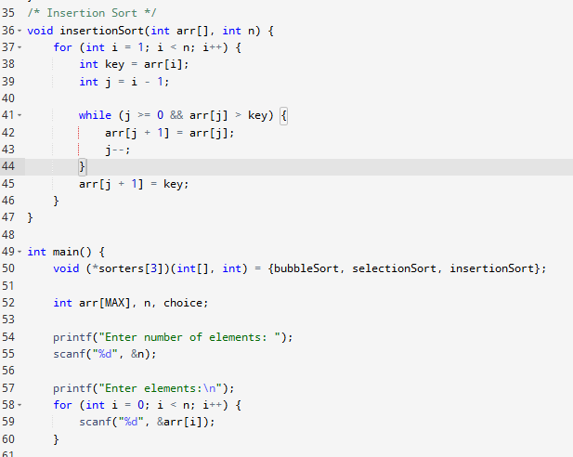
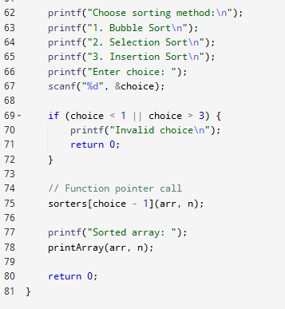

- Callback Function Array Processing
- Define a function processArray that accepts an integer array, its size, and a callback function as arguments.
- Implement callback functions (increment, doubleValue) that modify array elements in different ways.
- Demonstrate invoking processArray with different callback functions.
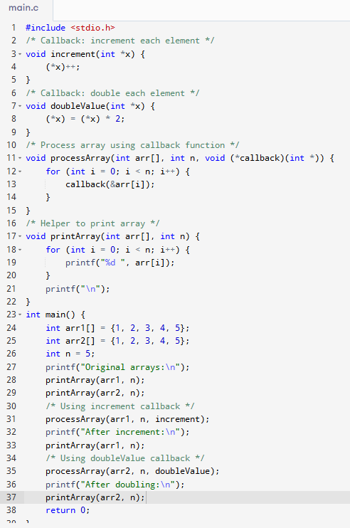

- Menu-driven Calculator Using Function Pointers
- Implement mathematical operations (power, modulo, squareRoot) as separate functions.
- Store these operation functions in a function pointer array.
- Provide a user-interactive menu to select and execute the chosen operation on input values.
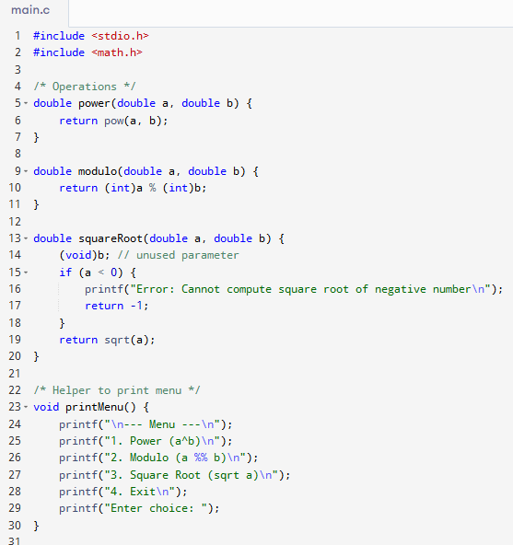
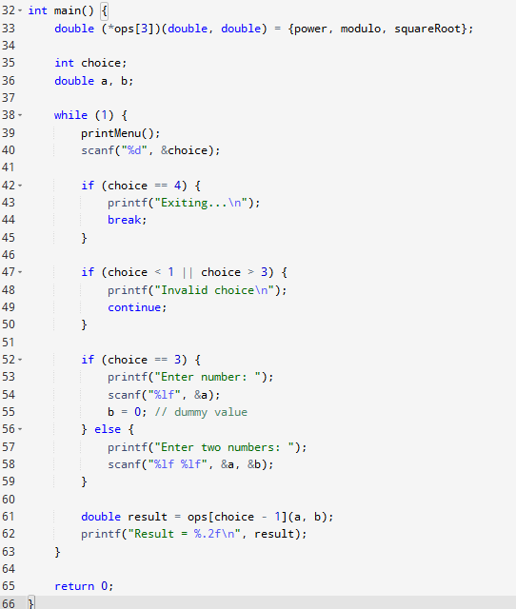
- State Machine Implementation
- Implement a basic state machine (initState, runState, stopState, errorState) with each state represented by a separate function.
- Use function pointers to transition between states based on user input or internal conditions.
- Demonstrate state transitions clearly in your program’s output.
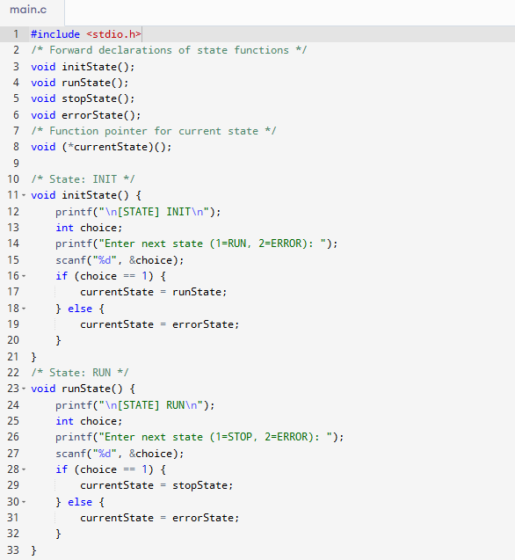
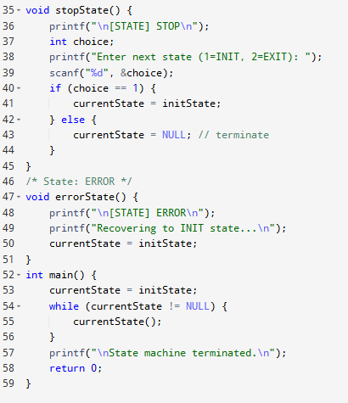

- Event Handling System
- Define events such as buttonPressEvent, sensorTriggerEvent.
- Implement handler functions for these events.
- Log Session an array of function pointers mapping each event to its corresponding handler function.
- Simulate event triggers, calling the appropriate handler through function pointers.
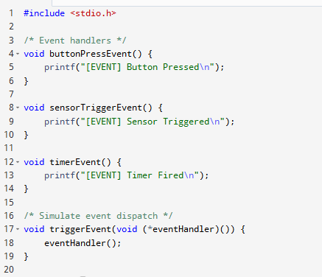
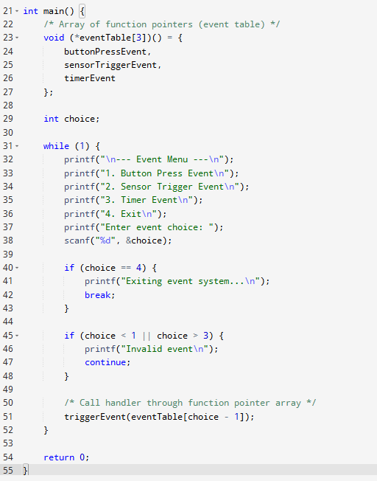

- Interrupt Handler Simulation
- Log Session several interrupt handler functions (e.g., timerInterrupt, keyboardInterrupt, errorInterrupt).
- Map these interrupt handlers using an array of function pointers.
- Simulate interrupts by invoking appropriate interrupt handlers using their pointers based on interrupt numbers entered by the user.
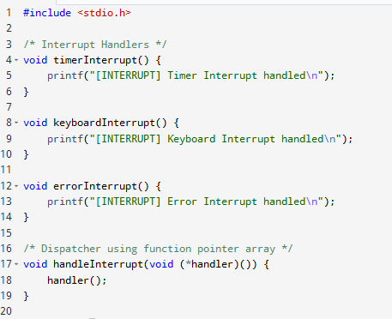
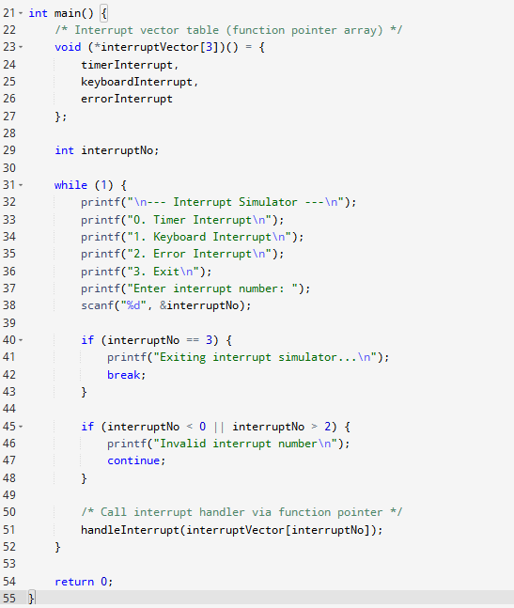
- Generic Find Function
- Implement a generic function find that takes an integer array, its size, and a function pointer as a condition.
- Log Session condition functions (e.g., isEven, isPositive, isPrime).
- Use find to identify and print the first element matching the provided condition.
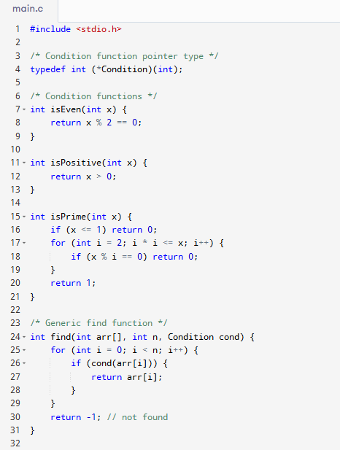
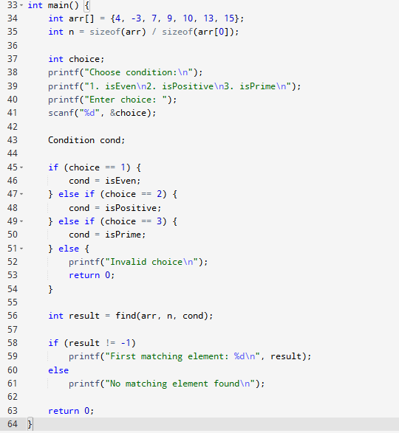
- Dynamic Logging Mechanism
- Implement three logging functions (consoleLog, fileLog, networkLog) with a common signature.
- Allow the program to select the appropriate logging method dynamically through function pointers.
- Demonstrate switching between logging methods at runtime based on user input.
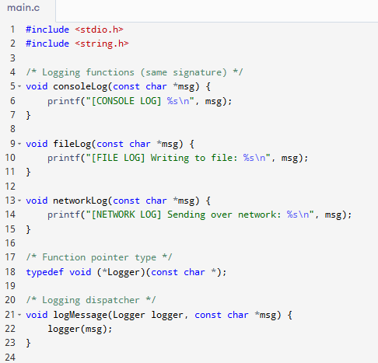
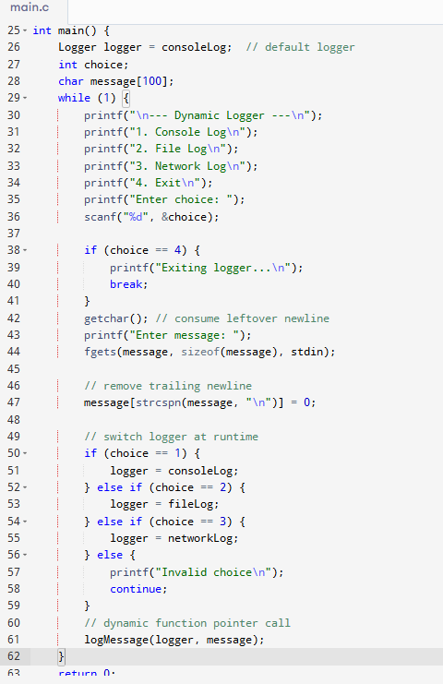
- Math Function Framework
- Write wrapper functions around standard mathematical functions (sin, cos, tan, log) with the same function prototype.
- Store pointers to these functions in an array.
- Provide an interface for users to select and execute a math function on a given floating-point input.
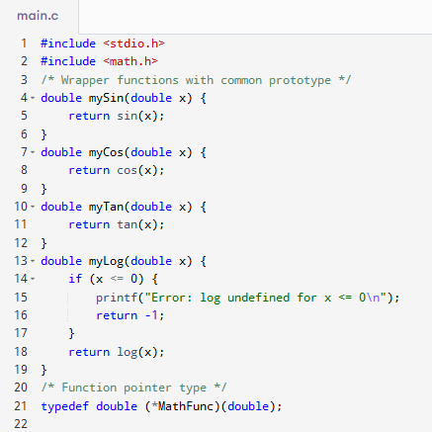
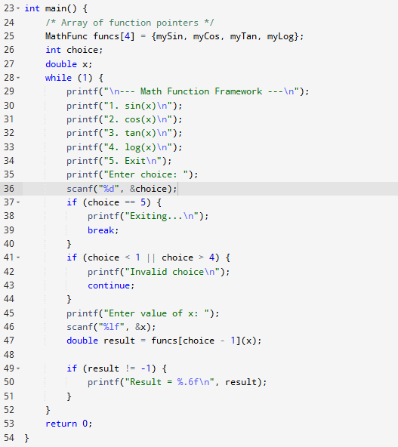

- Function Pointer as Return Value
  - Implement multiple arithmetic functions (add, subtract, multiply).
  - Write a function getOperation(char *name) that takes a string (like "add" or "subtract") and returns a pointer to the corresponding function.
  - Use this return value to perform the selected operation on user-provided numbers.

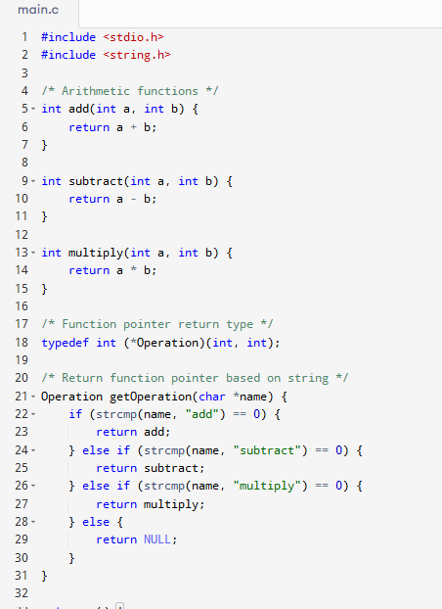
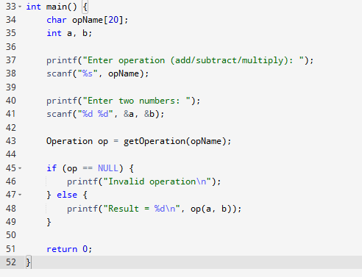
- Function Pointer Array for String Operations
- Implement several string manipulation functions (reverseString, toUpperCase, countVowels), each accepting a string argument.
- Store these functions in an array of function pointers.
- Prompt the user to choose an operation and apply it to their input string using the selected function pointer.
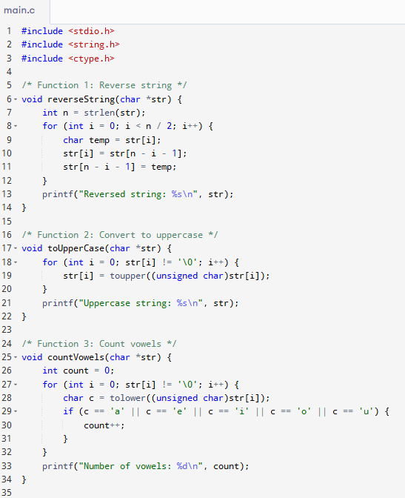
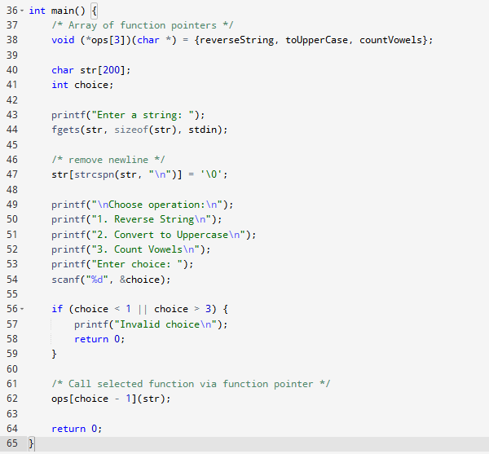
- Passing Function Pointers to Standard Algorithms
- Define a structure representing a record (e.g., struct Person { char name[30]; int age; }).
- Implement multiple comparison functions for sorting (e.g., by name, by age).
- Use the C standard library function qsort, passing these comparison functions as function pointers to sort an array of records in different ways.
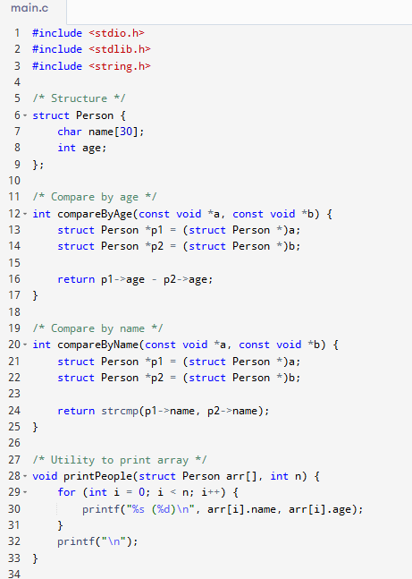
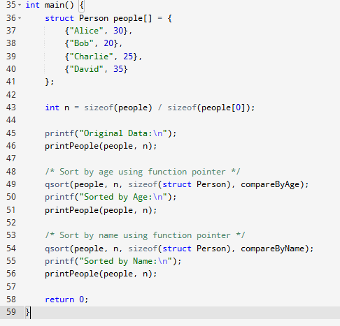

- Chained Function Pointer Calls
- Write several functions that transform an integer (e.g., doubleValue, increment, square).
- Log Session an array of function pointers representing a pipeline of operations.
- Pass a number through the pipeline by applying each function in sequence, using the array of pointers.
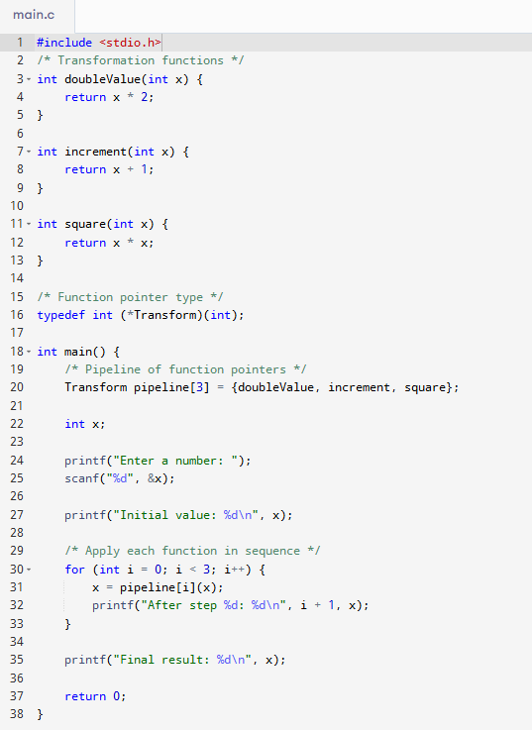

- Multi-dimensional Function Pointer Array
- Define arithmetic functions for both int and float types (e.g., intAdd, floatAdd).
- Organize the function pointers in a two-dimensional array:
- First dimension: operation type (arithmetic, bitwise)
- Second dimension: data type (int, float)
- Demonstrate calling the correct function based on selected type and operation.
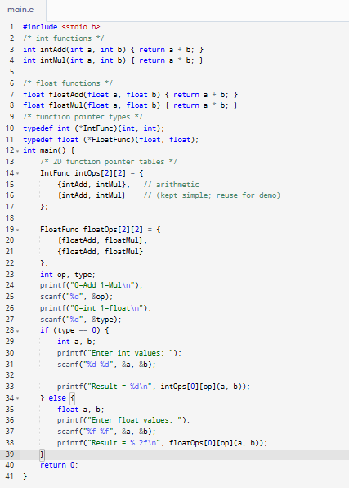

- Recursive Function Pointer
  - Implement a recursive function (such as factorial or fibonacci) using a function pointer variable instead of directly calling the function by name.
  - Show that the recursion works correctly using only the pointer.
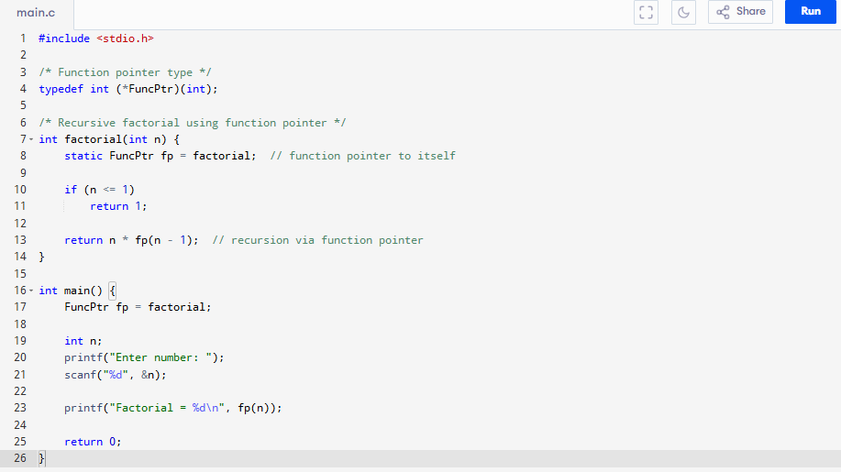

- Array of Function Pointers in a Structure
  - Define a structure (e.g., Calculator) that contains an array of function pointers for operations (add, subtract, multiply).
  - Instantiate the structure and use it to call the various operations on input values, demonstrating how the structure can perform different calculations.
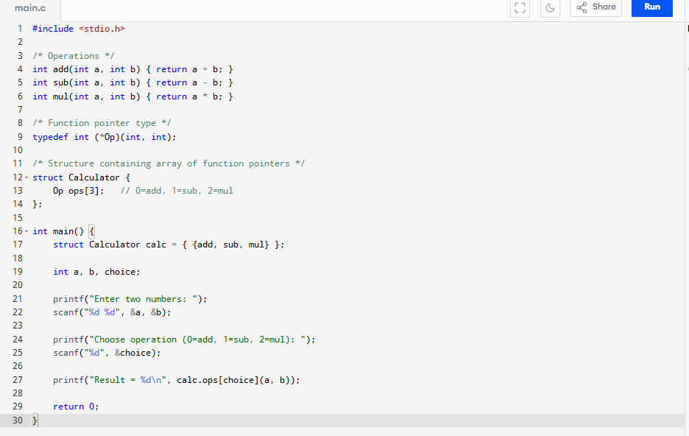

- Replace Switch-Case with Function Pointer Table
- Simulate a command-based application where each command is represented by a number.
- Instead of using a large switch-case block to handle commands, create a function pointer table.
- Use the input command number as an index to call the corresponding handler function via the function pointer table.
