Structures:
1. Structure vs Union in Embedded Systems
Goal
Understand how structures and unions differ in terms of memory layout, access, and use in embedded systems, particularly in data interpretation and memory saving.
Activity
- Define a structure and a union with three different data types (e.g., char, int, float).
- Print the size of each and compare.
- Write values to each member and observe the behavior.
- Map the union onto a byte buffer and visualize how different types share memory.
- Document a scenario where only one data type is valid at a time (e.g., packet command structure).
Tip: Use sizeof() and printf() to track memory usage and value overlap.
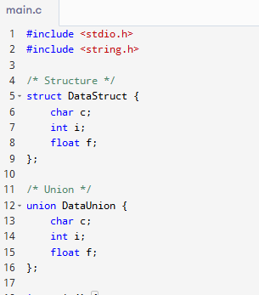
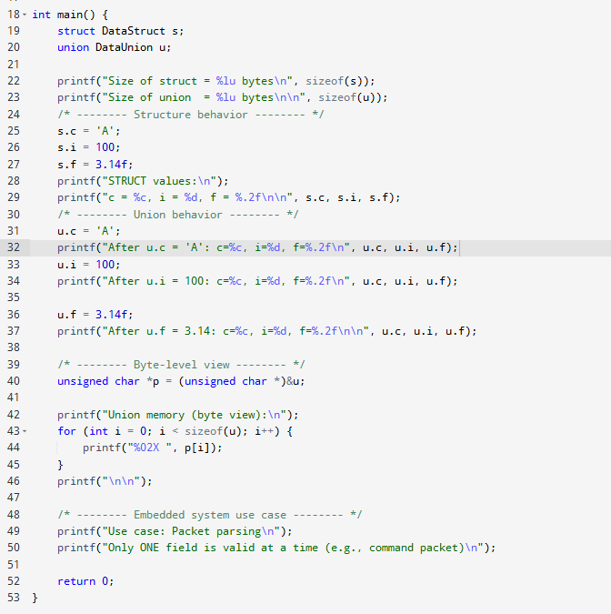
2. Bit-fields in Structures
Goal
Learn to define and use bit-fields to manage individual bits for hardware register simulation.
Activity
- Log Session a structure using bit-fields to represent an 8-bit status register.
- Assign values to specific flags.
- Log Session a mock register with error, ready, and mode bits.
- Write code to toggle specific flags without using bitwise operators.
- Reflect on how compilers handle ordering and alignment of bit-fields.
Tip: Bit-fields may behave differently on different compilers—don't assume portability.
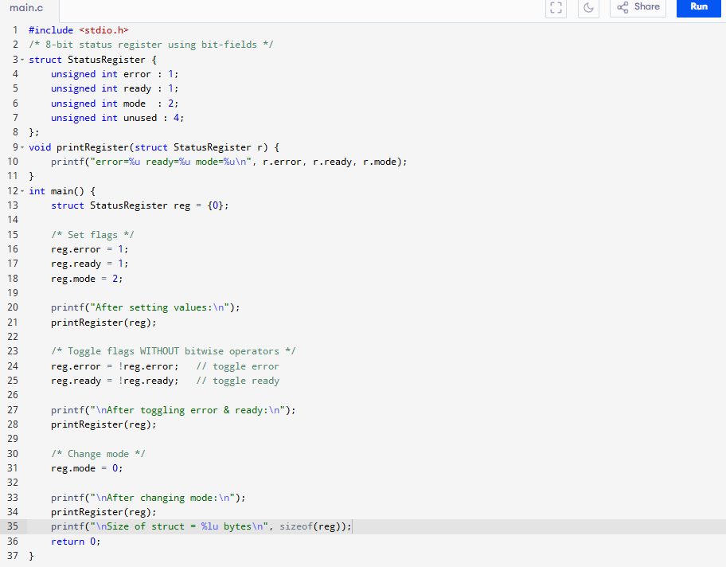

3. Structure Padding, Alignment, and Packing
Goal
Understand how padding affects structure size and how to control layout using packing directives.
Activity
- Log Session a structure with mixed data types (char, int, short).
- Check the size and member offsets using sizeof() and pointer arithmetic.
- Reorder members to reduce padding and observe the change in size.
- Use #pragma pack(1) and compare memory layout.
- Simulate a communication packet where field alignment matters.
Tip: Use offsetof() macro to determine the byte offset of each field.
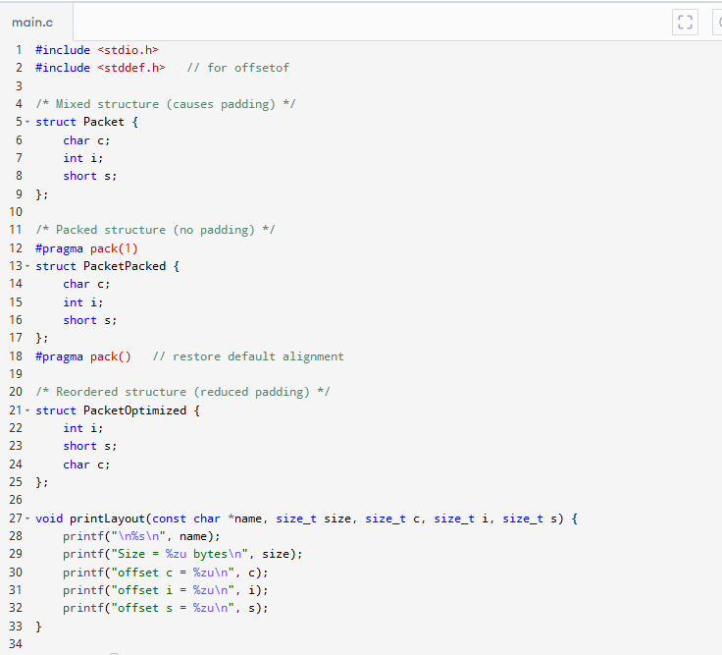
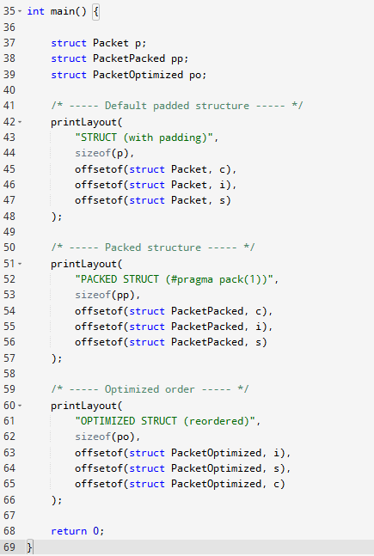

4. Function Pointers in Structures
Goal
Learn how to include and use function pointers inside structures for callback mechanisms and dynamic behavior in embedded systems.
Activity
- Define a structure containing function pointers.
- Initialize it with different functions and invoke them.
- Use this setup to simulate a hardware driver interface with different behavior implementations.
- Demonstrate dynamic assignment and execution of function pointers based on a condition or input.
Tip: Use typedef for cleaner function pointer declarations.
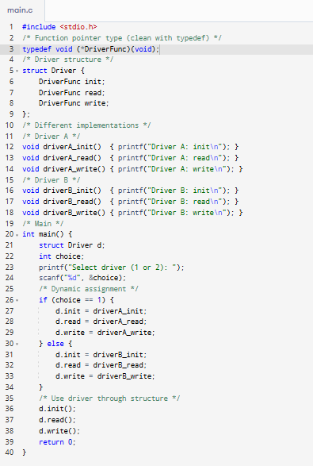

5. Dynamic Memory with Structures
Goal
Understand how to allocate and free memory dynamically for structures, including use cases like linked lists and memory pools in embedded systems.
Activity
- Use malloc() to allocate a structure dynamically and assign values to members.
- Build a simple singly linked list using structure and pointers.
- Implement a queue using structure-based nodes.
- Write a memory pool manager that uses an array of structures and a free list.
Tip: Always check malloc() return and release memory using free() after usage.
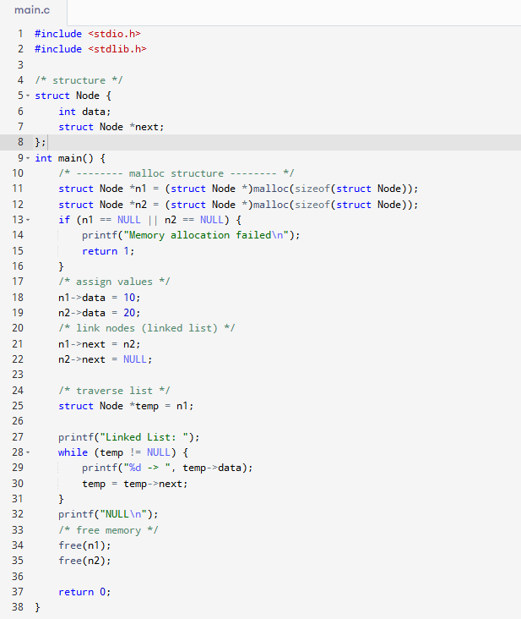

6. Structure Pointers and Memory Access
Goal
Understand the use of pointers to structures for efficient memory access and how to use the arrow operator for member access.
Activity
- Declare a pointer to a structure and allocate memory using malloc().
- Use arrow operator to assign and print structure member values.
- Simulate memory-mapped peripheral access using structure pointers.
- Illustrate how structure pointers simplify code in register programming.
Tip: Always initialize structure pointers and check for NULL before dereferencing.
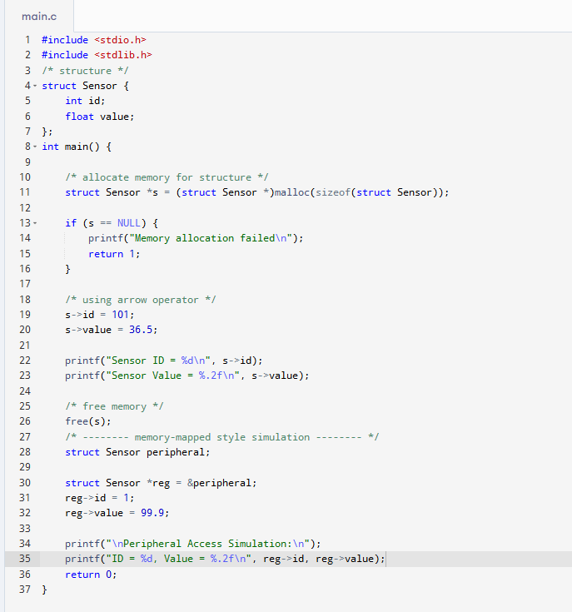

7. Nested Structures and Arrays within Structures
Goal
Explore how to organize complex data using nested structures and how to embed arrays inside structures for buffer management.
Activity
- Log Session a structure with another structure as a member.
- Log Session an array of structures to hold multiple sensor values.
- Include arrays within a structure to buffer a set of samples.
- Model a protocol layer with header and payload sub-structures.
Tip: Use typedef to simplify nested structure declarations.
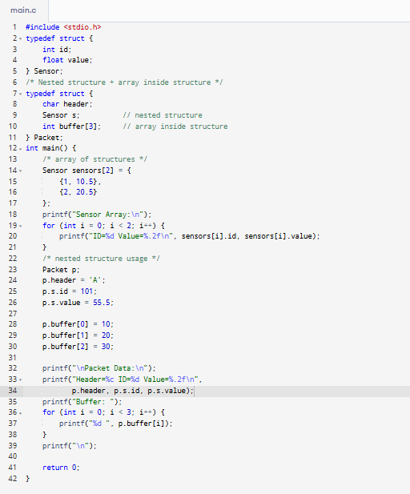

8. Structures and Functions
Goal
Learn how to pass structures to and return structures from functions and understand the trade-offs between pass-by-value and pass-by-reference.
Activity
- Write a function that takes a structure as a value argument and modifies it.
- Write a function that takes a pointer to structure and modifies it.
- Return a structure from a function and print its values.
- Measure memory usage and performance difference between pass-by-value and reference.
Tip: Prefer passing by pointer in embedded systems for performance and memory efficiency.
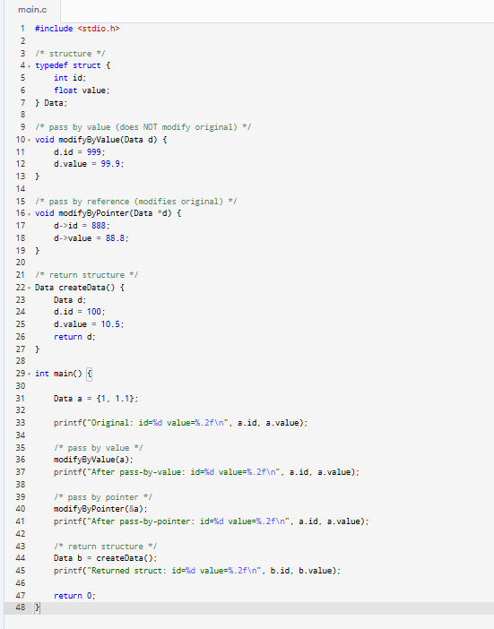

9. Introduction to Structures in C
Goal
Grasp the basic concept of structures in C, including their need, syntax, and difference from arrays and unions.
Activity
- Define a simple structure with multiple data types.
- Compare it with an array and a union with similar members.
- Initialize the structure in different ways and print values.
- Analyze why structures are preferred in peripheral register grouping.
Tip: Structures allow logically grouping different data types under one name.
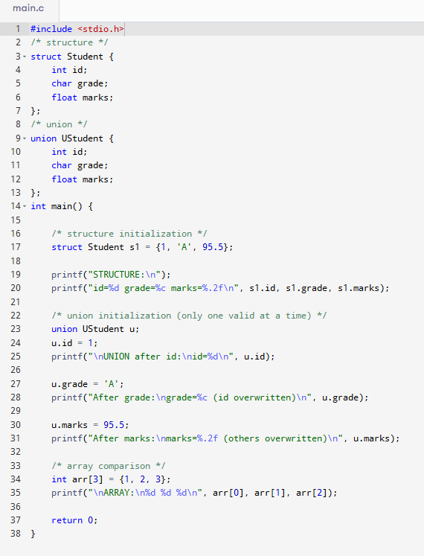

10. Structure Declaration and Initialization
Goal
Understand the proper way to declare and initialize structures using multiple techniques and best practices.
Activity
- Declare structure variables globally, locally, and statically.
- Use designated initializers for clarity.
- Use typedef to create aliases for complex structures.
- Discuss structure initialization in embedded register mapping.
Tip: Static initialization is preferred for compile-time register definitions.
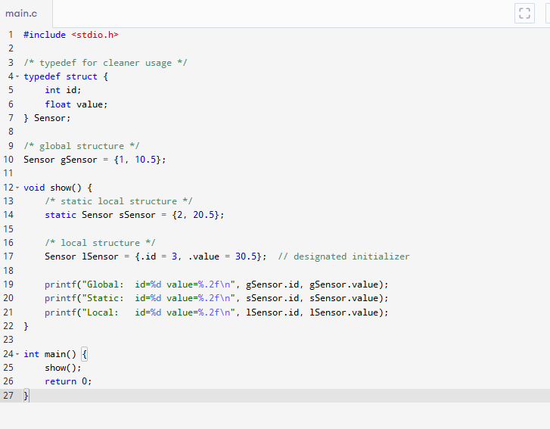

11. Memory Layout of Structures
Goal
Analyze the internal memory layout of structures, including padding, alignment, and impact on memory optimization.
Activity
- Define a structure and use sizeof() to observe unexpected sizes.
- Use different data type orderings and compare structure size.
- Simulate structure layout for peripheral memory mapping.
- Apply structure packing using #pragma and compare memory efficiency.
Tip: Misaligned structures can cause performance hits on some architectures.
