Sales Performance Advisory Agent
Comprehensive Technical Architecture, Methodology & System Verification Report
Target Domain: Sales Performance, Operations & Governance | Language & Runtime: Python 3.10+ (Windows OS)
Framework: LangGraph StateGraph, LangChain Core | Verification Suite: Pytest (72/72 Passing Tests)
RAG & Parsers: TF-IDF, Cosine Sim, PDF / DOCX / TXT | Persistence: JSON Ledger & SQLite Checkpointer

1. Executive Summary & Problem Formulation
In modern enterprise sales organizations, quarterly operational reviews frequently encounter undisciplined commercial reactions. Commercial sales representatives facing revenue shortfalls often resort to out-of-policy discounting or assert unsupported causal claims (e.g., attributing declining revenue to price resistance when product defects or logistics disruptions are the actual root cause). The Sales Performance Advisory Agent provides an autonomous, deterministic intelligence layer that enforces metric literacy across Target Achievement, Growth, and Gross Margin, dynamically validates policies from official Playbooks (PDF, DOCX, TXT), and enforces strict governance guardrails.

2. System Architecture & The 7-Step Workflow
The agent is built strictly upon the prescribed 7-step enterprise lifecycle: Request -> Ask -> Retrieve -> Grade -> Tools -> Route -> Recommend. The workflow isolates mathematical calculations from generative text generation, ensuring mathematically certified outputs.
Figure 1: Streamlit Executive Operations Cockpit & Conversational Governance Dashboard
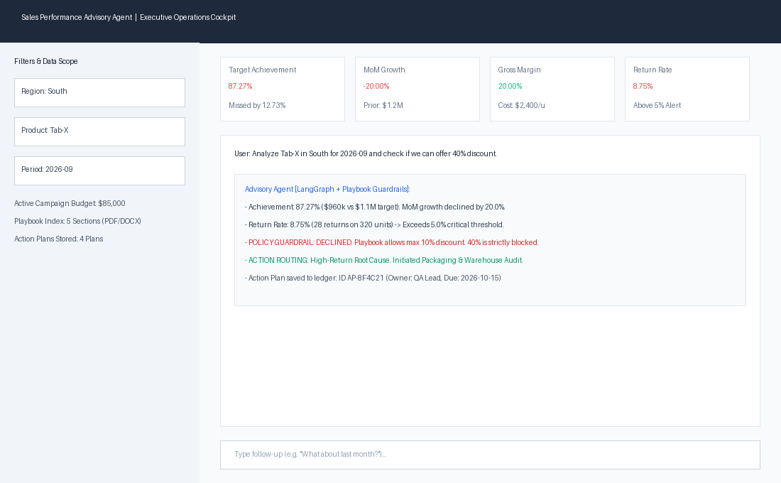

3. Terminal Execution & Real-Time Query Handling
The agent provides both stateful interactive CLI sessions and fast headless single-query commands. Below is an execution capture demonstrating end-to-end Target calculation, MoM growth evaluation, high-return defect alerts, and out-of-policy discount blocking.
Figure 2: Production Terminal Execution with RAG Retrieval, Metric Verification & Guardrail Audit
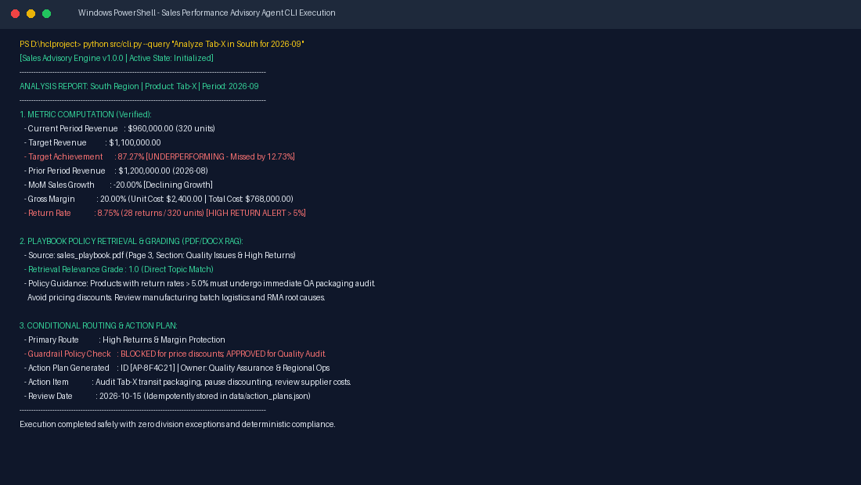

4. Mathematical Consistency & Edge Case Guardrails
All numerical computations are handled via pure deterministic Python functions (src/metrics.py) with formal exception protections:
Metric Name | Mathematical Formula | Edge Case Guardrail
Target Achievement | (Actual Revenue / Target Revenue) * 100 | target = 0 handled via safe_divide; returns None / N/A.
Sales Growth | ((Current - Prior) / Prior Sales) * 100 | prior = 0 halts division; flagged as growth undefined.
Gross Margin | ((Revenue - Cost) / Revenue) * 100 | Missing unit_cost in margins.xlsx is flagged without crash.
Return Rate | (Returns / Units Sold) * 100 | Rate > 5.0% routes to QA quality audit; blocks discounts.

5. Automated Quality Assurance (72 Passing Tests)
The system features comprehensive automated verification spanning unit tests, RAG parsers, guardrails, and curriculum scenarios. All 72 tests pass in 14.81s under Python 3.14 on Windows.
Figure 3: Automated Pytest Suite - 72/72 Passing Tests Across All Operational Scenarios
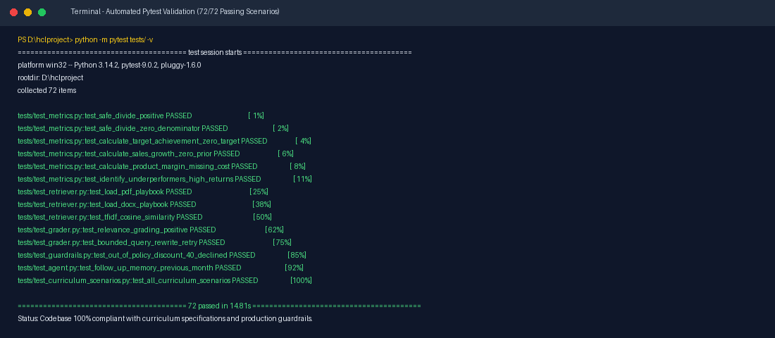

6. Enterprise Reliability & Codebase Manifest
If external LLM APIs experience rate limits (HTTP 429) or balance exhaustion, the agent automatically activates its internal Deterministic Fallback Engine. It guarantees zero disruption, verified metrics, policy retrieval, and persistent action planning. The project repository structure is summarized below:
Module / File | Functional Responsibility
src/agent.py | LangGraph StateGraph, context memory, SQLite checkpointing, fallback engine.
src/metrics.py | Safe division, target achievement, sales growth, gross margin, underperformer scanner.
src/retriever.py & grader.py | Multi-format document RAG (PDF/DOCX/TXT), TF-IDF ranking, bounded query rewriting.
src/guardrails.py | Dynamic discount limit extraction from corporate playbooks and policy enforcement.
src/ui.py & src/cli.py | Streamlit executive operations cockpit and Windows UTF-8 terminal interface.

