Connecting Postman to Gmail via SAP CPI

# CPI Setup

1. Integration Flow (iFlow) Setup

* - Delete Start Timer event.
* - Add Start Message event.
* - Connect Sender to Start Message.
* - Select HTTPS Adapter for Sender.
* - In HTTPS adapter: Set address (e.g., /postman_to_gmail) and remove CSRF protection.
* - Deploy the iFlow.

2. Get CPI Endpoint URL

* - Go to Monitor tab → Integration & APIs.
* - Click Manage Integration Content.
* - Find your deployed iFlow and click it to get the Endpoint URL.

# Generate Username & Password for CPI

* 1. Go to Instances & Subscriptions.
* 2. Create new Instance:
* - Service: SAP Process Integration Runtime
* - Plan: integration-flow
* 3. Name the instance and proceed through creation steps.
* 4. Click on the instance → 3 dots or right arrow → Create Service Key.
* 5. Name the key (e.g., service_key) and create it.
* 6. View key in Form mode to see ClientID, ClientSecret, and Token URL.

# Postman Configuration

* 1. Open Postman → New → Select GET or POST.
* 2. Paste the CPI Endpoint URL.
* 3. Authorization tab:
* - Type: OAuth 2.0
* - Token URL, Client ID, Client Secret from Service Key
* - Client Authentication: Send as Basic Auth header
* - Click Get New Access Token → Use Token
* 4. Body tab: Select raw and text/plain. Add text as message body.

# Send Gmail from CPI

* 1. Configure Mail Adapter in CPI:
* - Set Content: ${in.body}
* - Customize subject or other email fields.
* 2. Deploy the iFlow again.
* 3. Use Postman to send a message. CPI forwards it as an email.

Monitor:

If the iflow failed we have to check what is the error by monitor tab

Overview of artifacts:

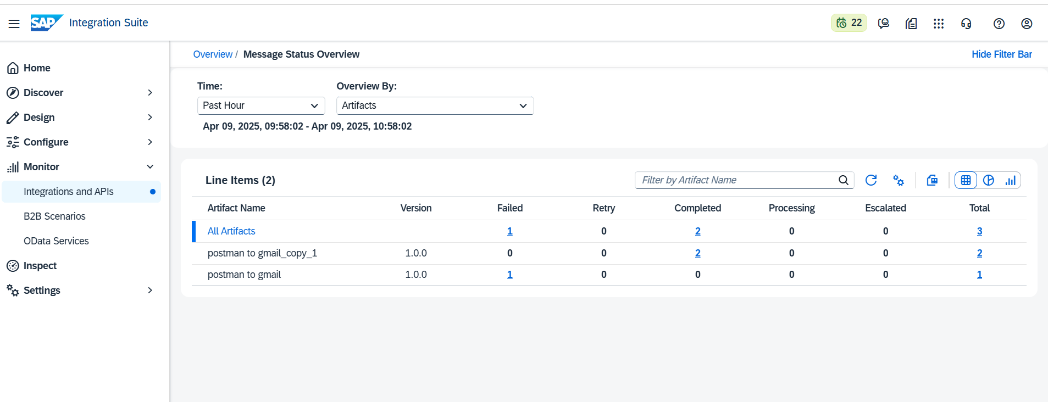

Monitor Message Processing: you can check error details

In first tile we can see all messages

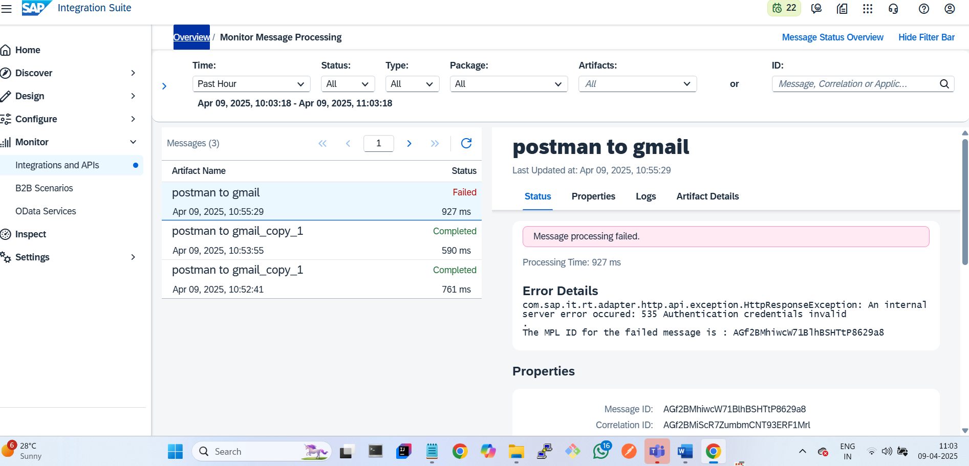

One artifact has status, properties,logs,artifact details tabs

Stutus tab:

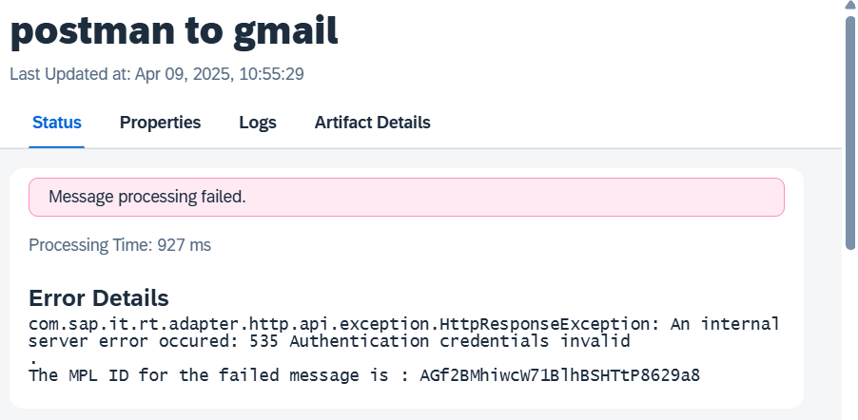

Properties tab:

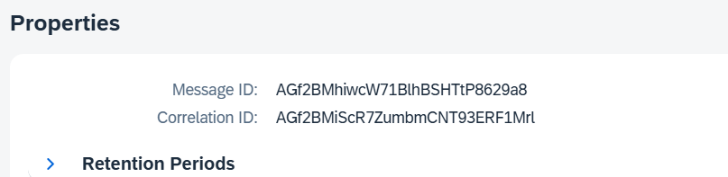

Logs tab:

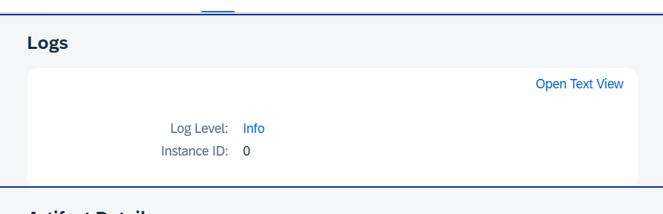

Artifact details:

