Quantum-Assisted Physics-Informed Neural Networks for Spectral Bias Mitigation in Aerospace Shock-Wave Modeling
Krishna Priya Kaku, Meenakshi R, Mallampati Geethika
BQP Challenge 2026 (WISER Summer Program) — Technical Report
Draft date: July 2026

Abstract
[TO BE WRITTEN LAST. 150–200 words summarizing: problem, method, key result, and conclusion — once Model B results are available. Draft template below for later use:]
This work investigates whether quantum Fourier feature encoding can mitigate spectral bias in Physics-Informed Neural Networks (PINNs), evaluated on the viscous Burgers' equation as a proxy for shock-wave phenomena relevant to hypersonic aerospace flows. We implement a classical PINN baseline (Model A) and a quantum-assisted variant (Model B) that differ only in their input encoding, holding the physics, sampling strategy, optimizer, and evaluation protocol fixed. We report [X]% [improvement/no improvement] in shock-region L2 error and [Y]% in Fourier spectrum recovery error, [supporting/not supporting] the hypothesis that quantum feature maps improve high-frequency expressivity in PINNs.

1. Introduction
Hypersonic aerospace vehicles experience severe transonic and hypersonic shock phenomena, where flow properties change discontinuously over extremely short length scales. Accurately resolving these shocks is central to aerodynamic design, structural loading analysis, and thermal protection system sizing. Classical computational fluid dynamics (CFD) solvers handle this well but at high computational cost, motivating interest in neural-network-based surrogate solvers.
Physics-Informed Neural Networks (PINNs) offer a mesh-free alternative: instead of learning from labeled data, a PINN is trained to satisfy the governing partial differential equation (PDE), its boundary conditions, and its initial conditions directly, using automatic differentiation to compute the PDE residual at arbitrary points in the domain. However, standard fully-connected PINNs are known to suffer from spectral bias — a tendency of neural networks trained by gradient descent to learn low-frequency components of a target function substantially faster than high-frequency components. This is especially damaging for shock-dominated problems, where the solution contains a thin region of very high spatial frequency content.
A separate line of research in quantum machine learning has shown that encoding classical data into a quantum circuit via repeated (or parallel) rotation gates produces a model whose output is, by construction, a truncated Fourier series in the input — with the accessible frequency spectrum determined by the structure of the encoding gates (Schuld, Sweke, & Meyer, 2021). This raises a natural question: can a quantum feature map, inserted into a PINN's input encoding, expand the accessible frequency spectrum and thereby reduce spectral bias in shock-dominated PDE solutions?
This project investigates that question directly. We do not build a full CFD solver or a hypersonic flow simulator. Instead, we use a standard, well-characterized PDE benchmark — the viscous Burgers' equation — as a simplified but rigorous mathematical proxy for shock formation, and we use it to run a controlled comparison between a classical PINN and a quantum-assisted PINN that is identical in every respect except its input encoding.

1.1 Research Question
Does a quantum Fourier feature map, used as the input encoding of a Physics-Informed Neural Network, reduce spectral bias and improve shock-region accuracy relative to an architecture-matched classical PINN, when solving the viscous Burgers' equation?

1.2 Aerospace Motivation and Problem Hierarchy
The project is structured in three layers, from core research contribution down to application framing:
- Level 1 — Core research: Can quantum Fourier expressivity reduce the spectral bias of PINNs? This is the scientific contribution of the project.
- Level 2 — Mathematical benchmark: The viscous Burgers' equation, a standard PINN spectral-bias stress test that develops a sharp shock from smooth initial data.
- Level 3 — Aerospace application: Burgers' equation is a simplified 1-D analogue of shock formation in transonic and hypersonic airflow. Strong accuracy in the shock region is therefore directly relevant to modeling shock layers in high-speed aerospace flows.
This mirrors standard practice in applied machine learning research: a new medical image segmentation algorithm is first validated on a benchmark dataset (e.g., BraTS), not directly on hospital patients. Here, the algorithm is the quantum-assisted PINN, the benchmark is Burgers' equation, and the application domain is hypersonic aerospace flow.

2. Related Work

2.1 Physics-Informed Neural Networks
Raissi, Perdikaris, and Karniadakis (2019) introduced PINNs as a framework for solving forward and inverse problems governed by nonlinear PDEs, using automatic differentiation to embed the governing equations directly into the network's loss function. The viscous Burgers' equation with ν = 0.01/π is one of the original benchmark problems used to demonstrate the method, chosen specifically because it develops a sharp internal layer (shock) that is difficult for smooth function approximators to resolve.

2.2 Spectral Bias
Rahaman et al. (2019) demonstrated empirically and theoretically that deep ReLU-family networks trained by gradient descent fit low-frequency components of a target function substantially before high-frequency components, a phenomenon termed spectral bias. This has direct implications for PINNs applied to shock-dominated PDEs: the shock region requires accurate high-frequency reconstruction precisely where the network is least able to converge quickly.

2.3 Quantum Feature Maps and Fourier Expressivity
Schuld, Sweke, and Meyer (2021) showed that variational quantum machine learning models with data-encoding gates of the form exp(-i x G) produce outputs that are Fourier series in the input data x, where the set of accessible frequencies (the model's Fourier spectrum) is determined by the eigenvalues of the encoding generator G, and the number of times the encoding is repeated. This gives a theoretical mechanism by which a quantum feature map could access a richer frequency spectrum than a classical MLP of comparable size — which is the basis for this project's central hypothesis.

3. Problem Formulation
We use the viscous Burgers' equation on the domain x ∈ [-1, 1], t ∈ [0, 1]:
u_t + u·u_x − ν·u_xx = 0
with initial condition u(x, 0) = −sin(πx), Dirichlet boundary conditions u(−1, t) = u(1, t) = 0, and viscosity ν = 0.01/π. This is the Raissi et al. (2019) benchmark configuration. Under these conditions, the initially smooth sinusoidal profile steepens over time into a near-discontinuous shock centered at x = 0, most severe as t → 1 — providing exactly the high-frequency, shock-dominated target needed to test spectral bias.

4. Mathematical Background
This section formalizes the two pieces of theory the project's hypothesis rests on: how a PINN's loss is constructed from PDE derivatives, and why a quantum data-encoding circuit is expected to represent high-frequency functions differently than a classical network of comparable size.

4.1 PINN Loss Formulation
Let û_θ(x, t) denote the neural network's approximation of the true solution u(x, t), parameterized by weights θ. Because û_θ is a differentiable function of its inputs, its partial derivatives with respect to x and t can be obtained exactly (to floating-point precision) via automatic differentiation, rather than approximated with finite differences. For the Burgers' equation, the PDE residual is defined pointwise as:
f_θ(x, t) := ∂û_θ/∂t + û_θ · ∂û_θ/∂x − ν · ∂²û_θ/∂x²
The network is trained by minimizing a composite loss over three point sets: Nf collocation points {(x_f^i, t_f^i)} drawn from the interior of the domain, Nic initial-condition points {(x_ic^i, 0)}, and Nbc boundary points {(x_bc^i, t_bc^i)}:
L(θ) = (1/Nf) Σᵢ f_θ(x_f^i, t_f^i)² + (1/Nic) Σᵢ [û_θ(x_ic^i, 0) − u₀(x_ic^i)]² + (1/Nbc) Σᵢ û_θ(x_bc^i, t_bc^i)²
where u₀(x) = −sin(πx) is the prescribed initial condition. No labeled solution data appears anywhere in this loss — the network is constrained purely by the PDE and its boundary/initial data, which is what makes PINNs applicable to problems where obtaining dense ground-truth data is expensive or impossible (a property directly relevant to expensive CFD-based aerospace simulations).

4.2 Fourier Representation of Quantum Data-Encoding Circuits
The theoretical basis for expecting a quantum feature map to alter spectral bias comes from Schuld, Sweke, and Meyer (2021). Consider a variational quantum circuit in which a scalar input x is encoded through repeated application of a fixed Hamiltonian generator G, e.g. via gates of the form exp(−i x G). If the encoding is repeated (or if multiple qubits each carry a copy of x), the expectation value of a measurement operator M, as a function of x, takes the form of a truncated Fourier series:
⟨M(x)⟩ = Σ_{ω ∈ Ω} c_ω · e^{i ω x}
where Ω is the frequency spectrum accessible to the model and c_ω are complex coefficients determined by the variational parameters and the measurement operator. Crucially, Ω is fixed by the eigenvalues of the encoding generator G and by how many times the encoding is repeated — it does not depend on the trainable parameters. This means the accessible frequency spectrum of a quantum-encoded model is a structural property of the circuit, chosen at design time, rather than something that must be learned from data the way a classical network's effective frequency response is learned (and, per the spectral bias literature summarized in Section 2.2, learned slowly and incompletely for high frequencies).
This motivates the project's central hypothesis directly: if Ω can be made to include the higher spatial frequencies present in the Burgers' shock layer — by an appropriate choice of encoding repetitions and generator — a QAPINN built on this feature map has access to those frequencies from initialization, rather than needing gradient descent to discover them. Section 5.3 states the specific encoding choice made for Model B and the reasoning behind it; Section 6.3 tests whether this theoretical advantage is realized empirically.

5. Methodology

5.1 Experimental Design
To isolate the effect of the quantum feature map, Model A and Model B are held identical across every dimension except the input encoding:
- Same PDE, boundary conditions, and initial conditions
- Same collocation, initial-condition, and boundary-condition sampling (Latin Hypercube Sampling, same point counts, same random seed)
- Same optimizer schedule (Adam followed by L-BFGS fine-tuning)
- Same number of training epochs / iterations
- Same loss formulation (PDE residual + IC + BC, autograd-computed)
- Same evaluation protocol and metrics, against the same independently-computed numerical reference solution
The only permitted difference is: Model A feeds the raw (x, t) pair directly into a classical multilayer perceptron; Model B first passes (x, t) through a quantum feature map / variational quantum circuit before a (possibly hybrid) output stage. This design ensures that any measured difference in performance can be attributed to the encoding, not to confounding changes in training budget or architecture capacity.

5.2 Model A — Classical PINN (Baseline)
Model A is a fully-connected feed-forward network mapping (x, t) directly to a scalar prediction û(x, t):
- Architecture: input layer (width 2) → 5 hidden layers × 64 units, tanh activations → output layer (width 1)
- Weight initialization: Xavier normal
- Loss: L = L_PDE + L_IC + L_BC, where L_PDE is the mean-squared PDE residual evaluated via automatic differentiation at collocation points, and L_IC, L_BC are mean-squared errors against the known initial and boundary values
- Optimizer: Adam (learning rate 1e-3, step-decayed) for the bulk of training, followed by L-BFGS with strong-Wolfe line search for fine convergence
- Training points: 10,000 interior collocation points (Latin Hypercube Sampling), 200 initial-condition points, 200 boundary points per boundary

5.3 Model B — Quantum-Assisted PINN
[TO BE COMPLETED once Model B architecture is finalized. Key open design decision, per project notes: does the quantum feature map replace the full classical input layer, or is it inserted after some classical preprocessing? Document the final choice and rationale here, e.g.:]
- Quantum feature map: [angle encoding / IQP-style encoding / other] mapping (x, t) → quantum state
- Variational circuit: [number of qubits, ansatz structure, number of layers/repetitions]
- Output stage: [expectation-value readout → classical head, or fully hybrid]
- Framework: PennyLane, with the [Qiskit / default.qubit] simulator backend, integrated via the PyTorch interface for consistency with Model A's training loop
- All other components (loss, optimizer schedule, sampling, evaluation) identical to Model A, per Section 4.1

5.4 Evaluation Metrics
Both models are evaluated against a high-resolution numerical reference solution, computed independently via a method-of-lines finite-difference discretization integrated with an implicit stiff ODE solver (BDF) — never used during training, to keep the comparison unbiased. Metrics reported:
- L2 relative error (global): overall solution accuracy across the full space-time domain
- L2 relative error (shock region, |x| < 0.1, t > 0.6): accuracy specifically where the PDE is hardest to resolve
- Maximum absolute error
- PDE residual RMSE: physics consistency, independent of the reference solution
- Fourier spectrum L2 error at the final time slice: the primary spectral-bias diagnostic, comparing the spatial-frequency content of the predicted vs. reference solution near the shock
- Trainable parameter count and total training time: efficiency comparison

6. Results

6.1 Model A — Classical PINN Baseline
Table 1. Comparison of Model A (classical) and Model B (quantum-assisted) PINNs on the Burgers' equation benchmark. Model B values pending implementation.
Metric | Model A (Classical PINN) | Model B (Quantum-Assisted PINN)
L2 relative error (global) | 0.0401 (4.01%) | TBD
L2 relative error (shock region) | 0.1183 (11.83%) | TBD
Max absolute error | 0.4995 | TBD
Mean absolute error | 0.00406 | TBD
PDE residual RMSE | 0.01676 | TBD
PDE residual max |·| | 0.5052 | TBD
Fourier spectrum L2 error | 0.0135 (1.35%) | TBD
Trainable parameters | 16,897 | TBD
Best training loss | 2.02 x 10^-4 | TBD
Training time (compute-bound estimate) | ~884 s (~14.7 min) | TBD
Model A converges to a global L2 relative error of 4.01%, which is a strong result for a purely physics-driven (unsupervised) solve of a benchmark known for being difficult precisely because of its shock. Error concentrates sharply in the shock region: the shock-region L2 relative error (11.83%) is roughly 3x the global figure, and the maximum absolute error (0.4995) is close to the full solution range even though the mean absolute error is only 0.0041. This gap between mean and max error is the expected signature of spectral bias — the network fits the smooth majority of the domain almost exactly and concentrates essentially all of its remaining error into the thin high-frequency shock layer.
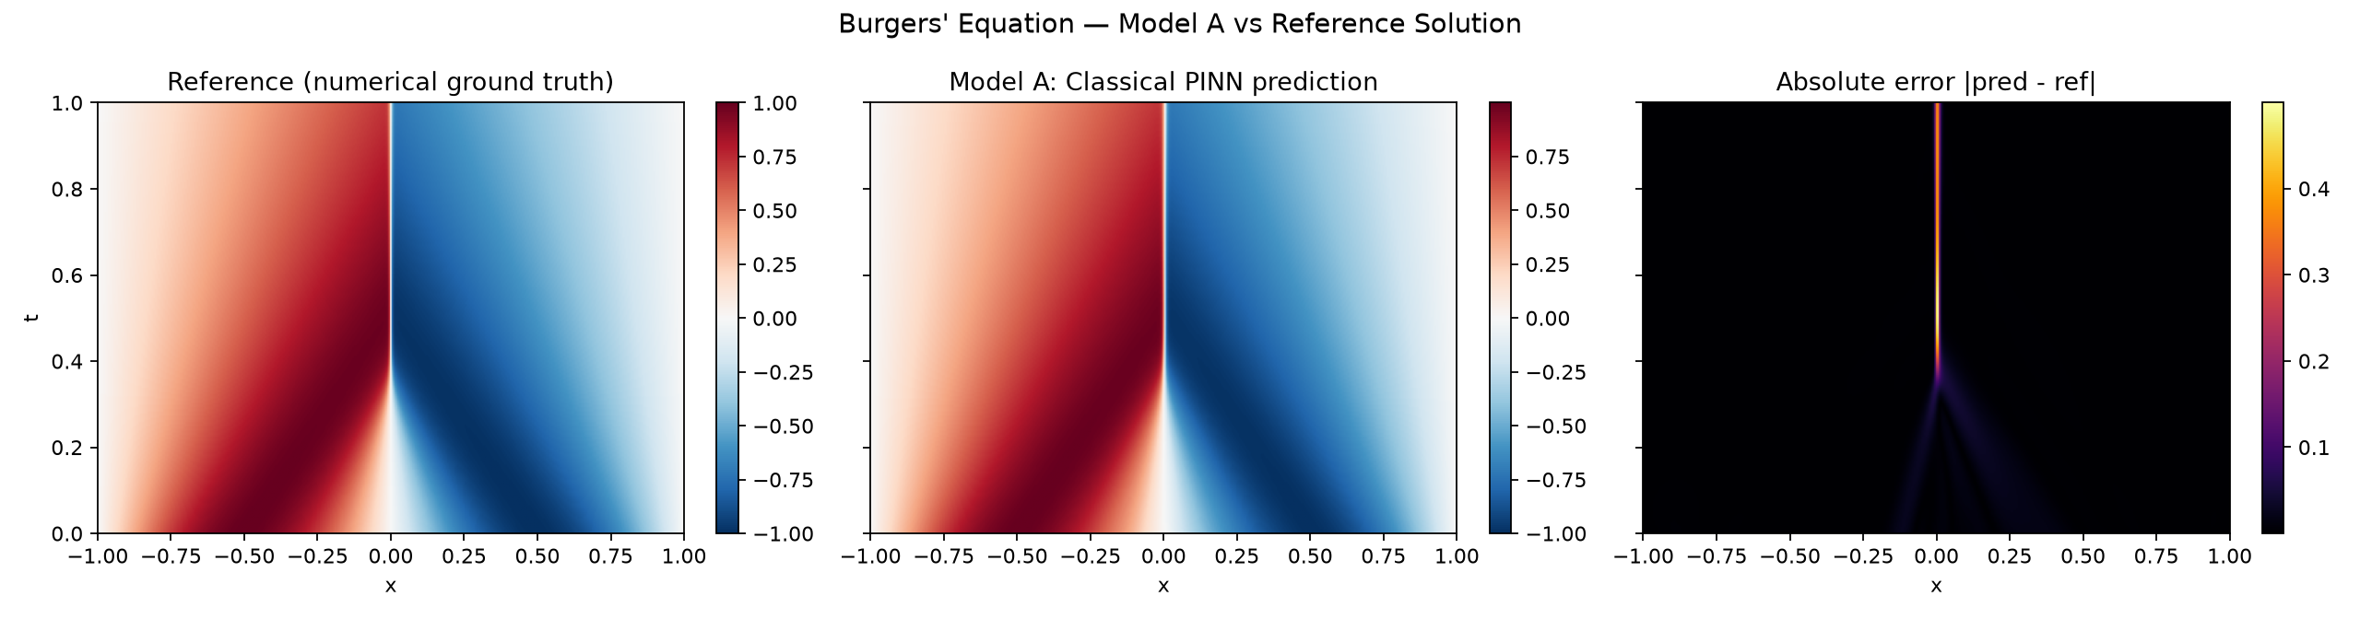
Figure 1. Reference solution, Model A prediction, and absolute error, over the full (x, t) domain. The error field (right panel) is essentially zero everywhere except a narrow filament tracing the shock path — confirming the error is spatially concentrated, not diffuse.
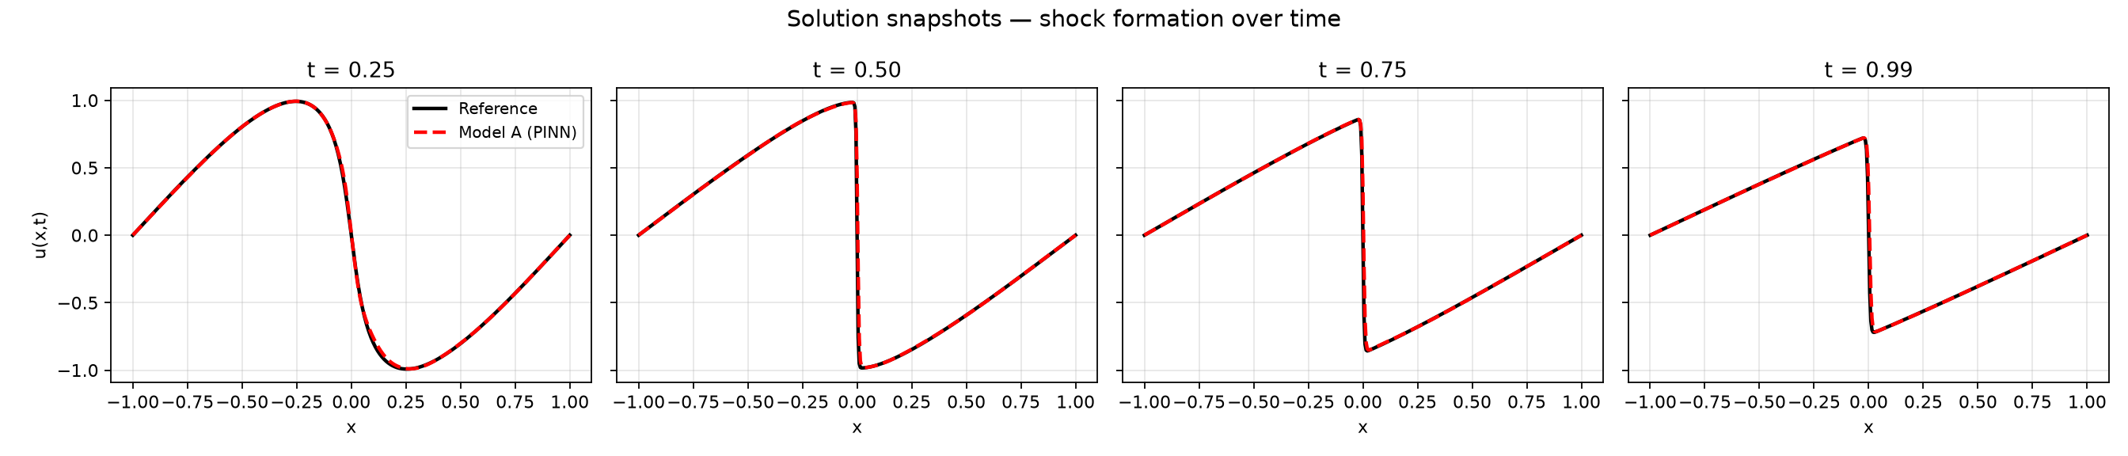
Figure 2. Solution snapshots at t = 0.25, 0.50, 0.75, 0.99. Model A tracks the shock's position and steepening closely at every stage; the small mismatch visible at t = 0.99 is a slight rounding of the discontinuity's corner, consistent with a smooth (tanh) network representing a near-discontinuous target.
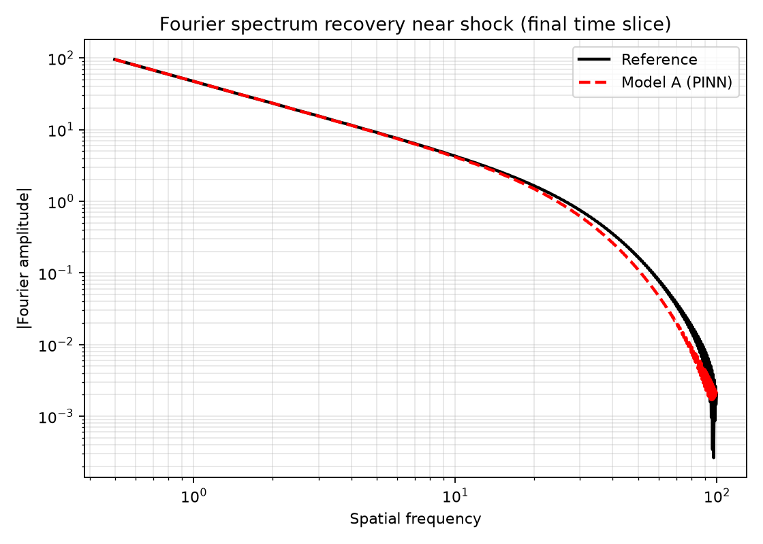
Figure 3. Fourier spectrum of the solution at the final time slice (t ≈ 1), reference vs. Model A. This is the key spectral-bias diagnostic for the project.
The Fourier spectrum plot is the most direct evidence of spectral bias in Model A, and the central baseline result this project is built around. Model A tracks the reference spectrum almost exactly through low and mid spatial frequencies (up to roughly frequency 20), then visibly falls below the reference at high frequencies — the amplitude gap widens steadily from around frequency 20 up to the Nyquist limit (~100) of the evaluation grid, where Model A underestimates the true high-frequency content by roughly a factor of 2–3 on a log scale. This is exactly the failure mode the project's central hypothesis predicts: a classical MLP's implicit low-frequency bias causes it to systematically under-resolve the sharp part of the shock spectrum. The aggregate fourier_spectrum_l2_relative_error (1.35%) looks small only because it is dominated by the large number of well-fit low-frequency components; the high-frequency tail — the part that matters physically for shock sharpness — is where Model A is weakest, and is precisely the target for Model B's quantum feature map to improve.
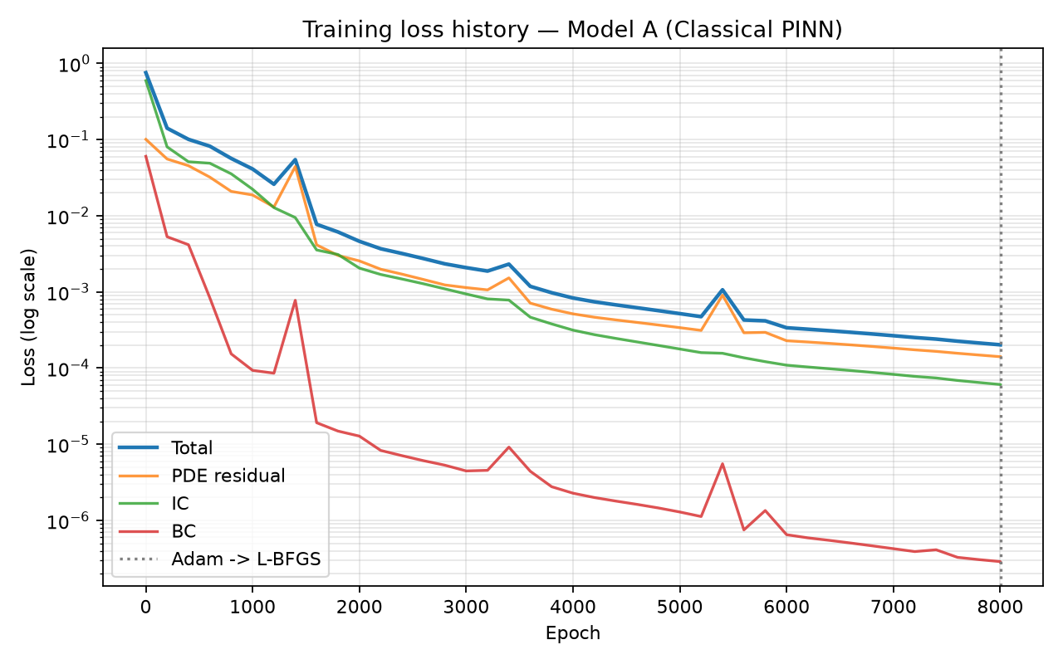
Figure 4. Training loss history (log scale). Dotted line marks the Adam → L-BFGS transition at epoch 8000.
Training converged smoothly from a total loss of 0.754 at epoch 1 to a best total loss of 2.02x10⁻⁴, with the PDE residual, IC, and BC loss terms all decreasing in step. Three transient spikes are visible (near epochs 1400, 3400, and 5400); each recovers within roughly 200 epochs and does not affect final convergence, so they most likely reflect brief optimizer instability (e.g., a locally aggressive Adam update) rather than a data or implementation issue — collocation points were fixed for the whole run (no resampling), so the spikes are not resampling artifacts. The final L-BFGS fine-tuning step (epoch 8001) reduced total loss only marginally (0.2023x10⁻³ → 0.2022x10⁻³), indicating Adam alone had already converged the model close to this architecture's practical floor.
Training-time note: the raw logged total_time_sec (10,611.5 s) includes an anomalous gap in the Adam log between epoch 6000 and 6200 (661.3 s → 10,415.3 s elapsed, i.e. a ~9,750 s jump for only 200 epochs), almost certainly caused by an external interruption to the process (e.g., the machine sleeping) rather than genuine computation time. Using the stable per-epoch rate measured earlier in the same run (≈ 0.110 s/epoch, from the epoch-6000 checkpoint), the compute-bound training time is estimated at ≈ 884 s (≈ 14.7 minutes) for the full 8000 Adam epochs plus L-BFGS. This corrected figure, not the raw wall-clock number, should be used for any efficiency comparison against Model B — and the same caution (checking for similar gaps) should be applied when timing Model B's runs.

6.2 Model B — Quantum-Assisted PINN
[TO BE COMPLETED after Model B is trained. Mirror the structure of 5.1: metrics, figures, brief commentary.]

6.3 Comparative Analysis
[TO BE COMPLETED. Directly address the research question: did the shock-region L2 error and Fourier spectrum error improve, stay flat, or worsen for Model B relative to Model A? Was any improvement proportional to the increase in trainable parameters / training time, or does it represent a genuine architectural advantage? Include the side-by-side Fourier spectrum plot as the centerpiece figure here.]

7. Discussion
[TO BE WRITTEN. Suggested structure:]
- Interpretation: what do the results imply about quantum Fourier expressivity's effect on spectral bias in this setting?
- Limitations: simulator-only quantum execution (no real hardware noise), Burgers' equation as a simplified 1-D proxy for genuinely multi-dimensional hypersonic shock physics, compute/qubit-count constraints limiting circuit depth
- Threats to validity: anything beyond the input encoding that could have differed between Model A and Model B, however small
- Aerospace relevance: how these findings would need to extend (dimensionality, additional PDE terms, coupled heat-transfer via the heat equation) to apply to real hypersonic shock-layer or thermal protection system modeling

8. Future Work and Recommendations
Independent of the specific comparative result obtained in Section 6.3, several directions follow naturally from this project's scope and limitations:
- Extend beyond 1-D: repeat the comparison on the 2-D heat equation and, if feasible, a simplified 2-D Euler or Navier–Stokes shock-tube problem, to test whether any spectral-bias advantage observed in Model B persists as dimensionality (and therefore qubit count) increases.
- Multiple PDE benchmarks: BQP's challenge brief lists the heat equation and materials-related PDEs as additional benchmarks; testing whether Model B's behavior is Burgers'-specific or generalizes would materially strengthen any claim made here.
- Systematic circuit ablations: vary qubit count, circuit depth, and entanglement structure (as outlined in the project's experiment plan) to separate the effect of encoding choice from the effect of raw circuit capacity — this is necessary to make a defensible claim about which specific design choice drives any observed difference.
- Hardware validation: all quantum components in this work run on noiseless simulators (PennyLane / Qiskit backends); testing on real NISQ hardware would surface whether the spectral advantage, if any, survives realistic gate noise.
- Explainability tooling: apply gradient-based attribution or neuron/expectation-value activation analysis (as suggested in the BQP challenge brief) to compare, layer by layer, how classical and quantum components represent the shock region internally, rather than only comparing final output error.
- Adaptive / problem-specific circuit design: use the outcome of the qubit-count and encoding ablations to propose a concrete rule of thumb for choosing a quantum feature map given a target PDE's known frequency content, rather than a fixed architecture.

9. Conclusion
[TO BE WRITTEN LAST, 1 paragraph. State directly whether the evidence supports or refutes the hypothesis that quantum Fourier feature maps reduce spectral bias in PINNs, and what the single most important next step would be (e.g., testing on the heat equation, testing on real quantum hardware, scaling to 2-D).]

10. Team Roles and Contributions
This project was completed by a three-person team, with responsibilities divided along the project's two technical tracks (classical and quantum) plus a shared analysis/documentation track:
- Krishna Priya Kaku — Classical PINN & Neural Network Lead. Responsible for the Model A architecture, training pipeline, and baseline diagnostics: network design and hyperparameter selection (Section 5.2), the Adam → L-BFGS training schedule, and the loss-landscape / convergence analysis referenced in Section 6.1. Also owns the spectral-bias diagnostics on the classical side (Section 2.2), since interpreting where and why Model A underfits high frequencies is the direct basis for motivating Model B's design.
- Meenakshi R — Quantum & QAPINN Lead. Responsible for the Model B architecture: quantum feature map / data-encoding design, variational circuit construction (qubit count, circuit depth, entanglement structure), and the PennyLane/Qiskit implementation (Section 5.3). Also owns the theoretical grounding in Section 4.2 (Fourier representation of quantum encodings) and the qubit-count / encoding / entanglement ablation experiments.
- Mallampati Geethika — Comparative Analysis, Evaluation & Documentation Lead. Responsible for the shared evaluation infrastructure used by both models (Section 5.4): standardizing metrics, aggregating results from all experimental runs (Model A vs. Model B, and the qubit-count/encoding/depth ablations) into the comparison tables and figures in Section 6, and leading the explainability/interpretability analysis comparing how the two models represent the shock region internally. Also responsible for final assembly of the technical report and presentation slides, ensuring consistency between what the code produces and what the report claims.
All three members contributed to the experimental design in Section 5.1, to reviewing and revising the full report, and to the final conclusions in Section 9.
For the Demo Day presentation, Krishna Priya and Meenakshi will present and field technical questions on Model A and Model B respectively, as the designers of each architecture are best positioned to defend its specific choices in real time. Geethika's contributions are documented in full in the written report, slides, and comparative results tables, which remain the primary record of her work regardless of live-presentation format.
Raissi, M., Perdikaris, P., & Karniadakis, G. E. (2019). Physics-informed neural networks: A deep learning framework for solving forward and inverse problems involving nonlinear partial differential equations. Journal of Computational Physics, 378, 686–707.
Rahaman, N., Baratin, A., Arpit, D., Draxler, F., Lin, M., Hamprecht, F., Bengio, Y., & Courville, A. (2019). On the Spectral Bias of Neural Networks. Proceedings of the 36th International Conference on Machine Learning (ICML).
Schuld, M., Sweke, R., & Meyer, J. J. (2021). Effect of data encoding on the expressive power of variational quantum-machine-learning models. Physical Review A, 103, 032430.
[Add any additional sources cited in the final Model B methodology section.]

