Quantum-Assisted Physics-Informed Neural Networks for Aerospace Shock-Wave Modeling: A Mechanistic Investigation of Representation, Optimization, and Spectral Bias
Meenakshi R, Krishna Priya Kaku, Mallampati Geethika
BQP Challenge 2026 (WISER Summer Program) — Technical Report

Abstract
Accurate learning of shock-dominated PDE solutions remains challenging because Physics-Informed Neural Networks (PINNs) exhibit spectral bias, learning smooth, low-frequency solution components faster than sharp, high-frequency features such as shocks. We investigate whether a quantum data-encoding feature map — motivated by the theoretical result that such encodings produce Fourier-series outputs — can mitigate this bias in a hybrid Quantum-Assisted PINN (QAPINN), using the viscous Burgers' equation as a shock-dominated benchmark relevant to hypersonic aerospace flow. A classical PINN baseline (Model A) and a series of QAPINN configurations (Model B) were evaluated under a controlled protocol. The initial QAPINN configuration underperformed the classical baseline substantially, converging during Adam optimization toward a near-trivial solution. Systematic ablation across qubit count, circuit depth, entanglement pattern, and data encoding identified encoding as the only architectural factor with a clean, unconfounded effect on performance. Amplitude encoding combined with L-BFGS refinement and an extended training budget reduced the global L2 error from 98.36% to 47.02% and the Fourier-domain error from 88.90% to 33.45%, without increasing the underlying 85-parameter model's capacity. The classical PINN nonetheless remained the stronger performer throughout. We conclude that representation and optimization strategy — not circuit size — are the dominant factors governing QAPINN performance on this benchmark, and that this work's primary contribution is a characterization of the QAPINN design space rather than a demonstration of quantum advantage.

Contributions
The contributions of this work are:
- Development of a controlled Classical PINN vs. QAPINN comparison framework, sharing every component except input encoding between the two models.
- Systematic investigation of representation, optimizer behavior, and circuit architecture through controlled ablations and targeted follow-up experiments.
- Evidence that encoding strategy and optimization strategy dominate QAPINN performance on this benchmark, whereas qubit count, circuit depth, and entanglement pattern do not, under the settings evaluated.

1. Introduction
Hypersonic aerospace vehicles experience shock phenomena in which flow properties change discontinuously over very short length scales. Resolving these shocks accurately matters for aerodynamic design, structural loading, and thermal protection system sizing. Classical CFD solvers handle this well but at high computational cost, motivating interest in neural-network surrogate solvers.
Physics-Informed Neural Networks (PINNs) train a network to satisfy a governing PDE, plus its boundary and initial conditions, using automatic differentiation — with no labeled solution data required. Standard fully-connected PINNs, however, suffer from spectral bias: gradient descent fits low-frequency components of a target function faster than high-frequency ones. This is especially damaging for shock-dominated problems, since the shock itself is the highest-frequency feature in the domain.
Separately, quantum machine learning research has shown that a quantum circuit encoding classical data via repeated rotation gates produces an output that is, by construction, a Fourier series in the input, with the accessible frequency spectrum fixed by the encoding's structure (Schuld, Sweke, & Meyer, 2021). This raises a direct question: can such an encoding, used as a PINN's input layer, expand its accessible frequency spectrum and thereby reduce spectral bias at the shock?
We evaluate this question on the viscous Burgers' equation — a standard, well-characterized benchmark that develops a sharp shock from smooth initial data — rather than a full CFD solver or flow simulator. This mirrors standard practice in applied ML research: a new algorithm is first validated on a benchmark before deployment on real data. Here, the algorithm is the QAPINN, the benchmark is Burgers' equation, and the target application is hypersonic aerospace flow.
Despite rapid progress in quantum machine learning, there is comparatively little understanding of which architectural components of hybrid quantum PINNs actually influence performance. This work addresses that gap directly, treating the QAPINN's design choices — not just its headline accuracy — as the object of study.

1.1 Research Question
Does a quantum feature map, used as a PINN's input encoding, reduce spectral bias and improve shock-region accuracy relative to a classical PINN on the viscous Burgers' equation — and if the improvement does not fully materialize, which architectural and optimization factors explain why?

1.2 Aerospace Motivation and Problem Hierarchy
The project is structured hierarchically. At the core is the scientific question of whether quantum feature maps can reduce PINN spectral bias. This is investigated using the viscous Burgers' equation as a controlled mathematical benchmark, chosen as a one-dimensional analogue of shock formation in hypersonic aerospace flow.

2. Related Work

2.1 Physics-Informed Neural Networks
Raissi, Perdikaris, and Karniadakis (2019) introduced PINNs, embedding a governing PDE directly into a network's loss via automatic differentiation. The viscous Burgers' equation with ν = 0.01/π is one of their original benchmarks, chosen because it develops a sharp internal layer that is difficult for smooth function approximators to resolve.

2.2 Spectral Bias
Rahaman et al. (2019) showed that deep networks trained by gradient descent fit low-frequency components of a target function well before high-frequency components. For shock-dominated PDEs, this means the shock — the highest-frequency feature — is systematically the hardest and slowest part of the solution for a PINN to learn.

2.3 Quantum Feature Maps and Fourier Expressivity
Schuld, Sweke, and Meyer (2021) showed that a variational quantum circuit encoding data via gates of the form exp(−i x G) produces an output that is a Fourier series in x, with the accessible frequency spectrum fixed by the eigenvalues of the encoding generator G and by how many times the encoding repeats. This is the theoretical basis for this project's hypothesis: a quantum feature map could, in principle, access frequency content a classical MLP of comparable size cannot.
Existing work motivates the use of quantum feature maps in principle, but comparatively few studies isolate the individual contribution of encoding, circuit architecture, optimizer behavior, and training budget through controlled experiments on a shared benchmark. This gap motivates the present study.

3. Problem Formulation
We use the viscous Burgers' equation on x ∈ [-1, 1], t ∈ [0, 1]:
u_t + u·u_x − ν·u_xx = 0
with u(x, 0) = −sin(πx), u(−1, t) = u(1, t) = 0, and ν = 0.01/π — the Raissi et al. (2019) configuration. The initially smooth profile steepens into a near-discontinuous shock centered at x = 0, most severe as t → 1.

4. Mathematical Background

4.1 PINN Loss Formulation
Let û_θ(x, t) denote the network's approximation of u(x, t). The PDE residual is:
f_θ(x, t) := ∂û_θ/∂t + û_θ · ∂û_θ/∂x − ν · ∂²û_θ/∂x²
Training minimizes a composite loss over collocation, initial-condition, and boundary points:
L(θ) = (1/Nf) Σ f_θ² + (1/Nic) Σ [û_θ(x,0) − u₀(x)]² + (1/Nbc) Σ û_θ(boundary)²
No labeled solution data appears anywhere — the network is constrained purely by physics, which is what makes PINNs applicable where dense ground truth is expensive (as in real CFD-based aerospace simulation).

4.2 Fourier Representation of Quantum Data-Encoding Circuits
Following Schuld, Sweke & Meyer (2021): for a circuit encoding scalar input x via repeated gates exp(−i x G), the expectation value of a measurement operator M is a truncated Fourier series:
⟨M(x)⟩ = Σ_{ω∈Ω} c_ω · e^{iωx}
where the frequency set Ω is fixed by the encoding generator's eigenvalues and repetition count — not by the trainable parameters. Only the coefficients c_ω are learned; more circuit depth, more qubits, or different entanglement can reweight frequencies already in Ω, but cannot add a frequency the encoding never exposed. This is the specific mechanism motivating Model B's angle-reuploading design (Section 5.3), and — as Section 7.2 discusses — the specific mechanism the ablation results in Section 6.3 are consistent with.

5. Methodology

5.1 Experimental Design
Model A and Model B are held identical except for input encoding: same PDE/BC/IC, same Latin Hypercube sampling strategy, same Adam → L-BFGS optimizer schedule, same 1:1:1 loss weighting, same evaluation protocol against an independent numerical reference solution.
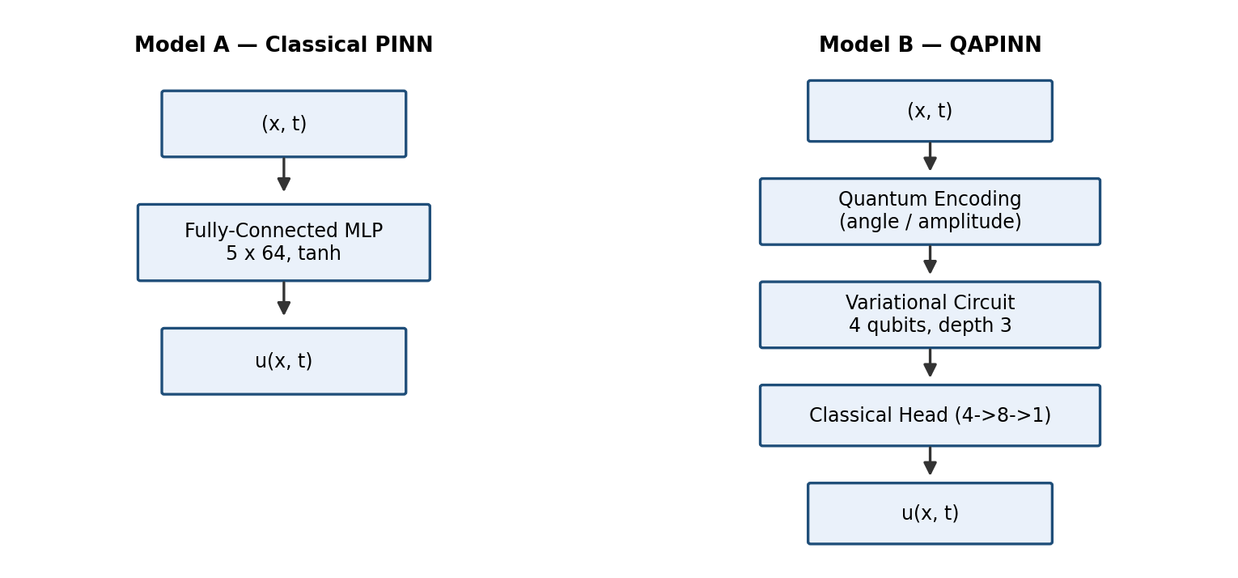
Figure 1. Architecture comparison — Model A (classical MLP) vs. Model B (quantum encoding + variational circuit + classical head).
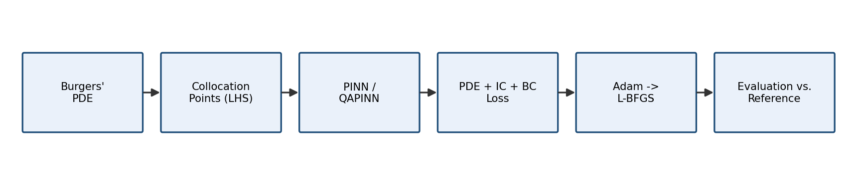
Figure 2. Shared training pipeline for both models.
Disclosed deviation: Model B's default training budget (4,000 collocation points, 3,000 Adam epochs) is smaller than Model A's (10,000 / 8,000), because simulating and double differentiating through a quantum circuit is substantially more expensive per point. This deviation is tested directly, not left as an assumption — see Section 6.6.
5.2 Model A — Classical PINN (Baseline)
Model A is a 5-layer tanh PINN with Xavier initialization, trained using Adam followed by L-BFGS on 10,000 LHS collocation points together with initial and boundary condition samples.

5.3 Model B — Quantum-Assisted PINN
Model B replaces the classical input representation entirely with a quantum circuit ("direct" input mode), making quantum encoding the first operation applied to the normalized spatial-temporal coordinates. Unlike Model A, which first projects the input through a fully connected layer before feature extraction, Model B directly maps the normalized coordinates into a quantum feature map. Consequently, the quantum encoding becomes the first representation stage, allowing the variational quantum circuit to operate directly on quantum-encoded spatial information rather than on classically transformed features. The default implementation employs angle re-uploading encoding, where (x,t) are re-encoded using RY and RZ rotations before every variational layer to improve representational capacity, as discussed in Section 4.2.
The default quantum circuit consists of 4 qubits, 3 variational layers, and circular entanglement. Controlled ablation experiments additionally evaluate qubit counts {2, 4, 6}, circuit depths {1, 2, 4}, entanglement patterns {linear, circular, full}, and encoding strategies {angle, angle re-uploading, amplitude}, with the results presented in Section 6.3. Quantum measurements are obtained from Pauli-Z expectation values on each qubit and passed to a lightweight classical readout network (4→8→1) to predict (x,t). The implementation uses PennyLane with the default.qubit simulator and backpropagation-based automatic differentiation, enabling the second-order derivatives required for PDE residual evaluation. The complete Model B contains only 85 trainable parameters, approximately 0.50% of Model A's 16,897 parameters.
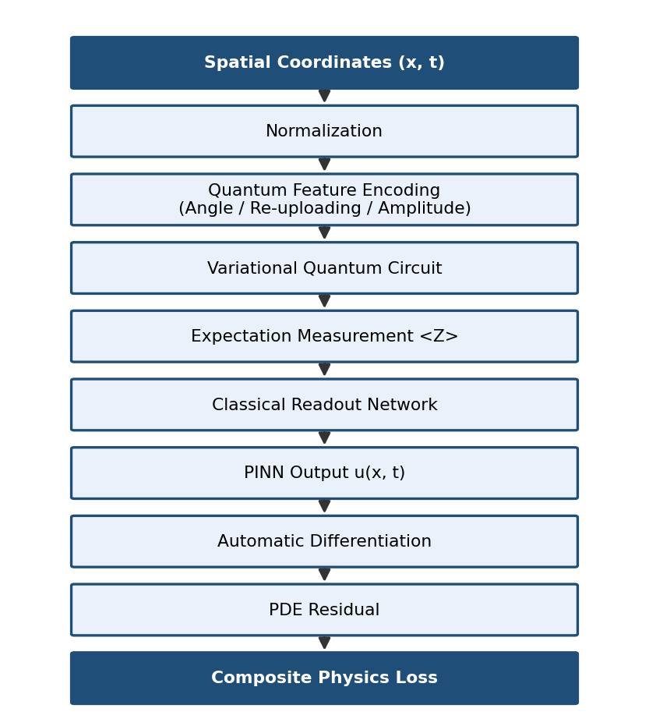
Figure 3. Detailed Model B pipeline, from spatial coordinates through the composite physics loss.

5.4 Evaluation Metrics
Metric | Question it answers
L2 relative error (global / shock-region) | How far off is the prediction, overall and specifically at the shock?
PDE residual (mean / max / RMSE) | How well does the prediction satisfy the physics itself, independent of the true solution?
Fourier spectrum L2 error | How well does the predicted solution's frequency content match the true solution's — the direct test of the spectral-bias hypothesis
Trainable parameters | Model capacity
Training time | Compute cost

5.5 Experimental Workflow
Beyond the initial Model A vs. Model B comparison, the project followed an evidence-driven sequence of experiments, each motivated by the previous result rather than planned in full:
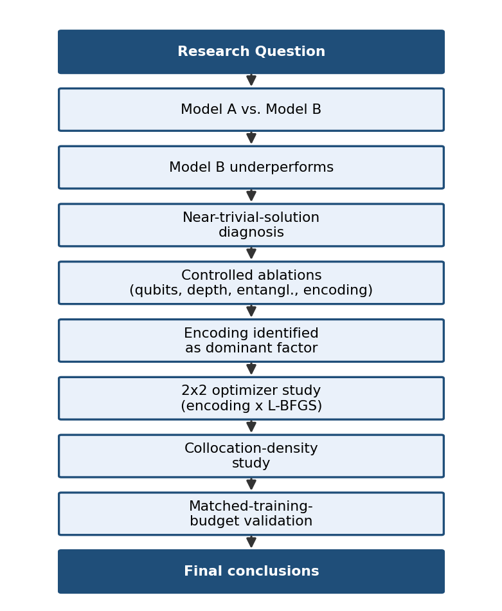
Figure 4. Experimental workflow — each stage was motivated by the finding of the one before it.

6. Results

6.1 Model A — Classical PINN Baseline
Metric | Value
L2 relative error (global) | 4.01%
L2 relative error (shock region) | 11.83%
Fourier spectrum L2 error | 1.35%
PDE residual RMSE | 0.0168
Trainable parameters | 16,897
Training time | ~884s (~14.7 min)

Model A tracks the reference spectrum almost exactly at low/mid frequencies, then measurably falls off at high frequencies — the expected spectral-bias signature, and the baseline every Model B result below is measured against.

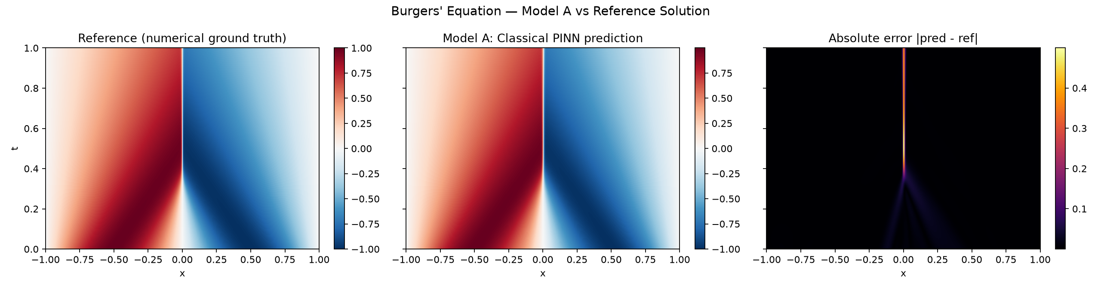
Figure 5. Model A: reference, prediction, and absolute error.
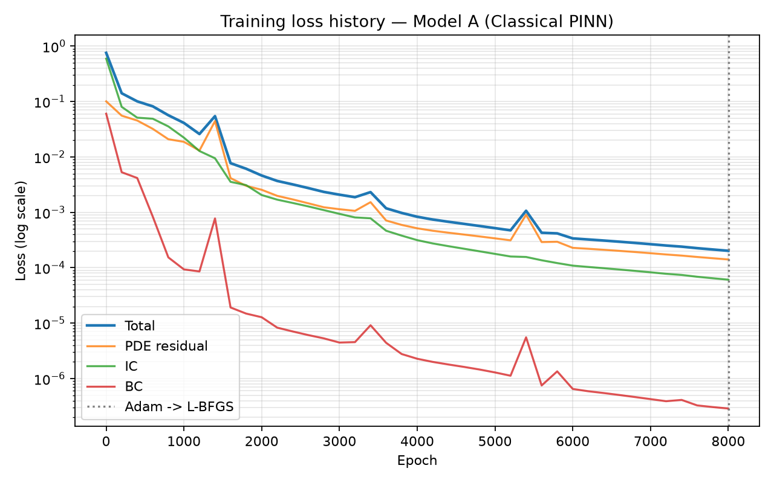
Figure 6. Model A: training loss history.

6.2 Model B Baseline — and the Near-Trivial-Solution Diagnosis
Metric | Model A | Model B (baseline)
L2 relative error (global) | 4.01% | 98.36%
L2 relative error (shock region) | 11.83% | 99.85%
Fourier spectrum L2 error | 1.35% | 88.90%
PDE residual RMSE | 0.0168 | 0.1785
Trainable parameters | 16,897 | 85

During Adam training, Model B's PDE and boundary losses dropped to near-zero within ~600 epochs, but the initial-condition loss plateaued at 0.465–0.467 for the remaining ~2,400 epochs. This value is close to the loss a model predicting u≡0 would obtain against u₀(x)=−sin(πx): E[sin²(πx)] = 0.5 exactly. Since u≡0 also trivially satisfies the PDE residual and boundary conditions, this pattern — near-zero PDE/BC loss with IC loss near 0.5 — is consistent with convergence toward a near-trivial solution, a failure mode documented by Wang, Teng, & Perdikaris (2021) for PINNs with imbalanced loss-term gradients.
L-BFGS partially recovered from this: IC loss fell from 0.4645 to 0.4091 over 300 iterations while PDE loss rose only moderately (0.0032 → 0.0294), improving global L2 error from 99.86% (Adam-only) to 98.36% and Fourier error from 98.67% to 88.90% — real improvement, not enough to approach Model A.

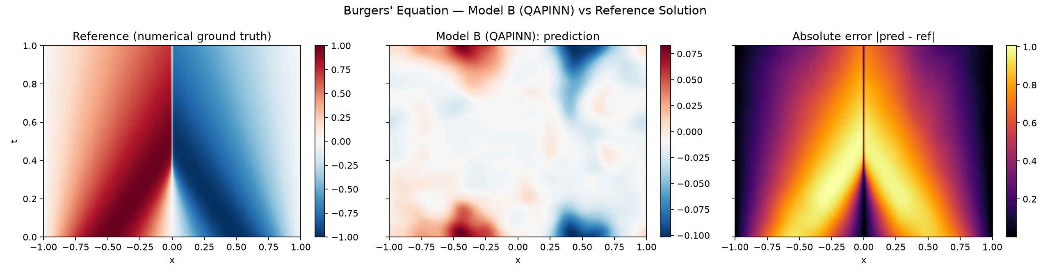
Figure 7. Model B (baseline config): reference, prediction, and absolute error.

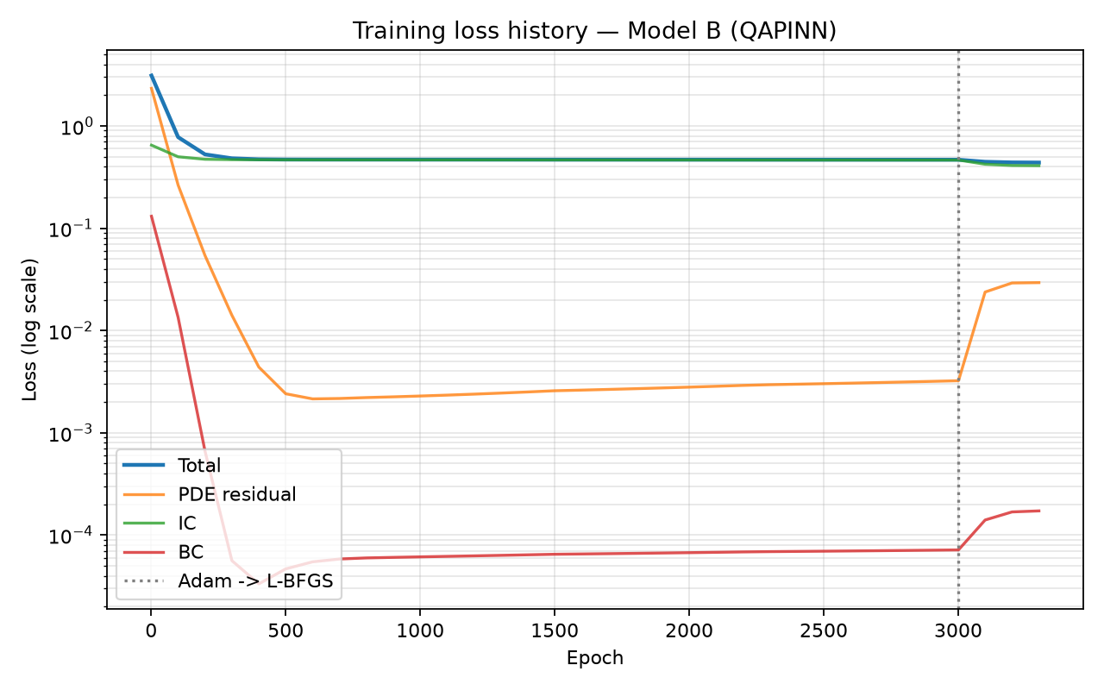
Figure 8. Model B (baseline config): training loss history.

6.3 Ablation Study: Qubits, Depth, Entanglement, Encoding
All ablation runs used a reduced budget (800 collocation points, 300 Adam epochs, L-BFGS off) to make a 12-run sweep tractable. This means every angle-based variant's Adam phase plateaus at the same near-trivial-solution ceiling described in Section 6.2 — so the qubit, depth, and entanglement axes are confounded by that shared ceiling, not truly differentiated by it. Only the encoding axis shows a signal that breaks free of this ceiling.

Axis | Values tested | Global L2 range | Signal?
Qubits | 2, 4, 6 | 0.998 – 1.000 | No — flat, within shared plateau
Depth | 1, 2, 4 | 0.999 – 1.005 | No — flat, within shared plateau
Entanglement | linear, circular, full | 0.990 – 1.000 | No — flat, within shared plateau
Encoding | angle, angle re-upl., amplitude | 0.800 – 1.000 | Yes — amplitude alone escapes the plateau

Amplitude encoding was the only configuration whose IC loss never plateaued during the 300-epoch Adam-only ablation budget — it decreased smoothly throughout (0.428 → 0.218), reaching a global L2 error of 79.96% and Fourier error = 76.59% without any L-BFGS refinement, versus ~99–100% for every angle-based variant at the same budget.

6.4 Follow-Up: Amplitude Encoding + L-BFGS (Controlled 2×2 Comparison)
To isolate L-BFGS's effect from encoding's effect, angle re-uploading was re-run at the identical 800-point / 300-epoch / 100-iteration budget amplitude encoding used, producing a fully controlled 2×2 comparison — only encoding and LBFGS-on/off vary:
Encoding | Adam-only L2 | Adam+L-BFGS L2 | Shock L2 (Adam+LBFGS)
Angle re-uploading | 100.04% | 98.35% | 100.03% (unchanged)
Amplitude | 79.96% | 55.47% | 89.12%

At identical budget, L-BFGS barely moves angle re-uploading and does not improve the shock region at all, while it measurably improves amplitude encoding across every metric. Among the experiments conducted in this study, this provides the clearest evidence of an interaction between encoding strategy and optimization: amplitude encoding produces a loss landscape L-BFGS can exploit; angle re-uploading's near-trivial plateau resists it at this budget.

6.5 Collocation-Density Sensitivity
Testing whether more sampling points — rather than encoding or optimizer — explain the remaining gap, amplitude encoding + L-BFGS was re-run at 800, 2,000, and 4,000 collocation points, all else fixed:
Collocation points | L2 relative error (global) | L2 relative error (shock region) | PDE RMSE
800 | 55.47% | 89.12% | 0.2439
2,000 | 57.77% | 90.45% | 0.2475
4,000 | 55.38% | 88.84% | 0.2587

Flat across a 5x range — collocation density, in this range, does not explain the remaining accuracy gap. This is a clean negative result: more sampling points alone is not the lever that closes the gap to Model A.

6.6 Matched-Training-Budget Validation
The strongest remaining objection — that amplitude encoding's advantage was an artifact of a smaller training budget than Model A received — was tested directly by running amplitude encoding at Model A's exact budget (10,000 collocation points, 8,000 Adam epochs, up to 2,000 L-BFGS iterations):
Metric | Model A | Amplitude, 800/300/100 | Amplitude, matched budget
L2 relative error (global) | 4.01% | 55.47% | 47.02%
L2 relative error (shock region) | 11.83% | 89.12% | 78.79%
Fourier error | 1.35% | 53.99% | 33.45%
PDE residual RMSE | 0.0168 | 0.2439 | 0.2022
Training time | ~884s | 70.4s | 6,914s (~115 min)

Increasing the training budget further improved solution quality (Global L2: 55.47%→47.02%; Fourier error: 53.99%→33.45%), demonstrating that the earlier gains were not merely budget artifacts. Although the classical PINN remained superior, the performance gap narrowed substantially, and the loss continued decreasing at the final iteration, indicating incomplete convergence.
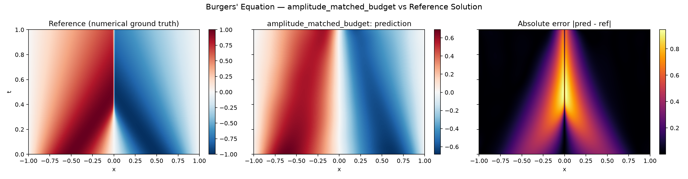
Figure 9. Matched-budget run: reference, prediction, and absolute error. Compared against Figure 7 (Model B baseline), the prediction visibly tracks the shock's shape rather than remaining flat, though a substantial error band remains centered on the shock.
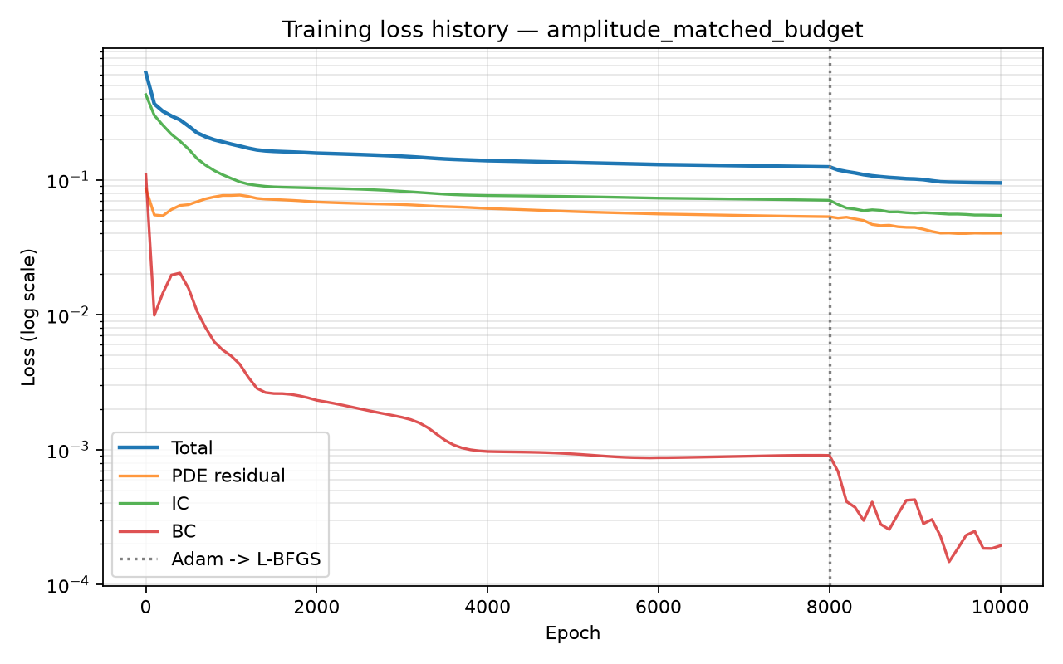
Figure 10. Matched-budget run: training loss history. Total loss is still declining at the final logged iteration, confirming the run had not fully converged when stopped.

6.7 Comparative Summary
Configuration | L2 (global) | L2 (shock region) | Fourier Error | Params
Model A (classical) | 4.01% | 11.83% | 1.35% | 16,897
Model B, baseline (angle re-upl.) | 98.36% | 99.85% | 88.90% | 85
Model B, amplitude (Adam-only, 800pt) | 79.96% | 98.64% | 76.59% | 85
Model B, amplitude+LBFGS (800pt) | 55.47% | 89.12% | 53.99% | 85
Model B, amplitude+LBFGS, matched budget | 47.02% | 78.79% | 33.45% | 85

Table 6.7 summarizes the progression across all experiments. Performance improvements were achieved through representation and optimization strategy rather than increased model capacity. Although the classical PINN remained superior, the gap narrowed substantially after amplitude encoding, L-BFGS refinement, and matched-budget training.

7. Discussion

7.1 Hypothesis-by-Hypothesis Findings
Restructuring the project's experiments as explicit hypothesis tests, rather than a chronology of runs, makes the evidence base clearer:
# | Hypothesis | Result | Evidence
H1 | More qubits improve accuracy | Not supported | Qubit ablation (6.3)
H2 | Greater circuit depth improves accuracy | Not supported | Depth ablation (6.3)
H3 | Entanglement pattern affects accuracy | Not supported | Entanglement ablation (6.3)
H4 | Data encoding strongly influences performance | Supported | Encoding ablation (6.3)
H5 | L-BFGS improves performance after Adam | Supported, encoding-dependent | Controlled 2×2 (6.4)
H6 | More collocation points improve accuracy | Not supported (800–4,000 range) | Collocation sweep (6.5)
H7 | More training budget improves accuracy | Supported | Matched-budget run (6.6)
H8 | Lower PDE residual implies better accuracy | Not consistently supported | Cross-run comparison (6.2, 6.6)

7.2 Mechanistic Interpretation
Three findings, read together, point toward a coherent explanation rather than isolated results. First, encoding is the first operation in the quantum circuit — every subsequent operation (variational layers, entanglement) acts on information already mapped into quantum states by that encoding. Section 4.2's theorem makes this precise: the accessible frequency set Ω is fixed by the encoding structure alone, not by circuit depth or qubit count. H1–H3's null results and H4's strong positive result are consistent with exactly this mechanism — additional quantum resources cannot recover frequency content the encoding never exposed.
Second, angle re-uploading was expected, based on the Fourier-series theorem in Section 4.2, to outperform amplitude encoding. However, amplitude encoding consistently produced the strongest empirical results. Rather than contradicting the theoretical framework, this suggests that expressivity and trainability are distinct properties. While the Fourier-series theorem characterizes representational capacity, the observed encoding–optimizer interaction indicates that optimization dynamics also play a critical role. The precise mechanism behind amplitude encoding's advantage remains an open question.
Third, representation and optimization interact rather than acting independently: L-BFGS meaningfully improved amplitude encoding but barely moved angle re-uploading at identical budget (H5). This suggests amplitude encoding produces a more favorable loss landscape — one L-BFGS's curvature information can exploit — rather than L-BFGS being unconditionally more powerful. Finally, every improvement in Sections 6.4–6.6 occurred without increasing the model's 85 trainable parameters: the gains came from representation and training strategy, not capacity, a stronger and more specific conclusion than 'amplitude encoding worked better.'

7.3 Limitations and Threats to Validity
- Not fully parameter-matched: Model B's default budget is smaller than Model A's (Section 5.1); the matched-budget experiment (6.6) addresses this directly but at only one encoding configuration
- Ablation axes (qubits, depth, entanglement) were tested only at a reduced, LBFGS-off budget, confounded by the shared near-trivial-solution ceiling (Section 6.3) — their true effect at full budget remains untested
- Simulator-only quantum execution: no real NISQ hardware noise is represented
- Single PDE benchmark: all conclusions are scoped to the viscous Burgers' equation and should not be generalized to other PDEs or QAPINN architectures without further experiments
- Burgers' equation is a simplified 1-D proxy; genuine hypersonic shock physics involves additional coupled, multi-dimensional terms not present here

8. Reproducibility
All experiments are runnable end-to-end from the project's public GitHub repository. Table below documents the exact environment used to produce the results in Section 6.
Item | Value
Python version | 3.13.7
PyTorch version | 2.13.0 (CPU)
PennyLane version | 0.45.1
PennyLane-Qiskit version | 0.45.0
Operating system | Microsoft Windows 11 Home (Build 26200)
Quantum backend | PennyLane default.qubit (noiseless simulator), backprop differentiation
GitHub repository | https://github.com/meenakshi-re18/qapinn-bqp-challenge.git

All reported training times are wall-clock CPU times on the hardware above; no GPU acceleration was used for either model.

9. Future Work and Recommendations
The following directions remain open for future investigation:
- Evaluate additional PDE benchmarks, including the heat equation, wave equation, and simplified 2-D Navier–Stokes shock-tube problems, to assess the generality of the findings.
- Validate the proposed approach on real quantum hardware (e.g., IBM Quantum) to evaluate robustness under realistic noise.
- Develop adaptive quantum encoding strategies guided by the frequency characteristics of the target PDE.
- Investigate the expressivity–trainability trade-off to determine whether amplitude encoding's advantage arises from representational capacity or optimization dynamics.
- Perform full-budget ablation studies with larger collocation sets and L-BFGS refinement to reassess the effects of qubit count, circuit depth, and entanglement.

10. Conclusion
The hypothesis motivating this work — that a quantum feature map could mitigate PINN spectral bias — is not confirmed on this benchmark: the classical PINN outperformed every evaluated QAPINN configuration, in some cases by more than an order of magnitude. What emerged instead is a more specific and, we believe, more useful result: within the QAPINN design space, encoding choice and optimization strategy measurably affect performance, while circuit size (qubits, depth, entanglement) does not, at least at the budgets tested. Amplitude encoding, combined with L-BFGS refinement and a larger training budget, reduced the gap to the classical baseline from roughly 24x to roughly 12x on global L2 error — achieved entirely through representation and training-strategy choices, without adding a single trainable parameter.
The most surprising result was not that the initial QAPINN underperformed — that was anticipated as a possible outcome from the outset — but that amplitude encoding outperformed angle re-uploading, the encoding this project's own theoretical framework (Section 4.2) predicted would win. That tension is unresolved and is, in our view, the most interesting open question this project raises, not a weakness to hide.
More broadly, this work demonstrates that representation and optimization must be considered jointly when designing hybrid quantum PINNs, as theoretical expressivity alone did not reliably predict empirical performance.

11. Team Roles and Contributions
Author | Role | Key Contributions
Meenakshi R | Quantum & QAPINN Research Lead | Designed and implemented the QAPINN architecture; developed the hybrid quantum-classical model; designed and executed all experiments and ablation studies; analyzed results; managed reproducibility and GitHub.
Krishna Priya Kaku | Classical PINN & Numerical Modelling Lead | Led the Classical PINN (Model A) development and validation; contributed to the physics-informed methodology, controlled experimental design, comparative analysis, debugging, technical discussions, and technical report preparation.
Mallampati Geethika | Comparative Analysis & Documentation Lead | Led comparative evaluation and documentation; contributed to literature review, result interpretation, report preparation, figures, tables, and presentation materials.

References
- Raissi, M., Perdikaris, P., & Karniadakis, G. E. (2019). Physics-informed neural networks: A deep learning framework for solving forward and inverse problems involving nonlinear partial differential equations. Journal of Computational Physics, 378, 686–707.
- Rahaman, N., Baratin, A., Arpit, D., Draxler, F., Lin, M., Hamprecht, F., Bengio, Y., & Courville, A. (2019). On the Spectral Bias of Neural Networks. Proceedings of the 36th International Conference on Machine Learning (ICML).
- Schuld, M., Sweke, R., & Meyer, J. J. (2021). Effect of data encoding on the expressive power of variational quantum-machine-learning models. Physical Review A, 103, 032430.
- Wang, S., Teng, Y., & Perdikaris, P. (2021). Understanding and mitigating gradient pathologies in physics-informed neural networks. SIAM Journal on Scientific Computing, 43(5), A3055–A3081.

