Categories:

**1.kids:**

**Balancing Beam**

This is an easy activity and can be great for younger kids and toddlers and helps them improve motor skills and their balance.

**Balancing Beam:**

**Materials**:

.Coloured tape

.Flat floor space to play

**.How to Play:**

1.Stick different coloured tapes tape on the floor

Each coloured tape can have a different rule to walk on. For example, you can ask the kid to walk on one leg on the red coloured tape

2.The child has to walk only on the tape. If he falls off the tape, heâ€™ll be out of the game.

3.The child that walks the entire length of the tape without falling off the tape wins the game

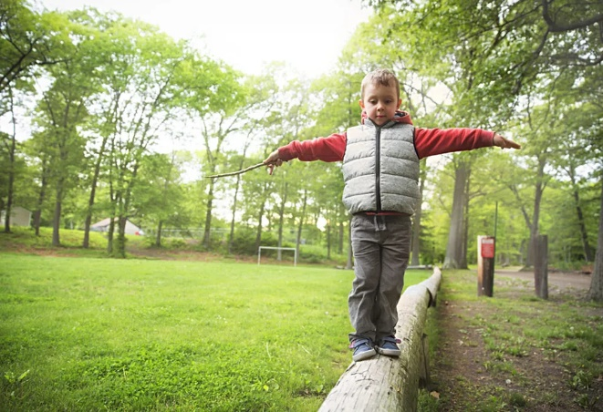

**No of participents:1**

**Indoor Bowling:**

Create a simple bowling alley in your house and have fun. This game is also ideal for hand-eye coordination in children.

**Materials:**

Flat floor space to play

Ten empty bottles or soda cans

Plastic ball or a tennis ball

Tape

Marker

Spray paint

**How to Play:**

1.Using the tape, create a bowling lane

Peel off the wrappers of the cans and the bottles and spray paint them. Allow them to dry

2.Arrange the bottles at the end of the line. You may arrange it like bowling pins or stack them on top of each other to form a pyramid

Ask the child to strike this arrangement using the ball

**No of participents:**

**1 0r 2**

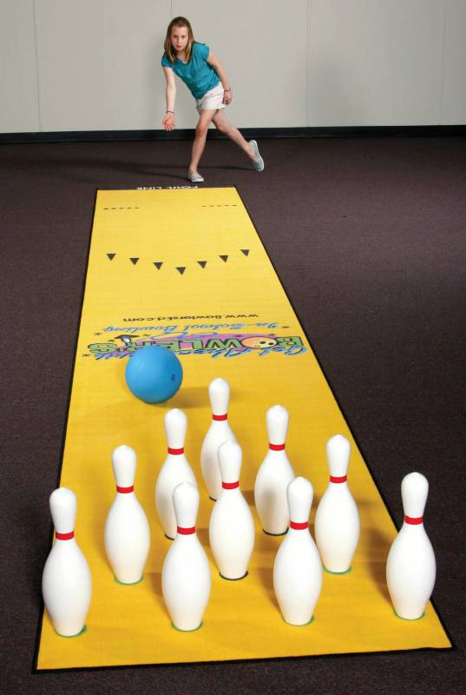

**Hide and seek:**

With some space inside the house, you can play this for hours.

**Required area:**

* Space to play inside the house

**How to Play**

Ask one child to close his eyes and count till 20 until the rest of them hide in different places

* Once the seeker is done with counting, he will have to go to find others
* The first person to be caught has to count the next time when the others hide again

**No of participants:**

a group of kids

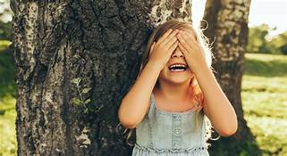

Bubble game:

Bubbles

This is one of the easiest ways to enjoy bubbles indoor without creating a mess.

**What You Will Need:**

* Straw
* Dishwashing soap
* Plate

**How to Play**

* Place a small amount of dishwashing soap on a plate and pour some water on it and mix it until some suds begin to form
* Ask your child to place one end of the straw in the suds and blow gently from the other end to make bubbles

No of participants:

.1 or more players

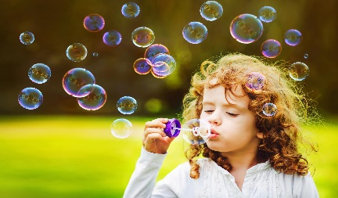

Musical chair:

It is an energetic game which brings energy among kids

**What You Will Need**

* Music
* Chairs

**How to Play**

* Place chairs (1 less than the total number of players) in a circle
* Play music and ask the players to dance around the chairs
* When the music stops, they will need to sit on the closest chair. The person without a chair is out of the game. This chair and[music game](https://parenting.firstcry.com/articles/15-interactive-music-games-for-kids/?ref=interlink) is very much fun

**No of participants:**

A group of kids

