PHASE 7 – PROJECT DOCUMENTATION
Project Title:
Streamlining IT Procurement: Automating Standard Laptop Orders with Flow Designer
1. Introduction
The Project Documentation Phase focuses on preparing and organizing the complete documentation of the Standard Laptop Procurement Automation project. The documentation describes the problem, requirements, system design, implementation, testing, and final outcome of the project.
The project documentation is prepared to provide a clear understanding of how ServiceNow Flow Designer is used to automate the creation and assignment of Catalog Tasks for Standard Laptop requests.
2. Project Overview
The project implements an automated IT procurement workflow using ServiceNow Flow Designer.
When a user submits a Standard Laptop request through the Service Catalog and the request is approved, the configured Flow is triggered automatically. The Flow creates a Catalog Task with the required task details and assigns it to the Hardware group.
Project Workflow
User → Standard Laptop Request → Approval → Flow Trigger → Create Catalog Task → Hardware Assignment

3. Problem Statement
The existing IT procurement process for standard laptop requests may involve manual activities such as task creation and assignment. This can result in delays, additional effort, and errors.
The proposed automation addresses this problem by automatically creating and assigning the required Catalog Task after the Standard Laptop request is approved.
4. Project Objectives
The main objectives of the project are:
- To automate the Standard Laptop request process.
- To reduce manual intervention.
- To automatically create Catalog Tasks.
- To assign tasks to the Hardware team.
- To reduce processing delays and errors.
- To improve the efficiency of IT procurement operations.
5. Technologies and Tools Used
Technology / Tool | Purpose
ServiceNow | IT service management platform
Flow Designer | Workflow automation
Service Catalog | Laptop request submission
Standard Laptop | Catalog Item
Service Catalog Trigger | Starts the Flow
Create Catalog Task | Creates the required task
Hardware Group | Receives the task
Web Browser | Accessing ServiceNow

6. Flow Configuration
The automation Flow was configured with the following details:
Configuration | Value
Flow Name | Standard laptop task
Application | Global
Run As | System User
Trigger | Service Catalog
Action | Create Catalog Task
Short Description | Laptop need to be Configured
Description | Laptop need to be Configured
Assignment Group | Hardware
Approval | Approved

7. Implementation Summary
The project implementation was completed through the following steps:
- Created the Standard laptop task Flow.
- Configured the Service Catalog trigger.
- Added the Create Catalog Task action.
- Configured the task description.
- Set the Assignment Group to Hardware.
- Configured the approval condition.
- Activated the Flow.
- Assigned the Flow to the Standard Laptop catalog item.
- Submitted a Standard Laptop request.
- Approved the request.
- Verified automatic Catalog Task creation.
- Verified Hardware group assignment.
8. Testing Summary
The implemented automation was tested using different test cases.
The testing verified:
- Standard Laptop catalog item access.
- Request submission.
- Request creation.
- Request approval.
- Flow execution.
- Catalog Task creation.
- Short Description.
- Description.
- Hardware assignment.
- Complete end-to-end workflow.
The testing confirmed that the configured workflow performed the intended automation process.
9. Project Outcome
The completed project provides an automated process for handling Standard Laptop requests.
The final process is:

Standard Laptop Request
↓
Request Approval
↓
Service Catalog Trigger
↓
Flow Execution
↓
Catalog Task Creation
↓
Assignment to Hardware Groups

This reduces manual task creation and provides a structured workflow for the Hardware team.

10. Documentation and Evidence
The project documentation contains the required project information and supporting evidence.
The following screenshots can be included where appropriate:
- Flow Designer configuration
- Service Catalog Trigger
- Create Catalog Task configuration
- Catalog Task field configuration
- Activated Flow
- Standard Laptop Flow assignment
- Submitted request
- Approved request
- Automatically created Catalog Task
- Hardware assignment
Important: Phase 7 is mainly the documentation phase. You don't need to add every screenshot again if the same screenshots are already clearly available in Phase 5 and Phase 6.

11. Project Files and Repository Structure
The project files are organized phase-wise in a public GitHub repository.
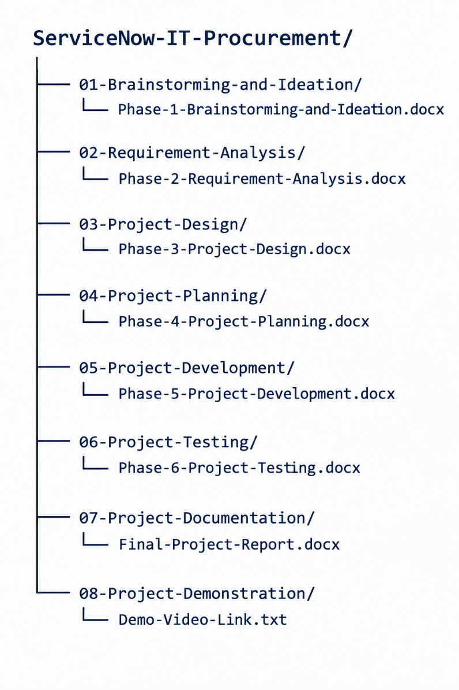
12. Conclusion
The Project Documentation Phase consolidates the complete details of the Standard Laptop Procurement Automation project. The documentation covers the project requirements, design, development, testing, implementation details, and final outcome.
The completed documentation provides a structured reference for understanding and demonstrating the ServiceNow Flow Designer automation.

