PHASE 5 – PROJECT DEVELOPMENT
Project Title
Streamlining IT Procurement: Automating Standard Laptop Orders with Flow Designer
1. Introduction
The Project Development Phase focuses on implementing the designed automation solution in the ServiceNow platform. The Standard Laptop request process is configured using Service Catalog and Flow Designer. The flow automatically creates a Catalog Task and assigns it to the Hardware team after the request is approved.
2. Development Environment
The project was developed using the following ServiceNow components:
- ServiceNow Platform
- Flow Designer
- Service Catalog
- Standard Laptop Catalog Item
- Service Catalog Trigger
- Create Catalog Task Action
- Requested Item
- Catalog Task
- Hardware Assignment Group

3. Flow Creation
A new flow was created in Flow Designer with the following configuration:
Flow Name: Standard laptop task
Application: Global
Run As: System User
The flow is designed to automate the creation of a laptop configuration task.
Flow Designer with “Standard laptop task”
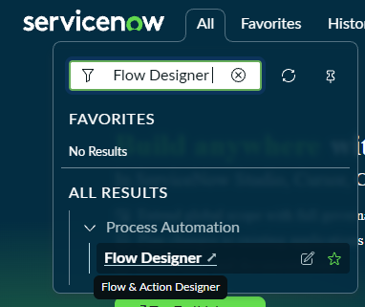

4. Service Catalog Trigger Configuration
A Service Catalog trigger was added to the flow. This trigger starts the flow when the Standard Laptop service request is processed.

Service Catalog Trigger Configuration
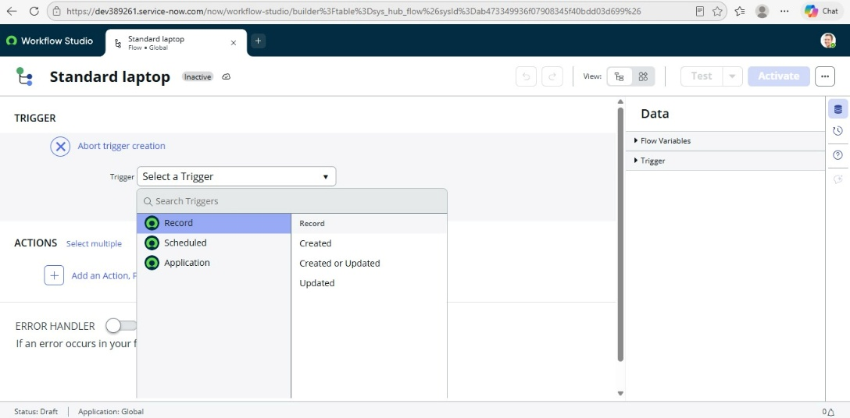

5. Create Catalog Task Action
The Create Catalog Task action was added to automatically generate a task for the requested laptop.
The Requested Item Record is used as the Request Item, and the Catalog Task table is automatically selected.
Create Catalog Task Action
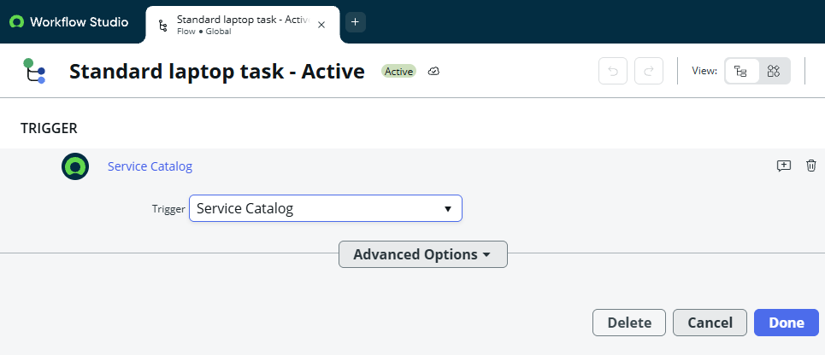

6. Task Configuration
The Catalog Task was configured with the following values:
Field | Value
Short Description | Laptop need to be Configured
Description | Laptop need to be Configured
Assignment Group | Hardware
Approval | Approved

Catalog Task Field Configuration
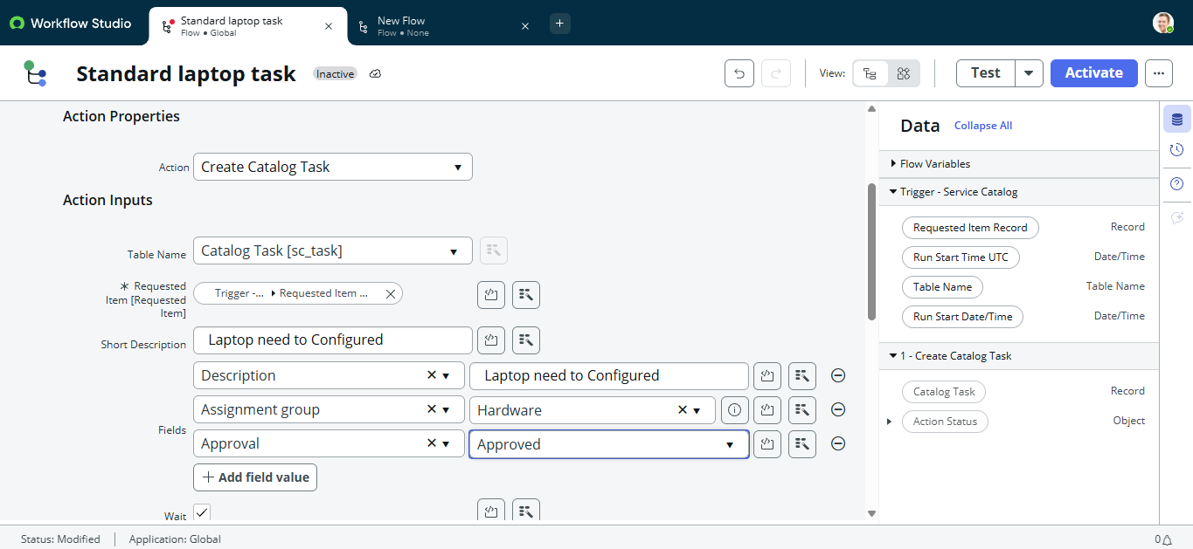

7. Flow Activation
After completing the required configurations, the flow was saved and activated.
Flow: Standard laptop task
Status: Active

Activated Flow
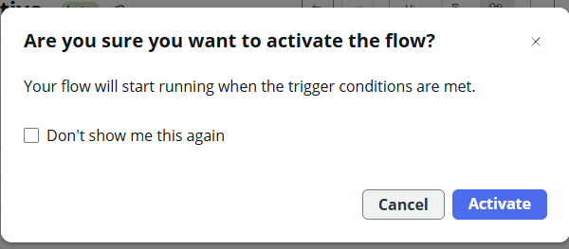

8. Assigning the Flow to Standard Laptop
The created flow was assigned to the Standard Laptop Service Catalog item.
The Process Engine configuration was updated to use the Standard laptop task flow.
Standard Laptop Catalog Item with Flow Assignment
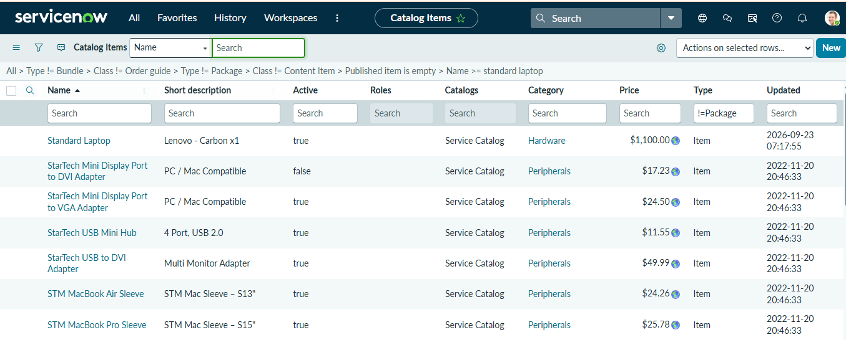

9. Submitting a Standard Laptop Request
The Standard Laptop catalog item was opened from the Service Catalog and an order was submitted.
The request generates a Request Number and a Requested Item.
Standard Laptop Request Submitted
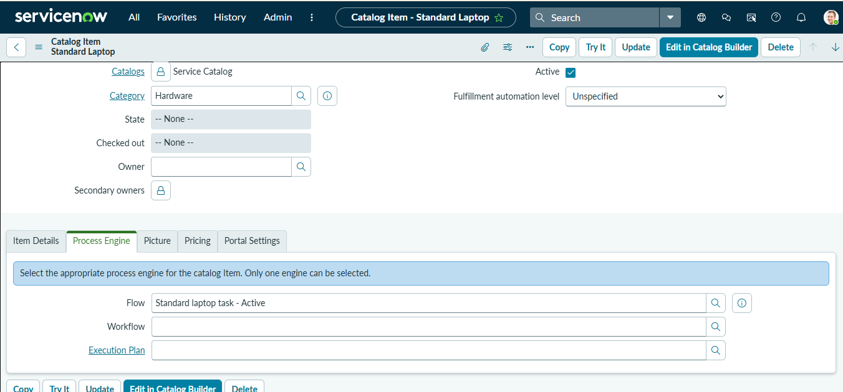

10. Catalog Task Creation
After the request is approved, the configured flow runs automatically and creates a Catalog Task.
The generated task contains the configured description and is assigned to the Hardware group.

Automatically Created Catalog Task
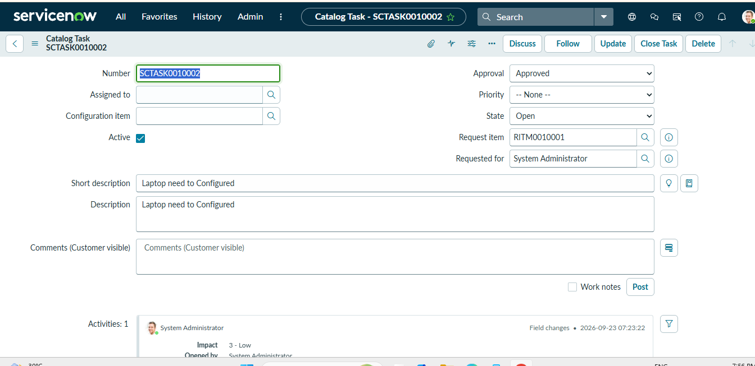

11. Development Output
The completed development produces the following automated process:
Standard Laptop Request → Approval → Flow Trigger → Create Catalog Task → Hardware Assignment → Laptop Configuration
This implementation reduces the need for manually creating and assigning laptop configuration tasks.
12. Conclusion
The Project Development Phase successfully implements the planned ServiceNow automation. The Standard Laptop request is connected to Flow Designer, and the system automatically creates and assigns a Catalog Task to the Hardware team after approval. This provides a structured and automated approach to standard laptop procurement.

