Apache Kafka

Large companies contain hundreds of microservices, all needing data to operate. When we talk about technologies that they use, we come across Apache Kafka, which is used to handle trillions of data per day. In this blog, let’s understand what Kafka is and why it is so popular.

Let’s take an example of microservices involved in ride application. When a ride is completed, this information is needed by multiple microservices.

Ride management service manages ride information.

Email notification service sends a ride receipt in the email.

Driver management service manages driver information. It updates the status of the driver so that he can be allocated for the next ride.

Fraud detection service detects any fraudulent activity that had happened in the ride.

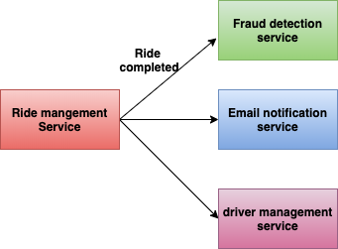

Ride management microservices

In this case, we have many services that need ride-completion data to operate on. If synchronous calls are made to all services then we will end up making this request slower. And also it will introduce coupling between services.

We can make calls asynchronous by using a background job processor like Sidekiq or Go-craft. In this case, we need to add jobs in ride-management-service. Whenever a new service wants ride-completion data, we need to do code changes in ride-management-service to add new jobs. This won’t solve the above problem of coupling between services.

The next approach is to use some queue like RabbitMQ. In this case, only one consumer can consume the data from the queue. In the above scenario, we have many consumers who need ride-completion data. So simple queue won’t solve our problem.

How nice would it be if we have a publisher-subscriber system here?

Press enter or click to view image in full size

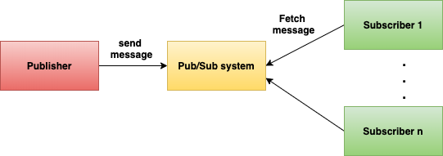

Pub/Sub system

Whenever an event happens, the publisher publishes messages to the messaging system. Any microservice that needs this information can subscribe to it. This type of architecture is called event-driven architecture. It provides multiple benefits:

Loosely coupled microservices

Asynchronous communication

Easily scalable since services are decoupled.

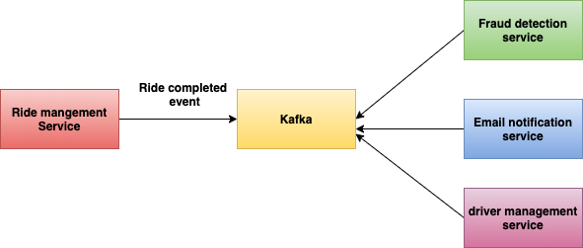

Ride management microservices with Kafka

Apache Kafka is one such publisher-subscriber messaging system. We can have multiple consumers who can read the same events. The data sent to Kafka is persisted to some duration defined by the retention policy.

In Kafka, publishers are called producers. And subscribers are called consumers. In the above example, when a ride gets completed, producers can publish this event to Kafka, and all other services which require this event can subscribe to it. But where and how does Kafka store these events?

1. Introduction to Apache Kafka
Apache Kafka is a distributed event streaming platform used for building real-time data pipelines and streaming applications. It allows systems to publish, store, and process streams of records in a fault-tolerant and scalable way. Kafka is widely used in microservices architecture, log aggregation, messaging systems, and event-driven systems.
In simple terms, Kafka acts as a central backbone where producers send events/messages and consumers read and process them.
Example Use Case:
• Order Service publishes order events
• Payment Service consumes order events
• Notification Service also consumes the same events

2. Kafka Core Components

Kafka Cluster
A Kafka cluster is a group of multiple Kafka brokers working together to provide scalability, high availability, and fault tolerance.

Broker

The place where topics are kept and maintained are called Brokers/ Kafka servers. Kafka broker receives messages from producers and stores them on disk. When a consumer wants to read from a topic then it must establish a connection with a broker. Upon the connection, consumers can read from the beginning of the topic or from the time connection is made.Topic

In Kafka, the specific location where messages are stored is called Topic. If we have to compare it with the SQL database then the topic is like a table and the message is like a row of data. But in Kafka, Message is an immutable record which means that once they are received into a topic they can not be changed. Each message that is sent is appended to a time-ordered sequence. This style of maintaining data as events is an architectural style known as event sourcing

Partition
Partitions divide a topic into smaller units to allow parallel processing and scalability. Each partition maintains message order.

Producer
Producers are applications that publish messages to Kafka topics.

Consumer
Consumers read messages from Kafka topics and process them.

Consumer Group
A consumer group is a set of consumers working together to consume messages from a topic in parallel.

ZooKeeper / KRaft
ZooKeeper was traditionally used for broker coordination, metadata management, and leader election. Modern Kafka uses KRaft mode which removes ZooKeeper and manages metadata internally.

3. Kafka Working Mechanism
1. Producers send messages to topics.
2. Topics are divided into partitions stored across brokers.
3. Brokers manage storage and replication.
4. Consumers subscribe to topics and read messages.
5. Consumer groups allow parallel consumption.
6. Offsets track message consumption progress.

4. Visual Explanation Based on Provided Diagrams
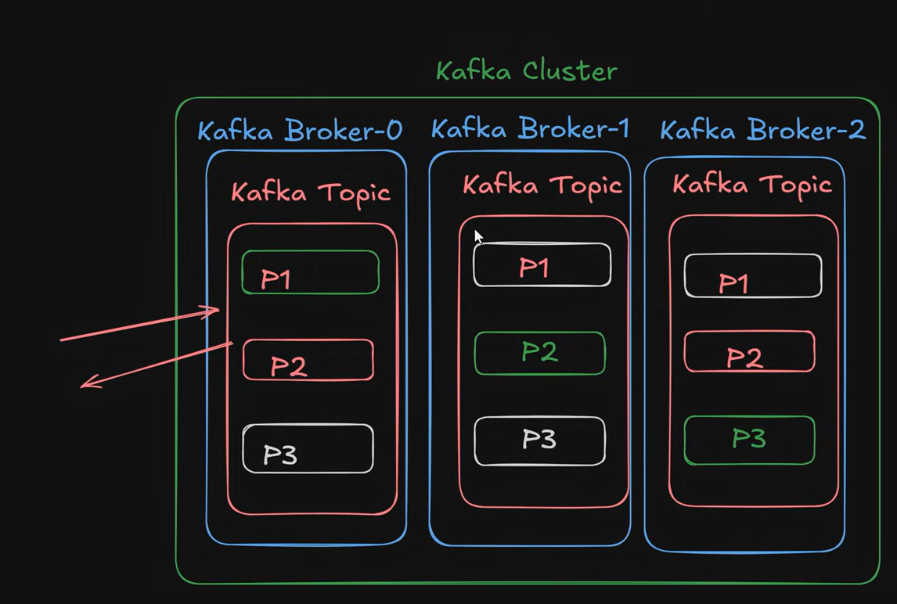

Kafka Cluster and Broker with Partitions
A Kafka cluster contains multiple brokers. Each broker stores topic partitions. Partitions are distributed across brokers for scalability and fault tolerance.

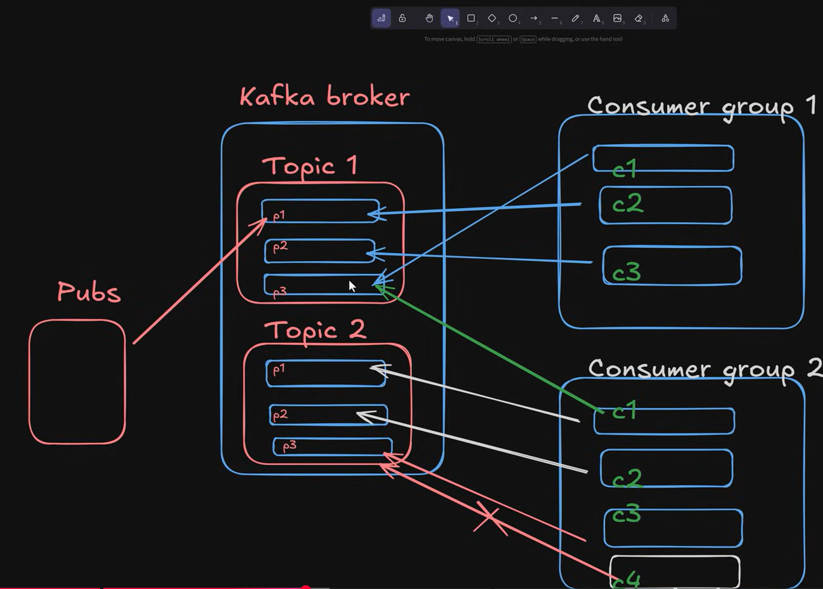

Producers, Topics, and Consumer Groups
Producers publish messages to topics which are divided into partitions. Each partition in a consumer group is consumed by only one consumer within the same group, but multiple consumer groups can consume the same partition independently.

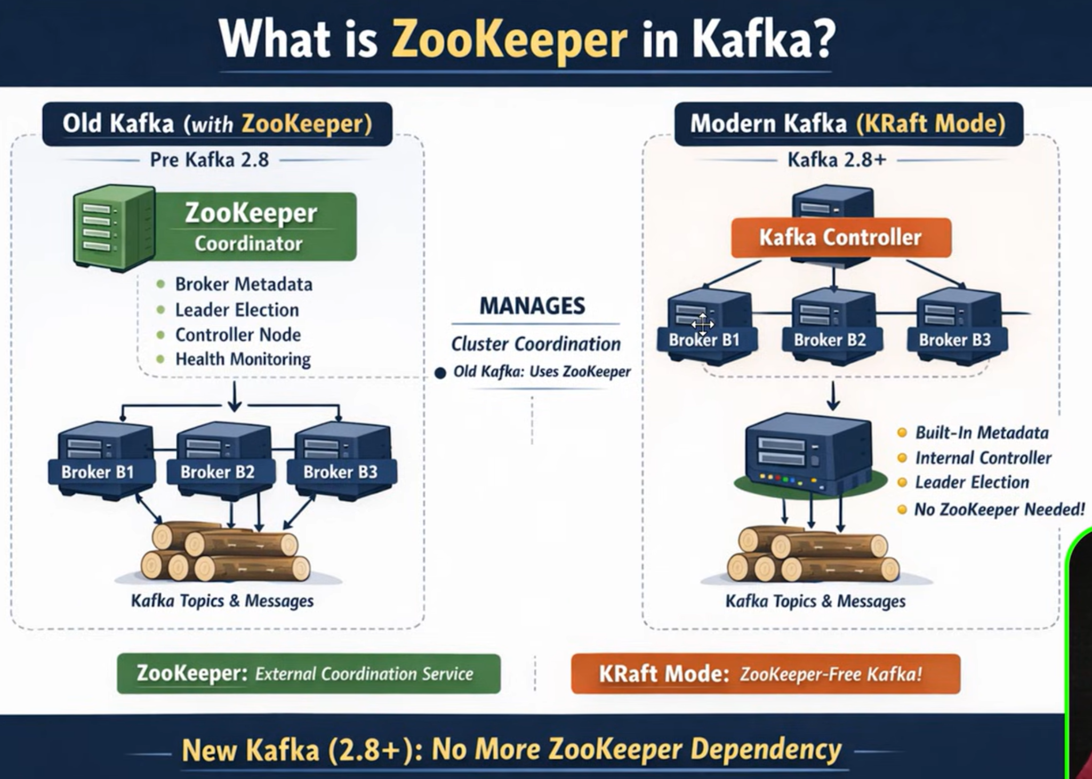

ZooKeeper vs KRaft Mode
Older Kafka versions used ZooKeeper for coordination, leader election, and cluster metadata management. Modern Kafka uses KRaft mode which provides internal metadata management and removes the need for ZooKeeper.

Fault tolerance in Apache Kafka
What happens when the broker/server goes down? Is all the data lost?

Partition Replication
Fault tolerance in Kafka is done by copying the partition data to other brokers which are known as replicas. There is a configuration that specifies how many copies of the partition you need. Its called a replication factor.
Each broker will hold one or more partitions. And each of these partitions can either be a replica or leader for the topic. All the writes and reads to a topic go through the leader and the leader coordinates to update replicas with new data.


In this image green colous is Leader and white coloue is followers

In the above example, there are three brokers. For partition-1, Broker-1 is a leader. Broker-2 and Broker-3 are the replica brokers.
So what ever Leader is doing same will be reflected in the followers the same things will be reflected in the followers
Consumers will always deal with the leaders not with the brokers
think like because of some reasons the Broker-1 stops working so in that case any one of the followers act as leader and prevents the data loss and flow
Who decides the leaders i.e Zookeper means Zookeper is the person who will decides the leaders nothing but leader election
So in real time applications it will we multiple brokers/servers are maintained not one broker

🚀 Step-by-Step Spring Boot Kafka Setup

✅ STEP 1 — Add Dependency
Maven
<dependency>
<groupId>org.springframework.kafka</groupId>
<artifactId>spring-kafka</artifactId>
</dependency>
That’s it 👍

✅ STEP 2 — application.yml Config
Same like RabbitMQ host/port — but Kafka uses bootstrap-servers.
spring:
kafka:
bootstrap-servers: localhost:9092

consumer:
group-id: my-group
auto-offset-reset: earliest
key-deserializer: org.apache.kafka.common.serialization.StringDeserializer
value-deserializer: org.apache.kafka.common.serialization.StringDeserializer

producer:
key-serializer: org.apache.kafka.common.serialization.StringSerializer
value-serializer: org.apache.kafka.common.serialization.StringSerializer
No username/password normally (unless secured cluster).

✅ STEP 3 — Topic Configuration (Optional but Recommended)
Equivalent to:
👉 Queue + Exchange creation in RabbitMQ.
@Configuration
public class KafkaTopicConfig {

@Bean
public NewTopic orderTopic() {
return TopicBuilder.name("order-topic")
.partitions(3)
.replicas(1)
.build();
}
}
Spring will auto-create topic if broker allows.

✅ STEP 4 — Producer Service (RabbitTemplate Equivalent)
RabbitMQ:
RabbitTemplate.convertAndSend()
Kafka:
KafkaTemplate.send()
@Service
public class KafkaProducerService {

@Autowired
private KafkaTemplate<String, String> kafkaTemplate;

public void sendMessage(String message) {
kafkaTemplate.send("order-topic", message);
}
}

✅ STEP 5 — Consumer Listener (@RabbitListener Equivalent)
RabbitMQ:
@RabbitListener
Kafka:
@KafkaListener
@Service
public class KafkaConsumerService {

@KafkaListener(topics = "order-topic", groupId = "my-group")
public void listen(String message) {
System.out.println("Received message: " + message);
}
}
Done 👍 that’s your consumer.

✅ STEP 6 — Controller (Test API)
@RestController
@RequestMapping("/kafka")
public class KafkaController {

@Autowired
private KafkaProducerService producerService;

@GetMapping("/send")
public String send(@RequestParam String msg) {
producerService.sendMessage(msg);
return "Message sent";
}
}
Test:
http://localhost:8080/kafka/send?msg=hello

🧠 Full Flow (Exactly Like RabbitMQ Thinking)
Controller
↓
KafkaTemplate.send()
↓
Kafka Broker (Topic + Partition)
↓
@KafkaListener Consumer

🧠 First — Big Concept Difference
🐰 RabbitMQ Client Config = Connection Settings
You mainly configure:
- where broker is
- how to connect
- queue binding
Message consumption behaviour mostly server-driven.

🐘 Kafka Client Config = Connection + Consumption Behaviour
Kafka needs:
- broker location
- how to read messages
- how to serialize data
- where to start reading (offset logic)
- consumer group behaviour
Because Kafka consumers control how they read data.

⚙️ Now Your Config Explained

✅ 1️⃣ bootstrap-servers
bootstrap-servers: localhost:9092
👉 Equivalent to RabbitMQ:
host + port
But Kafka has many brokers.
Example:
bootstrap-servers: localhost:9092,localhost:9093
Spring connects to one → fetches full cluster metadata.
So bootstrap server = entry point to cluster.

✅ 2️⃣ consumer.group-id
group-id: my-group
👉 RabbitMQ equivalent = multiple consumers on same queue.
But Kafka uses consumer groups for:
- load balancing
- parallel consumption
- fault tolerance
Example:
Topic has 3 partitions
Group has 3 consumers
→ each gets 1 partition
Without group-id → Kafka treats consumer as independent.

✅ 3️⃣ auto-offset-reset
auto-offset-reset: earliest
VERY IMPORTANT concept — RabbitMQ does NOT have this.
Kafka stores:
offset = last consumed position
When consumer starts FIRST TIME:
Value | Meaning
earliest | read from beginning
latest | read only new messages
Example:
Topic has 100 old messages
Consumer starts
earliest → reads all 100
latest → reads only future ones

✅ 4️⃣ key-deserializer
key-deserializer: StringDeserializer
Kafka stores data as bytes.
When consuming:
byte[] → String
byte[] → JSON → Object
Deserializer converts Kafka bytes → Java object.
RabbitMQ usually handles conversion internally or via converter.

✅ 5️⃣ value-deserializer
Same concept but for message body.

✅ 6️⃣ producer.key-serializer
StringSerializer
Producer sends:
Java object → bytes
Serializer converts:
String → byte[]
JSON → byte[]
DTO → byte[]
RabbitMQ hides this mostly.
Kafka makes it explicit.

✅ 7️⃣ producer.value-serializer
Same but for message content.

📊 Why Kafka Needs More Config Than RabbitMQ
Concept | RabbitMQ | Kafka
Offset tracking | ❌ No | ✅ Yes
Replay messages | ❌ No | ✅ Yes
Consumer positioning | ❌ No | ✅ Yes
Partition routing | ❌ No | ✅ Yes
Serialization control | Mostly hidden | Explicit
Consumer groups | Basic | Core architecture

🔥 Real Production Kafka Config Adds Even More
You’ll later see:
enable-auto-commit
max-poll-records
session-timeout-ms
fetch-min-bytes
acks
retries
batch-size
linger-ms
These control:
- throughput
- reliability
- batching
- retry logic

✅ 1️⃣ How to give multiple group IDs in Kafka ?
👉 first understand one important thing:
👉 group-id is NOT global for the application
👉 it is per consumer (listener)
means:
- one listener → one group
- another listener → another group
you don’t define multiple groups in single yml property normally.

🔹 Method 1 — override groupId in @KafkaListener (MOST COMMON)
yml
spring:
kafka:
bootstrap-servers: localhost:9092
consumer:
group-id: default-group

listener 1
@KafkaListener(topics = "order-topic", groupId = "group-A")
public void listenA(String msg){
System.out.println("Group A -> " + msg);
}

listener 2
@KafkaListener(topics = "order-topic", groupId = "group-B")
public void listenB(String msg){
System.out.println("Group B -> " + msg);
}
👉 result:
- both groups receive message
- each group has its own offset
- independent consumption

🔹 Method 2 — separate consumer factories (advanced)
used when:
- different deserializers
- different configs
- different security
but 90% projects use @KafkaListener(groupId="")

✅ 2️⃣ Partitions & Replicas — VERY IMPORTANT CONCEPT
🔹 Partitions
topic → divided into partitions
example:
topic = orders
partitions = 3
orders-0
orders-1
orders-2
why ?
👉 parallel processing
👉 scaling
👉 load distribution

🔹 Replicas — YES 👍 followers
you are correct.
replication = copies of partition
example:
partition 0
leader -> broker1
follower -> broker2
follower -> broker3

🔹 Roles
🟢 Leader
- handles read
- handles write
- producer sends here
- consumer reads here

🔵 Followers
- copy data from leader
- passive
- for fault tolerance

🔹 What happens if leader dies ?
Kafka automatically:
👉 promotes one follower → new leader
this is why Kafka is fault tolerant.

🔹 Example while creating topic
kafka-topics.sh \
--create \
--topic orders \
--partitions 3 \
--replication-factor 2 \
--bootstrap-server localhost:9092
means:
- 3 partitions
- each partition has 2 copies
  - 1 leader
  - 1 follower

✅ 3️⃣ Visual Understanding
partition + replica structure
Broker1:
orders-0 (leader)
orders-1 (follower)

Broker2:
orders-0 (follower)
orders-1 (leader)
load balancing + failover 👍

✅ 4️⃣ Consumer Groups vs Partitions (VERY IMPORTANT INTERVIEW)
if:
partitions = 3
group consumers = 3
each consumer gets one partition
C1 -> P0
C2 -> P1
C3 -> P2

if:
consumers > partitions
some consumers idle

if:
consumers < partitions
consumer handles multiple partitions

✅ 5️⃣ Big Difference From RabbitMQ
Feature | Kafka | RabbitMQ
group id | consumer scaling | no concept
partition | parallel processing | queue based
replica | fault tolerance | mirrored queues
offset | consumer controlled | broker controlled

ahh good 👍 now you’re going into multi-broker / multi-cluster Kafka — nice level up.
first small correction:
👉 topics are NOT created “in a server” normally
👉 topics belong to a Kafka cluster
👉 brokers inside the cluster store partitions
so there are 2 different cases — you need to know which one you mean.

✅ 🟢 CASE 1 — Same Kafka Cluster (multiple brokers)
example:
Broker1 → 9092
Broker2 → 9093
Broker3 → 9094
when you create:
@Bean
public NewTopic orderTopic() {
return TopicBuilder.name("order-topic")
.partitions(3)
.replicas(2)
.build();
}
👉 Kafka automatically distributes partitions across brokers.
you DO NOT choose server manually.
example distribution internally:
order-topic-0 -> broker1 (leader)
order-topic-1 -> broker2 (leader)
order-topic-2 -> broker3 (leader)
so answer:
👉 you cannot say "this topic only on broker1"
👉 Kafka manages distribution automatically.

✅ 🟢 CASE 2 — Different Kafka Clusters (Different Servers)
THIS is probably what you mean.
example:
Cluster A → localhost:9092
Cluster B → localhost:9095
👉 now you need multiple Kafka configurations in Spring Boot.

🔹 Step 1 — application.yml
kafka:
cluster1:
bootstrap-servers: localhost:9092

cluster2:
bootstrap-servers: localhost:9095

🔹 Step 2 — Config for Cluster 1
@Bean
public KafkaAdmin kafkaAdmin1() {
Map<String, Object> configs = new HashMap<>();
configs.put(AdminClientConfig.BOOTSTRAP_SERVERS_CONFIG, "localhost:9092");
return new KafkaAdmin(configs);
}

@Bean
public NewTopic topicCluster1() {
return TopicBuilder.name("topic-cluster1")
.partitions(2)
.replicas(1)
.build();
}

🔹 Step 3 — Config for Cluster 2
@Bean
public KafkaAdmin kafkaAdmin2() {
Map<String, Object> configs = new HashMap<>();
configs.put(AdminClientConfig.BOOTSTRAP_SERVERS_CONFIG, "localhost:9095");
return new KafkaAdmin(configs);
}
👉 but important:
Spring Boot default topic creation works only with one KafkaAdmin.
for multiple clusters → you usually:
- create topics manually
- OR use AdminClient manually

🔹 Step 4 — Manual Topic Creation Using AdminClient
Properties props = new Properties();
props.put(AdminClientConfig.BOOTSTRAP_SERVERS_CONFIG, "localhost:9095");

try (AdminClient adminClient = AdminClient.create(props)) {

NewTopic topic = new NewTopic("topic-cluster2", 3, (short)1);

adminClient.createTopics(Collections.singleton(topic));
}

✅ 🧠 REAL WORLD ARCHITECTURE
normally companies:
- 1 cluster per environment
  - dev cluster
  - staging cluster
  - prod cluster
NOT:
❌ topic per server
❌ manual broker mapping

🎯 VERY IMPORTANT THING YOU SHOULD KNOW
this is WRONG thinking in Kafka:
topic → server
correct thinking:
topic → cluster
cluster → multiple brokers
broker → partitions

