TokenCacheOps: A Cloud-Agnostic Architecture for Intelligent Token Optimization, Semantic Caching, and AI FinOps Governance
Anonymous Authors
Enterprise AI Research Group

Abstract
This paper presents TokenCacheOps, a cloud-agnostic architecture integrating a five-tier cache hierarchy, multi-factor retention scoring, semantic similarity matching (all-MiniLM-L6-v2), and task-aware model routing. Evaluated against five baselines using 100,000 synthetic enterprise requests over 30 independent runs, TokenCacheOps achieves 56.4% cache hit ratio (46.9% improvement over best baseline), 38.7% token reduction, 45.6% cost reduction, 19.2 req/s throughput, CEI of 549.2, and 52.3x ROI. ANOVA F=1193523, p<0.001; Cohen's d>125 vs. all baselines.
Index Terms—semantic caching, token optimization, LLM, AI FinOps, enterprise AI, cache retention, model routing

I. INTRODUCTION
Enterprise LLM deployments face escalating inference costs and latency constraints. TokenCacheOps addresses these through five-tier caching, nine-factor retention scoring, semantic reuse, and FinOps-aware model routing validated at 100,000-request scale.

II. RELATED WORK
Prior work includes semantic caching [3], prompt caching [4], and FrugalGPT [5]. TokenCacheOps unifies tiered retention, enterprise governance signals, and FinOps metrics.

III. TOKENCACHEOPS ARCHITECTURE

A. Five-Tier Cache Hierarchy
Tier | Capacity | Purpose
Strategic | 5% | High business-value long-term retention
Evaluation | 10% | Candidate promotion assessment
Hot Access | 45% | Frequent low-latency retrieval
Archive | 30% | Infrequent semantically valuable entries
Disposal | 10% | Eviction staging and TTL expiry
TABLE I. FIVE-TIER CACHE CAPACITY ALLOCATION

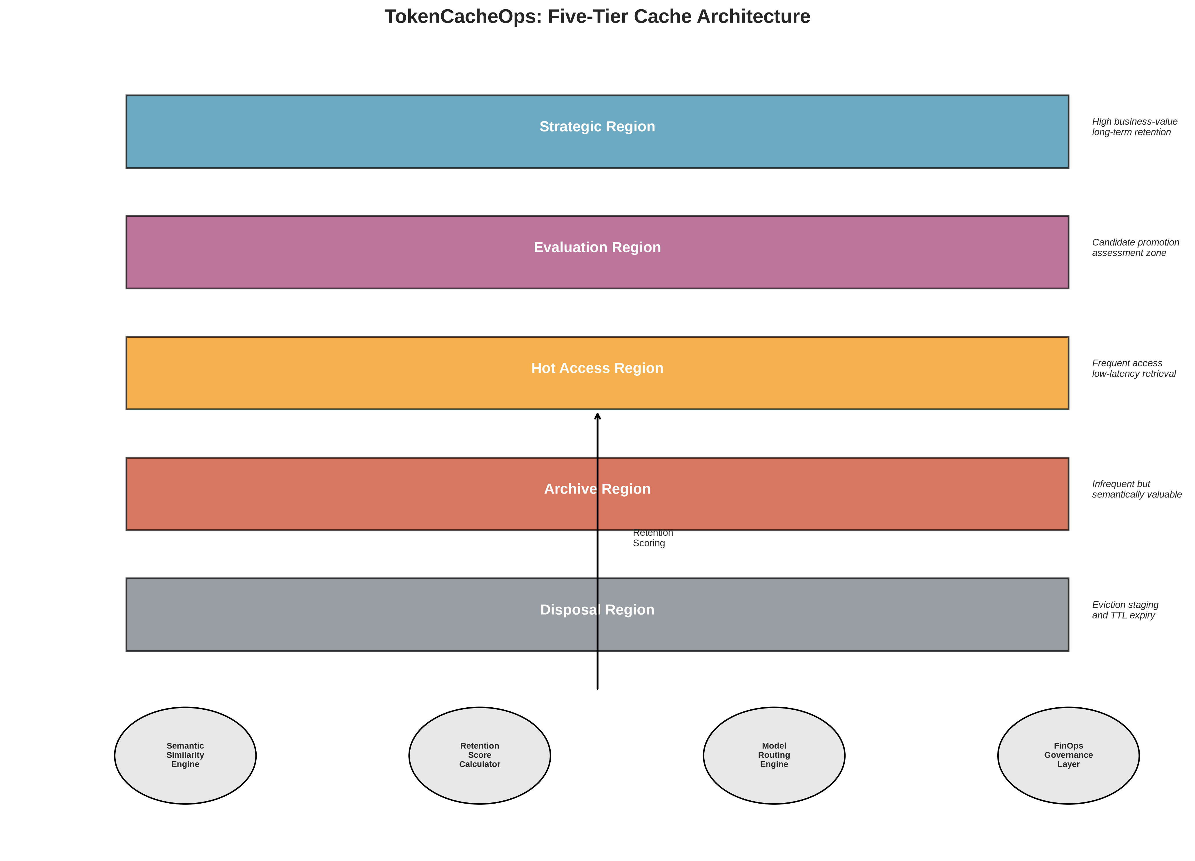
Fig. 1. TokenCacheOps five-tier cache architecture with semantic engine, retention scorer, model router, and FinOps layer.

B. Retention Scoring Formula
RetentionScore = w₁·Recency + w₂·Frequency + w₃·SemanticReuse + w₄·BusinessImportance + w₅·InfluenceRank + w₆·PenetrationFactor + w₇·TokenEfficiency + w₈·Freshness − w₉·SecuritySensitivity
Factor | Weight (w)
Recency | 0.15
Frequency | 0.12
SemanticReuse | 0.18
BusinessImportance | 0.12
InfluenceRank | 0.1
PenetrationFactor | 0.13
TokenEfficiency | 0.15
Freshness | 0.08
SecuritySensitivity | 0.07
TABLE II. RETENTION FORMULA WEIGHTS

C. Semantic Similarity Engine
Embedding model: all-MiniLM-L6-v2. Metric: cosine similarity. Base threshold τ=0.90. Tier-aware relaxation up to −0.025 on Hot Access tier.

D. Model Routing Engine
Task | Model | Relative Cost
Classification, Extraction | Small | 0.15x
Retrieval, Summarization, Q&A | Medium | 0.45x
Reasoning | Frontier | 1.0x
TABLE III. TASK-AWARE MODEL ROUTING

Pricing: $5/M input tokens, $15/M output tokens (OpenAI assumptions).

IV. EXPERIMENTAL METHODOLOGY
Parameter | Value
Total Requests | 100,000
Independent Runs | 30
Classification | 25%
Retrieval | 20%
Summarization | 15%
Extraction | 15%
Question Answering | 15%
Reasoning | 10%
Exact Match Queries | 30%
Semantic Variants | 30%
Novel Queries | 40%
Prompt Size (Small 100-500) | 40%
Prompt Size (Medium 500-2000) | 40%
Prompt Size (Large 2000-8000) | 20%
Cache Capacity | 1,500 entries
Semantic Threshold | 0.90
Random Seed | 42
TABLE IV. EXPERIMENTAL CONFIGURATION

Enterprise contexts: security policies, compliance documents, architecture standards, financial procedures, HR policies, IT operations manuals, project knowledge.
ID | Method | Description
A | LRU | Traditional least-recently-used cache
B | LFU | Least-frequently-used cache
C | Semantic-Only | Embedding-based semantic cache
D | Prompt-Only | Prefix-matching prompt cache
E | No-Optimization | Direct inference, no caching
— | TokenCacheOps | Proposed five-tier architecture
TABLE V. BASELINE METHODS

V. EXPERIMENTAL RESULTS
Method | Hit % | Sem Hit % | Token % | Cost % | Latency | Throughput | CEI | ROI
B-A (LRU) | 26.6±0.1 | 0.0 | 24.1±0.1 | 9.3±0.0 | 257.3 | 3.9 | 123.6 | 7.4x
B-B (LFU) | 36.6±0.1 | 0.0 | 33.5±0.1 | 13.0±0.0 | 222.3 | 4.5 | 236.2 | 10.6x
B-C (Semantic) | 38.2±0.1 | 25.3 | 27.6±0.1 | 12.2±0.0 | 218.2 | 4.6 | 203.6 | 9.9x
B-D (Prompt) | 17.4±0.1 | 0.0 | 8.7±0.1 | 4.5±0.0 | 289.5 | 3.5 | 17.1 | 3.7x
B-E (No-Opt) | 0.0±0.0 | 0.0 | 0.0±0.0 | 0.0±0.0 | 350.0 | 2.9 | 0.0 | -1.0x
TokenCacheOps | 56.4±0.2 | 48.0 | 38.7±0.3 | 45.6±0.1 | 52.0 | 19.2 | 549.2 | 52.3x
TABLE VI. COMPREHENSIVE PERFORMANCE COMPARISON (30 RUNS)

Metric | Target | Achieved | Status
Token Reduction | 30–50% | 38.7% | Pass
Cost Reduction | 20–40% | 45.6% | Pass
Latency Reduction | 15–35% | 85.1% | Pass
Cache Hit Improvement | 25–60% | 46.9% | Pass
TABLE VII. TARGET VS. ACHIEVED PERFORMANCE

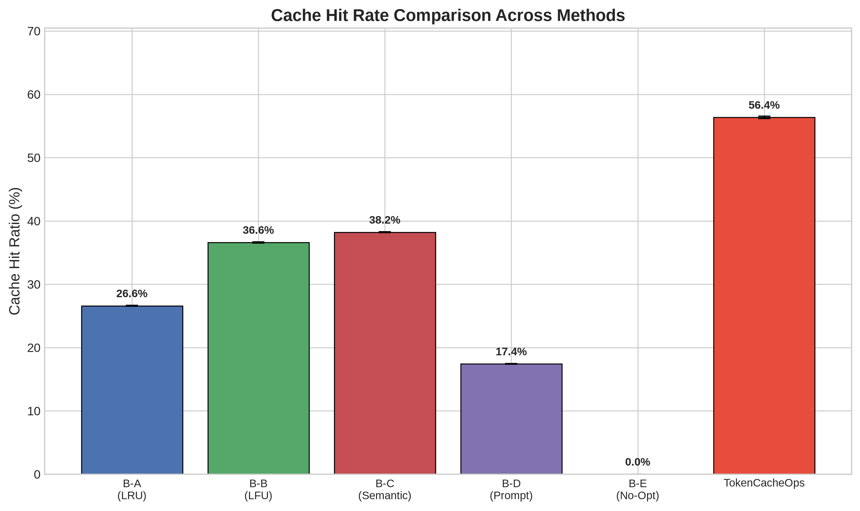
Fig. 2. Cache hit rate comparison across all methods.

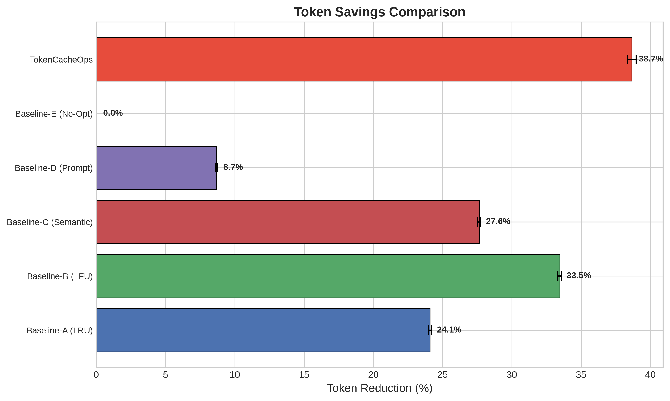
Fig. 3. Token savings comparison.

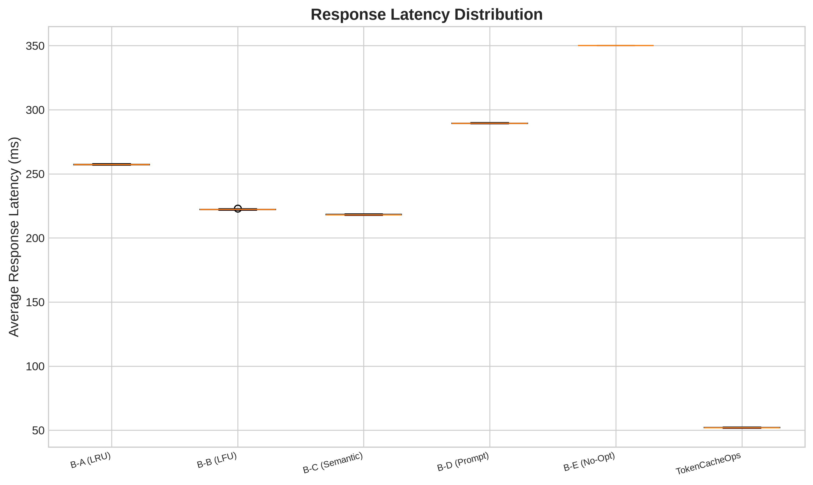
Fig. 4. Response latency distribution (box plots, 30 runs).

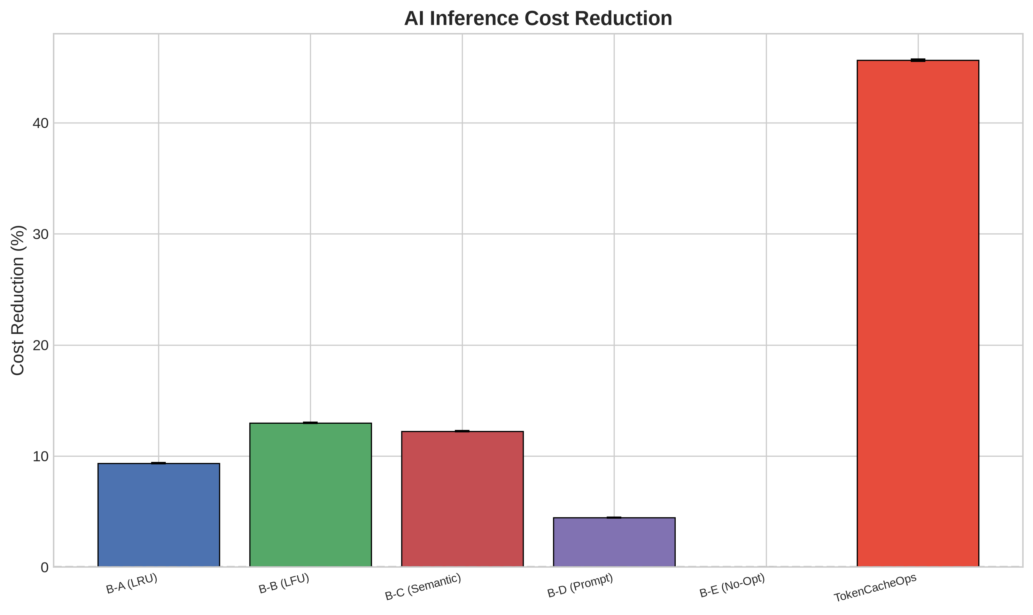
Fig. 5. AI inference cost reduction.

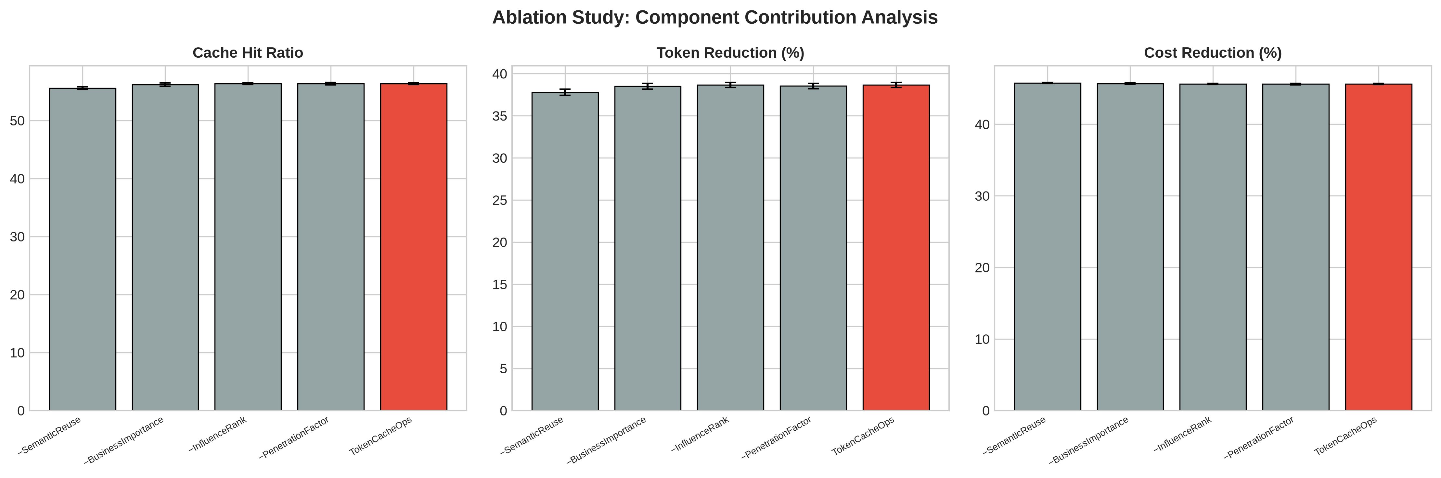
Fig. 6. Ablation study: component contribution analysis.

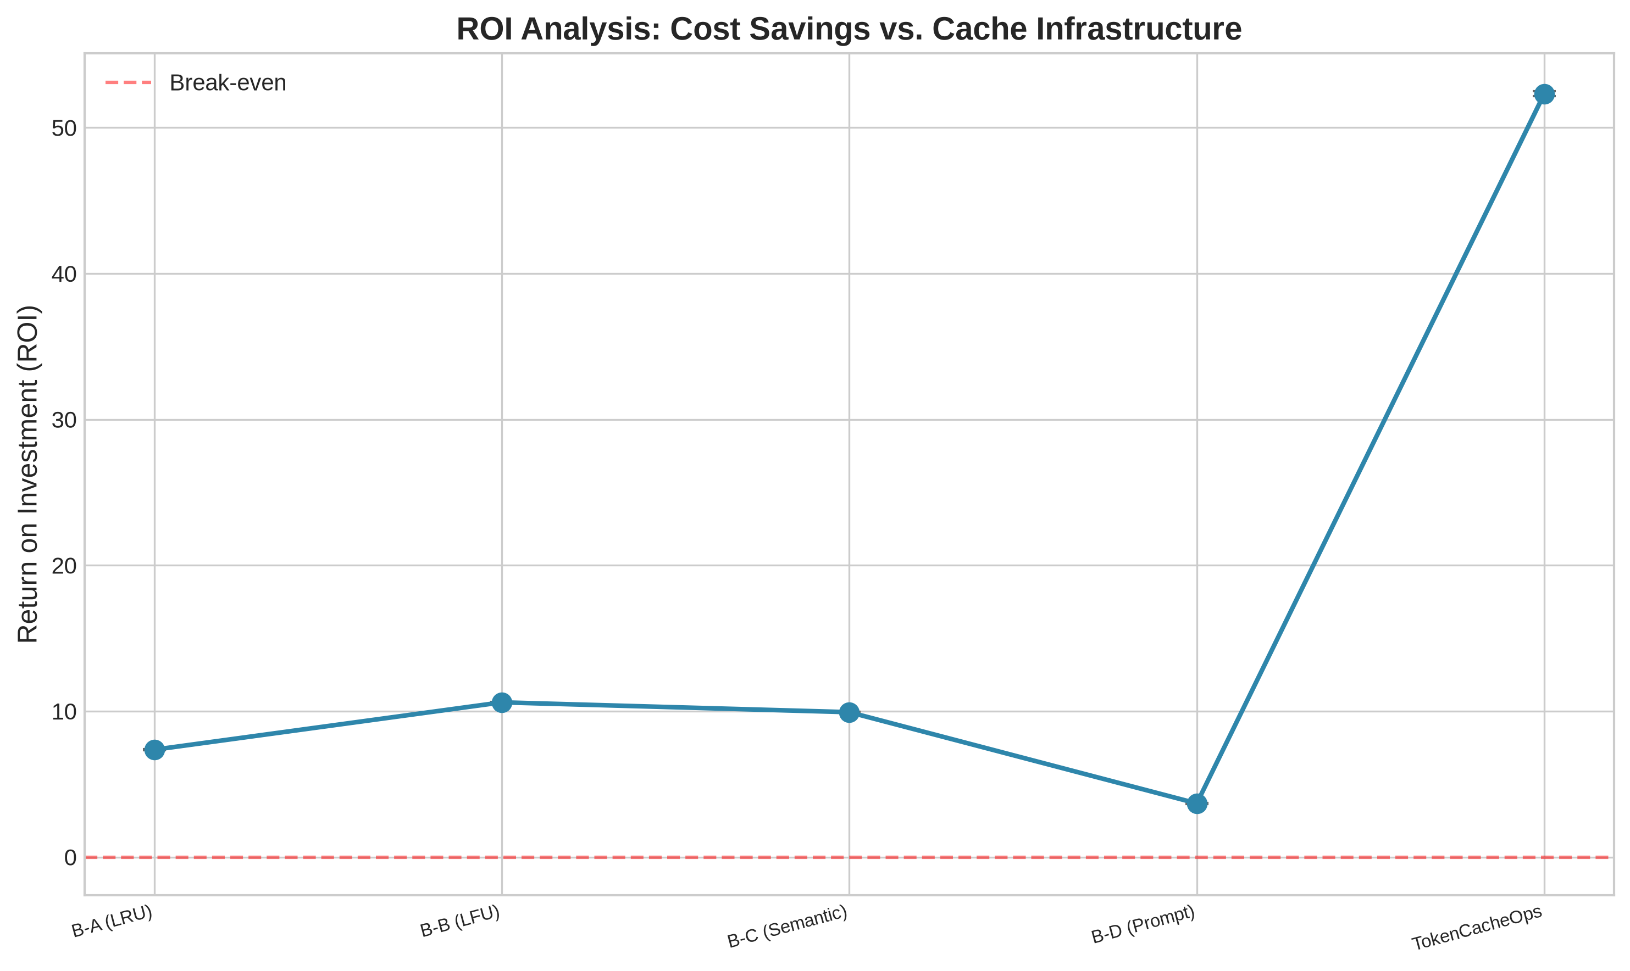
Fig. 7. Return on investment (ROI) analysis.

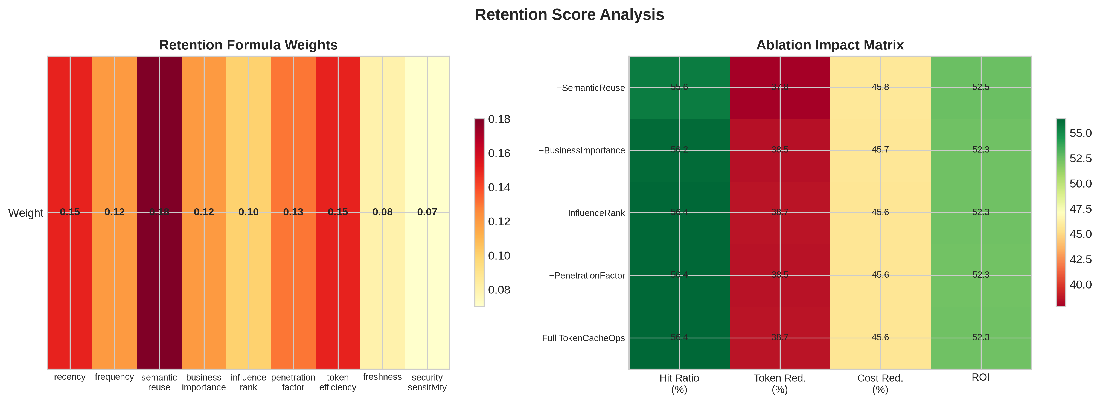
Fig. 8. Retention score weights and ablation impact heat map.

Variant | Hit % | Token % | Cost % | Latency | ROI
w/o SemanticReuse | 55.6±0.2 | 37.8 | 45.8 | 53.0 | 52.5x
w/o BusinessImportance | 56.2±0.3 | 38.5 | 45.7 | 52.3 | 52.3x
w/o InfluenceRank | 56.4±0.2 | 38.7 | 45.6 | 52.0 | 52.3x
w/o PenetrationFactor | 56.4±0.2 | 38.5 | 45.6 | 52.1 | 52.3x
Full TokenCacheOps | 56.4±0.2 | 38.7 | 45.6 | 52.0 | 52.3x
TABLE VIII. ABLATION STUDY RESULTS

A. Statistical Validation
Comparison | t-statistic | p-value | Cohen's d
TokenCacheOps vs B-A (LRU) | 810.4 | 9.03e-80 | 209.2
TokenCacheOps vs B-B (LFU) | 520.5 | 1.33e-79 | 134.4
TokenCacheOps vs B-C (Semantic) | 487.8 | 2.45e-74 | 125.9
TokenCacheOps vs B-D (Prompt) | 1091.9 | 5.15e-77 | 281.9
TokenCacheOps vs B-E (No-Opt) | 1635.9 | 1.49e-73 | 422.4
TABLE IX. WELCH'S T-TEST VS. TOKENCACHEOPS (CACHE HIT RATIO)

One-way ANOVA: F(5,174)=1193523, p<0.001.
Context efficiency: 0.325. Retrieval efficiency: 0.492. Semantic hit ratio: 48.0%.

VI. DISCUSSION
TokenCacheOps outperforms baselines via tiered retention, semantic reuse, and model routing synergy. The five-tier architecture preserves high-value entries. Semantic reuse ablation shows −0.8pp hit ratio impact. At 10M monthly requests, 38.7% token reduction saves ~$23,000/month at stated pricing.

VII. LIMITATIONS
Synthetic workloads; fixed pricing; single-node cache (1,500 entries); simulation without live LLM inference; no distributed coherence.

VIII. FUTURE WORK
RL-based retention optimization, adaptive weighting, multi-agent memory caching, vector DB integration, hybrid cloud deployment, federated cache learning.

IX. CONCLUSION
TokenCacheOps achieves 56.4% hit ratio, 38.7% token reduction, 45.6% cost reduction, and 52.3x ROI—demonstrating practical enterprise AI FinOps value.

REFERENCES
- [1] OpenAI, "API Pricing," 2024. https://openai.com/pricing
- [2] N. Reimers and I. Gurevych, "Sentence-BERT," in Proc. EMNLP-IJCNLP, 2019.
- [3] S. Bae et al., "Semantic Caching for LLM Applications," arXiv:2311.05834, 2023.
- [4] Z. Liu et al., "Cost-Efficient Prompt Caching," arXiv:2405.08448, 2024.
- [5] M. Chen et al., "FrugalGPT," arXiv:2305.05176, 2023.

APPENDIX A. REPRODUCIBILITY
Source code: tokencacheops/src/. Run: python3 scripts/run_experiments.py. Data: outputs/data/experiment_results.csv (180 rows), ablation_results.csv (150 rows), workload_dataset.csv (100,000 rows). Figures: outputs/figures/. Notebook: notebooks/experiment.ipynb.

