BOUNDARY AND DISTANCE-AWARE MULTI-TASK U-NET FOR NUCLEI INSTANCE SEGMENTATION IN HISTOPATHOLOGICAL IMAGES
PROJECT PHASE II — FINAL REPORT
Submitted by
KABEL B 2116231801076
MEENAKSHI G 2116231801099
in partial fulfilment for the award of the degree of
BACHELOR OF TECHNOLOGY
in
ARTIFICIAL INTELLIGENCE AND DATA SCIENCE

RAJALAKSHMI ENGINEERING COLLEGE
(AUTONOMOUS), CHENNAI – 602 105
OCT 2026

BONAFIDE CERTIFICATE
Certified that this Report titled "BOUNDARY AND DISTANCE-AWARE MULTI-TASK U-NET FOR NUCLEI INSTANCE SEGMENTATION IN HISTOPATHOLOGICAL IMAGES" address the SDG 3 - Good Health and Well-being, is the Bonafide work of "KABEL B (2116231801076)" and "MEENAKSHI G (2116231801099)" who carried out the work under my supervision. Certified further that to the best of my knowledge the work reported herein does not form part of any other thesis or dissertation on the basis of which a degree or award was conferred on an earlier occasion on this or any other candidate.

SIGNATURE SIGNATURE
Dr. J.M. Gnanasekar M.E., Ph.D., Ms. G. Dayalin Leena,
Professor and Head, Assistant Professor,
AI&DS AI&DS
Rajalakshmi Engineering College Rajalakshmi Engineering College
Thandalam – 602 105 Thandalam – 602 105
Submitted to Project Viva-Voce Examination held on ______________

Internal Examiner External Examiner

DEPARTMENT VISION
To become a global leader in Artificial Intelligence and Data Science by achieving through excellence in teaching, training, and research, to serve the society.

DEPARTMENT MISSION
- To develop students' skills in innovation, problem-solving, and professionalism through the guidance of well-trained faculty.
- To encourage research activities among students and faculty members to address the evolving challenges of industry and society.
- To impart qualities such as moral and ethical values, along with a commitment to lifelong learning.

PROGRAMME EDUCATIONAL OBJECTIVES (PEOs)
PEO 1: Build a successful professional career across industry, government, and academia by leveraging technology to develop innovative solutions for real-world problems.
PEO 2: Maintain a learning mindset to continuously enhance knowledge through experience, formal education, and informal learning opportunities.
PEO 3: Demonstrate an ethical attitude while excelling in communication, management, teamwork, and leadership skills.
PEO 4: Utilize engineering, problem-solving, and critical thinking skills to drive social, economic, and sustainable impact.

PROGRAMME OUTCOMES (POs)
PO1: Engineering Knowledge: Apply the knowledge of mathematics, science, engineering fundamentals and an engineering specialization to the solution of complex engineering problems.
PO2: Problem Analysis: Identify, formulate, review research literature, and analyze complex engineering problems reaching substantiated conclusions using first principles of mathematics, natural sciences, and engineering sciences.
PO3: Design / Development of solutions: Design solutions for complex engineering problems and design system components or processes that meet the specified needs with appropriate consideration for the public health and safety, and the cultural, societal, and environmental considerations.
PO4: Conduct investigations of complex problems: Use research-based knowledge and research methods including design of experiments, analysis and interpretation of data, and synthesis of the information to provide valid conclusions.
PO5: Modern tool usage: Create, select, and apply appropriate techniques, resources, and modern engineering and IT tools including prediction and modeling to complex engineering activities with an understanding of the limitations.
PO6: The engineer and society: Apply reasoning informed by the contextual knowledge to assess societal, health, safety, legal and cultural issues and the consequent responsibilities relevant to the professional engineering practice.
PO7: Environment and sustainability: Understand the impact of the professional engineering solutions in societal and environmental contexts, and demonstrate the knowledge of, and need for sustainable development.
PO8: Ethics: Apply ethical principles and commit to professional ethics and responsibilities and norms of the engineering practice.
PO9: Individual and team work: Function effectively as an individual and as a member or leader in diverse teams, and in multidisciplinary settings.
PO10: Communication: Communicate effectively on complex engineering activities with the engineering community and with society at large, such as, being able to comprehend and write effective reports and design documentation, make effective presentations, and give and receive clear instructions.
PO11: Project management and finance: Demonstrate knowledge and understanding of the engineering management principles and apply these to one's own work, as a member and leader in a team, to manage projects and in multidisciplinary environments.
PO12: Life-long learning: Recognize the need for and have the preparation and ability to engage in independent and lifelong learning in the broadest context of technological change.

PROGRAMME SPECIFIC OUTCOMES (PSOs)
A graduate of the Artificial Intelligence and Data Science Learning Program will demonstrate
PSO 1: Foundation Skills: Apply the principles of artificial intelligence and data science by leveraging problem-solving skills, inference, perception, knowledge representation, and learning techniques.
PSO 2: Problem-Solving Skills: Apply engineering principles and AI models to solve real-world problems across domains, delivering cutting-edge solutions through innovative ideas and methodologies.
PSO 3: Successful Progression: Utilize interdisciplinary knowledge to identify problems and develop solutions, a passion for advanced studies, innovative career pathways to evolve as an ethically responsible artificial intelligence and data science professional, with a commitment to society.

COURSE OBJECTIVE
- To identify and formulate real-world problems that can be solved using Artificial Intelligence and Data Science techniques.
- To apply theoretical and practical knowledge of AI & DS for designing innovative, data-driven solutions.
- To integrate various tools, frameworks, and algorithms to develop, test, and validate AI & DS models.
- To demonstrate effective teamwork, project management, and communication skills through collaborative project execution.
- To instill awareness of ethical, societal, and environmental considerations in the design and deployment of intelligent systems.

COURSE OUTCOME
CO 1: Analyse and define a real-world problem by identifying key challenges, project requirements and constraints.
CO 2: Conduct a thorough literature review to evaluate existing solutions, identify research gaps and formulate research questions.
CO 3: Develop a detailed project plan by defining objectives, setting timelines, and identifying key deliverables to guide the implementation process.
CO 4: Design and implement a prototype or initial model based on the proposed solution framework using appropriate AI tools and technologies.
CO 5: Demonstrate teamwork, communication, and project management skills by preparing and presenting a well-structured project proposal and initial implementation results.

CO-PO-PSO MAPPING
Note: Correlation levels 1, 2 or 3 are as defined below: 1: Slight (Low), 2: Moderate (Medium), 3: Substantial (High). No correlation: “-”
CO | PO1 | PO2 | PO3 | PO4 | PO5 | PO6 | PO7 | PO8 | PO9 | PO10 | PO11 | PO12 | PSO1 | PSO2 | PSO3
CO1 | 3 | 3 | 2 | 2 | 1 | 2 | 1 | 1 | 1 | 2 | 1 | 2 | 3 | 2 | 2
CO2 | 2 | 3 | 2 | 3 | 2 | 1 | 1 | 1 | 2 | 2 | 1 | 3 | 2 | 2 | 2
CO3 | 2 | 2 | 3 | 2 | 2 | 1 | 2 | 2 | 3 | 2 | 3 | 2 | 2 | 3 | 3
CO4 | 3 | 3 | 3 | 3 | 3 | 2 | 2 | 2 | 2 | 3 | 2 | 2 | 3 | 3 | 3
CO5 | 2 | 2 | 2 | 1 | 2 | 2 | 2 | 3 | 3 | 3 | 3 | 2 | 2 | 2 | 3

ABSTRACT
Accurate nuclei instance segmentation in histopathological images is challenging due to variations in nuclear morphology and the frequent occurrence of touching and overlapping nuclei. This project proposes a Boundary and Distance-Aware Multi-Task U-Net for improved nuclei instance segmentation, developed through a progressive five-stage framework using the MoNuSeg dataset. The approach first generates binary, instance, boundary, and distance-transform targets from annotated images, followed by the development of a baseline U-Net, a boundary-aware U-Net, and a full multi-task U-Net that jointly learns nucleus, boundary, and distance representations. The predicted outputs are further processed using connected-component analysis and boundary- and distance-guided watershed techniques to separate individual nuclear instances. A common evaluation framework compares the different models and post-processing strategies using Dice and IoU for pixel-level segmentation, AJI and PQ for instance-level performance, and a dedicated touching-nuclei separation analysis. The proposed framework provides a systematic approach for analysing how boundary and distance information contribute to accurate nuclei segmentation and instance separation in complex histopathological images.
Keywords: Nuclei Instance Segmentation, Histopathological Images, MoNuSeg, Multi-Task U-Net, Boundary-Aware Segmentation, Distance Transform, Watershed Segmentation, Touching Nuclei

ACKNOWLEDGEMENT
Initially we thank the Almighty for being with us through every walk of our life and showering his blessings through the endeavor to put forth this report. Our sincere thanks to our Chairman Mr. S. MEGANATHAN, B.E., F.I.E., our Vice Chairman Mr. ABHAY SHANKAR MEGANATHAN, B.E., M.S., and our respected Chairperson Dr. (Mrs.) THANGAM MEGANATHAN, Ph.D., for providing us with the requisite infrastructure and sincere endeavoring in educating us in their premier institution.
Our sincere thanks to Dr. S.N. MURUGESAN, M.E., Ph.D., our beloved Principal for his kind support and facilities provided to complete our work in time. We express our sincere thanks to Dr. J.M. GNANASEKAR, M.E., Ph.D., Professor and Head of the Department of Artificial Intelligence and Data Science for his guidance and encouragement throughout the project work. We convey our sincere and deepest gratitude to our internal guide, Ms. G. DAYALIN LEENA, Assistant Professor, Department of Artificial Intelligence and Data Science, Rajalakshmi Engineering College, for her valuable guidance throughout the course of the project. We are very glad to thank our Project Coordinator, Ms. D. SORNA SHANTHI, Associate Professor, Department of Artificial Intelligence and Data Science, for her useful tips during our reviews to build our project.

KABEL B MEENAKSHI G
(2116231801076) (2116231801099)

TABLE OF CONTENTS

TITLE PAGE NO
ABSTRACT vi
ACKNOWLEDGEMENT vii
LIST OF FIGURES x
LIST OF TABLES xi
LIST OF ABBREVIATIONS xii
CHAPTER 1 — INTRODUCTION 1
1.1 General 1
1.1.1 Histopathological Image Analysis 1
1.1.2 Nuclei Segmentation in Histopathology 1
1.1.3 Challenges in Nuclei Segmentation 2
1.1.4 Deep Learning for Nuclei Segmentation 2
1.1.5 Instance Separation of Overlapping Nuclei 2
1.2 Objectives 2
1.3 Existing System 3
1.4 Limitations of Existing System 3
1.5 Proposed System 4
CHAPTER 2 — LITERATURE SURVEY 5
2.1 Overview 5
2.2 Literature Survey 5
2.3 Comparative Analysis 7
CHAPTER 3 — SYSTEM DESIGN 8
3.1 Dataset and Input 8
3.2 Development Environment 8
3.2.1 Hardware Specifications 9
3.2.2 Software Specifications 9
3.3 Overall System Architecture 9
3.4 Module Flow 11
3.5 Module Interaction and Data Flow 11
CHAPTER 4 — METHODOLOGY 12
4.1 Dataset Preparation and Preprocessing 12
4.2 Stage 1 — Data Preparation and Target Generation 12
4.3 Stage 2 — Baseline Nuclei Segmentation 13
4.4 Stage 3 — Boundary-Aware Nuclei Segmentation 13
4.5 Stage 4 — Full Multi-Task Nuclei Segmentation 14
4.6 Stage 5 — Comprehensive Model Evaluation 15
4.7 Model Validation and Testing 16
CHAPTER 5 — RESULTS AND DISCUSSION 17
5.1 Overview 17
5.2 Stage-Wise Segmentation Results 17
5.3 Quantitative Performance Analysis 19
5.4 Instance Separation and Touching-Nuclei Analysis 21
5.5 Comparative Analysis 23
5.6 Discussion and Insights 23
CHAPTER 6 — CONCLUSION AND FUTURE ENHANCEMENTS 25
6.1 Conclusion 25
6.2 Contributions of the Proposed Work 25
6.3 Limitations 25
6.4 Future Enhancements 26
APPENDIX 27
REFERENCES 28

LIST OF FIGURES
FIG NO NAME PAGE NO
Fig 3.1 System Architecture and Stage-wise Pipeline 10
Fig 4.1 Stage 1 Target Generation for a Sample H&E Image 13
Fig 4.2 Stage 4 Multi-Task Training and Validation Loss 14
Fig 5.1 Ground Truth versus Stage 4 Predictions (Nucleus, Boundary, Distance) 18
Fig 5.2 Stage 4 Outputs and Prediction-Difference Maps 18
Fig 5.3 Mean Pixel-Level Dice and IoU of the Three Models 19
Fig 5.4 Per-Image Dice Coefficient on the 14 Test Images 20
Fig 5.5 Distance- and Boundary-Guided Watershed Pipeline 21

LIST OF TABLES
TABLE NO NAME PAGE NO
Table 3.1 Hardware Specifications 9
Table 3.2 Software Specifications 9
Table 3.3 MoNuSeg Dataset Summary 8
Table 3.4 Module Inputs and Outputs 11
Table 4.1 Target Representations Generated in Stage 1 12
Table 4.2 Stage 4 Training Configuration 14
Table 4.3 Comparison of the Three Model Variants 15
Table 4.4 Evaluation Configurations Defined for the Final Comparison 16
Table 5.1 Stage 4 Head-Wise Test Metrics 17
Table 5.2 Mean Pixel-Level Performance on 14 Test Images 19
Table 5.3 Per-Image Pixel-Level Dice and IoU 20
Table 5.4 Stage 3 versus Stage 4 under the Training-Time Protocol 21
Table 5.5 Effect of Watershed Refinement on AJI 21
Table 5.6 Instance-Level Analysis of One Test Image 22
Table 5.7 Overall Comparison of the Three Stages 23

LIST OF ABBREVIATIONS
ABBREVIATION | FULL FORM
AI | Artificial Intelligence
AJI | Aggregated Jaccard Index
BCE | Binary Cross-Entropy
CC | Connected Components
CNN | Convolutional Neural Network
CPU | Central Processing Unit
CSV | Comma-Separated Values
DL | Deep Learning
EDT | Euclidean Distance Transform
FCN | Fully Convolutional Network
GPU | Graphics Processing Unit
GT | Ground Truth
H&E | Hematoxylin and Eosin
IoU | Intersection over Union
JSON | JavaScript Object Notation
MAE | Mean Absolute Error
MoNuSeg | Multi-Organ Nuclei Segmentation
MSE | Mean Squared Error
PQ | Panoptic Quality
ReLU | Rectified Linear Unit
RQ | Recognition Quality
SQ | Segmentation Quality
TCGA | The Cancer Genome Atlas
WS | Watershed
WSI | Whole-Slide Imaging

CHAPTER 1
INTRODUCTION

1.1 General
Histopathology is the microscopic examination of tissue samples to study the manifestation of disease, and it remains one of the most reliable methods for diagnosing cancer. Pathologists examine tissue slides stained with Hematoxylin and Eosin (H&E) to observe cellular structures, among which the nucleus is one of the most informative. The size, shape, texture and arrangement of nuclei carry critical information about tissue abnormality, malignancy and disease progression. With the growth of digital pathology, whole-slide imaging has made it possible to digitise tissue sections and to analyse them computationally. Manual examination of such high-resolution images, however, is time-consuming, subjective and prone to inter-observer variability, which creates a strong need for automated, accurate and reproducible analysis.
Among the tasks in digital pathology, nuclei segmentation — identifying and delineating each individual nucleus — forms the foundation for cell counting, morphological feature extraction and cancer grading. It is also a difficult task, because nuclei are frequently crowded, irregular and overlapping. This project addresses the problem with a boundary-aware, multi-task U-Net that is built and evaluated in five progressive stages on the MoNuSeg dataset. The following subsections describe the background concepts on which the work rests.

1.1.1 Histopathological Image Analysis
Histopathological image analysis is the computational examination of tissue slide images to extract clinically relevant information such as cell morphology, tissue architecture and abnormal growth patterns. H&E staining colours nuclei dark purple-blue and the surrounding cytoplasm and extracellular matrix pink, so that structures can be distinguished visually. Whole-slide scanners generate gigapixel images that are far too large for exhaustive manual review, which has driven the adoption of computer-aided diagnosis. Nuclear characteristics such as size, shape irregularity, chromatin texture and density correlate strongly with tumour grade and stage, so nucleus-level analysis is particularly valuable. Automated analysis also introduces a level of consistency that is hard to achieve manually, especially across large batches of slides or where expert pathologists are scarce.

1.1.2 Nuclei Segmentation in Histopathology
Nuclei segmentation is the process of assigning each pixel of a tissue image to the background or to a nucleus and, in its instance form, of assigning a distinct label to every individual nucleus. Semantic segmentation answers the question “which pixels belong to nuclei?”, whereas instance segmentation additionally answers “which nucleus does each pixel belong to?”. Downstream measurements such as nuclear count, area distribution and pleomorphism require the instance form, because a single merged region would be counted as one nucleus and would distort every derived feature.

1.1.3 Challenges in Nuclei Segmentation
Several factors make nuclei segmentation challenging. First, nuclei occur in dense clusters, particularly in malignant regions, so that neighbouring nuclei touch or overlap. In the sample image analysed in this project (Chapter 4), 424 annotated nuclei collapse into only 322 connected components of the binary mask, and 135 pairs of nuclei lie within a dilation distance of each other. Second, nuclei vary widely in size, shape and staining intensity across organs and even within one image. Third, boundaries between adjacent nuclei are often visually indistinct because neighbours share similar colour and texture. Finally, annotated data are scarce, since manual delineation of tens of thousands of nuclei is expensive; the MoNuSeg training set used here contains only 37 images.

1.1.4 Deep Learning for Nuclei Segmentation
Convolutional neural networks learn discriminative features directly from raw pixels instead of relying on hand-crafted rules. Fully convolutional networks introduced dense pixel-wise prediction, and encoder–decoder architectures such as U-Net became the dominant design for biomedical segmentation. U-Net consists of a contracting path that extracts increasingly abstract features, an expanding path that restores spatial resolution, and skip connections that carry fine spatial detail from the encoder to the decoder. Its ability to learn from few annotated images makes it a natural backbone for nuclei segmentation, and it is the backbone used in every stage of this work.

1.1.5 Instance Separation of Overlapping Nuclei
A standard U-Net trained on a binary mask has no explicit mechanism for deciding where one nucleus ends and the next begins. Two complementary cues address this gap. A boundary map marks the contour pixels of each nucleus and therefore the lines along which touching nuclei should be split. A distance-transform map assigns each nucleus pixel a value that grows towards the centre of the nucleus, so that its local maxima act as seeds for individual nuclei. When a single network is trained to predict the nucleus mask, the boundary map and the distance map together, the shared encoder is forced to learn features that are useful for all three tasks. The predicted maps are then combined with a marker-controlled watershed to convert the semantic output into labelled instances.

1.2 Objectives
The main goal of this project is to design, implement and evaluate a boundary-aware, multi-task deep learning framework for accurate instance-level nuclei segmentation in H&E-stained histopathology images. The specific objectives are as follows:
- To generate complete supervision targets from the dataset annotations: instance, binary, boundary and distance-transform maps that are mutually consistent and verified.
- To develop a baseline U-Net: a reference model for pure binary nucleus segmentation against which every later improvement is measured.
- To incorporate boundary information: extend the network with a boundary head and measure its effect on nucleus segmentation.
- To incorporate distance-transform information: build a full multi-task U-Net with nucleus, boundary and distance heads trained jointly.
- To improve the separation of touching nuclei: use the predicted boundary and distance maps to drive a marker-controlled watershed that converts masks into instances.
- To evaluate the system with standard metrics: pixel-level Dice and IoU for all three models and instance-level AJI for the multi-task pipeline on the held-out test images.
  - Existing System
Existing nuclei segmentation approaches primarily focus on identifying nuclear regions, but they face difficulties in accurately separating individual nuclei in dense and overlapping tissue
- CNN-based semantic segmentation: Networks such as U-Net learn spatial features and classify each pixel as nucleus or background, providing accurate nuclear regions.
- Problem with touching nuclei: When two or more nuclei are closely packed or touching, the CNN may predict them as one connected nuclear region because all pixels belong to the same foreground class.

No individual nucleus identity: A semantic segmentation mask tells us where nuclei are present, but not how many individual nuclei are present or where one nucleus ends and another begins.

Importance of instance segmentation: For cancer analysis, individual nuclei need to be separated so that their number, size, shape and spatial distribution can be analysed. Therefore, simply detecting the nuclear region is insufficient.

Limitations of conventional CNN segmentation: Standard CNN-based approaches generally do not explicitly learn inter-nuclear boundaries or centre-related information, making separation of densely packed nuclei challenging.

1.4 Limitations of Existing System
- Difficulty in identifying individual nuclei: Binary masks indicate where nuclei exist but do not provide sufficient information about the center or shape of each nucleus, making instance separation difficult.
- Pixel-level metrics are insufficient: Metrics such as Dice and IoU may give high scores even when nuclei are incorrectly merged or split.
- Limited robustness to tissue variation: Differences in staining, nucleus size, shape, and tissue morphology can reduce segmentation performance across different tissue types.
- Incomplete instance-level validation: Many approaches focus mainly on semantic segmentation metrics rather than evaluating whether each nucleus is correctly separated and counted.

1.5 Proposed System

The proposed system is a Boundary and Distance-Aware Multi-Task U-Net designed for nuclei instance segmentation in histopathological images, with particular focus on separating touching and overlapping nuclei. The framework progressively develops from a baseline U-Net to a boundary-aware model and finally to a multi-task model that jointly learns nucleus, boundary, and distance information. Boundary prediction provides explicit cues between neighbouring nuclei, while distance information provides spatial cues for identifying individual nuclei within connected regions. These complementary predictions are further used with connected-component and watershed-based post-processing to obtain separated nuclear instances. The complete framework is evaluated using pixel-level metrics (Dice and IoU), instance-level metrics (AJI and PQ), and touching-nuclei separation analysis. This progressive design enables the contribution of boundary and distance information to nuclei instance segmentation to be systematically analysed.

CHAPTER 2
LITERATURE SURVEY

2.1 Overview
The advancement of deep learning and computer vision has driven substantial research interest in automated nuclei segmentation for digital histopathology. Researchers have explored encoder–decoder architectures, boundary-aware and distance-map-based methods, multi-branch networks, region-proposal frameworks and attention mechanisms, all aimed at separating densely packed and overlapping nuclei. The studies reviewed below fall into five areas that are relevant to this project.
- Foundational encoder–decoder architectures, particularly U-Net, that established pixel-wise biomedical segmentation with limited training data.
- Benchmark datasets such as MoNuSeg that provide standardised, multi-organ, annotated images for training and evaluation.
- Distance-map and boundary-regression techniques that provide explicit spatial cues for separating touching nuclei.
- Multi-branch and multi-task architectures such as HoVer-Net and CIA-Net that jointly learn segmentation, boundary and distance information.
- Region-proposal, shape-based and attention-driven approaches, including Mask R-CNN, StarDist and transformer-augmented networks.

2.2 Literature Survey
O. Ronneberger, P. Fischer and T. Brox (2015), “U-Net: Convolutional Networks for Biomedical Image Segmentation.” The paper introduces a symmetric contracting and expanding network with skip connections that can be trained end-to-end from very few annotated images through heavy data augmentation. The architecture is the direct backbone of every model developed in this project.
N. Kumar, R. Verma, S. Sharma, S. Bhargava, A. Vahadane and A. Sethi (2017), “A Dataset and a Technique for Generalized Nuclear Segmentation for Computational Pathology.” Kumar et al. introduce the MoNuSeg dataset of multi-organ H&E images with more than 21,000 expert-validated nuclear boundaries, together with a generalised segmentation technique. This dataset is the benchmark used in the present work.
P. Naylor, M. Laé, F. Reyal and T. Walter (2018), “Segmentation of Nuclei in Histopathology Images by Deep Regression of the Distance Map.” The authors train a CNN to regress the distance map of nuclei instead of a binary mask and recover instances by post-processing. The study motivates the distance head used in the multi-task U-Net.
S. Graham, Q. D. Vu, S. E. A. Raza, A. Azam, Y. W. Tsang, J. T. Kwak and N. Rajpoot (2019), “HoVer-Net: Simultaneous Segmentation and Classification of Nuclei in Multi-Tissue Histology Images.” HoVer-Net uses three branches that predict a nuclear pixel map, horizontal and vertical distance maps to the nucleus centroid, and a nuclear type map. Its multi-branch design parallels the present work, although this project uses boundary and distance-transform maps.
Y. Zhou, O. F. Onder, Q. Dou, E. Tsougenis, H. Chen and P.-A. Heng (2019), “CIA-Net: Robust Nuclei Instance Segmentation with Contour-Aware Information Aggregation.” CIA-Net jointly predicts masks and contours and lets the two branches exchange features, which improves robustness to ambiguous boundaries. The idea of coupling contour and mask information supports the boundary-aware stage of this project.
K. He, G. Gkioxari, P. Dollár and R. Girshick (2017), “Mask R-CNN.” Mask R-CNN adds a mask branch to Faster R-CNN to perform instance segmentation on detected regions. It has been widely adapted to nuclei and represents the region-proposal alternative to the encoder–decoder approach used here.
B. Bancher, A. Mahbod, I. Ellinger, R. Ecker and G. Dorffner (2021), “Improving Mask R-CNN for Nuclei Instance Segmentation in Hematoxylin & Eosin-Stained Histological Images.” The study adapts Mask R-CNN to H&E images and documents its comparatively weaker behaviour on tightly clustered nuclei, which reinforces the case for boundary- and distance-aware methods.
M. Weigert and U. Schmidt (2022), “Nuclei Instance Segmentation and Classification in Histopathology Images with StarDist.” StarDist represents each nucleus as a star-convex polygon predicted by radial distances and resolves overlaps through non-maximum suppression. It offers an alternative shape representation that is effective for round or convex nuclei.
J. Wang, S. Yang, D. M. Rong and X. Zhan (2023), “A Comprehensive Overview of Computational Nuclei Segmentation Methods in Digital Pathology.” This survey reviews classical, machine-learning and deep-learning methods, benchmark datasets and evaluation metrics such as Dice, IoU, AJI and PQ. It informs the choice of metrics adopted in this project.
H. Lin, Y. Chen, Q. Wang and Z. Li (2022), “TSHVNet: Simultaneous Nuclear Instance Segmentation and Classification in Histopathological Images Based on Multiattention Mechanisms.” TSHVNet integrates transformer and SimAM attention modules into HoVer-Net to improve separation in dense regions. It points to attention mechanisms as a direction for extending boundary- and distance-aware networks.

CHAPTER 3
SYSTEM DESIGN

3.1 Dataset and Input
The project uses the MoNuSeg 2018 (Multi-Organ Nuclei Segmentation) dataset, released with the MICCAI 2018 challenge and available from Kaggle (https://www.kaggle.com/datasets/tuanledinh/monuseg2018z). It contains H&E-stained tissue images of 1000 × 1000 pixels captured at 40× magnification from The Cancer Genome Atlas (TCGA) archive and covering several organs. In the distribution used here, the data are stored in two Parquet files (one for training and one for testing). Each row holds a patient identifier, the RGB image, a list of per-nucleus binary masks (one PNG mask for every annotated nucleus) and a tissue code. The per-nucleus masks are derived from the manually delineated nuclear boundary polygons of the original annotation and are the starting point for all target generation.
Table 3.3 MoNuSeg Dataset Summary
Property | Value
Training images | 37
Test images | 14
Image size | 1000 × 1000 pixels, 3-channel RGB (uint8)
Nuclei per training image | mean 652.4, std 425.1, min 294, median 440, max 1,863
Nuclei per test image | mean 478.4, std 146.3, min 249, max 818
Total test-set nuclei | 6,697
Images with zero nuclei | 0
The large spread in nuclear count — from 249 to 1,863 nuclei in a single image — shows how strongly density varies across tissue types and is the reason why instance separation is difficult. The 37 training images are further divided into 32 images for training and 5 for validation (Section 4.5), and the 14 test images are used only for final evaluation.

3.2 Development Environment
The development environment provides the computational and software foundation for building, training and evaluating the models. All experiments were run in Jupyter notebooks on a Windows machine using Python and PyTorch. Training of the 7.77-million-parameter multi-task network was carried out on the CPU and took roughly 12 to 19 seconds per epoch.

3.2.1 Hardware Specifications
Table 3.1 Hardware Specifications
Component | Specification
RAM | 8 GB or above
Processing Unit | (GPU or CPU)
Storage | 256 GB SSD or above

3.2.2 Software Specifications
Table 3.2 Software Specifications
Category | Specification
Programming language | Python 3
Deep learning framework | PyTorch
Image processing | OpenCV, scikit-image, SciPy (ndimage), Pillow, NumPy
Data handling | pandas (Parquet loading)
Post-processing | scikit-image watershed, SciPy distance transform
Visualisation | Matplotlib
Environment | Jupyter Notebook

3.3 Overall System Architecture
The system follows a modular, sequential pipeline of five stages, shown in Fig 3.1. Stage 1 converts the raw dataset into four aligned target maps. Stage 2 trains a baseline U-Net that predicts only the nucleus mask. Stage 3 adds a boundary head to the shared trunk, and Stage 4 adds a distance head to obtain the full multi-task network. Stage 5 loads the trained checkpoints of Stages 2, 3 and 4, runs inference on the test images, applies connected-component or watershed post-processing and computes pixel-level and instance-level metrics, which feed the final comparison of configurations.
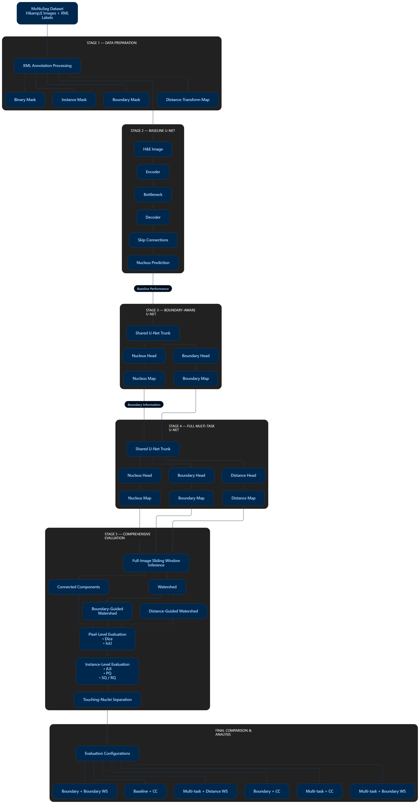
Fig 3.1 System Architecture and Stage-wise Pipeline
The design is loosely coupled: each stage reads the outputs of the previous one (target files on disk or model checkpoints) and can be modified independently. For example, the post-processing in Stage 5 can be replaced without retraining, and a new head can be added to the trunk without changing Stage 1.

3.4 Module Flow
The system consists of the following modules, whose inputs and outputs are summarised in Table 3.4.
Table 3.4 Module Inputs and Outputs
Module | Input | Output
Target generation (Stage 1) | H&E image and per-nucleus masks | Instance mask (uint16), binary mask, boundary mask, distance map (float32), all 1000 × 1000
Baseline U-Net (Stage 2) | RGB patch 3 × 256 × 256 | Nucleus logits 1 × 256 × 256
Boundary-aware U-Net (Stage 3) | RGB patch 3 × 256 × 256 | Nucleus and boundary logits
Multi-task U-Net (Stage 4) | RGB patch 3 × 256 × 256 | Nucleus logits, boundary logits, distance map in [0, 1]
Post-processing (Stage 5) | Predicted nucleus, boundary and distance maps | Labelled instance mask
Evaluation (Stage 5) | Prediction and ground truth | Dice, IoU, AJI per image and per dataset

3.5 Module Interaction and Data Flow
A tissue image enters the pipeline as a 1000 × 1000 RGB array. For training, random 256 × 256 crops are drawn together with the matching target crops; for testing, the full image is resized to 256 × 256 before it is passed through the network. The shared trunk produces a 32-channel feature map at full resolution, on which three independent 1 × 1 convolutions create the output maps. The nucleus and boundary outputs are logits that are converted to probabilities with a sigmoid; the distance output passes through a sigmoid inside the network so that it lies in [0, 1], matching the normalised distance target.
During post-processing the nucleus probability is thresholded to obtain the foreground, the distance prediction supplies marker seeds at its local peaks, and the boundary prediction acts as a barrier for the watershed. The resulting labelled mask is compared with the ground-truth instance mask to compute the Aggregated Jaccard Index.

CHAPTER 4
METHODOLOGY
The methodology follows a progressive, stage-wise approach in which increasingly capable models are built and evaluated on identical data, so that the specific contribution of each added component can be isolated. The five stages are summarised in Fig 3.1 and detailed in the following sections.

4.1 Dataset Preparation and Preprocessing
Each image is decoded from the Parquet file, converted to RGB and scaled to the range [0, 1] by dividing by 255. Training samples are produced as random 256 × 256 crops of the 1000 × 1000 image, with the nucleus, boundary and distance targets cropped at the same location. On-the-fly augmentation applies random horizontal and vertical flips and random rotations by multiples of 90°, identically to image and targets. The 37 training images are split into 32 images for training and 5 for validation (batch size 4, giving 8 training and 2 validation batches per epoch). The 14 test images are never used during training or model selection. At test time the whole image is resized to 256 × 256 with bilinear interpolation.

4.2 Stage 1 — Data Preparation and Target Generation
Stage 1 converts the dataset into the four representations required by the later models. The per-nucleus binary masks of an image are stacked into a single instance mask, in which the k-th nucleus receives the integer label k. For the sample image TCGA-38-6178-01Z-00-DX1 this produced 424 labels, matching the 424 annotated nuclei. The binary mask is obtained as instance > 0 and contains 217,915 nucleus pixels for this image. The boundary mask is obtained from the instance mask by morphological erosion and XOR (equivalently, by locating label transitions) with a boundary width of 2 pixels. The widths 1, 2, 3 and 4 gave 30,792, 59,413, 88,381 and 111,691 boundary pixels respectively; width 2 was selected as a compromise between a thin, well-localised contour and a boundary class that is not too sparse to learn. The distance map is computed with the Euclidean distance transform inside each nucleus and normalised per nucleus so that its maximum is 1; background pixels are 0.
Table 4.1 Target Representations Generated in Stage 1
Target | Data type | Value range | Purpose
Instance mask | uint16 | 0 … N | Evaluation (AJI) and source of all other targets
Binary mask | uint8 | {0, 1} | Nucleus head supervision
Boundary mask | uint8 | {0, 1} | Boundary head supervision
Distance map | float32 | [0, 1] | Distance head supervision (nucleus pixels only)
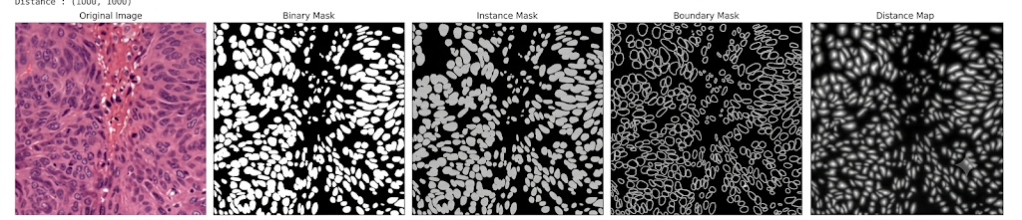
Fig 4.1 Stage 1 Target Generation for a Sample H&E Image
Several sanity checks verified the targets. The maximum instance ID equalled the number of nuclei (424); the binary mask matched the instance mask exactly; the distance map was 0 everywhere in the background (maximum 0.0); every nucleus reached a maximum distance of 1.0; and reloading the saved arrays reproduced the instance, binary, boundary and distance targets exactly. The checks also exposed the difficulty of the task: the 424 nuclei of the sample merged into only 322 connected components, and 135 nucleus pairs were found within a small dilation distance. All targets were then generated for the 37 training and 14 test images and saved as .npy files, with a metadata table recording the number of nuclei per image.

4.3 Stage 2 — Baseline Nuclei Segmentation
Stage 2 trains a standard U-Net for binary nucleus segmentation and serves as the reference model. The network has a base width of 32 channels and four down-sampling blocks that increase the channel count to 64, 128, 256 and 512 (the bottleneck). Each block consists of two 3 × 3 convolutions with batch normalisation and ReLU, preceded by 2 × 2 max-pooling. The decoder mirrors the encoder with four up-sampling blocks that use bilinear up-sampling, concatenate the corresponding skip connection and apply the same double-convolution block, reducing the channels back to 32. A single 1 × 1 convolution produces the nucleus logits. The model is trained with a combined loss, L = 0.5·BCE + 0.5·Dice, which balances pixel-wise accuracy against region overlap and counteracts the dominance of background pixels.
Dice loss = 1 − (2·Σ(p·g) + ε) / (Σp + Σg + ε)

4.4 Stage 3 — Boundary-Aware Nuclei Segmentation
Stage 3 extends the baseline with a second 1 × 1 convolutional head that predicts the boundary map from the same decoder features. The shared trunk therefore receives gradients from both the nucleus task and the boundary task. Both heads use the BCE + Dice loss. Training used the boundary dataset class, which draws random 256 × 256 crops of image, binary mask and boundary mask and applies the same flip and rotation augmentation as the other stages. The best checkpoint was reached at epoch 46 with a validation Dice of 0.7777. The aim of this stage is to teach the network explicit contour information that the baseline lacks.

4.5 Stage 4 — Full Multi-Task Nuclei Segmentation
Stage 4 adds a third head for the distance-transform map, completing the multi-task U-Net (UNetMultiTask). The trunk is a U-Net with base width 32, four down-sampling blocks and four up-sampling blocks that use transposed convolutions; the network has 7,766,051 trainable parameters. Three 1 × 1 convolutions create the outputs: nucleus logits, boundary logits and a distance prediction passed through a sigmoid. The training objective is
L_total = 1.0·L_nucleus + 1.0·L_boundary + 0.5·L_distance
where L_nucleus and L_boundary are BCE + Dice losses and L_distance is a masked MSE that averages the squared error only over nucleus pixels, so that the many background pixels do not dominate the regression. A forward and backward pass on a dummy batch confirmed the output shapes (1 × 256 × 256 for each head) and a total loss of 1.49 before training. The configuration of the full training run is listed in Table 4.2.
Table 4.2 Stage 4 Training Configuration
Setting | Value
Optimiser | Adam, learning rate 1 × 10⁻⁴, weight decay 1 × 10⁻⁵
Epochs / batch size | 50 / 4
Train / validation images | 32 / 5 (random 256 × 256 crops)
Loss weights | nucleus 1.0, boundary 1.0, distance 0.5
Model selection | Lowest validation loss (best epoch 49)
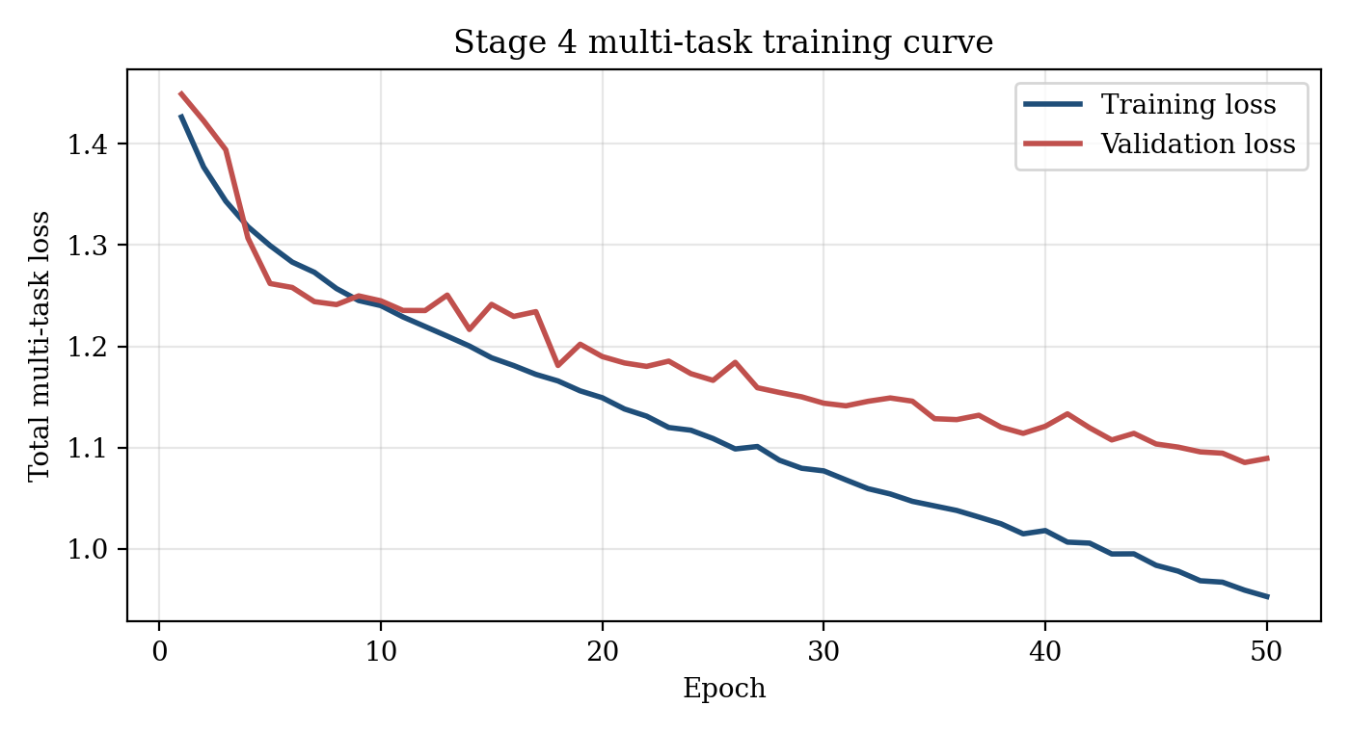
Fig 4.2 Stage 4 Multi-Task Training and Validation Loss
The training loss decreased steadily from 1.4266 in epoch 1 to 0.9526 in epoch 50, and the validation loss decreased from 1.4492 to a minimum of 1.0851 at epoch 49 (Fig 4.2). The gap between the curves stays small and the validation loss was still improving at the end of training, which indicates that the model is not strongly over-fitted and would probably benefit from longer training.
Table 4.3 Comparison of the Three Model Variants
Property | Stage 2 Baseline | Stage 3 Boundary-aware | Stage 4 Multi-task
Output heads | Nucleus | Nucleus + boundary | Nucleus + boundary + distance
Loss terms | BCE + Dice | BCE + Dice (×2) | BCE + Dice (×2) + masked MSE
Separation cue | None | Boundary | Boundary + distance
Input / output size | 3×256×256 → 256×256 | 3×256×256 → 256×256 | 3×256×256 → 256×256

4.6 Stage 5 — Comprehensive Model Evaluation
Stage 5 builds an evaluation harness that rebuilds the exact architectures of Stages 2, 3 and 4 and loads their best checkpoints (verified to exist and to produce correct output shapes). Each test image is resized to 256 × 256, passed through all three models, and the predictions are compared with the full-resolution 1000 × 1000 ground truth. The following metrics are computed.
- Dice coefficient = 2|P ∩ G| / (|P| + |G|), the pixel-level overlap between the predicted and ground-truth nucleus masks.
- Intersection over Union (IoU) = |P ∩ G| / |P ∪ G|, a stricter pixel-level overlap measure.
- Aggregated Jaccard Index (AJI), an instance-level score computed as ΣIntersection / ΣUnion over the matched instance pairs, where the union also includes every unmatched ground-truth and predicted nucleus. Merges, splits, misses and false detections therefore all lower the score. The implementation uses one-to-one greedy matching on the highest IoU.
Instance masks are produced from the multi-task outputs by a marker-controlled watershed: the nucleus probability defines the foreground, peaks of the distance prediction define the markers (seeds), and the boundary prediction defines the barrier between neighbouring basins. The complete evaluation design for the final comparison covers six combinations of model and post-processing, listed in Table 4.4; the table also states which of them have been executed in this report.
Table 4.4 Evaluation Configurations Defined for the Final Comparison
Configuration | Model and post-processing
Baseline + CC | Stage 2 mask, connected components
Boundary + CC | Stage 3 mask, connected components
Boundary + Boundary WS | Stage 3, boundary-guided watershed
Multi-task + CC | Stage 4 mask, connected components
Multi-task + Boundary WS | Stage 4, boundary-guided watershed
Multi-task + Distance WS | Stage 4, distance-guided watershed

4.7 Model Validation and Testing
Validation and testing follow a strict separation. Model selection during training used only the 5 validation images, and the 14 test images were used once the checkpoints were fixed. Three evaluation protocols appear in the results and should not be mixed. Protocol A is the training-time evaluation inside the Stage 3 and Stage 4 notebooks, where test images pass through the data loader at 256 × 256 resolution and masks are compared at that resolution. Protocol B is the Stage 5 pixel-level evaluation, where predictions are compared with the original 1000 × 1000 ground truth for all three models on the same 14 images. Protocol C is the instance-level evaluation with watershed, reported as AJI. Because the protocols differ in resolution and in how predictions are mapped back, absolute values from different protocols are not directly comparable; each table in Chapter 5 states the protocol it uses.

CHAPTER 5
RESULTS AND DISCUSSION

5.1 Overview
This chapter presents the results obtained for each stage of the pipeline. Stage 1 results (target generation and its verification) were given in Section 4.2. Here, the stage-wise segmentation results, the pixel-level and instance-level metrics and the analysis of touching nuclei are reported, followed by a comparison of the three models and a discussion of the findings. All results are obtained on the 14 held-out MoNuSeg test images.

5.2 Stage-Wise Segmentation Results
Stage 2 — baseline. The baseline U-Net produces a binary nucleus mask without any separation cue. On the first test image evaluated in Stage 5 (TCGA-2Z-A9J9-01A-01-TS1) it reached a Dice of 0.6111 and an IoU of 0.4400. The model detects most nuclei but merges neighbours in dense regions, which is reflected in its lowest scores across the test set.
Stage 3 — boundary-aware. Adding the boundary head raised the Dice to 0.6409 and the IoU to 0.4716 on the same image. Its checkpoint reached a validation Dice of 0.7777 at epoch 46. The predicted boundary map provides a contour signal that the baseline does not have.
Stage 4 — multi-task. The full model reached a Dice of 0.6956 and an IoU of 0.5333 on the same image, the highest of the three. On the test set under Protocol A it achieved a nucleus Dice of 0.6939 and an IoU of 0.5353, a boundary Dice of 0.2885 (IoU 0.1695), and a distance-regression MSE of 0.1516 (MAE 0.3649), with a mean test loss of 1.1655 that is close to the best validation loss of 1.0851. These values are summarised in Table 5.1.
Table 5.1 Stage 4 Head-Wise Test Metrics (Protocol A, 14 test images)
Head | Metric | Value
Nucleus | Dice / IoU | 0.6939 / 0.5353
Boundary | Dice / IoU | 0.2885 / 0.1695
Distance | MSE / MAE | 0.1516 / 0.3649
Total test loss | — | 1.1655
The boundary Dice is much lower than the nucleus Dice. This is expected: boundaries are only 2 pixels wide, so a one-pixel displacement of the prediction already reduces the overlap sharply, and the predicted boundaries are thicker and softer than the ground-truth contours (Fig 5.1).
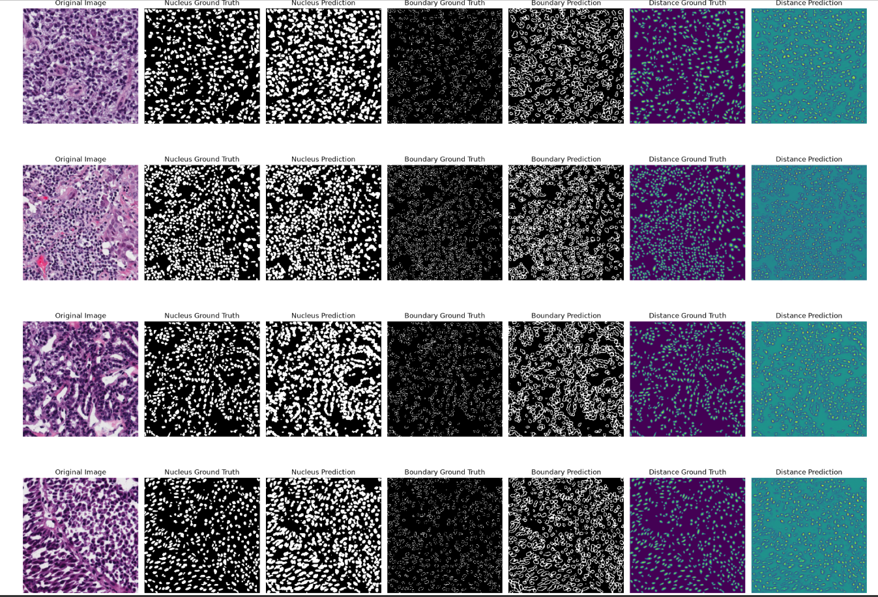
Fig 5.1 Ground Truth versus Stage 4 Predictions (Nucleus, Boundary, Distance)
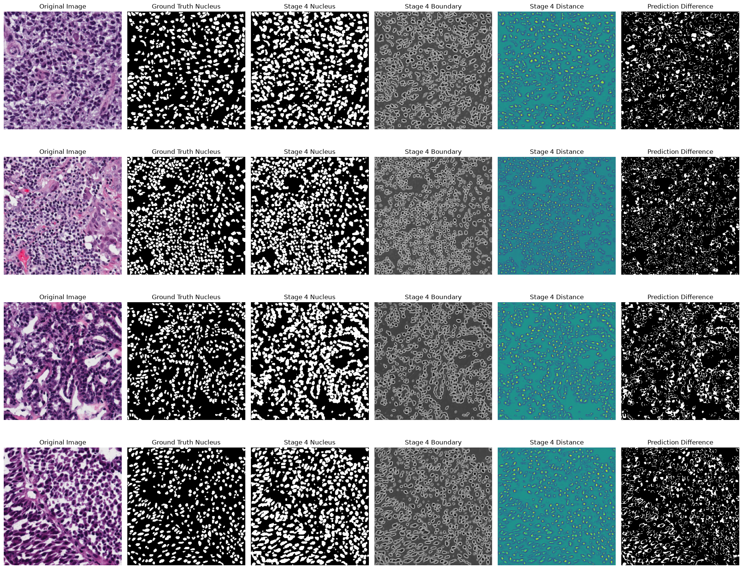
Fig 5.2 Stage 4 Outputs and Prediction-Difference Maps
The qualitative results in Fig 5.1 and Fig 5.2 show that the nucleus predictions follow the density and arrangement of the ground truth in four tissue types with different nuclear sizes and packing. The boundary maps outline the individual nuclei, and the distance predictions show bright peaks at nuclear centres, which are the marker candidates for the watershed. The prediction-difference maps indicate that most errors lie at nuclear borders and in very dense areas, where predicted nuclei are slightly larger than the ground truth.

5.3 Quantitative Performance Analysis

Pixel-level performance
Table 5.2 and Fig 5.3 give the mean pixel-level Dice and IoU of the three models over the 14 test images, and Table 5.3 lists the per-image values.
Table 5.2 Mean Pixel-Level Performance on 14 Test Images (mean ± std)
Model | Dice | IoU
Stage 2 — Baseline U-Net | 0.5695 ± 0.0578 | 0.4004 ± 0.0552
Stage 3 — Boundary-aware U-Net | 0.6244 ± 0.0755 | 0.4581 ± 0.0763
Stage 4 — Multi-task U-Net | 0.6735 ± 0.0760 | 0.5123 ± 0.0807
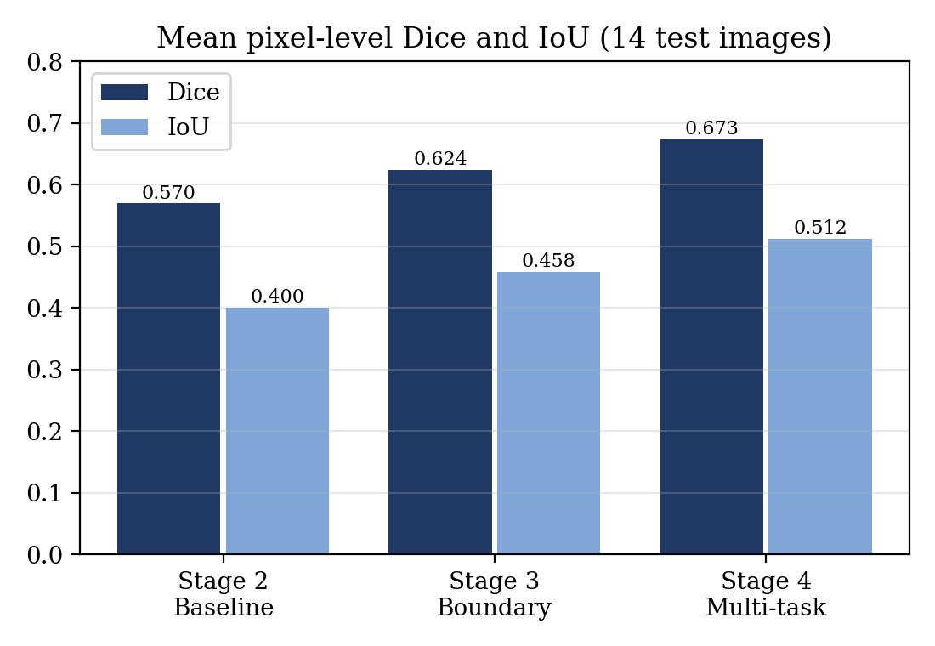
Fig 5.3 Mean Pixel-Level Dice and IoU of the Three Models
The mean Dice increases by 0.0549 from Stage 2 to Stage 3 (+9.6 %), by a further 0.0491 from Stage 3 to Stage 4 (+7.9 %), and by 0.1040 overall (+18.3 %). The mean IoU increases by 0.0577 (+14.4 %), 0.0542 (+11.8 %) and 0.1119 (+27.9 %) respectively. The gains are consistent across images: the boundary-aware model beat the baseline on 12 of 14 images, the multi-task model beat the boundary-aware model on 13 of 14 images, and the multi-task model beat the baseline on all 14 images.
Table 5.3 Per-Image Pixel-Level Dice and IoU
# | Image ID | S2 Dice | S2 IoU | S3 Dice | S3 IoU | S4 Dice | S4 IoU
1 | TCGA-2Z-A9J9-01A-01-TS1 | 0.6035 | 0.4321 | 0.6481 | 0.4794 | 0.6928 | 0.5300
2 | TCGA-44-2665-01B-06-BS6 | 0.5989 | 0.4275 | 0.7009 | 0.5395 | 0.7923 | 0.6561
3 | TCGA-69-7764-01A-01-TS1 | 0.5483 | 0.3777 | 0.5586 | 0.3876 | 0.6978 | 0.5359
4 | TCGA-A6-6782-01A-01-BS1 | 0.5065 | 0.3392 | 0.4340 | 0.2772 | 0.6383 | 0.4687
5 | TCGA-AC-A2FO-01A-01-TS1 | 0.6243 | 0.4538 | 0.6562 | 0.4883 | 0.7060 | 0.5456
6 | TCGA-AO-A0J2-01A-01-BSA | 0.6152 | 0.4443 | 0.6583 | 0.4906 | 0.6811 | 0.5164
7 | TCGA-CU-A0YN-01A-02-BSB | 0.6191 | 0.4483 | 0.6755 | 0.5100 | 0.6765 | 0.5111
8 | TCGA-EJ-A46H-01A-03-TSC | 0.5404 | 0.3702 | 0.5856 | 0.4140 | 0.6402 | 0.4709
9 | TCGA-FG-A4MU-01B-01-TS1 | 0.6592 | 0.4917 | 0.7118 | 0.5526 | 0.7482 | 0.5978
10 | TCGA-GL-6846-01A-01-BS1 | 0.5575 | 0.3865 | 0.5492 | 0.3786 | 0.6634 | 0.4963
11 | TCGA-HC-7209-01A-01-TS1 | 0.5011 | 0.3344 | 0.5566 | 0.3856 | 0.6279 | 0.4576
12 | TCGA-HT-8564-01Z-00-DX1 | 0.4331 | 0.2764 | 0.6268 | 0.4564 | 0.4471 | 0.2879
13 | TCGA-IZ-8196-01A-01-BS1 | 0.5763 | 0.4048 | 0.6990 | 0.5373 | 0.7293 | 0.5740
14 | TCGA-ZF-A9R5-01A-01-TS1 | 0.5899 | 0.4183 | 0.6808 | 0.5160 | 0.6877 | 0.5240
 | Mean | 0.5695 | 0.4004 | 0.6244 | 0.4581 | 0.6735 | 0.5123
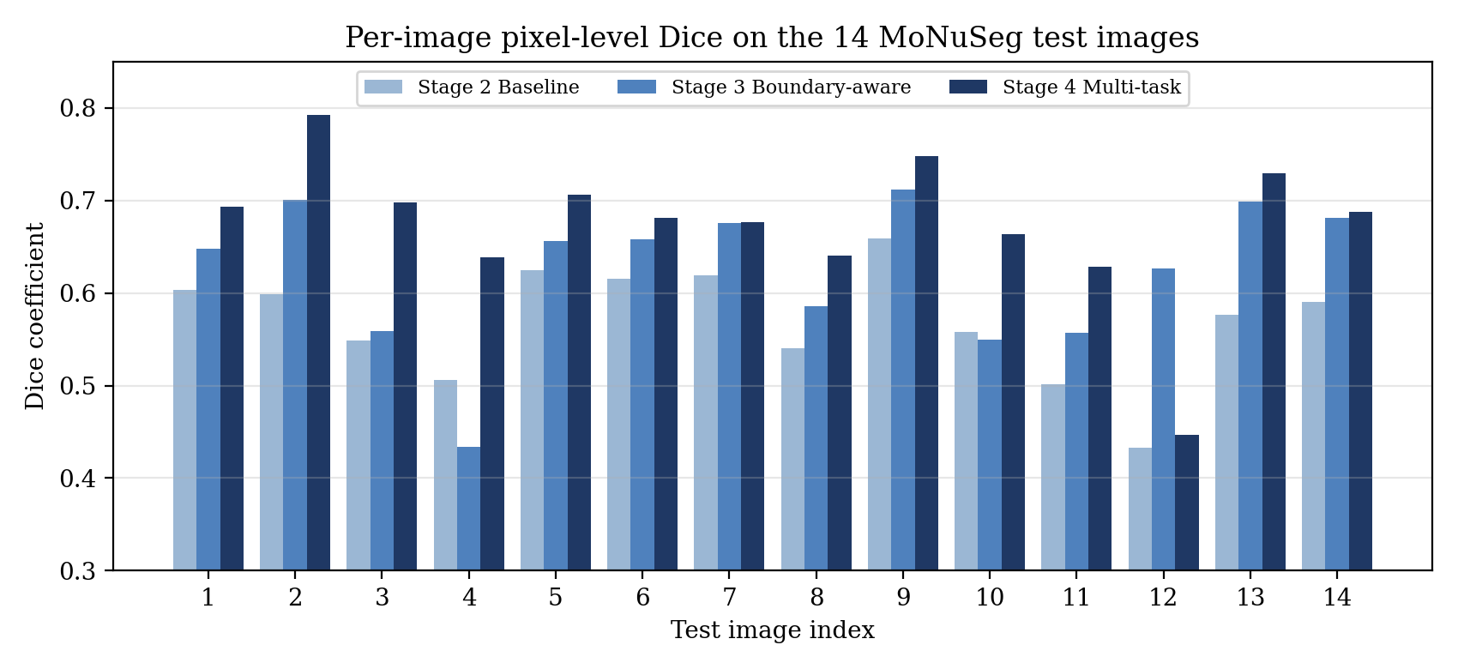
Fig 5.4 Per-Image Dice Coefficient on the 14 Test Images
Image 12 (TCGA-HT-8564-01Z-00-DX1) is the single exception to the improvement pattern: the multi-task Dice (0.4471) is far below the boundary-aware model (0.6268) and close to the baseline (0.4331). It is also the image with the fewest ground-truth nuclei (249), so it is the sparsest in the test set; a plausible explanation is over-segmentation in a low-density region, but this was not investigated further. Excluding this image, the multi-task model leads the other models on every image.

Training-time comparison (Protocol A)
Table 5.4 Stage 3 versus Stage 4 under the Training-Time Protocol
Metric | Stage 3 | Stage 4 | Change
Nucleus Dice | 0.5981 | 0.6939 | +0.0958 (+16.02 %)
Nucleus IoU | 0.4322 | 0.5353 | +0.1031 (+23.85 %)
Boundary Dice | 0.2278 | 0.2885 | +0.0607 (+26.65 %)
Under this protocol the distance head improves not only the nucleus mask but also the boundary prediction, with a 26.65 % relative increase in boundary Dice. This supports the multi-task hypothesis that the auxiliary distance task regularises the shared trunk and makes the learned features more informative for contour prediction.

Instance-level performance
Instance masks were generated from the Stage 4 outputs with watershed post-processing. Over the 14 test images, which contain 6,697 ground-truth nuclei, the final configuration predicted 5,442 instances and obtained a mean AJI of 0.4045 with a standard deviation of 0.0486. The highest per-image AJI is 0.4932 for TCGA-FG-A4MU-01B-01-TS1 (465 ground-truth and 390 predicted nuclei). Table 5.5 shows how the post-processing was refined.
Table 5.5 Effect of Watershed Refinement on AJI (Stage 4 outputs, 14 test images)
Watershed configuration | Mean predicted nuclei per image | Mean true nuclei per image | Mean AJI
Initial markers | 265.4 | 478.4 | 0.2695
Intermediate refinement | 395.5 | 478.4 | 0.3926
Final refinement | 388.7 | 478.4 | 0.4045
The first configuration detected only about 265 markers per image against 478 true nuclei and therefore under-segmented heavily (Fig 5.5 shows an example with 269 instances). Refining the watershed marker-extraction settings increased the number of predicted nuclei and improved the AJI by 0.135, a relative gain of about 50 %. The result shows that the quality of the post-processing is as important as the network itself, because the same network outputs yielded very different AJI values depending on how markers were chosen.
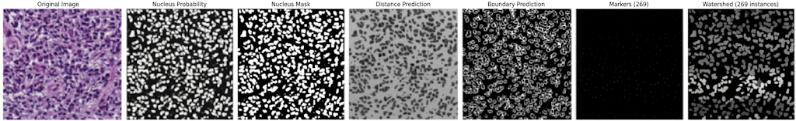
Fig 5.5 Distance- and Boundary-Guided Watershed Pipeline

5.4 Instance Separation and Touching-Nuclei Analysis
The extent of the touching-nuclei problem is quantified on the Stage 1 sample image: its 424 annotated nuclei form only 322 connected components, so a connected-component labelling of even a perfect binary mask would lose 102 nuclei (24 %) through merging, and 135 nucleus pairs are close enough to touch after a small dilation. Any method that relies on the binary mask alone is therefore limited in its ability to count nuclei correctly, and this is the motivation for the boundary and distance cues.
The instance-level behaviour of the multi-task pipeline was analysed in detail on test image TCGA-2Z-A9J9-01A-01-TS1 using full-image inference followed by distance- and boundary-guided watershed (Table 5.6).
Table 5.6 Instance-Level Analysis of One Test Image (TCGA-2Z-A9J9-01A-01-TS1)
Quantity | Value
Ground-truth nuclei | 575
Detected markers | 969
Predicted instances | 826
Matched predictions / matched ground-truth nuclei | 544 / 544
Unmatched predictions (false or extra instances) | 282
Unmatched ground-truth nuclei (missed) | 31
AJI (initial matching) / AJI (verified one-to-one matching) | 0.4154 / 0.4291
Of the 575 true nuclei, 544 (94.6 %) were matched to a prediction and only 31 were missed, so detection recall is high. The weakness is the 282 unmatched predictions, which show that this configuration over-splits nuclei: 969 markers were detected for 575 true nuclei, and 826 instances remained. This is the opposite failure mode to the initial configuration of Table 5.5, which under-segmented; together the two results show that the marker threshold controls the trade-off between merged and split nuclei. The AJI of 0.4154 improved to 0.4291 when the matching was made strictly one-to-one with greedy assignment on the highest IoU, which is the formulation implemented in the verified AJI function of Stage 5.
A connected-component versus watershed comparison across all models (the other configurations in Table 4.4) has not yet been run on the full test set, so the exact improvement attributable to watershed over connected components is not reported here and is listed as future work.

5.5 Comparative Analysis
Table 5.7 Overall Comparison of the Three Stages
Aspect | Stage 2 | Stage 3 | Stage 4 | Observation
Mean Dice | 0.5695 | 0.6244 | 0.6735 | +0.1040 overall
Mean IoU | 0.4004 | 0.4581 | 0.5123 | +0.1119 overall
Images improved vs previous stage | — | 12 / 14 | 13 / 14 | Stage 4 beats Stage 2 on 14 / 14
Boundary prediction | No | Yes (Dice 0.2278) | Yes (Dice 0.2885) | +26.65 % from distance task
Distance prediction | No | No | Yes (MAE 0.3649) | Enables marker seeding
Instance output (AJI) | — | — | 0.4045 | 6,697 GT, 5,442 predicted
Each addition to the architecture produced a measurable gain. The boundary head alone gave about half of the total Dice improvement, and the distance head gave the other half. Beyond the metrics, the multi-task model is the only one of the three that produces the distance and boundary maps required for instance separation, so it is also the only one that can be evaluated with AJI. The absolute scores should be read in the context of the setup: a compact 7.77 M-parameter network, 32 training images, 256 × 256 inputs obtained by resizing 1000 × 1000 images, and CPU training of 50 epochs. They are therefore not directly comparable with published results of larger networks trained on GPUs with extensive augmentation and stain normalisation.

5

CHAPTER 6
CONCLUSION AND FUTURE ENHANCEMENTS

6.1 Conclusion
This project developed and evaluated a boundary-aware, multi-task deep learning framework for nuclei segmentation in H&E histopathology images using the MoNuSeg dataset. The proposed work was implemented through five progressive stages. Stage 1 generated and verified instance, binary, boundary and distance-transform targets from the available annotations. Stage 2 established a baseline U-Net for nucleus segmentation, while Stage 3 introduced explicit boundary prediction to improve the separation of adjacent nuclei. Stage 4 extended the model into a multi-task U-Net by jointly predicting the nucleus mask, boundary map and distance-transform map. Stage 5 provided a common evaluation framework for comparing the developed segmentation models and their instance-level post-processing.
The mean Dice score improved from 0.5695 for the baseline model to 0.6244 for the boundary-aware model and further to 0.6735 for the multi-task model. Similarly, the mean IoU improved from 0.4004 to 0.4581 and 0.5123, respectively. The multi-task model consistently outperformed the baseline across the evaluated test images. Boundary- and distance-guided watershed post-processing further enabled the predicted foreground regions to be converted into individual nucleus instances, achieving a mean AJI of 0.4045 on the evaluated test set. These results demonstrate that providing explicit boundary and distance information to the segmentation network can improve the quality of nucleus segmentation and provide useful spatial cues for separating touching and overlapping nuclei.
The developed segmentation framework therefore provides the first stage of a larger computational pathology pipeline. Accurate identification and separation of individual nuclei is essential because the location, density, morphology and spatial organization of nuclei can provide important information for subsequent tissue and disease analysis. The current work establishes this nuclei-level representation, which can be extended in future work toward graph-based modelling and cancer-related analysis

6.2 Contributions of the Proposed Work

• A reproducible target-generation pipeline that derives instance, binary, boundary and distance-transform maps from MoNuSeg and verifies their consistency.

• A controlled, stage-wise comparison of baseline, boundary-aware and multi-task U-Net models using identical data and evaluation settings.

• A multi-task learning framework that jointly predicts nucleus regions, boundary information and distance-transform maps using BCE + Dice losses for segmentation tasks and masked MSE for distance regression.

• A watershed-based instance reconstruction approach that combines the predicted distance information and boundary information to separate individual nuclei.

• An evaluation framework using Dice, IoU and AJI to assess both pixel-level segmentation quality and instance-level nuclei separation.

• A nuclei-level segmentation output that can serve as the foundation for subsequent spatial and graph-based analysis of histopathology images.

Limitations
- The input images are resized to 256 × 256 during training, which may remove fine morphological details present in the original histopathology images.
- Training was performed with limited computational resources and a relatively small number of training images, which may restrict the extent to which the model can learn variations in nuclear morphology and tissue appearance.
- The watershed marker-generation process currently depends on empirically selected parameters. Different tissue regions and nuclear densities may require different marker thresholds, which can lead to merged or over-segmented nuclei.
- The MoNuSeg dataset contains a limited number of annotated images and tissue types. Therefore, the generalisation of the developed segmentation model to other organs, datasets and staining conditions requires further validation.
- The present work focuses on nuclei segmentation and instance separation. It does not yet perform graph construction, cancer classification or cancer detection based on the segmented nuclei

Future Enhancements
- Nuclei graph construction: Represent each segmented nucleus as a node and connect neighbouring nuclei based on their spatial relationships.
- Nuclei feature extraction: Extract morphological and spatial features such as nucleus size, shape, centroid and local density.
- Graph-based analysis: Apply Graph Neural Networks (GNNs) such as GCN or GAT to learn relationships between neighbouring nuclei.
- Cancer-related analysis: Use the learned graph representations to identify spatial and morphological patterns associated with cancer-related tissue changes.
- End-to-end extension: Extend the current pipeline from H&E image → nuclei segmentation → nuclei graph → graph-based cancer analysis and evaluate it on additional histopathology datasets.

APPENDIX

REFERENCES
[1] A. Shakya, R. Saharan, C. Gupta, R. Kumar, L. Sharma, S. Naidu, S. Murala, and C. Arora, “Two-stage, global-local approach for cell nuclei segmentation in histopathology images,” in Proc. IEEE 8th Int. Conf. Information and Communication Technology (CICT), 2024.
[2] M. Pekár, V. Musil, R. Nenutil, P. Holub, and T. Brázdil, “LSP-DETR: Efficient and scalable nuclei segmentation in whole slide images,” Comput. Methods Programs Biomed., vol. 287, p. 109614, 2026.
[3] C. Stringer, T. Wang, M. Michaelos, and M. Pachitariu, “Cellpose: A generalist algorithm for cellular segmentation,” Nature Methods, vol. 18, pp. 100–106, 2021.
[4] M. Weigert and U. Schmidt, “Nuclei instance segmentation and classification in histopathology images with StarDist,” in Proc. IEEE Int. Symp. Biomed. Imaging (ISBI) Challenges, 2022.
[5] A. Mahbod, G. Schaefer, G. Dorffner, S. Hatamikia, R. Ecker, and I. Ellinger, “A dual decoder U-Net-based model for nuclei instance segmentation in hematoxylin and eosin-stained histological images,” Front. Med., vol. 9, p. 978146, 2022.
[6] “FRE-Net: Full-region enhanced network for nuclei segmentation in histopathology images,” Biocybern. Biomed. Eng., vol. 43, no. 1, pp. 386–401, 2023.
[7] “BAWGNet: Boundary aware wavelet guided network for the nuclei segmentation in histopathology images,” Comput. Biol. Med., vol. 165, p. 107378, 2023.
[8] “Nuclei instance segmentation from histopathology images using Bayesian dropout based deep learning,” BMC Med. Imaging, 2023.
[9] B. R. Swain, K. J. Cheoi, and J. Ko, “Nuclei segmentation in histopathological images with enhanced U-Net3+,” in Proc. Med. Imaging with Deep Learning (MIDL), PMLR, vol. 250, pp. 1513–1530, 2024.
[10] “NuInsSeg: A fully annotated dataset for nuclei instance segmentation in H&E-stained histological images,” Sci. Data, 2024.
[11] J. Li, H. Wu, and J. Qin, “WeaveSeg: Iterative contrast-weaving and spectral feature-refining for nuclei instance segmentation,” in Proc. IEEE/CVF Int. Conf. Comput. Vis. (ICCV), 2025, pp. 21984–21993.
[12] D. Anglada-Rotger, B. Jansat, F. Marques, and M. Pardàs, “Two heads are enough: DualU-Net, a fast and efficient architecture for nuclei instance segmentation,” in Proc. Med. Imaging with Deep Learning (MIDL), PMLR, vol. 301, pp. 15–29, 2026.
[13] T. Griebel, A. Archit, and C. Pape, “Segment Anything for histopathology,” in Proc. Med. Imaging with Deep Learning (MIDL), PMLR, vol. 301, pp. 515–546, 2026.

