Task 4 Report
Smart Lighting Automation System using ESP32 and ThingSpeak

Objective
To develop an IoT-based Smart Lighting Automation System using an ESP32, an LDR sensor, and ThingSpeak cloud platform. The system measures ambient light, controls an LED automatically, and uploads sensor readings to ThingSpeak for visualization.

Components Used
- ESP32 Dev Board
- LDR Sensor Module
- LED
- 220Ω Resistor
- ThingSpeak Cloud
- Wokwi Simulator
- Wi-Fi

Circuit Connections
Component | Connection
LDR VCC | 3.3V
LDR GND | GND
LDR AO | GPIO36 (VP)
LED Anode | GPIO21 through 220Ω resistor
LED Cathode | GND

Working
The ESP32 continuously reads the analog value from the LDR sensor to monitor the ambient light intensity. It compares the measured value with a predefined threshold to determine the lighting condition. When the light intensity falls below the threshold, the ESP32 automatically turns the LED ON. When the light intensity rises above the threshold, the LED turns OFF. The measured light intensity values are transmitted to the ThingSpeak cloud platform every 20 seconds through a Wi-Fi connection. ThingSpeak stores the data and displays it as a real-time graph, enabling remote monitoring and visualization of light intensity changes.

Circuit diagrams
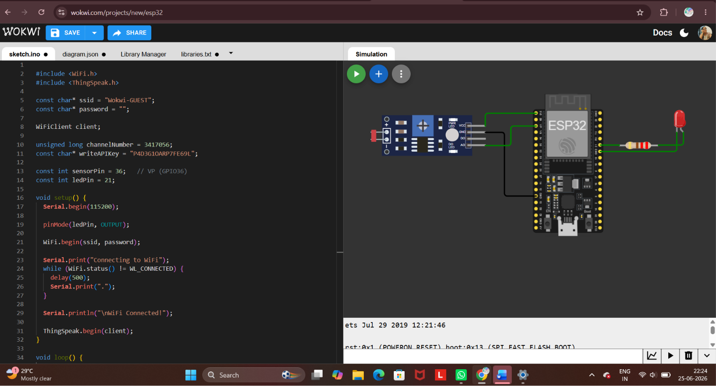
Figure 1: Circuit Diagram and Code
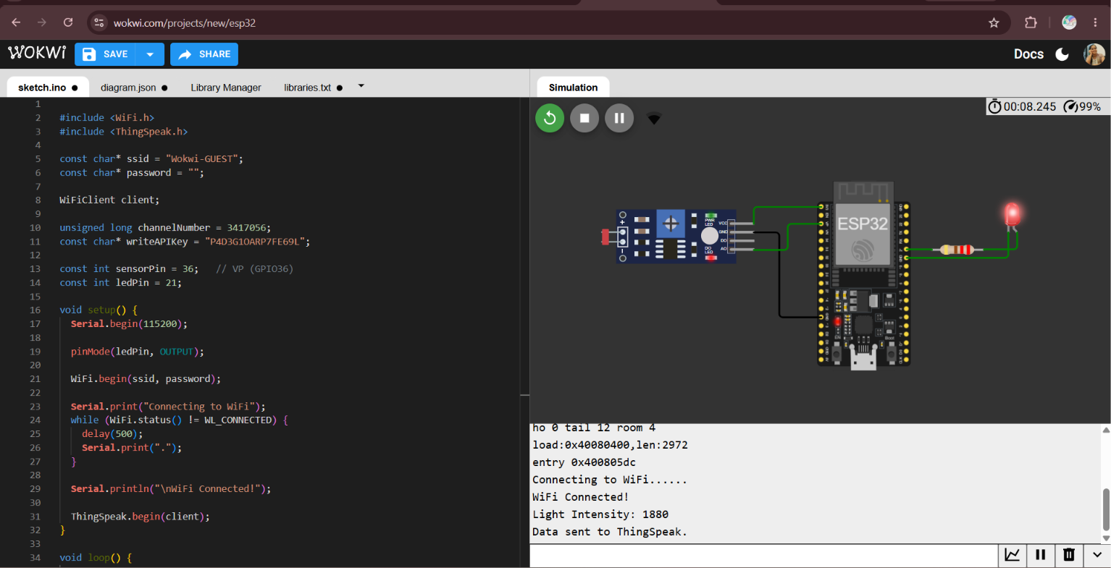
Figure 2: Simulation Output (LED ON and Serial Monitor)
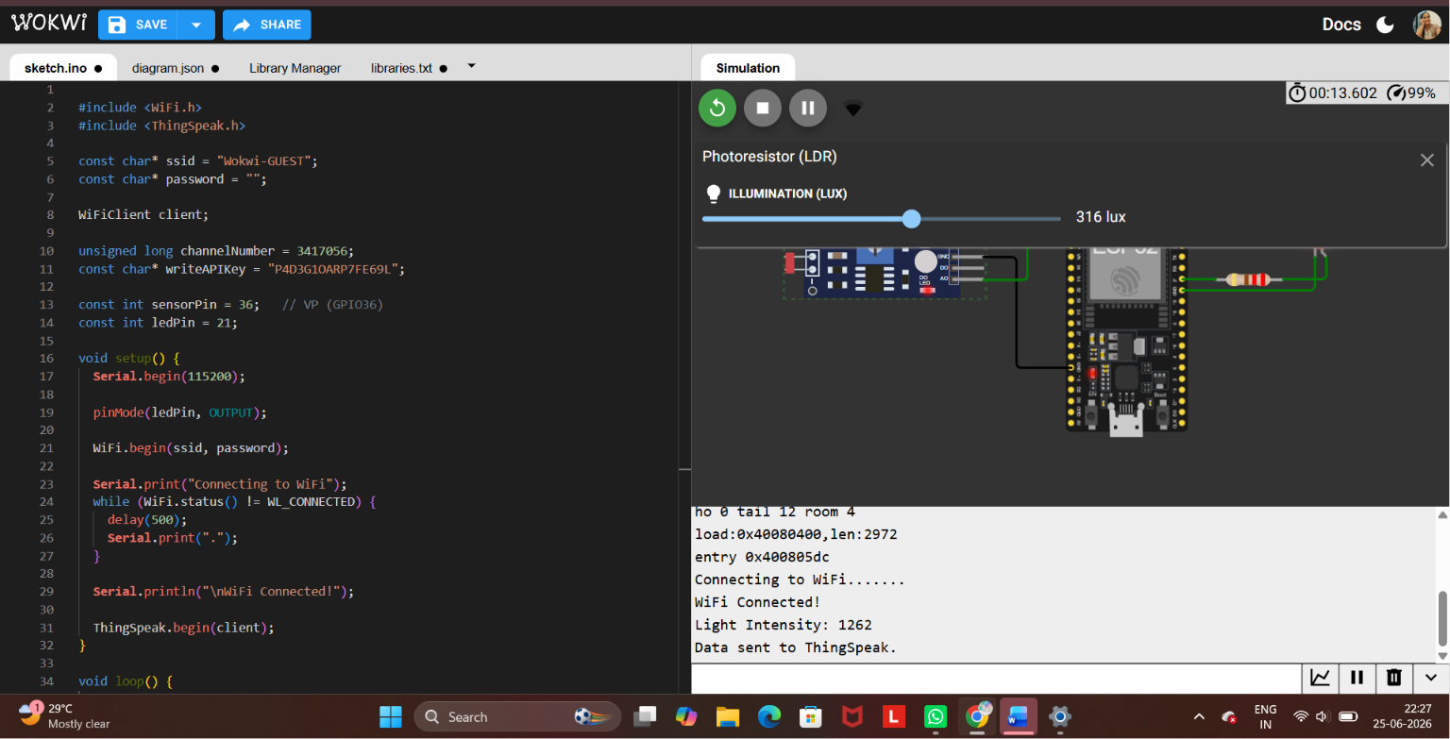
Figure 3: LDR Light Intensity Adjustment
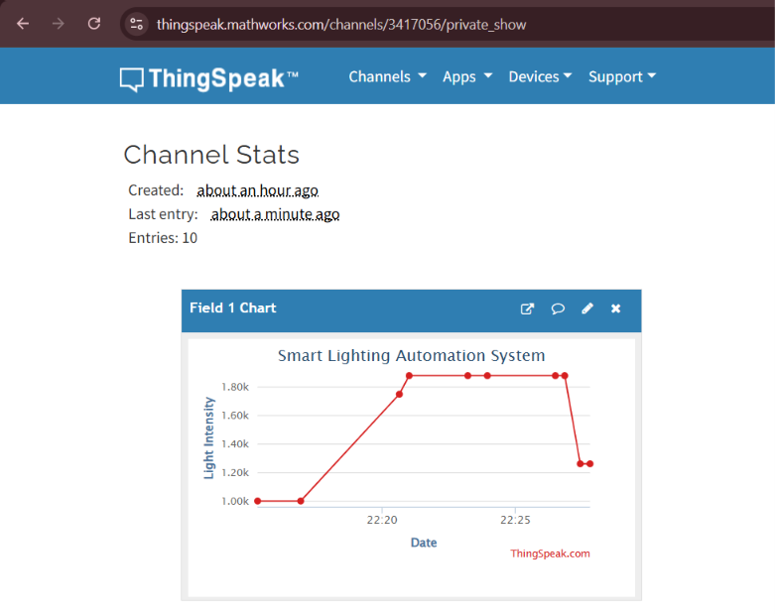
Figure 4: ThingSpeak Cloud Graph

Results
• ESP32 successfully connected to Wi-Fi.
• LDR sensor measured ambient light intensity.
• LED automatically turned ON/OFF based on light level.
• Sensor readings were successfully uploaded to ThingSpeak.
• ThingSpeak displayed the light intensity graph with changing values.

Conclusion
The project successfully demonstrates an IoT-based smart lighting system using ESP32 and ThingSpeak. Real-time sensor values were monitored, the LED responded automatically to ambient light, and cloud visualization confirmed successful data transmission.

