“Design and Development of an Online Voting System Using Aadhaar-Style OTP Verification”
A Project Report Submitted in the partial fulfillment of the requirements for the award of the degree of
BACHELOR OF TECHNOLOGY
In
DEPARTMENT OF COMPUTER SCIENCE ENGINEERING
&
DEPARTMENT OF COMPUTER SCIENCE AND INFORMATION TECHNOLOGY
By
K. SANDHYA RANI :2520030473
M. MEENAKSHI :2520030315

Under the Esteemed Guidance of
[Guide Name]
Assistant Professor
Department of Computer Science and Engineering



K L (Deemed to be) University
DEPARTMENT OF COMPUTER SCIENCE ENGINEERING
&
DEPARTMENT OF COMPUTER SCIENCE AND INFORMATION TECHNOLOGY
Declaration
The Project Report entitled “Design and Development of an Online Voting System Using Aadhaar-Style OTP Verification” is a record of Bonafide work of K. SANDHYA RANI - 2520030473, M. MEENAKSHI - 2520030315 submitted in partial fulfillment for the award of B. Tech in Computer Science and Engineering (or) Computer Science and Information Technology to the K L University. The results embodied in this report have not been copied from any other departments/University/Institute.

K. SANDHYA RANI – 2520030473
M. MEENAKSHI – 2520030315

K L (Deemed to be) University
DEPARTMENT OF COMPUTER SCIENCE ENGINEERING
&
DEPARTMENT OF COMPUTER SCIENCE AND INFORMATION TECHNOLOGY
CERTIFICATE
This is to certify that the mini project based report entitled “Design and Development of an Online Voting System Using Aadhaar-Style OTP Verification” is a bonafide work done and submitted by K. SANDHYA RANI - 2520030473, M. MEENAKSHI - 2520030315 in partial fulfillment of the requirements for the award of the degree of BACHELOR OF TECHNOLOGY in Department of Computer Science Engineering, K L (Deemed to be University), during the academic year 2025-2026.

Signature of the Guide
Signature of the Course Coordinator Signature of the HOD

ACKNOWLEDGEMENT
The success in this project would not have been possible but for the timely help and guidance rendered by many people. Our wish is to express our sincere thanks to all those who have assisted us in one way or the other for the completion of our project.
Our greatest appreciation goes to our Course Coordinator [Guide Name] and our guide [Guide Name], Department of Computer Science, whose tremendous support, encouragement and guidance for this project cannot be expressed in words.
We express our gratitude to Dr. P Venkateshwara Rao (CSE) / Dr. Kaja Shareef (CSIT), Head of the Department for Computer Science Engineering / Department for Computer Science and Information Technology for providing us with adequate facilities, ways and means by which we were able to complete this project-based Lab.
We thank all the members of the teaching and non-teaching staff, and also those who have assisted us directly or indirectly, for the successful completion of this project. Finally, we sincerely thank our parents, friends and classmates for their kind help and cooperation during our work.

K. SANDHYA RANI – 2520030473
M. MEENAKSHI – 2520030315
Abstract
Conventional voting depends heavily on physical polling locations, manual verification of voter records and manual handling of votes and results. These dependencies increase the effort required from voters and election personnel and make vote processing and result generation slow and error-prone. To address these issues, our project focuses on the Design and Development of an Online Voting System Using Aadhaar-Style OTP Verification. Our core aim was to implement a structured, web-based workflow that verifies a voter before voting, restricts every verified voter to a single vote, stores all data centrally and generates results automatically.
The system follows a clear sequence: the voter enters identification details and the registered mobile number; the system sends an OTP to that number; the voter enters the OTP for validation; the verified voter views the candidates and selects one; the vote is stored with the relevant voter, candidate and election details; and the votes are counted to generate the election result. The application is organised into five modules: Voter, Authentication, Voting, Admin and Result. Voter, candidate, election, OTP, vote and result information is stored in a MySQL database designed using an entity–relationship model.
The prototype is built using HTML, CSS and JavaScript for the front end, Python with Flask for the back end, and MySQL for the database, with VS Code used for development and a web browser used for testing. Its security controls include OTP-based verification, a one-vote restriction, voter verification status, controlled admin functions and database-backed vote records. The project is an academic prototype; official UIDAI authentication is not claimed, and real-world elections would need stronger security, auditability, privacy and independent verification. In summary, the project provides a clear foundation for studying authentication, database management and secure voting concepts.
Index
S. No | Chapters | Topics | Page.no
Acknowledgement
Abstract
1 | Introduction | 1.1 Background of the project  1.2 Problem statement  1.3 Scope of the project  1.4 Objective(s)  1.5 Importance of the application  1.6 Target users/audience | 7-10
2 | System Requirements | 2.1 Hardware requirements  2.2 Software requirements  2.3 Development tools and frameworks | 11-12
3 | Technology Stack | 3.1 Front-end (HTML, CSS, JavaScript)  3.2 Back-end (Python, Flask)  3.3 Database (MySQL)  3.4 Version Control (e.g., Git, GitHub)  3.5 APIs or External services (OTP delivery) | 13-14
4 | System Architecture | 4.1 High-level architecture diagram  4.2 Description of each layer (frontend, backend, database)  4.3 Deployment architecture (cloud, local, CI/CD pipelines) | 15-16
5 | Design | 5.1 System workflow  5.2 ER Diagram / Database schema  5.3 Table structure | 17-19
6 | Implementation | 6.1 Module-wise implementation  6.2 Front-end logic (UI rendering, state management)  6.3 API integration  6.4 Authentication & Authorization | 20-21
7 | Features | 7.1 List of main features  7.2 How each feature works (user perspective + technical description) | 22
8 | Testing | 8.1 Postman testing (frontend/backend)  8.2 Integration testing  8.3 Tools used for testing  8.4 Test cases and results | 23-24
9 | Deployment | 9.1 Steps to deploy  9.2 Environment configuration  9.3 Hosting of frontend and backend | 25
10 | Challenges & Limitations | 10.1 Issues faced during development  10.2 Solutions applied  10.3 Current limitations or known bugs | 26
11 | Future Enhancements | 11.1 Planned features  11.2 Possible integrations or optimizations | 27
12 | Conclusion | 12.1 Summary of the project  12.2 What was achieved  12.3 Skills learned during development | 28
13 | References | - Books, tutorials, APIs, documentation sites used | 29
14 | Appendices | - Screenshots of the app  - Sample code snippets  - Installation/setup instructions  - User manual or guide  - Geo Tag photos with guide  - Review forms with guide signatures | 30-34

CHAPTER -1 INTRODUCTION

1.1 Background of the Project
Voting is the foundation of a democratic society, and the manner in which votes are collected, verified and counted directly influences public trust in an election. For many years, voting has depended on physical polling stations, printed voter lists, manual identity checks and paper-based record keeping. These methods have served communities well, but they also require large amounts of time, coordination and human effort from both voters and election personnel.
The steady growth of web technologies, relational databases and mobile communication has changed the way citizens interact with public services. Online banking, e-governance portals, digital ticketing and online examinations have shown that identity can be verified electronically and that records can be maintained reliably in a central database. One of the most widely adopted techniques for such verification is the One-Time Password (OTP), in which a short-lived numeric code is sent to the mobile number registered by the user and must be entered correctly before access is granted.
This project, “Design and Development of an Online Voting System Using Aadhaar-Style OTP Verification”, applies these ideas to the voting process. The system provides a web-based workflow in which an eligible voter enters identification details, receives an OTP on the registered mobile number, verifies it, selects a candidate and submits one vote. The vote is stored in a central MySQL database, and the result module counts the stored votes and generates the election result automatically.
It is important to state the nature of the project clearly. The system is an academic prototype. The phrase “Aadhaar-style” indicates that the verification experience is modelled on the familiar pattern of OTP-based authentication to a registered mobile number. Official UIDAI authentication is not claimed, and it is outside the scope of this prototype unless an authorised integration is actually implemented. The aim of the project is to study and demonstrate how authentication, database management and one-vote control can be combined into a single, well-structured workflow.
From an engineering perspective, the project brings together several core areas of computer science:
- Web Technology: a browser-based interface built with HTML, CSS and JavaScript, supported by a Python Flask back end.
- Database Management: structured storage of voter, candidate, election, OTP, vote and result information in MySQL.
- Authentication and Security: OTP generation, expiry checking and verification status handling.
- Software Engineering: modular design, clear separation of responsibilities and systematic testing.
- User Experience Design: a short, step-by-step workflow that a first-time user can follow without training.
To summarise, the background of this project rests on three observations. First, conventional voting workflows depend heavily on physical infrastructure and manual handling of records. Second, OTP-based verification and relational databases make it practical to build a digital workflow that checks identity, restricts each voter to one vote and produces results automatically. Third, a prototype of this kind is a valuable learning platform for understanding authentication, data management and the design considerations of secure voting systems.

1.2 Problem Statement
Conventional voting arrangements face a number of practical limitations. A voter must travel to the designated polling location and must follow its operating schedule. Identity and voter records may require traditional checking and human involvement. Physical records and coordination between officials increase the workload of election personnel. Vote recording, consolidation of records and preparation of results can require considerable manual effort, and manual data entry may introduce record-management errors.
These limitations can be grouped under four headings:
- Accessibility: voters must reach the polling location and follow its operating schedule.
- Manual verification: identity and voter records may need conventional checking and significant human involvement.
- Administrative effort: physical records and coordination among officials increase the workload of election personnel.
- Processing: vote recording, record consolidation and result handling can require substantial manual effort.
The core requirement identified by this project is a system that verifies eligible voters before voting, restricts a verified voter to a single vote, stores vote data systematically, and supports faster result generation. Such a system should keep voter, candidate, election and vote information centrally managed so that administrators can monitor the process and obtain results without repeating manual counting steps.
The project therefore seeks to resolve the following problems:
- Replace repeated manual identity checking with an OTP-based verification step sent to the registered mobile number.
- Prevent duplicate voting by enforcing a one-vote rule against the voter’s verification and voting status.
- Store voters, candidates, elections and votes in a centralised, organised database.
- Automate vote counting and result generation from the stored records.
- Provide administrators with controlled functions to manage voters, candidates, elections and monitoring.

1.3 Scope of the Project
The scope of the project is defined as a web-based prototype that covers the complete voting cycle for a single election, from voter identification to result display. The scope can be described in technical, functional, administrative and academic terms.
Technically, the system is built as a three-part application. The front end, written in HTML, CSS and JavaScript, provides the pages that the voter and the administrator interact with. The back end, written in Python using the Flask framework, implements the business logic for authentication, voting and result generation. The database, implemented in MySQL, stores all application data. OTP verification provides the authentication step, VS Code is used as the development environment, and a standard web browser is used for testing.
Functionally, the scope includes the following:
- Entry of voter identification details and the registered mobile number.
- Generation of an OTP, its delivery to the registered mobile number, and its validation including expiry checking.
- Marking of the voter’s verification status after successful OTP validation.
- Display of active candidates and submission of exactly one vote by a verified voter.
- Storage of the vote together with the relevant voter, candidate and election details.
- Counting of valid votes and generation of candidate totals and the final result.
- Administrative functions for managing voters, adding or removing candidates, managing elections and monitoring voting status.
The following items are outside the scope of the present prototype:
- Official Aadhaar/UIDAI authentication, unless an authorised integration is explicitly implemented.
- Production-grade election security, independent auditability and legal certification required for real-world elections.
- Biometric verification, large-scale load handling and multi-region deployment.
- Support for multiple simultaneous election types beyond the basic election structure defined in the database.
By clearly separating what is implemented from what is not claimed, the project remains honest about its academic nature while still delivering a meaningful demonstration of a complete, end-to-end voting workflow.

1.4 Objectives of the Project
The main objective of the project is to design and develop a structured online voting workflow built around voter verification, one-vote control, centralised data management and automated result generation. The specific objectives are listed below.
- To design a web-based portal through which eligible voters can take part in an election.
- To verify the identity of a voter using an OTP sent to the registered mobile number before voting is allowed.
- To restrict every verified voter to casting only one vote in a given election.
- To store voter, candidate, election and vote information in a centralised MySQL database.
- To provide an admin module for managing voters, candidates, elections and for monitoring voting status.
- To count valid votes automatically and generate candidate-wise totals and the final result.
- To reduce paperwork and manual effort and to make vote processing faster and easier to manage.
- To create a foundation for studying authentication, database management and secure voting concepts.
Each objective is directly traceable to a module of the system. Objectives 2 and 3 are realised by the Authentication and Voting modules, objectives 4 and 5 by the database and Admin module, and objective 6 by the Result module.

1.5 Importance of the Application
The importance of the application lies in showing how a complete voting workflow can be organised digitally while keeping identity verification and vote restriction at its centre. For an election, the sequence of authenticating a voter, authorising one vote, recording it and counting it must be consistent and traceable. Treating these steps as a single connected system, rather than as separate manual tasks, is the main strength of the proposed approach.
The benefits of the system are summarised below.
- Reduced paperwork: voter, candidate, election and vote information is held in a database instead of physical records.
- Lower manual effort: identity verification and vote counting are performed by the application.
- Faster vote processing: a vote is recorded as soon as it is submitted, and results are generated directly from stored data.
- Automatic result calculation: valid votes are retrieved and totalled for each candidate without manual consolidation.
- Convenient user workflow: the voter follows six clear steps from entering details to submitting a vote.
- Educational value: the project illustrates authentication, relational database design, and modular web application development.
From an academic standpoint, the application is valuable because it connects theoretical subjects such as database management systems, web technologies, software engineering and information security through a single practical project.

1.6 Target Users / Audience
The system is designed for three groups of users.
- Voters: eligible persons who identify themselves, verify an OTP and cast one vote. The interface is deliberately simple so that first-time users can complete the process easily.
- Administrators / election officials: persons who manage voters, candidates and elections, monitor the voting status and view the final results.
- Students, faculty and evaluators: the academic audience that studies the prototype to understand authentication, database management and the design of secure voting concepts.
The prototype is intended for demonstration and learning. Real-world deployment would require additional legal, security and audit arrangements, which are discussed in Chapter 10 and Chapter 11.

CHAPTER -2 SYSTEM REQUIREMENTS

2.1 Hardware Requirements
The Online Voting System is a lightweight web application, and its hardware requirements are modest. They are divided into the requirements of the development machine, of the server that hosts the application, and of the end-user device.
Component | Development Machine | End-User Device
Processor | Intel Core i3 / AMD Ryzen 3 or higher | Dual-core processor, 1.8 GHz or above
RAM | 8 GB recommended (4 GB minimum) | 2 GB or more
Storage | At least 20 GB free space (SSD preferred) | Minimal, for browser cache only
Display | 1366 x 768 or higher | Any desktop, laptop, tablet or smartphone screen
Network | Stable internet connection for OTP service and package installation | Active internet connection
Peripherals | Keyboard and mouse | Touch screen or keyboard and mouse

The development machine runs the code editor, a local Flask server, the MySQL server and a web browser at the same time. A machine with 8 GB of RAM and an SSD allows these tools to run smoothly. Because the end user interacts with the system only through a web browser, no special hardware is required on the voter’s side; any device that can run a modern browser and receive an SMS on the registered mobile number is sufficient.
For demonstration, the Flask application and the MySQL database can run on the same computer. For hosted use, a small server or cloud instance with a dual-core CPU, 4 GB of RAM and sufficient disk space for the database is adequate for the expected prototype workload.

2.2 Software Requirements
Category | Requirement
Operating System | Windows 10/11, Ubuntu Linux or macOS
Front End | HTML, CSS, JavaScript
Back End | Python 3.x with the Flask framework
Database | MySQL Server with a MySQL connector library for Python
Authentication | OTP generation and verification logic; SMS delivery or simulated delivery for the registered mobile number
Code Editor | Visual Studio Code
Testing | Modern web browser (Google Chrome, Microsoft Edge or Mozilla Firefox)

Python is chosen as the back-end language because of its readable syntax and strong library support, and Flask is chosen because it is a lightweight framework that makes routing, request handling and template rendering straightforward for a project of this size. MySQL is chosen because it is a widely used, reliable relational database that supports the primary-key and foreign-key relationships required by the voting data model.

2.3 Development Tools and Frameworks
- Visual Studio Code: the primary editor for writing HTML, CSS, JavaScript and Python code, with extensions for Python and MySQL support.
- Flask: the Python micro-framework used to define routes, handle form submissions, call the OTP and voting logic, and render pages.
- MySQL (with a client such as MySQL Workbench or the command line): used to create the schema, insert test data and inspect stored records.
- Web browser developer tools: used to inspect page behaviour, network requests and console messages during testing.
- Python virtual environment (venv) and pip: used to isolate and install project dependencies.
These tools were selected because they are freely available, well documented and suitable for students. Together they allow a complete cycle of coding, running, testing and debugging on a single computer.

CHAPTER-3 TECHNOLOGY STACK
The technology stack of the project consists of a browser-based front end, a Python Flask back end, a MySQL database, and an OTP-based authentication step. VS Code is used for development and a web browser is used for testing. The sections below describe how each part contributes to the system.

3.1 Front-End Design
The front end is built with HTML, CSS and JavaScript. HTML defines the structure of each page, such as the voter details form, the OTP entry form, the candidate selection page and the result page. CSS controls the layout, colours and spacing so that the pages are clean and consistent. JavaScript adds client-side behaviour such as checking that required fields are filled, validating the format of the mobile number and OTP before submission, and showing messages to the user.
The design follows a step-by-step principle. Each screen asks the voter to do only one thing: enter details, enter the OTP, choose a candidate, or view a confirmation. This keeps the interface simple and reduces the chance of mistakes. Client-side validation improves usability, but all important checks are repeated on the server so that the system does not depend on the browser for security.

3.2 Back-End Design
The back end is written in Python using the Flask framework. Flask receives requests from the browser, runs the appropriate function, interacts with the database and returns a response. The back end is organised according to the modules of the system: the voter module, authentication module, voting module, admin module and result module.
The authentication logic generates the OTP, stores it with its generated time and expiry time, and later compares the submitted code with the stored code. The voting logic checks that the voter is verified and has not already voted before accepting a vote. The result logic retrieves valid votes and counts them for each candidate. Admin routes are protected so that only authorised administrators can manage voters, candidates and elections.

3.3 Database Design
MySQL is used as the relational database. It stores voter, user, admin, OTP, election, candidate, vote, voter record and result information in separate tables connected by primary and foreign keys. This organisation avoids duplication, preserves relationships such as “a vote refers to one candidate in one election”, and makes it possible to answer questions such as “how many valid votes did each candidate receive?” with a simple query. The detailed entity–relationship diagram and table structure are presented in Chapter 5.

3.4 Version Control
Version control records the history of changes to the source code and makes it easy to return to an earlier working version. For a team project, a tool such as Git, with a remote repository on a hosting service like GitHub, is the standard practice, and it is recommended for maintaining this project. The project folder structure is kept simple, with separate locations for templates, static files (CSS and JavaScript), Python modules and database scripts, so that it can be placed under version control easily.

3.5 APIs or External Services
The only external service required by the workflow is the delivery of the OTP to the registered mobile number. In the prototype, the OTP step demonstrates verification through the registered mobile number. The OTP logic is kept in a separate function so that the delivery method can be replaced without changing the rest of the application: the code may be shown on the server console during development, or sent by an SMS gateway service when one is configured.
Official UIDAI authentication services are not used. If an authorised integration is ever implemented in the future, it would replace only the OTP delivery and validation function, while the voting, database and result modules would remain unchanged. This is a benefit of the modular design.
Layer | Technology | Purpose
Frontend | HTML, CSS, JavaScript | User interface, form validation, user messages
Backend | Python, Flask | Routing, authentication logic, voting rules, results
Database | MySQL | Persistent storage of voters, candidates, elections, votes
Authentication | OTP verification | Verifying the voter via the registered mobile number
Development | VS Code | Writing and managing code
Testing | Web browser | Manual and functional testing of the workflow

CHAPTER -4 SYSTEM ARCHITECTURE

4.1 High-level architecture diagram
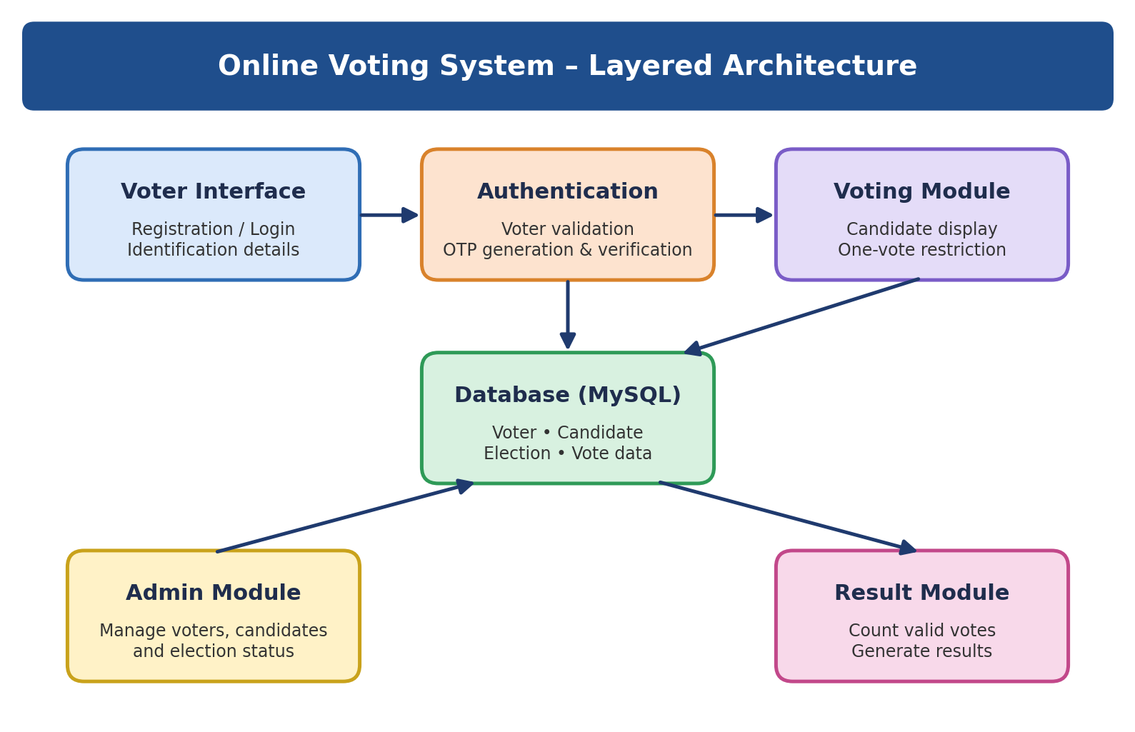
Figure 4.1: High-level architecture of the Online Voting System
The architecture is layered. The Voter Interface collects input from the voter. The Authentication layer validates the voter and handles OTP generation and verification. The Voting Module displays candidates and enforces the one-vote restriction. The Database stores voter, candidate, election and vote data. The Result Module and Admin Module operate on the stored information.

4.2 Description of Each Layer (Frontend, Backend, Database)
Presentation layer (Voter Interface). This layer consists of the HTML, CSS and JavaScript pages used for registration or login, entry of identification details, OTP entry, candidate selection and result display. It collects input and presents output but does not decide whether a vote is valid.
Authentication layer. After the voter submits identification details, this layer checks them against the stored voter record, generates an OTP, saves it with its generated time and expiry time, and sends it to the registered mobile number. When the voter enters the OTP, the layer checks that it matches, that it has not expired and that it has not already been used, and then marks the verification status of the voter.
Voting layer. Only a verified voter is allowed to reach this layer. It displays the active candidates for the running election, checks the one-vote condition, records the vote and associates it with the relevant voter, candidate and election. If the voter has already voted, the request is rejected.
Data layer (Database). MySQL holds voter, candidate, election and vote information along with OTP records, voter records and results. Relationships between tables are maintained by primary and foreign keys so that records remain consistent.
Result and admin layers. The result module retrieves valid votes, counts them, generates candidate totals and displays the final result. The admin module allows authorised administrators to manage voters, add or remove candidates, manage elections and monitor voting status.
Architecture logic. The presentation layer collects input; authentication validates the voter; the voting module enforces the one-vote workflow; the database stores records; and the result and admin modules operate on the stored information.

4.3 Deployment Architecture (Cloud, Local, CI/CD Pipelines)
For the academic prototype, the deployment architecture is local. The Flask application and the MySQL server run on the same computer, and the system is accessed through a browser on that computer or on other devices in the same network. This arrangement is simple, requires no hosting cost and is sufficient for demonstration and evaluation.
If the system is to be shared more widely, the same architecture can be placed on a cloud virtual machine or a platform-as-a-service host. In such a case, the Flask application would run behind a production-grade web server, the database would be hosted separately with restricted access, and HTTPS would be enabled to protect data in transit. A CI/CD pipeline that runs automated tests on every code change and then deploys the application could be added when the project grows beyond a prototype. These options are discussed further in Chapters 9 and 11.

CHAPTER -5 DESIGN

5.1 System Workflow
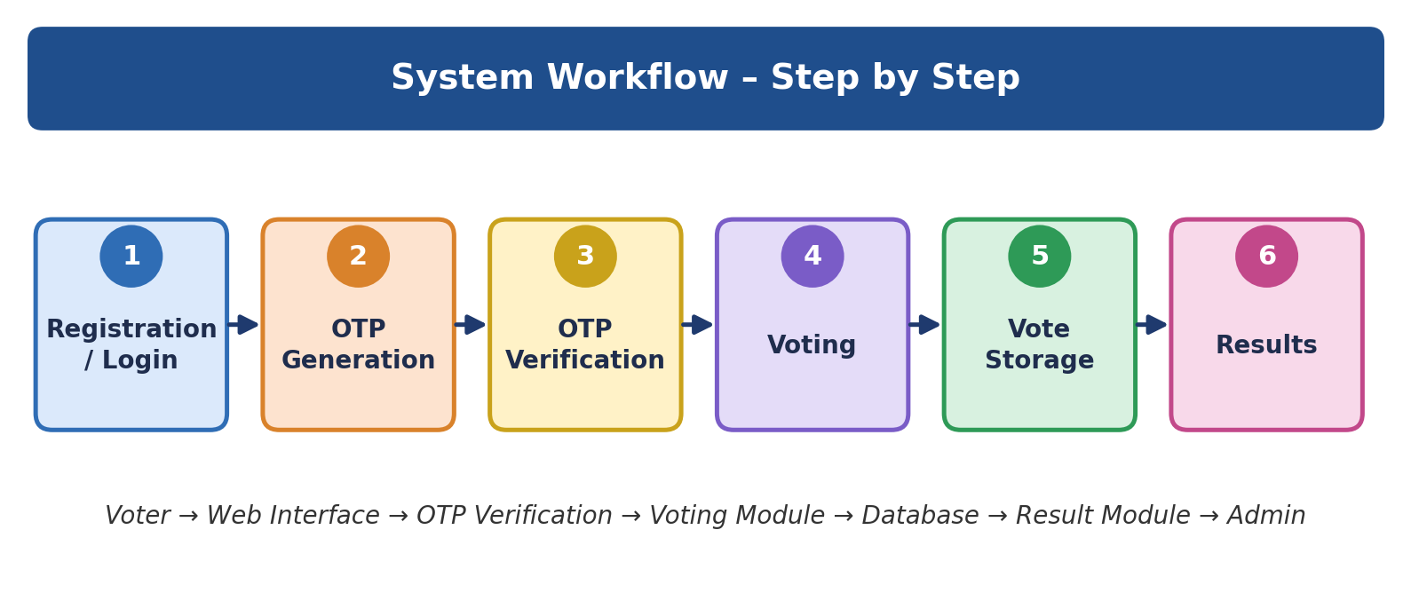
Figure 5.1: Step-by-step workflow of the system
Step | Stage | Description
1 | Registration / Login | Voter enters the required identification details and registered mobile number.
2 | OTP Generation | The system sends an OTP to the registered mobile number.
3 | Verification | The voter enters the OTP and the system validates it.
4 | Voting | The verified voter views the candidates and selects one candidate.
5 | Vote Storage | The vote is recorded with the relevant voter, candidate and election details.
6 | Results | Votes are counted and the election result is generated.

5.2 ER Diagram / Database Schema
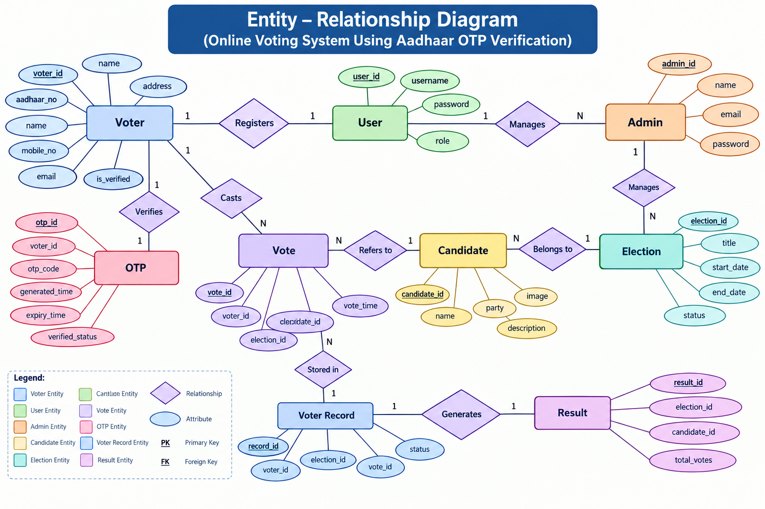
Figure 5.2: Entity–Relationship diagram of the Online Voting System
The ER diagram contains nine entities: Voter, User, Admin, OTP, Vote, Candidate, Election, Voter Record and Result. The main relationships are as follows: a Voter registers as a User; a User is managed by an Admin; an OTP verifies a Voter; a Voter casts a Vote; a Vote refers to a Candidate; a Candidate belongs to an Election; an Admin manages an Election; a Vote is stored in a Voter Record; and a Voter Record generates a Result.

5.3 Table Structure
The tables below list the attributes of each entity. PK denotes a primary key and FK denotes a foreign key. Data types are indicative and may be adjusted during implementation.
Table | Attributes
voter | voter_id (PK), aadhaar_no, name, address, mobile_no, email, is_verified
user | user_id (PK), username, password, role
admin | admin_id (PK), name, email, password
otp | otp_id (PK), voter_id (FK), otp_code, generated_time, expiry_time, verified_status
election | election_id (PK), title, start_date, end_date, status
candidate | candidate_id (PK), name, party, description, image
vote | vote_id (PK), voter_id (FK), candidate_id (FK), election_id (FK), vote_time
voter_record | record_id (PK), voter_id (FK), election_id (FK), vote_id (FK), status
result | result_id (PK), election_id (FK), candidate_id (FK), total_votes

Design decisions. The one-vote rule is supported by the voter_record table: before a vote is accepted, the system checks whether a record already exists for the same voter and election. A uniqueness constraint on the combination of voter and election can additionally be applied at database level so that a duplicate entry is rejected even if the application check is bypassed. Sensitive fields such as the identification number and passwords should be stored in masked or hashed form rather than as plain text.

CHAPTER -6 IMPLEMENTATION

6.1 Module-Wise Implementation
The system is implemented as five cooperating modules. Each module has a clear responsibility, and the modules communicate through the shared database.
Voter Module. This module allows the voter to enter identification details, request or receive an OTP, view candidates and cast one vote. It is the main entry point of the application for ordinary users. Input is validated both in the browser and on the server.
Authentication Module. This module validates the voter details against the stored voter record, generates the OTP, checks the OTP and its expiry, and marks the verification status. An OTP is accepted only once and only before its expiry time. A voter who has not been verified cannot proceed to voting.
Voting Module. This module displays the active candidates, checks the one-vote condition, records the vote and associates it with the election. The check and the insertion are performed together so that two requests cannot both succeed for the same voter.
Admin Module. This module lets an authorised administrator manage voters, add or remove candidates, manage elections and monitor the voting status. Its pages are accessible only after administrator login.
Result Module. This module retrieves valid votes, counts them, generates candidate totals and displays the final result. Because the result is calculated from stored votes, it can be regenerated at any time.

6.2 Front-End Logic (UI Rendering, State Management)
Pages are rendered by Flask templates, which insert dynamic data such as the list of candidates into the HTML. The application keeps track of the voter’s progress using a server-side session: after the details are accepted, the session records that an OTP has been issued; after OTP verification, it records that the voter is verified; after the vote is submitted, further voting attempts are blocked. JavaScript is used for form validation, for enabling the submit button only when a candidate is selected, and for displaying clear success and error messages.

6.3 API Integration
The application exposes a small set of routes that correspond to the steps of the workflow. The routes below are representative and are used for testing in Chapter 8.
Route | Method | Purpose
/login | POST | Accept identification details and registered mobile number
/send-otp | POST | Generate and send the OTP
/verify-otp | POST | Validate the OTP and mark verification status
/candidates | GET | List active candidates for the running election
/vote | POST | Record one vote for a verified voter
/results | GET | Return candidate-wise totals and the final result
/admin/* | GET/POST | Manage voters, candidates and elections (admin only)

OTP delivery is the only external integration. It is isolated in a single function, so the prototype can display the OTP during development and an SMS service can be attached later without modifying other code.

6.4 Authentication and Authorisation
Authentication establishes who the user is; authorisation decides what the user may do. For voters, authentication is the OTP check against the registered mobile number. Authorisation is expressed through the voter’s verification status and the one-vote rule: only a verified voter may vote, and only once per election. For administrators, authentication is by username and password, and authorisation by role, so that management pages and result controls are available only to administrators.
The following security controls are implemented or specified in the design: OTP-based verification, one-vote restriction, voter verification status, controlled admin functions and database-backed vote records. Further hardening measures are listed in Chapter 11.

CHAPTER 7- FEATURES

7.1 List of Main Features
- Web-based portal for eligible voters.
- OTP authentication through the registered mobile number.
- One-vote rule: a verified voter can cast only one vote.
- Admin control to manage voters, candidates, elections and results.
- Centralised storage of voter, candidate, election and vote information.
- Automated counting of valid votes and result generation.
- Clear, step-by-step voter workflow with validation messages.

7.2 How Each Feature Works
Web-based portal. From the user’s perspective, the voter opens the application in a browser and sees a simple form. Technically, Flask serves HTML templates styled with CSS and enhanced with JavaScript, so no installation is needed on the voter’s device.
OTP authentication. The voter enters identification details and the registered mobile number. The system looks up the voter, generates an OTP, stores it with a generated time and an expiry time, and sends it to the registered number. The voter types the code; the system checks that it matches, has not expired and has not been used, and then sets the verification status. If the code is wrong or expired, an error message is shown and a new OTP can be requested.
One-vote rule. After verification, the voter sees the candidates. When a candidate is selected and the vote is submitted, the system checks the voter record for the election. If no vote exists, the vote is stored and the voter record is updated; if a vote already exists, the request is rejected with a message. This ensures that a verified voter cannot vote twice.
Admin control. An administrator logs in and gains access to pages for voters, candidates and elections. Candidates can be added or removed, elections can be created or closed, and the voting status can be monitored. These actions modify the same database used by the voting and result modules, so changes are reflected immediately.
Centralised data. All information is stored in MySQL tables connected by keys. This allows the system to relate a vote to its voter, candidate and election, and to produce consistent reports.
Automated results. The result module reads the valid votes for the election, counts them per candidate, stores the totals in the result table and displays the candidate-wise totals and final outcome. No manual counting is required.

CHAPTER -8 TESTING

8.1 Postman Testing (Frontend/Backend)
Postman was used to test the back-end routes independently of the user interface. Each route in Section 6.3 was called with valid and invalid inputs, and the HTTP status code and response body were examined. For the voting workflow, a collection of requests was arranged in the same order as the real workflow: send OTP, verify OTP, list candidates, submit vote and view results.
Typical checks included the following. Submitting an unknown voter should be rejected. Submitting a wrong OTP should be rejected and the voter should remain unverified. Submitting an expired OTP should be rejected. Calling the vote route without verification should be refused. Calling the vote route a second time for the same voter and election should be refused. Calling admin routes without administrator login should be refused. Postman’s Tests tab can be used to assert expected status codes so that the whole collection can be re-run quickly after each change.
For the front end, the same behaviour was checked in the browser by entering invalid mobile numbers, leaving fields empty and attempting to submit without selecting a candidate, to confirm that validation messages appear and that incorrect requests are not sent.

8.2 Integration Testing
Integration testing verifies that the modules work together. The principal integration path is: voter details → OTP generation → OTP verification → candidate display → vote submission → database update → result generation. Testing this path end to end confirmed that data passed correctly between the interface, the authentication logic, the voting logic and the database.
- Authentication and database: the OTP stored in the database is the one that is checked, and the verification status is updated on success.
- Authentication and voting: a voter who is not verified cannot reach the voting step.
- Voting and database: a submitted vote is written with the correct voter, candidate and election, and the voter record is updated.
- Voting and results: after one or more test votes, the result module reports counts that match the stored votes.
- Admin and voting: a candidate added by the admin appears on the voting page, and a removed candidate no longer appears.

8.3 Tools Used for Testing
- Web browser (Chrome, Edge or Firefox) with developer tools for functional and interface testing.
- Postman for testing routes and inspecting responses.
- MySQL client (Workbench or command line) for verifying stored records after each test.
- VS Code terminal and Flask debug output for tracing errors.

8.4 Test Cases and Results
The table below lists representative test cases. The status column is to be completed by the team after executing each case on the final build.
ID | Test Case | Input / Condition | Expected Result | Status
TC-01 | Valid voter details | Registered voter and mobile number | OTP is generated and sent | To confirm
TC-02 | Unknown voter | Details not in the database | Request rejected with an error message | To confirm
TC-03 | Correct OTP | OTP entered within expiry time | Voter marked as verified | To confirm
TC-04 | Wrong OTP | Incorrect code entered | Verification fails; voter stays unverified | To confirm
TC-05 | Expired OTP | Code entered after expiry time | Verification fails; new OTP required | To confirm
TC-06 | Vote without verification | Direct call to vote route | Request refused | To confirm
TC-07 | Valid vote | Verified voter selects one candidate | Vote stored; voter record updated | To confirm
TC-08 | Duplicate vote | Same voter votes again | Second vote rejected | To confirm
TC-09 | Result generation | Votes stored for candidates | Totals match stored votes | To confirm
TC-10 | Admin access control | Admin page without login | Access denied | To confirm
TC-11 | Add / remove candidate | Admin adds and removes a candidate | Voting page updates accordingly | To confirm

Test results should be recorded against each case, with defects, fixes and retest outcomes noted. Once all cases pass, the prototype can be considered to meet its functional objectives.

CHAPTER -9 DEPLOYMENT

9.1 Steps to Deploy
- Install Python 3 and MySQL Server on the target machine.
- Copy the project folder to the machine and open it in VS Code or a terminal.
- Create and activate a Python virtual environment, then install the required packages (Flask and a MySQL connector) using pip.
- Create the database and tables by running the SQL schema script, and insert the initial admin, voter, election and candidate records.
- Set the database connection details and secret key in the configuration.
- Start the Flask application and open the displayed address in a web browser.
- Run the main workflow once (OTP, vote, result) to confirm that the installation works.

9.2 Environment Configuration
Configuration values such as the database host, user name, password, database name, OTP validity period and the Flask secret key should be kept in a configuration file or environment variables rather than hard-coded in the source files. Separate values can be used for development and for hosted use. Debug mode should be enabled only on the development machine. The OTP validity period is a configurable value so that it can be tuned without changing code.

9.3 Hosting of Frontend and Backend
In the prototype, the front-end pages are served by Flask itself, so the front end and back end are hosted together. For a wider demonstration, the application can be hosted on a cloud virtual machine or a platform that supports Python web applications, with the MySQL database on the same host or a managed database service. The Flask built-in server is intended for development; for hosted use, a production web server such as Gunicorn behind Nginx is recommended, together with HTTPS.
Because the system is an academic prototype, any hosted use should be limited to demonstration with test data. Real elections would require formal security review, auditability and legal approval.

CHAPTER -10 CHALLENGES & LIMITATIONS

10.1 Issues Faced During Development
- Designing OTP handling so that codes expire, cannot be reused and are tied to the correct voter.
- Enforcing the one-vote rule reliably, including when the same request is submitted more than once.
- Designing a database structure that links voters, candidates, elections, votes and results without duplication.
- Handling invalid or missing input without breaking the workflow.
- Keeping the interface simple while still collecting the information needed for verification.
- Deciding how to represent identification details safely without claiming official Aadhaar authentication.

10.2 Solutions Applied
- OTP records store the generated time, expiry time and verified status, and the check rejects expired or already-used codes.
- The voter record is checked and updated together with the vote insertion, and a uniqueness rule on voter and election is recommended at database level.
- The schema was normalised into separate entity tables connected by foreign keys, as shown in the ER diagram.
- Validation is performed on both the client and the server, with clear error messages.
- The interface was divided into short steps, one task per screen.
- The scope note clearly states that the project is an academic prototype using OTP verification on the registered mobile number.

10.3 Current Limitations or Known Bugs
- Internet access and system availability are required for the voting workflow.
- Real-world elections need stronger security, auditability, privacy, accessibility and independent verification than this prototype provides.
- Official Aadhaar/UIDAI integration is outside this academic prototype unless explicitly implemented.
- OTP-based verification confirms control of a registered mobile number; it does not by itself prove the voter’s identity beyond that.
- The prototype has not undergone independent security testing or large-scale load testing.

CHAPTER -11 FUTURE ENHANCEMENTS

11.1 Planned Features
- Role-based access control with finer-grained permissions for administrators and officials.
- Audit logs that record important actions such as OTP requests, verification attempts, vote submissions and admin changes.
- Stronger session security, including session timeouts and protection against session misuse.
- Encryption of sensitive data, and hashing of passwords and identification numbers.
- Better accessibility features, including support for multiple languages and screen readers.
- Result export and reporting for administrators.

11.2 Possible Integrations or Optimisations
- Integration with an authorised identity-verification service, if and when permitted, to replace the prototype OTP step.
- Integration with an SMS gateway for reliable OTP delivery.
- Independent security testing and penetration testing before any real-world use.
- Scalable deployment with a production web server, HTTPS, database backups and monitoring.
- Rate limiting and lockout rules for repeated wrong OTP attempts.
- Automated testing and a CI/CD pipeline to run tests on every code change.

CHAPTER -12 CONCLUSION

12.1 Summary of the Project
The project demonstrates a structured online voting workflow built around voter verification, one-vote control, centralised data management and automated result generation. A voter enters identification details and a registered mobile number; an OTP adds an authentication step before voting; the verified voter selects a candidate and submits one vote; the vote, candidate and election information are stored in the database; and the result module generates the outcome from the stored votes. Administrative functions support the management of voters, candidates, elections and results.
The main focus is not only online voting, but a complete workflow in which voter verification, vote restriction, data management and result generation work together as one system.

12.2 What Was Achieved
- A web-based voting workflow was designed covering registration or login, OTP generation, verification, voting, vote storage and results.
- OTP-based verification and a one-vote restriction were included as core controls.
- A relational database model with nine entities was designed and documented through an ER diagram.
- Five functional modules (Voter, Authentication, Voting, Admin and Result) were defined and implemented.
- The project scope was stated honestly as an academic prototype, with limitations and future work identified.

12.3 Skills Learned During Development
- Web development with HTML, CSS and JavaScript, and back-end development with Python and Flask.
- Relational database design and SQL with MySQL, including keys and relationships.
- Designing and validating an OTP-based authentication flow.
- Modular software design and the use of ER diagrams and workflow diagrams.
- Testing with a browser and Postman, and documenting test cases.
- Teamwork, planning, documentation and presentation of a software project.

CHAPTER -13 REFERENCES

Books
Pressman, R. S., & Maxim, B. R. (2019). Software Engineering: A Practitioner’s Approach (8th ed.). McGraw-Hill Education.
Sommerville, I. (2016). Software Engineering (10th ed.). Pearson Education.
Elmasri, R., & Navathe, S. B. (2016). Fundamentals of Database Systems (7th ed.). Pearson.
Grinberg, M. (2018). Flask Web Development (2nd ed.). O’Reilly Media.

Tutorials and Learning Resources
MDN Web Docs. HTML, CSS and JavaScript documentation. Retrieved from https://developer.mozilla.org
W3Schools. HTML, CSS, JavaScript and SQL Tutorials. Retrieved from https://www.w3schools.com
GeeksforGeeks. Python, Flask and DBMS tutorials. Retrieved from https://www.geeksforgeeks.org

Documentation and Tools
Flask Documentation. Retrieved from https://flask.palletsprojects.com
Python Documentation. Retrieved from https://docs.python.org
MySQL Reference Manual. Retrieved from https://dev.mysql.com/doc
Postman Learning Center. Retrieved from https://learning.postman.com
Visual Studio Code Documentation. Retrieved from https://code.visualstudio.com/docs

CHAPTER -14 APPENDICES

Screenshots of the app
[Insert screenshots here: voter details page, OTP page, candidate selection page, vote confirmation page, admin pages and result page.]

Sample code snippets
The snippets below are illustrative and show the logic of OTP generation, OTP verification and the one-vote check. They should be replaced or aligned with the final project code.
import random
from datetime import datetime, timedelta

def generate_otp(voter_id, cursor, minutes=5):
otp = str(random.randint(100000, 999999))
now = datetime.now()
expiry = now + timedelta(minutes=minutes)
cursor.execute(
"INSERT INTO otp (voter_id, otp_code, generated_time, expiry_time, verified_status) "
"VALUES (%s, %s, %s, %s, 0)", (voter_id, otp, now, expiry))
return otp
def verify_otp(voter_id, entered, cursor):
cursor.execute(
"SELECT otp_id, otp_code, expiry_time FROM otp "
"WHERE voter_id=%s AND verified_status=0 ORDER BY otp_id DESC LIMIT 1", (voter_id,))
row = cursor.fetchone()
if not row or row[2] < datetime.now() or row[1] != entered:
return False
cursor.execute("UPDATE otp SET verified_status=1 WHERE otp_id=%s", (row[0],))
cursor.execute("UPDATE voter SET is_verified=1 WHERE voter_id=%s", (voter_id,))
return True
def cast_vote(voter_id, candidate_id, election_id, cursor):
cursor.execute("SELECT is_verified FROM voter WHERE voter_id=%s", (voter_id,))
if cursor.fetchone()[0] != 1:
return "Not verified"
cursor.execute("SELECT 1 FROM voter_record WHERE voter_id=%s AND election_id=%s",
(voter_id, election_id))
if cursor.fetchone():
return "Already voted"
cursor.execute("INSERT INTO vote (voter_id, candidate_id, election_id, vote_time) "
"VALUES (%s, %s, %s, NOW())", (voter_id, candidate_id, election_id))
cursor.execute("INSERT INTO voter_record (voter_id, election_id, vote_id, status) "
"VALUES (%s, %s, LAST_INSERT_ID(), 'VOTED')", (voter_id, election_id))
return "Vote recorded"

Installation/setup instructions
The system runs on a computer with Python and MySQL installed. First, copy the project folder to the computer and open it in VS Code. Next, create a virtual environment and install Flask and the MySQL connector using pip. Then create the database from the provided SQL script and add sample admin, voter, election and candidate records. Update the database settings in the configuration, start the Flask application from the terminal, and open the address shown in the terminal in a web browser such as Chrome, Edge or Firefox.

User manual or guide
- Open the application in a web browser.
- Enter your identification details and the registered mobile number, and submit.
- Wait for the OTP on the registered mobile number and enter it on the verification page.
- After successful verification, view the list of candidates.
- Select one candidate and submit your vote. You cannot vote a second time in the same election.
- Administrators log in separately to manage voters, candidates and elections and to view the results.

Geo Tag photos with guide
[Insert geo-tagged photos with the guide here.]

Review forms with guide signatures
[Insert review forms with the guide’s signatures here.]

