|  |  |
| --- | --- |
| **Description:** | **Test case description:**    Create new account with account details |
| **Expected Result:** | Service should return true and account should be created in table |
| **Actual Result:** | Shown below. |
| **Conclusion/Remarks:** | Testing status: PASS |

**Step 1** – **Check accounts present in table**

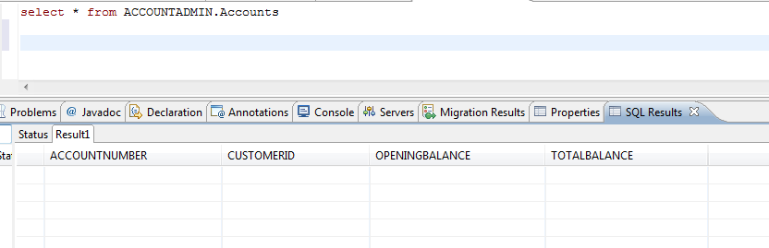

**Step -2 – create new account**

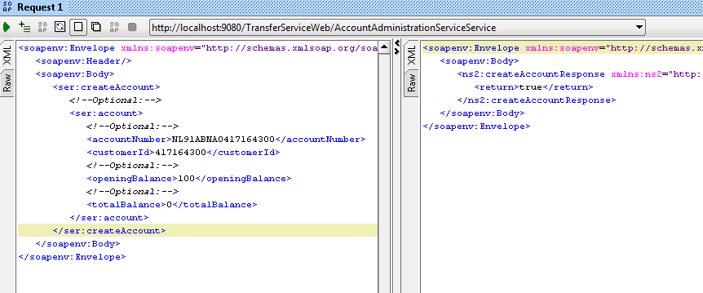

**Step 3- Check entry in database**

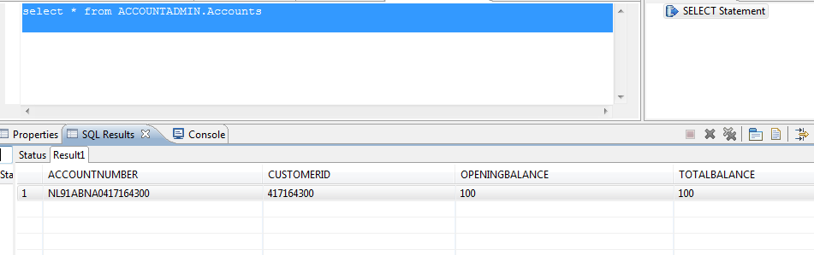

|  |  |
| --- | --- |
| **Description:** | **Test case description:**  Transfer amount from one account to another |
| **Expected Result:** | Service should return true and account should be created in table |
| **Actual Result:** | Shown below. |
| **Conclusion/Remarks:** | Testing status: PASS |

**Check Existing Account details –**

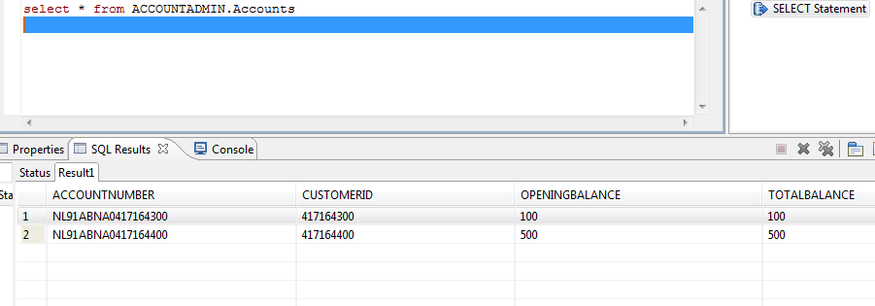

**Checking negative balance situation-**

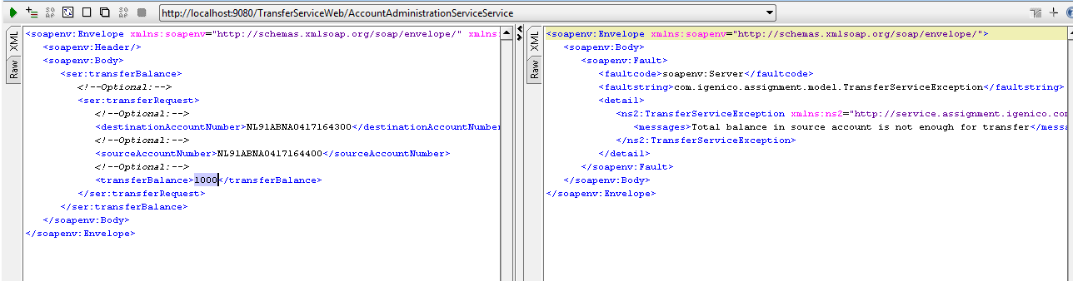

**Balance transfer with valid balance –**

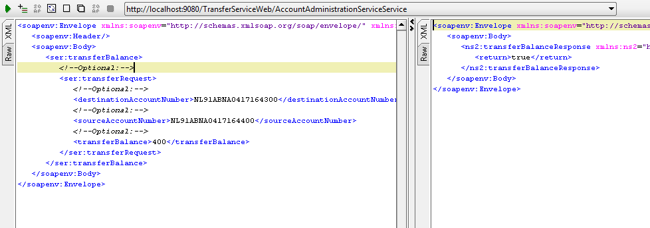

**Check balance in both accounts**

**DestinationAccount status**

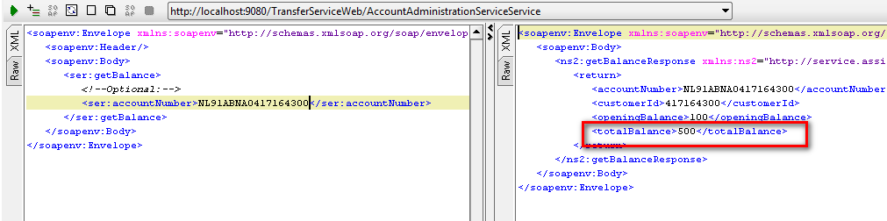

**SourceAccountStatus**

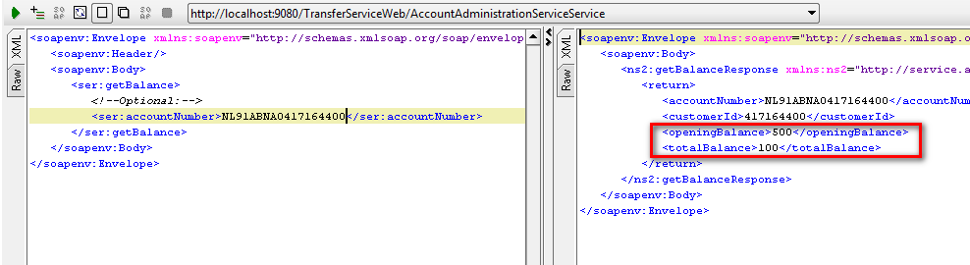

**Database Entries –**

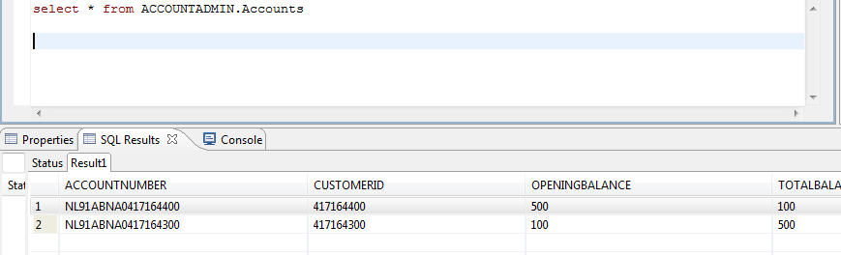

|  |  |
| --- | --- |
| **Description:** | **Test case description:**  Create account with existing account number |
| **Expected Result:** | Service should return error and account should not be created |
| **Actual Result:** | Shown below. |
| **Conclusion/Remarks:** | Testing status: PASS |

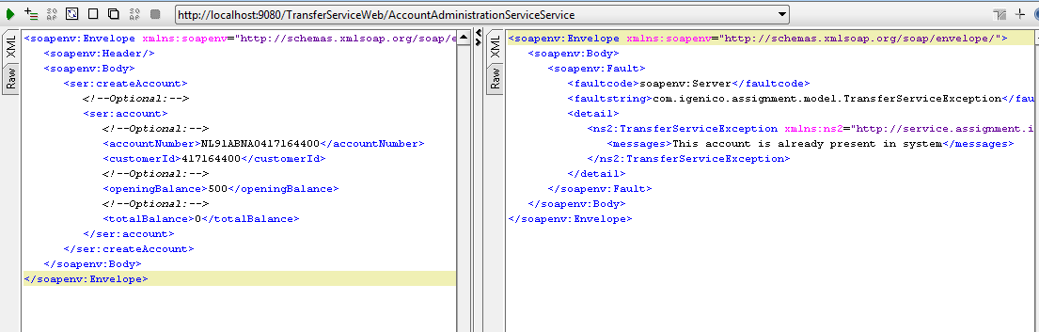

|  |  |
| --- | --- |
| **Description:** | **Test case description:**  Create account with existing account number |
| **Expected Result:** | Service should return error and account should not be created |
| **Actual Result:** | Shown below. |
| **Conclusion/Remarks:** | Testing status: PASS |