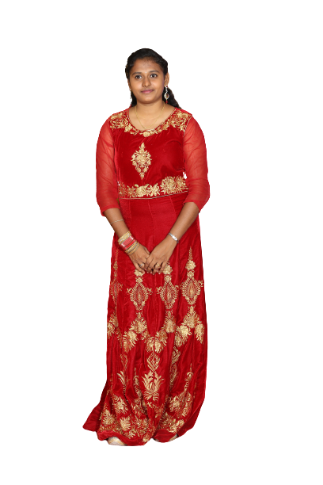 Bio – Meenakshi Ravikumar

Personal Information

Full Name: Meenakshi R

Date of Birth: 23.12.1994

Sex: Female

Email: Meenakshi.ravikumar@outlook.com

Phone Number: +91-99520 42804

Location (City, Country): Chennai, India.

Citizenship (Country): India

Current Engagement: Full-time

Current Annual Salary: 5,00,000 INR

Earliest Availability: June 01, 2022.

Social Profiles

LinkedIn: linkedin.com/in/meenakshiravikumar

GitHub: github.com/meenakshiravi7

Jovian: jovian.ai/meenakshi-ravikumar

Medium: medium.com/@meenuravi786

Work Experience

Guest Lecturer, GKM College of Engineering and Technology

Mar 2021- June 2021, Chennai

Courses handled:

1.Electronic Devices and Circuits

2.Circuit Theory

* Implemented and encouraged debate-style online environment to increase student engagement and promote critical thinking.
* Assisted struggling students to maintain progress levels by designing individualized lesson plans focussed on areas for improvement.
* Used variety of assessment tools and strategies to improve instruction methods.

Teaching Faculty – Alwin Group

June,2016 - Present, Chennai

* Observed and evaluated students’ performance, behaviour, social development and physical health.
* Enhanced student learning by optimizing wide range of instructional approaches and innovative classroom activities.
* Reviewed curriculum and devised alternate approaches to presenting lessons to increase student understanding.
* Served on school committee for STEM curriculum development.

Education

**Data Science Bootcamp, Jovian**

Oct 2021 - Present

Courses: Python Programming, Statistics, Data Analysis & Visualization, Machine Learning, SQL & Analytics.

Highlights: 600+ hours of coursework, 10 coding assignments, 3 projects. (Web Scraping, EDA, ML)

GKM College of Engineering & Technology, Chennai, India

* **Master’s Degree in Engineering, Communication Systems**

2017 - 2019, 8.05/10

Highlights: Built AUTOMATIC BOOK READER FOR VISUALLY CHALLENGED PEOPLE using Raspberry PI and Open-source OCR. Published a paper on the above in the 2nd International Conference on Recent Trends in Science and Technology.

* **Bachelor’s Degree in Engineering, Electronics and Communication**

2012 - 2016, 7.23/10

Highlights: Built STAFF SCHEDULER USING C# AND ARDUINO INTERFACING WITH DOT MARIX DISPLAY as my Final Year Project. The STAFF SCHEDULER has versatile applications in educational institutions and industries for monitoring the faculty and employees according to their scheduled tasks. Published a paper on my Staff Scheduler project in the IJIRCCE (International Journal of Innovative Research in Computer and Communication Engineering).

**Zion Matriculation Higher Secondary School**

* XII, Tamil Nadu Board – 2012, 89.25%
* X, Tamil Nadu Board – 2010, 91%

Online Courses

SQL

September,2020

* Completed SQL Fundamentals course on Sololearn
* Course Link: <https://www.sololearn.com/learning/1060>
* Certificate Link: <https://www.sololearn.com/Certificate/1060-19654013/jpg/>

Core Python (Python 3)

September,2020

* Completed Python 3 programming course on Sololearn
* Course Link: <https://www.sololearn.com/learning/1073>
* Certificate Link: <https://www.sololearn.com/Certificate/1073-19654013/jpg/>

Projects / Publications

**1.Scraping Book information using Python, Jovian**

* Used Books to Scrape site containing 1000 books from different genres to scrape.
* Scraped few information such as Book titles, Cost, Stock Availability and links to each book using BeautifulSoup and some helper functions.
* Stored the scraped information in Pandas dataframe and converted into CSV file.

**2. Exploratory Data Analysis and Visualization of Global Commodity Trade Data, Jovian**

* Worked with Global commodity Trade dataset from Kaggle containing 8.2 million rows and 10 columns of data.
* Identified the missing values through NumPy and Pandas, cleaned the dataset for further analysis.
* Analyzed and explored the numerical statistics of data.
* Asked questions and picturized the relationship between columns using Visualization techniques.

**3. E-commerce Product Classification using Machine Learning**

* Worked with Otto Group Product Classification dataset from Kaggle containing 93 features for more than 200,000 products.
* Performed EDA, feature Engineering and created training – validation split.
* Prepared data for modelling, trained and evaluated different ML models, tuned hyperparameters and reduce overfitting to improve the model.
* Obtained an accuracy of 98% on test dataset, after experimenting with 20 sets of hyperparameters.

**4. Automatic Book Reader For Visually Challenged People using Raspberry PI and Open-Source OCR.**

* Published a paper on the above in the 2nd International Conference on Recent Trends in Science and Technology.

**5. Staff Scheduler Using C# And Arduino Interfacing With Dot Matrix Display.**

* Published a Paper on my Staff scheduler project in the IJIRCCE (International Journal of Innovative Research in Computer and Communication Engineering)

Achievements & Awards

President Award in Bharat Scouts and Guides

* Received the prestigious Rashtrapathi Award from the President of India.
* Passed several tests in First aid, Camping, Signalling etc.,

Governor Award in Bharat Scouts and Guides

* Received Rajyapuraskar Award from honourable Governor.
* Passed several tests proving knowledge in Camping, Sports, Knots etc.,

Skills

* Python Programming, Statistics, Data Analysis & Visualization, Machine Learning, SQL & Analytics.
* Effective time management
* Multi-tasking
* Ability to work under pressure

Blog Posts

1. [Web scraping Book data using Python](https://meenucreations-my.sharepoint.com/personal/meenu_meenucreations_onmicrosoft_com/Documents/Web%20scraping%20Book%20data%20using%20Python) - <https://medium.com/@meenuravi786/web-scraping-book-data-using-python-eb2e761fdc14>

### [Data Analysis on Global Trade Statistics](https://medium.com/@meenuravi786/data-analysis-on-global-trade-statistics-563c7b7f95af?source=your_stories_page----------------------------------------) - <https://medium.com/@meenuravi786/data-analysis-on-global-trade-statistics-563c7b7f95af>

### [Dive into NumPy with these 5 functions](https://medium.com/@meenuravi786/dive-into-numpy-with-these-5-functions-3a950b428c02?source=your_stories_page----------------------------------------) - <https://medium.com/@meenuravi786/dive-into-numpy-with-these-5-functions-3a950b428c02>

### [ML model-Product Classification Challenge — Otto group](https://medium.com/@meenuravi786/ml-model-product-classification-challenge-otto-group-cef96bb4cf5b?source=your_stories_page----------------------------------------) - <https://medium.com/@meenuravi786/ml-model-product-classification-challenge-otto-group-cef96bb4cf5b>

Other Interests / Hobbies

Avid Reader

* Avid reader of several fiction books such as the entire Harry Potter set, R.L Stine novels, R.L. Stevenson novels, Enid Blyton’s works and noted Tamil literature books

Calligraphist

* Interested in trying different font styles.

Sketching & Craftworks

* Created several silk thread products as a hobby
* Created several sketches of nature, animals and birds