Integrated Trauma Care Platform

Submitted by

Quantumweave Intelligence Private Limited
Mobile: 9447103005 Email: info@quantumweaveintelligence.com

Introduction

The Integrated Trauma Care Platform developed by Quantumweave Intelligence is designed as a comprehensive digital infrastructure to support coordinated trauma response across ambulance services, hospitals, command centers, and emergency authorities. The platform integrates geospatial monitoring, ambulance dispatch coordination, hospital resource visibility, incident lifecycle management, patient triage reporting, and performance analytics into a unified operational environment that supports real-time emergency response management.

The system architecture enables emergency operators to monitor accident incidents in real time, dispatch the most appropriate ambulance resources, track vehicle movement during response and patient transport, coordinate hospital readiness, and maintain structured trauma response records for operational review and government analytics. The command center dashboard provides a live geospatial view of incidents, ambulance positions, hospital capabilities, and accident-prone locations across the region, enabling authorities to maintain situational awareness during emergency events.

Ambulance crews interact with the platform through a mobile interface designed for field operations. This interface enables rapid reporting of accident incidents, automatic capture of GPS coordinates, and structured recording of patient triage information. Paramedics can document patient vital signs including Glasgow Coma Scale score, blood pressure, oxygen saturation, respiratory rate, and injury descriptions directly at the accident scene. This clinical information is transmitted securely in real time to the command center and the receiving hospital, allowing emergency departments to prepare trauma teams, operating theatres, and critical care facilities before the patient arrives.

The platform maintains a centralized trauma incident registry that records every emergency event along with dispatch timelines, patient triage information, ambulance movement history, and hospital transport records. This structured registry enables authorities to analyse emergency response performance, identify operational bottlenecks, and monitor compliance with the critical Golden Hour treatment window during which timely medical intervention significantly improves patient survival outcomes.

In addition to supporting operational emergency response, the system includes advanced simulation and analytics capabilities that enable authorities to analyse historical accident patterns, identify high-risk road segments, evaluate ambulance coverage across districts, and simulate infrastructure improvements such as new ambulance bases or trauma center upgrades. These capabilities support evidence-based decision making for road safety improvements, emergency infrastructure planning, and continuous enhancement of trauma care services across the state.
Integrated Trauma Care Platform – System Architecture

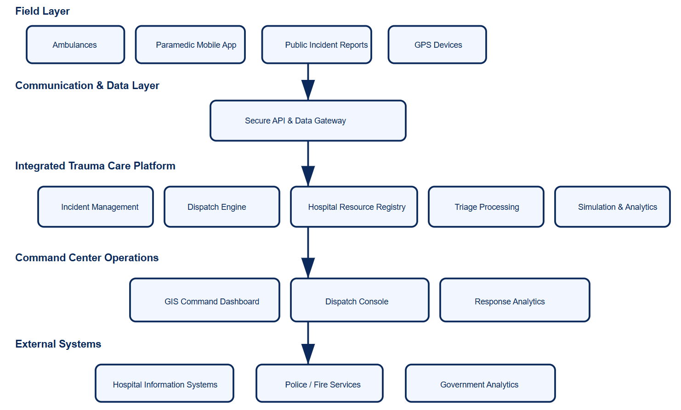

The Integrated Trauma Care Platform architecture is designed to support coordinated emergency response across field responders, command centers, hospitals, and government monitoring systems. The architecture follows a layered structure that separates field operations, communication infrastructure, core platform services, operational command interfaces, and external system integrations. This layered design ensures that the platform can scale across districts and eventually support statewide trauma response coordination while maintaining reliable real-time communication between all stakeholders involved in emergency care.

Field Layer – Incident Detection and Data Capture

The field layer represents the operational edge of the system where emergency events originate and initial response actions occur. This layer includes ambulances, paramedic mobile applications, GPS tracking devices, and public incident reporting interfaces.

When an accident occurs, incidents may be detected either through paramedics arriving on scene, through GPS-enabled ambulance units reporting activity, or through public reporting interfaces that allow citizens to submit accident alerts along with GPS location and optional photographic evidence. The paramedic mobile application enables field responders to create a new incident record by automatically capturing the geographic coordinates of the accident location and entering structured details such as accident type, severity, and number of patients involved.

During rescue operations, paramedics record patient triage information including vital signs such as pulse rate, oxygen saturation, Glasgow Coma Scale score, blood pressure, respiratory rate, and injury descriptions. This information forms the first structured clinical record of the incident and is transmitted to the platform in real time.

The field layer therefore functions as the primary data generation environment for the trauma response ecosystem, providing accurate and timely information to the rest of the platform.

Communication and Data Gateway Layer

The communication layer connects field responders and operational systems to the central trauma platform through secure data channels. This layer includes API gateways, secure network communication interfaces, and integration connectors for GPS tracking devices and mobile applications.

All incident reports, ambulance location updates, triage data, and operational status changes pass through this gateway before entering the core platform services. The gateway performs authentication, validation, and routing of incoming data to the appropriate system modules. This ensures that information from multiple sources—including ambulances, hospitals, and public reporting interfaces—can be consolidated into a unified operational data stream.

The gateway architecture also enables integration with external systems such as hospital information systems, emergency operations centers, and government analytics platforms. By maintaining standardized API interfaces, the system can exchange operational data securely with other digital infrastructure used by public authorities.

Core Platform Layer – Integrated Trauma Coordination Engine

The central layer of the architecture represents the core processing engine of the trauma care platform. This layer contains the operational modules responsible for incident coordination, resource allocation, patient triage processing, hospital resource monitoring, and analytical modelling.

The incident management module maintains a structured record of every accident event and tracks the lifecycle of the incident from initial report through dispatch, on-scene stabilization, patient transport, and incident closure. Each event is assigned a unique identifier and maintains a complete timeline of actions taken during the response.

The dispatch engine analyses the location of the incident along with the real-time status of ambulances and recommends the most appropriate unit for dispatch. Factors such as distance, ambulance availability, and operational readiness are considered when selecting the optimal responder. The dispatch recommendation is presented to command center operators who may confirm or override the recommendation if necessary.

The hospital resource registry continuously maintains updated information about hospital capabilities including trauma level classification, ICU bed availability, emergency department capacity, and specialized equipment readiness. When patient triage information is received from paramedics, the system evaluates the patient’s clinical severity and identifies the most appropriate hospital capable of providing treatment. This prevents critically injured patients from being transported to facilities that lack the necessary resources.

The triage processing module calculates structured triage scores based on the clinical data recorded by paramedics and classifies patients according to recognized emergency triage protocols. This classification helps determine transport priority and ensures that hospitals receive advance notification of patient condition before arrival.

In parallel, the analytics and simulation modules analyse both real-time and historical data to monitor response performance and evaluate infrastructure coverage. These capabilities enable the system to simulate accident scenarios and identify gaps in ambulance coverage or hospital accessibility across the region.

Command Center Operations Layer

The command center layer provides operational dashboards used by emergency coordinators to monitor incidents and manage emergency response activities. The primary interface is the GIS-based command dashboard, which displays real-time geographic visualization of ambulance movements, hospital locations, accident incidents, and black spot zones.

Operators can observe active incidents, track ambulance dispatch progress, and monitor hospital readiness through a single integrated dashboard. This operational view provides immediate situational awareness and enables rapid decision-making during emergency events.
The dispatch console allows operators to initiate or confirm ambulance dispatch decisions recommended by the platform. Operators can also manually assign ambulances, update incident status, or escalate incidents to mass casualty mode if multiple patients are involved.

The analytics dashboard provides authorities with insights into emergency response performance, including response times, patient transport durations, district-level performance indicators, and golden hour compliance metrics. These insights help identify operational bottlenecks and guide improvements to emergency infrastructure planning.

External Systems and Interagency Integration

The architecture supports integration with external systems that participate in emergency response operations. Hospital information systems can exchange patient transport notifications and hospital capacity updates with the trauma platform, ensuring that receiving hospitals are prepared for incoming patients.

Integration with police and fire services enables coordinated response to major incidents where traffic management or vehicle extrication may be required. These agencies can access shared operational information about the incident and coordinate their actions through the same situational data.

Government analytics systems can access aggregated trauma incident data to support policy planning, road safety improvements, and infrastructure development initiatives. Historical incident records provide valuable insights into accident patterns, high-risk road segments, and emergency response performance across districts.

System Outcomes and Operational Impact

The architecture enables a fully integrated trauma response ecosystem where information flows continuously between field responders, command centers, hospitals, and government authorities. By combining real-time geospatial monitoring, structured patient triage reporting, automated resource allocation, and hospital readiness coordination, the platform significantly improves the efficiency of emergency response operations.

The system reduces delays in ambulance dispatch, ensures that patients are transported to the most appropriate medical facility, and enables hospitals to prepare trauma teams before patient arrival. These improvements directly contribute to better utilization of the critical golden hour following serious accidents.

In addition to improving real-time emergency response, the platform generates structured operational data that supports long-term improvements in trauma care infrastructure and road safety planning. Authorities can analyse accident trends, identify underserved regions, and optimize emergency resource distribution based on evidence generated by the system.

Through this integrated architecture, the platform transforms trauma response from a fragmented set of independent services into a coordinated digital ecosystem capable of saving lives through faster and more intelligent emergency care.

Integrated Trauma Care Platform – Golden Hour Operational Workflow

The Golden Hour Operational Workflow illustrates how the Integrated Trauma Care Platform coordinates emergency response activities from the moment an accident occurs until the patient receives treatment at a hospital. The workflow demonstrates the complete operational chain that enables faster response and improved survival outcomes during the critical first hour after a traumatic injury.
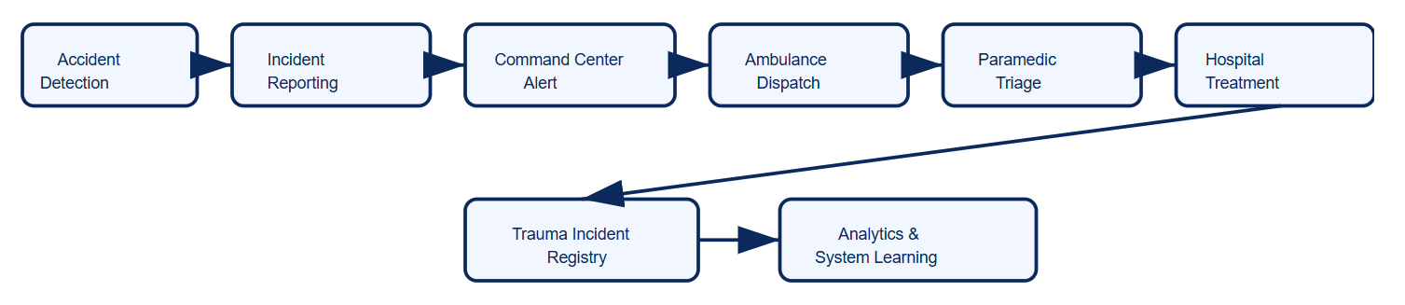
The process begins with accident detection, which may occur through paramedics arriving at the scene, ambulance units reporting an incident, or members of the public submitting an accident report through the system’s reporting interface. The incident location is automatically captured using GPS coordinates to ensure precise identification of the accident site.

Once an incident is reported, the information is transmitted to the central command center, where the platform generates an operational alert for dispatch operators. The command center dashboard displays the incident location on a geospatial map along with nearby ambulance units and hospital facilities. This immediate situational awareness allows emergency operators to quickly evaluate available resources and coordinate the response.

The platform’s dispatch engine then identifies the nearest available ambulance based on location, operational readiness, and travel time. Dispatch operators can confirm the recommendation, and the selected ambulance is immediately deployed to the accident scene. Throughout the response journey, the system continuously tracks the ambulance location and updates estimated arrival times.

Upon reaching the accident scene, paramedics perform patient assessment and triage using the mobile application. The application allows paramedics to record patient vital signs such as Glasgow Coma Scale score, blood pressure, oxygen saturation, respiratory rate, and injury details. This information is transmitted in real time to the command center and the receiving hospital, allowing emergency departments to prepare trauma teams and medical resources before the patient arrives.

Based on the patient’s triage severity and hospital resource availability, the platform recommends the most appropriate receiving hospital. This ensures that critically injured patients are transported directly to facilities capable of providing the required level of care, avoiding delays caused by hospital diversion.

After patient transport and hospital admission, the incident details—including dispatch timelines, triage data, ambulance movement history, and hospital transport records—are stored in the central trauma incident registry. This registry serves as a comprehensive record of the emergency response event and supports operational review and compliance monitoring.

The collected data is then analyzed by the platform’s analytics and system learning modules, which evaluate response times, identify operational bottlenecks, and detect patterns in accident occurrences. These insights enable authorities to improve ambulance deployment strategies, optimize hospital coordination, and strengthen emergency response infrastructure across districts.

Through this coordinated workflow, the platform ensures that emergency response activities—from accident detection to hospital treatment—are executed efficiently within the critical Golden Hour, significantly improving trauma survival outcomes.

Table 1. Feature Compliance Table – Based on Requirement Video

Feature Category | Requirement from Video | Implementation Status
Geospatial Command Center | Real-time GIS map showing ambulance locations | Implemented
 | Map layers for hospitals, ambulances, black spots, incidents and road networks | Implemented
 | Visualization of active accident incidents | Implemented
 | Trauma hospital categorization by capability level | Implemented
 | District-level ambulance coverage monitoring | Implemented
 | Command center KPI dashboard | Implemented
Ambulance Fleet Management | Ambulance registry with operational status | Implemented
 | Automatic nearest ambulance identification | Implemented
 | Dispatch recommendation with manual override | Implemented
 | Continuous real-time ambulance tracking | Implemented
Ambulance Staging Stations | Petrol pump staging station registry | Implemented
 | Ambulance deployment to staging stations | Implemented
Hospital Resource Registry | Hospital registry with trauma classification | Implemented
 | ICU bed availability monitoring | Implemented
 | Hospital recommendation based on capacity and proximity | Implemented
 | Trauma slot reservation during patient transport | Implemented
Black Spot Management | Accident-prone location registry | Implemented
 | Accident density heatmap | Implemented
High Risk Zone Analysis | Identification of underserved response zones | Implemented
 | AI-based infrastructure recommendations | Implemented
Field Incident Reporting | Mobile reporting interface for paramedics | Implemented
 | GPS-based accident location capture | Implemented
 | Incident ID auto-generation | Implemented
Incident Lifecycle Management | Incident status workflow management | Implemented
 | Incident timeline with operational timestamps | Implemented
Patient Triage | Structured patient assessment form | Implemented
 | Recording of vital signs and injury details | Implemented
 | Multi-patient support per incident | Implemented
Automated Triage | Automatic triage score calculation | Implemented
 | START triage protocol classification | Implemented
Simulation and Planning | Accident simulation capability | Implemented
 | Infrastructure coverage analysis | Implemented
Trauma Registry | Centralized trauma incident database | Implemented
Golden Hour Monitoring | Response time monitoring and performance analytics | Implemented
System Integration | GPS integration for ambulance tracking | Implemented
 | API integration capability with hospital systems | Implemented
 | Role-based secure access control | Implemented

Additional Operational Features (Currently Progressing)

Feature | Description | Status
Traffic-aware ambulance routing | Integration of live traffic information to recommend optimal ambulance routes | Development in Progress
Turn-by-turn navigation | Navigation assistance for ambulance drivers during dispatch and patient transport | Development in Progress
Ventilator and equipment monitoring | Real-time availability of ventilators, blood banks, operating theatres, and specialist readiness | Development in Progress
Hospital emergency readiness dashboard | Dedicated hospital dashboard for monitoring incoming trauma cases and ambulance ETA | Development in Progress
Pre-arrival trauma alerts | Automatic alerts sent to hospitals with patient triage details before ambulance arrival | Development in Progress
Offline incident reporting | Mobile app functionality for incident reporting in low-connectivity regions | Development in Progress
Accident scene photo capture | Photo documentation of accident scenes via the paramedic mobile application | Development in Progress
Multi-agency coordination | Shared operational interface for ambulance services, police, fire services, and emergency authorities | Development in Progress
Public incident reporting interface | Citizen reporting interface with GPS location capture | Development in Progress
Historical accident analytics | Time-based accident pattern analysis and road safety intelligence reports | Development in Progress
Ambulance readiness monitoring | Monitoring of vehicle readiness including refuelling, cleaning, and maintenance status | Development in Progress
Emergency department capacity indicator | Real-time ED occupancy monitoring to avoid hospital overload | Development in Progress
Mass Casualty Incident mode | Dedicated operational workflow for incidents involving multiple casualties | Development in Progress
Command center alert engine | Automated alerts for response delays, hospital overload, and ambulance shortages | Development in Progress

Future Scope and Planned Enhancements

Feature | Description | Status
Predictive accident risk forecasting | Machine learning models to predict accident probability using historical data, weather patterns, and traffic density | Planned
Dynamic ambulance pre-positioning | Automated recommendations for ambulance deployment in predicted high-risk areas | Planned
Wearable medical device integration | Integration with portable medical devices for automatic vitals capture | Planned
Continuous vitals streaming | Real-time patient vitals transmission from ambulance to hospital | Planned
AI-powered dispatch optimization | Machine learning-based ambulance dispatch recommendation engine | Planned
Telemedicine support | Secure video consultation between paramedics and hospital physicians during transport | Planned
National health system integration | Integration with Ayushman Bharat Digital Mission and national ambulance networks | Planned
Automated outcome tracking | Linking trauma incidents with hospital discharge outcomes | Planned
Trauma outcome analytics | Learning system to continuously improve emergency response performance | Planned

This document summarizes the functional capabilities of the Integrated Trauma Care Platform in alignment with the features demonstrated in the requirement video, along with additional operational capabilities currently under development and future enhancements planned for the system.

If we were to pilot this in a specific district, how quickly could your "off-the-shelf" solution be deployed?

Our platform is designed as a configurable off-the-shelf solution that can be rapidly deployed at a district level. Once access to ambulance tracking feeds and participating hospital details is available, the system can typically be operational within 4–6 weeks. This includes configuration of district maps and resources, onboarding ambulances and hospitals, deployment of the paramedic mobile application, and training of command center operators and hospital staff.

Any existing deployments where you have integrated multiple hospital chains with a centralized dispatch.

Our platform architecture has been designed specifically to support centralized emergency coordination across multiple hospitals and ambulance fleets through a unified command center. The system enables hospitals to update their resource readiness status while allowing dispatch operators to monitor ambulance movement and incident status from a centralized dashboard.

While a full state-wide multi-hospital deployment is currently under pilot readiness, the platform has been engineered and validated to support integration with multiple hospital networks through secure APIs and hospital resource registries. The architecture allows hospitals from different chains to participate in the same trauma response ecosystem while maintaining their own internal hospital information systems.

The design aligns with the operational model used in emergency medical services where ambulances are coordinated through centralized dispatch networks such as Kerala’s 108 / Kanivu ambulance service, which integrates multiple ambulances across districts through a coordinated call center and dispatch infrastructure.

Our current platform demonstrates the same capability by allowing multiple hospitals to be registered within the trauma resource registry, share real-time capacity indicators, and receive coordinated dispatch notifications from a single operational command center. This architecture ensures that the system can seamlessly support multi-hospital trauma networks at district or state scale once operational deployment is initiated.

