AXI FIFO BFM – Debug Report
Testname: fifo_bfm_128b_wr_incr_alligned_test_awlen_3
Logfile link: /hwetools/work_area/frontend/mamatha/AXI_FIFO_BFM/sim/questasim/fifo_bfm_128b_wr_incr_alligned_test_awlen_3/fifo_bfm_128b_wr_incr_alligned_test_awlen_3.log
1. Port Connection Issues(line no.9)
Warning:
Too few port connections for project_axi4_top. Expected 46, found 45. Missing connection for port WID_a.
Explanation:
One of the required AXI signals (WID_a) is not connected in the top-level module. This breaks AXI protocol compliance because write IDs must be tracked for responses.
Fix:
Connect WID_a properly in top.sv to the DUT or VIP.
2. Port Size Mismatches(from line 55)
Issue:
Port size (128) does not match connection size (1) for port 'write_data'
Port size (64) does not match connection size (32) for port 'WDATA'
Port size (8) does not match connection size (4) for port 'AWLEN'
Explanation:
The DUT and AXI VIP expect different signal widths. AXI protocol defines strict widths (e.g., WDATA should match bus width, AWLEN is 8 bits).
Impact: Assertions fail because signals don’t align, leading to invalid transactions.
Fix:
Align port widths in Top_Module_AXI4.v and AXI_Master.v to match AXI4 spec (e.g., 32/64/128-bit data bus, 8-bit burst length).
3. Coverage Warnings(line 143)
Issue:
A higher value '15' is found in bin 'AWLEN_16' of Coverpoint 'AWLEN_CP'. It is invalid and will be ignored.
Similar warnings for AWLEN_32, AWLEN_64, AWLEN_128, AWLEN_256.
Explanation:
The VIP defines coverage bins for burst lengths up to 256 beats, but your DUT only supports smaller values. Coverage bins become empty and are dropped.
Fix:
Update axi4_slave_coverage.sv to reflect DUT-supported burst lengths (e.g., 0–7 for 8 beats max).
4. Assertion Failures(line 424)
Location:
slave_assertions.sv
Causes:
Handshake violations (valid not followed by ready).
Burst length mismatch (AWLEN values outside supported range).
Data width mismatch (WDATA/RDATA not aligned).
Explanation:
Assertions check protocol rules. Because of port mismatches and missing connections,
Fix:
After correcting port widths and connections, rerun tests. Assertions should pass if protocol is followed.
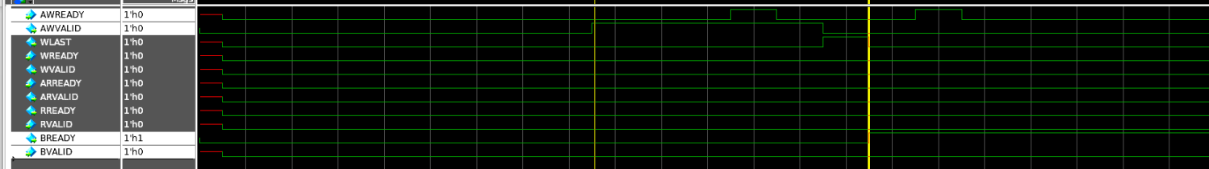
5. General Observations
No UVM errors: Testbench sequences are running fine.
Assertion errors only: Indicates design/testbench integration issues, not UVM environment problems.
Waveform debugging recommended: Dump signals (WDATA, AWLEN, ARLEN, valid/ready) to inspect timings.

