* **Initial Steps:**

**Step 1:** Create your **GitHub** account.

**Step 2:** Click on the link [meenalpannase/Bench_assignment (github.com)](https://github.com/meenalpannase/Bench_assignment)

* **Fork:**

**Step 3:** Click on **Fork** at the top right to get that code in your Repositories.

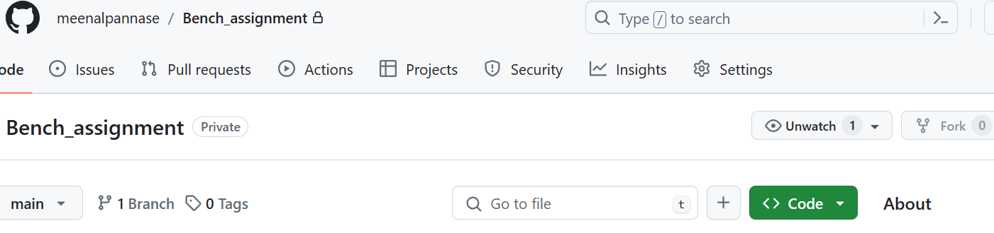

* **Create Directory:**

**Step 4:** Now in your putty or unix terminal (Vnc Viewer), follow the below commands.

Create your directory in below path

**cd /hwetools/work_area/frontend/**

**mkdir Meenal/**

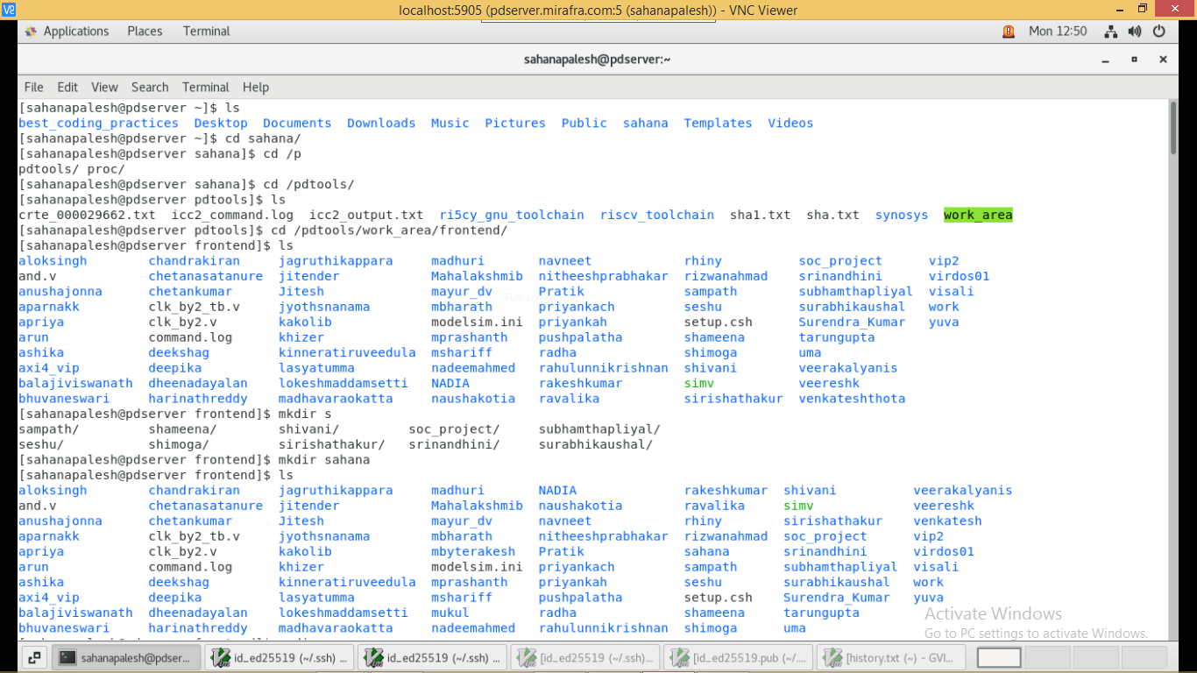

* **Configuration:**

**Step 5:** In putty/unix configure your mirafra user_name and email id as shown

**cd Meenal/**

**git config --global user.name "meenalpannase"**

**git config --global user.email** [**meenalp@gmail.com**](mailto:meenalp@gmail.com)

* **SSH key in Linux:**

**Step 6:** Create ssh key,

**ssh-keygen -t ed25519 -C "**[**meenalp@gmail.com**](mailto:meenalp@gmail.com)**"**

Now press **Yes** and Press **Enter** until it gets added and your path is obtained and give below command

**gvim ~/.ssh/id_ed25519.pub**

**Below image given is for reference**

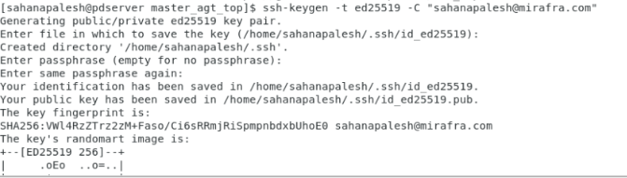

**Step 7:** Now ssh key will be generated and copy the file contents.

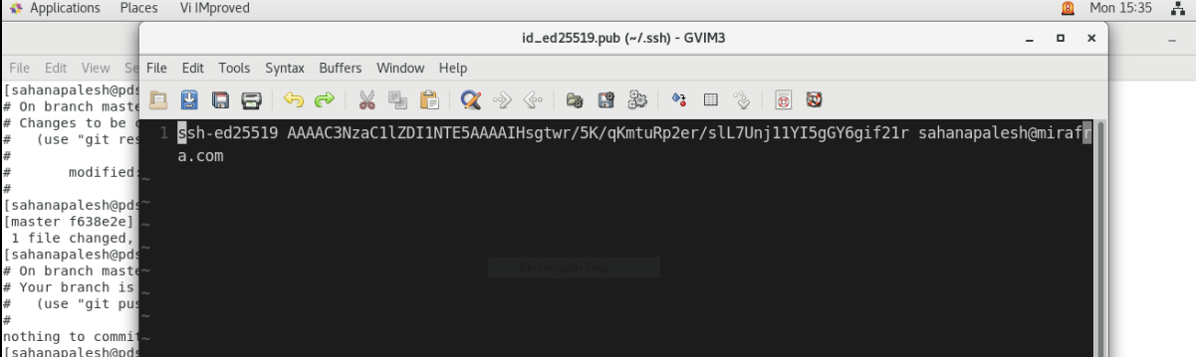

* **SSH key in GitHub:**

**Step 8:** Go to GitHub → Settings(of your account) → Account Settings → SSH and GPG keys → New SSH key

Title: **mirafra_server**

Key: (Paste the copied SSH key from putty/unix)

Now click on Add SSH keys

Below image is given for reference.

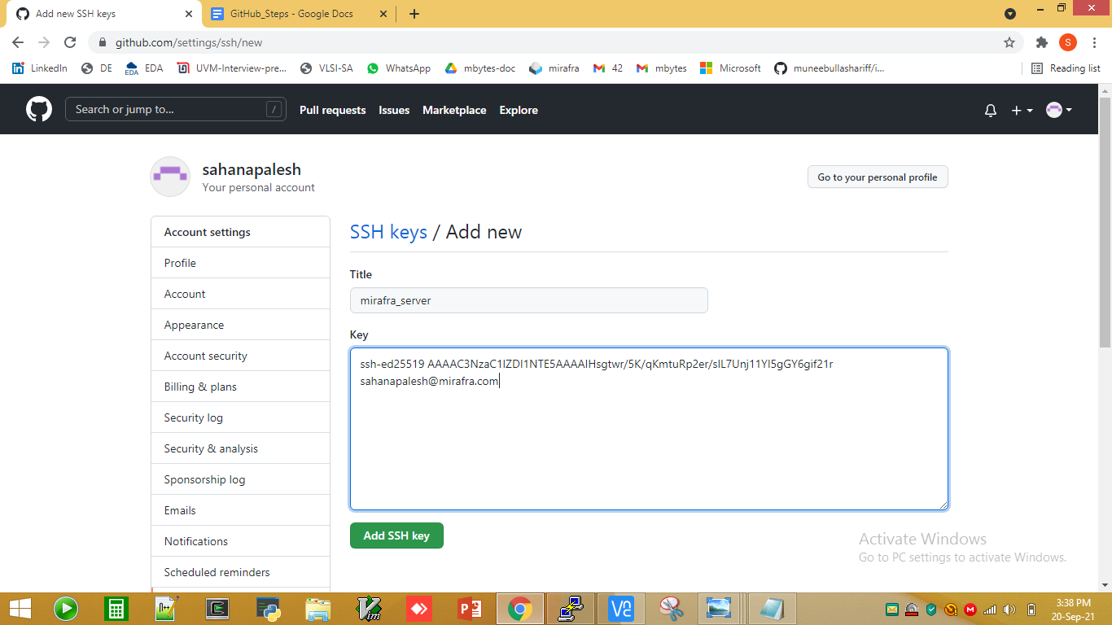

**Step 9:** Now you can use the SSH link from GitHub → Repository (particular folder- i2c_vip) → code → Copy SSH link.

**Below image is given for reference**

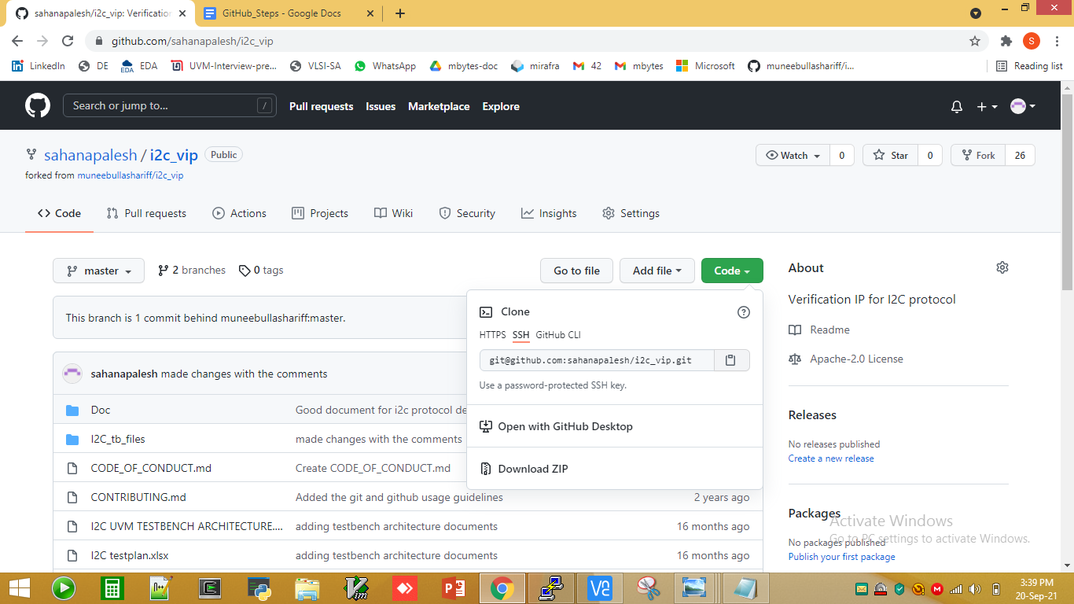

* **Git Clone:**

**Step 10:** Go to putty/unix terminal and clone the path as following command

**git clone** [**git@github.com:meenalpannase/Bench_assignment.git**](mailto:git@github.com:meenalpannase/Bench_assignment.git)

**Below image is given for reference**

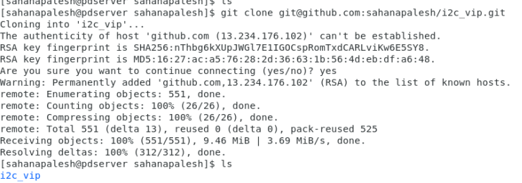

**Step 11:** Go to the master folder and check for git status

**cd meenalpannase/Bench_assignment/UVM/Scorboard_assignment** **git status**

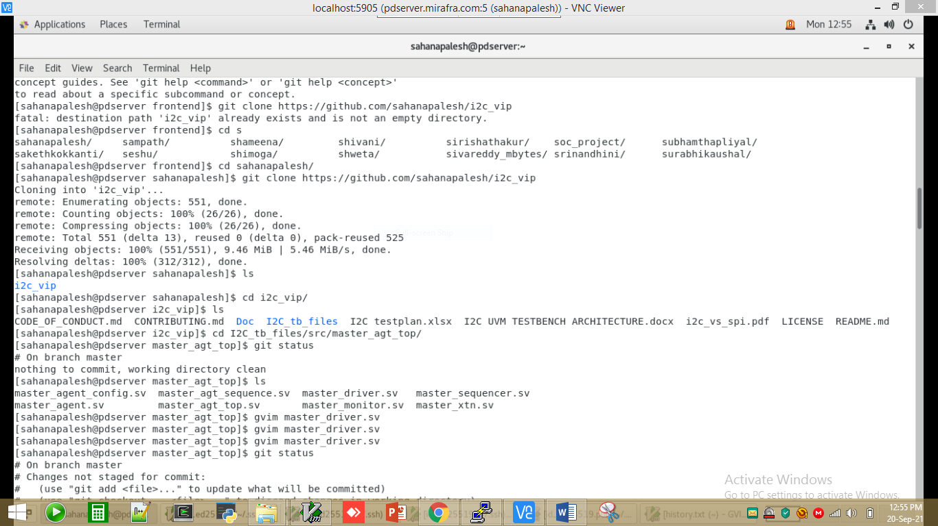

**Step 12:** Edit a file in gvim as shown and check status

**gvim scoreboard_assignment.sv**

**git status**

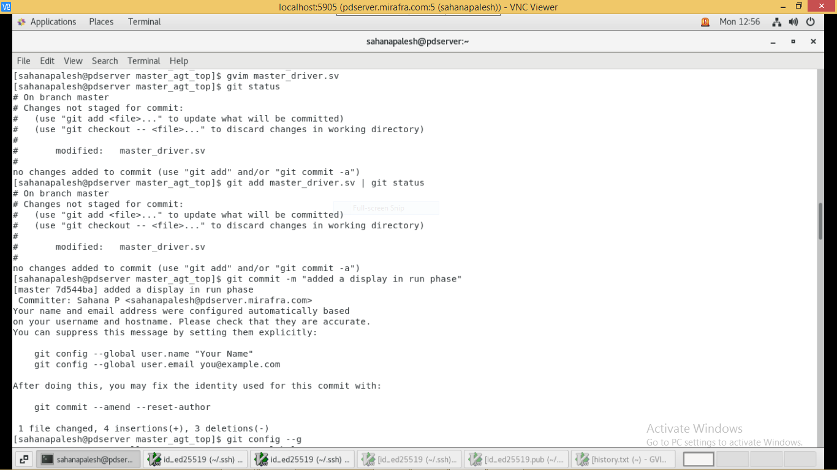

**Step13:**

**After editing the code save your code into your own work area and then copy same code to following path with your name as given in example below:**

**/**hwetools/work_area/frontend/assignments_bench2024/uvm_assignments/scoreboard or driver or sequence/

**For ex: /**hwetools/work_area/frontend/assignments_bench2024/uvm_assignments/scoreboard or driver or sequence/ scoreboard7or driver or sequence/yourname.sv