AGILE PROJECT DOCUMENTATION
Project Name: Career Match AI
Project Title:
AI Career Companion Agent for Internship Matching and Interview Preparation

Prepared By: Madireddy Meena Mahanth Harinadh
Project Duration: July 22, 2026 – September 10, 2026
Mentor: Mr. Vijay Parmar

Index
No. | Section | Page No.
1 | Project Overview | 3
2 | Project Objective | 4
3 | Technology Stack | 5
4 | Project Requirements | 7
5 | System Architecture / Workflow | 8
6 | Product Backlog | 11
7 | Sprint Planning | 13
8 | Sprint Tasks & Status | 15
9 | Implementation / Key Features | 16
10 | Testing | 20
11 | Challenges & Solutions | 22
12 | Final Project Status | 23
 | Limitations | 24
 | Future Scope | 25
 | Conclusion | 26

1. Project Overview

1.1 Project Name
Career Match AI

1.2 What is the Project?
Career Match AI is an AI-powered web application built for the Infosys AI internship program. It combines four capabilities behind a single authenticated experience: (1) resume upload and AI-assisted structured data extraction, (2) semantic matching of a candidate's profile against a set of internship postings using vector similarity search, (3) an AI-driven mock interview agent that asks role-specific questions and scores each answer, and (4) a document question-answering feature that lets a user upload a PDF and ask questions grounded strictly in that document's content. The current system uses a React 19 + TypeScript + Vite single-page frontend, a FastAPI backend, PostgreSQL (production) for structured relational data, FAISS indexes for semantic retrieval, the Groq API for language generation and evaluation, and Sentence-Transformers (all-MiniLM-L6-v2) for generating embeddings. The frontend is deployed on Vercel and the backend on Render (production configuration; deployment verification pending).

1.3 Problem Statement
Internship seekers commonly face several practical difficulties: it is time-consuming to manually compare a resume against many internship listings to judge fit; candidates often do not have a structured, searchable record of their own skills, projects, and experience; and many candidates lack easy access to realistic, role-specific interview practice with actionable feedback. Career Match AI addresses these problems by automatically extracting structured information from an uploaded resume, using semantic search to surface internships that are conceptually related to the candidate's skills and experience (rather than requiring exact keyword matches), and providing an AI interviewer that asks questions and scores responses. The system also allows a user to upload any PDF and ask questions about it, answered strictly from that document's content.
NOTE
The application presents matches, scores, and interview feedback as AI-generated decision-support output. It does not guarantee interview selection, internship placement, or employment outcomes.

1.4 Target Users
- Students
- Internship seekers
- Early-career candidates preparing for technical or behavioral interviews

2. Project Objective
The project was built to achieve the following objectives:
- Automate structured extraction of candidate information (skills, education, work experience, and projects) from an uploaded PDF resume using a large language model (Groq API).
- Match a candidate against a set of internship postings using semantic (embedding-based) retrieval rather than plain keyword search.
- Provide AI-assisted, role-specific mock interview practice with per-answer scoring and written feedback, followed by a dynamically generated next question.
- Enable document-grounded question answering, so a user can upload a PDF and receive answers based only on that document's content.
- Combine a relational database (PostgreSQL in production) as the structured source of truth with FAISS vector indexes as a dedicated semantic retrieval layer, rather than forcing one store to do both jobs. (The original development build used MySQL, ChromaDB and Google Gemini; see Section 3.)

3. Technology Stack
The table below lists the technologies of the current Career Match AI stack.
Category | Technology | Purpose
Programming Language | Python 3 | Backend application logic, AI services, and data access
Frontend Language / Tooling | TypeScript, Vite | Type-safe frontend code and fast development/build tooling
Frontend Framework | React 19 | Single-page application UI
Routing | React Router v7 | Client-side page routing and protected routes
Styling | Tailwind CSS | Utility-first styling of the frontend
HTTP Client | Axios | Frontend-to-backend API requests, with a JWT bearer token attached via an interceptor
Icons | Lucide React | UI iconography across the frontend pages
Backend Framework | FastAPI | REST API layer exposing auth, profile, resume, matching, interview, and document endpoints
ORM | SQLAlchemy 2.x | Object-relational mapping (PostgreSQL in production; SQLite as local development fallback)
Migrations | Alembic | Configured for schema migrations (see note below)
Config / Validation | Pydantic / pydantic-settings | Environment-based settings and request/response schema validation
Database | PostgreSQL (cloud / managed) for production | Production relational source of truth for users, profiles, resumes, internships, matches, documents, and interview sessions
Vector Search | FAISS | Vector similarity search over internship postings and user-uploaded document chunks
Embeddings | Sentence-Transformers ("all-MiniLM-L6-v2") | Converts resume text, internship text, and document chunks into vector embeddings
AI / LLM | Groq API | Structured resume extraction, interview question generation and scoring, match explanations, and document Q&A
Authentication | JWT (python-jose) + Passlib (bcrypt) | Token-based session authentication and password hashing
Document Processing | PyPDF2 | Text extraction from uploaded PDF resumes and documents
Testing | pytest + FastAPI TestClient | Automated backend tests (currently covering authentication)
Frontend Hosting | Vercel | Production frontend hosting (verification pending)
Backend Hosting | Render | Production API hosting (verification pending)
Monitoring | UptimeRobot | Uptime monitoring via /health (not confirmed as configured)
NOTE
Note: the frontend's package.json also lists "recharts", but no component imports or renders it, so it is not listed as in use. Historical note: the original build used MySQL, ChromaDB and Google Gemini; they were replaced by PostgreSQL, FAISS and Groq. Hosting and monitoring are described in Section 5.1.
NOTE
Note on Alembic: an Alembic configuration exists, but the reviewed snapshot had no migration version files under alembic/versions; tables are created via Base.metadata.create_all. Re-verify against the current repository.

4. Project Requirements

4.1 Functional Requirements
- User registration and login using email and password (JWT-based session authentication).
- Retrieval and update of the current user's profile (name, phone, location, headline, summary, LinkedIn/GitHub/portfolio links, preferred roles and locations).
- Resume upload; the upload endpoint accepts .pdf and .docx file extensions, but text is currently extracted only from PDF files — a .docx upload is stored but is not parsed for content in the current implementation.
- AI-based structured extraction of resume data (name, contact details, summary, skills, education, experience, projects) using the Groq LLM, saved to the relational database and used to auto-fill empty profile fields.
- Semantic internship matching: the active resume is converted to a text summary, embedded, and compared against a FAISS index of internship postings to retrieve the top matches.
- AI-generated match explanations, and matched/missing skill lists, produced by the Groq LLM and persisted per match.
- AI mock interview sessions: a user selects a target role and difficulty, and the system starts a session, asks an opening question, and continues with an evaluate-then-ask-next-question loop.
- Per-answer interview scoring (0–10) and written feedback, generated by the Groq LLM and stored alongside each answer.
- Document upload (PDF only) and chunk-based indexing into a FAISS index for later retrieval.
- Document-grounded question answering: a user's question is answered using only the chunks retrieved from that user's own uploaded document(s).

4.2 Non-Functional Requirements
- Security: passwords are hashed with bcrypt; API access requires a valid JWT bearer token (7-day expiry).
- User data isolation: resumes, documents, matches, and interview sessions are filtered by the authenticated user's ID; document retrieval returns only the requesting user's own chunks.
- Error handling: the API returns structured HTTP errors (e.g., 400 for a duplicate registration or invalid file type, 404 for a missing interview session or document, 403 for an invalid token).
- Configuration management: secrets and endpoints (database URL, JWT secret, Groq API key, vector index location, upload directory) are read from environment variables.
- Maintainability: the backend is organized into clear layers — API routes, Pydantic schemas, SQLAlchemy models, and services — separating request handling from business logic.
NOTE
CORS is currently configured to allow all origins (allow_origins=["*"]), which the source code itself comments is intended for development and should be restricted before production use.

5. System Architecture / Workflow
This section describes the architecture, components, and data flow of each AI-driven feature, updated for the current Groq / PostgreSQL / FAISS stack.

5.1 High-Level Architecture
At a high level, the system follows a standard client–API–data-and-AI-services architecture:
- User → React Frontend (Vite, TypeScript, Tailwind, Axios) → FastAPI Backend
- FastAPI Backend → PostgreSQL (structured application data via SQLAlchemy; SQLite may be used as a local development fallback)
- FastAPI Backend → FAISS (semantic vector search for internships and documents)
- FastAPI Backend → Sentence-Transformers (local embedding generation)
- FastAPI Backend → Groq API (resume extraction, match explanations, interview evaluation, document Q&A)
The frontend communicates with the backend exclusively over REST endpoints prefixed with /api/v1, grouped into auth, profile, resumes, matching, interview, and documents routers. Authentication uses an OAuth2-compatible password flow: the frontend logs in against /api/v1/auth/login and attaches the returned bearer token via an Axios interceptor. Production configuration: User → Vercel React frontend → (HTTPS API) → Render FastAPI backend → Cloud PostgreSQL and Groq API, with FAISS and Sentence-Transformers in the retrieval layer. A single FastAPI application exposes a lightweight GET /health endpoint for Render health checks; UptimeRobot can monitor https://YOUR-RENDER-SERVICE.onrender.com/health (deployment and monitor setup pending verification).

5.2 Resume Processing Workflow
The documented flow, based on app/api/routes/resume.py and app/services/resume_parser.py (LLM provider updated to Groq), is:
- User uploads a file (.pdf or .docx accepted at the API level) through the Resume page.
- The file is saved to the server's configured upload directory.
- If the file is a PDF, its text is extracted with PyPDF2 (extract_text_from_pdf). If it is a .docx, no text extraction is currently performed — an empty string is passed forward.
- The extracted text is sent to the Groq LLM with a prompt instructing it to return a structured JSON object matching a fixed schema (name, contact details, summary, skills, education, experience, projects) and explicitly told not to invent information.
- The JSON response is parsed and validated against a Pydantic schema (ResumeExtractionSchema).
- The parsed resume, along with its structured skills, education entries, experience entries, and projects, is saved to the relational database (PostgreSQL in production; resumes, resume_skills, resume_educations, resume_experiences, resume_projects tables); any previous active resume for the user is deactivated.
- Empty profile fields (name, phone, LinkedIn, GitHub, summary) are automatically filled in from the parsed resume data if they were not already set.
NOTE
The final implementation currently performs PDF text extraction and structured extraction end-to-end. DOCX files are accepted by the upload endpoint but are not yet parsed for text content.

5.3 Internship Matching Workflow
The documented flow, based on app/services/matching_service.py and app/services/embedding_service.py (retrieval updated to FAISS, LLM to Groq), is:
- The candidate's active resume is retrieved from the database.
- A plain-text candidate summary is built by concatenating the skill names, experience descriptions/titles, and project descriptions/technologies from the parsed resume.
- This text is embedded using the Sentence-Transformers all-MiniLM-L6-v2 model.
- The embedding is used to query the FAISS internships index for the 5 nearest internship postings by L2 distance (top-k carried over from the original build).
- Each result's raw distance is converted to a similarity score with the formula similarity_score = max(0, 100 − distance × 50), as found in the original source code (carried over to the FAISS-based build).
- For each matched internship, the Groq LLM is asked to compare the candidate text against the internship's requirements and produce a short explanation plus lists of matched and missing skills, based only on the given text.
- The match (scores, explanation, matched/missing skills) is saved to the matches table and returned to the frontend.
NOTE
The internship postings currently searched against are the 5 demo internships created by backend/scripts/seed_database.py (Data Science Intern, Backend Developer Intern, Generative AI Intern, Frontend Developer Intern, and Data Engineering Intern) — a small, illustrative/demo dataset rather than a live or large-scale internship catalogue.

5.4 Interview Agent Workflow
The documented flow, based on app/services/interview_agent.py and app/api/routes/interview.py (LLM provider updated to Groq), is:
- The user starts a session by choosing a target_role and difficulty; a new interview_sessions row is created.
- The backend immediately calls the same evaluation function with a placeholder "Hello, I am ready to start the interview" message to generate the opening question, seeded with the candidate's resume text (trimmed to 2000 characters) and the target role/difficulty.
- The opening AI question is stored as an interview_messages row (role = "ai").
- When the candidate submits an answer, a single Groq LLM call is made with the full conversation history and the new answer; the prompt asks the model to (1) score the answer 0–10 with concise feedback and (2) ask the next question, in one fixed-format response (SCORE / FEEDBACK / NEXT_QUESTION lines) that the backend parses.
- The user's answer, its score, and its feedback are saved as one message row; the next AI question is saved as a second message row.
- The frontend receives and displays the full running message list, including per-answer scores and feedback.

5.5 Document Q&A Workflow
The documented flow, based on app/services/document_qa_agent.py and app/api/routes/document.py (retrieval updated to FAISS, LLM to Groq), is:
- The upload endpoint accepts PDF files only (a non-PDF filename is rejected with an HTTP 400 error).
- The uploaded PDF's text is extracted with PyPDF2 and split into fixed-size chunks of 1,000 characters (simple character-count chunking, with no overlap or semantic boundary logic).
- Each chunk is embedded (Sentence-Transformers) and added to the FAISS documents index together with metadata identifying the owning user_id, the document_id, and the chunk index.
- When the user asks a question, the question is embedded and the FAISS index is queried for the 3 nearest chunks (top-k carried over), restricted to the requesting user's own document chunks.
- The retrieved chunk text is passed to the Groq LLM as context, with an explicit instruction to answer only from that context and to say so if the answer is not contained in it.
- If no LLM API key is configured, the backend still returns retrieved context (truncated) instead of a generated answer, rather than failing outright.

5.6 PostgreSQL vs. FAISS
The system deliberately uses two different databases for two different jobs, rather than using a single database for both:

PostgreSQL
Acts as the structured, relational source of truth (SQLite may serve as a local development fallback) for: users, profiles, resumes and their parsed data, internship postings, matches, documents (metadata), and interview sessions/messages.

FAISS
Acts as the semantic retrieval (vector similarity search) layer, together with Sentence-Transformers embeddings, for internship similarity search during matching and chunk-level retrieval for document Q&A. FAISS is a similarity-search library rather than a database, so it complements the relational store.
PostgreSQL | FAISS
Structured relational data | Vector (embedding) data
Transactional storage | Semantic similarity search
Source of truth | Retrieval / index layer
Relationships and constraints (foreign keys) | Embedding-based nearest-neighbour search
Using PostgreSQL for structured records keeps referential integrity (for example, a match always references a real user and a real internship). Using FAISS indexes for embeddings lets the system find conceptually similar content that a plain keyword search would miss. Combining the two avoids forcing either component to do a job it is not designed for.

6. Product Backlog
NOTE
This backlog reflects the final implementation's backlog/status, reconstructed from the source code. It is not a historical record of how or when each item was actually tracked during development, as no sprint board or issue tracker was provided in the project evidence.
ID | Feature / Task | Priority | Status
P001 | Project setup (backend + frontend scaffolding) | High | Done
P002 | Database schema and PostgreSQL setup (originally MySQL) | High | Done
P003 | User authentication (register, login, JWT) | High | Done
P004 | Profile management (get/update) | Medium | Done
P005 | Resume upload endpoint | High | Done
P006 | PDF text extraction | High | Done
P007 | Groq-based structured resume parsing (originally Gemini) | High | Done
P008 | DOCX resume text extraction | Medium | Pending
P009 | Embedding generation (Sentence-Transformers) | High | Done
P010 | FAISS integration (internships + documents indexes; originally ChromaDB) | High | Done
P011 | Internship demo data seeding | Medium | Done
P012 | Semantic internship matching + Groq explanation | High | Done
P013 | AI interview agent (session, scoring, next question) | High | Done
P014 | Document upload + chunked indexing | High | Done
P015 | Document-grounded Q&A with user isolation | High | Done
P016 | Frontend pages (Login, Register, Dashboard, Profile, Resume, Matching, Interview, Documents, Settings) | High | Done
P017 | Automated backend testing | Medium | Partial — authentication only
P018 | Project documentation | High | Done
P019 | Production deployment and monitoring (Vercel frontend, Render backend, Cloud PostgreSQL, UptimeRobot via /health) | Medium | Pending verification

7. Sprint Planning
NOTE
Not available in the provided project evidence: no sprint board, issue tracker export, or dated commit history was supplied. The development phases below are reconstructed from the final implementation's structure and mapped onto the stated overall project duration (July 22 – September 10, 2026, approximately 7 weeks) for presentation purposes only; they do not represent a verified historical schedule. Historical development note: the sprint items below describe the original development stack (MySQL, ChromaDB, Google Gemini); the current implementation uses PostgreSQL, FAISS and Groq (Section 3).

Sprint 1 — Project Setup & Database
Goal: Establish the backend and frontend project structure and the MySQL schema.
- Set up FastAPI backend project structure (api/core/db/schemas/services)
- Set up React + TypeScript + Vite + Tailwind frontend project structure
- Define SQLAlchemy models for users, profiles, resumes, internships, matches, documents, and interview sessions
- Configure environment variables (.env) and Alembic

Sprint 2 — Authentication & Profile
Goal: Implement account creation, login, and profile management.
- Implement password hashing and JWT token issuance
- Implement register, login, and "current user" endpoints
- Implement profile get/update endpoints and the Profile page

Sprint 3 — Resume Processing
Goal: Implement resume upload and AI-based structured extraction.
- Implement PDF upload and PyPDF2 text extraction
- Integrate Gemini for structured resume field extraction
- Persist parsed skills, education, experience, and projects to MySQL

Sprint 4 — Semantic Matching (RAG Foundation)
Goal: Stand up the vector retrieval layer and internship matching.
- Integrate ChromaDB and Sentence-Transformers embeddings
- Seed demo internship data and index it into ChromaDB
- Implement matching_service.py and the /matching/internships endpoint

Sprint 5 — Interview Agent & Document Q&A
Goal: Implement the two remaining Gemini-driven features.
- Implement interview session creation and the evaluate/next-question loop
- Implement document upload, chunking, indexing, and grounded Q&A with per-user retrieval filtering

Sprint 6 — Frontend Integration & Testing
Goal: Connect all frontend pages to the backend and add automated tests.
- Build out Dashboard, Resume, Matching, Interview, Documents, and Settings pages
- Add automated authentication tests (tests/test_auth.py)
- Prepare final project documentation

8. Sprint Tasks & Status
NOTE
As with Section 7, per-sprint assignment and exact historical status changes are not available in the provided project evidence. The table below shows the status of each task organized under the reconstructed sprint labels from Section 7; items naming MySQL, ChromaDB or Gemini describe the original development stack, not the current one.
Sprint | Task | Status | Remarks
Sprint 1 | Backend/frontend project scaffolding | Done | Reflects final structure; historical per-sprint tracking not available
Sprint 1 | MySQL schema (SQLAlchemy models) | Done | —
Sprint 2 | Authentication (register/login/JWT) | Done | —
Sprint 2 | Profile management | Done | —
Sprint 3 | PDF resume upload & text extraction | Done | DOCX extraction not implemented
Sprint 3 | Gemini structured resume parsing | Done | —
Sprint 4 | ChromaDB + Sentence-Transformers integration | Done | —
Sprint 4 | Internship demo data seeding | Done | 5 demo internships
Sprint 4 | Semantic internship matching | Done | —
Sprint 5 | AI interview agent | Done | —
Sprint 5 | Document upload, chunking & Q&A | Done | PDF only
Sprint 6 | Frontend page integration | Done | —
Sprint 6 | Automated testing | In Progress | Only authentication tests present
Sprint 6 | Final documentation | Done | This document

9. Implementation / Key Features

Feature 1 — Authentication

Description
Allows a candidate to create an account, log in, and access protected pages and API routes.

Implementation
Implemented with FastAPI's OAuth2PasswordRequestForm-based /auth/login endpoint, bcrypt password hashing via Passlib, and JWT access tokens (7-day expiry) verified on each protected request through a FastAPI dependency (get_current_user). The frontend AuthContext stores the token and attaches it to every Axios request.

Output
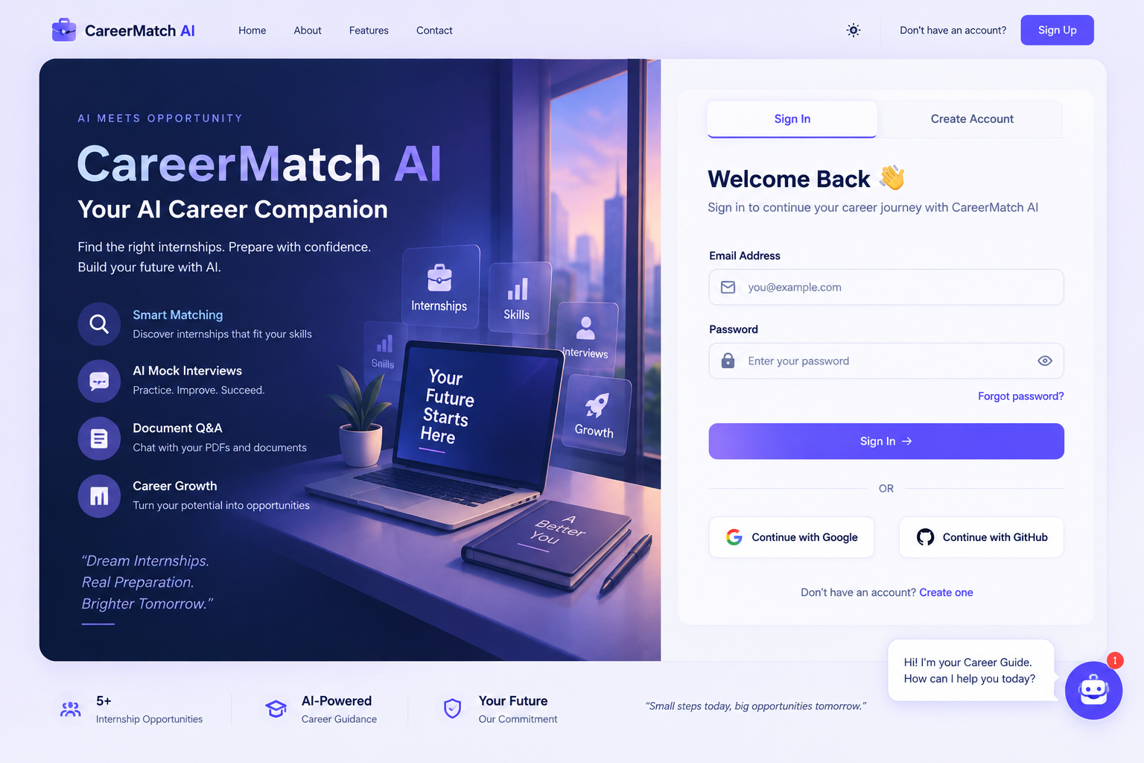
Figure 9.1 — Login / Registration Interface

Result
A user can register, log in, and receive a bearer token that grants access to the Dashboard and all other protected pages; invalid credentials are rejected with an HTTP 400 error.
Note on figures: Figures 9.1–9.6 are retained unchanged from an earlier UI iteration (purple/indigo theme). The current Career Match AI interface uses a warm orange / charcoal / cream identity: in dark mode, warm near-black/charcoal surfaces with an orange accent and subtle green status accents; in light mode, a warm cream background with white cards and an orange primary accent.

Feature 2 — Profile Management

Description
Lets a user view and edit their profile (name, phone, location, headline, summary, links, preferred roles/locations).

Implementation
A dedicated profiles table (one-to-one with users) is exposed through GET and PUT /profile endpoints. A profile row is auto-created on first access if one does not already exist. Fields left blank by the user are also auto-filled from resume parsing (see Feature 3).

Output
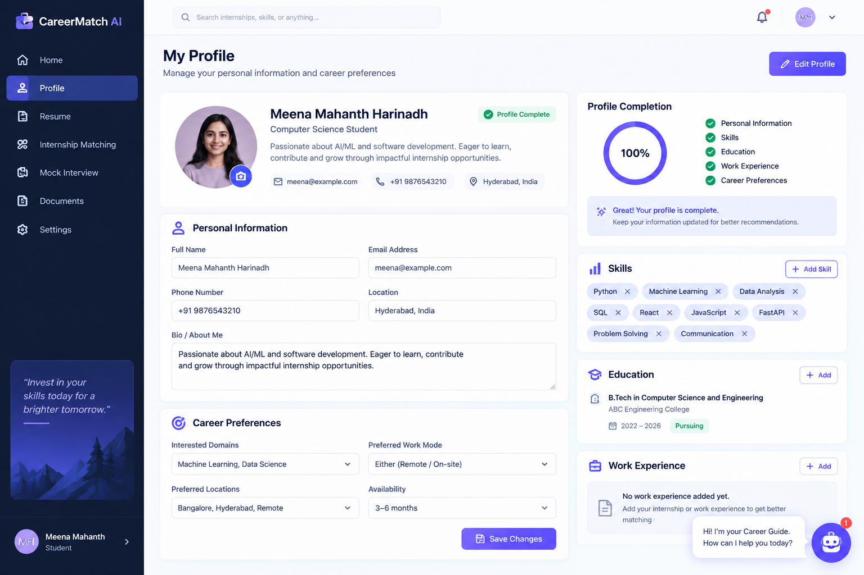
Figure 9.2 — Profile Page

Result
A user can view their profile and update it; fields populate automatically after a resume is parsed if they were previously empty.

Feature 3 — Resume Upload & Parsing

Description
Lets a user upload a resume and have its content converted into structured data.

Implementation
The /resumes/upload endpoint accepts .pdf and .docx files, but only PDF files are currently processed: text is extracted with PyPDF2, then sent to the Groq LLM with a schema-constrained prompt to extract name, contact details, summary, skills, education, experience, and projects as JSON. The parsed result is validated with Pydantic and saved across the resumes table and its related skill/education/experience/project tables.

Output
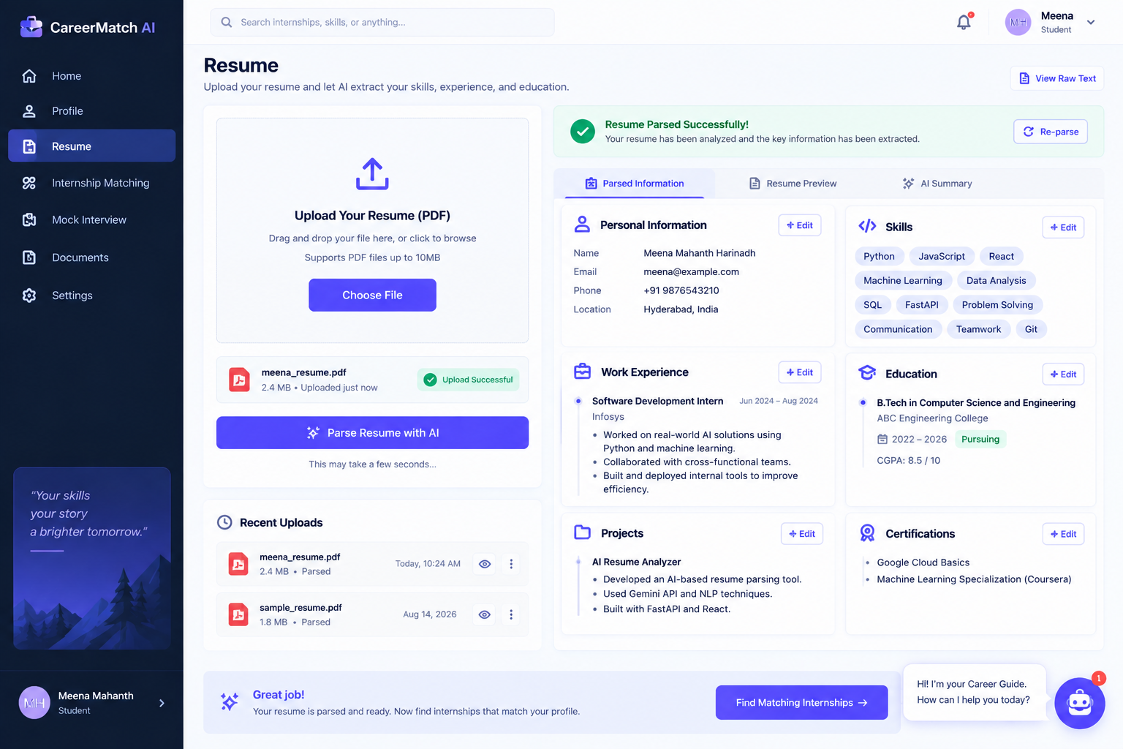
Figure 9.3 — Resume Upload and Parsed Data

Result
Uploading a PDF resume produces a structured, saved record of the candidate's skills, education, experience, and projects, and updates blank profile fields. DOCX uploads are currently accepted by the endpoint but are not text-extracted or parsed.

Feature 4 — Internship Matching

Description
Surfaces internships that are semantically relevant to the candidate's parsed resume.

Implementation
The candidate's skills/experience/projects are summarized into text, embedded with Sentence-Transformers, and compared against a FAISS index of internship postings using nearest-neighbour (L2 distance) search. Distances are converted to a 0–100 similarity score, and the Groq LLM generates a short explanation and matched/missing skill lists for each result, which are saved and returned to the frontend Matching page.

Output
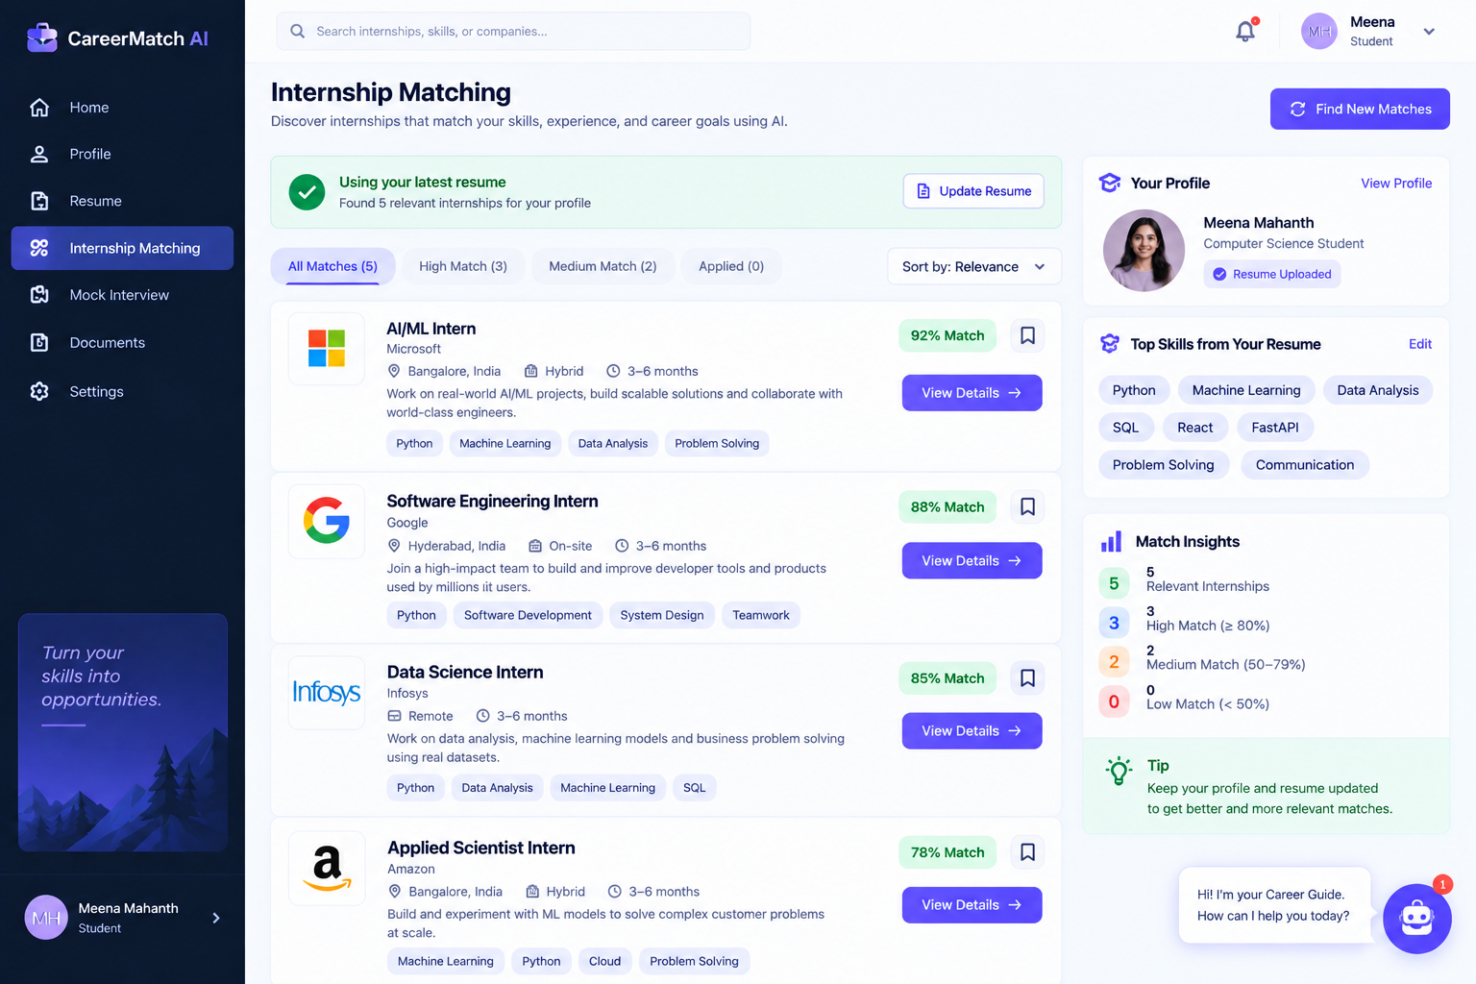
Figure 9.4 — Internship Matching Results

Result
A candidate receives up to 5 ranked internship matches (from the seeded demo dataset) with a similarity score, an AI-generated explanation, and matched/missing skill lists.

Feature 5 — AI Interview Agent

Description
Provides an AI-driven mock interview experience tailored to a chosen role and difficulty.

Implementation
A user starts a session with a target role and difficulty; the backend generates an opening question with the Groq LLM, seeded with the candidate's resume text. Each subsequent answer is evaluated in the same model call that produces the next question, following a fixed SCORE / FEEDBACK / NEXT_QUESTION response format that the backend parses and stores per message.

Output
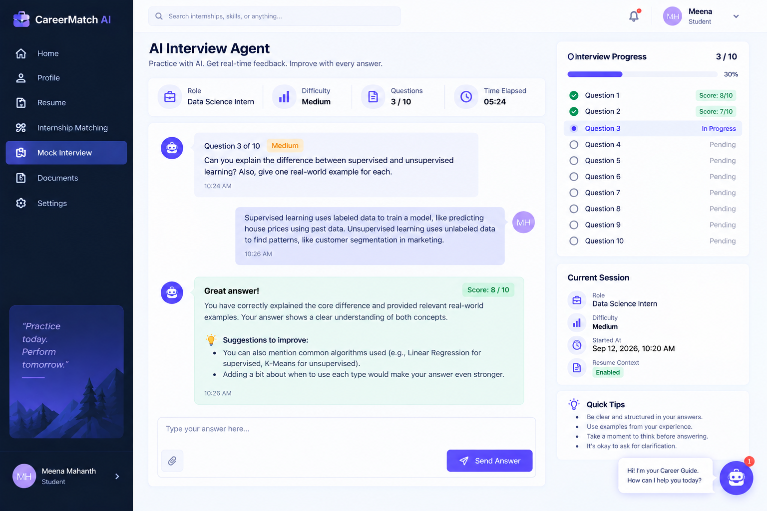
Figure 9.5 — AI Interview Agent

Result
A candidate can hold a multi-turn mock interview and receive a 0–10 score and written feedback after each answer, along with a new, contextually relevant question.

Feature 6 — Document Q&A

Description
Lets a user upload an arbitrary PDF document and ask questions answered only from that document.

Implementation
The /documents/upload endpoint accepts PDF files only, extracts text with PyPDF2, splits it into fixed 1,000-character chunks, embeds each chunk, and stores it in a FAISS documents index tagged with the owning user's ID. Questions are embedded and matched against the top 3 chunks belonging to that same user, and the Groq LLM is instructed to answer only from that retrieved context.

Output
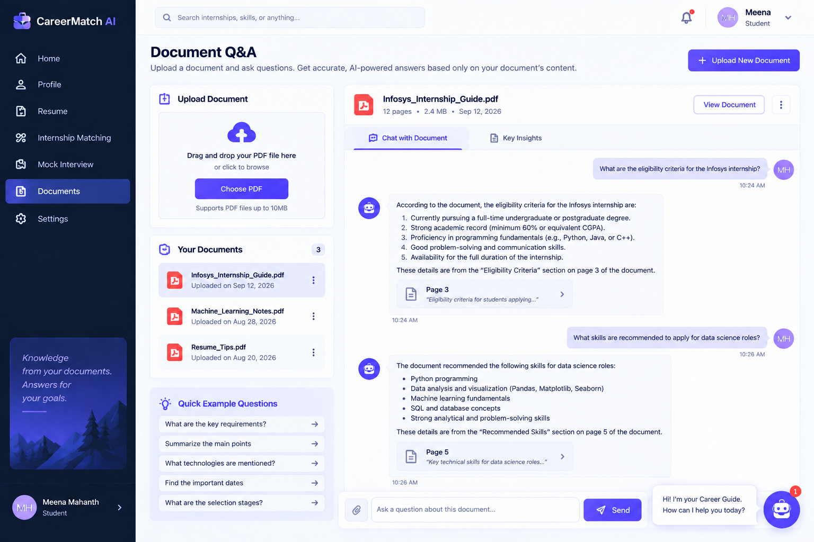
Figure 9.6 — Document Q&A

Result
A user can upload a PDF and ask questions about it, receiving answers grounded in the document's own text; if the retrieved context does not contain the answer, the system responds that the document does not contain enough information.

10. Testing
The repository includes one automated backend test file, tests/test_auth.py, run with pytest and FastAPI's TestClient, covering user registration and login. No automated tests were found for resume parsing, matching, the interview agent, or document Q&A. The table below lists both the existing automated test and the manually testable behaviors implied by the source code; results are marked "Not yet verified" wherever no executed test run or evidence was available.
Test ID | Test Case | Expected Result | Actual Result | Status
T001 | Register a new user (POST /api/v1/auth/register) | User is created and returned (or a 400 error if the email already exists) | Automated pytest test present in tests/test_auth.py (test_register_user); not executed in the documentation environment (requires a configured database instance) | Not yet verified
T002 | Log in with valid credentials (POST /api/v1/auth/login) | A 200 response containing an access_token | Automated pytest test present in tests/test_auth.py (test_login_user); not executed in the documentation environment | Not yet verified
T003 | Upload a PDF resume and parse it | Resume text is extracted and structured fields are returned/saved | No automated test found for this endpoint | Not yet verified
T004 | Upload a non-PDF/DOCX file as a resume | HTTP 400 error ("Only PDF and DOCX files are allowed") | Enforced directly in resume.py's file-extension check; no automated test found | Not yet verified
T005 | Run internship matching for a candidate with an active resume | Up to 5 ranked internship matches with scores and explanations | No automated test found for this endpoint | Not yet verified
T006 | Start and continue an interview session | Opening question generated; subsequent answers scored with feedback and a next question | No automated test found for this endpoint | Not yet verified
T007 | Upload a PDF document and ask a grounded question | Answer generated using only retrieved document chunks | No automated test found for this endpoint | Not yet verified
T008 | Upload a non-PDF file as a document | HTTP 400 error ("Only PDF files are allowed for documents currently") | Enforced directly in document.py's file-extension check; no automated test found | Not yet verified

10.1 AI / RAG Testing
The following AI/RAG-related behaviors are implemented in the source code but are not covered by any automated test in the provided repository:
- Skill-based internship matching (semantic similarity via Sentence-Transformers + FAISS)
- Resume-based structured data extraction accuracy (Groq LLM)
- Document-grounded Q&A correctness and refusal behavior when context is insufficient
- Interview question generation relevance and score consistency
NOTE
No accuracy percentages, benchmark scores, or measured evaluation metrics for the matching, extraction, or Q&A features were found in the project evidence, so none are claimed in this document.

11. Challenges & Solutions
NOTE
The challenges below are drawn directly from patterns and safeguards observed in the source code (fallback handling, explicit anti-hallucination instructions, per-user retrieval scoping, and the distance-to-score conversion). No project notes, issue tracker, or personal account of development challenges was included in the provided evidence, so no additional narrative challenges beyond what the code itself demonstrates are claimed here. Technology names reflect the current stack (Groq, FAISS); the safeguards were originally observed in the Gemini/ChromaDB build.
Challenge | Solution
Extracting structured information from unstructured resume text | Combined PyPDF2 text extraction with a schema-constrained Groq LLM prompt that explicitly instructs the model not to invent missing fields, and validated the model's JSON output against a Pydantic schema (ResumeExtractionSchema) before saving it.
Making internship search semantic rather than keyword-based | Used Sentence-Transformers to embed both candidate profile text and internship postings, and used FAISS nearest-neighbour search so that conceptually related skills/experience can match an internship even without exact keyword overlap.
Keeping a user's uploaded documents private from other users during retrieval | Scoped document retrieval to the requesting user only. The original build attached a user_id field to each chunk's ChromaDB metadata and applied a where={"user_id": ...} filter on every document-search query; the equivalent mechanism in the current FAISS-based retrieval should be re-verified against the code.
Turning a raw similarity distance into an interpretable score | Converted the L2 distance returned by vector search into a bounded similarity_score using the formula max(0, 100 − distance × 50) in matching_service.py, so the frontend can display a simple 0–100 score instead of a raw distance value.
Application configuration relies on an LLM API key that may not always be present | Each LLM-dependent service function checks settings.LLM_API_KEY (the Groq API key in the current configuration) and returns a safe fallback (an empty extraction schema, a neutral match explanation, or a message asking the user to configure the key) instead of raising an unhandled error when the key is missing.

12. Final Project Status

12.1 Completed Features
- User registration, login, and JWT-based authentication
- Profile retrieval and update, with auto-fill from parsed resume data
- PDF resume upload with PyPDF2 text extraction and Groq-based structured extraction
- Semantic internship matching using Sentence-Transformers embeddings and FAISS, with Groq-generated match explanations
- Multi-turn AI mock interview agent with per-answer scoring and feedback
- PDF document upload, chunked indexing, and user-isolated document-grounded Q&A
- A React frontend covering Login, Register, Dashboard, Profile, Resume, Matching, Interview, Documents, and Settings pages

12.2 In Progress
- Automated test coverage — only authentication is currently covered by pytest tests; resume, matching, interview, and document Q&A endpoints have no automated tests in the provided repository.

12.3 Pending
- DOCX resume text extraction (the upload endpoint accepts .docx files, but text extraction is implemented for PDF only)
- DOCX or other document formats for the Document Q&A feature (PDF only is currently accepted)
- Database migration history via Alembic (configured, but no migration version files are present in the provided repository)

12.4 Final Outcome
Career Match AI was successfully built as a working, end-to-end application covering resume parsing, semantic internship matching, an AI interview agent, and document-grounded Q&A, backed by a PostgreSQL (production) + FAISS data architecture and Groq-based AI services (the original development build used MySQL, ChromaDB and Gemini). Based on the reviewed source code, the application runs as an integrated system: a user can register, log in, upload a PDF resume and have it parsed, view semantically matched internships from the seeded demo dataset, practice a scored mock interview, and upload a PDF to ask grounded questions about it. The production deployment (Vercel frontend, Render backend, Cloud PostgreSQL, UptimeRobot monitoring via /health) is documented as the intended configuration and its verification is pending. What remains incomplete is broader automated test coverage beyond authentication, DOCX-format resume/document parsing, and an applied Alembic migration history.

Limitations
- Resume text extraction currently supports PDF files only; .docx resumes are accepted by the upload endpoint but are not parsed for content.
- Document Q&A currently accepts PDF files only.
- The FAISS vector indexes are local to the backend service rather than a hosted/managed vector database; index persistence on the production host (Render) should be verified.
- The Sentence-Transformers embedding model ("all-MiniLM-L6-v2") is downloaded on first run, which can add to first-time startup time.
- The internship dataset used for matching is a small, seeded demo dataset (5 postings), not a live or large-scale internship catalogue.
- CORS is currently configured to allow all origins, which the source code itself flags as a development-only setting.
- No Alembic migration version files are present in the provided repository, even though Alembic is configured; schema creation currently relies on SQLAlchemy's create_all.

Future Scope
- Add DOCX resume parsing support
- Expand the internship dataset beyond the current demo set
- Add automated tests for resume parsing, matching, the interview agent, and document Q&A
- Add measured evaluation of matching relevance and retrieval quality
- Support additional document formats for Document Q&A
- Introduce an applied Alembic migration history for schema changes
- Restrict CORS to specific origins and harden configuration for a production deployment
- Complete and verify the production deployment (Vercel, Render, Cloud PostgreSQL, UptimeRobot monitoring via /health) and explore further scaling (e.g., containerization, a managed vector store)
All items above are proposed future improvements and are not part of the current final implementation.

Conclusion
Career Match AI demonstrates an end-to-end application of AI techniques to a practical career-readiness problem, combining structured data extraction, retrieval-augmented generation, and conversational AI evaluation within a single system. The project integrates a React/TypeScript frontend with a FastAPI backend, and pairs PostgreSQL as the production relational source of truth with FAISS as a dedicated semantic retrieval layer, avoiding the need to force one component to serve both structured storage and vector search. The Groq API is used across the system for structured resume extraction, match explanation, interview question generation and scoring, and grounded document question answering, while Sentence-Transformers provides the underlying embeddings used for all semantic search. Together, these components allow a candidate to move from uploading a resume, to discovering relevant internships, to practicing interviews, to asking grounded questions of their own documents, within one authenticated application.

