**Activity 3: I will make a Haiku for you!**

Please refer to Activity 2’s instructions if you forgot different coding commands. Alternatively, you could visit the git [documentation](https://git-scm.com/doc).

Go on to Github and one of you should fork the following repository - https://github.com/ClintonProfessional/haiku.git

Invite your group members as collaborators so they can make edits to your forked repository.

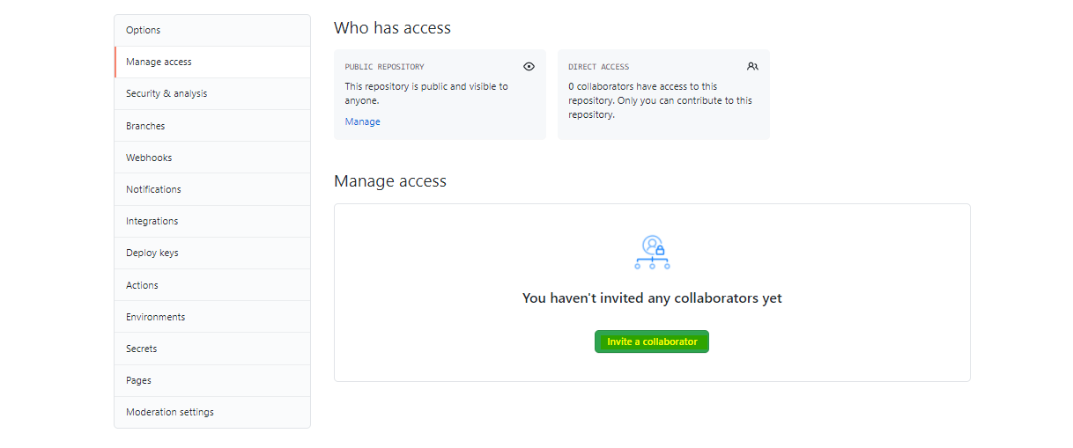

**You will have to write a Haiku as a group for your nice instructors! You can create branches of this repository and work on different lines (1, 2 or 3).**

Please clone the forked repository onto your computer using Git Bash.

Write the haiku using Git Bash (so nano into the file and write it out).

Commit those changes and push it to the main remote repository on Github.

Leave Git Bash. Swap back to Github and one of you can send a Pull request to the original Admin to ask if he/she likes the Haiku (through code review and comments). The Admin should say no for the first attempt and yes to the second one (hence the admin should merge the changes after one iteration of back and forth comments). You can re-edit the Haiku file using Git Bash, commit the new changes, push to your main repository and the commits should update on the original Pull request.

## 