**FRONT OFFICE ASSIGNMENT**

**TOPIC: TREND ANALYSIS**

**HOTEL NAME: GRAND HYATT MUMBAI**

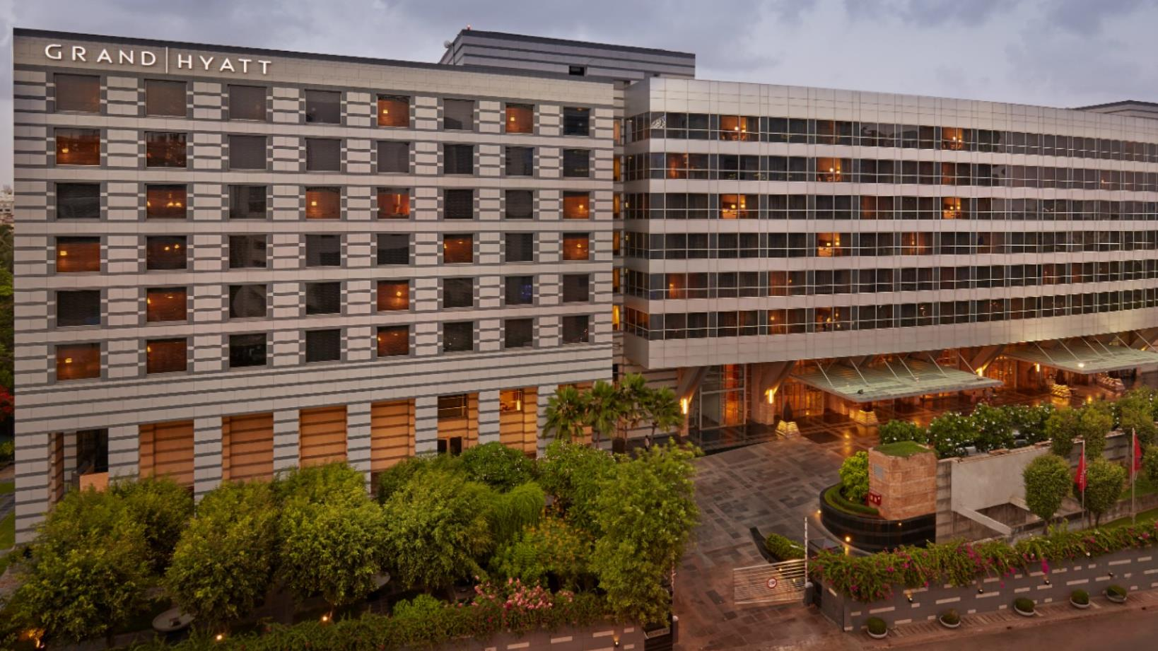

**ROOM CATEGORIES:**

* **GRAND VIEW KING**
* **GRAND VIEW QUEEN**
* **GRAND ROOM TWIN**
* **GRAND ROOM KING**
* **GRAND ROOM QUEEN**
* **GRAND ROOM TWIN**

**TIME PERIOD – 25 February to 6th March (10 Days)**

**NAME – VASUNDHARA PANDEY**

**COUNCIL No. – 1841112216**

**BATCH - D**

**ROOM CATEGORY:**

* **GRAND VIEW KING**
* **GRAND VIEW QUEEN**
* **GRAND ROOM TWIN**

|  |  |  |  |  |
| --- | --- | --- | --- | --- |
| DATE | TIME | PRICE(MMT) | PRICE(GoIbibo) | PRICE(Booking.com) |
| 25 February | **8.00 am** | 5783 | 5405 | 5330 |
|  | **2.00 pm** | 4826 | 5342 | 4952 |
|  | **9.00 pm** | 5363 | 5330 | 5405 |
| 26 February | **8.00 am** | 5619 | 4952 | 5525 |
|  | **2.00 pm** | 5363 | 5208 | 5619 |
|  | **9.00 pm** | 5405 | 5363 | 5406 |
| 27 February | **8.00 am** | 5330 | 5342 | 5619 |
|  | **2.00 pm** | 4952 | 5313 | 5723 |
|  | **9.00 pm** | 5619 | 5208 | 5802 |
| 28 February | **8.00 am** | 5702 | 5507 | 5330 |
|  | **2.00 pm** | 5525 | 5507 | 5525 |
|  | **9.00 pm** | 4826 | 5405 | 5342 |
| 1 March | **8.00 am** | 5018 | 5619 | 5405 |
|  | **2.00 pm** | 5702 | 5619 | 5619 |
|  | **9.00 pm** | 5363 | 5802 | 5723 |
| 2 March | **8.00 am** | 5330 | 5363 | 4952 |
|  | **2.00 pm** | 5619 | 5405 | 5525 |
|  | **9.00 pm** | 5405 | 5330 | 5406 |
| 3 March | **8.00 am** | 4826 | 5405 | 5619 |
|  | **2.00 pm** | 4952 | 5313 | 5723 |
|  | **9.00 pm** | 4826 | 5405 | 4826 |
| 4 March | **8.00 am** | 5525 | 5507 | 5702 |
|  | **2.00 pm** | 5702 | 5342 | 4952 |
|  | **9.00 pm** | 5330 | 5622 | 5405 |
| 5 March | **8.00 am** | 5208 | 5363 | 5619 |
|  | **2.00 pm** | 5363 | 4826 | 5330 |
|  | **9.00 pm** | 5525 | 5802 | 5342 |
| 6 March | **8.00 am** | 5405 | 5208 | 5330 |
|  | **2.00 pm** | 4952 | 5313 | 5525 |
|  | **9.00 pm** | 5619 | 5330 | 5702 |

**ROOM CATEGORY:**

* **GRAND ROOM KING**
* **GRAND ROOM QUEEN**
* **GRAND ROOM TWIN**

|  |  |  |  |  |
| --- | --- | --- | --- | --- |
| DATE | TIME | PRICE(MMT) | PRICE(GoIbibo) | PRICE(Booking.com) |
| 25 February | **8.00 am** | 4973 | 4497 | 4497 |
|  | **2.00 pm** | 4463 | 4997 | 4463 |
|  | **9.00 pm** | 4016 | 4711 | 4973 |
| 26 February | **8.00 am** | 4497 | 4497 | 4711 |
|  | **2.00 pm** | 4561 | 4016 | 4827 |
|  | **9.00 pm** | 4863 | 4997 | 4705 |
| 27 February | **8.00 am** | 4128 | 4827 | 4208 |
|  | **2.00 pm** | 4463 | 4293 | 4313 |
|  | **9.00 pm** | 4711 | 4973 | 4612 |
| 28 February | **8.00 am** | 4973 | 4522 | 4973 |
|  | **2.00 pm** | 4463 | 4293 | 4863 |
|  | **9.00 pm** | 4016 | 4497 | 4497 |
| 1 March | **8.00 am** | 4208 | 4711 | 4973 |
|  | **2.00 pm** | 4561 | 4463 | 4711 |
|  | **9.00 pm** | 4128 | 4711 | 4827 |
| 2 March | **8.00 am** | 4497 | 4827 | 4612 |
|  | **2.00 pm** | 4463 | 4497 | 4497 |
|  | **9.00 pm** | 4863 | 4973 | 4705 |
| 3 March | **8.00 am** | 4026 | 4976 | 4863 |
|  | **2.00 pm** | 4128 | 4293 | 4692 |
|  | **9.00 pm** | 4016 | 4497 | 4497 |
| 4 March | **8.00 am** | 4973 | 4997 | 4208 |
|  | **2.00 pm** | 4128 | 4322 | 4313 |
|  | **9.00 pm** | 4711 | 4016 | 4497 |
| 5 March | **8.00 am** | 4497 | 4827 | 4711 |
|  | **2.00 pm** | 4463 | 4293 | 4827 |
|  | **9.00 pm** | 4863 | 4973 | 4973 |
| 6 March | **8.00 am** | 4973 | 4997 | 4612 |
|  | **2.00 pm** | 4561 | 4463 | 4705 |
|  | **9.00 pm** | 4016 | 4973 | 4973 |