**How to Install Python**

You can install Python on any operating system such as Windows, Mac OS X, Linux/Unix and others.

To install the Python on your operating system, go to this link: <https://www.python.org/downloads/>. You will see a screen like this.  
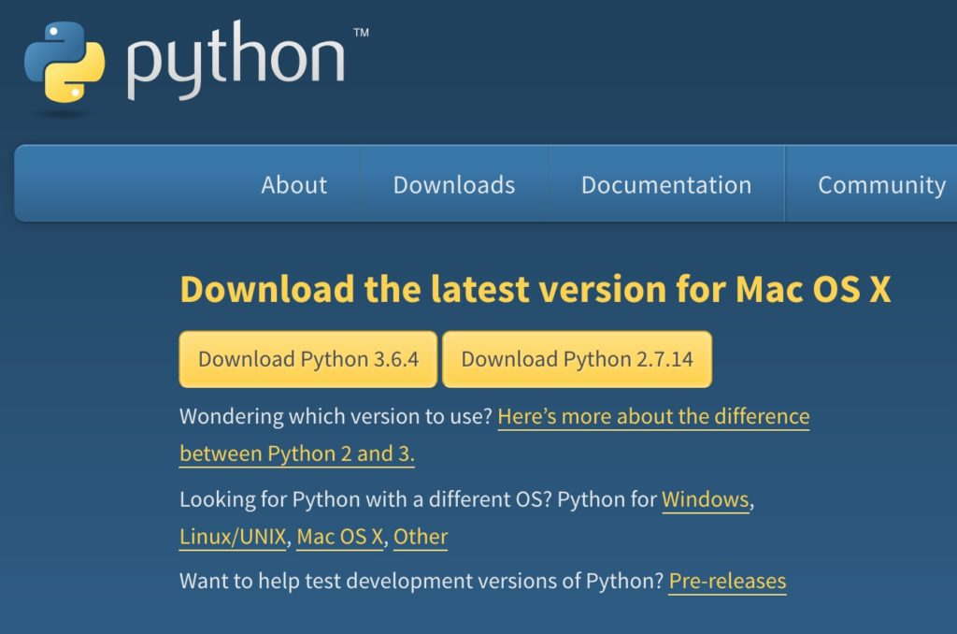

This is the **official Python website** and it will detect the operating system and based on that it would recommend you to download Python. Here I am using Mac OS X so it gave me the download options for Python 2 and Python 3 for Mac OS X. I would recommend you to download the **latest version of Python 3** (Python 3.6.4 in the screenshot).

Installation steps are pretty simple. You just have to accept the agreement and finish the installation.

If you are using Mac OS X then you may notice that Python is already installed in your system,  
however it would most likely be a Python 2 so you can download the latest Python 3 version from here and install it in your system.