**Introduction to Python Programming language**

Python is developed by **Guido van Rossum**. Guido van Rossum started implementing Python in 1989. Python is a very simple programming language so even if you are new to programming, you can learn python without facing any issues.

**Interesting fact**: Python is named after the comedy television show Monty Python’s Flying Circus. It is not named after the Python snake.

**Features of Python programming language**

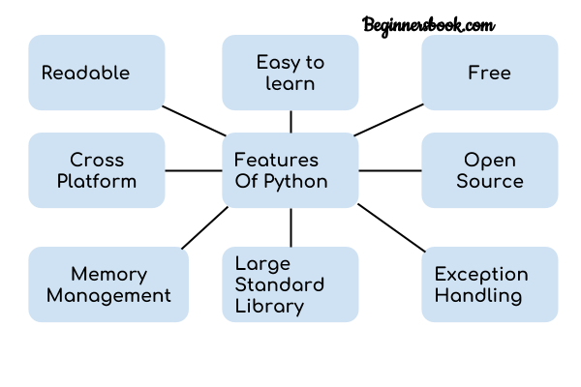  
1. **Readable:** Python is a very readable language.

2. **Easy to Learn:** Learning python is easy as this is a expressive and high level programming language, which means it is easy to understand the language and thus easy to learn.

3. **Cross platform:** Python is available and can run on various operating systems such as Mac, Windows, Linux, Unix etc. This makes it a cross platform and portable language.

4. **Open Source:** Python is a open source programming language.

5. **Large standard library:** Python comes with a large standard library that has some handy codes and functions which we can use while writing code in Python.

6. **Free:** Python is free to download and use. This means you can download it for free and use it in your application. See: [Open Source Python License](https://docs.python.org/3/license.html). Python is an example of a FLOSS (Free/Libre Open Source Software), which means you can freely distribute copies of this software, read its source code and modify it.

7. **Supports exception handling:** If you are new, you may wonder what is an exception? An exception is an event that can occur during program exception and can disrupt the normal flow of program. Python supports exception handling which means we can write less error prone code and can test various scenarios that can cause an exception later on.

8. **Advanced features:** Supports generators and list comprehensions. We will cover these features later.

9. **Automatic memory management:** Python supports automatic memory management which means the memory is cleared and freed automatically. You do not have to bother clearing the memory.

**What Can You Do with Python?**

You may be wondering what all are the applications of Python. There are so many applications of Python, here are some of the them.  
1. Web development – Web framework like Django and Flask are based on Python. They help you write server side code which helps you manage database, write backend programming logic, mapping urls etc.

2. Machine learning – There are many machine learning applications written in Python. Machine learning is a way to write a logic so that a machine can learn and solve a particular problem on its own. For example, products recommendation in websites like Amazon, Flipkart, eBay etc. is a machine learning algorithm that recognises user’s interest. Face recognition and Voice recognition in your phone is another example of machine learning.

3. Data Analysis – Data analysis and data visualisation in form of charts can also be developed using Python.

4. Scripting – Scripting is writing small programs to automate simple tasks such as sending automated response emails etc. Such type of applications can also be written in Python programming language.

5. Game development – You can develop games using Python.

6. You can develop Embedded applications in Python.

7. Desktop applications – You can develop desktop application in Python using library like TKinter or QT.

**How to install Python**

Python installation is pretty simple, you can install it on any operating system such as Windows, Mac OS X, Ubuntu etc. Just follow the steps in this article – [Python Installation](https://beginnersbook.com/2018/01/python-installation/)