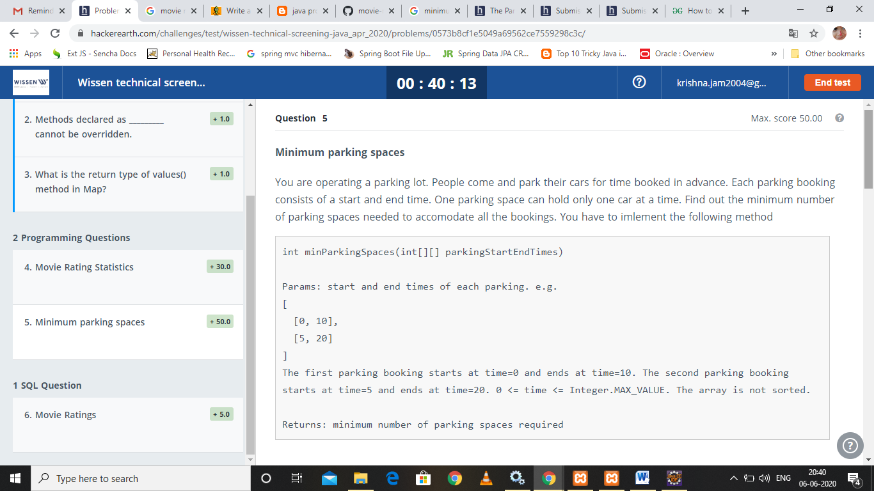

import java.io.\*;

import java.util.\*;

public class TestClass {

    static int minParkingSpaces(int[][] parkingStartEndTimes) {

// YOUR CODE HERE

    }

    // DO NOT MODIFY ANYTHING BELOW THIS LINE!!

    public static void main(String[] args) throws IOException {

        BufferedReader br = new BufferedReader(new InputStreamReader(System.in));

        PrintWriter wr = new PrintWriter(System.out);

        int n = Integer.parseInt(br.readLine().trim());

        int[][] parkingStartEndTimeList = new int[n][2];

        String[] parkingStartEndTimes = br.readLine().split(" ");

        for (int i = 0; i < n; i++) {

            String[] parkingStartEndTime = parkingStartEndTimes[i].split(",");

            for (int j = 0; j < parkingStartEndTime.length; j++) {

                parkingStartEndTimeList[i][j] = Integer.parseInt(parkingStartEndTime[j]);

            }

        }

        int out = minParkingSpaces(parkingStartEndTimeList);

        System.out.println(out);

        wr.close();

        br.close();

    }

}

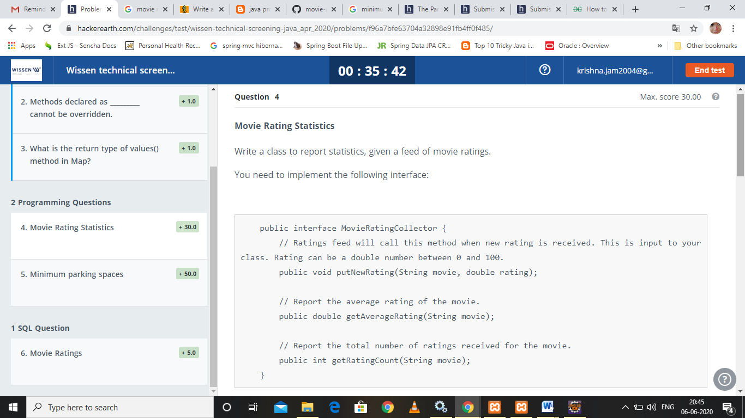

import java.util.\*;

public class MovieRatingCollector {

public static class RatingCollectorImpl implements RatingCollector {

@Override

public void putNewRating(String movie, double rating) {

// YOUR CODE HERE

}

@Override

public double getAverageRating(String movie) {

// YOUR CODE HERE

}

@Override

public int getRatingCount(String movie) {

// YOUR CODE HERE

}

}

////////////////// DO NOT MODIFY BELOW THIS LINE ///////////////////

public interface RatingCollector {

// This is an input. Make note of this rating. Rating can be a double number between 0 and 100.

void putNewRating(String movie, double rating);

// Get the average rating

double getAverageRating(String movie);

// Get the total number of ratings received for the movie

int getRatingCount(String movie);

}

public static void main(String[] args) {

Scanner scanner = new Scanner(System.in);

int numLines = Integer.parseInt(scanner.nextLine());

int currentLine = 0;

while (currentLine++ < numLines) {

final RatingCollector stats = new RatingCollectorImpl();

final Set<String> movies = new TreeSet<>();

String line = scanner.nextLine();

String[] inputs = line.split(",");

for (int i = 0; i < inputs.length; ++i) {

String[] tokens = inputs[i].split(" ");

final String symbol = tokens[0];

movies.add(symbol);

final double price = Double.parseDouble(tokens[1]);

stats.putNewRating(symbol, price);

}

for (String movie : movies) {

System.out.println(

String.format("%s %.4f %d", movie, stats.getAverageRating(movie), stats.getRatingCount(movie)));

}

}

scanner.close();

}

}