1. What is Normalization?

I)Normalization is a process in database design that organizes data to reduce redundancy (remove repeated values) and improve data integrity.

II)The primary goal of normalization is to divide a large table into smaller, related

III) tables and link them using relationship

Here are the three main normal forms (1NF,2NF,3NF) with an example

A] First Normal Form (1NF): Ensures atomicity and uniqueness (each attribute contain one value)

B] Second Normal Form (2NF): Eliminates Partial dependencies

C] Third Normal Form (3NF): Eliminates transitive dependencies (transitive dependency)

A] First Normal Form (1NF): 1 NF ensures that each column in a table contains atomic (invisible values) that each record is unique

Example:

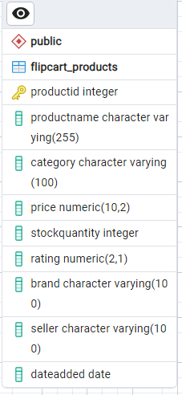

**1NF**

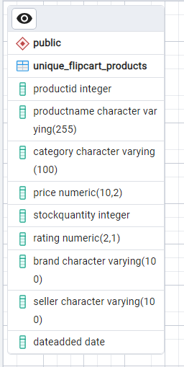

B] Second Normal Form (2NF): 2NF addresses the problem of partial dependency. a table is in 2NF if it is in 1NF and all non -key attributes are fully functionally dependent on the primary key. this means that the non key attributes should not depend on a just a part of a composite key.

Example: the product id is unique then it can use as primary key.

**2NF**

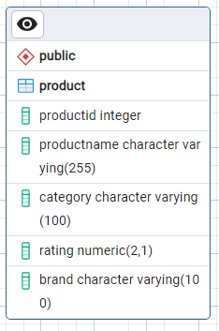

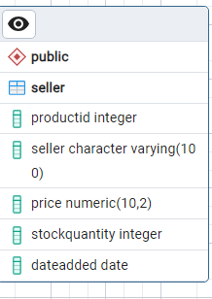

This seller table is fully depended on the combination of productid and seller

C] Third Normal Form(3NF): 3NF ensures that there is no transitive dependency. a table is in 3NF if it is in 2NF, and no non key attributes is dependent on another non key attribute

Example:

**3NF**