**Difference between HTTP1.1 vs HTTP2**

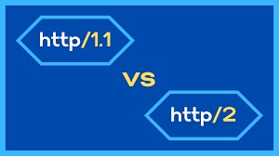

**Multiplexing:** HTTP/1.1 loads resources one after the other, so if one resource cannot be loaded, it blocks all the other resources behind it. In contrast, HTTP/2 is able to use a single TCP connection to send multiple streams of data at once so that no one resource blocks any other resource.

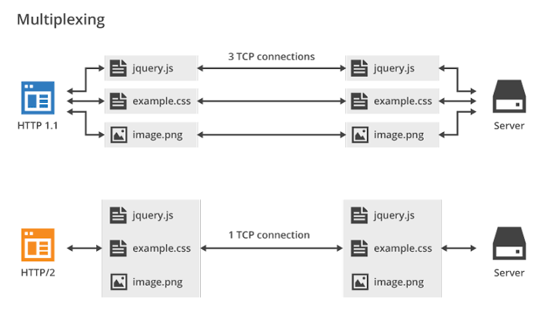

**HTTP/1.1 vs. HTTP/2 Protocol:** HTTP/2 improved on HTTP/1.1 in a number of ways that allowed for speedier content delivery and improved user experience, including:

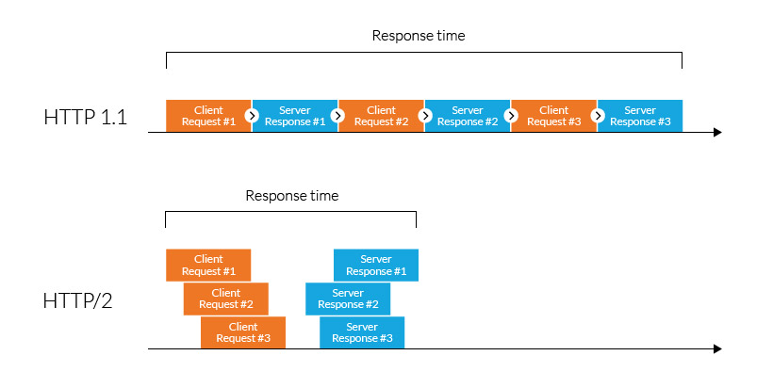

* **Binary protocols** – Binary protocols consume less bandwidth, are more efficiently parsed and are less error-prone than the textual protocols used by HTTP/1.1. Additionally, they can better handle elements such as whitespace, capitalization and line endings.
* **Header compression** – HTTP/2 uses header compression to reduce the overhead caused by TCP’s [slow-start](https://en.wikipedia.org/wiki/TCP_congestion_control#Slow_start) mechanism.
* **Server push** – HTTP/2 servers push likely-to-be-used resources into a browser’s cache, even before they’re requested. This allows browsers to display content without additional request cycles.
* **Increased security** – Web browsers only support HTTP/2 via encrypted connections, increasing user and application security.

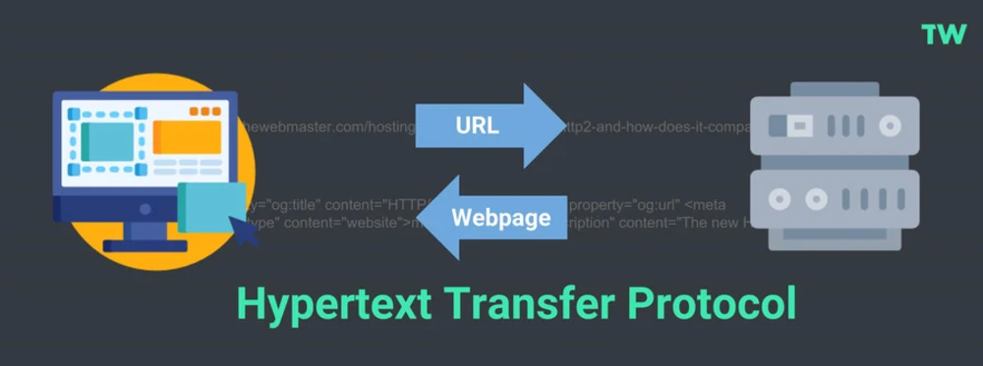



### **HTTP/1 vs HTTP/2 Results:**Based on a limited set of results, **HTTP/2 is faster** than HTTP/1.1 by around 14%. I hope to increase the sample size in due course.

