pwd Linux
Learned in FLM & Ashok IT channel
Operating System:
- Operating system is a software
- Mediator between Users & Computers
- Without OS we can't use computer

Diff b/w Windows & Linux:

Windows Linux
-> Developed by Microsoft -> Community based OS
-> Commercial OS (Paid) -> Free & Open Source
-> GUI Based -> CLI(Commond Line Interface) Based OD
-> Single User based -> Multi User OS
-> Security Features are less -> Provides High Security
-> Recommended for personal use -> For Business use

Linux History:

- Developed by Linus Torvalds in 1991
- He got inspired by Minux OS

(Li)nux + Mi (nux) = Linux OS

Linux Distributions:

- Linus Torcalds fiven linux Os as free and open source
- Many I released their own flavours of Linux OS

Eg: Amazon Linux, Red Hat, Ubuntu, Cent OS, SuSe, Kali Linux, Fedora etc.,

- there are 200+ linuxes in market

Linux VM Setup in AWS Cloud:

USER -- Terminal --- Ec2 Instances
|-> use key pair to secure the shell

-> I will connect my linux machine to windows machine through ssh client

ssh Client: GitHub, MobaXterm, Putty

Linux Architecture:

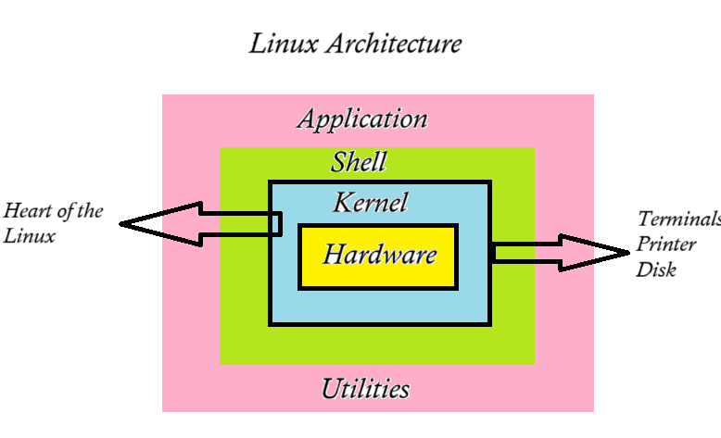

What is Shell?
- Shell is like a Container
- It’s a interface b/w users and Kernel
- The default shell in Linux BASH, the GNU Bourne Again Shell
- The Shell is most commonly used to run commands

# Find default shell in Linux $ echo $0

What is Kernel?
- Kernel is a heart of Linux OS
- The Linux kernel is the ain component of a Linux OS
- It is the core interface blw a computer’s hardware and its processes

What is kernel does?
- Memory Management
- Process Management
- Device Drivers
- System calls and security

File System Hierarchy(FHS) of Linux:
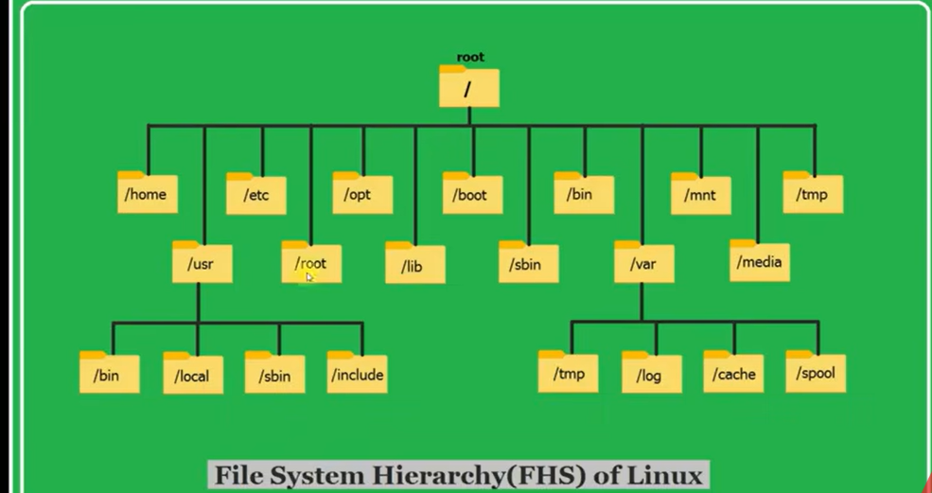
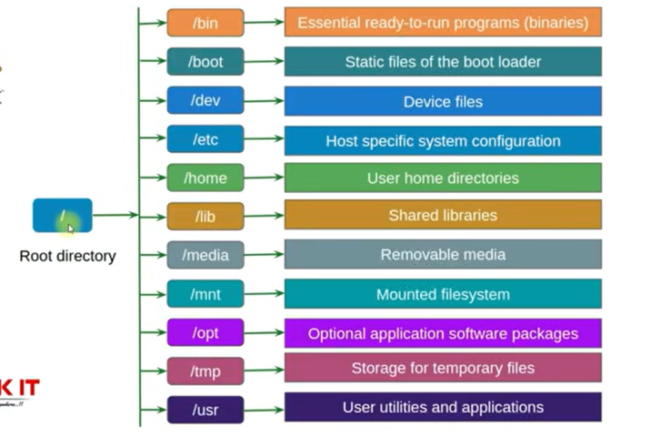

Documentation Commands:
Man
Info
Help
Commands:
Whoami
Pwd
Date
Cal -> Current date
Cal 2049 -> 2049 Calander
Cal 05 2049 –> May 2049 Calander
uname ->System information
uname -r -> Kernel Version
uname -i -> Hardware platform information
arch -> System architecture details
uptime -> When this machine is uptime running
free -> Memory level details
clear -> clear the terminal
history -> All commands that you are executed

Files & Directories:
- ls - list of directories
- mkdir devops – create a directory
- rmdir devops - remove a directory
- ls -l - display entire directory including access(ASCENDING)
- ls -lr - display list of directories in reverse(DESCENDING)
- ls -lt - display latest content in top and old content in bottom
- ls -ltr - display Old content in top and latest content in bottom
- ls -la - display hidden files(starts with .)
- touch – create a empty file
Eg: touch f1.txt
touch f1.txt f2.txt f3.txt
- rm – remove the file
    - Eg: rm <File-name>
    - rm f3.txt
    - rm *.txt
    - r, a*.txt
    - rm -rf <dir-name> - used to delete the directory forcefully.If there any file inside that directory then you will use this command
- mv f2.txt f211.txt – rename & move from one to another location
        - Eg: mv <present-name> <new-name>
        - mv <present-location> <new-location>
- cd – change the directory
- Eg: cd .. – used to one step back from directory
- cd ~ - display the current directory from root
- cat - used to create a file (prints from top to bottom)
- Eg: cat > f1.txt – Enter the data & override the data
- cat f1.txt – prints the data which is there in that file
- cat >> f1.txt - append the data
- cat -n f1.txt – display the text along with line number
- cat f1.txt f2.txt > f3.txt – concat the f1 & f2 date in f3.txt
- tac f1.txt – prints from bottom to top
- rev f1.txt – reverse the each line of data
- cp - copy
Eg: cp <file1><file2>
- wc – display the count of lines, words, letters in given file

Filters & Editors:
- head : to display file data from top(default 10 lines)
- head f1.txt
- head -n 5 f1.txt(print first 5 lines only)
- head -n 15 f1.txt (print first 15 lines only)

- tail : to display file data from bottom (default 10 lines)
- head f1.txt
- head -n 5 f1.txt(print last 5 lines only)
- head -n 15 f1.txt (print last15 lines only)
- gref : used to search the word in file
stands for global regular expression print
- gref -i ‘DevOps’ f1.txt (ignores the case sensitive)
- gref ‘DevOps’ f1.txt (print lines having DevOps keyword)
- gref -n -i ‘course’ f1.txt (print lines having course with line number)
- gref -v ‘course’ f1.txt (print lines which doesn’t have course keyword)
- gref -I -n ‘linux’ * (search linux in all files of pwd)
Text Editors in linux:
- vi (visual editor) :
- It is default editor in linux machines
- Using ‘vi’ we can create new files and we can modify existing file data
Eg: vi f1.txt
- Vi command is having 3 modes
- Command mode(just to open the file)
- Insert mode (to edit the file) - press ‘i’ in keyword
- Esc mode (to comeout from insert mode) -press ‘esc’ in keyword
NOTE:
Vi command will open the file if it is already available otherwise it will create new file and it will open that file
IMPORTANT POINT:
## Save changes & close the file => :wq
## Without saving changes close the file => :q!

File creation commands in Linux:
Touch : to create empty file
Cat : create file with data
Cp: copy one file into another file(cp f1.txt f2.txt)
Vi : create and open file for editinh(vi f3.txt)

Reading file data commands in linux:
Cat : print file data from top to bottom
Tac : print file data from bottom to top
Rev : print each line in reverse order
Head : print first 10 lines of file data
Tail : print last 10 lines of file data
Vi : open the file
Gref : pattern match (search)

SED Command:
- Stands for Stream editor
- Used to process the data (substitute , delete, print, insert)
- Using SED command we can perform operation on the file without opening the file
- Very powerful command in linux
- We will use below options with SED command
      - S – SUBSTITUTE
      - D – DELETE
      - P – PRINT
      - I – INSERT
I/P:
what is Linux?
Linux is free, Linux is community based.
Linux is very famous. Linux is easy. Linux is secured.

- Replace first occurrence of linux with unix in every line
Eg: sed 's/Linux/Unix/' os.txt
O/P:
what is Unix?
Unix is free, Linux is community based.
Unix is very famous. Linux is easy. Linux is secured.

- Replace second occurrence of linux with unix in every line
Eg: sed 's/Linux/Unix/2' os.txt
O/P:
what is Linux?
Linux is free, Unix is community based.
Linux is very famous. Unix is easy. Linux is secured.

- Replace third occurrence of linux with unix in every line
Eg: sed 's/Linux/Unix/3' os.txt
O/P:
what is Linux?
Linux is free, Linux is community based.
Linux is very famous. Linux is easy. Unix is secured.

- Replace all occurrences of linux with unix in every line
Eg: sed 's/Linux/Unix/g' os.txt
O/P:
what is Unix?
Unix is free, Unix is community based.
Unix is very famous. Unix is easy. Unix is secured.

- Substitute linux with unix and save changes in the file
Eg: sed -i 's/Linux/Unix/g' os.txt
O/P:
what is Unix?
Unix is free, Unix is community based.
Unix is very famous. Unix is easy. Unix is secured.

- Delete first line of the file
Eg: sed -i ‘1d’ os.txt
O/P:
Unix is free, Unix is community based.
Unix is very famous. Unix is easy. Unix is secured.
- Delete 4th line of the file
Eg: sed -i ‘4d’ os.txt

- Delete last line of the file
Eg: sed -i ‘$d’ os.txt

- Delete from 3rd line to last line
Eg: sed -i ‘3, $d’ os.txt

- Delete from 10th line to 15th line
Eg: sed -i ’10, 15d’ os.txt

- Print 10th line only
Eg: sed -n ‘10p’ os.txt

- Print data from 2nd line to 5th line
Eg: sed -n ‘2,5p’ os.txt

- Insert the data in 2nd line
Eg: sed -I ‘2i\i want to learn devOps’ os.txt
- Add line at end of file
Eg: sed -i ‘$a\i am from ashokit’ os.txt

User & Group Management in LINUX OS:
User Management:
- Linux is a multi user based OS
- Multiple users can access single linux machine and can perform multi tasking at a time
NOTE: “ec2 -user” is a default user in “amazon linux’’ vm. Ec2-user having sudo privileges.

Amazon Linux AMI - ec2-user (default user)
Ubuntu AMI - ubuntu (default user)
- When we create user account, for user one home directory will be created.
Ec2 -user /home/ec2-user/
John /home/John/
Shivaya /home/Shivaya/
- Display all users in Linux
Eg: cat /etc/passwd
- Create user
Eg: sudo useradd <uname>
- Set pwd for user
Eg: sudo passwd <uname>
- Switch user account
Eg: su <uname>
- Navigate to current user home directory
Eg: cd ~
- Delete user along with user home directory
Eg: sudo userdel john –remove

NOTE:
/etc/passwd : This file contains user information
/etc/shadow : This file contains user passwords in encrypted format

Working with user groups in Linux:
- When we create user in linux, for that user one user group also will be created with the given username.
- Display all groups
Eg: cat /etc/group
- Create group in linux
Eg: sudo groupadd <group-name>
- Add user to group
Eg: sudo usermod -aG <group-name> <username>
- Remove user from group
Eg: sudo gpasswd -d<uname> <group-name>
- Display user belongs to group
Eg: sudo lid -g <group-name>
- Check one user belongs to how many groups
Eg: id<uname>
- Delete group
Eg: sudo groupdel <group-name>

TASK:
How to enable password based Authentication in Linux Virtual machine

Assignment: Create new user and connect with Linux Vm using newly created user account

Uname: ashokit
Pwd : ashokit@123

- To connect with Linux Vm using our own user account (Eg: ashokit) , we need to enable password based Authentication in Linux Vm.
- To enable Password Based Authentication in Linux vm then we need to modify below configuration file.
- sudoers
- sshd-config

What is sudoers file in Linux?(Most Important for sudoers file)
- It is very important configuration file in linux machine.
- Using this file we can control which user can run command as a superuser.

- Print sudoers file content
Eg: sudo cat /etc/sudoers
- Open sudoers file
Eg: sudo visudo
- Add below line under root user
Eg: <uname> ALL=(ALL) ALL

- After making the changes to close sudoers file we need to execute
(Ctrl + X+Y +Enter)

How to enable password based authentication for users in linux VM?

- In Linux VM, by default password authentication is NO.
- If we want to connect with Linux VM by using username and password then we need to set password authentication values as YES.
- WE WILL MODIFY THIS IN ‘sshd_config’ file.

Working with File Permissions in Linux Machine:
File Permissions in Linux:
- Using file permissions we can secure our files and we can protect our file data.
- We have 3 types of permissions in linux.
- R -> Read
- W -> Write
- X -> Execute
- File/ directory permissions will be represented like below
Eg: rwxrwxrwx f1.txt
- File permissions contains 9 characters and those are divided into 3parts
  - First 3 characters => User/owner permissions
  - Middle 3 characters => Group permissions
  - Last 3 characters => Other user permissions
- Lets under file permissions with different scenarios

Scenario 1:: rw-r—r--f1.txt

User: (rw-) : read + write
Group: (r--) : Only read
Others : (r--) : only read

Scenario 2:: rwxr-xr-x f1.txt

User: (rwx) : read + write+execute
Group: (r-x) : read +execute
Others : (r-x) : read +execute

Scenario 3:: rwx—xr-x f1.txt

User: (rwx) : read + write+execute
Group: (--x) : execute
Others : (r-x) : read +execute

- To change file/directory permissions we will use ‘chmod’ command.
- + -> represents adding
- - -> represents removing
- Giving execute permissions for user
Eg: chmod u+x f1.txt
- Giving write permission for group
Eg: chmod g+w f1.txt
- Remove execute permissions for others
Eg: chmod o-x f1.txt
- Give all permiossions for group
Eg: chmod g+rwx f1.txt
- Remove all permissions for others
Eg: chmod 0-rwx f1.txt

File Permissions in Numeric Format:
- => No permission
- => Execute
- => Write
- => (2+1) => Write + Execute
- => Read
- =>(4+1) => Read + Execute
- =>(4+2) => Read + Write
- => (6+1) => Read + Write + Execute

Eg: chmod 111 f1.txt
chmod 222 f1.txt
chmod 007 f1.txt
chmod 077 f1.txt

Networking commands:
- Ping: To check connectivity.
Eg: ping www.google.com
ping www.facebook.com
ping 192.168.1.34
- Wget: It is used to download files from internet
Eg: Wget <url>
once above is run completed and that represents in a zip file, then unzip that zip file using below command
Unzip (filename).
- Curl: It is used to send the http request to the url
Eg: curl <url>
- ifConfig: To get IP address of our machine

Package Managers in Linux:
- Package means a software
Eg: git, maven, java, python etc..
- Package managers are used to manage software packages (softwares) in linux machine.
- Package managers are specific to linux distribution
Amazon Linux ====> yum
Ubuntu Linux ====> apt
- Check git client installed or not
Eg: git –version
- Install git client s/w
Eg: sudo yum install git -y
- Check git installed path
Eg: whereis git
- Check java installed or not
Eg: java –version
- Install java s/w
Eg: sudo yum install git -y
- Check java installed path
Eg: whereis java

Webserver Setup in Linux Vm:
- Webserver is a software which is used to run websites / web applications.
- Website means collection of web pages.
Eg: Login page, Register page, Dashboard page, About us page …
- Websites are divided into 2 types
- Static Website
- Dynamic Website
- The website which gives same response for every user is called as Static website.
Eg: www.eenadu.com
- The website which gives response based on logged in user is called as dynamic website.
Eg: gmail.com, amazon.com
- To run static websites we can use ‘’httd” as webserver
- To run dynamic websites we can use “tomcat, iis, jboss, weblogic as webservers

- Install httpd webserver
Eg: sudo yum install httpd -y
- Check httpd status
Eg: sudo service httpd status
- Start httpd server
Eg: sudo service httpd start

NOTE: TO ACCESS OUR WEBSERVER WE NEED TO ENABLE HTTP PROTOCOL IN EC2 VM SECURITY GROUP INBOUND RULES.
- Navigate to website content directory
Eg: cd /var/www/html
- Create index.html file with website content.
Eg: sudo vi index.html
- We can access our webserver using ec2-vm public ip.
INTERVIEW QUESTIONS:
- What is difference between Linux and Unix?
Linux : Free OS
Unix : Proprioty OS.

- How do you find out what process is using a specific port like 8080?
Sudo lsof -i : 8080

- What does the ‘chmod 755’ command do?
User (7) : Read + write + execute
Group(5): Read + Execute
Other(5) : Read + Execute

- What is the difference between a soft link and hard link?
Soft link (Symlink) : Points to the file path
Hard Link : Points to the file inode. Still works if original file is deleted
- What are the file permissions in Linux? How do you change them?
rwxrwxrwx

chmod
- How to check the disk space usage?
df -h
du -sh /dir/path/
- What command is used to view system logs?
Journalctl
- What is the difference between apt and yum?
Yum: RHEL-based (CentOS, Fedora, Amazon Linux)
Apt : Debain-based (Ubuntu)
- How do you add user to a group?
Sudo usermod -aG <group-name> <user-name>
- How do you search for a string in a file using the terminal?
gref “search-term” filename
- What is the difference between /etc/passwd and /etc/shadow?
/etc/passwd: User details
/etc/shadow: Encrypted passwords(more secure)
- How do you manage services with systemd?
Using systemctl we can manage services
Systemctl start nginx
Systemctl enable docker
Systemctl status sshd

- How to find 30 days old files in linux?
Usiong find command with ntime.

- How to find linux OS family details?
Cat /etc/os-release
- How to find linux kernel version?
Uname -r
- How to find user belongs to which groups?
id <uname>
- How to check linux machine execution time?
uptime
- How to change file/directory owner in linux?
chown
- How to enable pwd based authentication in linux?
We need to enable in “/etc/sshd/sshd_config” file
- How to provide sudo privileges for a user in linux?
By configuring user in sudoers file (visudo)
- How to create a user without home directory?
- Create user along with home directory
Eg: sudo adduser Shiva
- Create user without home directory
Eg: sudo useradd -M meena

- How to change the password for the user?
Sudo passwd <username>

