What is Maven?
- Maven is a project management tool.
- Maven is build tool as well
- Maven is Open source
- It is developed by Apache in Java
- It is for Java

What you do in a software project so manages the projects?
- We do the configuration
- We do the downloading the source code
- We do the initialization
- We do the compilation
- We do the Packaging
- We do the Unit Testing
- We do the Acceptance testing
- We do the deployment
- We do the documentation
- We do the reporting
- We do the clean
All above tasks are done by maven, if you’re create maven project.

History of Maven?
Apache.org
1000’s open source
Each project contains below same things
- Dependency management
- Compile
- Test
- Package
- Install
- Clean
- Reports
- Documents

Maven ------------------ > automatic ---------------------- >
- No difference scripting
- No new skillsets are required
Maven says – if you follow my process – I will automated everything..
Other tools:
Makefile - > ant - > maven - > Gradle
Makefile - > NANT - > Msbuild
Rake
How to install maven?
Pre- requisite –
- JRE -- > JDK
- Download a mvn package from – https://maven.apache.org/download.cgi
- Extract it c drive or opt
- Set a path.
Eg: maven_home/bin --------- > PATH
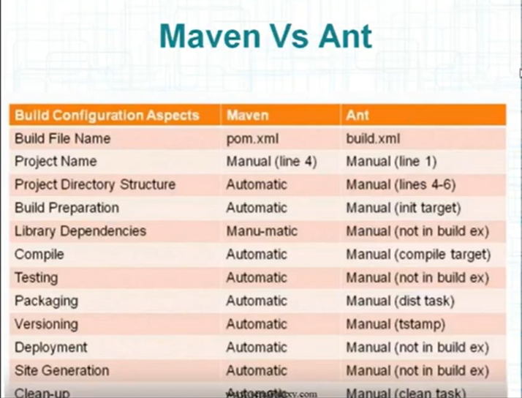

How maven works?
- Maven Software is divided into two parts
- Maven core - just understand the plugins
- Plugins - features of maven
- Core plugins
- External plugins.

================ All these will happen =============
Project Directory Structure
Build Preparation
Compile
Testing
Packaging
Versioning
Cleanup

How??
Plugins
How to verify?
$ mvn
$ mvn -v

At its core, Apache Maven is a powerful build automation tool used primarily for Java projects. Think of it as the "project manager" for your code. It doesn't just compile your files; it manages your dependencies (the libraries you need), handles the build lifecycle, and ensures that your project structure remains consistent.

How Maven Works: The Basics
Maven operates on the principle of Convention over Configuration. This means it has a standard way of doing things—like where your source code lives (src/main/java) and where your tests go—so you don't have to spend hours setting up your environment.
The POM File (pom.xml)
Everything in Maven revolves around the Project Object Model. This XML file is the heart of your project. It contains:
- Metadata: Project name, version, and group ID.
- Dependencies: A list of external libraries (like Spring or JUnit) your project needs. Maven automatically downloads these from a central repository.
- Plugins: Extra tools for tasks like generating documentation or deploying to a server.

Maven in the DevOps Lifecycle
In a DevOps environment, Maven is the "engine" inside your CI/CD (Continuous Integration/Continuous Deployment) pipeline. Here is how it is typically used in real-world projects:
1. Standardization
In large teams, everyone might have different local setups. Maven ensures that whether the code is built on your laptop, a colleague's Mac, or a Linux build server, the process is exactly the same.
2. Automated Dependency Management
Manually downloading .jar files is a nightmare and leads to "version hell." Maven handles this by:
- Checking the pom.xml.
- Downloading the correct versions from the Maven Central Repository.
- Storing them in a local cache to speed up future builds.
3. Integration with CI Tools (Jenkins, GitLab CI, GitHub Actions)
When you push code to a repository, a CI tool triggers Maven using specific Build Lifecycles:
Phase | What it does
mvn clean | Removes the target folder (old build artifacts).
mvn compile | Compiles the source code.
mvn test | Runs unit tests to ensure the new code didn't break anything.
mvn package | Bundles the compiled code into a distributable format (like a .JAR or .WAR).
mvn install | Puts the package in your local repository for use in other projects.
mvn deploy | Uploads the final artifact to a remote repository (like Nexus or Artifactory).

Why DevOps Engineers Love It
- Reproducibility: You get the same result every time you run the build.
- Transitive Dependencies: If you need Library A, and Library A needs Library B, Maven fetches both. You don't have to track the "friends of friends" yourself.
- Quality Gates: You can configure the pipeline to fail the build if Maven tests don't pass, preventing "buggy" code from reaching production.
Are you planning to integrate Maven into a specific CI tool like Jenkins, or are you just getting started with setting up your first pom.xml?

Gemini gives this about maven
What is Maven? Tell me more about maven? How to use it in real time projects?
What is Maven?
Apache Maven is a powerful project management and build automation tool used primarily for Java projects. Think of it as a project manager in a box. It handles how your code is built, which external libraries (dependencies) it needs, and how it is packaged for deployment.
At its core, Maven uses a Declarative Approach. Instead of writing complex scripts to tell the computer how to build your project, you describe what the project looks like in a single XML file called the POM (Project Object Model).

Key Concepts of Maven
1. The POM File (pom.xml)
This is the heart of any Maven project. It contains all the configuration details:
- Artifact ID & Group ID: Unique identifiers for your project.
- Dependencies: A list of external libraries (like Selenium, TestNG, or Apache POI) your project needs.
- Plugins: Additional tools that help with tasks like compiling code or generating reports.
2. Dependency Management
Before Maven, you had to manually download .jar files and add them to your build path. With Maven, you simply add a few lines to your pom.xml. Maven then automatically downloads those libraries from the Maven Central Repository and manages their versions for you.

3. The Build Lifecycle
Maven follows a specific sequence of steps to build a project:
- Compile: Converts source code (.java) into bytecode (.class).
- Test: Runs unit tests (e.g., using JUnit or TestNG).
- Package: Bundles the compiled code into a distributable format like a JAR or WAR file.
NOTE:
1. What is a JAR File?
JAR stands for Java ARchive. It is the standard format for aggregating many Java class files, associated metadata, and resources (like text or images) into one file.
- Primary Use: Desktop applications, libraries (APIs), or command-line tools.
- Structure: It contains .class files and a Manifest file (META-INF/MANIFEST.MF), which tells the Java Virtual Machine (JVM) which class contains the main method to start the program.
- Execution: You typically run it using the command: java -jar filename.jar.

2. What is a WAR File?
WAR stands for Web Application ARchive. While it is technically a JAR file under the hood, it has a specific internal structure designed to be run on a Web Server (like Tomcat or JBoss).
- Primary Use: Web applications (websites, portals, or web services).
- Structure: It includes a WEB-INF directory, a web.xml file (the deployment descriptor), and folders for HTML, CSS, JavaScript, and Java servlets.
- Execution: You don't "run" a WAR file manually like a JAR; instead, you deploy it. You drop the file into a web server's "webapps" folder, and the server handle
==================================================================================
- Install: Moves the package to your local repository so other local projects can use it.
- Deploy: Copies the final package to a remote repository for sharing with the team.

How to Use Maven in Real-Time Projects
In a professional environment—especially in automation testing—Maven is the standard. Here is how it is typically implemented:
1. Standard Directory Structure
Maven enforces a specific folder hierarchy, which makes it easy for any developer to understand a new project immediately:
- src/main/java: Your application source code.
- src/test/java: Your test scripts (Automation suites).
- src/main/resources: Configuration files, properties, or XMLs.
- target/: Where Maven stores the generated output (JARs, reports).
2. Integrating with Automation Frameworks
In real-time automation (like Selenium with Java), you use Maven to:
- Manage Drivers: Use dependencies like WebDriverManager so you don't have to manually download chromedriver.exe.
- Version Control: Ensure everyone on the team is using the exact same version of Selenium and TestNG by defining the version once in the pom.xml.
3. Continuous Integration (CI/CD)
This is where Maven shines. Tools like Jenkins or Azure DevOps don't "click" buttons in an IDE. Instead, they run Maven commands.
- A Jenkins job will trigger a command like mvn clean test.
- Maven will then clean the previous build, download any missing dependencies, compile the code, and execute the tests automatically.
4. Profiles for Different Environments
You can use Maven Profiles to switch between environments (Dev, QA, UAT). For example:
- mvn test -PQA could run tests against your QA URL.
- mvn test -PProd could run a smoke suite against Production.

Example: A Simple Dependency in pom.xml
If you wanted to add Selenium to your project, you wouldn't download a file. You would just add this:
XML
<dependency>
<groupId>org.seleniumhq.selenium</groupId>
<artifactId>selenium-java</artifactId>
<version>4.18.0</version>
</dependency>

Are you planning to migrate an existing project to Maven, or are you starting a new framework from scratch?
I am starting a new framework from scratch? How will I create a new framework?
Starting a new automation framework from scratch is an exciting move, especially with your background in Selenium and Java. Since you are already familiar with BDD and Cucumber, the best approach is to build a Maven-based Page Object Model (POM) framework.
Here is a step-by-step blueprint to build a robust, professional-grade framework:

1. Project Initialization
The first step is setting up the environment and structure.
- Create a Maven Project: In your IDE (IntelliJ or Eclipse), select New Project > Maven. This gives you the standard src/main/java and src/test/java folders.
- Configure pom.xml: Add your core dependencies. You’ll need:
  - Selenium Java (Browser automation)
  - WebDriverManager (Automatic driver management)
  - TestNG or JUnit (Execution engine)
  - Cucumber-Java & Cucumber-TestNG (For BDD support)

2. Design the Folder Structure
A clean structure is what separates a beginner project from a professional framework.
- src/main/java:
  - com.projectName.pages: Store your Page Classes (locators and actions).
  - com.projectName.base: The BaseTest or BasePage to initialize the WebDriver.
  - com.projectName.utils: Helper classes for Excel reading, screenshots, and wait-handling.
- src/test/java:
  - com.projectName.stepdefinitions: The logic for your Cucumber steps.
  - com.projectName.runner: The TestRunner class to execute the suite.
- src/test/resources:
  - features: Your .feature files written in Gherkin.
  - config.properties: URL, browser type, and timeout settings.

3. Implement the Page Object Model (POM)
POM ensures that if a UI element changes, you only update it in one place.
- Create Page Classes: Each web page should have its own class.
- Encapsulation: Keep your @FindBy locators private and create public methods (like loginToApp(user, pass)) to interact with them.

4. Integrate BDD (Cucumber)
Since you’ve worked with Cucumber before, this will be the layer that makes your tests readable for non-technical stakeholders.
- Feature Files: Write scenarios like Scenario: Verify Login with valid credentials.
- Step Definitions: Link the Gherkin steps to your Java methods using the Page Objects.
- Hooks: Use @Before and @After to start and quit the browser automatically.

5. Add Advanced "Real-Time" Features
To make this framework production-ready, include these components:
- Explicit Waits: Avoid Thread.sleep(). Create a utility that uses WebDriverWait for element stability.
- Reporting: Integrate Extent Reports or Allure Reports. They provide visual dashboards showing screenshots of failed tests.
- Parallel Execution: Configure the testng.xml or use the Maven Failsafe plugin to run tests in multiple browsers simultaneously to save time.
- Retry Mechanism: Implement an IRetryAnalyzer to automatically re-run tests that fail due to network glitches or "flakiness."

6. Version Control & CI/CD
A framework isn't complete until it lives in a shared ecosystem.
- Git: Initialize a repository and push your code to GitHub or GitLab.
- Jenkins: Create a Maven project in Jenkins. Use the build command mvn clean test to trigger your suite whenever code is updated.

Quick Checklist for your First Script
- Does the browser open via the BaseClass?
- Are constants (URL, Browser) pulled from a .properties file?
- Does it capture a screenshot on failure?
- Is the report generating in the target/ folder?

