GIT & GIT – HUB
GITHUB:
- GIT is version control software
- GIT HUB is a platform which is used to store project related files / source code at one place.
- In git hub, we can create source code repository to store project code.
- All developers can connect to project repository to store all the source code (Code Integration will become very easy)

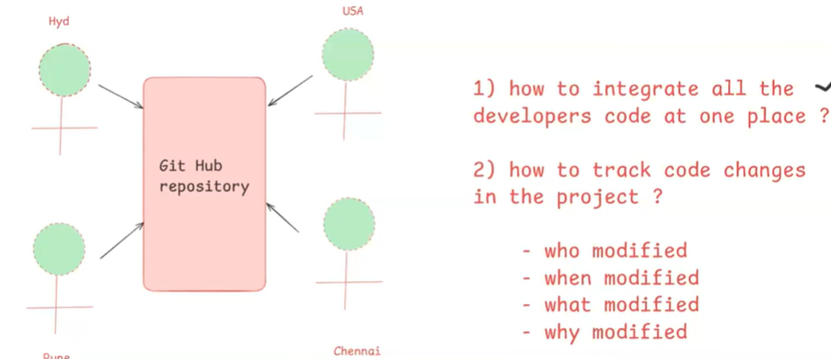

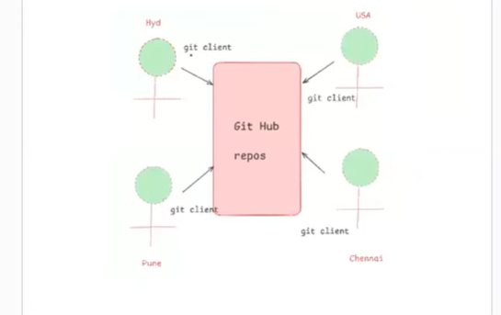

- Git Hub repository will monitor all code changes
- Who modified
- When modified
- What modified
- Why modified

Environment SETUP:
- Create account in www.github.com ( Free of cost)
- Download and install ‘git client ‘ software in our system
URL: https://git-scm.com/downloads
- Open git bash and configure your name and your email using below commands.
- git config –global user.name “your-name”
- git config –global user.email “your-email”
NOTE: Configuring name and email is just one time process in git bash.

What is Git Hub Repository?
- Repository is a place where we can store project source code/files.
- For every project one git hub repository will be created
- We can create 2 types of repositories in git hub
- Public repo(anyone can see & you choose who can commit)
- Private repo(you vhoose who can see & who can commit)

@@Project Git Repo URL : https://github.com/meenatripurana214-lgtm/sbi_loans_app.git
@@Session Git Repo URL: https://github.com/ashokitschool /sbi_loans_app.git
- Project team members will connect with fit repository using the URL.

Questions:
- What is Git Hub & why?
- Environment setup
- What is Git hub repository?

Git Architecture:
- Working Tree – Our project folder is called as Working Tree.
- Staging Area
- Local Repository
- Central Repository(Remote Repository).

GIT ARCHITECTURE
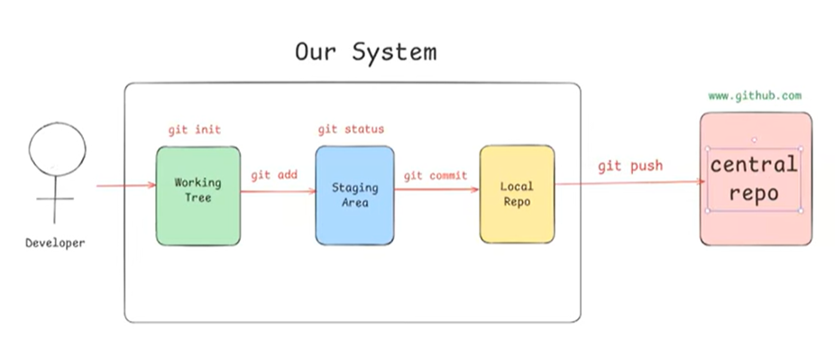
echo "# sbi_loans_app" >> README.md
git init
git add README.md
git commit -m "first commit"
git branch -M main
git remote add origin https://github.com/meenatripurana214-lgtm/sbi_loans_app.git(It is used to specify the central repo URL)
git push -u origin main

Commands:
- git init: Initialize working tree

- git status: display files status (staged and un-staged)

- git add: Add file(s) to staging area
git add <file-name>
git add .

- git commit: Commit staged files to local repo
git commit -m <msg>

- git push: Publish local commits to central repo
- git restore: to unstage + to discard file changes
- git log: to display commit history
- git rm : to remove file
git rm <file-name>

NOTE: After ‘git rm’ execution we need to execute commit and push to delete file from central repo.

